quarto-03

library(reticulate)  
use_condaenv("sklearn")

## Table

Markdown table

Demonstration of pipe table syntax

| Default | Left | Right | Center |
| --- | --- | --- | --- |
| 12 | 12 | 12 | 12 |
| 123 | 123 | 123 | 123 |
| 1 | 1 | 1 | 1 |

| fruit | price |
| --- | --- |
| apple | 2.05 |
| pear | 1.37 |
| orange | 3.09 |

| fruit | price |
| --- | --- |
| apple | 2.05 |
| pear | 1.37 |
| orange | 3.09 |

Table 1: My Caption

| Col1 | Col2 | Col3 |
| --- | --- | --- |
| A | B | C |
| E | F | G |
| A | G | G |

See Table 1.

|  |  |  |  |  |  |  |  |  |  |  |  |  |  |  |  |  |  |  |  |  |  |  |  |  |  |
| --- | --- | --- | --- | --- | --- | --- | --- | --- | --- | --- | --- | --- | --- | --- | --- | --- | --- | --- | --- | --- | --- | --- | --- | --- | --- |
| (a) First Table   | Col1 | Col2 | Col3 | | --- | --- | --- | | A | B | C | | E | F | G | | A | G | G | | (b) Second Table   | Col1 | Col2 | Col3 | | --- | --- | --- | | A | B | C | | E | F | G | | A | G | G | |

Table 2: Main Caption

See Table 2 for details, especially Table 2 (b).

from IPython.display import Markdown  
from tabulate import tabulate  
table = [["Sun",696000,1989100000],  
 ["Earth",6371,5973.6],  
 ["Moon",1737,73.5],  
 ["Mars",3390,641.85]]  
Markdown(tabulate(  
 table,   
 headers=["Planet","R (km)", "mass (x 10^29 kg)"]  
))

Table 3: Planets

| Planet | R (km) | mass (x 10^29 kg) |
| --- | --- | --- |
| Sun | 696000 | 1.9891e+09 |
| Earth | 6371 | 5973.6 |
| Moon | 1737 | 73.5 |
| Mars | 3390 | 641.85 |

library(knitr)  
kable(head(cars))

Table 4: Cars

| speed | dist |
| --- | --- |
| 4 | 2 |
| 4 | 10 |
| 7 | 4 |
| 7 | 22 |
| 8 | 16 |
| 9 | 10 |

```{r}  
#| label: tbl-example  
#| tbl-cap: "Example"  
#| tbl-subcap:  
#| - "Cars"  
#| - "Pressure"  
#| layout-ncol: 2  
  
library(knitr)  
kable(head(cars))  
kable(head(pressure))  
```

|  |  |  |  |  |  |  |  |  |  |  |  |  |  |  |  |  |  |  |  |  |  |  |  |  |  |  |  |  |  |
| --- | --- | --- | --- | --- | --- | --- | --- | --- | --- | --- | --- | --- | --- | --- | --- | --- | --- | --- | --- | --- | --- | --- | --- | --- | --- | --- | --- | --- | --- |
| (a) Cars   | speed | dist | | --- | --- | | 4 | 2 | | 4 | 10 | | 7 | 4 | | 7 | 22 | | 8 | 16 | | 9 | 10 | | (b) Pressure   | temperature | pressure | | --- | --- | | 0 | 0.0002 | | 20 | 0.0012 | | 40 | 0.0060 | | 60 | 0.0300 | | 80 | 0.0900 | | 100 | 0.2700 | |

Table 5: Example

Sample grid table.

| Fruit | Price | Advantages |
| --- | --- | --- |
| Bananas | $1.34 | * built-in wrapper * bright color |
| Oranges | $2.10 | * cures scurvy * tasty |

## Diagram

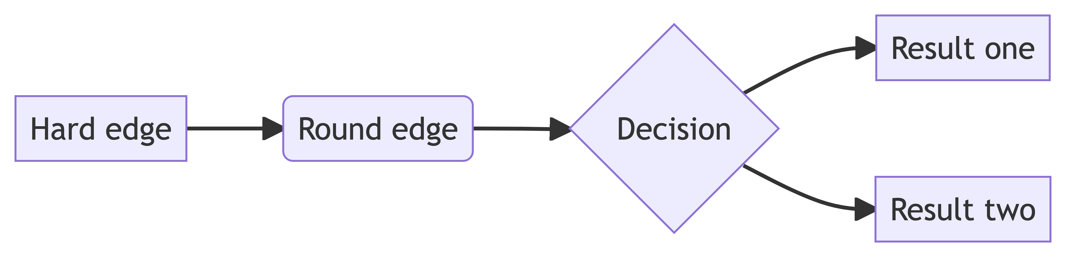

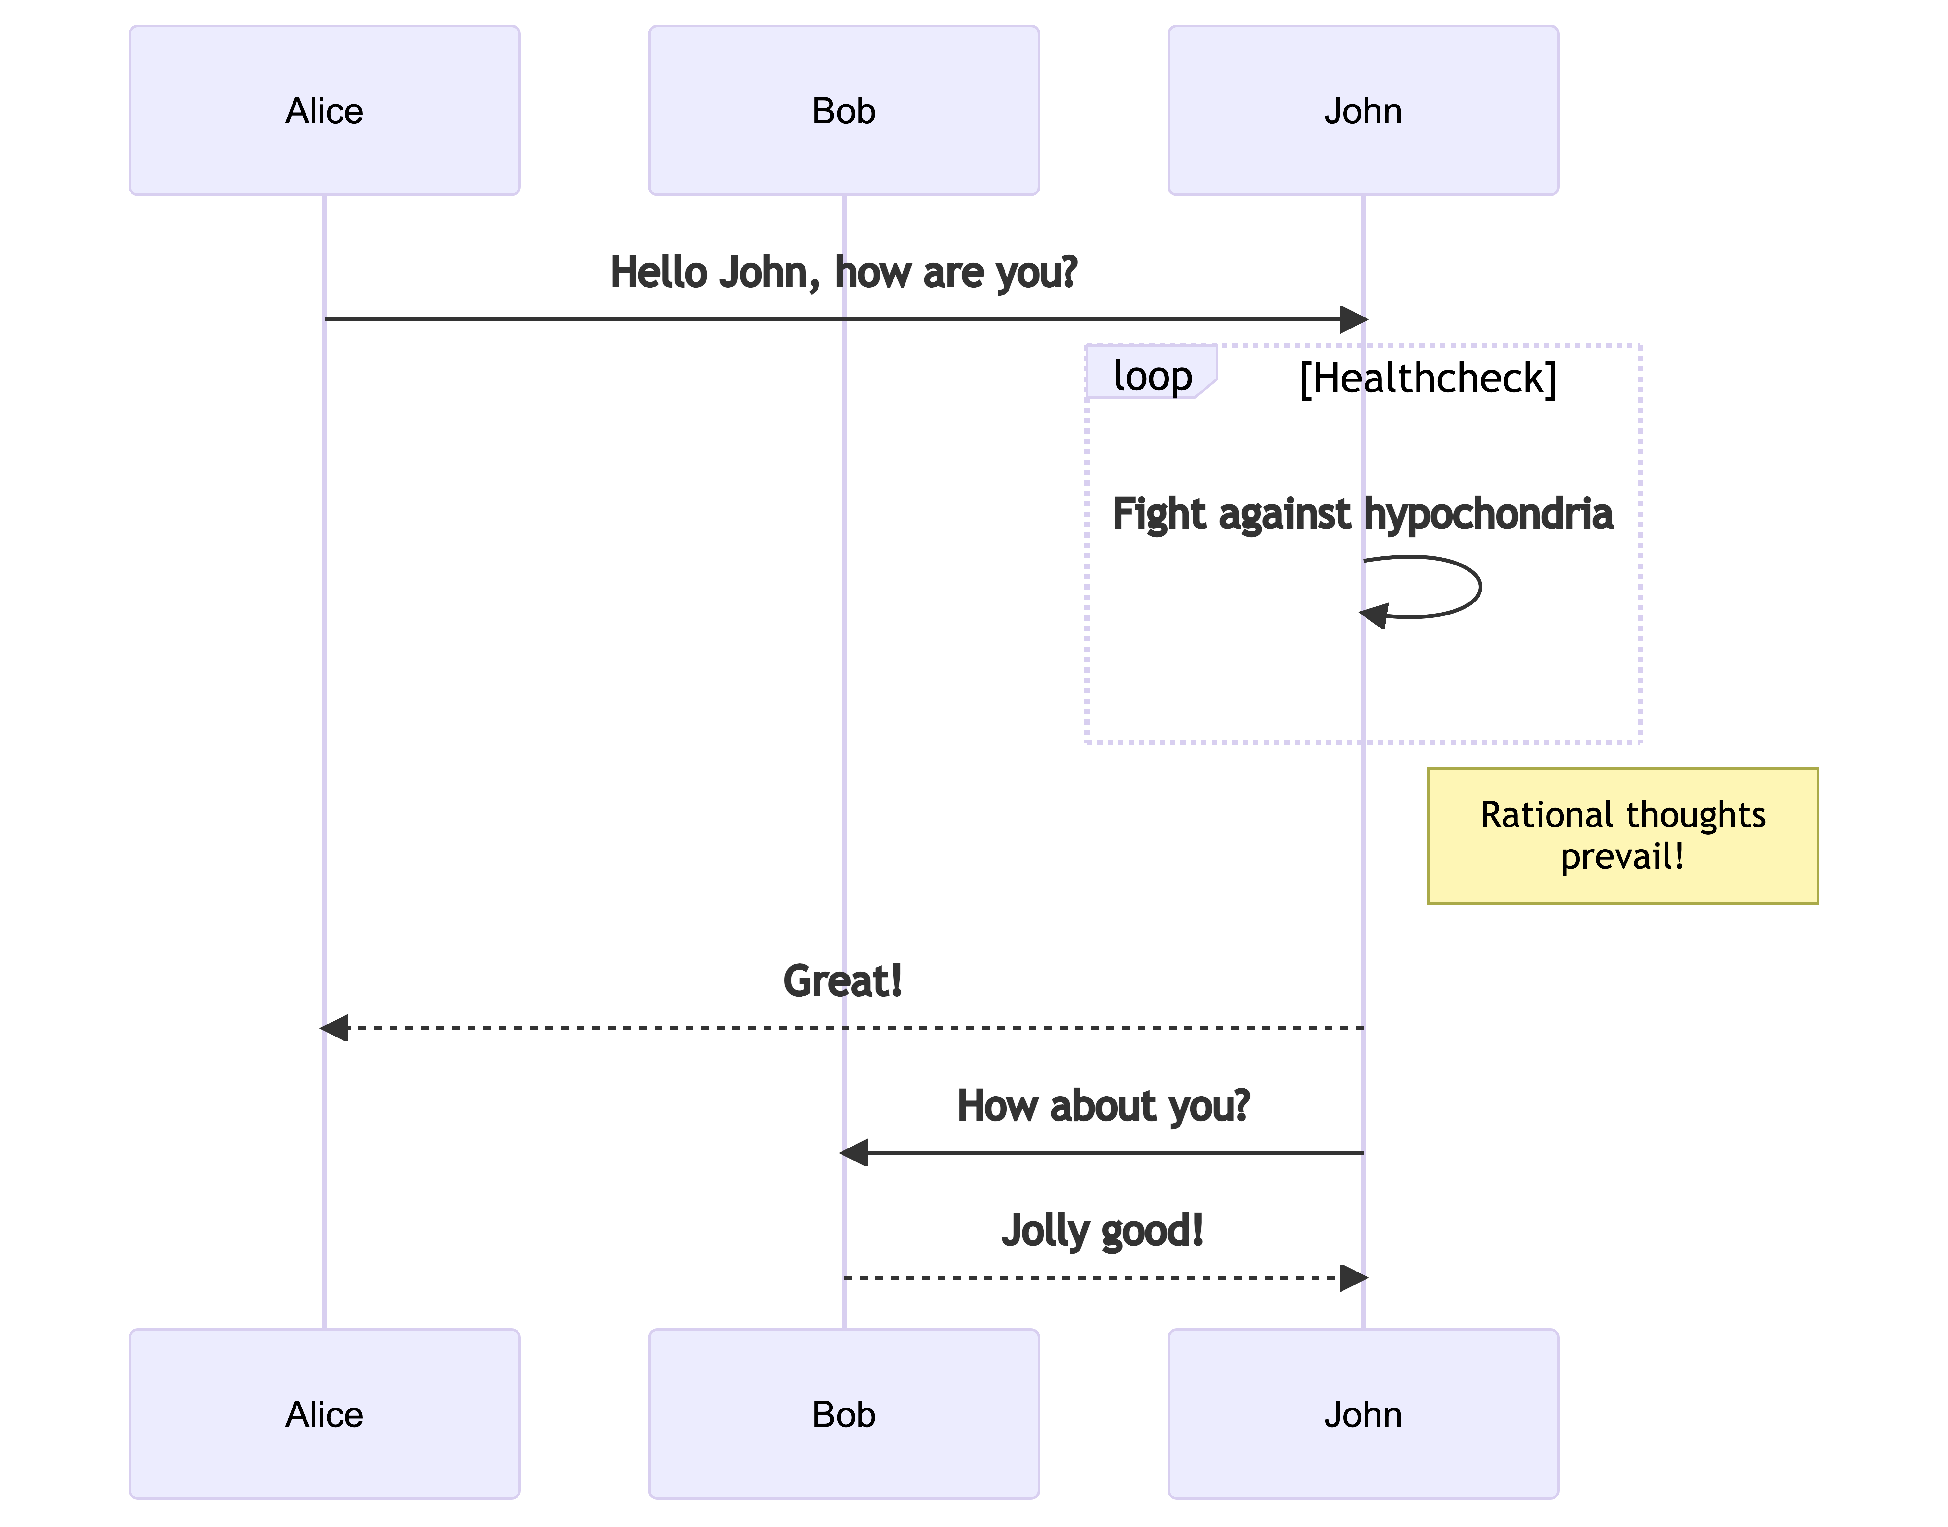

|  |  |
| --- | --- |
| |  | | --- | |  |   Figure 1: This is a simple graphviz graph. |

|  |
| --- |
| Note |
| Note that there are five types of callouts, including: note, warning, important, tip, and caution. |

|  |
| --- |
| Tip With Caption |
| This is an example of a callout with a caption. |

|  |
| --- |
| Expand To Learn About Collapse |
| This is an example of a ‘folded’ caution callout that can be expanded by the user. You can use collapse="true" to collapse it by default or collapse="false" to make a collapsible callout that is expanded by default. |

|  |
| --- |
| Pay Attention |
| Using callouts is an effective way to highlight content that your reader give special consideration or attention. |