Mycroforest Feedback 19 June 2024

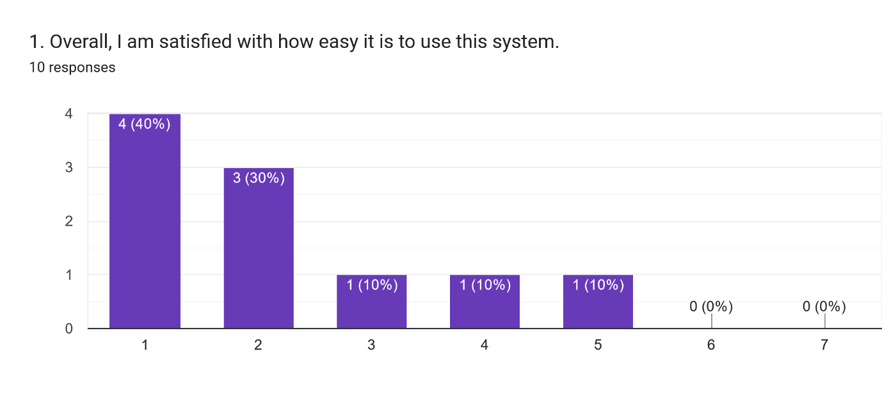

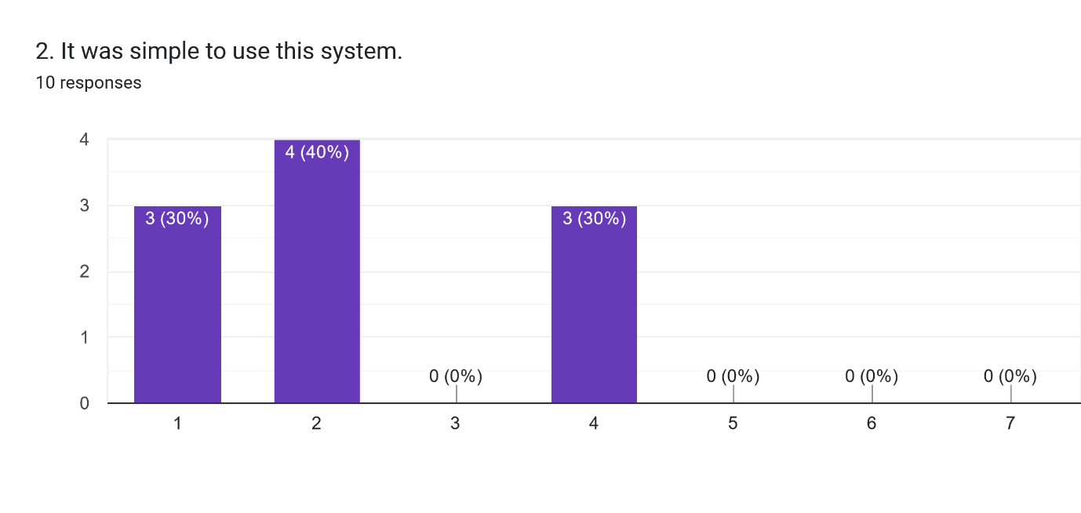

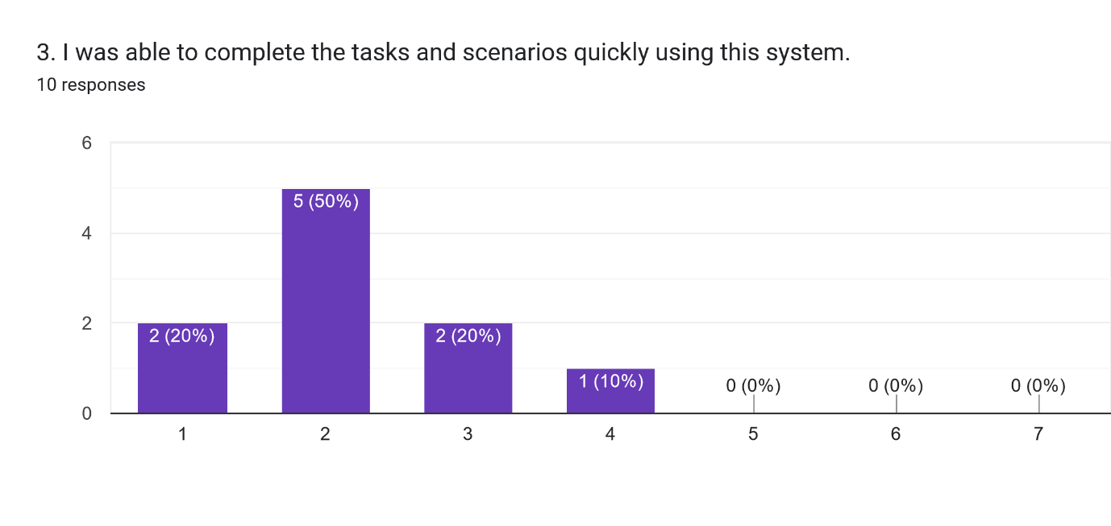

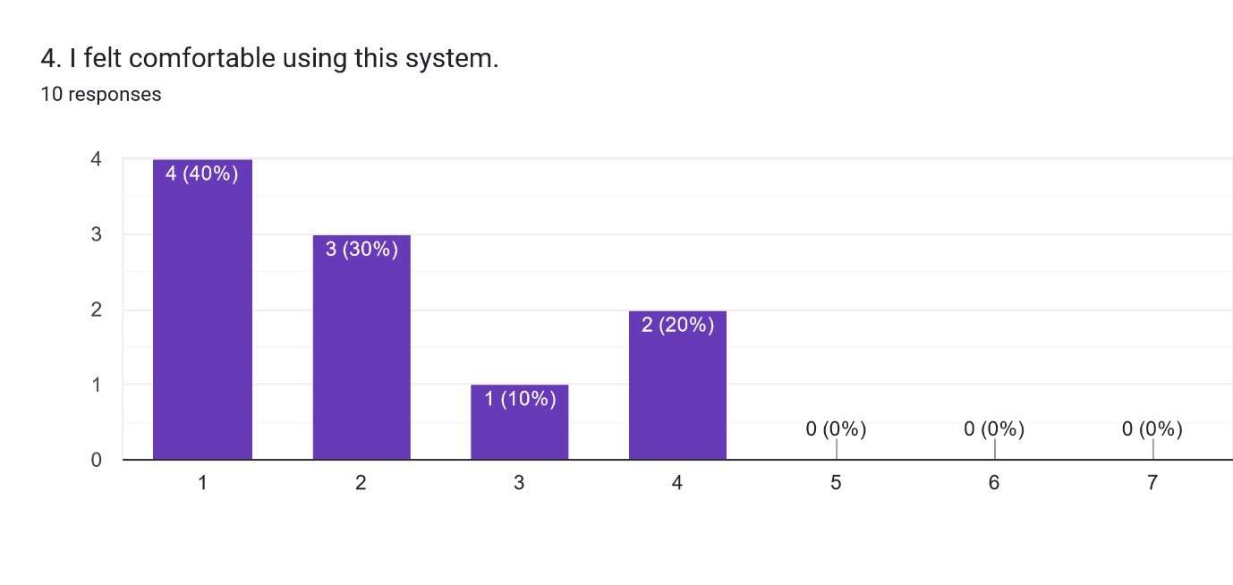

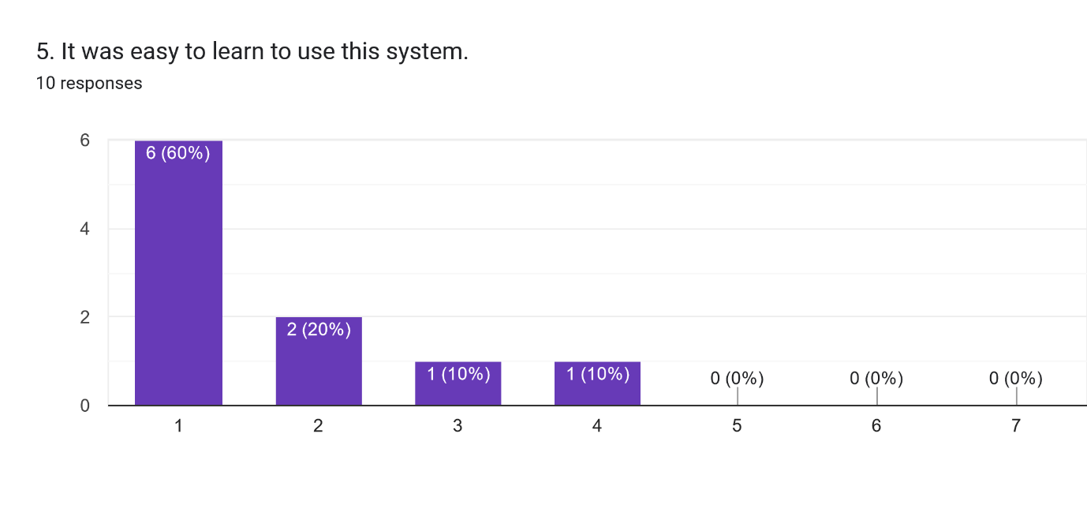

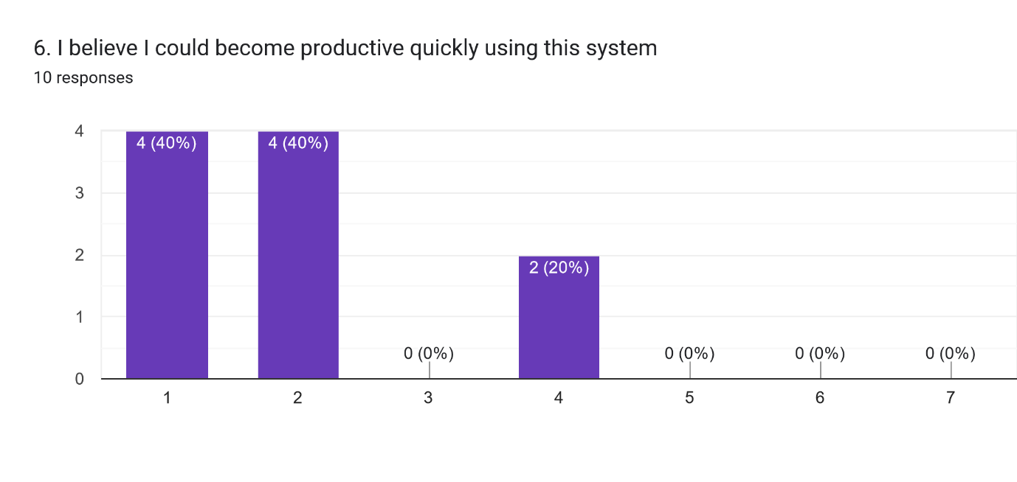

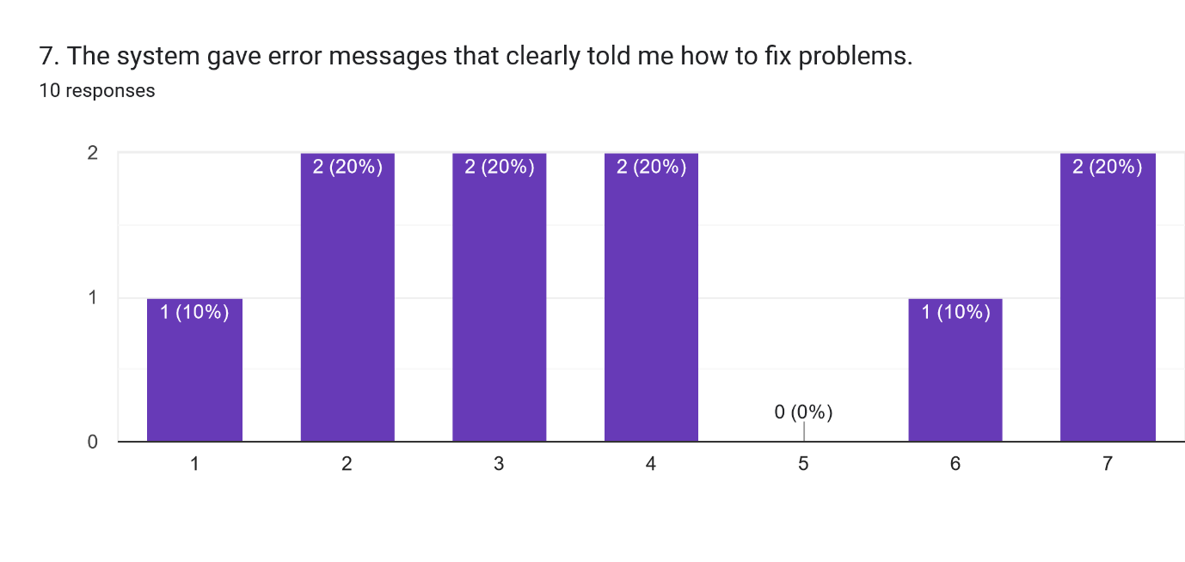

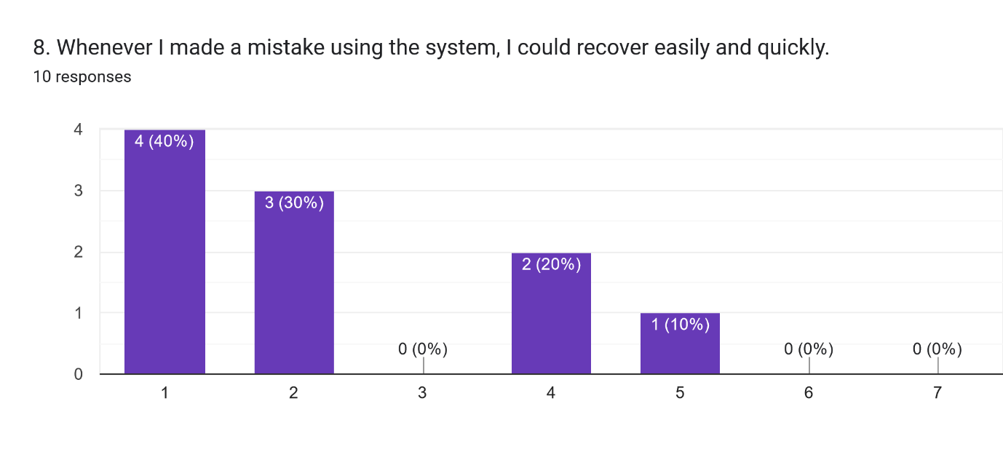

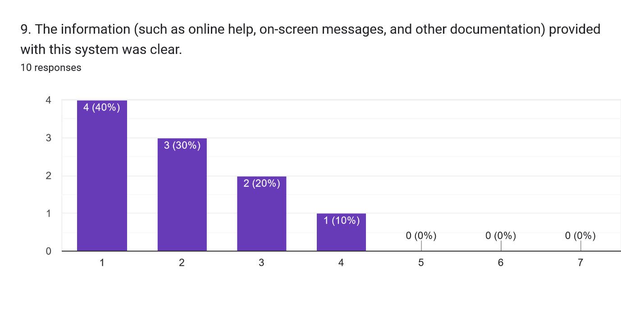

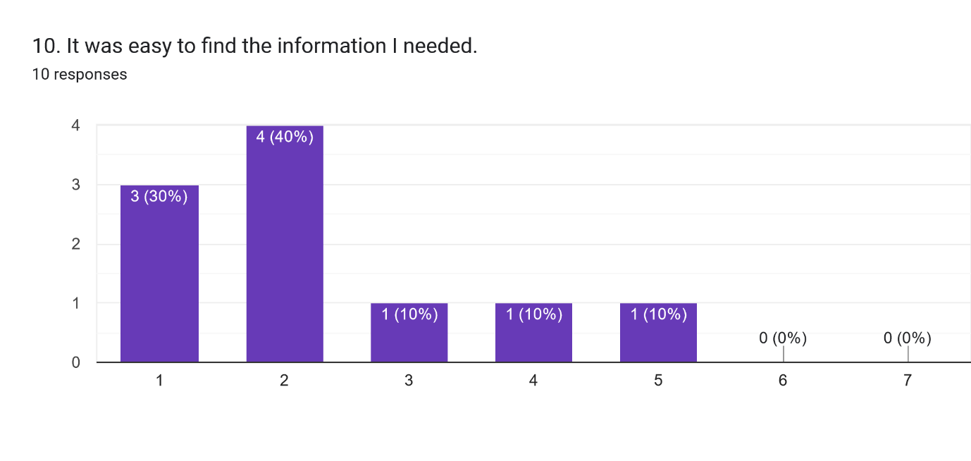

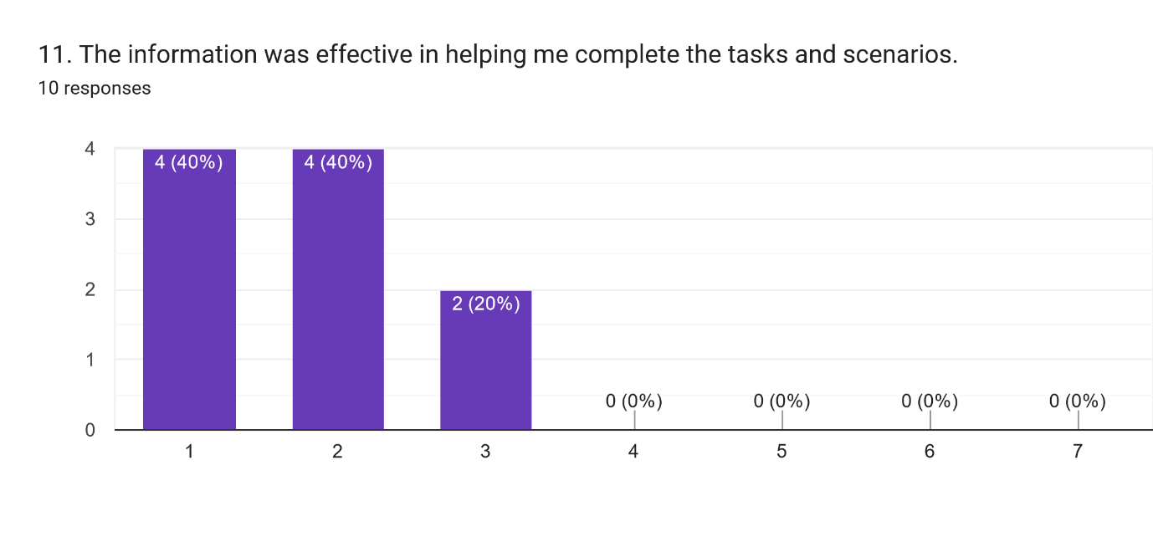

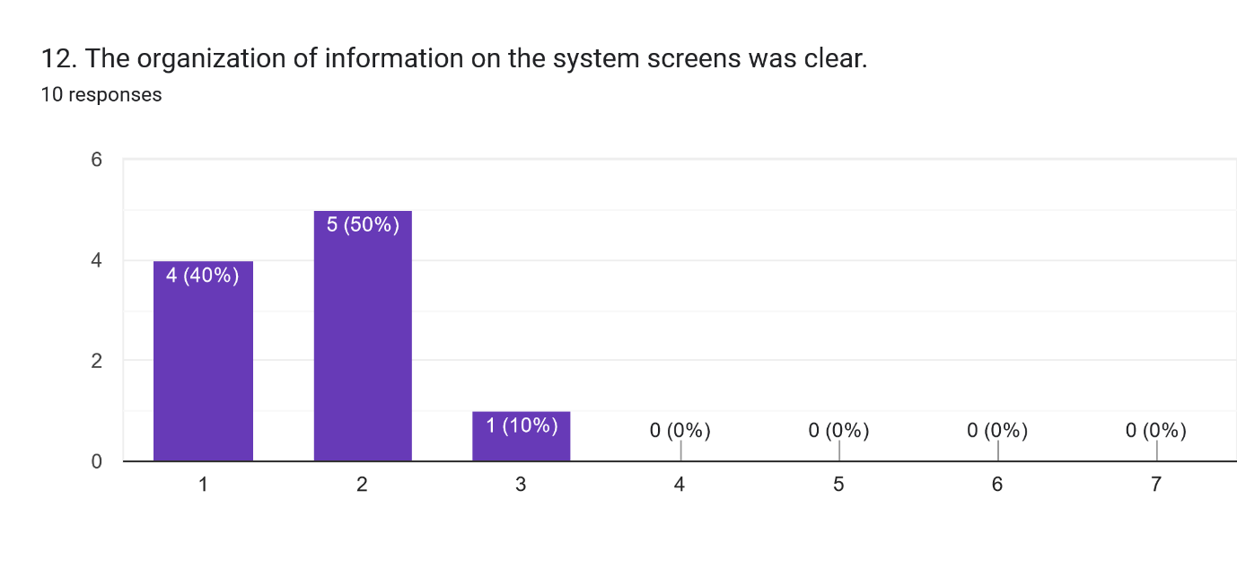

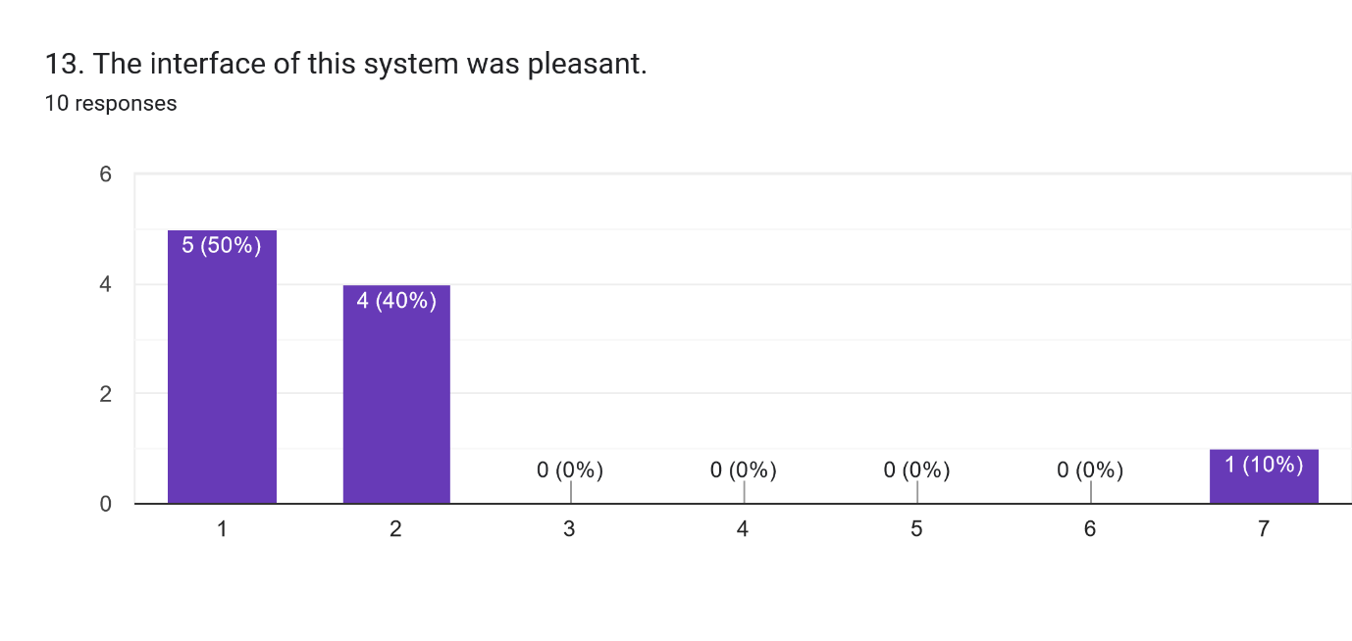

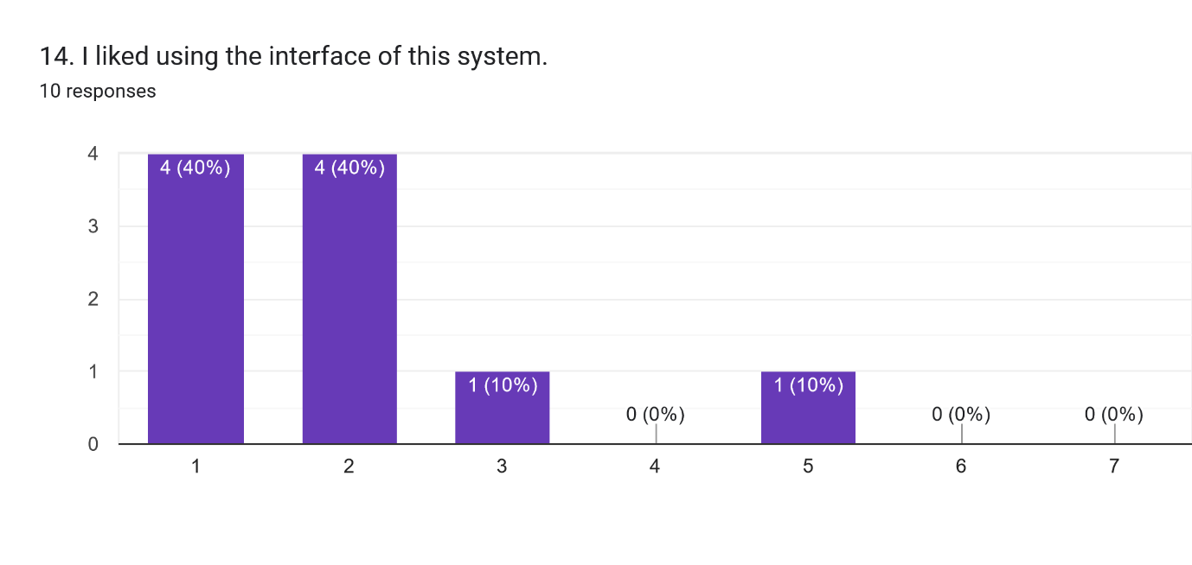

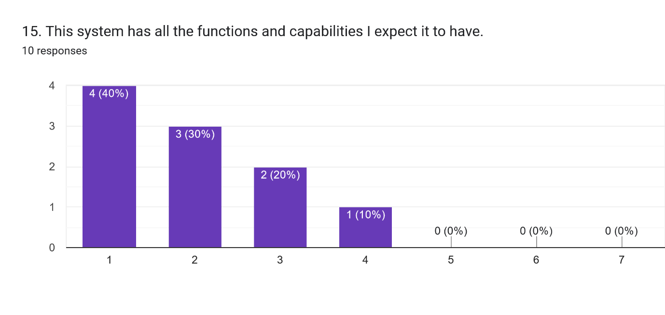

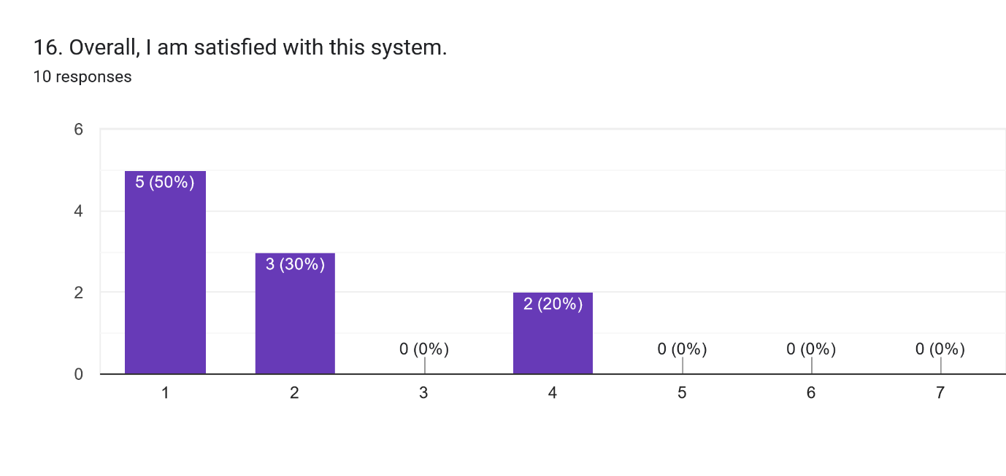

Forms response chart. Question title: 17. This system made me think about responsible forest management and the important role that forests play in keeping atmospheric CO2 levels in check.
. Number of responses: 10 responses.

Forms response chart. Question title: 18. I feel like I learned something valuable using this system.
. Number of responses: 10 responses.

Forms response chart. Question title: 19. Tools like Mycroforest makes learning engaging.
. Number of responses: 10 responses.

Forms response chart. Question title: 20. I think a lesson using this tool will be a valuable use of time at school.
. Number of responses: 10 responses.

Forms response chart. Question title: 25. One a scale of 1 to 10, how concerned were you about climate change before this learning activity.
. Number of responses: 10 responses.

Forms response chart. Question title: 26. One a scale of 1 to 10, how concerned are you about climate change after this learning activity.
. Number of responses: 10 responses.

|  |  |
| --- | --- |
| 21. What did you like best about this tool? | 22. How do you think this tool can be improved to further enhance your learning or user experience? |
| * It was fun. * Simple and quick. * Tree. * Deforestation. * How easy it was to use. * The simplicity. * How clearly it showed us how forestry affects CO2 emissions. * It was good, very useful. * It was easy to use and very informative. * The idea of how forestry model worked. | * Nothing. * Different scenarios. * More tree. * Idk. * Manage money. * Add timing for the trees being planted etc. * No error messages came up. * I do not know. * Make it more clear how the years and rotation period work. * The information page is hard to find. |

23. If you come into possession of a forest, what will you do?

* Balance CO2 with money.
* Manage it accordingly.
* Not deforestation.
* Chop it down and make some money then buy a yacht.
* Manage the forest.
* Research for a good plan to keep co2 low enough and make money at the same time.
* Manage the CO2 emissions.
* Try to find the perfect middle ground and think about our world.
* Plan and manage it to make money while keeping C02 levels low.
* Think about my life decisions.

24. Please state your one key takeaway from this experience.

* Lower CO2 more air in the atmosphere.
* the effect trees have.
* Trees.
* 👍
* Climate change.
* Comp science can mix with forestry.
* The most sustainable way to manage a forest doesn't necessarily affect profits.
* That it is important to manage forestry beforehand in order to do what’s best for the environment.
* Forests are important.