School of Computer Science and Statistics

MycroForest – Exploring the use of a microworld to teach about economic viability of climate aware forest management.

*Gayathri Girish Nair*

Supervisor: Brendan Tangney

Co-supervisor: Silvia Caldararu

August 2024

A Thesis submitted in partial fulfilment

of the requirements for the degree of

*Master of Science in Computer Science*

**Declaration**

I, the undersigned, declare that this work has not previously been submitted as an exercise for a degree at this, or any other University, and that unless otherwise stated, is my own work.

Include statement 1 or 2 as appropriate.   
1.    I did not make use of AI tools in the work described in this document, including the preparation of the document itself.   
OR  
2.    The use made of AI tools in work described here, including the preparation of the document itself, is outlined in an appendix, as per the School guidelines. If relevant, use made of AI is also described in the body of the document.



GAYATHRI GIRISH NAIR August 16, 2024

**Acknowledgements**

**Abstract**

Ever since industrialization, CO2 levels in our atmosphere have continued to rise at an unnaturally fast pace due to anthropogenic activity. Today, forests absorb 30% of global annual emissions [1] and are integral to combating climate change. But they are also fragile, so education about forest management is important. This is especially true for those in the 15 to 24 age group as they constitute decision makers of tomorrow who will inherit the planet and the challenge of rapid climate change. The Cities and Climate Change Project by the Intergovernmental Panel on Climate Change (IPCC) suggests that individuals in this category are have a strong sense of accountability, and are open to change [2]; thereby making climate change education very important for this group.

Several tools exist [3-7] to inform about ideas related to climate change and/or forests. Many are scientifically accurate decision-making aidsaimed at experts or adults. Others are more abstract yet informative educational games. Few among these targets the youth. Many of them tackle multiple problems at once which while informative, can be distracting/overwhelming. Effective education depends on learner engagement. Education technology tools based on microworlds have been proven to be successful at achieving this [8-11].

Thus, “MycroForest” as proposed here, is a web based microworld aimed at teaching young adults about the connection between forest management and CO2 levels in the atmosphere. The tool enables learners to take on the role of a forest owner in a virtual world. They may draft management plans involving planting trees or felling them for wood. Consequences of plans are reflected on the composition of the forest, CO2 levels in the atmosphere, and the learner’s virtual monetary assets. Using this tool, learners can be set challenges of increasing complexity ranging from maximising income from the forest, to maximizing carbon capture while also generating income.

Under the hood, MycroForest is composed of a simulation, User Interface (UI) components, and input variables. The simulation is a simplified representation of tree growth and the carbon cycle using an object oriented approach. Designing a simulation that reflects patterns seen in nature, drafting a user friendly interface to best support possible effective learning scenarios, and developing the app using the NextJS framework were key design and implementation challenges faced as part of this project.

The proposed teaching tool was evaluated at a 2 hours session with 10 Transition Year students on the [TAP Bridge2College Programme](https://www.tcd.ie/trinityaccess/schools/secondary/bridge-to-college/) at Trinity College Dublin. Feedback was also obtained from tutors at the event. Overall, response to the app is largely positive with student finding it “informative”, “fun” and “simple to use”.

Overall, MycroForest is a web based teaching tool where students take on the role of a forest owner and put their own forest management plans to the test while striving to meet challenges set around learning scenarios and in the process, learn about the importance and difficulty of sustainable forest management in a constructivist fashion.

**Table of Contents**

1 Introduction 9

1.1 Motivation 9

1.2 Goal 12

1.3 Referencing 13

1.4 Ethics 13

1.5 Document Structure 13

2 Background 15

2.1 Forest Management 15

2.2 Education Technology 15

2.3 Simulation Design 15

2.3.1 Agent Based Simulation (ABS) 15

2.3.2 Discrete Event Simulation (DES) 19

2.3.3 Hybrid Simulation 21

2.3.4 Object Oriented Design 22

2.3.5 Time Advance 24

2.4 Human Computer Interaction 25

2.5 Related Work 27

2.5.1 Climate Change Education 27

2.5.2 Existing Tools 27

2.6 Summary 27

3 Design 28

3.1 Scope 28

3.2 Pedagogical Approach 28

3.3 UI & HCI Design 28

3.3.1 App Pages 28

3.3.2 HCI Principles 38

3.3.3 Data Visualization 40

3.4 System Architecture 46

3.4.1 Simulation Model 46

3.4.2 Input Variables 70

3.4.3 UI Components 74

3.5 Detailed Technical Design 74

3.6 Summary 74

4 Implementation 75

5 Testing and Evaluation 76

5.1 Pilot Testing 76

5.2 Bridge2College Workshop 76

5.3 Usability Evaluation 76

5.3.1 System Usability Scale (SUS) 76

5.3.2 Post-Study Usability Questionnaire (PSSUQ) 76

5.3.3 Usability Results 76

5.4 User and Educator Feedback 76

5.4.1 Instruments Used 76

5.4.2 Findings 76

5.5 Summary 76

6 Conclusion 77

6.1 Recap 77

6.2 Limitations 77

6.3 Future Work 77

6.4 Personal Reflection 77

7 Bibliography 78

8 Appendices 84

8.1 Survey Instruments Used 84

8.2 Use of GenAI in this Work 84

# Introduction

This section documents the motivation for this project and its goals. Referencing style adopted, and ethical compliance is also discussed here.

## Motivation

Currently, we are amidst a climate emergency caused primarily due to heavy dependence on fossil fuels which show no signs of significant decline. There are multiple reasons for our global collective failure to reduce carbon emissions including economic, geo-political, psychological, and sociological factors. [12] Climate change negatively impacts almost all life on Earth given increasing temperatures, ocean acidification, desertification, and greater prevalence of extreme weather events, which in turn, would negatively impact society by leading to forced human migration, increased mortality, and possibly increased tension between societal factions at different stages of development and wealth [13]. Such environmental and socio-economic effects may also disrupt key industries, particularly agriculture [13], as productivity suffers. [12]

Since now considered an existential threat to humanity, it has been recognized that timely mitigation of rapid climate change demands global transformative reform at a fundamental level across technological, economic, and social factors that underpin direct drivers like fossil fuel usage. This was one of many messages put forth at the UN Climate Change Conference COP26 in Nov 2021. Such large scale drastic yet necessary changes however, are unlikely to happen via government efforts alone. It would require a shift in collective mindset and understanding between all stakeholders and key decision makers. [12] This is why, correct education targeted at key demographics like the youth is crucial to combating climate change.

In 2018, the Cities and Climate Change Project by the Intergovernmental Panel on Climate Change (IPCC) involved 99 youths (individuals aged 15 to 24) across diverse geographic and socio-economic backgrounds that collaborated with each other first digitally and then in person to produce the International Youth White Paper on Climate Change: Education and Cities. This project showed that the youth, to varying degrees, are aware of climate change, inequalities regarding responsibility or accountability of global warming and the importance of individual action. Feelings that they reported on the matter include fear, despair, guilt, shame, urgency, sadness, helplessness, and promisingly, hope and positive reappraisal. This suggests that young individuals who will soon comprise key decision makers tasked with solving the challenge of climate change, are indeed, eager to do something about it. [2] Thus, MycroForest aims to informing more members of this age bracket about the link between forest management and climate change.

So far, worldwide responses to government policies have been lukewarm at best despite several climate negotiations. There is a need to reinforce awareness about the urgency of the situation. It is important to realize that, given the difficult to model, non-linear and dynamic nature of Earth’s climate, there exists a real risk of unexpected catastrophic changes catching us off guard despite best climate modelling efforts. Based on current trends and models, global average temperature is predicted to rise to between 2.1 °C and 3.9 °C by the end of the century which is expected to trigger several planetary tipping points from beyond which, restoration of natural systems become extremely difficult if not impossible. [12]

A *carbon sink* refers to any mechanism that absorbs more carbon than it releases to effectively remove it from the air so as not to contribute towards global warming. [14] Enhancing existing carbon sinks or creating new ones is among three suggested courses of action against climate change to avoid a dire future with the others being reduction of greenhouse gas (GHG) emissions and modification of Earth’s energy balance. Efforts to lower GHG emissions have been historically inefficient and climate geo-engineering ideas like ocean iron fertilization, solar radiation management and marine cloud brightening have often proven infeasible or risky. [12] This means focussing on development and preservation of carbon sinks is a most practical option of the three.

Although Carbon Dioxide (CO2) is an important GHG that keeps Earth warm enough to support life, it’s concentration in the atmosphere in excess is the primary driver of global warming and climate change. [13] Plants require CO2 for photosynthesis. Consequently, the almost 4 billion hectares of forests on earth absorb a large amount (around 30% of global emissions in 2022 [15]) of carbon from the air and store a portion of it as biomass. They are thus an important carbon sink [16, 17]. This carbon sink status of forests is however, fragile due to human activities. [17] Forests that are logged can turn into carbon sources. A carbon source refers to a system that releases more CO2 than it absorbs. This is because although forest regrowth is associated with fast absorption of carbon, deforestation leads to loss of a large amount of sequestered carbon due to heterotrophic activity and biological respiration as well as harvested biomass being burned for energy [15, 18]. Moreover, given that humans emit more CO2 than what new growth is estimated to be able to absorb, it is generally widely accepted that to fight climate change, in addition to planting more trees, active preservation of existing forests is necessary. [16]

This is supported by results of a detailed study by A. Daigneault et. al. in 2022 which modelled 81 future socioeconomic and climate policy scenarios across three common Forest Section Models to assess future forest climate mitigation pathways between years 2015 and 2105 [17]. In 95% of scenarios so modelled, projections point towards an increase in global forest carbon stocks under afforestation, shifting harvest patterns, and intensification of forest management. Further, with timber price expected to increase in the future and changes in forest carbon stocks found to be more positively correlated with changes in forest area and timber price than with wood harvests, the study by A. Daigneault et. al. also hints at it likely being possible to maintain economic viability of forests while promoting carbon sequestration through careful forest management strategies and alternate means of income generation.

Thus, teaching about the link between forest management and atmospheric CO2 levels while also allowing learners to explore economic viability of forests through timber harvesting and other means of generating income from forests is a great way to promote awareness about the need to conserve forests, harvest responsibly, and discover new ways to sustainably earn from them. This also encourages learners to think about the financial motive, an indirect but fundamental influencer that underpins deforestation, which in turn, is a direct driver of climate change. The MycroForest teaching tool as presented in this work, strives to do this.

C. Karsgaard and D. Davidson, in their work about youth perspectives and Climate Change Education, point out some aspects of existing teaching approaches that may be strengthened. They stress the need to move away from the abstract “save the planet” idea to more concrete examples of how this might look like practically, to inspire action. [2] To this end, MycroForest presents sustainable forest management as one specific way to combat climate change.

Furthermore, while existing education concentrates on scientific reasons around the "what" and "how" of climate change; social, political, cultural, and economic reasons that define "why" is often overlooked. [2] By allowing learners to investigate the earning potential of a forest both in terms of timber sales and other resources or services, MycroForest garners attention onto the underlying economic “why” that motivates deforestation and by extension, climate change.

Increased engagement and attention w.r.t the subject matter has been linked to deeper understanding. Mindfulness that results from greater engagement often results in learners making a conscious effort to resolve conflict in their minds that stem from discrepancies between existing and new notions of an idea to eventually culminate in mental accommodation of novel concepts and improved assimilation of existing knowledge. [19] Further, teaching methods that promote problem-based, reflective, and inquiry-based learning have shown to strengthen persistence of learned ideas and enthusiasm towards learning [11].

A microworld is an interactive environment anchored on the theory of constructivism as first proposed by Jean Piaget [20] that facilitates such, long lasting and deep learning through “learning by doing or making” [21]. While microworlds may be digital or physical, the former makes for a more widely and easily accessible teaching tool [2]. Thus, MycroForest is a web-based teaching tool that incorporates a microworld comprising a simple conceptual model of a forest that learners can interact with through making their own forest management plans and decisions.

On the whole, the need to effectively educate the next generation about use of forests as carbon sinks being one practical part of the solution to the pressing issue of rapid climate change while encouraging them to think about economic viability of sustainable forest management, serves as prime motivation for this project.

## Goal

The goal of this project is to build a microworld to inform 15 to 24 year old learners about the relationship between forest management decisions and atmospheric CO2 concentration, a key driver of climate change. In addition to the opportunity to earn income from timber sales, the tool shall also simulate effects of considering other streams of income from forests in an attempt to draw attention to the idea of conscientious commerce which is one of many principles encouraged as part of ensuring a sustainable future [22].

The result should be a user-friendly web application that comes with built-in help and support for gradual introduction of complexity. The tool should allow for features to be hidden and revealed at different stages in the learning activity so that learners may master simpler features first before gradually being introduced to the full complexity of the tool in stages, thereby ensuring a low entry threshold. [9]

The tool should incorporate a conceptual model of forest growth and the carbon cycle that reflects reality in sufficient detail. The simulated world should draw from observed natural phenomenon and be based on figures as measured on Earth. [4]

To promote self-regulated learning**,** the tool should be engaging and facilitate constructivist learning by allowing learners to draft their own forest management plans [19]. Learners should be able to take on the role of a private forest owner and make decisions regarding the number, frequency and type of trees chopped or planted over multiple years. They should also be able to pick between 3 options to earn income from the forest. Lastly, the app should allow users to increase or decrease amount of CO2 emissions due to fossil fuel usage and view effects of their decisions across time.

Hybridization of a microworld with elements of a simulation and gaming have been shown to produce particularly effective and engaging learning environments. Thus, to introduce gamification to improve motivation as well as further promote self-regulated learning, goal setting and ability to monitor own performance is key. The app should thus, enable learners to set targets such as atmospheric CO2 concentration and income goals such that graphical feedback presented informs about whether or not these targets have been met. [19]

Research shows that learners performed best when similar teaching tools provide graphical feedback supported by some instructional support. [23] Thus, MycroForest should favour graphics over text on the User Interface (UI) and reciprocate all user actions with graphical feedback. Built-in, easily accessible explanatory help is to be provided and land content should be indicated using informative icons that change over time. Adding or removing of forest management actions and income streams should be facilitated through a graphical user interface and consequence of CO2 concentration in the air should be displayed on a scale with different colours coding expected quality of life for humans after considering effects of climate change at various value ranges.

Since exploratory learning is effective when guided by some structure. [9] MycroForest should be developed such that it is possible to formulate challenges using the app that increase the likelihood of specific learning outcomes. For example, it should be possible to set a challenge that encourages learners to maximize income from forests and another that allows them to strive towards minimizing CO2 concentration so that the two may be combined in a third challenge to teach about the trade-off between these goals.

Finally, this project aims to evaluate MycroForest in terms of user experience, learning experience and changes in attitude towards climate change by having Transition Year students use the application as part of a 2 hour learning session and share feedback. Feedback should also be collected from tutors to assess perceived utility of this application as a teaching tool from the perspective of educators.

## Referencing

This document adopts the Numerical style of referencing with EndNote to manage literature connected to Microsoft Word for inserting citations and the Bibliography.

## Ethics

The tool was used by (N=20) TY students for a period of 1.5 hours as part of a two-day workshop, within the Bridge2College programme, exploring different aspects of climate change. Ethical approval for researching different aspects of the Bridge2College programme had been granted by the School of Computer Science & Statistics.

## Document Structure

This document is organized such that this section 1 presents an overview and section 2 provides details regarding related areas of research and other similar tools. Section 3 explains design decisions, section 4 describes the implementation approach and Section 5 presents app evaluation methodology and results. Section 6 wraps up main content with a condensed review of the entire project.

# Background

This section reviews other similar tools and describes existing work in areas like forest management, simulation design, education technology, and Human Computer Interaction (HCP) that guided key design decisions.

## Forest Management

## Education Technology

Education technology (EduTech) refers to software designed to facilitate learning. These include tools that are used to actively impart knowledge like e-books, mobile learning tools (e.g. [Duolingo](https://www.duolingo.com/), [Khan Academy](https://www.khanacademy.org/)), microworlds, serious educational games and ones that indirectly support it like assessment tools (e.g. [Kahoot](https://kahoot.com/), [Google Forms](https://www.google.com/forms/about/)), leaning management systems (e.g. [Blackboard](https://www.blackboard.com/), [Canvas](https://www.instructure.com/canvas), [Moodle](https://moodle.org/)), text based tools ([MS Word](https://www.microsoft.com/en-ie/microsoft-365/word), [Google Docs](https://www.google.com/docs/about/)), knowledge organization tools (e.g. [Evernote](https://evernote.com/), [Notion](https://www.notion.so/), [Mendeley](https://www.mendeley.com/)), synchronous collaboration tools, multimodal production tools ([Zoom](https://zoom.us/), [MS Teams](https://www.microsoft.com/en-ie/microsoft-teams/log-in)), etc. [24] Depending on design, EduTech tools can be empowering or constraining. [25] When they promote learner engagement, they have been shown to improve depth and persistence of learning. [11]

Many studies define engagement as active participation or positive interaction of the learner with the teaching tool or learning material as well as with peers and faculty. Others describe it based on the amount of time, effort, or energy invested in the learning activity. [24] Engagement improves learning because it invokes mindfulness in learners causing them to employ conscious effort and thought that results in development of personally meaningful knowledge. This is important because the likes of John Dewey, a pioneer in the “pragmatism” school of thought [26] and whose ideas inspired the much celebrated pedagogical paradigm of constructionism, subscribe to the notion that knowledge is only useful to someone when they find it personally meaningful. [19]

Constructionism is a learning theory rooted in "learning by making". It promotes self-regulated learning by encouraging students to build their own solutions. Constructionism is based on Constructivism, which is the idea that new understanding is built upon existing knowledge. [10] A microworld is a type of EduTech tool that is based on constructionism. It provides learners a digital, often simplified, model of some real-world system or idea that they can explore. Computational objects-to-think-with (OTTW) are central to the design of a microworld. [21] These are digital constructs in the microworld that learners can manipulate to elicit a response from the system as part of exploratory activities culminating in knowledge construction. [8, 10]

A child’s sandbox is an example of a natural microworld where sand and tools like the bucket or shovel act as OTTW such that interacting with them through play leads to the child develop an intuitive understanding of volumes (mathematics) and particle flow (physics). [19] Logo, Boxer, and SimCalc are examples of some of the earliest digital microworlds used as a teaching tool, often to educate about mathematics or physics related principles. [27] Given advancements in technology (object oriented programming languages, improved graphics, web based applications) and the ability of microworlds to represent interdependent chains of cause and effect found abundantly in human and natural systems such as economics, the food web, disease progression, plant growth, and the effects of climate change on ecosystems they are useful in multiple domains beyond mathematics and physics. [27-29]

At the heart of any microworld, is its ability to facilitate self-regulated learning (SRL) wherein the learner takes initiative in managing their own learning. According to Rieber from 1996, self-regulated learners are (i) intrinsically motivated (they find the activity rewarding or enjoyable), (ii) metacognitively active (they engage in planning an goal-setting), and (iii) behaviourally active (they tweak the environment to suit individual learning styles). [19] These characteristics closely parallel the 3 widely accepted components (affective/emotional, cognitive, behavioural) that comprise student engagement as described by Bond et. al. in their extensive statistical analysis of literature concerning EduTech and student engagement. [24] Thus, facilitating SRL promotes learner engagement in the activity. This reinforces the notion established through years of studies, that well-designed Microworlds make for particularly engaging teaching tools. [8-10, 21, 27]. The Piagetian Learning Theory (PLT) by Jean Piaget whose ideas strongly inspired the proponent of microworlds Seymour Papert, and the Flow Theory of Optimal Experience (FTOE) by Mihaly Csikszentmihalyi are 2 popular theoretical frameworks that define necessary conditions for SRL. [19]

PLT accredits learning and knowledge building to resolution of mental **epistemic conflict**s between existing mental models and contradicting experiences or observations encountered in the learning environment. Such observations are made through the process of deliberately attempting to assess and understand known as **self-reflection**. Conflicts are resolved either through *assimilation* when the learner is able to understand by placing experiences within existing mental models or through *accommodation* wherein learners tweak, rebuild or expand existing mental models to accommodate new ideas in a process referred to as **self-regulation**. Thus, the 3 properties of epistemic conflict, self-reflection, and self-regulation summarize PLT. [19]

The flow state refers to the deepest level of engagement in an activity. This state is known to be beneficial for learning as it often results in psychological growth. The FTOE framework defines 8 components of an activity that may induce this state of heightened focus. They are (i) an optimized challenge level, (ii) ability to command the learner’s complete attention, (iii) clear goals, (iv) clear feedback, (v) provides an absorbing enough experience to free the learner about other worries, (vi) provides the learner a sense of control, (vii) frees the learner of feelings of self-consciousness and (viii) distorts the learner’s sense of time such that they feel it passing by quicker. Such a state is often reported by gamers. This indicates that gaming elements may be incorporated into microworlds to improve engagement. [19]

One way to introduce gamification into a microworld is to structure learning activities around challenges that learners strive to meet. The disadvantage with this strategy is that it is difficult to determine the right level of challenge difficulty such that learners are neither bored nor stressed. A common solution is to make multiple challenges available at varying levels of difficulty. [19]

Many a time, microworlds that try to teach about real world systems comprise a simulation model. This is especially the case if educational material is based on a natural system as is the case with MycroForest. To maintain learner engagement, it is necessary that simulation-as-microworld learning tools follow the “match the user principle” such that ideas presented “expand as the learner is ready” so as not to overwhelm. This is known as model progression. It is also necessary to ensure that such tools entail good UX to avoid learner frustration. [9, 19, 29]

Rieber in 2005, over several studies both directly (based on results of own work with colleagues) and indirectly (based on literature review) investigated how different representations of content influenced learning from simulations, games, and microworlds. [9] Table 1 summarizes key observations from this work.

|  |  |  |  |
| --- | --- | --- | --- |
| **Simulation** | Graphical feedback accompanied by short, embedded multimedia explanations result in better understanding of ideas by students compared to when only graphical or textual feedback was provided instead. | Most students learn from microworlds only when exploration occurs within context of some carefully designed learning activity that provides structure. | **Microworld** |
| Providing short explanations intermittently boosts understanding as this makes it easier for learners to link thoughts to experiences. The alternative of a tutorial is less effective because it separates explanation from experience. |
| Learners consistently reported lesser frustration when feedback was graphical rather than textual. | Students who engaged in content related discussions demonstrated increased learning. | **Game** |
| Instructional support is best provided while students use the simulation as opposed to before, because the latter can lead to students forming early hypotheses that are generally hard to displace later even if evidence points against it. | Three game characteristics most favored by children in a study wherein student designed games were evaluated by other students were (i) storyline quality, (ii) competition, and (iii) appropriate challenge. |
| Students significantly benefit from simulations that build up complexity in stages (model progression) allowing enough time for developing a good grasp on easier tool mechanics and ideas before moving on to more complex ones. |

Table 1. Observations regarding use of simulations, microworlds, and games as educational tools from Rieber's study in 2005. [9]

Although simulations, microworlds, and games, are all commonly adapted to be interactive educational tools, the best approach seems to be to combine relevant ideas from all 3 tool design approaches to optimize specific learning experiences. For instance, based on explored work, it may be concluded that although educational simulations present a great deal of information through visualization of dynamic complex systems, they also present the disadvantage that the mental model that learners develop is can be difficult to evaluate for correctness. This is why, in tools like MycroForest wherein an underlying simulation model is imperative to correct emergent behaviour of the system, a simulation-as-microworld approach can be beneficial as the constructionist nature of microworlds produce tangible external artifacts in the form of learner creations that are representative of the internal mental model of learners. [9]

Overall, there is significant evidence to suggest that hybridization of the constructivist concept of a microworld with elements of a simulation and gaming can results is a particularly effective and engaging learning environment. [9, 10, 19, 30]

## Simulation Design

In order for forest management plans applied to the virtual forest within MycroForest to produce similar outcomes w.r.t amount of carbon in the environment as observed in the real world, it is necessary for the microworld to simulate tree growth and the carbon cycle sufficiently realistically.

A “model” here, refers to a representation of some primary system. When such a model can be updated over time based on simulated conditions to mimic true behaviour of a dynamic primary system, it is referred to as a “simulation”. [31] Thus, at the heart of every simulation is a model of the system that it represents.

There exist several ways of modelling dynamic biological processes like forest growth, forest yield, forest succession, primary productivity, carbon storage, nutrient cycling, water balance, etc. This is because given their inherent high complexity, the large time periods over which ecological processes may play out, and their critical role in supporting life, simulating them is one of best ways to understand them better and conduct experiments without disturbing real-world systems. [32]

Of the many simulation paradigms, Agent Based Model Simulation Discrete Event Simulation are two popular ones.

### Agent Based Simulation (ABS)

ABS is a type of simulation that leverages an Agent Based Model (ABM) as the underlying model.

ABMs represent a system using independent agents with their own memory and rules that interact with each other and the environment. [33]

In the space of biological and ecosystem as well as climate modelling, ABMs are extremely popular. [33] This is because such systems are most often composed of discrete entities that independently interact with a shared environment or each other over time to accomplish their own separate goals such that composite behaviour patterns emerge as a consequence. This inspires natural progression towards modelling these entities as agents in an ABM. [33, 34] Also, ABMs impose no restrictions as to how many attributes or rules each agent can have, which makes it an attractive option for modelling complex systems like forests or entire ecosystems. [35] Furthermore, students who used education technology incorporating ABMs have been shown to outperform others on account of having understood cause and effect relationships more readily. Such students reported being able to “see” patterns better. This is thought to have been a consequence of the “agent perspective” and learners having found the idea of individual contribution within a shared environment resulting in emergent behaviour intuitive and straightforward. [30] Thus, MycroForest models tree growth and carbon capture as an ABM where trees are agents, and they interact with the environment composed of land and carbon reservoirs like air and soil.

ABMs support varying levels of abstraction. This may be readily observed in context of plant growth modelling. In population level ABMs, an agent refers to an individual plant. This facilitates capture of emerging forest level behaviours. On the other hand, individual level ABMs take this a step further and are more nuanced with agents now referring to specific modules within a single plant. This could be structural components like leaves, roots, and so on, or more abstract constituents like pools of carbonates. [35] Since MycroForest aims to teach about forest level changes under the influence of a learner’s management plan as opposed to plant physiology or the growth mechanism, the ABM within MycroForest is a population level one with a forest comprising a population of trees.

Underlying assumptions that influence key mechanisms like increase in tree volume or reproduction pattern, can also vary in terms of both approach and level of detail. [35] The following 2 examples of slightly different plant growth ABMs built on empirical and mechanistic approaches respectively, demonstrate this difference. [35]

Example 1: JABOWA [35, 36]

* Consider the JABOWA model. It simulates new growth in forests in response to changes in canopy cover. This was among the first uses of ABM in plant ecology. Here, underlying sub-routines that drive key processes like increase in tree volume is based on simple equations that capture observed phenomenon or relationships on a high level. For example, annual growth rate is modelled as follows.

This equation incorporates attributes of the tree agent, namely Diameter at Breast Height (DBH), tree height, maximum DBH, maximum height and leaf area, with R being an added constant and suggesting “change” in volume . Tree height is computed as with and being species specific constants, based on the ratio gleaned from available data on real tree diameters and heights. This equation also captures known phenomenon such as growth being directly proportional to amount of sunlight received using the term and it also being inversely proportional to energy required to maintain living tissue as captured using the term . Notice that volume of the tree is computed as . This is derived from the formula for the volume of a cylinder and therefore, stems from an assumption of the volume of a tree being akin to that of a cylinder. Another assumption here, is that other growth conditions are optimal. These assumptions simplify the model and makes computation faster.

* Thus, the aforementioned growth mechanism simplified via assumptions like that of optimal growing conditions, models growth rate of the tree using an empirical formula that incorporates agent attributes like diameter and height based on rules influenced by statistical insights gained from data.
* The JABOWA ABM built upon empirical equations that modelled just 9 tree characteristics (species, age, size, spatial location, growth rate, mortality, shade tolerance, reproduction, competitive ability) and 7 environmental characteristics (canopy gaps, light availability, spatial location, environmental stress, aging, altitude) was able to simulate real ecosystem behaviours such as competition, secondary succession and change in vegetation at different elevations. This goes to show that complex systems can be simulated in useful detail even when some of that complexity is abstracted away through simplifying assumptions.

Example 2: PLATHO [35, 37]

* Consider the PLATHO model which simulates plant growth to understand resource allocation patterns. It accomplishes this through sub-models that each capture a different plant process. Phenological development, photosynthesis, water and nitrogen uptake by roots, biomass growth, respiration, and senescence are the 6 mechanisms so modelled. This is also a population level ABM wherein each plant is an agent.
* Within a plant, assimilates, structural biomass, carbon-based secondary compounds, and reserves comprise 4 key biochemical pools that PLATHO takes into consideration. The simulation is a result of repeatedly computing resource fluxes between these pools and generating, storing, as well as transferring resources accordingly. The whole system, therefore, revolves around executing functions that update the state of certain plant and environment variables to meet the demand for resources like nitrogen, carbon, water and so on, at various plant organs.
* This type of modelling also incorporates some assumptions like “potential allocation to defensive compounds is inversely correlated to maximal plant growth rate” and simplifications such as representing volume of a tree as that of a cylinder. Since there may be multiple actions that can be executed in response to certain program states, there is a need for prioritization. This is facilitated by assumptions or rules based on existing knowledge such as “photosynthesis is less affected by nitrogen deficiency than growth”.
* Although often not necessary for simpler systems, with complex primary systems, the mechanistic modelling approach can represent parts of the model using mathematical equations. Given below, is one expression that is a part of the PLATHO model. It calculates total potential carbohydrate demand as needed for structural growth and synthesis of defensive compounds.

Here, is the maximum growth rate, is the amount of living structural biomass, represents the time step, is a factor in the range 0 to 1 that is a function of air temperature, and is a factor in the range 0 to 1 that is a function of the phenological stage of the plant based on its seasonal growth cycle.

* Overall, the PLATHO model facilitated testing of several hypothesis and revealed likelihood of responses to different conditions. It successfully reproduced several observed results like the effect of nitrogen fertilization on rate of biomass gain validated upon comparison of simulated and measured values of apple trees which largely matched. Even when simulated results differed from observed truths such as when the model overestimated the effect of CO2 on the concentration of defence-related compounds in spruce needles, this triggered further investigate and revealed the importance of effects such as acclimatisation of plants to increased levels of CO2 over time, thereby contributing to increased understanding.

Example 1 and 2: Contrasting or Complementary

Literature often presents empirical and mechanistic methods as contrasting ways of modelling. Often, this distinction is clear. Mechanistic modelling involves formulating a conceptual representation of some primary system based entirely on knowledge of its underlying structural elements and functional mechanisms. Such models may or may not represent processes or parts thereof using mathematical expressions. Algorithms or functions based on informed assumptions are the key drivers of simulation. On the other hand, empirical modelling is rooted in entire systems being represented using a high level mathematical function based solely on statistical relationships uncovered from measured data. This is useful when outputs or attribute values of a primary system is available as data, but knowledge about its underlying structure or functioning is limited. [31]

The primary difference between JABOWA and PLATHO lies in the level of mechanistic detail that the model captures. JABOWA captures plant growth at a much higher level with representations incorporating tree attributes like height, diameter, and leaf area, but not explicitly modelling detailed processes like photosynthesis, respiration, and water uptake. Thus, it swaps sub-models as in PLATHO for parameters in an equation whose values are informed from real tree attribute data. This is what makes JABOWA more empirical a model than PLATHO. PLATHO is more mechanistic because sub-models are built to represent underlying biochemical processes. This models plant growth more realistically in greater detail.

That said, when the primary system modelled is very complex, as is botany or ecology, there is a need to intentionally limit the level of detail modelled for computational feasibility or to reflect the specific purpose of simulation. Also, knowledge about the underlying system is likely partially available, but still incomplete and fragmented. Thus, in such situations, it can be argued that the distinction between the two modelling approaches is often blurred.

Although more so than JABOWA, PLATHO is still not entirely mechanistic. It has embedded empirical modelling elements such as use of mathematical expressions to simplify sub-model processes formulated based on observed data in addition to knowledge about the primary system’s underlying mechanics. Similarly, JABOWA also makes a few mechanistic assumptions to make decisions regarding what attributes are to be included in an expression and what characteristics are to be considered for modelling so as to promote emergence of appropriately realistic behaviour.

Biology, ecology and climate change are thus, examples of domains wherein simulation of primary systems may call for an ABM which is built on hybrid modelling approaches that combine mechanistic and empirical elements to better suit unique requirements. [31] Thus, the ABM within MycroForest models key processes like tree growth and reproduction using high-level mathematical expressions based on certain mechanistic, informed assumptions or rules about underlying mechanisms and structure of the system like the relationship between height and diameter of trees, coniferous trees generally being more long lived than deciduous ones, and so on. This results in a model that mimics real-world phenomenon but is still fast enough to be computationally feasible and provide smooth user experience.

### Discrete Event Simulation (DES)

A Discrete Event Simulation (DES) is simulation paradigm that models the primary system using a Discrete Event Model (DEM). This is among most popular simulation paradigms and is particularly suited to modelling process flow. [38] It breaks down system behaviour into an ordered sequence of events or processes that can but need not occur at regular time intervals. [33]

This event or process oriented worldview that underpins DES allows for some real-world time to be abstracted away as time between events is not simulated. Modelling evolution of the system from event to event instead of from moment to moment makes it possible to simulate slow systems in a shorter time frame. Time periods between events when there is minimal change is not simulated and thus, does not contribute to duration of the simulation. Also, events can be structured such that state changes over long time periods in the real world is executed within a single event to make the simulation faster. [39] Time scales over which forests grow and change significantly is generally long. This is one reason why real-world trial and error based assessment of forest management strategies is often infeasible. Thus, the ability to hasten slow, real-world processes in simulation that comes with DES is deemed very beneficial in the forestry sector. [38]

At the broadest level, all DEMs comprise entities and a priority queue that manages events. [39] Running a DEM usually involves the following 3 steps that get iteratively executed until a stopping condition is met. [40]

1. Execute events as per the calendar.

The “calendar” is just an ordered set of events. Across literatures, it is also referred to as a “schedule”, “plan”, or “priority queue”.

1. Execute “activities” or “processes” that constitute each event.

It is permitted under the DES paradigm for these processes to include stochastic elements or have a probabilistic execution duration rather than a deterministic one. Uncertainty is often modelled using suitable probability distributions and can entail use of a random number generator.

1. Update entity attributes, system states, and statistics in response to executed processes.

A use case wherein DES is most popular, is decision making or when there is a need to compare strategies because human decisions can easily be incorporated as separate events added to the simulation queue. This is the prime reason for incorporating DES into MycroForest where it manages timely execution of forest management actions added by the user. In forestry, DES is frequently used to compare different forest management or harvesting strategies in addition to assessing effects of different facility layout or equipment configurations, comparing resource logistics management strategies, and performing cost assessments. [38] The work of K. Westlund, L. E. Sundström and L. Eliasson [41] is a most recent example of this. They present an optimization-simulation framework to assess performance delivery of wood supply chains under varying weather conditions which affect road accessibility and by extension the ability to transport resources. Their framework has 2 parts. An optimization model produces a good wood harvest schedule based on demand and supply capabilities. This feasible harvest schedule along with weather scenarios, customer order details, and forest road segment data are provided as input to a DEM which simulates events in the schedule to facilitate comparison of delivery performance under varying weather conditions as input by the human user. [41]

The idea of entities that generate events comprising a set of instructions to be executed at planned times is one that is very practical to implement in software. DES is very compatible with Object Oriented programming because model entities can readily be implemented as objects with their properties being entity attributes and their methods defining events or event processes. [39]

Simulations in general are used for one of two purposes being either to analyse some phenomenon or system, or to provide a training environment to teach about it. There is evidence of DES being beneficial when incorporated into teaching tools as its structure makes it easy to incorporate learner decisions into the existing event schedule. [38, 42]

MycroForest is implemented in an Object Oriented manner as this allows for better separation of concerns and keeps code flexible and resistant to breaking. This teaching tool aims to allow learners to create and explore effects of different forest management strategies over 300 years on a virtual forest that they own. This presents an ideal use case for DES w.r.t scheduling and execution of management actions as events.

### Hybrid Simulation

Briefly put, DES is apt for modelling discrete decisions/actions over time and ABS is apt for capturing individual agent interactions with the environment that results in emergent behaviour. When it comes to simulating plant growth and carbon capture that gives rise to forest-level patterns from independent tree interactions with the environment, ABS is appropriate. DMS is more appropriate for simulation of discrete user generated actions that gets executed as and when planned. Therefore, a hybrid approach that incorporates both these methods of simulation is likely most beneficial. Thus, MycroForest adopts ABS to model tree growth with each tree object being an agent and adopts DES to manage a planner that shall contain forest management actions created by learners which get executes as and when planned.

Such a hybrid approach to simulation incorporating elements of more than one simulation paradigm is not uncommon. It is frequently observed in the health care, supply chain management, manufacturing, and construction domains. In fact, the combination of ABS + DES is considered to be most effective in “any situation which includes resources that must perform activities as well as human interactions where individual behaviours alter how these activities proceed” [43]. This once again points towards the decision to incorporate this combination within MycroForest being sound.

HS is often adopted as an attempt to manage complexity of particular primary systems. It allows for complex problems to be broken down into smaller parts such that the simulation paradigm most suited to each part may be employed. Moreover, HS accommodates abstraction of parts of the system thereby helping strike an accuracy or complexity and performance trade-off balance. [44, 45]

A key challenge with HS is compatibility of integration of the two simulation paradigms adopted. Ensuring interoperability between elements from different simulation methodologies can be difficult. [44, 45] In addition to these two simulation paradigms, MycroForest also leverages a more general Object Oriented (OO) design as shall be discussed in the following section, to simulate the remainder of system mechanisms. This OO design ties DES and ABS together because it is compatible with DES as previously discussed, as well as with ABS as agents may be objects and agent types, classes. [43]

### Object Oriented Design

Object Oriented (OO) here, refers to the general software design pattern of viewing a system as a sum of several objects or entities with their own data and functions that interact with each other. Object Oriented Simulation (OOS) is when the idea of the world being composed of “objects” is incorporated into the design of the simulation. An important reason for popularity of this notion is that it is the most natural way to represent many real-world systems. For example, a single cell may be modelled as being composed of objects representing its various functional units like cell membrane, nucleus, mitochondria, cytoplasm, etc. Even abstract or non-physical elements of a system, like say the force of gravity in a physics simulation, can be modelled as an object if some unique attributes and functions can be associated with it. [46]

Given below are 4 ideas that are referred to as the 4 pillars of OO design. [47, 48]

1. **Abstraction**: This principle dictates that only most relevant attributes and functions be implemented. Further, this entails that functions be implemented at a high enough level for callers to be able to leverage it for desired results without being concerned about the intricacies of how it works. For instance, it can be made possible to call a function drive(A, B) that takes the caller from point A to B without having to call functions like startEngine(), shiftGears(), or pressAccelerator(). The main advantage of following this principle is that it helps manage complexity and minimize use of computational resources while making code more reusable and maintainable. In MycroForest for example, the main aim is to have trees absorb and release carbon such that their presence or absence results in changes in CO2 in the atmosphere as is observed in the real world. Thus, it is only necessary to keep track of how much carbon is stored in a tree. Details about where this is stored and the mechanism of carbon allocation between different plant organs is irrelevant. Thus, the volume of the tree may be simplified to that of a cylinder and amount of carbon in a tree can be abstracted to x% of the mass of that tree such that x = average value of the proportion of carbon in real trees based on real world data.
2. **Encapsulation**: This principle urges that each object be self-contained with clear responsibilities and specialized attributes as well as functions to perform its unique role within the system such that only those properties or methods that other objects or functions need to be able to access is exposed publicly whilst all others remain private. The main advantage that this presents is modularization or separation of concerns which in turn ensures that code is flexible and can be updated with minimal breakage. For example, in the implementation of MycroForest, there exists a function called computeBiodiversityScore() within the Land class. A “class” is the term used to refer to the type or definition of an object. Consider a Shirt class with an attribute colour. Then, Shirt(“blue”) and Shirt(“red”) would both be objects of the Shirt class. This computeBiodiversityScore() function contains the algorithm that computes biodiversity of the land based on composition of the forest. This is a private function that no objects outside the Land class can directly call. Thus, code elements outside the Land class object cannot compute biodiversity score themselves, but they may still access its value via a public attribute of Land that stores it after computation. At one point during development, there was a need to rectify an older way of computing biodiversity score wherein a forest with the most no. of old trees was assigned highest score to another approach where a certain ratio of young to old trees as observed in natural forests was to be scored highest. Since encapsulation of the functionality of biodiversity score was implemented, this was easy to do with there being the need to update only a single function.
3. **Inheritance**: OO design allows for there to be a class hierarchy where classes lower in the hierarchy known as “children” or “child” classes of those above known as “parent” classes received attributes or functions of the parent class. Thus, child classes inherit properties of their parents. The reason for creation of such child classes is often to personalize or extend functionalities of the parent in several unique ways. For example, if Vehicle() is the parent class, then Car(), MotorBike(), and Truck() may be children who all inherit properties like colour and functions like drive() from Vehicle() but may also have other features unique to each child. This can aid in reducing code duplication. For example, in MycroForest, classes Timber, NTFP, and Recreation are all children of the IncomeSource class. This serves to say that there are 3 ways of earning from the forest. Income may be generated by selling timber, non-timber forest products (NTFPs) or by selling permits that allow the public to use the forest for recreational activities. Because Timber, NTFP, and Recreation inherit from IncomeStream, the sell() function need only be defined once within the parent class IncomeStream. All children, also inherit this functionality.
4. **Polymorphism**: This idea states that the same attribute or function may be defined again with a different value. A common use case is where children inherit a function from the parent and then redefine or extend it. For example, consider a Mammal() class with a speak() method. Child classes Dog and Cat may inherit the speak() method and then modify it to facilitate barking and meowing respectively. This allows for behaviour sharing with minimal resource overhead.

MycroForest adopts an OO design because it provides a natural way to map the real-world hierarchical structure to code components while keeping code modular, concise, reusable, and flexible. MycroForest defines an Environment class that contains a Land object which in turn can contain several Tree objects, mimicking natural world structure.

Furthermore, OOS has the advantage that communication between objects is simple to implement with the standard practice being via function calls and variable fetching. This is much less resource intensive than other methods of communication such as message passing, or event based ones that could require continuous listening for events or the need to store state of all objects at each timestep to facilitate replayability. This simplicity that does not demand strict enforcement of more paradigm related principles, also makes it easier to integrate both other paradigms with the remainder of the simulation. [46]

All simulations require some form of simulation time synchronization. This can be challenging when HS is adopted. [46] MycroForest overcomes this challenge by implementing a Simulation class that coordinates processes of all other simulation objects. It does this by taking the first step that triggers a time step update. This motion to update time is propagated to nested objects and soon leads to all simulated objects moving forwards in time. The tree agents that are a part of the growth ABS execute their independent behaviours within their respective time update functions. The Simulation object also contains a Planner object comprising an ordered sequence of learner defined forest management events which get executed at planned years.

### Time Advance

The time advance mechanism is a key component of every simulation. A time advance mechanism refers to how progress of time is modelled within the simulation. There are generally 2 ways to implement this. [43]

1. **Time Step:** This method of time advance involves selecting a certain period of time as step size such that all simulated times are multiples of this time step . Thus, when the simulation runs, each timestep shall involve incrementing the simulation clock by and then updating all system variables to emulated changes that take place within this time step. This type of time advance is the norm for ABS implementations.
2. **Next Event:** This method of time advance is rooted in the event worldview of DES. Here, all stage changes are triggered by execution of events that may be scheduled at irregular intervals of time. Time between events is not simulated. Unsurprisingly, most DES implementations adopt this method of time advance.

MycroForest implements time advance using the Time Step method such that 1 year. MycroForest aims to allow users to scrub forwards or backwards through a timeline GUI and move to any simulated year to view the state of the world at that point in time. This adds replayability to the simulation which improves understanding of the cause – effect relationship w.r.t the learner’s created management plans and corresponding changes in the microworld. It is easier for the learner to measure impact of their decisions and determine when to execute management actions if the model progresses predictably in fixed time steps. Moreover, forest management activities such as felling trees and planting them in the real world, is generally planned such that unit of time is years. This is because trees, depending on their species, generally have long lifespans ranging from anywhere between 50 to 3000 years with the oldest known living tree, the Great Basin Bristlecone Pine, estimated to be at least 5000 years old. [49]

The major disadvantage with the time step method is that the rate at which the simulation can progress gets strictly limited to . It is impossible to step through faster than this. Typical implications of such a rate limit include it being impossible to imagine different scenarios where decisions made may be faster or slower and vast variations in model behaviour under different time step sizes. Of these two common concerns, it is the second one that applied to MycroForest because plant growth is continuous with the rate of growth being significantly different across seasons for most deciduous trees. This makes it difficult to pick a value for as behaviour of the model could be significantly different depending on whether 1 month, 1 season, 1 year, or 1 decade.

A common approach to minimizing the influence of on model behaviour is to set it to be very small so that changes are almost smooth. This is, however, not feasible in case of MycroForest because of the long lifespan of trees. If day, the simulation would simply take too long to run, given that the aim is to allow learners to view changes over 300 years. It is necessary to simulate between 200 to 300 years. The more time that can be simulated, the more visible long term effects of forest management plans become. This is because significant changes in carbon levels on Earth occur over centuries. Also, real world forest management actions are often planned in rotations to allow trees enough time to mature between timber harvests. A rotation period, i.e. time between subsequent timber harvests, range from 5 to 150 years with common values being 20 or 40 years [50]. Thus, while both 1 month and 1 season were initially considered to be , this was later abandoned for 1 year because annual update is compliant with real world forest management planning time frames, is large enough to visualize significant changes in tree growth over their long lifespans and allows the simulation to cover a long enough timeframe so as to be able to see effects of changing carbon levels, all while keeping the time taken to animate through it reasonably short.

## Human Computer Interaction

Human Computer Interaction (HCI) is the discipline concerning design and implementation of interfaces between human users and computer systems that ensure realization of user goals through appropriate system responses with good usability - functionality balance to maximize effectiveness of human - machine communication where usability is a measure of a system's capability to enable efficient and appropriate task fulfilment. [51, 52]

Interfaces are determined by the amount and variety of inputs and outputs they are to handle. Based on this, human – computer interfaces get categorized as Uni – Model wherein user input is received via a single channel (a.k.a. modality) or Multi – Model when more than one input channel like facial/body movement detection (vision based), voice recognition (audio based) or keyboards/mouse interaction (sensor based) methods of communication is involved in the interaction. While Multi – Modal interfaces are more likely to grant a more immersive or wholesome user experience, it has 2 notable disadvantages. [52] Vision or audio based HCI often requires special technology (e.g. infrared cameras, speech recognition software, haptic devices, etc.) which can reduce accessibility and affordability of the associated system. Also, multiple communication modalities with a computer system can be distracting, especially for young learners using a teaching tool. Hence, MycroForest provides a simple Uni – Modal means of HCI wherein learners interact with the tool via familiar mouse and keyboard sensor based interactions.

Another common HCI grouping is that of active and passive HCI. Active HCI involves direct and deliberate interaction between users and systems in a command – action event flow wherein systems respond only upon user initiated action. For example, a typical email send action requires that the user click on the send button first. MycroForest presents an active HCI. This allows for experiential learning and increased user control, both of which contribute towards a good learning experience. [53] Passive HCI on the other hand involve systems that detect the user and pick up on non-physical or indirect environmental queues to which they then respond. Voice commands like “Hey Siri” is an example of this. [54]

Furthermore, current technological advancements like Augmented Reality (AR), Artificial Intelligence (AI), the Internet of Things (IoT) and improved computational capability in general, drives HCI further, to realization of Intelligent HCI and Ambient HCI. Voice recognition, face/gaze detection, naturalistic textual and verbal conversations, etc. are indicative of Intelligent HCI. Ambient HCI is when devices embedded in the environment enable humans to interface with machines without any apparent physical barriers like the need for a keyboard/mouse. [54] Future technologies like Human Brain Interfaces may take this further still and completely blur the line between human and synthetic senses.

The HCI discipline is, however, fragmented with no single universally acknowledged set of principles to guide HCI theory application. Instead, there are several good perspectives with some like Norman's model from 1988 being more practical than others such as Nemirovsky's Audience Participation Model from 2003. [51]

Its intuitiveness makes Norman's Model a particularly popular choice. This model splits the HCI experience into 7 iterative steps: (i) Goal establishment. (ii) Intention formation. (iii) Action sequence specification. (iv) Action execution. (v) System state perception. (vi) System state interpretation. (vii) System state evaluation. These are organized such that steps (i) to (iv) comprise an “execution” component and steps (v) to (vii) comprise the other “evaluation” component. Further, undesirable HCI is defined as a consequence of the “gulf of execution” and the “gulf of evaluation” which may be thought of as misalignment between “task language” (user's conceptual understanding and the actions they can take to achieve their goals) and “core language” (system's internal processes, responses, etc., and how it represents information to the user). Other researchers like Abowd and Beale in 1991 extended Norman’s ideas by defining the User Interface (UI) as a bridge connecting the languages. They state 4 key mappings between task and core languages that the UI must ensure is strong. These are (i) Articulation (user maps their goals to actions), (ii) Performance (system interprets user actions correctly and makes appropriate state changes in response), (iii) Presentation (system presents updated state), and (iv) Observation (users updates mental model/understanding based on presented changes). [55]

One challenge with Norman’s Model even with Abowd and Beale’s explicit UI extension is that is that it can still seem abstract from a developer or UI designer’s perspective. Thus, it may be advantageous when aiming to design applications in accordance with Norman’s Model to also try to adhere to more practical guidelines like Jacob Nielsen's usability heuristics which is a set of 10 rules to avoid common interface design problems. These are (i) Use simple language with no irrelevant information. (ii) Speak the user’s language such that information is presented in a familiar fashion. (iii) Minimize memory load such that the user need not remember all information between dialogues. (iv) Maintain consistency. Words or actions must mean the same thing throughout. (v) Provide timely and apt feedback. (vi) Clearly mark exits to allow users to undo mistakes or revert state to a previous version. (vii) Incorporate few shortcuts for the benefit of expert users. (viii) Display good error messages. (ix) Design to prevent errors. (x) Ensure help is readily available. [51]

To address the lack of consensus on a single set of best principles in the field, V. Hinze-Hoare in 2007 conducted a survey of HCI literature and assigned scores to key principles within them weighted based on proportion of overall citations the corresponding authors received. This analysis suggests 8 fundamental principles of HCI in decreasing order of weightage being (i) Recoverability (ii) Familiarity (iii) Consistency (iv) Substitutivity (v) Task Migratability (vi) Synthesisability (vii) Predictability (viii) Perceptual Ergonomics. [51]. The first three were most significant and is inherent within Nielsen’s 10 principles.

Thus, the UI of MycroForest strives to facilitate Norman’s interaction experience while trying to follow Jacob Nielsen's usability heuristics to strengthen the mapping between the user’s understanding of the system and the system’s responses to the user.

## Related Work

### Climate Change Education

### Existing Tools

## Summary

# Design

## Scope

## Pedagogical Approach

As discussed before in the background section, appropriate hybridization of microworlds, simulations, and game theory in education technology has been shown to improve learning. Tastefully visualized simulations provide an informative representation of a real-world system or idea that learners may readily relate to. Microworlds present users with multiple avenues to manipulate characteristics of the underlying model and thus interact with it. Exploration of a microworld that provides timely and appropriate types of feedback can command and keep attention of learners, thereby owing for an absorbing experience. Ability to build custom virtual constructs in the microworld invokes a sense of control in learners. Gamification of this experience through incorporation of challenges into the simulation-as-microworld with the option for model progression and varying challenge intensities, can grant users a challenge at an appropriate difficulty level so as not to overwhelm or bore such that they find trying to overcome it stimulating and enjoyable. Finally, a narrative can be built into the teaching tool to add an element of fantasy or role-play and present a storyline within which learners may be mentally freed of other worries and can opt to imagine themselves operating in, free of self-consciousness. Thus, combining elements from simulations, microworlds, and games likely better caters towards SRL than does any of these approaches alone.

MycroForest is a microworld that incorporates a simulation to model forest growth and the carbon cycle. It also incorporates game like ideas such as target setting. TO DO …

Targets gamification, clear goals. Team challenges. At least 5 challenges. Hero’s journey. Model progression. Short multimedia embeddings easily accessible. Learning activity – introduction, …. Frequent debriefing.

## UI & HCI Design

This section explains the UI of MycroForest and reasoning that underpins its design.

### App Pages

MycroForest comprises 4 web pages. Following passages explain what each page looks like, possible interactions, and its purpose.

#### **Landing Page**

This is the first page that the learner sees. It displays the name of the application, its icon, text summarizing the premise of this app that reads “Economically Viable Climate Aware Forest Management”, and instructions on how to proceed which reads “Press Enter”. This content is hidden by a dark veil and is revealed when the user hovers over it with their mouse that acts like a torch. This little exercise serves to pique the interest of learners and drop a hint as to the nature of the application being that it demands active participation. Upon pressing the “Enter” key on the keyboard, the dark veil disappears, content gets updated, and text that reads “Hi” with a prompt urging the user to click it, replaces the app icon. Towards the bottom of the screen, two words “Help” and “Word” also appear. Hovering over these, reveal navigation instructions that inform the learner that they must press the “H” and “W” keys to navigate to the “Help” and “World” page respectively.

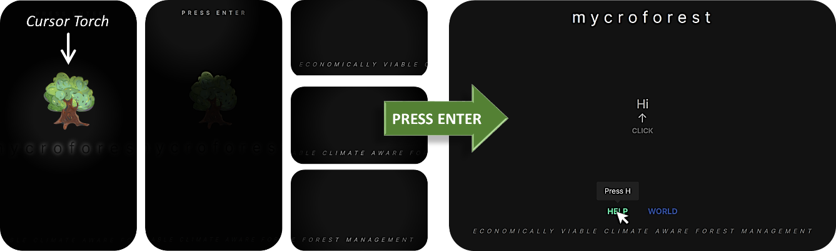

Figure 1. Landing page. Left: Interactive mouse cursor torch reveal content. Right: Introductory content that is revealed upon pressing the "Enter" key.

Clicking on “Hi” begins a dialogue which progressively introduces the learner to the app. The first time that a user starts this click-through session, they must complete it before they can navigate to other pages. Attempting to move to other pages mid-way, causes a message to appear that reads “Your enthusiasm is much appreciated, but I’m not done yet. Please continue clicking. I promise this won’t take long”. Each item in the following list is one piece of dialogue. When the learner clicks on the text, it fades to reveal the next dialogue until the last one is reached.

* “Hi.”
* “I’ve been expecting you.”
* “You’ve chosen well.”
* “They say it’s been here for at least 200 years.”
* “The forest is healthy and fairly large.”
* “I’d say it’s a good size for a first time forest owner like yourself.” – This suggests to the user that they will be assuming the role of a forest owner.
* “Your forest offers valuable resources like wood.” – This hints at how the user will be able to sell wood and other resources to earn coins.
* “I’m sorry to hear about global warming and rapid climate change on Earth.” – This directs attention to the theme of climate change.
* “But it’s not a bother here; your forest regulates the carbon cycle.” – This subtly informs about how the forest aids in managing atmospheric CO2 levels in the microworld.
* “As your adviser, I’ve arranged for help. An interactive map will manifest when you press ‘H’ on your keyboard. It’ll walk you through the lay of the land and all what you can do here.” – This informs about the help page.
* “Help will also appear upon clicking the ‘?’ symbol whenever available.” – This informs about quick access “Help” that is available on the world and planner pages.
* “When you’re ready, just press ‘W’ to delve into the world.” – This informs about the world page.
* “Press ‘Escape’ to return to this page.” – This informs about how to navigate back to the landing page.
* “Explore away! ⟲” – This marks the end of the dialogue. Clicking on the reset icon ⟲ displays the “Hi” message once again.

#### **Help Page**

Pressing “H” on the keyboard reveals the help page with an interactive graph whose nodes correspond to components in the microworld. Double clicking a node causes a pop-up window to appear with text and images describing significance of that component and how the learner can interact with it. Each node shaped like a leaf may be clicked and dragged such that the other nodes and links follow in a fluid motion. This simply serves to add an element of enjoyment cause users to stay and explore topics which shall improve their understanding of the app.

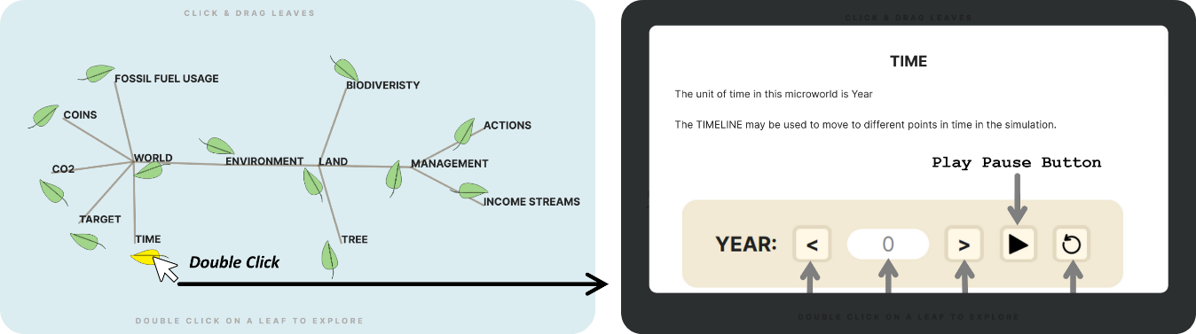

Figure 2. Help page with interactive graph. Double clicking a leaf node reveals pop-up text and graphics explaining significance and use of associated microworld component.

#### **World Page**

Pressing the “W” key on the keyboard takes the learner to the main Graphical User Interface (GUI) of the application. This is where users are expected to spend most of their time.

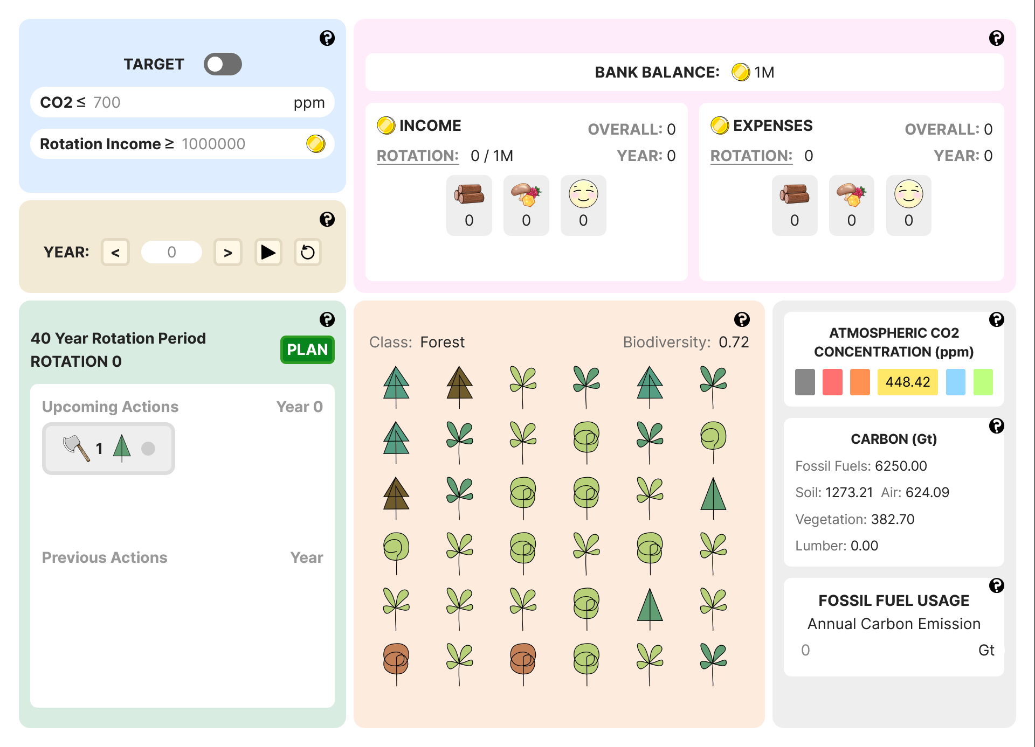

Figure 3. World page. This is the tool's main GUI.

Following paragraphs explain each UI element using parts of text and graphics displayed to learners when they click on the “?” icon in the tool or read about it in the Help page.

*Land Plot*

The land has 36 spots arranged in a 6 x 6 grid. Each of these 36 spots may either contain a tree or nothing. Hovering over land content reveals its type at the bottom of the plot. Different types of trees are displayed using different icons.

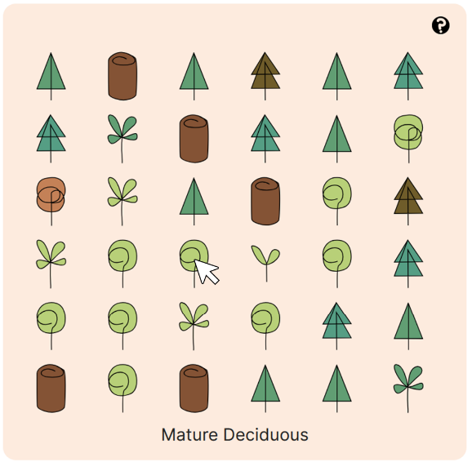

Figure 4. Land plot with mouse over interaction.

*Timeline*

The TIMLINE may be used to move to different points in time in the simulation.

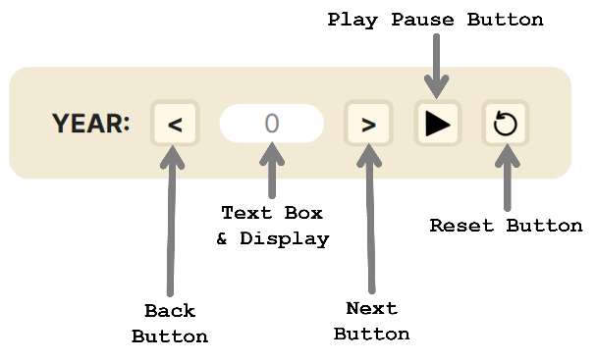

Figure 5. Timeline controls.

Clicking the PLAY BUTTON runs the simulation, and the current year in the microworld is updated with every timestep. The number in the display changes to reflect this. Once clicked, the play button changes to a PAUSE BUTTON. Clicking the pause button pauses the simulation and it changes back into the play button. The RESET BUTTON may be clicked to go back to year 0. The BACK and NEXT buttons can be clicked to go one year before or after.

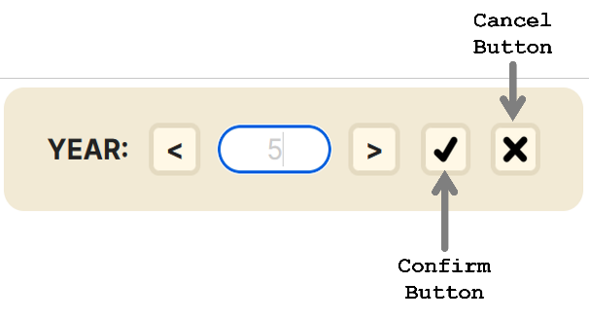

Figure 6. Timeline text field update interaction.

In the TEXTBOX, learners may type in any year within simulation range (0 to 300 years) and the microworld jumps to that point in time. Upon entering some input, the play/pause and reset buttons change to a CONFIRM BUTTON and CANCEL BUTTON as shown above. Clicking the confirm button applies the change to the year and cancel prevents this. If input is invalid (not an integer in the allowed range) then the input box turns red to indicate this and the change will not be applied even upon confirmation.

*Plan Viewer*

The PLAN VIEWER panel displays planned actions, the current rotation number and set rotation period. Once a plan has been drafted using the planner that can be accessed by clicking on the PLAN button, actions that were most recently processed along with the corresponding year is displayed under Previous Actions. Similarly, actions to be processed next along with the corresponding year, are displayed under Upcoming Actions. These action tags are horizontally scrollable if there are more of them than can fit within the view frame.

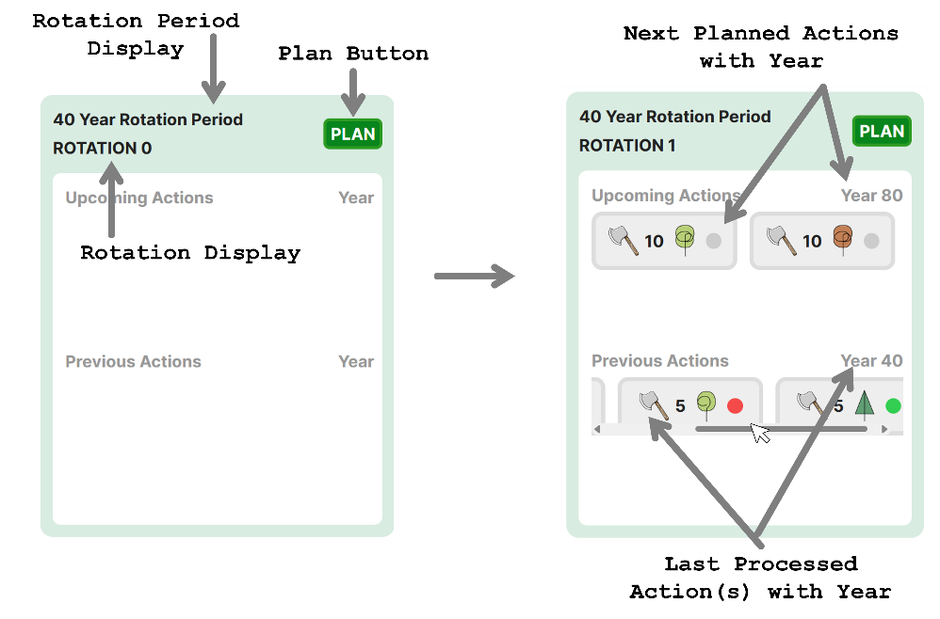

Figure 7. Plan viewer interactions.

*Money Viewer*

The MONEY NIEWER PANEL displays bank balance, income, and expenses. BANK BALANCE is the total amount of coins that the learner has at any given point in the simulation. Coins are the currency of this microworld.

INCOME refers to no. of coins earned. Overall income is how much the learner has earned so far in the simulation, yearly income is how much they’ve earned this year alone, and rotation income is how much they’ve earned in this rotation alone.

EXPENSES refer to how much the learner has spent overall, this year, and this rotation. Felling/planting a tree costs coins that comprise this expenditure.

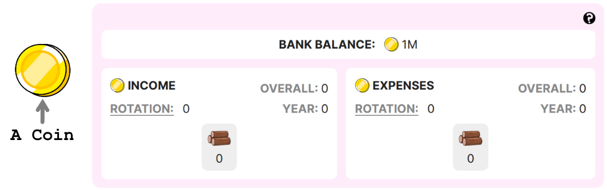

Figure 8. Money panel overview.

By default, it is income/expense per rotation that is visible below the icon representing type of income stream. Learners may click on 'OVERALL', 'YEAR' or 'ROTATION' to update this. Hovering over the icon reveals the name of the income stream.

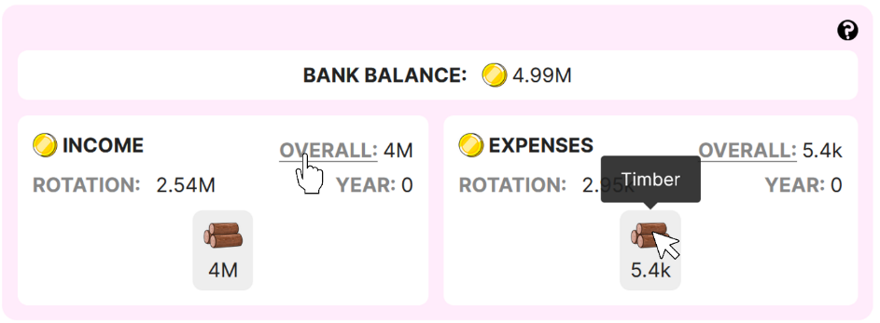

Figure 9. Money panel interaction.

When there are multiple sources of income, a breakup of income and expenses per stream is displayed using a colour coded proportion bar. Hovering over each colour displays the income stream and its contribution.

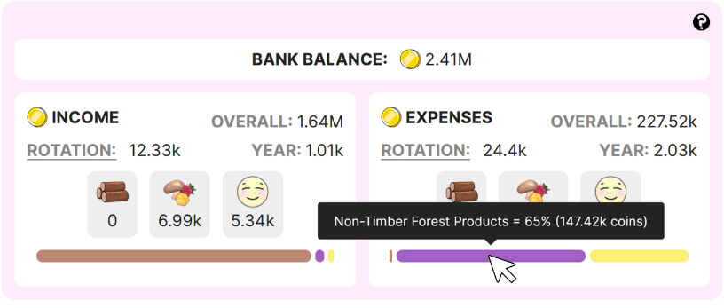

Figure 10. Income stream breakup.

*CO2 Scale*

Natural processes like respiration and anthropogenic (human generated) ones like burning of wood or fossil fuels, and so on, release carbon into the atmosphere in gaseous form, of which a large part is CO2. CO2 concentration in the microworld has been organized into an easy-to-read scale as shown below. Associated with each band in the scale, is a label that is indicative of the expected quality of life for humans at that level of atmospheric CO2 concentration after considering climate change related effects. Current levels of CO2 at each point in the simulation is displayed in the ATMOSPHERIC CO2 CONCENTRATION panel as shown below. The number within a coloured tile is the current concentration. Hovering over each tile, reveals its range and quality of life label.

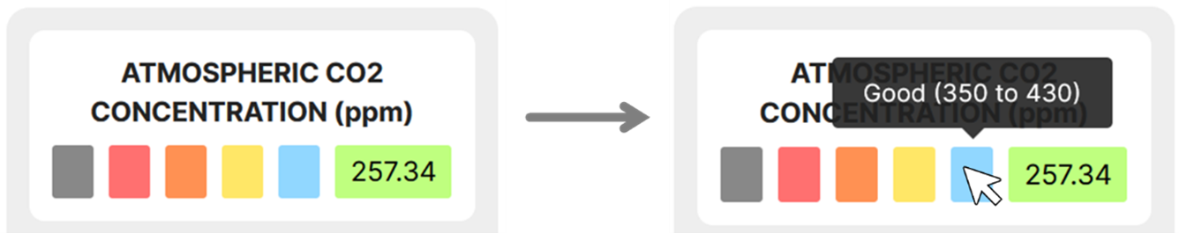

Figure 11. CO2 concentration display panel.

*Targets*

Learners may set a target as part of challenges. The TARGET panel displays this as follows.

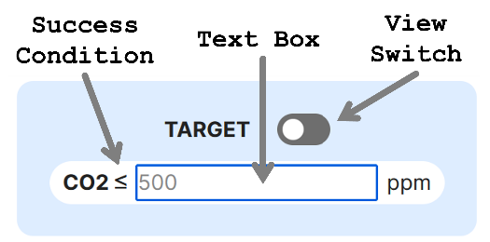

Figure 12. Target panel interaction.

Learners can type into the TEXTBOX, the CO2 concentration below which atmospheric CO2 levels must never dip. The VIEW switch can be toggled on and off. When on, the target panel displays whether the target is being currently met or not. If the success condition is satisfied, then a green border indicates this. If the target could not be met, then a red border shows this. The point in time at which the target first failed, is also indicated (notation Y2, Y3 and so on, means Year 2, Year 3, etc.).

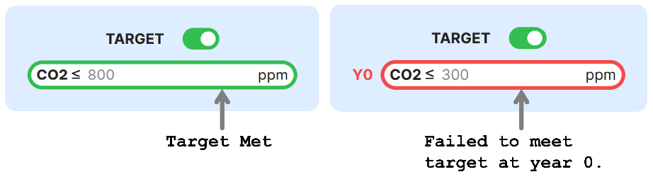

Figure 13. Atmospheric CO2 concentration target met or failed display.

Similarly, a target income value can also be set. This is the minimum income you're looking to earn every rotation. If learner fail to meet this target, the rotation at which this failure first occurred is displayed beside the target field using the notation of letter R followed by the rotation number.

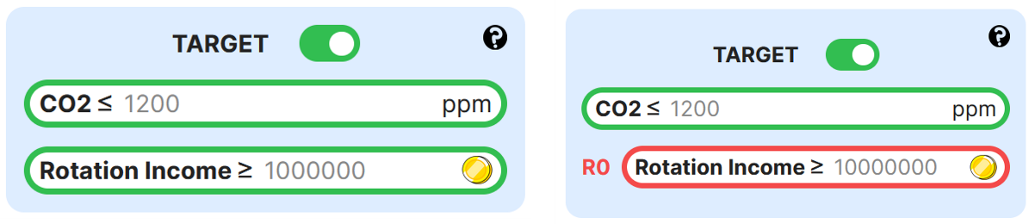

Figure 14. Income target met and failed display.

*Fossil Fuel Usage*

The FOSSIL FUEL EMISSIONS panel both displays and allows learners to set the amount of carbon released into the atmosphere annually due to humans burning fossil fuels for energy. By, default, annual emissions due to fossil fuel use is set to 0 GtC. This can be changed by typing any positive whole number into the textbox as shown below.

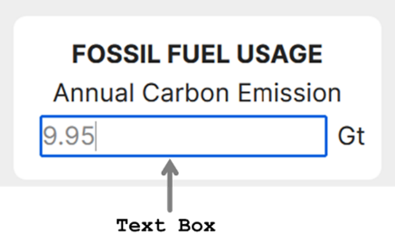

Figure 15. Fossil fuel emissions panel.

*Carbon Composition Display*

The carbon panel displays the exact amount of carbon in each reservoir throughout the simulation. In this world, there are 5 carbon reservoirs. Amount of carbon in all these reservoirs are expressed in Gigatonnes (Gt) of Carbon (1 Gt = kgs).

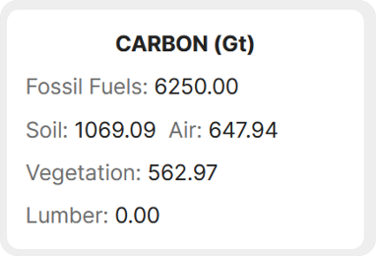

Figure 16. Carbon distribution panel.

#### **Planner Page**

The world page contains a “PLAN” button that leads to the planner page. The MANAGEMENT ACTION PLANNER here allows for creation of forest management plans involving planting or felling trees and activation of other streams of income from the forest. The “BACK” button on this page can be used to return to the world page.

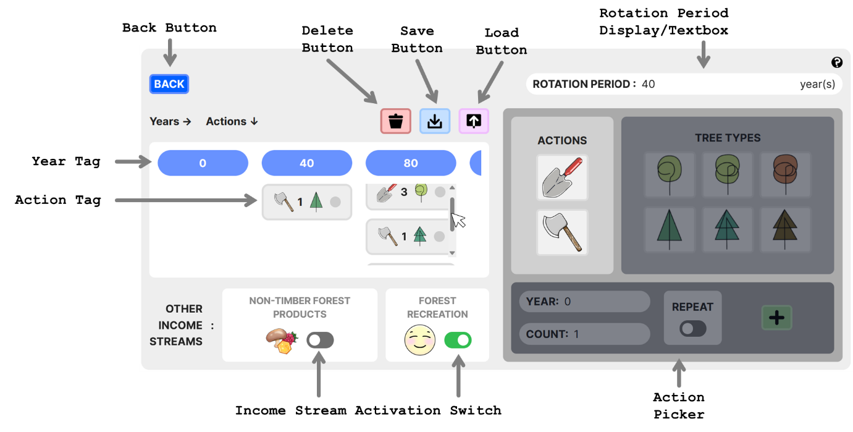

Figure 17. Planner page that contains a GUI that facilitates forest management plan creation.

There are two possible management actions to choose from.

1. **Felling:** Only mature, old growth, or senescent trees may be felled. Depending on the size of the tree felled, it can cost up to 3000 coins to fell a tree. The income that the felled tree fetches will depend on the wood density of the tree and its size. Nevertheless, felling a tree always leads to some income from timber.
2. **Planting**: Irrespective of the life stage chosen from the action picker, upon planting, the tree of chosen type will start out as a seedling. Planting a tree of either type incurs a fixed cost of 277 coins.

To add a new action, first, the type of action must be selected. Then, the tree to apply that action to, must be selected. Finally, the maximum no. of trees to be affected as well as the year this action should be executed in, should be set using the text boxes. If invalid numbers are entered into these text boxes, then the change is not applied and the text turns red. If the REPEAT option is turned on, then this means that the picked action will be performed every rotation starting from the year associated with the picked action. Once happy with the settings, clicking the ADD BUTTON adds a new action tag to the plan.

Rotation period can be set by changing the value within the ROTATION PERIOD TEXT BOX. Invalid entries (integers ≤ 0, integers ≥ max no. of simulated years = 300, negative numbers, floating point numbers, input containing characters other than numbers) is highlighted in red and will not lead to an update of the rotation period value.

The blue year tags represent years at the beginning of each rotation as per set rotation period. This view frame is also horizontally scrollable. ACTION TAGS associated with actions added using the ACTION PICKER will appear under their corresponding year tags. These action tags under each year tag are vertically scrollable in case of view frame overflow. Clicking an action tag, selects it. Clicking a selected action tag, deselects it. Multiple tags may be selected at once. Selected actions may then be deleted by clicking the DELETE BUTTON. Double clicking the DELETE BUTTON deletes all planned actions. Clicking the SAVE BUTTON saves the current state of microworld along with the latest plan and other settings. he UPLOAD BUTTON can be used to load previously saved states.

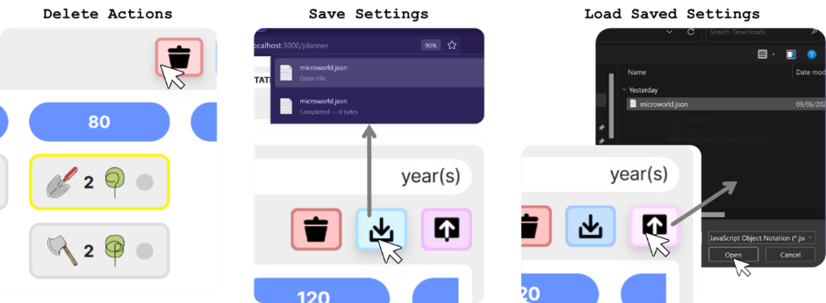

Figure 18. Management action planner. Delete actions and save or load plans interaction.

If the learner chooses to add an action for a year that falls within a rotation and not at the beginning of one, then such years appear in red to indicate this.

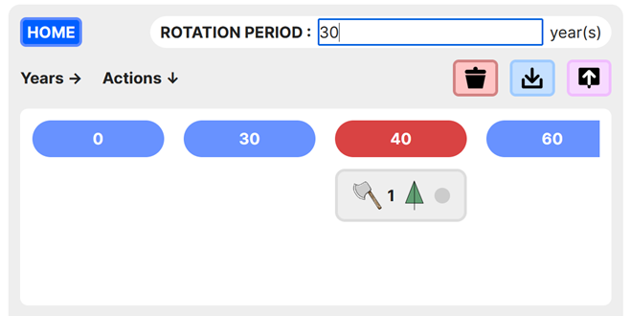

Figure 19. Within rotation action coloration difference.

An action tag displays information about the corresponding action and its execution status. If an action was successfully executed for all no. of the specified type of tree, then execution status is green. If it was only possible to execute this action for a fraction of the originally specified no of trees, then the status is yellow indicating that this action was executed for how many ever trees as was available on land at the time, although that was lesser than the specified count. A red status indicates that the action could not be executed at all (perhaps because there was no instance of the given tree type and age on land).

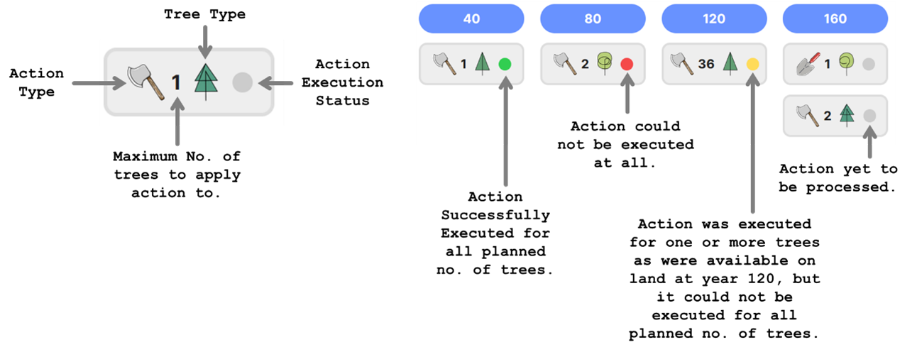

Figure 20. Significance of action tags.

Income can be generated from the forest via the timber income stream by selling wood from felled trees. When the fell action gets executed successfully, harvested timber is sold and gets used. There are also other ways of earning from a forest other than the TIMBER INCOME STREAM. Learners may harvest and sell other resources found in the forest like honey, mushrooms, and berries. Another option is to open the forest up for public recreational use and earn income from selling visitor permits. Switching on the corresponding switch activates each income stream.

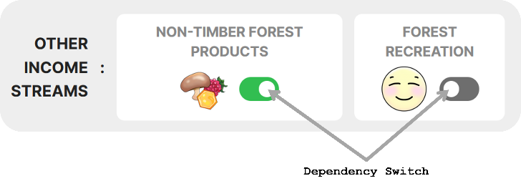

Figure 21. Other active and inactive income streams.

### HCI Principles

Table 1 summarises HCI principles that MycroForest has tried to adhere to.

|  |  |  |
| --- | --- | --- |
| ***Norman's Model*** | ***Task – Core Language Mapping*** | ***Jacob Nielsen's Usability Heuristics*** |
| (i) Goal establishment. | (i) Articulation: User maps their goals to actions. | (i) Use simple language with no irrelevant information. |
| (ii) Intention formation. | (ii) Performance: System interprets user actions and responds correctly. | (ii) Speak the user's language. |
| (iii) Action sequence specification. | (iii) Presentation: System presents updated state. | (iii) Minimize memory load. |
| (iv) Action execution. | (iv) Observation: Users update mental model based on presented changes. | (iv) Maintain consistency. |
| (v) System state perception. |  | (v) Provide timely and apt feedback. |
| (vi) System state interpretation. |  | (vi) Clearly mark exits. |
| (vii) System state evaluation. |  | (vii) Incorporate shortcuts for expert users. |
|  |  | (viii) Display good error messages. |
|  |  | (ix) Design to prevent errors. |
|  |  | (x) Ensure help is readily available. |

Table 2. HCI principles summary.

**Norman’s Model & Task – Core Language Mapping:** *ARTICULATION →* MycroForest presents a great use case for direct incorporation of Norman’s Model. The tool allows explicit CO2 and income targets or ***goals*** to be set. Challenges as part of the learning activity guides learner ***intentions***. The primary interaction expected of users is that of forest management plan development. The management action planner provides an action picker and plan viewer that facilitate a simple way to craft plans as well as immediately view it. Such provision to view and edit plans easily caters towards ***principle (iii)*** from Norman’s Model. Further, MycroForest allows learners to trigger ***action execution*** and step through their plans easily using the timeline’s play, pause and step buttons. *PERFORMANCE + PRESENTATION →* The land plot, money viewer, CO2 panel, carbon panel and the targets panel all reflect **system state** changes after each timestep so that users may ***perceive*** all relevant consequences of their plan. MycroForest strives to make it easy for users to interpret cause-effect patterns. *OBSERVATION →* Thus, an option to pause and replay the simulation or jump to specific points in time is provided to aid in investigation of what exactly a plan does to the virtual forest. It is possible to save and reload starting forests and plans. Action execution status (successful, partially successful, failure) is also presented for further clarity. Changes to land content is graphically displayed and animated as the simulation runs so that users may detect changes more easily. All these factors hope to support ***learner interpretation*** of the system. Lastly, colour has been leveraged in both the targets panel and the CO2 panel to highlight idealness of conditions, thereby aiding learners in ***evaluating*** system state.

**Jacob Nielsen's Usability Heuristics:** The role of text in MycroForest is largely confined to explanatory reasons as the UI on main pages like the world and planner page is primarily graphics heavy. The learner only encounters paragraphs of text when they are learning to use the app using either the “?” icons or the help page. ***Language*** of this text is kept ***simple*** so that young adults find it its easily comprehensible. Icons depict ***familiar*** items that are largely unambiguous (axe = fell a tree, chopped logs = timber, plus = add, dustbin = delete, etc.). Slightly stylized tree icons come with an explanation that clarifies information (tree species and life stage) that they encode. All interactive elements are traditional and common ones (buttons, text boxes, toggle switches, scroll bars, mouse over action, click action, double click action, keypress action) that learners are most likely familiar with. The plan viewer displays action crafted in the planner page on the world page. Action execution status viewed on the world page gets reflected on the planner page. Plans including all world settings (targets, initial forest composition, active income streams, management actions) can be saved and reloaded. Learners can thus worry less about keeping their plans in ***memory*** and focus more on interpreting their results. All terms in MycroForest mean the same thing on every page. Display language (graphical and textual) is kept ***consistent***. As discussed earlier, the tool immediately provides ***feedback*** upon time updates and action execution by updating the UI to reflect system state changes. Users can reset the simulation anytime, delete entire plans/individual actions, reload a saved world, or simply refresh the browser to get a fresh starting forest and default settings. This facilitates ***undoing*** of mistakes or starting afresh if required. No shortcuts are implemented. ***Erroneous*** text box inputs are met with text turning red or a red border around the text box. Further, there are measures in place that ***prevent errors***. For example, it is not possible to load or reload the planner page without having navigated there from the world page. This prevents world state corruption. Comprehensive built in ***help*** is available in bite sized chunks so as not to inform but not overwhelm.

### Data Visualization

**Note:** Content in this section is based on knowledge gained from lecture material put together by Prof. John Dingliana for the CS7DS4/CSU44056 – Data Visualization module that the author of this document has undertaken at Trinity College Dublin as part of the MSc. Computer Science programme (2023 – 24).

Centuries of research suggests that sight is the most important human sense. [56] Thus, data visualization is an integral part of software design. Presentation of content greatly influences a user’s mental model of a system as well as the rate at which they are able to develop the right understanding.

#### **What?**

TheDataset w.r.t MycroForest is the underlying simulation model.Dataset typeis temporal as system state changes over time. This model is visible to the user via system state variables displayed and thus this is the data that is visualized. Different types of data benefit from different visualization methods. Broadly, data can be quantitative (number) or categorical (not a number). Quantitative data can be discrete (integers) or continuous (real numbers). Categorical data may be binary (1/0, yes/no, true/false), nominal (not ordered, e.g. red, green, blue), ordinal (ordered; e.g. small, medium, large). Table 1 identifies key data attributes that are visualized in MycroForest and their types.

|  |  |  |  |  |  |
| --- | --- | --- | --- | --- | --- |
| **Data:** | Years | Tree Type | Tree Age | Tree Position | Income |
| **Description:** | Current year in simulation. | Coniferous or deciduous. | Age of the tree. | Position [x, y] of tree on land grid. | Money earned. |
| **Type:** | Quantitative Discrete | Categorical Nominal | Quantitative Discrete | Categorical Nominal | Quantitative Continuous |
|  | | | | | |
| **Data:** | Expenses | Biodiversity | Total Money | CO2 | Carbon |
| **Description:** | Money spent. | How biodiverse is the land? | Bank balance. | Atmospheric CO2 concentration. | Amount of carbon in various reservoirs. |
| **Type:** | Quantitative Continuous | Quantitative Continuous | Quantitative Continuous | Quantitative Continuous | Quantitative Continuous |
|  | | | | | |
| **Data:** | Action Type | Action Tree Affected | Action Year | Action Num Trees Affected | Is Action Successful |
| **Description:** | Fell or plant. | Type and age of the tree targeted by the action. | Year at which the action is to be executed. | The no. of trees that the action is to affect. | Successful, partially successful, failure. |
| **Type:** | Categorical Nominal | Categorical Nominal | Quantitative Continuous | Quantitative Discrete | Categorical Ordinal |
|  | | | | | |
| **Data:** | Is Action Repeated | Target Values | Is Target Met | Is Income Stream Active | Rotation Period |
| **Description:** | Whether this action is to be repeated periodically. | Set CO2 or income target. | Whether target is met. | Whether an income stream is active. | Set rotation period. |
| **Type:** | Categorical Binary | Quantitative Continuous | Categorical Binary | Categorical Binary | Quantitative Discrete |

Table 3. Visualized data attributes and their types.

#### **Why?**

Data visualizations typically serves one of 2 purposes. They may be explanatory when the data story (interesting or meaningful idea like an association between variables, a trend, etc.) is known and the visualization is orchestrated to convey this known idea to the viewer. Exploratory visualization on the other hand often presents almost all available data to the viewer who then investigates or explores it to possibly discover a data story. Here the visualization designer is unaware of valuation conclusions or meaningful observations that may or may not be present in displayed content. The model is built on informed decisions driven by research. It is built to resemble a known system. Thus, at the broadest level, the purpose of data visualization within MycroForest is ***explanatory***.

Task abstraction is the next, deeper level of data visualization. It refers to identification of what viewers might do with the data. The actions – targets framework captures this well. Briefly put, this framework considers possible actions that users may perform (verbs) on certain target potions or characteristics (nouns) of visualized data. Following are few action – target task abstraction examples. Actions are blue, and targets are magenta.

* Prospective business owners might analyse consumer trends regarding their product and consume information as they discover key customer bases. They may also analyse and produce their own data about striking features in the dataset. For example, annotating customers by derived age categories might have revealed that most of them are millennials.
* Doctors may search a brain scan to look up and confirm the shape of the frontal lobe, locate the hippocampus, browse for possible known neural activation paths, or explore to see if there are unexpected abnormalities.
* An air crash investigator might query flight data to compare it with data from past crashes in hopes of identifying similarities. They may summarise instrument readings from normal flights by plotting distributions and extract data extremes like min and max values to see if crash related values would be outliers.

Similarly, using MycroForest, learners may produce forest management plans and compare results of various such plans against each other to discover dependencies between order and choice of management actions and system state change trends over time such as changes in forest composition, atmospheric CO2 concentration, income earned from the forest, the biodiversity score, etc. Users may explore different strategies as they browse through varying values for other settings like rotation period lengths and activation of income streams to locate plans that achieve goals like carbon sequestration maximization, income generation maximization, or both. In the process they learn about challenges and best practices w.r.t economically viable climate aware forest management.

#### **How?**

Graphically depicting data involves picking appropriate encoding channels. Encoding channels refer to graphical primitives that a visualization is composed of. There are 8 such channels or attributes of graphical elements that may be altered to encode variances in data. They are position, shape, size, brightness, colour, orientation, texture, and motion. These channels have certain characteristics. They may be selective (allows easy distinguishability), associative (supports grouping), ordinal (displays clear change in order) or quantitative (allows for quantification of difference between data points). The range of unique data point types that a channel can support is another channel characteristic referred to as range.

Often, more than one channel or more than one instance of a channel may be preset within the same visualization. Some such combinations like that of position + colour is preferred due to greater visual separability over others like colour + colour (e.g. using multiple hues of a colour to grade variables grouped by colour). Once encoding channels are determined, they are incorporated into visualization idioms which are essentially just specific types of graphs (e.g. scatter plot, line plot, pie chart, etc.). Idioms may simply encode data by arranging it and mapping it to specific channels. They can also allow for manipulation of data through depicting change and facilitating selection or navigation. Different idioms can be combined within a visualization through techniques like juxtaposing, partitioning, or superimposing them. Lastly visualization idioms can be designed to help reduce data and manage complexity though incorporation of data filtering, aggregation, or embedding.

Thus, several design decisions are involved in presenting content such that the visualization “addresses a clear objective” while “avoiding distortion” of data and “handles complexity” in the dataset well enough so as not the distract or overwhelm the viewer when informing them. Following paragraphs explain such decisions that inspired main graphical displays in MycroForest.

Most data attribute values in MycroForest get updated every timestep as the simulation runs. This change over time is captured using the motion encoding channel through animation wherein land content symbols, action plan viewer action tags, and all money as well as CO2 and carbon related numbers on the world page get updated after every time step.

The **land plot** visualizes Tree Age, Tree Type. Tree Age can range from 0 to 100 years while they are alive. They may remain on land for more years after they die until completely decayed. Using a different colour or shape to precisely show how long a tree has remained on land will only overwhelm the viewer. To manage this complexity, trees of different ages were organized under 6 age groups and an interaction was introduced where learners can hover over a tree icon to reveal its precise species and age. Similarly, Biodiversity score is a continuous value in the 0 to 1 range. To improve differentiability, the land was classified as “Unforested”, “Plantation”, “Forest”, or “Ecosystem” based on increasing order of biodiversity score. Figure 22 shows how both colour and shape was varied to distinguish between tree types and age groups. Once dead, behaviour of both trees is same. Hence, dead trees are depicted using the same symbol for both species. The land in MycroForest is a grid with 6 rows and 6 columns. Each row – column intersection is a land position. This set up is very compatible with a scatter plot. Thus, the scatter plot idiom was used to encode position of trees on land. Change in composition over time is animated and thus encoded using the motion channel.

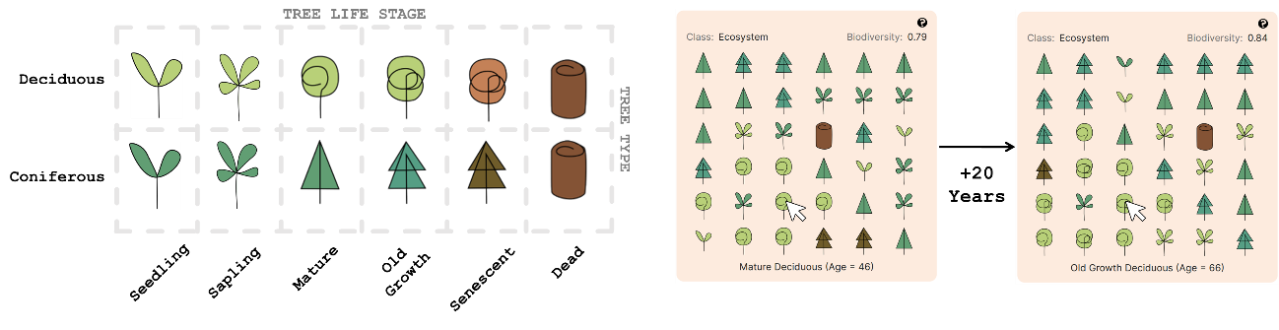

Figure 22. Land plot visualization that leverages colour, shape, position, and motion encoding channels.

The **money viewer** panel displays Income, Expenses, Total Money, and Is Income Stream Active data. Here, as well as in all other graphical elements, the precision of displayed numbers is restricted to at most 2 decimal points as greater precision does not add to the learner’s understanding and would only serve to distract them. There are 3 possible income streams (Timber, NTFP, Recreation) and two types of figures (income, expenses) that change over time. Thus, complexity of data is high. The total bank balance and overall income and expenses over the entire simulation so far, is displayed using text. But this hides some information such as money earned / spent per rotation and year. Thus, figures were grouped into 3 time-based levels (per rotation, per year, overall) and displayed at different positions of the screen. Displaying these 3 figures for all the 3 income streams will present the user with too many numbers at a time to take in. To manage this, only figures related to active income streams are displayed. When there is more than one active income stream, by default, steam wise split of income/expenses is displayed only for “per rotation income”. Users can view this breakup for any time level by clicking on the heading for that time level. The fact that this time level is clickable is indicated by the text gaining an underline upon hover. The currently selected or last clicked time level’s heading retains that underline even when the mouse pointer is not over it to show that this is the selected level. Also, to make comparison easier, when there is more than 1 active income stream, a stacked bar idiom is used to quickly convey proportion contributed to by each income stream. Hovering over a bar, colour coded to map to specific income streams, reveals more detail such as name of income stream, precise contribution percentage and exactly how many coins were earned or spent. As the simulation runs, these figures change over time. Thus, the money panel leverages the position, colour, size (size of each bar in stacked bar plot), and motion encoding channels to organize and display money related data. Aggregation and interactive reveal are used to manage complexity.

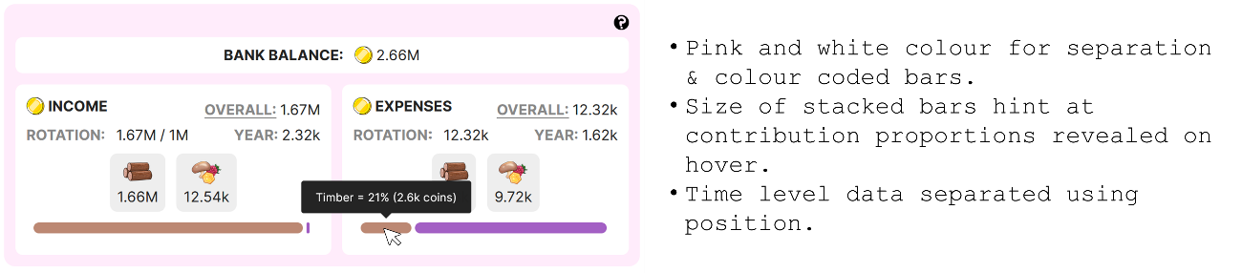

Figure 23. Money panel visualization that leverages colour, size, position, and motion encoding channels.

Both the planner and the plan viewer visualize forest management plans created by learners that comprise management actions. Each management action is a combination of 5 data attributes (Action Type, Action Tree Affected, Action Num Trees Affected, Is Action Successful, Action Year). There are 2400 possible unique actions (fell 6 unique age-species combination of tree and plant 2 species of tree per year of the simulation that spans 300 years). This complexity due to high dimensionality was reduced using following methods.

* Encode 4 action attributes into 1 symbol or visual element wherein colour is used to distinguished between different action execution statuses (red = failed, amber = partially successful, green = successful).
* Not every year is visualized in the Planner. Only years marking the beginning of each rotation is displayed using a blue year tag. They are positioned such that only a portion of all year tags are visible at a time. Learners may use the scroll bar to reveal others. Colour is used to distinguish years within a rotation (red year tag) from those that mark the beginning of one (blue year tag). Colour is also used to indicate selection of an action tag.
* In the plan viewer, only last processed and upcoming action tags are displayed separated using position (upcoming on the top and last processed on the bottom). Learners can click on the PLAN button to view the planner for details.

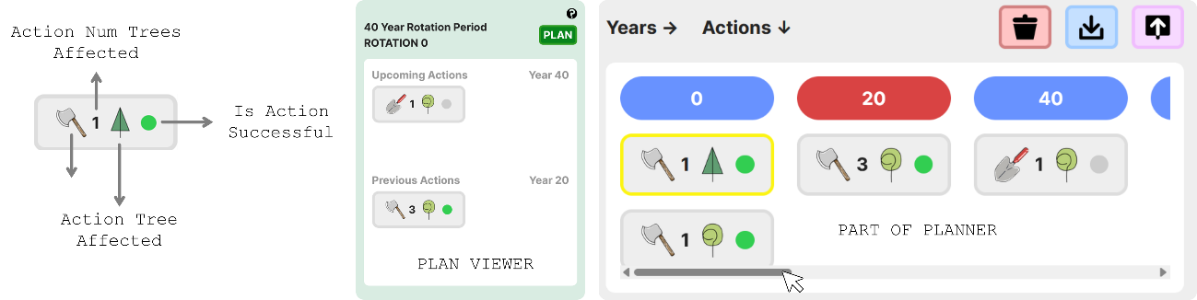

Figure 24. Management plans visualized using position, colour, and motion (plan viewer content changes over time) encoding channels.

CO2 concentrations change over time and are quantitative continuous values with high range. Thus, once again, to improve interpretability, these values were categorized into categories based on impact on human life due to climate change and colour coded. Only the current precise value is displayed and will get updated each timestep. Hovering over any colour reveals its category, thereby saving screen space needed for a legend.

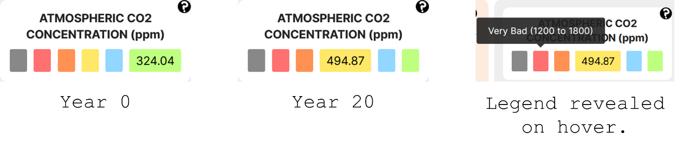

Figure 25. Colour and motion (updates over time) encoding channels used in the CO2 panel.

Another notable display design decision is the use of red and green colours to indicate whether a target has been achieved (green) or not (red).

Lastly, the decision was made to use a toggleable switch component as means of input for attributes like “Is Serious Mode”, “Is Income Stream Active” and “Is Action Repeated” whose values the learner can set since these components are implemented to have a distinctly separate colour and shape in ON and OFF positions which encode the categorical binary nature of these attributes well.

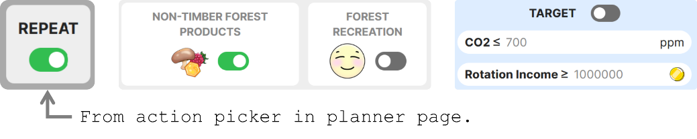

Figure 26. Use of switches.

Thus, overall, key encoding channels leveraged are colour, position, size, and motion with position + colour being the most used combination visible even in the general layout of the world and planner pages (each group of related graphical elements separated from others by placing them inside a different coloured panel) as this is generally considered to be the best (no ambiguity) combination w.r.t visual separability.

## System Architecture

Structurally, MycroForest can be thought of as being composed of a simulation model, UI components, and input variables as shown in Figure 1.

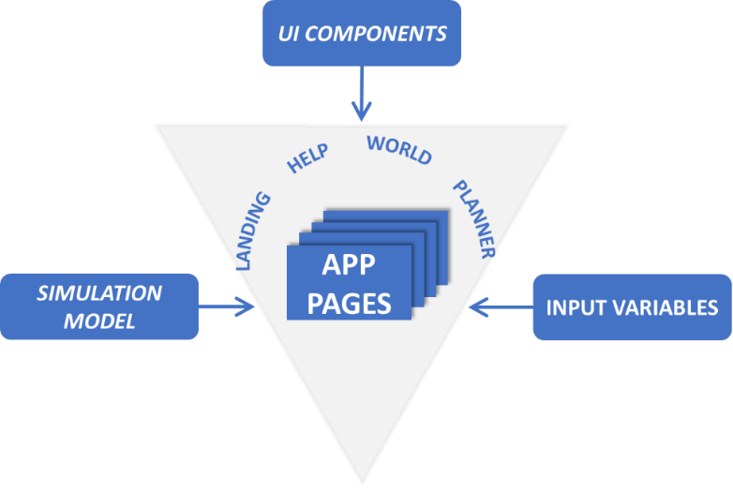

Figure 27. MycroForest App Structure

### Simulation Model

This section presents the conceptual model that the simulation is based on as well as research that inspired it.

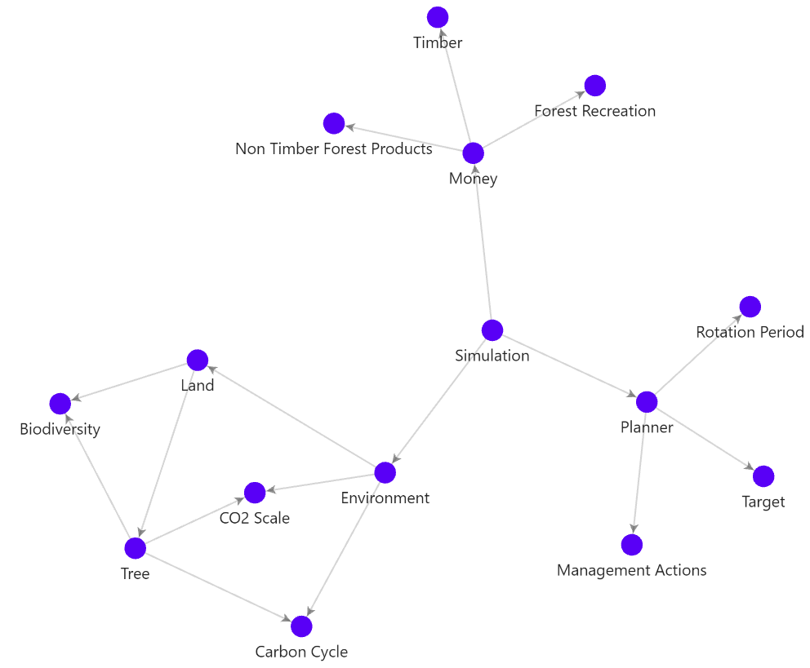

Figure 28. Graph representation of simulation conceptual model entities. Click on a node to navigate to its explanation.

Figure 6 above is a graph representation of the simulation conceptual model. Each node represents a key idea or component as explained below.

#### **Simulation**

The simulation is the master component from which all other components may be reached. Its primary purpose is to coordinate all world elements and initialize the microworld. The simulation contains the microworld's Environment, and a Planner to keep track of user generated forest management plans. It triggers state update of all world components in accordance with passage of time and prompts update of the UI to reflect model changes. Furthermore, the simulation keeps track of forest resources and manages influx and outflux of Money.

*Back to graph.*

#### **Environment**

The environment is composed of the atmosphere, Land, and carbon reservoirs. In this microworld, there are 5 carbon reservoirs as follows. Carbon moves between them to emulate a simplified Carbon Cycle.

1. **Soil**: The soil holds carbon in the form of organic material (plant/animal remains, microbes, etc.) or minerals. [57]
2. **Fossil Fuels**: Of all the CO2 locked away in the earth, around 5 to 10000 Gigatonnes (Gt) is present as fossil fuels. [57] Fossil fuels are essentially remains of dead organisms from Earth’s distant past that upon having been buried deep underground and exposed to great pressure and temperature over time has turned into energy dense oil, solids (coal), and gas.
3. **Atmosphere:** The mass of the atmosphere is about 5.1e+18 kg = 5.1e+21g. [58]Given the mass of CO2 (solute) in the air (solution) in grams and the mass of the atmosphere in grams, concentration of CO2 in Parts Per Million (PPM) is computed as . [59, 60] The CO2 Scale categorizes ranges of CO2 concentration in the air into different classes based on its implication on quality of human life after having accounted for associated climatic conditions.
4. **Vegetation**: The plants on land sequester carbon dioxide (CO2) from the atmosphere. Carbon sequestration refers to the process through which CO2 is removed from the atmosphere and held in solid or liquid form. [61]
5. **Lumber**: This is a man-made reservoir. It refers to all wood that’s preserved in use (furniture, construction, etc.) and not burned for energy. When we preserve wood, we significantly slow down its breakdown and re-entry into the carbon cycle via natural decay. [62, 63]

When the simulation is created, there is a need to initialize carbon reserves with starting carbon amounts. The following paragraphs explain how these starting amounts were arrived at.

On earth, the amount of carbon in the air, soil, vegetation, and fossil fuels is estimated to be around 800, 2300, 550, and 10000 GtC respectively. [57] In order to allow for an initial CO2 concentration that sustains plant growth in the microworld, it was necessary to scale down the amount of carbon in the air from 800 GtC as on earth to 500 GtC. Thus, starting values for amount of carbon in each reservoir in the microworld is based on the following composition that though smaller, is the same ratio as on earth.

* Air = 500 GtC.
* Soil = GtC.
* Vegetation = GtC.
* Fossil Fuels = GtC.

At the initial stage in the simulation, all carbon in soil and vegetation is assumed to be in the air. As plants grow, they capture and store this carbon in themselves and the soil. Thus, starting amount of CO2 in the microworld is as given below.

* Air = 1437.5 + 343.75 + 500 GtC = 2281.25 GtC = 2281.25 2.28e+18 gC.
* Soil = 0 gC.
* Vegetation = 0 gC.
* Fossil Fuels = 6250 GtC = 6250 6.25e+18 gC.
* Lumber = 0 gC.

Table 1 summarizes this distribution of carbon among the various carbon reservoirs represented within the microworld.

|  |  |  |  |  |  |
| --- | --- | --- | --- | --- | --- |
| **Reservoir:** | *Fossil Fuels* | *Soil* | *Air* | *Vegetation* | *Lumber* |
| **Earth GtC:** | 10000 | 2300 | 800 | 550 | 0 |
| **Scaled GtC:** | 6250 | 1437.5 | 500 | 343.75 | 0 |
| **Starting gC:** | 6.25E+18 | 0 | 2.28E+18 | 0 | 0 |

Table 4. Carbon distribution among reservoirs.

*Back to graph.*

#### **CO2 Scale**

Atmospheric CO2 concentration is expressed in Parts Per Million (ppm). This is the standard. PPM is a measure of the concentration of a substance in a solution or gas. It is a proportion, just like percent. 80 percent is 80 parts out of 100. 80 ppm is 80 parts out of 1,000,000. Here, ppm indicates the number of parts of CO2 per 1 million parts of the total air in the atmosphere. [60]

CO2 concentration in the microworld has been organized into a scale as shown below. Associated with each band in the scale, is a label and colour that is indicative of the expected quality of life for humans at that level of atmospheric CO2 concentration after considering corresponding climate change effects.



Figure 29. Quality of human life based associated with concentration of CO2 in the atmosphere.

Similarly, another scale was developed to categorize various levels of photosynthetic efficiency of plants at different atmospheric CO2 concentrations.



Figure 30. Photosynthetic efficiency associated with concentration of CO2 in the atmosphere.

Above scales were developed based on following information.

* Photosynthesis is more effective at CO2 concentrations ranging from 700 to 1800 with around 1000 being max efficiency. Beyond 1800, conditions may start to become toxic for plants. [64]
* Below about 200 ppm concentration of CO2, photosynthesis is extremely difficult with it being impossible less than or equal to 150 ppm. [65]
* Atmospheric CO2 levels during human evolution 200 to 300 ppm. [66]
* Pre-industrial atmospheric CO2 levels ppm. [66]
* 20th century atmospheric CO2 levels 300 to 250 ppm. [66]
* Atmospheric level of CO2 that would push the world past its target for avoiding dangerous climate change 430 ppm. [66]
* One of our best estimates of an atmospheric CO2 level that would be a tipping point beyond which global temperatures would rise by 8 to 10 1200 ppm. [67]
* Lowest known atmospheric CO2 level ever based on findings from ice cores 172 ppm (650,000 to 800,000 years ago). [68]

In the scale regarding quality of human life, when CO2 in the air falls below 200 ppm or rises above 1800 ppm, this corresponds to impossible living conditions because at the lower end, photosynthesis becomes difficult and at the higher end, global warming is expected to lead to inhospitable climate. In the microworld, while values in the 200 to 350 ppm range is ideal, CO2 level is regarded as manageable if it stays in the green, blue, or yellow range between 200 to 700 ppm. This range is wider than on Earth where tolerable levels would more likely be between 200 to 500 ppm. This is because unlike in the real world, in this microworld, shifts in atmospheric CO2 is exaggerated because carbon absorbed and released by trees is scaled by a large number to allow for just 36 trees to mimic all forests on Earth and significantly impact carbon levels in the environment. If CO2 levels are in the 700 to 1200 ppm range, then it is considered bad for human life because this nears the expected tipping point beyond 1200 ppm beyond which it is difficult to revert to ideal conditions. Since this dangerous point is exceeded when atmospheric CO2 levels are in the 1200 to 1800 ppm range, this is categorized as “Very Bad” for human quality of life.

*Back to graph.*

#### **Carbon Cycle**

The carbon cycle refers to movement of the carbon element between the various states and locations in which it exists on our planet. Carbon is plentiful on Earth with most of it bound to rock in the lithosphere. Remaining carbon may be found dissolved or calcified in the ocean, in minerals or organic material in the soil, as CO2 or other gasses in the air, and in life including plants and animals. A large amount of it is also trapped as fossil fuels deep in the earth. Any location where carbon is found in large quantities is referred to as a carbon reservoir. [57] The movement of carbon between these reservoirs can be categorized into two types of carbon cycles, namely the slow and fast carbon cycle. [57]

* **Slow Carbon Cycle:** This cycle moves carbon between air, water, and rock slowly over 100 to 200 million years. Air bound carbon dissolved in water rains down as a weak carbonic acid which slowly reacts with rock to chemically weather them thereby releasing minerals like calcium, magnesium, potassium, etc. as well as carbon. These ions end up in the ocean via rivers where they are utilized by organisms that transform them into hard material like calcium carbonate that gets deposited as sediment on the ocean floor and gets compressed over time to produce rock such as limestone. Lastly, volcanic activity returns some carbon locked away deep within the earth into the atmosphere to complete the cycle. [57]
* **Fast Carbon Cycle:** This cycle primarily concerns the biosphere or life on earth and it’s fast enough for effects to be visible within a human lifetime. Plants and phytoplankton can absorb CO2 from the atmosphere and turn it into sugar through a chemical reaction termed as photosynthesis. When carbohydrates produced by photosynthesizers are broken down to produce energy either by themselves or by other organisms that directly or indirectly consume them, carbon dioxide and other carbon compounds are released back into the air through respiration. Carbon in life is also released into the soil and air when the organism dies and decays. [57]

Left undisturbed, the slow and fast carbon cycles maintain amount of carbon in each reservoir fairly in the same range of values over millennia. Human activities like burning fossil fuels for energy moves a large quantity of carbon from the slow to fast carbon cycle quickly so as to significantly alter carbon balance between reservoirs. Additionally, deforestation and anthropogenic land use changes reduce carbon sequestration ability of the biosphere and soil, further aggravating the problem of carbon saturation thereby leading to ocean acidification, global warming, and consequently, erratic weather. [57]

MycroForest models key elements of the fast carbon cycle and ignores the slow one as effects of the latter is largely negligible within the 300 years that the simulation spans. Following paragraphs explain how carbon is transferred between the 5 modelled reservoirs (air, soil, vegetation, lumber, fossil fuels) in the microworld.

*Tree Growth & Decay*

In the microworld within MycroForest, vegetation refers to the trees. Trees both absorb and emit carbon. This carbon transfer mechanism is slightly different w.r.t each of the growth, biomass maintenance, and decay phases of a tree’s existence. Corresponding modelling variations are as follows.

* **Growth**: As previously discussed, plants absorb carbon from the air in the form of CO2 for photosynthesis. This means that carbon in plant biomass originates from the air. In the microworld, carbon absorbed by a tree each time it grows is computed as the amount of carbon in new growth. Let a tree have grown in volume by . Let density of the biomass of the tree be . Then, the tree’s weight should have increased by . Of the total weight of the tree, around 50% is dry weight. [69] Thus, The amount of carbon in the new volume of the tree is about 47.5% of its dry weight. [69] So, This absorbed carbon will get added to the total amount of carbon in the vegetation reservoir and subtracted from the air reservoir such that and .
* **Maintenance:** In addition to increase in height and/or diameter, a tree will also need to replace biomass lost due to damage or natural shedding. [36] The amount of carbon in this biomass that is replaced is referred to here, as maintenance carbon. This carbon is modelled as being subtracted from the air and added to the soil without levels in the vegetation reservoir increasing or decreasing since the net amount of biomass lost to the soil is more or less same as the amount that is absorbed from the air to replenish it. Let the volume of biomass that is replaced for maintenance be equal to 1% of a tree's total volume . This proportion of 1% is a number that works well with other existing microworld settings and was arbitrarily chosen as it was not possible to find real-world numbers for this figure. Just as before, , , . This amount of maintenance carbon is subtracted from the air and added to the soil such that and .
* **Decay**: As trees decay, the carbon stored in them re-enters the air and soil reservoirs from the vegetation reservoir. If a tree has died and remains on land, 15% of the carbon stored in it is released into the atmosphere and soil per year. [70] Thus, amount of volume decayed each time step is set to equal 15% of the volume of the tree at the time of death. Let amount of carbon that is lost during decay each year be fixed at where t = time right before the tree died. Thus, weight of the dead tree lost to decay would be and consequently, volume would be where is the density of wood. That is, after each year, volume of a dead tree that remains in soil, changes as . Amount of volume decayed each time step is set to equal 15% of the volume of the tree at the time of death. Of the amount of carbon decayed each year, around 35% may end up in the soil with 65% getting released back into the atmosphere. [71] So, and .

*Soil Release*

Presence of organic matter in soil makes it an important carbon reservoir. It naturally releases a certain portion of stored carbon into the air through processes like respiration of microorganisms. The approximate amount of carbon in the soil is 2300 Gt. Around 60 Gt of carbon is lost per year. [57] Thus, in the microworld, the amount of carbon that the soil releases back into the atmosphere each year is set to of the carbon in the soil. Therefore, annual soil carbon release such on each 1 year time update, and .

*Timber Usage*

Harvested wood or timber has many uses. It may be burned for heating and power generation or can be used in construction as well as to make products like paper. In this microworld, uses for harvested timber have been categorized into either “energy” or “lumber” where the former refers to all use involving burning of wood and the latter represents all use cases where the wood is preserved. On average, around 50% of harvested wood worldwide is used to produce energy. [72] The mass of carbon is computed from mass of harvested timber multiplied by factors for dry weight % and carbon % as previously shown. Thus and

It is assumed that 100% of the carbon in wood used to generate energy is released into the air and that 100% of the carbon in wood used as lumber is preserved. This means that every time harvested wood gets used up, carbon gets added to both the lumber and air reservoirs as and .

Timber is obtained when a tree is felled. When a tree is chopped, around 25% (roots = 21.3% [73] + the stump + some foliage) of that tree is assumed to remain on land while the rest of it (75%) is harvested. Thus, where .

In the real world, it’s likely that not all burned wood ends up in the atmosphere since some of it may be turned to ash etc. However, most of it does indeed re-enter the atmosphere and hence this is a safe assumption to make w.r.t this microworld.

Also, for simplicity, in this microworld, it is assumed that wood which is used for lumber is preserved responsibly such that its potential lifespan in the use phase is maximized. Thus, carbon stored in lumber is not released back into the air in the simulation timeframe. In reality however, carbon storage in preserved wood or lumber is not as straightforward. Amount of carbon sequestered in wood products depends on several factors at the wood production, use, and end of life stages. In the production phase, amount of carbon in harvested wood varies depending on the tree type as different species have different wood densities. Hardwood from deciduous tropical species is denser and hence is preferred to make durable goods. But this demand often leads to irresponsible sourcing of wood which ultimately leads to more carbon being released than what is preserved in wood and accounted for by new growth. If wood is sourced responsibly and preserved such that new growth is encouraged in its place, then this can result in an increased carbon sink effect even after taking into consideration, emissions involved in transport of harvested wood and its processing. In the use phase, wood products keep sequestered carbon from re-entering the fast carbon cycle until its end of life when it begins to degrade. At this stage, the best course of action is to recycle it into secondary wood products like a particle board as that would extend its life and keep carbon locked away for longer. This can be beneficial even when considering the energy needed for recycling. Another, less desirable option is to burn it to produce greener energy compared to that produced via burning of fossil fuels. These are, however, ideal scenarios. It is an unfortunate truth that a lot of harvested wood end up in landfills in or ever before their end of life stage where they rot quickly and in addition to CO2 may also release more potent greenhouse gasses like methane (CH4). Also, while improving the durability of wood is a good approach to maintaining its role as a carbon safe, several methods of wood modification to make it harder or better suitable to substitute materials like plastic or concrete involves intense processing and use of toxic preservatives like CCA or ACQ which ultimately does more harm than good in terms of energy needed for modification and toxic waste. [62] Nevertheless, w.r.t to this microworld, the assumption that carbon in lumber is not returned to the air is a sound one because if responsibly produced and used, wood can indeed lock away carbon out of the fast carbon cycle for centuries. [63]

*Fossil Fuel Usage*

As previously discussed, under normal conditions carbon from fossil fuels is released into the atmosphere very slowly over millennia via the slow carbon cycle. But since the industrial age, humans have extracted, processed, and burned resulting petroleum based oil, coal, and gas for energy thereby quickly releasing a large about of carbon from fossil fuels into the environment. In 2023 alone, 36.8 Gigatonnes of CO2 (GtCO2) 10 Gigatonnes of Carbon (GtC) was added into the atmosphere by humans. [57, 74]

By default, in the environment, amount of carbon added into the atmosphere from the fossil fuels carbon reserve, computed as and , is set to be 0 GtC. The learner is provided the option to set this parameter to any positive value.

*Back to graph.*

#### **Land**

The land in MycroForest wherein trees grow is represented as a grid with 6 rows and 6 columns amounting to a total of 36 spots. Each spot may host 1 live Tree. Thus, the land can contain up to 36 living trees. The value of 36 spots is an arbitrary choice that is intentionally kept relatively small so that it can be visually tracked while also ensuring its big enough for different forest management plans to produce varying results.

Assuming trees are grown in rows with average distance between them being 25 ft, then 1 acre of forest could comfortably support around 83 trees (as per this [tree spacing and distance calculator](https://treeplantation.com/tree-spacing-calculator.html)). Therefore, 36 trees would occupy 0.43 acres = 1740.15 . Thus, the size of land in this microworld is approximated to span 1740 . This is too small to represent the size of a real forest (the average size of a privately owned forest in Ireland is around 8 ha = 80,000 [75]). But, given only 36 trees in this microworld, scaling real world figures associated with forests such that they are relevant to a 1740 piece of land should help map real world figures to those in the microworld more accurately.

Land content determines the amount of Biodiversity it harbours which in turn, influences tree growth rate, ability of trees to recover from stress, and money earned from some income streams.

*Spot Availability*

In the microworld, a tree can only grow if a suitable spot is available on land. A spot on land is considered free and available for new growth only if one of the following conditions is true.

* There are no trees in the spot.
* There is only one dead tree in the spot such that it has decayed to the point where . The value of 0.5 is arbitrary, but this rule serves to emulate how in nature, new growth may arise from the remains of a dead tree even as it is still decaying.

Thus, each spot on land can have at most one live tree.

In code, each position in the 2D 6 grid representing the land is mapped to a list. This list may only ever contain at most 2 Tree objects. The object at position 0 in this land spot list is the latest addition to the land spot and is always the only object that gets displayed on the UI.

*Initialization*

When the simulated world is first created, seedlings are planted as per a predefined species composition of 60% coniferous trees and 40% deciduous trees. The microworld is set to have 92% free space and 8% spots having seedlings such that 60% of those seedlings are coniferous and 40% are deciduous. This leads to there being 2 coniferous seedlings and 1 deciduous seedling and 33 empty spots. [76] This choice is based on composition of forests in Ireland. As the forest grows wild and changes over time, this composition may change. This is because not all other parameters in the microworld are based on values from Ireland. Furthermore, there likely being other variables influencing forest composition that has not been modelled might explain this change in composition over time. Nevertheless, this is a good assumption for starting composition.

Once initialized, the forest is left to grow for 200 years. The resulting old growth forest is the starting forest that the players work with. The starting position of seedlings is random. Thus, one can get a different forest on each browser refresh. Learners may save specific forests and reload them later.

*Back to graph.*

#### **Tree**

Trees in MycroForest may be one of 2 types, deciduous, and coniferous. This is an abstraction of the multitude of species on Earth. The term deciduous here refers to trees like oak, maple, mango, sandalwood tree, etc. which shed leaves in winter or bears fleshy fruits and/or flowers while the term coniferous refers to evergreen trees like cedar, fir, spruce, larch, etc. that largely reproduce via cones, remains full and green throughout seasons and has modified needle like leaves. The categorization of “coniferous” and “deciduous” was chosen over others like “hardwood” and “softwood” because unlike the latter which can be misleading given that there exist “hardwood” species with soft wood and vice versa, the former presents cleanest separation. [77] Properties of either category as shall be discussed below, assumes values that are averages of multiple trees under that category and are not therefore based on any single tree or species.

Table 2 below lists differences between properties of the two species as implemented in MycroForest. Property values are based on certain real world observations. On average, coniferous trees are taller [78, 79], more long lived [80], have softer wood [77, 81], mature slower [82] and reproduce less often [83] compared to deciduous trees.

|  |  |
| --- | --- |
| **Coniferous** | **Deciduous** |
| Maximum height = 70 m. [78] | Maximum height = 40 m. [79] |
| Reproduction interval = 2.5 years. [84] | Reproduction interval = 1 year. |
| Wood density = 6e+5 g/ [81] | Wood density = 7e+5 g/ [81] |
| Evergreen. Does not shed leaves seasonally. Thus, % of carbon lost and replenished per year in addition to growth (maintenance carbon %) = 1%. [77] | Sheds all leaves in autumn and regrows them in spring. Thus, maintenance carbon is assumed to be = 40%. [77] |
| No. of years spent in each stage of life in increasing order = grows from seedling to sapling after 4 years, matures at age 26, becomes old growth at age 60 and enters the senescent stage at age 90 before dying at age 100. | No. of years spent in each stage of life in increasing order = grows from seedling to sapling after 3 years, matures at age 21, becomes old growth at age 47 and enters the senescent stage at age 70 before dying at age 80. |

Table 5. Difference between coniferous and deciduous trees.

As seedlings, both trees are assumed to have the same height of 0.2 m as it was hard to distinguish between species [85]. Also, given knowledge from aforementioned sources, tree age groupings created, as shown in Figure 26, is based on informed assumptions.

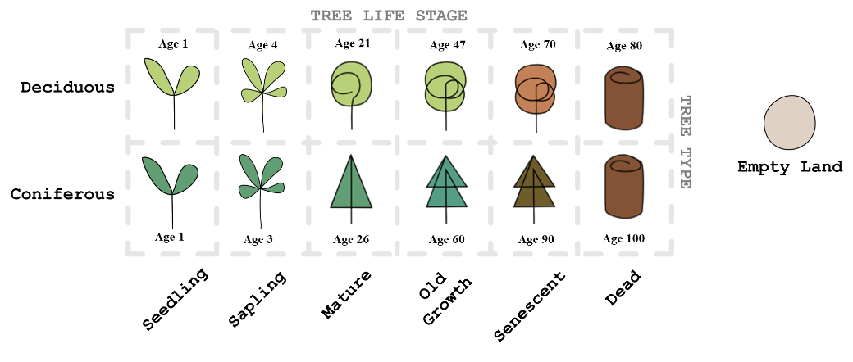

Figure 31. Possible land content with ages.

Trees in the microworld are modelled to live and die as they do in the real world. When they are alive, they grow and can reproduce. After death they decay until no more mass remains. Also, live trees are under stress due to environmental factors and aging. Increased amounts of stress negatively effects growth [86], but certain conditions like high biodiversity in the forest can help reduce the impact of stress. Trees may recover from environmental stress when conditions are favourable again. [87] Following passages explain how each such key mechanisms is modelled within MycroForest.

*Stress*

Modelling tree mortality as a consequence of stress is a common approach. MycroForest growth model incorporates the following real world observations regarding effects of stress on tree vigour as have other models in the past [86, 88].

* Growth of trees decline when under environmental stress.
* Trees under high stress or significant amounts of stress for long periods enter breakdown mode followed by quick death.
* Demand for photosynthates (products of photosynthesis) or other resources (water, nitrogen, phosphorus, etc.) exceeding supply is one key inducer of stress in plants.
* Stress that plants are under increases when there is more of a particular resource than ideal such as when heat is too high, there is too much CO2 or water etc.
* When conditions become favourable again, trees can recover from stress. From the Tree Decline Recovery Seesaw model presented in [87] captures the relationship between tree vigour and stress well.

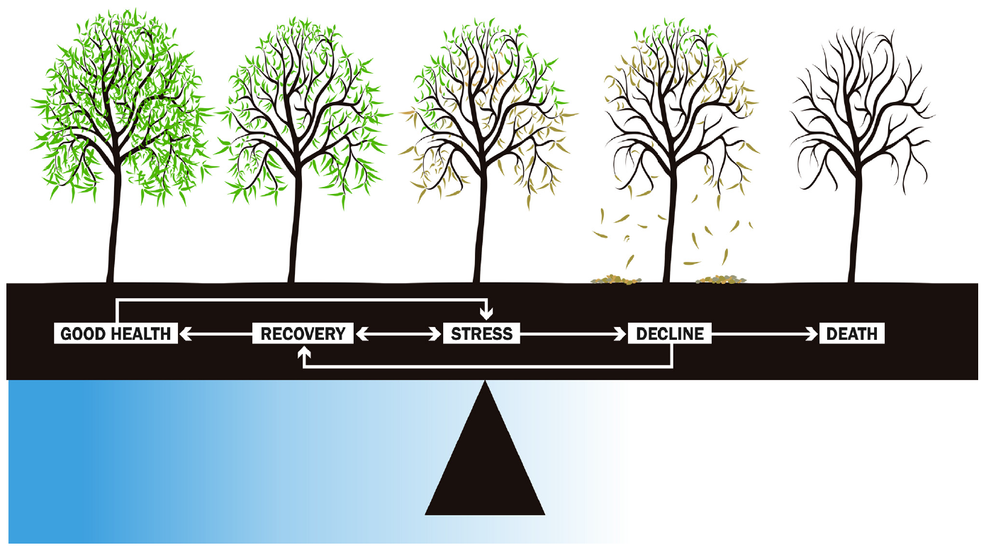

Figure 32. The Tree Decline Recovery Seesaw model illustrating how health of a drought stressed tree shifts between varying stages. Physical changes like leaf re-growth and loss indicates recovery and decline respectively. [87]

In MycroForest, trees have a “stress” property, and they die only when .

Living trees are under stress due to environmental conditions (atmospheric 𝐶𝑂2 concentration) and time (age).

In this microworld, availability of CO2 is the only environmental stressor modelled due to it being most associated with climate change. In reality however, there are a multitude of environmental stressors both biotic like pests or disease and abiotic like temperature, competition among trees, natural disasters, etc. [89] Modelling these would be out of scope and will likely add unnecessary complexity. Instead, all other environmental factors are assumed to be ideal. Stress due to atmospheric CO2 concentration is computed based on the tree's tolerance to CO2 levels in the air. Seedlings and saplings (premature trees) are more vulnerable to atmospheric stress than mature trees.

Table 3 shows assumed mapping between CO2 availability in the air and stress induced in the tree. This tolerance mapping was developed based on the previously presented CO2 Scale that links atmospheric CO2 concentration to photosynthetic efficiency.

|  |  |  |
| --- | --- | --- |
| **CO2** | | |
| ***Availability (ppm)*** | ***Stress per Year*** | |
| *Premature* | *Mature* |
| < 200 | 1 | 1 |
| < 430 | 0.01 | 0.001 |
| < 700 | 0.0001 | 0.00001 |
| < 1200 | 0 | 0 |
| < 1800 | 0.0005 | 0.00005 |
| >= 1800 | 0.1 | 0.01 |

Table 6. Tolerance of trees to CO2 availability.

Age related stress is maximum when a tree reaches maximum lifetime age. It increases by a small, fixed aging stress factor = 0.01 every year after a tree enters the senescent stage. This captures decline in health associated with old age.

When conditions are favourable, trees recover from past stress. Healthier plants (those under less stress) recover faster. Rate of recovery is determined by a fixed stress recovery factor that was arbitrarily chosen based on the informed assumption that recovery from stress is generally gradual. [87]

*Living*

If after considering latest environmental and age related stress, a tree is still alive, the following actions may take place.

* **Recovery:** The tree may recover from stress as mentioned previously.
* **Growth**: Physical growth of a tree involves both gaining added volume and gaining maintenance volume. Maintenance volume refers to biomass gained to replenish existing volume that is assumed to have been either naturally shed (self-pruning) or lost due to damage. Maintenance volume is computed as an arbitrary fixed percent of the existing volume of the tree; . This is assumed to vary between species as and based on knowledge that deciduous trees seasonally shed leaves while coniferous trees love very little biomass this way. Generally, in the real world, due to several reasons beyond the scope of this project, height of trees is limited. However, most researchers agree that diameter of most trees continue to grow throughout their lives although this slows down significantly after they mature. Continued growth in diameter is often referred to as being part of “secondary growth”. This combination of primary and secondary growth is modelled in MycroForest as follows. For simplicity, volume of a tree is assumed to be similar to that of a cylinder. Note that growth volume, height, or diameter in the notation below refers to the amount of new growth. This is different from new volume, diameter, or height which refers to the aggregate sum of the old value and new growth resulting in the latest value.

Once the tree has reached maximum height, secondary growth takes place.

Where the secondary growth factor is assumed to be and

Growth declines as stress increases. However, since more biodiverse forests are more resilient, the Biodiversity stress reduction factor can help counter negative effects of stress on growth. [90]

Maximum growth height per year is based on the age of the tree at the beginning of its mature stage and how tall it can get. Maximum growth diameter is simply computed based on maximum growth height using the relationship assumed to be where is hight of a tree in meters and is the diameter of a tree in centimetres. [91] Thus, given , maximum amount that the tree can grow by as part of primary growth at each time step can be computed as follows.

All growth volume so gained (maintenance + primary + secondary growth) leads to carbon sequestration as part of the Carbon Cycle as previously discussed.

* **Reproduction**: Trees may reproduce every reproduction interval no. of years only if there is a free space adjacent to the tree and the tree is in either the mature or old growth life stage with where it is assumed that . This mechanism keeps the forest populated over time. The two types of trees have varying of years after which they may reproduce.

Both types of trees can reproduce only if there is at least one free spot adjacent to itself. Most conifers reproduce via cones or rely on wind dispersion while a large no. of deciduous trees produce fruits that appeal to a wide variety of fauna which carry the fruits that they ingest and dispose them further from the parent tree. Biotic means of dispersal (by means of animal carriers) can result in wider seed spread. [77] Thus, deciduous trees can spawn seedlings in 2 more spots 2 steps away from them parent in addition to immediately adjacent positions as can coniferous trees. depicts this.

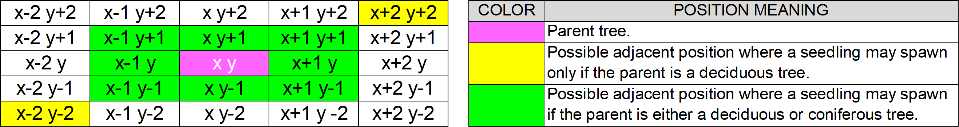

Figure 33. Positions around a parent tree where new seedlings may spawn.

* **Death & Decay**: Either naturally over time or when they are chopped (chopping induces maximum stress), once , they die. Once dead, trees decay as mentioned under the Carbon Cycle section.

*Back to graph.*

#### **Biodiversity**

Biodiversity refers to the variety of different life forms that a forest supports. This is generally regarded as a good indicator of a forest’s health. Greater the biodiversity, greater the health of the forest and the more resilient it is due to several factors like associated increased genetic variability leading to faster adaptation to change, increased tree diversity meaning lesser chance of complete forest die out due to diseases or pests that target specific species and overall better ability to maintain ecosystem functions like healthy nutrient cycles due to extensive mycorrhizal networks, etc. [92, 93] The 3 main values related to biodiversity that is computed within MycroForest are Biodiversity Score , Biodiversity Category , and Biodiversity Stress Reduction Factor .

Mixed forests with trees of varying ages are healthy. They host rich biodiversity. Even dead trees (dead wood) contribute towards increased biodiversity (fungi, insects, etc). [92-96]

Thus, biodiversity score shall consider species as well as age composition of the forest and following rules are assumed.

* A forest with 50% coniferous trees and 50% deciduous ones (maximum species mixing) receives highest biodiversity score of 1.
* If no trees, then biodiversity score .
* For each coniferous tree, if there exists a deciduous tree then .
* For each remaining coniferous or deciduous tree for which there is another tree of the same type .
* For each remaining coniferous or deciduous tree for which there is no other tree of any type .
* The final score shall min max scaled to a value between 0 and 1 as since land is comprised of 36 spots.

Further, it is assumed that a forest most closely resembling a real old growth forest in age composition harbours most biodiversity and receives a score of 1. This score drops to 0 based on how much the virtual forest’s age composition differs from that of the real forest. Figure 12, Figure 13, and Figure 14, present tree age composition of an old growth forest in Vienansalo Wilderness, Eastern Fennoscandia. [96]

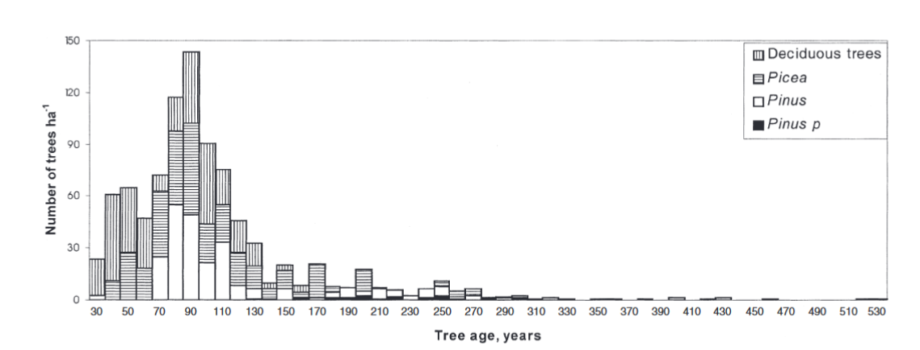

Figure 34. Distribution of no. of mature trees by age per hectare based on data from an old growth forest in Vienansalo Wilderness, Eastern Fennoscandia. [96]

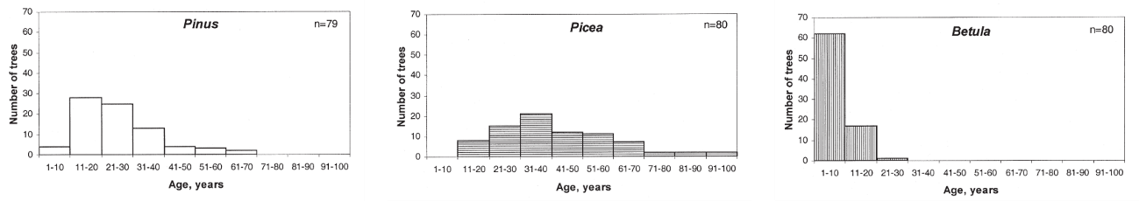

Figure 35. No. of seedlings and saplings per hectare based on data from an old growth forest in Vienansalo Wilderness, Eastern Fennoscandia. [96]

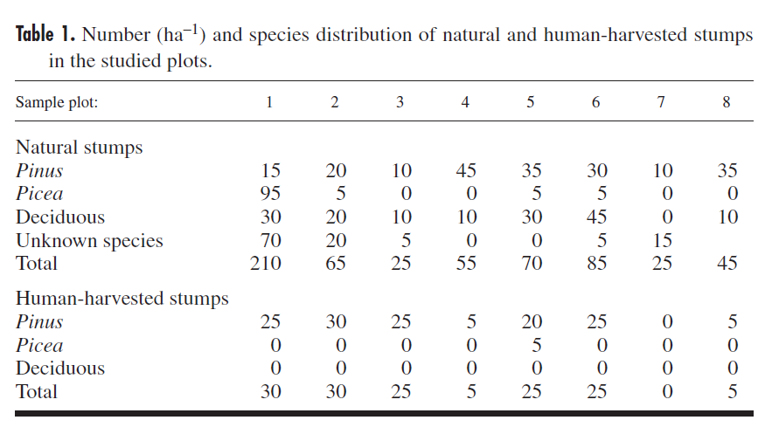

Figure 36. No. of dead tree stumps per hectare based on data from an old growth forest in Vienansalo Wilderness, Eastern Fennoscandia. [96]

Since age of the oldest and youngest trees in this forest differ from that in the microworld, to mimic age composition of the real forest, there is a need to map age group ranges in the microworld to corresponding ranges in the real forest. This scaling was done to obtain Table 4. by computing where number on the original scale, corresponding number on the new scale, and = minimum and maximum value on the original scale respectively and, and = the minimum and maximum value on the new scale respectively.

|  |  |  |  |  |  |  |  |  |
| --- | --- | --- | --- | --- | --- | --- | --- | --- |
| ***TREE AGE MAPPING*** | | | | | | | | |
| ***Life Stage*** | ***Microworld*** | | | | ***Real Forest*** | | | |
| Deciduous | | Coniferous | | Deciduous | | Coniferous | |
| Min | Max | Min | Max | Min | Max | Min | Max |
| Seedling | 0 | 3 | 0 | 4 | 0 | 15 | 0 | 50 |
| Sapling | 3 | 21 | 4 | 26 | 15 | 30 | 50 | 100 |
| Mature | 21 | 47 | 26 | 60 | 30 | 100 | 100 | 133 |
| Old Growth | 47 | 70 | 60 | 90 | 100 | 162 | 133 | 525 |
| Senescent | 70 | 80 | 90 | 100 | 162 | 212 | 525 | 575 |

Table 7. Mapping of tree ages in the microworld to those observed in a real forest.

Based on tree age groupings from Table 4 and approximate tree per hectare counts gleaned from Figure 12, Figure 13, and Figure 14, an approximate ideal age composition as in Table 5 was arrived at with seedlings and saplings making up 15% of the forest, mature trees comprising 35% of it, old growth trees and senescent trees contributing to 20% of it and dead trees accounting for the remaining 30% of it.

|  |  |  |  |  |  |  |
| --- | --- | --- | --- | --- | --- | --- |
| ***TREE AGE COMPOSITION*** | | | | | | |
| ***Life Stage*** | ***Real Forest*** | | | | | |
| Deciduous | | Coniferous | | Mean % | Approx. Round |
| Count | % | Count | % |
| Seedling | 65 | 11.50 | 115 | 13.05 | 12 | 15 |
| Sapling | 25 | 4.42 | 45 | 5.11 | 5 |
| Mature | 220 | 38.94 | 241 | 27.36 | 33 | 35 |
| Old Growth | 95 | 16.81 | 160 | 18.16 | 17 | 20 |
| Senescent | 5 | 0.88 | 10 | 1.14 | 1 |
| Dead | 155 | 27.43 | 310 | 35.19 | 31 | 30 |
| Total | 565 | 100.00 | 881 | 100.00 | 100 | 100 |

Table 8. Ideal proportion of each tree age category.

Calculating age related biodiversity score involves computing the following for each of the 4 age groupings (seedlingSapling, mature, oldGrowthSenescent, dead) and then computing the average to obtain final value for .

* No. of trees, .
* Ideal proportion of trees of this age group, .
* Current proportion of trees of this age group, .
* Maximum possible error = .
* Minimum possible error .
* .
* After min-max scaling, .
* .
* .

Final biodiversity score is then computed as .

Based on the knowledge that ecosystems are more biodiverse than new forests or plantations [92] and that biodiversity is proportional to forest resilience as previously discussed, the following land categorization and biodiversity based stress reduction values in Table 6 were formulated.

|  |  |  |
| --- | --- | --- |
| Biodiversity Score Range | Land Category | Biodiversity Reduction Factor |
|  | Unforested | 0 |
|  | Plantation | 0.01 |
|  | Forest | 0.1 |
|  | Ecosystem | 0.3 |

Table 9. Assumed mapping between biodiversity score range and land category as well as biodiversity stress reduction factor.

*Back to graph.*

#### **Planner**

The planner in MycroForest is an object that maintains the learner’s working forest management plan. It’s a mapping of years in the simulation timeline to Management Actions.

Targets set the learner is also kept track of in the planner along with the latest Rotation Period setting.

Furthermore, the planner contains switches which can be used to set whether other streams of income are to be considered active or not.

*Back to graph.*

#### **Management Action**

A management actions are actions that learns can choose to be done that affects the forest.

Creating a new management action involves selecting the following.

* The type of action.
* The type of tree (species, age) the action is to be applied to.
* The no. of trees that are to be affected.
* The year in which this action is to be executed.
* Whether this action is to be repeated periodically.

There are 2 types of management actions as follows.

1. **Fell**: Felling a tree causes the following events.
   * The price to fell a tree is paid if possible. If there aren’t enough funds in the bank, then this activity fails to get executed.
   * It is assumed that around 25% (roots = 21.3% [95] + stump + some foliage) of a felled tree remains on the land and will decay over time. Thus, when felled 75% of the tree is considered to have been harvested. The corresponding volume so obtained gets added to available timber resource stock.
   * Harvested timber is sold with 50% of it getting used to generate energy [72] and the remaining 50% going towards lumber.
2. **Plant**: Planting a tree involves the following.
   * The price to plant a tree is paid if possible. If there aren’t enough funds in the bank, then this activity fails to get executed.
   * This action is only executed if there is a free spot on land adjacent to the parent where the seedling may be placed. If a free spot is identified, a new seedling appears on land.

***Note:*** Trees in the microworld, as previously mentioned, can reproduce naturally. They can also be planted by the learner, but even if this is not done, as long as there is a parent tree on land in its mature or old growth life stage, a new seedling may sprout at a free position adjacent to it.

*Back to graph.*

#### **Target**

This microworld allows for 2 types of targets to be set.

1. **CO2 Level:** If the CO2 level exceeds this set target at any point in the simulation, then this means that the current plan fails to meet this target. The year in which this target failed to be met for the first time will be indicated beside the corresponding text field.
2. **Income**: If the current plan failed to generate enough income to exceed or equal this set income value, then that means this target has not been met. The year in which this target failed to be met for the first time will be indicated beside the corresponding text field.

Any time that a target is successfully met, the corresponding text field on the UI gains a green border. This turns red in case of failure to meet the target.

*Back to graph.*

#### **Rotation Period**

In MycroForest, it is possible for trees to be felled or planted every X no. of years. This X is the rotation period. It exists to allow for management actions such as fell and plant to be scheduled at the beginning of each rotation. This type of planning in rotations mimics real world forestry and agriculture practices. In this context, a rotation is generally defined as “the number of years between the formation or regeneration of a crop and its harvest”. [97]

*Back to graph.*

#### **Money**

The virtual currency within the microworld is coin. In MycroForest there are 3 possible ways to earn from the forest as follows.

1. Timber
2. Non Timber Forest Products (NTFPs)
3. Forest Recreation

*Back to graph.*

#### **Timber**

Timber in the microworld refers to wood harvested upon felling a tree, of which 50% is used as lumber and the rest is burned for energy. [72]

*Availability*

Availabilityof this resource depends on the number and size of trees that were felled each time step.

*Income*

At the end of each simulation timestep, the amount (in kg) of wood that was harvested in that step is sold and used. In the real world, different types of wood have varying prices. On average, the price of wood can be assumed as being $1.5 per lb = $3.3 per kg €3.03 per kg. [98] Thus, in the microworld, timber fetches 3 coins per kg.

*Expenditure*

Felling the biggest trees can cost up to 3000 coins [99]. This maximum amount is multiplied by percent of full growth the tree has reached at the time of chopping to obtain felling cost equal to the height of the tree divided by its maximum height and then multiplied by the max felling cost.

Planting a tree of either species costs 277 coins [100].

*Back to graph.*

#### **Non Timber Forest Products**

Income from forests may come in the form of non-timber forest products (NTFPs) like mushrooms, berries, or honey.

*Availability*

A good number for wild ***mushroom*** yield from a European forest can be assumed to be 44.5 kg/ha/year based on yield from a Spanish forest. [101] That is 44.5 kg per 10000 per year = 0.00445 kg/year/. Thus, for the1740 micro forest, that's around 7.743 kg/year 8 kg/year.

On average, around 20 kg of ***honey*** can be harvested from one bee hive per year [102]. n Europe, density of wild honeybee colonies has been estimated to be around 0.26/. [103] This means there may be around 2.6e-8 colonies per . Thus, a 1740 micro forest can have 4.524e-5 bee colonies, each outputting 20 kg of honey per year to result in total honey generation of around 9.05e-4 kg/year.

With intensive ***berry*** picking, it is possible for a group of people to harvest around 10 kg of wild berries per year by foraging close to home. [104] Based on this, it is assumed that 5 kg of berries are foraged from the forest in the microworld per annum.

Overall, total availability of NTFPs would thus be around 13 kg/year. This income stream is not as dependable as timber. Thus, the decision was made to model availability using a normal distribution where mean is assumed to be and standard deviation is assumed to be .

This income stream is dependent on both biodiversity score and amount of deadwood in the forest (saprophytes like mushrooms thrive on deadwood [105]) as follows.

* Let the maximum availability of NTFPs before considering effects of biodiversity score and abundance of deadwood be .
* W.r.t the impact of biodiversity score, the mean of the normal distribution is assumed to be highest when biodiversity score = 1.0. Thus, given biodiversity score, . Here, is a scaling factor to reduce harshness of impact of slight reductions in biodiversity.
* W.r.t the impact of proportion of deadwood on land, given , . Once again, the scaling factor smoothens changes in availability for changes in deadwood proportion.

*Income*

In Ireland, as of 2024, wild mushrooms can fetch around €80/kg [106], wild berries can fetch around €25/kg [107], and wild honey can fetch around €65/kg [108]. Thus, price fetched per kg for NTFPs may be assumed to be 170 coins/kg.

*Expenditure*

Harvesting NTFP requires a work force. It takes a person a little over 20 hours to cover one acre = 4046.86 by foot [109]. That's about 0.005 hrs per . Thus, covering the 1740.15 of forest land in the microworld would take 1 person around 8.6 hrs. Let the employee take 15 hours to harvest (forage & gather) products (mushrooms, honey, berries) from 1740.15 of forest. Say, the worker needs to cover the equivalent of the whole forest 3 times a year for harvests, then they would need to work for 45 hrs/year. Let there be 2 workers, at a wage of 18 coins/hr [110], maintenance cost = coins/year. If there are not enough funds to pay forest workers, then this income stream’s availability is set to 0.

*Back to graph.*

#### **Forest Recreation**

Forests may be opened to the public for recreational use which can include forest trails, picnicking spots, and other activities like camping. This can fetch money.

*Availability*

As of 2022, there are 808,848 ha = 8088480000 of forest in Ireland. It is expected that these forests receive around 29105759 visits per annum [111]. Based on this, no. of visits per of forest per year may be computed as visits/year/. Thus, on average, a 1740 forest in this microworld can be expected to receive around 7 visits/year. These no. of visits too, can vary significantly based on several factors like climate, economic situations, etc. Thus, here too, availability is modelled to be drawn from a normal distribution with and as . One feature that will most likely affect no. of visits is biodiversity score of the forests as people generally prefer visiting healthier forests rich in life. Thus, availability of visitors here, depends on biodiversity score as .

*Income*

Income from forests open to public recreation may be generated via multiple means as follows.

* Admission/Parking Charge = 5 coins [112, 113]
* Guided tours = 10 coins [112, 113]
* Special activities (Zip Lining, Mushroom Picking, etc.) = 30 coins [112, 114, 115].
* Group Events (Birthday Parties, Yoga, etc.) = 20 coins/individual [116]

Assuming 1 of all visits to be guided tours, another 1 to be a special activity and the rest to be normal visits with 1 group (20 individuals) activity per year, income per year may be computed as coins.

*Expenditure*

Opening a forest for public recreation can involve establishment and maintenance of infrastructure.

Establishment of infrastructure would have associated one-time expenses. In 2006, restoration of around 44 hectares = 440000 of forest land cost about €8,000,000 [117]. Adjusting for change in currency value, in January 2024, that's around €10,114,114 (using this [CPI Inflation Calculator](https://visual.cso.ie/?body=entity/cpicalculator)). Thus, in this microworld, the initial one-time cost to make forest land suitable for recreational activities can be considered to be around coins per . Thus, for a 1740 forest, this would be around 40020 coins.

Established infrastructure would also need to be maintained. Maintenance would require employees and also resources, both of which cost money.

It was not possible to find definitive numbers that hint at how many employees may be required to maintain forest recreation facilities. This varies greatly. An estimate for no. of workers per of forest was arrived at for the microworld based on no. of people that Coillte (owns large areas of forest in Ireland), with around 4.4e+9 of managed forest land [118], employs. In 2016, it employed around 862 people [119]. Considering no. of employees to be 850 people, no. of people employed per may be computed as employees/. Thus, no. of employees for the 1740 forest in the microworld = .

If each employee works for 8 hours a day for 5 days a week for 52 weeks a year, then each employee works around 2080 hours a year. In Ireland, as of 2024, forest workers get paid around €18 per hour [110]. Thus, maintenance cost due to employee wages per of forest for a 1740 forest can be computed as coins/year.

Purchase of resources needed to maintain facilities every year would also contribute to maintenance cost. Once again, it is difficult to come across numbers for this. Thus, here it is assumed to be a fraction (1%) of the initial establishment cost

Thus, total maintenance cost for a 1740 forest would be 400 + 13 = 413 coins/year.

*Back to graph.*

### Input Variables

Input variables here, refer to a collection of 41 global variables that comprise all informed simulation hyperparameter choices based on research. These settings are separated from the rest of the program to facilitate easy experimentation with different simulation settings without needing to update code. Table 1 displays these variables organized into 9 categories for better comprehension.

|  |  |  |
| --- | --- | --- |
| Tree | | Carbon Dynamics |
| BIODIVERSITY_STRESS_REDUCTION_FACTOR C_PC_TREE C_WEIGHT_SCALE_FACTOR DECAY_HEIGHT_THRESHOLD HEIGHT_MAX HEIGHT_START_SEEDLING LIFE_STAGE_TREE REPRODUCTION_INTERVAL REPRODUCTION_STRESS_THRESHOLD TOLERANCE_CO2 TREE_REMAINS_AFTER_FELL  SEC_GROWTH_PC STRESS_AGING STRESS_RECOVERY_FACTOR WOOD_DENSITY WOOD_DRY_WEIGHT_PC | | C_START C_PC_DECAY CO2_FOSSIL_FUEL_ANNUAL_EMISSION_START TREE_VOLUME_MAINTENANCE_PC DECAY_PC_SOIL SOIL_RELEASE_PC |
| Land |
| BIODIVERSITY_CATEGORIES LAND_AGE_COMP LAND_FREE_PC_START LAND_SIZE SPECIES_COMPOSITION_START |
| Finances | Time | Targets |
| COST_MGMT_ACTION FUNDS_START INCOME_SOURCES | INIT_NUM_YEARS TIME_MAX SIMULATION_DELAY | TARGET_CO2_START TARGET_INCOME_START |
| Forest Management | | Air |
| ROTATION_START TIMBER_USAGE  AVAILABILITY_SCALE_FACTOR | | AIR_MASS ENV_SCALE ENV_SCALE_COLORS |

Table 10. Categorized input variables.

Given below are brief descriptions of the significance of each of these variables.

Tree: This category comprises settings related to tree agents within the simulation.

* BIODIVERSITY_STRESS_REDUCTION_FACTOR = A mapping of land category (Unforested, Plantation, Forest, Ecosystem) to a value in the range 0 to 1. This value is the factor that stress which trees are under gets reduced by as a result of land biodiversity. Greater biodiversity often implies greater resilience and hence more recovery from stress.
* C_PC_TREE = The proportion of carbon in dry mass of a tree.
* C_WEIGHT_SCALE_FACTOR = The factor by which carbon absorbed or released by a tree is scaled so that a very small no. of trees may simulate carbon absorbed and released at rates similar to that of all of Earth’s forests.
* DECAY_HEIGHT_THRESHOLD = The proportion of the original height of the live tree which when a decaying tree should be reduced to before a new seedling may grow at that spot on the land.
* HEIGHT_MAX = Maximum height of the tree.
* HEIGHT_START_SEEDLING = Height of a seedling when it first spawns.
* LIFE_STAGE_TREE = Each life stage category mapped to the no. of years after which the tree shall be considered to belong to that age group.
* REPRODUCTION_INTERVAL = No. of years after which trees may reproduce.
* REPRODUCTION_STRESS_THRESHOLD = The value that stress must be below for a tree to be able to reproduce.
* TOLERANCE_CO2 = Atmospheric CO2 levels mapped to stress that the tree will be under when at that level.
* TREE_REMAINS_AFTER_FELL = Proportion of the original tree that remains on land after it has been chopped.
* SEC_GROWTH_PC = Proportion of maximum growth volume that accounts for secondary growth.
* STRESS_AGING = The amount of stress that a tree is under after it enters the senescence life stage.
* STRESS_RECOVERY_FACTOR = The proportion of a tree’s remaining health by which value it can recover from stress.
* WOOD_DENSITY = Density of wood in g/.
* WOOD_DRY_WEIGHT_PC = The proportion of a dry weight in a tree’s mass.

Carbon Dynamics: This category comprises settings related to amount of carbon that is in or gets transferred between carbon reservoirs in the microworld.

* C_START = Each carbon reservoir (air, soil, vegetation, lumber, fossil fuels) mapped to the amount of carbon in g within it at the initialization of the world.
* C_PC_DECAY = The proportion of carbon in a tree that is lost per decay action.
* CO2_FOSSIL_FUEL_ANNUAL_EMISSION_START = The default amount of CO2 that is released into the air at the beginning of the simulation.
* TREE_MAINTENANCE_PC = The proportion of carbon in a tree that gets moved from the air to the soil as the tree ages to represent the amount of biomass that trees replace for reasons other than growth such as damage or natural shedding.
* DECAY_PC_SOIL = The proportion of carbon in the decayed portion of a tree that gets transferred into the soil. The remainder is transferred into the air.
* SOIL_RELEASE_PC = The proportion of stored carbon that soil naturally releases into the air every year.

Land: This category comprises settings related to the land upon which the forest grows.

* BIODIVERSITY_CATEGORIES = A mapping between names under which the land gets classified based on biodiversity and corresponding biodiversity score value range that shall result in this categorization.
* LAND_AGE_COMP = The ideal proportion of trees belonging to each age group.
* LAND_FREE_PC_START = The proportion of free spots on the land when the microworld is initialized.
* LAND_SIZE = The no. of rows and columns that comprise the land grid.
* SPECIES_COMPOSITION_START = The proportion of each species of tree (deciduous, coniferous) on land at microworld initialization.

Finances: This category comprises settings related to money that is to be paid or may be earned.

* COST_MGMT_ACTION = Maximum no. of coins that would need to be paid to execute each forest management action (fell, plant).
* FUNDS_START = No. of coins in the bank at microworld initialization.
* INCOME_SOURCES = A mapping between the name of each income source and related information such as no. of coins earned per unit of corresponding resource sold, whether this income source is active upon initialization and the color, label as well as icon associated with that income stream.

Time: This category comprises settings related to simulation time.

* INIT_NUM_YEARS = No. of years the simulation runs for prior to the forest being presented to the user. This is to simulate the learner coming into procession of a pre-existing forest as is almost always the case in the real world.
* TIME_MAX = The maximum no. of years for which the simulation can be run.
* SIMULATION_DELAY = The minimum no. of milliseconds of delay before each time step is visualized. That is, this is the animation frame refresh delay in milliseconds.

Targets: This category comprises settings related to targets that learners can set to keep track of their performance.

* TARGET_CO2_START = Default starting maximum atmospheric CO2 level target.
* TARGET_CO2_INCOME = Default starting minimum income per rotation target.

Forest Management: This category comprises settings related forest management.

* ROTATION_START = Default rotation period.
* TIMBER_USAGE = The proportion of harvested wood that gets allocated for specific uses (lumber, energy).
* AVAILABILITY_SCALE_FACTOR = A scaling factor to smoothen changes in availability of NTFPs in accordance with changes in biodiversity score or proportion of deadwood on land.

Air: This category comprises settings related to properties of the air.

* AIR_MASS = Total mass of the atmosphere in grams.
* ENV_SCALE = A mapping of various CO2 levels to the danger level category w.r.t human quality of life.
* ENV_SCALE_COLORS = A mapping of each atmospheric CO2 level category to a specific color by which to represent it.

### UI Components

UI components are built using ReactJS and encapsulate visual and interactive elements of the MycroForest. Page specific components are those components that are used only within a single page. These are more specialized when compared to the page agnostic components that may be useful across pages. Many components are output-only, meaning that their existence is solely justified by the need to display information to the user. Others are input-only such that their primary purpose is to provide an interface via which users may provide input that gets incorporated into the simulation model. Few other components both output data and accept user input. These are input-output components. Together, this component architecture as displayed in Figure 15 keeps code modular and enhances maintainability and reusability.

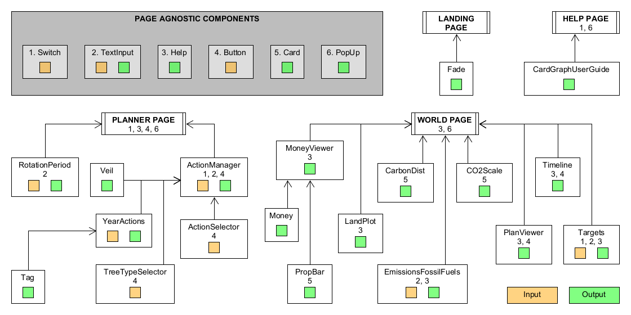

Figure 37. Illustration of how UI components relate to each other. Application pages may be thought of as root components. Page specific components are linked via arrows either directly or indirectly with their parent page. Page agnostic components are displayed within a grey box on the top left corner and are numbered. Is the number corresponding to a page-agnostic component appears within the box representing a page-specific or root component, then this means that the latter incorporates one or more instances of the former. Green boxes in components indicate that this container outputs data. Similarly, an orange box indicates that it accepts input from users.

## Detailed Technical Design

UML Diagram. Algorithms and data structures used.

## Summary

# Implementation

# Testing and Evaluation

## Pilot Testing

## Bridge2College Workshop

## Usability Evaluation

### System Usability Scale (SUS)

### Post-Study Usability Questionnaire (PSSUQ)

### Usability Results

## User and Educator Feedback

### Instruments Used

### Findings

## Summary

# Conclusion

## Recap

## Limitations

## Future Work

## Personal Reflection

# Bibliography

1. *Forests can help us limit climate change – here is how*. 2023, United Nations Development Programme (UNDP).

2. Karsgaard, C. and D. Davidson, *Must we wait for youth to speak out before we listen? International youth perspectives and climate change education.* Educational Review, 2023. **75**(1): p. 74-92.

3. Fouqueray, T., et al., *Interdisciplinary modeling and participatory simulation of forest management to foster adaptation to climate change.* Environmental Modelling &amp; Software, 2022. **151**: p. 105338.

4. Garcia, C. and E. Speelman, *Landscape Approaches, Wicked Problems and Role Playing Games*. 2017.

5. International Institute for Applied Systems Analysis (IIASA), S.S., Centre for Systems Solutions, Games 4 Sustainability, *About That Forest*. 2018.

6. Agency, E.S. *Forest Kids game on biodiversity now available* 2022 [cited 2024 3 July]; Available from: <https://www.esa.int/Education/Forest_Kids_game_on_biodiversity_now_available>.

7. Yoshida, R., et al., *Life-size Board Game “Human SUGOROKU” To Teach Children about Vegetation Succession - Application of Human Sensing Technology to Embodied Education.* CSEDU 2015 - 7th International Conference on Computer Supported Education, Proceedings, 2015. **2**: p. 295-300.

8. Hoyles, C., R. Noss, and R. Adamson, *Rethinking the Microworld Idea.* Journal of Educational Computing Research, 2002. **27**(1): p. 29-53.

9. Rieber, L.P. *Multimedia Learning in Games, Simulations, and Microworlds*. Cambridge Handbook of Multimedia Learning, 2005.

10. Dabholkar, S., *Restructurating Science Learning with Emergent Systems Microworld (ESM)-based Learning Environments*. 2021, Northwestern University: United States -- Illinois. p. 356.

11. Lilian, G.K., *Education for Sustainable Development Pedagogy in Pre-Primary Social Studies Curriculum in Kenya: Review of Literature.* Journal La Edusci, 2022. **3**(3): p. 1-12.

12. Gabric, A.J., *The Climate Change Crisis: A Review of Its Causes and Possible Responses.* Atmosphere, 2023. **14**(7): p. 1081.

13. Kabir, M., et al., *Climate change due to increasing concentration of carbon dioxide and its impacts on environment in 21st century; a mini review.* Journal of King Saud University - Science, 2023. **35**(5): p. 102693.

14. Society, N.G. *Carbon Sources and Sinks*. 2023 [cited 2024 7 July]; Available from: <https://education.nationalgeographic.org/resource/carbon-sources-and-sinks/>.

15. Fergesen, J. *Trees Help Protect the Planet From Climate Change. But The World Isn’t Doing Enough to Protect Forests*. 2022.

16. Andrew Moseman, C.H., Cesar Terrer. *How many new trees would we need to offset our carbon emissions?* 2024 [cited 2024 9 July]; Available from: <https://climate.mit.edu/ask-mit/how-many-new-trees-would-we-need-offset-our-carbon-emissions>.

17. Daigneault, A., et al., *How the future of the global forest sink depends on timber demand, forest management, and carbon policies.* Global Environmental Change, 2022. **76**: p. 102582.

18. Mills, M.B., et al., *Tropical forests post-logging are a persistent net carbon source to the atmosphere.* Proceedings of the National Academy of Sciences, 2023. **120**(3).

19. Rieber, L.P., *Seriously considering play: Designing interactive learning environments based on the blending of microworlds, simulations, and games.* Educational Technology Research and Development, 1996. **44**(2): p. 43-58.

20. Piaget, J., *Play, Dreams And Imitation In Childhood.* 1951.

21. Morado, M.F., A.E. Melo, and A. Jarman, *Learning by making: A framework to revisit practices in a constructionist learning environment.* British Journal of Educational Technology, 2021. **52**(3): p. 1093-1115.

22. Ram Booj, N.I., *Sustainability Education: Setting the Context*, in *Sustainability Education for a Better World*, N.I. Ram Booj, Editor. 2022, Cambridge Scholars. p. 1-30.

23. Belcher, B.K., K., *Can environmental services improve local livelihoods?* Ecosystem Services. 2005: id21 natural resources highlights.

24. Bond, M., et al., *Mapping research in student engagement and educational technology in higher education: a systematic evidence map.* International Journal of Educational Technology in Higher Education, 2020. **17**(1).

25. Mulla, S. and G. Nagarjuna, *EdTech as an Empowering Tool: Designing Digital Learning Environments to Extend the Action Space for Learning and Foster Digital Agency*. 2023, Springer Nature Switzerland. p. 69-74.

26. Hargraves, V. *Dewey’s educational philosophy*. 2021 [cited 2024; Available from: <https://theeducationhub.org.nz/deweys-educational-philosophy/>.

27. Rieber, L.P., *Microworlds*, in *Handbook of research on educational communications and technology, 2nd ed.* 2004, Lawrence Erlbaum Associates Publishers: Mahwah, NJ, US. p. 583-603.

28. Green, D.W., *Understanding Microworlds.* The Quarterly Journal of Experimental Psychology Section A, 2001. **54**(3): p. 879-901.

29. Oikonomidis, A. and C. Iliopoulos. *Web-Based Simulation Systems in Technological Education Implemented as Micro-worlds*. 2010. IEEE.

30. Xiang, L., S. Goodpaster, and A. Mitchell, *Supporting Three-dimensional Learning on Ecosystems Using an Agent-Based Computer Model.* Journal of Science Education and Technology, 2022. **31**(4): p. 473-489.

31. Thakur, A.K., *Model: Mechanistic vs Empirical*, in *New Trends in Pharmacokinetics*, A. Rescigno and A.K. Thakur, Editors. 1991, Springer US: Boston, MA. p. 41-51.

32. Peng, C., *Understanding the role of forest simulation models in sustainable forest management.* Environmental Impact Assessment Review, 2000. **20**(4): p. 481-501.

33. Moon, Y.B., *Simulation modelling for sustainability: a review of the literature.* International Journal of Sustainable Engineering, 2017. **10**(1): p. 2-19.

34. Macal, C.M. and M.J. North. *Tutorial on agent-based modeling and simulation*. in *Proceedings of the Winter Simulation Conference, 2005.* 2005.

35. Zhang, B. and D.L. DeAngelis, *An overview of agent-based models in plant biology and ecology.* Annals of Botany, 2020. **126**(4): p. 539-557.

36. Botkin, D.B., J.F. Janak, and J.R. Wallis, *Some Ecological Consequences of a Computer Model of Forest Growth.* The Journal of Ecology, 1972. **60**(3): p. 849.

37. Gayler, S., et al., *A Dynamical Model of Environmental Effects on Allocation to Carbon-based Secondary Compounds in Juvenile Trees.* Annals of botany, 2008. **101**: p. 1089-98.

38. Opacic, L. and T. Sowlati, *Applications of Discrete-Event Simulation in the Forest Products Sector: A Review.* Forest Products Journal, 2017. **67**(3-4): p. 219-229.

39. Ullrich, O. and D. Lückerath, *An Introduction to Discrete-Event Modeling and Simulation.* SNE Simulation Notes Europe, 2017. **27**(1): p. 9-16.

40. Ingalls, R.G. *Introduction to simulation*. 2011. IEEE.

41. Westlund, K., L.E. Sundström, and L. Eliasson, *An optimization and discrete event simulation framework for evaluating delivery performance in Swedish wood supply chains under stochastic weather variations.* International Journal of Forest Engineering, 2024. **35**(2): p. 326-337.

42. Da Silva, T.M.P., et al., *Discrete event simulation to build simulators for teaching.* Journal of Simulation, 2014. **8**(4): p. 325-334.

43. Heath, S.K., et al. *Cross-paradigm simulation modeling: Challenges and successes*. 2011. IEEE.

44. Eldabi, T., et al. *HYBRID SIMULATION CHALLENGES AND OPPORTUNITIES: A LIFE-CYCLE APPROACH*. 2018. IEEE.

45. Djanatliev, A. and R. German. *Towards a guide to domain-specific hybrid simulation*. 2015. IEEE.

46. Bischak, D.P. and S.D. Roberts. *Object-oriented simulation*. 1991. IEEE.

47. R. Morelli, R.W., *Java, Java, Java Object-Oriented Problem Solving*. 2017: Trinity College Hartford, CT.

48. Parr, K. *The Four Pillars of Object-Oriented Programming*. 2020 [cited 2024; Available from: <https://www.freecodecamp.org/news/four-pillars-of-object-oriented-programming/>.

49. Baley, A. *What Is The Lifespan Of A Tree: How The Age Of A Tree Is Determined*. 2021 [cited 2024 July]; 15]. Available from: <https://www.gardeningknowhow.com/ornamental/trees/tgen/lifespan-of-a-tree.htm>.

50. Başkent, E.Z. and J. Kašpar, *Exploring the effects of various rotation lengths on the ecosystem services within a multiple-use management framework.* Forest Ecology and Management, 2023. **538**: p. 120974.

51. Hinze-Hoare, V., *The Review and Analysis of Human Computer Interaction (HCI) Principles.* arXiv pre-print server, 2007.

52. Gupta, J., M. Ahuja, and N. Garg. *A Review on Human-Computer Interaction (HCI)*. 2022. IEEE.

53. Nagalingam, V. and R. Ibrahim, *User Experience of Educational Games: A Review of the Elements.* Procedia Computer Science, 2015. **72**: p. 423-433.

54. Jyoti, G.K., *Research Paper on Human Computer Interaction (HCI).* International Journal for Multidisciplinary Research (IJFMR), 2023. **5**(2).

55. Pastel, R. *CS4760, HU4642 & CS5760: Human-Computer Interactions & Usability*. 2016 [cited 2024; Available from: <https://cs4760.csl.mtu.edu/2016/lectures/normans-interaction-theory/>.

56. Majid, A., et al., *Differential coding of perception in the world’s languages.* Proceedings of the National Academy of Sciences of the United States of America, 2018. **115**(45): p. 11369-11376.

57. Riebeek, H. *The Carbon Cycle*. 2011 [cited 2024; Available from: <https://earthobservatory.nasa.gov/features/CarbonCycle>.

58. Williams, D.D.R. *Earth Fact Sheet*. 2024 [cited 2024; Available from: <https://nssdc.gsfc.nasa.gov/planetary/factsheet/earthfact.html>.

59. Sands, D. *Parts Per Million | PPM Definition, Units & Calculation*. 2023 [cited 2024; Available from: <https://study.com/academy/lesson/parts-per-million-definition-calculation-example.html>.

60. Meter, C. *What is CO2 ppm?* 2023 [cited 2024; Available from: <https://www.co2meter.com/blogs/news/co2-ppm>.

61. Davis, U. *What is Carbon Sequestration and How Does it Work?* 2019 [cited 2024; Available from: <https://clear.ucdavis.edu/explainers/what-carbon-sequestration>.

62. Lugt, P.v.d., *Carbon Storage Utilising Timber Products*, in *ENVIRONMENT INDUSTRY MAGAZINE*. 2020. p. 76-80.

63. Scion. *Locking up carbon long-term in timber buildings*. Scion Connections Issue 34 2019 [cited 2024; Available from: <https://www.scionresearch.com/about-us/about-scion/corporate-publications/scion-connections/past-issues-list/scion-connections-issue-34,-december-2019/locking-up-carbon-long-term-in-timber-buildings>.

64. Megha Poudel, B.D. *Greenhouse Carbon Dioxide Supplementation*. 2023 [cited 2024; Available from: <https://extension.okstate.edu/fact-sheets/greenhouse-carbon-dioxide-supplementation.html>.

65. Gov, M. *Greenhouse CO2 Supplement*. [cited 2024; Available from: <https://www.gov.mb.ca/agriculture/crops/crop-management/co2-supplement.html>.

66. Moseman, A. *What is the ideal level of carbon dioxide in the atmosphere for human life?* 2021 [cited 2024; Available from: <https://climate.mit.edu/ask-mit/what-ideal-level-carbon-dioxide-atmosphere-human-life>.

67. Hausfather, Z. *Extreme CO2 levels could trigger clouds ‘tipping point’ and 8C of global warming*. 2019 [cited 2024; Available from: <https://www.carbonbrief.org/extreme-co2-levels-could-trigger-clouds-tipping-point-and-8c-of-global-warming/>.

68. Lüthi, D., et al., *High-resolution carbon dioxide concentration record 650,000–800,000 years before present.* Nature, 2008. **453**(7193): p. 379-382.

69. ecotree. *How much CO2 does a tree absorb?* ; Available from: <https://ecotree.green/en/how-much-co2-does-a-tree-absorb>.

70. Marisa Stone, K.N., Sebastian Seibold, David Lindenmayer. *This unassuming item releases 10.9 billion tonnes of carbon every year.* 2021 [cited 2024; Available from: <https://www.weforum.org/agenda/2021/09/decaying-forest-wood-carbon-climate-change-co2/>.

71. Gastronomicus. Where does the CO2 absorbed by trees end up? 2021; Available from: <https://www.reddit.com/r/askscience/comments/phvr8h/where_does_the_co2_absorbed_by_trees_end_up/>.

72. Wisconsin, U.o. *Facts About Wood*. 2020 [cited 2024; Available from: <https://www3.uwsp.edu/cnr-ap/KEEP/Documents/Activities/Energy%20Fact%20Sheets/FactsAboutWood.pdf>.

73. He, H., et al., *Allometric biomass equations for 12 tree species in coniferous and broadleaved mixed forests, Northeastern China.* PLOS ONE, 2018. **13**(1): p. e0186226.

74. Cassidy, E. *Emissions from Fossil Fuels Continue to Rise*. 2024 [cited 2024; Available from: <https://earthobservatory.nasa.gov/images/152519/emissions-from-fossil-fuels-continue-to-rise>.

75. Forestry, S. *Forestry Facts*. [cited 2024; Available from: <https://swsforestry.ie/why-plant/forestry-facts/>.

76. Department of Agriculture, F.a.t.M.I., *Forest Statistics Ireland 2023*. 2023, Ireland: Department of Agriculture, Food and the Marine Ireland.

77. Thomas H. Everett, G.P.B. *Popular classifications*. 2024 [cited 2024; Available from: <https://www.britannica.com/plant/tree/Popular-classifications>.

78. Eckenwalder, J.E. *conifer*. [cited 2024; Available from: <https://www.britannica.com/plant/conifer>.

79. Moran, N., *Tree Guide*. 2023, dlr Comhairle Contae County Council.

80. Biondi, F., D.M. Meko, and G. Piovesan, *Maximum tree lifespans derived from public-domain dendrochronological data.* iScience, 2023. **26**(3): p. 106138.

81. Matmatch. *Density of wood in kg/m3, g/cm3, lb/ft3 – the ultimate guide*. [cited 2024; Available from: <https://matmatch.com/learn/property/density-of-wood>.

82. Greenmax. *The Impressive Power of Conifers for the Climate*. [cited 2024; Available from: <https://greenmax.eu/en/the-impressive-power-of-conifers-for-the-climate/>.

83. Wall, S.B.V., *MASTING IN ANIMAL-DISPERSED PINES FACILITATES SEED DISPERSAL.* ECOLOGY, 2002. **83**(12): p. 3243-3532.

84. Wikipedia. *Conifer*. [cited 2024; Available from: <https://en.wikipedia.org/wiki/Conifer>.

85. Services, T.T. *Education: Reclamation: Seedling Characteristics*. [cited 2024; Available from: <https://treetimeservices.ca/education/reclamation/seedling-characteristics>.

86. Pedersen, B.S., *Modeling tree mortality in response to short- and long-term environmental stresses.* Ecological Modelling, 1998. **105**(2): p. 347-351.

87. Whyte, G., et al., *The Tree Decline Recovery Seesaw; a conceptual model of the decline and recovery of drought stressed plantation trees.* Forest Ecology and Management, 2016. **370**: p. 102-113.

88. Hülsmann, L., et al., *How to kill a tree: empirical mortality models for 18 species and their performance in a dynamic forest model.* Ecological Applications, 2018. **28**(2): p. 522-540.

89. Das, A.J., N.L. Stephenson, and K.P. Davis, *Why do trees die? Characterizing the drivers of background tree mortality.* Ecology, 2016. **97**(10): p. 2616-2627.

90. Brockerhoff, E.G., et al., *Forest biodiversity, ecosystem functioning and the provision of ecosystem services.* Biodiversity and Conservation, 2017. **26**(13): p. 3005-3035.

91. Chen, X. and D.G. Brockway, *Height-diameter Relationships in Longleaf Pine and Four Swamp Tree Species.* Journal of Plant Studies, 2017. **6**(2): p. 94.

92. Scotland, F.A.L. *Biodiversity and you* 2020 [cited 2024; Available from: <https://forestryandland.gov.scot/blog/biodiversity-and-you>.

93. I. Thompson, B.M., S. McNulty, A. Mosseler, *Forest Resilience, Biodiversity, and Climate Change: a synthesis of the biodiversity/resilience/stability relationship in forest ecosystems.* . 2009, Secretariat of the Convention on Biological Diversity: Montreal. p. 1-67.

94. Wang, X., et al., *The biodiversity benefit of native forests and mixed‐species plantations over monoculture plantations.* Diversity and Distributions, 2019. **25**(11): p. 1721-1735.

95. Hertzog, L.R., et al., *Mixing of tree species is especially beneficial for biodiversity in fragmented landscapes, without compromising forest functioning.* Journal of Applied Ecology, 2021. **58**(12): p. 2903-2913.

96. Kuuluvainen, T., et al., *Tree age distributions in old-growth forest sites in Vienansalo wilderness, eastern Fennoscandia.* Silva Fennica, 2002. **36**(1).

97. studocu. *ROTATION*. 2023 [cited 2024; Available from: <https://www.studocu.com/in/document/sam-higginbottom-university-of-agriculture-technology-and-sciences/agroforestry-management/rotation/27330074>.

98. Press, L.A. *Buying Wood by the Pound*. 2021 [cited 2024; Available from: <https://blog.lostartpress.com/2021/03/21/buying-wood-by-the-pound/>.

99. Services, G. *Factors Influencing Tree Removal Costs*. [cited 2024; Available from: <https://www.grasshopperservices.ie/tree-removal-cost/>.

100. Nita, A. *How Much Does it Cost to Plant a Tree in 2024?* 2023; Available from: <https://lawnlove.com/blog/cost-to-plant-tree/>.

101. Miina, J., et al., *Promoting wild mushroom yields by forest management*. 2016.

102. Flanagan, D. *Bee Keeping and Honey Production*. 2017 [cited 2024; Available from: <https://www.teagasc.ie/rural-economy/rural-development/diversification/bee-keeping-and-honey-production/>.

103. Visick, O.D. and F.L.W. Ratnieks, *Density of wild honey bee, <i>Apis mellifera</i>, colonies worldwide.* Ecology and Evolution, 2023. **13**(10).

104. Riedl, M., et al., *Analysis of Significant Factors Influencing the Amount of Collected Forest Berries in the Czech Republic.* Forests, 2020. **11**(10): p. 1114.

105. Forest, H.o.E. *5 fungi to spot in the Forest*. 2020 [cited 2024; Available from: <https://heartofenglandforest.org/news/5-fungi-spot-forest>.

106. Mushrooms, B.M. *Wild Irish Mushrooms*. 2024 [cited 2024; Available from: <https://ballyhouramushrooms.ie/store/Wild-Irish-Mushrooms-c87664037>.

107. Pick, P.W. *Wild Berries*. 2024 [cited 2024; Available from: <https://pacificwildpick.com/collections/berries>.

108. Killester, D.H. *Pure Irish Honey*. 2024 [cited 2024; Available from: <https://dublinhoneykillester.ie/product/pure-irish-honey-killester/>.

109. Liu, V. How long does it take a person to walk an acre? 2021; Available from: <https://www.quora.com/How-long-does-it-take-a-person-to-walk-an-acre>.

110. Expert, S. *Forest Worker Avg. Salary*. 2024 [cited 2024; Available from: <https://www.salaryexpert.com/salary/job/forest-worker/ireland>.

111. Department of Agriculture, F.a.t.M.I., *Forest Statistics 2022*. 2022, Department of Agriculture, Food and the Marine Ireland.

112. Avondale, B.T.T. *Tickets & Prices*. 2024 [cited 2024; Available from: <https://www.beyondthetreesavondale.com/plan-your-visit/tickets-prices/>.

113. Park, L.K.F.A.A. *Admission Charges 2023*. 2023 [cited 2024; Available from: <https://loughkey.ie/admission-prices/>.

114. PARK, A. *Zipit Farran Park*. 2024 [cited 2024; Available from: <https://zipit.ie/locations/farran-park/park-info/>.

115. Park, L.K.F.A.A. *Boda Borg*. 2024 [cited 2024; Available from: <https://loughkey.ie/activities/boda-borg/>.

116. Club, T.F. *Birth Day Parties*. 2024; Available from: <https://www.theforestclub.ie/childrens-birthday-parties>.

117. Murphy, W., *Forest Recreation in a Commercial Environmen*. CONFORD Ireland.

118. Coillte. *FORESTRY*. [cited 2024; Available from: <https://www.coillte.ie/our-business/our-divisions/forestry/>.

119. Wikipedia. *Coillte*. [cited 2024; Available from: <https://en.wikipedia.org/wiki/Coillte>.

# Appendices

## Survey Instruments Used

## Use of GenAI in this Work