MycroForest Help Page

# TARGET

You may set yourself a target as part of challenges. The TARGET panel displays this as follows.

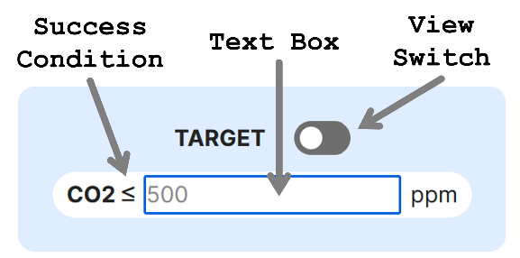

You may type into the TEXTBOX, the CO2 concentration below which atmospheric CO2 levels must never dip.

The VIEW switch can be toggled on and off. When on, the target panel displays whether the target is being currently met or not.

If the success condition is satisfied, then a green border indicates this. If the target could not be met, then a red border shows this. The point in time at which the target first failed, is also indicated (notation Y2, Y3 and so on, means Year 2, Year 3, etc.).

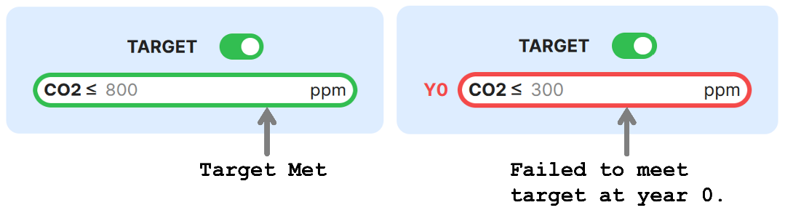

Similarly, a target income value can also be set. This is the minimum income you're looking to earn every rotation.

If you fail to meet this target, the rotation at which this failure first occurred is displayed beside the target field using the notation of letter R followed by the rotation number.

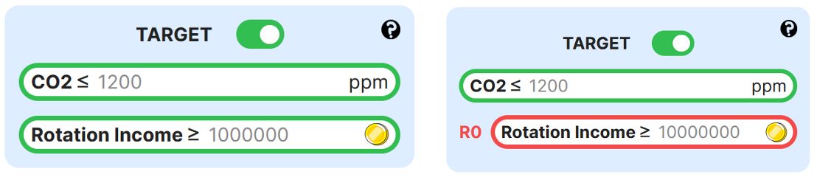

# CO2