MycroForest Quick Help

# TARGET

You may set yourself a target as part of challenges. The TARGET panel displays this as follows.

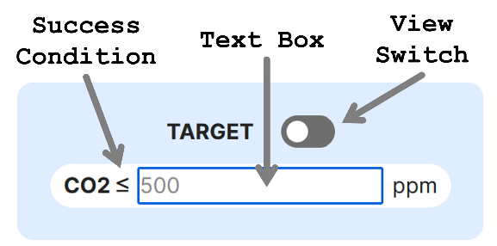

You may type into the TEXTBOX, the CO2 concentration below which atmospheric CO2 levels must never dip.

The VIEW switch can be toggled on and off. When on, the target panel displays whether the target is being currently met or not.

If the success condition is satisfied, then a green border indicates this. If the target could not be met, then a red border shows this. The point in time at which the target first failed, is also indicated (notation Y2, Y3 and so on, means Year 2, Year 3, etc.).

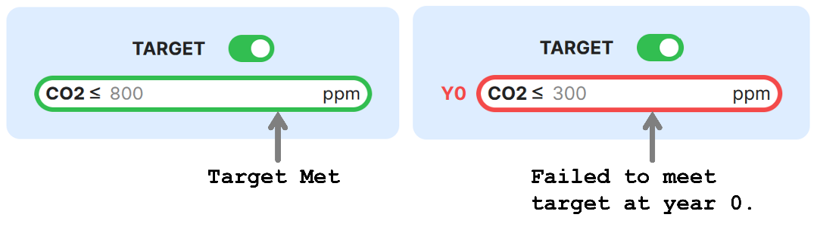

Similarly, a target income value can also be set. This is the minimum income you're looking to earn every rotation.

If you fail to meet this target, the rotation at which this failure first occurred is displayed beside the target field using the notation of letter R followed by the rotation number.

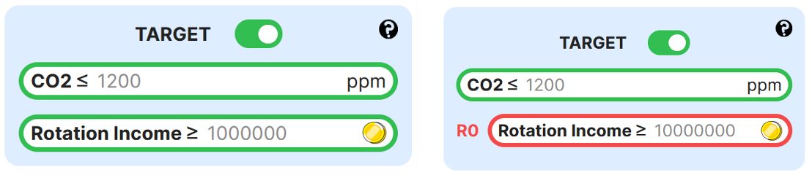

# CO2

Natural processes like respiration and anthropogenic (human generated) ones like burning of wood or fossil fuels, and so on, release carbon into the atmosphere in gaseous form, of which a large part is CO2. CO2 is a greenhouse gas that traps heat within the atmosphere and keeps the planet toasty. Mars has too little CO2. Venus has too much. On Earth, it's just right. Mars and Venus are both thought to have started out much like earth with similar conditions.

Atmospheric CO2 concentration is expressed in Parts Per Million (ppm). This is the standard. It is a measure of the concentration of a substance in a solution or gas. It is a proportion, just like percent. 80 percent is 80 parts out of 100. 80 ppm is 80 parts out of 1,000,000. Here, this indicates the number of parts of CO2 per 1 million parts of the total air in the atmosphere.

CO2 concentration in the microworld has been organized into an easy-to-read scale as shown below. Associated with each band in the scale, is a label that is indicative of the expected quality of life for humans at that level of atmospheric CO2 concentration after considering climate change related effects.



Current levels of CO2 at each point in the simulation is displayed in the ATMOSPHERIC CO2 CONCENTRATION panel as shown below. The number within a colored tile is the current concentration. Hovering over each tile, reveals its range and quality of life label.

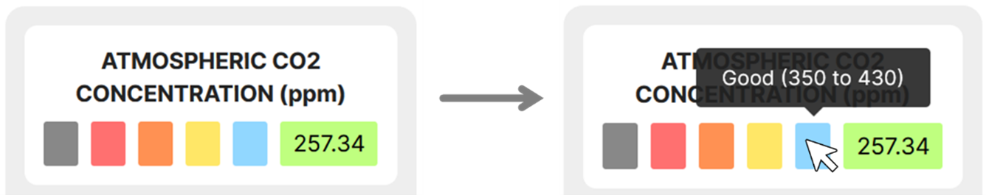

# FOSSIL FUEL EMISSIONS

In 2023, 36.8 GtCO2 which is about 10 GtC was released into the atmosphere due to fossil fuel usage.

By, default, annual emissions due to fossil fuel use is set to 0 GtC. This can be increased by typing a value into the textbox as shown below.

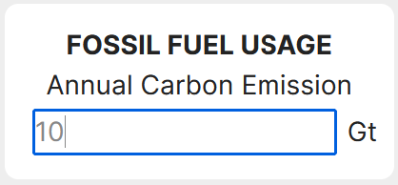

# COINS

Coins are the currency of this microworld. The COIN PANEL displays your bank balance, income, and expenses.

BANK BALANCE is the total amount of coins that you have at any given point in the simulation.

INCOME refers to no. of coins you have earned. Overall income is how much you've earned so far in the simulation, yearly income is how much you've earned this year alone, and rotation income is how much you have earned in this rotation alone.

EXPENSES refer to how much you have spent overall, this year, and this rotation. Felling/planting a tree costs coins that comprise this expenditure.

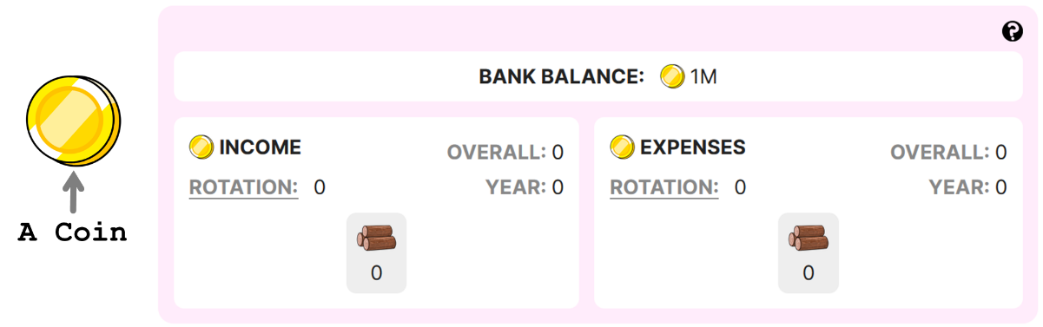

By default, it is income/expense per rotation that is visible below the icon representing type of income stream. You may click on 'OVERALL', 'YEAR' or 'ROTATION' to update this. Hover over the icon to view the name of the income stream.

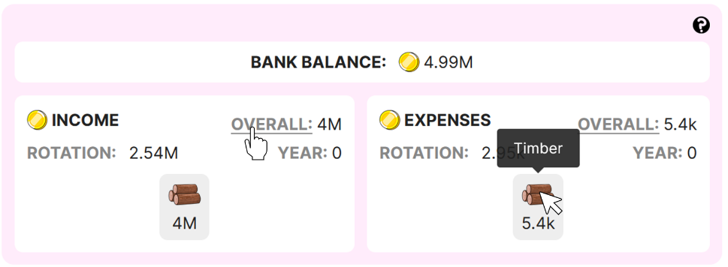

When there are multiple sources of income, a breakup of income and expenses per stream is displayed using a color coded proportion bar. Hover over each color to view the income stream and its contribution.

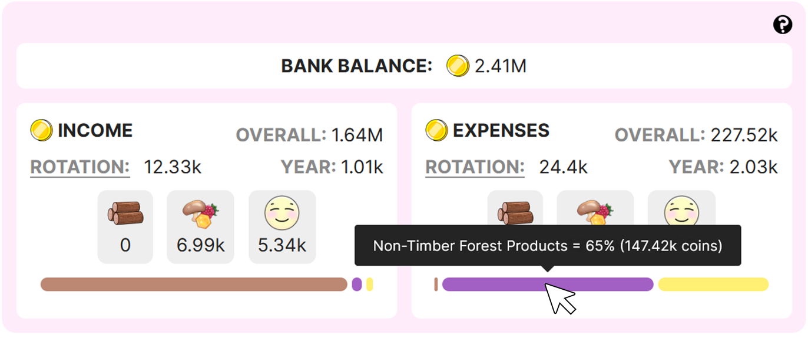

# MANAGEMENT ACTION PLANNER

The management action planner enables you to craft forest management plans.

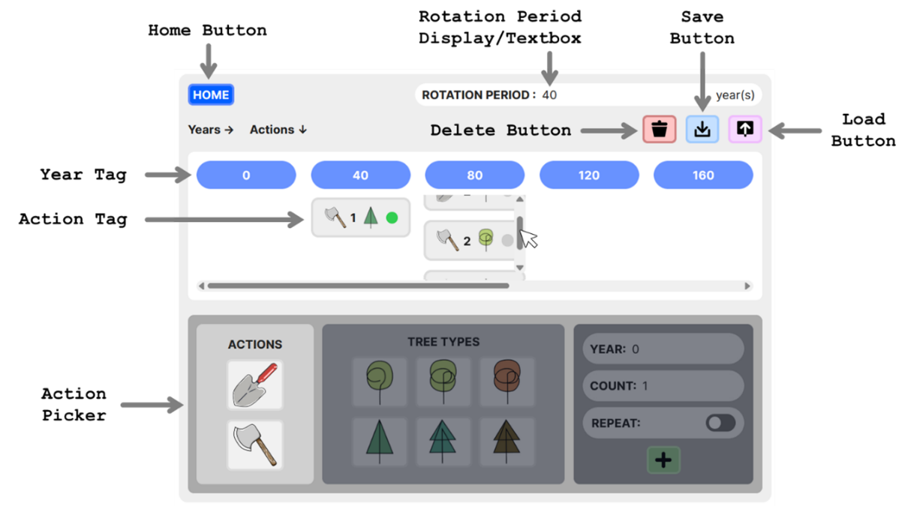

The BACK BUTTON can be clicked to return to the world page.

Rotation period can be set by changing the value within the ROTATION PERIOD TEXT BOX. Invalid entries (integers ≤ 0, integers ≥ max no. of simulated years = 300, negative numbers, floating point numbers, input containing characters other than numbers) is highlighted in red and will not lead to an update of the rotation period value.

The blue year tags represent years at the beginning of each rotation as per set rotation period. This view frame is also horizontally scrollable. ACTION TAGS associated with actions added using the ACTION PICKER will appear under their corresponding year tags. These action tags under each year tag are vertically scrollable in case of view frame overflow.

Clicking an action tag, selects it. Clicking a selected action tag, deselects it. Multiple tags may be selected at once. Selected actions may then be deleted by clicking the DELETE BUTTON. Double clicking the DELETE BUTTON deletes all planned actions.

Clicking the SAVE BUTTON saves the current state of microworld along with the latest plan and other settings.

The UPLOAD BUTTON can be used to load previously saved states.

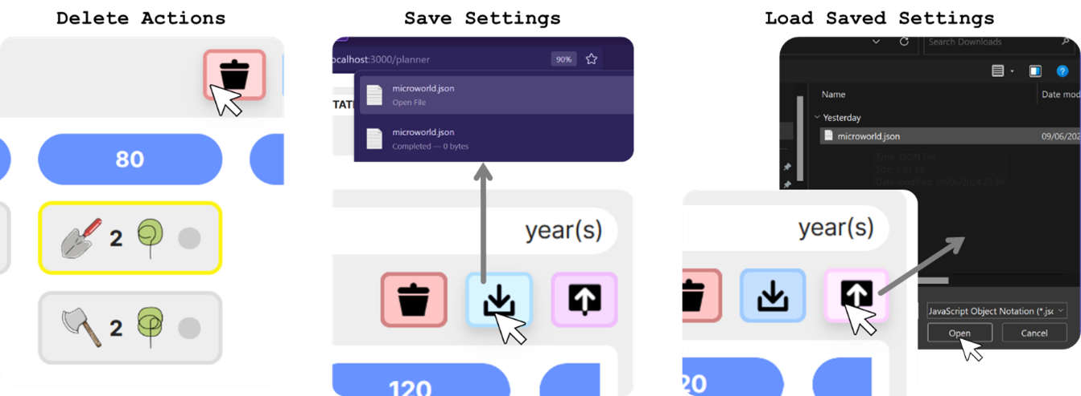

If you choose to add an action for a year that falls within a rotation and not at the beginning of one, then such years appear in red to indicate this.

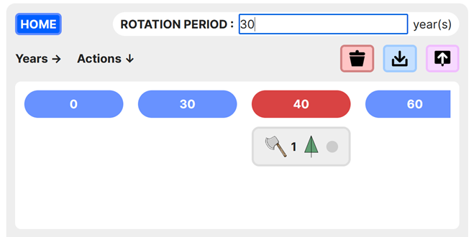

An action tag displays information about the corresponding action and its execution status. If an action was successfully executed for all no. of the specified type of tree, then execution status is green. If it was only possible to execute this action for a fraction of the originally specified no of trees, then the status is yellow indicating that this action was executed for how many ever trees as was available on land at the time, although that was lesser than the specified count. A red status indicates that the action could not be executed at all (perhaps because there was no instance of the given tree type and age on land).

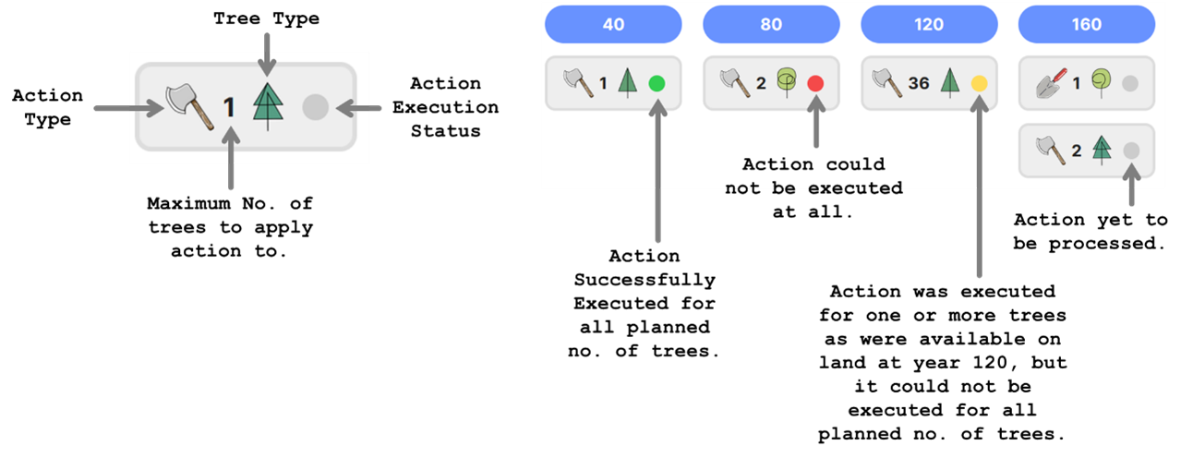

It's the action picker that facilitates the addition of a new action to the plan.

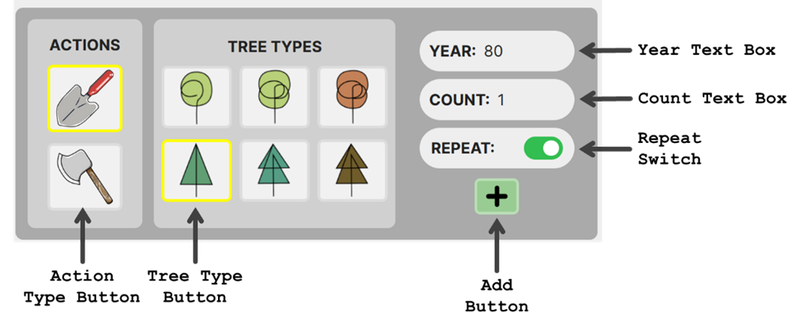

To add a new action, first, the type of action must be selected. Then, the tree to apply that action to, must be selected. Finally, the maximum no. of trees to be affected as well as the year this action should be executed in, should be set using the text boxes.

If invalid numbers are entered into these text boxes, then the change is not applied and the text turns red.

If the REPEAT option is turned on, then this means that the picked action will be performed every rotation starting from the year associated with the picked action.

Once happy with the settings, clicking the ADD BUTTON adds a new action tag to the plan.

There are more ways of earning from a forest other than the TIMBER INCOME STREAM.

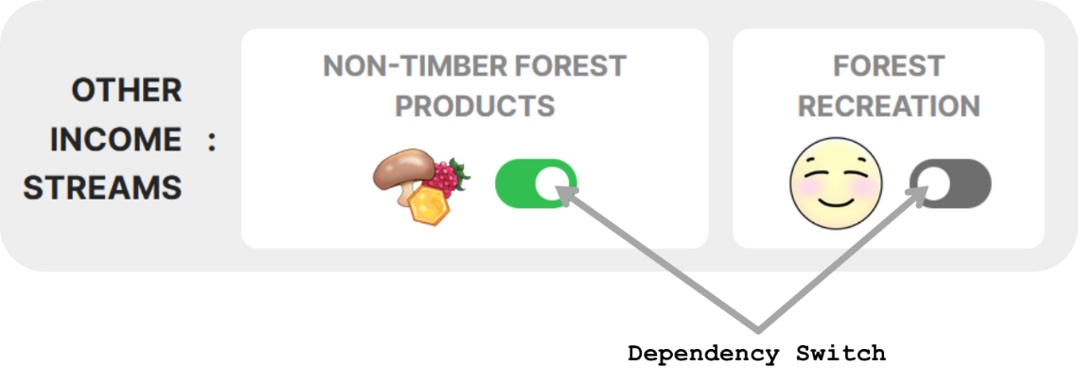

You may harvest and sell other resources found in the forest like honey, mushrooms, and berries. Around 14 kgs of such produce may be available per year, but it may be a bit more or less. This is the NON-TIMBER FOREST PRODUCTS income stream. It is less reliable than the timber income stream. Each kg of produce sells for 170 coins. Maintaining this income stream costs 1620 coins per year to pay workers for harvesting. Switch on the corresponding dependency switch to consider this income stream.

Another option is to open the forest up for public recreational use. You can earn around 465 coins per year this way. However, this too can vary a little depending on no. of visitors and hence is less reliable than timber. This is the FOREST RECREATION income stream. It requires both an initial one-time investment of 40024 coins to establish necessary infrastructure and a yearly maintenance payment of 413 coins in employee wages to sustain it. Switch on the corresponding dependency switch to consider this income stream. In the real world, it may be possible for a portion, or all of the initial investment cost to be paid for using a government grant or other aid money.