Forests as Carbon Sinks

Teaching Tool

Contents

Overview 1

Introduction 2

World Mechanics 3

Aging 3

Demand 3

Biodiversity 4

Growth 4

Stress 5

Reproduction 6

Basic Needs 6

Carbon Capture 6

Interaction Mechanics 6

Actions 6

Plan Drafting 7

Passage of Time 7

Bibliography 7

***Note:*** *Numbers in this document are arbitrarily set and are open to future tweaks. Portions in red mark desirable features that could not be included into the simulation mechanics as of yet.*

# Overview

This teaching tool educates through an interactive session, about managing forests to act as carbon sinks.

Users shall take on the role of a private forest owner who can make management decisions that influence the resources they can supply from the forest and the amount of carbon it is able to sequester.

The goal of the simulation is to encourage realization of the following.

1. **Retaining old growth forests** is the best way to sequester carbon. The best management plan is no management for the most part with limited human interference except in the form of disaster mitigation in case of severe calamities.
2. Funding ecosystem restoration whilst ensuring minimum carbon footprint is challenging. **Intermittent timber plantations to fund for restoration** is a likely best solution.
3. Despite best efforts, the only way to significantly increase carbon sequestration is to **reduce resource consumption** in addition to ecosystem restoration efforts.

# Introduction

This section introduces how a user progresses through the simulation and learning objectives of this tool.

Initially, the user is presented with a mixed forests scenario where 1 big plot of land is divided into 4 quadrants (2 understocked subplots, 1 plantation and 1 ecosystem). This tries to capture how the world today is a mix of intact and non-intact forests with a small percent of the land being a thriving ecosystem.

The world has a set starting atmospheric carbon level, trees on the plot, and monetary capital (available to the user). Carbon levels (atmospheric and sequestered) shall be kept track of, along with biodiversity and tree count and properties throughout the simulation.

Following are a list of key props that comprise this world.

* **Tree:** Trees maybe coniferous or deciduous. These are the 2 kinds of trees that users work with in this world. Both share many parameters but also have unique features as shall be discussed in following sections.
* **Demand:** Demand refers to demand for resources measured in m3.
* A black background with a black square

  Description automatically generated with medium confidence**Barcon:** Barcon is the currency used in this simulation.
* **Plan:** Users may draft plans that can be set up to repeat after a set interval of time (called a rotation). These plans are how users define their management strategies that they can then see playing out across time.
* **Timeline and related controls:** The timeframe within which Users explore their various options is set to be 100 years. The interface shall feature a timeline that can be scrubbed to explore specific points in time and play/pause buttons enable Users to view consequences of their decisions unfold before them in a video like fashion.
* **Land:** The land is divided into subplots and then further into positions on a grid. Each grid spot can support a single living tree. Users may select 1 or more grid spots and chose to perform an action at that position.

The simulation progresses in **3 levels**.

**Level 1:** The objective for this level is to make as much profit as possible at the end of 100 years without getting broke in between. Learning outcomes include discovering that such an approach with no concerns regarding the carbon footprint can result in catastrophic carbon levels in the atmosphere. Also, this level serves as a way for users to get comfortable with the interface.

**Level 2:** The objective for this level is to draft a plan that, at the end of 100 years, reduces as much carbon from the atmosphere as possible without getting broke. This is tricky. The learning objective for this task is to realise how this may not be as straight forward as it initially seems (just planting as many trees as possible will not work as this is not economically practical). As they attempt this level, users may stumble upon existing forest management strategies like reforestation, afforestation, proforestation and young forest initiative to eventually arrive at best possible solutions like intermittent plantations to fund ecosystem restoration (a most practical and likely the optimal strategy).

**Level 3:** So far, the user has never been able to control demand. Now, they can increase or more logically, decrease demand for resources in addition to creating policies to improve sustainable carbon capture. The learning outcome here is for users to realize that even with the best forest management strategy to combat climate change, significant change is only possible when we reduce our resource consumption to meet nature in the middle and ensure the survival of our species and the planet as we know it.

# World Mechanics

This section discusses how various processes within the system work.

## Aging

As previously mentioned, there are 2 possible trees for a user to interact with. A coniferous tree and a deciduous one.

Both trees have an age property that stores the no. of years they’ve been alive for. The following table defines the life stages of each kind of tree.

In the simulated world, the maximum life expectancy of a conifer tree is 100 years while that of a deciduous tree is slightly lower at 80 years. *{On average conifer trees are more long lived than deciduous ones.}*

|  |  |  |  |  |  |  |
| --- | --- | --- | --- | --- | --- | --- |
| Stage – In increasing order of maturity. | Conifer – Inclusive Age Range | Conifer – Years spent in this stage. | Conifer – Age at the end of this stage. | Deciduous – Inclusive Age Range | Deciduous – Years spent in this stage. | Deciduous – Age at the end of this stage. |
| Seedling | [0 – 3] | 3 | 4 | [0 – 2] | 2 | 3 |
| Sapling | [4 – 25] | 22 | 26 | [3 – 20] | 18 | 21 |
| Mature | [26 – 59] | 34 | 60 | [21 – 46] | 26 | 47 |
| Old Growth | [60 – 89] | 30 | 90 | [47 – 69] | 23 | 70 |
| Senescent | [90 – 99] | 5 – 10 | 95 – 100 | [70 – 79] | 5 – 10 | 75 – 80 |
| Dead | Until Decay | Until Decay | 90 + rand[5, 10] | Until Decay | Until Decay | 70 + rand[5, 10] |

***Note:*** *rand => random.*

Trees reproduce only in the mature and old growth stages. They may be felled for timber any time after they’ve reached the mature stage. *{Trees are felled only after their timber reaches a specific quality and volume.}*

Decay rate of wood of coniferous trees is 10 m3/year and that of deciduous ones are 20 m3 per year. *{Deciduous tree wood is hardier than conifer wood.}* At the end of decay, 40% of the carbon re-enters the atmosphere and 60% gets sequestered into the soil enriching it.

## Timber Demand

Demand expressed as weight in kg. A change percent per decade may be set.

Increase in demand leads to greater returns from resource sales.

Unmet demands add carbon to the atmosphere. *{Unmet demand for wood products is met by more energy demanding materials.}* This property is what shall encourage users to reduce resource consumption (a.k.a. “demand” in this simulation).

Use for demanded timber is categorized into 2 groups being Lumber or Energy such that of demand contributes towards Lumber and of it contributes towards energy. This percent can be set, but neither Lumber nor Energy timber % can be set to < 20% of total demand.

## Biodiversity

Biodiversity is a property linked to each quadrant of the land such that their sum captures biodiversity of the entire plot of land.

Biodiversity at every position depends on the following.

* Number and type of trees. *{Mixed forests with more trees harbour greater biodiversity.}*
  + If for each coniferous tree, there exists 1 deciduous tree, then biodiversity += 3 for each such tree pair.
  + If for each coniferous tree, there exists 1 coniferous tree and no deciduous trees or if for each deciduous tree, there exists 1 deciduous tree and no coniferous tree, then for each such pair, biodiversity += 2.
  + If there is just 1 coniferous or deciduous tree, then biodiversity += 1.
  + If there are no trees, then biodiversity += 0.
* Age of trees. *{Older forests contain more biodiversity.}*
  + Compute histogram of trees at various life stages and add to biodiversity, a value = .
* Human activity. *{Human interference, irrespective of whether for better/worse in the long run, immediately leads to a loss in biodiversity due to disturbance to the ecosystem.}*
  + User action of felling reduces biodiversity by 10 per tree.
  + Other user actions reduce biodiversity by 5 per tree.
* Based on increasing levels of biodiversity, land may be classified as unforested, plantation, forest, or ecosystem.

## Growth

Trees have the following properties that are both expressed as a %.

* Stress (stress = 1.0 => death).
* Maximum growth rate per year.
* Maximum height = 82 feet for a coniferous tree and 65 feet for a deciduous tree respectively.

*{Conifer trees are on average taller than deciduous ones.}*

* Maximum diameter = rand[12, 24]/rand[8,16] inches for a conifer/deciduous tree respectively.

*{Conifer trees on average have larger trunk diameters than deciduous ones.}*

Biodiversity (BD) classes imply certain levels of stress reduction w.r.t growth rate as follows.

* Unforested = 0 reduction.
* Plantation = 0.01 reduction.
* Forest = 0.1 reduction.
* Ecosystem = 0.3 reduction.

Growth rate may be calculated as follows. *{Growth rate per year varies based on stress that the tree is under and the biodiversity of the environment that can reduce this stress through provision of nutrients.}*

A conifer tree grows by units in diameter and units in height each year until it reaches maximum height and diameter after which further increase in volume does not occur. *{A height to diameter ratio of 10:1 assumed here.}*

A deciduous tree grows by units in diameter and units in height each year until it reaches maximum height and diameter after which further increase in volume does not occur. *{A height to diameter ratio of 5:1 assumed here.}*

## Stress

Time, living conditions, disasters and logging are the main stressors of the tree.

1. Time

* After reaching the senescence stage, stress increases by 0.01 every year. *{When closer to death, health declines slowly.}*
* Seedlings have a narrower ideal range for basic needs. This captures how they are more vulnerable to environmental stressors.

1. Basic Needs

* Basic needs include water, temperature, and CO2. Perhaps soil-nutrients.
* Each need has an associated function that captures the requirement that the corresponding tree has for that basic need. Each tree thus, has a function that given availability of a resource outputs the stress [0, 1] that the tree is under w.r.t that resource. *{Plants have tolerance for environmental stresses.}*
* ***Water Requirement:***Water requirement is directly proportional to the volume of the tree. Deciduous trees require more water (they lose more water through transpiration via their broad leaves) than coniferous ones. Too little water is very stressful and too much water is also stressful.
* ***Temperature Requirement:*** Coniferous trees are more tolerant to lower temperatures than deciduous trees. Both too low and too high of a temperature is stressful.
* ***CO2 Requirement:***The more the CO2 in the atmosphere, the less the stress. This relationship is introduced in this model to capture how in the real world, when there is more CO2 in the atmosphere, there is more growth.

1. Logging

* Logging implies chopping down of a tree and this immediately causes stress to equal 1.0 (maximum since range = [0, 1.0]) meaning that the tree has died.

## Reproduction

If there is free space adjacent to the tree & the tree is mature & then the tree reproduces resulting in a new seedling at an adjacent empty grid spot.

Trees may reproduce just once every 20 years.

## Environmental Conditions

Availability of water, value of temperature and amount of CO2 in the atmosphere can be set by admin users through a climatogram like plot referred to here as an ***environment-gram*** that captures change in values across months of the year.

Example climatograms are given below.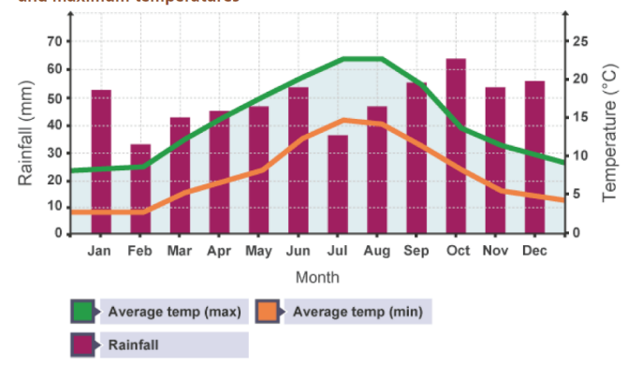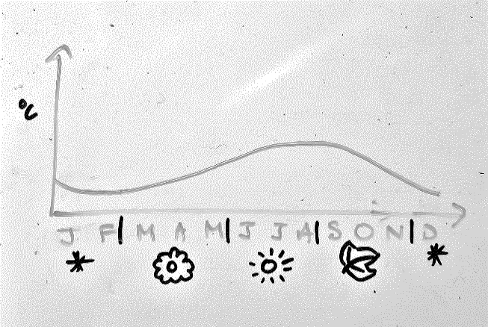

With seasons.

(Hensbergen & Cedergren, 2023)

Annual stress regarding basic needs is thus computed as the sum of stress induced by season average value of the basic need.

Environmentograms (line graphs) may be edited by admin users to simulate extreme scenarios or set a scenario of choice.

## Carbon Capture

In the simulated world, coniferous trees have a weight of 300 kg/m3 while deciduous ones have a weight of 400 kg/m3. *{Wood of deciduous trees are often denser than that of coniferous trees.}*

A coniferous tree removes kilograms of carbon from the environment where is volume and is growth rate. Similarly, a deciduous tree removes . *{It’s assumed here that a tree removes roughly half its volume’s worth of carbon from the environment whilst being influenced by other factors like growth rate.}*

If a tree dies naturally, then it remains in the environment and decays (reduces in volume) over time at a constant rate of 1%. At each time step, off all the carbon stored in this 1% of decayed tree 70% returns to the atmosphere while 30% remains in the soil.

If timber is sourced for lumber, then only 10% of the carbon in it is released into the atmosphere immediately; whereas, if it is sourced for energy, then 100% of the carbon in it is released into the atmosphere immediately.

To summarize,

*Carbon gets released into the atmosphere in the following ways.*

* When a tree dies naturally, a portion of the carbon it absorbed is released over time.
* When a tree is felled for timber used as lumber, 10% of the carbon absorbed by the tree is released immediately.
* When a tree is felled for timber used to meet energy requirements, 100% of the carbon absorbed by the tree is released immediately.

*Carbon gets absorbed from the atmosphere in the following ways.*

* At each timestep, each tree that is alive, absorbs carbon equivalent to a portion of their volume.

# Interaction Mechanics

Discussed here, are various actions that a user may perform in the simulation and how this shall impact the world.

## Actions

The user may choose to perform one of the following 3 core actions.

1. Fell (remove) a tree.

* Felling of a tree kills it and removes it from the land. *{Felled timber does not add to deadwood}* It does not enter the “dead” life stage wherein it remains in the land since the implication is that this tree was used to fulfil a human need.
* Carbon equivalent to 0.4 amount of carbon sequestered by the tree is released back into the atmosphere.
* Felling costs 0.8 * volume of tree worth of Barcons.
* User earns current *resource price* * (1 + *demand change*) Barcons per m3 of the felled tree. Resource price starts at 1 Barcon.

1. Plant (add) a tree.

* Tree maybe planted as a seedling or sapling.
* Planting costs volume of seedling/sapling worth of Barcons.

## Plan Drafting

Users may edit or save plans.

Plan rotation period can be set [5, 40] years.

Positions on land where actions are to be applied can be selected.

Against chosen years, actions to be undertaken can be defined using UI buttons. Filters like tree type, maturity, biotic, abiotic can be applied (e.g., cut down only trees in the senescent life stage).

Actions as per plan will be executed whenever the rules of the simulation (financially and logically) allow it.

Policies that lead to personal bests w.r.t the level objective gets saved automatically.

Status of each action comprising the plan (whether it got executed/not) is visible on UI (green = executed, red = not possible to execute) at any point in the timeline.

## Passage of Time

Users may pause or play time (to view result of plan).

Users may move a pointer using the mouse to scrub across the timeline.

Users view and traverse time on the “year”, “season” or “month” scale.

World change computations happen on the “month” scale.

World values such as carbon in the atmosphere and sequestered as well as available money etc, changes as time passes in the simulated world.

# Bibliography

Hensbergen, H. v., & Cedergren, K. S. (2023). *A guide to multiple-use forest management planning for small and medium forest enterprises.* United Nations. Rome: Food and Agriculture Organization (FAO). Retrieved from https://doi.org/10.4060/cc6780en