**ME459 Default Project: Collision of Triangular Mesh with a collection of Spheres**

**Problem Description**:

For this project you will have to write code that carries out a collision detection step. This is very important in computer games and physics-based simulation.

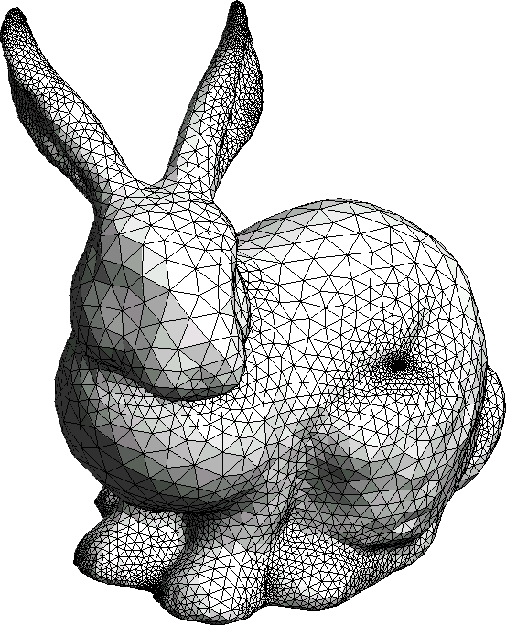

Imagine you have one sphere and you have a mesh, which is simply a collection of triangles. This collection of triangles might come from a meshing of a bunny, for instance (see the figure).

In addition to the mesh, you are given a collection of spheres, all of the same radius. You have to take each sphere and figure out if it touches any triangle of the mesh. You have to check all spheres.

What is given to you:

1. A collection of triangles that together make a mesh
2. A collection of spheres, all of the same radius.

Desired output:

1. A set of sphere-triangle pairs. It is understood that such a pair indicates a contact event; i.e., the sphere in the pair touches the triangle in that pair.

**How we will test your code**:

* We expect your program to read a mesh file called mesh.input that has the following structure:
  + The first line will be a single integer representing the number of triangles.
  + After this first line, every 3 consecutive lines will represent a triangle:
    - Line 1 will have coordinates of node 1 or the triangle in the form x,y,z
    - Line 2 will have coordinates of node 2 or the triangle in the form x,y,z
    - Line 3 will have coordinates of node 3 or the triangle in the form x,y,z
  + This pattern of 3 lines will continue to the end of the file.
* We expect your program to read a file called spheres.input that contains the radius and sphere center information. This file will be a CSV file.
  + The first line will read: x,y,z
  + The second line will contain only the value of the sphere radius
  + The third line will contain a single integer representing the number of spheres
  + All subsequent lines will contain a comma-separated triplet of the x, y, and z coordinates of a sphere.
* We expect that when run your program generate a file called collision_detection.out that has the following format:
  + There should be a single header line reading: s,t
  + All subsequent lines should indicate a single distinct contact pair with a sphere ID and a triangle ID. The IDs should correspond to the order in which the spheres and triangles were read in, ie, the first sphere should have ID 0 and the first triangle should have ID 0.
    - The format of these lines should be: i,j  
      Where i is the ID of the sphere and j is the ID of the triangle
  + Note that none of the lines contain whitespace.
  + We expect your code to indicate how much time (in milliseconds) it took to run the collision detection task. Only measure the time for the collision detection, not the reading in/writing out of data

**Observations**:

* Use your ME459 git repo to store the code under the folder FinalProject
* Use doxygen to document your code
* Use CMake to manage the build process
* We will test your program with meshes that have about 30,000 triangles. We expect to have more than 100,000 spheres that will be tested for collision

**Deliverables**:

* Your code
* A PDF doxygen documentation of your code
* A report commenting on the design of the code
* Discussion of some benchmark tests:
  + How the execution times goes up as the mesh size (number of triangles in the mesh) goes up
  + How the execution times goes up as the number of spheres in the collision detection problem goes up