ISM6106: Systems Analysis

Combined sections RG7, RG9, RXU, RXY -1218

Lab 1 The smart vehicle object model

Graciela E. Gonzalez 6350999 id

I selected for my design a tiny little bear toy that move by itself once the switch is turned on and execute the following operations according the button on his belly is pushed.

1. Walk, forward, backward, turn left , turn right
2. Turn around when an obstacle is reached
3. Dance
4. Sing
5. Flash lights

My Design encompasses the main class named as walkingtoy and the associated classes with corresponding methods and attributes.

This class is related to the classes

1. Switch -composition
2. Wheels-composition
3. Light sensor-composition
4. Sing Sensor-composition
5. Move Sensor-composition
6. Button this class generalize to the 6 buttons the movingtoy has in its belly and that all of them are aggregations for the main class movingtoy.

Attached a photograph of my device and the vpp class diagram from the Visual Paradigm is uploaded to github in a separate image file, for better visibility.

Further the JAVA implementation will be also uploaded as the completion of this assignment.

The way moving toy operates is using a switch that is started from one of the buttons in the belly of the toy that is the

The button START is the one who turn on and off the toy, once turned on all lights flashes and the is the only operated the

Buttonheart that has two methods connect the switch to the different operations modes

Sing, move , stopped

The three sensors that trigger each operation interfaced by different buttons are classes designed and all of them are compositions of the moving toy class, and the switch also is a composition fo the moving toy class, the wheels are also a composition and it has two wheels , cardinality is included in all of these clases in VPP Diagram separated attached.

There a button abstract class that all the 6 buttons inherit and all of them generalize the button class having their own classes that mainly connect to a specific sensor triggering the function that each button performs.

The sensors are moving to move forward , backward , turn tight , turn left and change direction when obstacles found.

Light sensor stop flashes , increase light and decrease light.

Sing sensor stop sing or start sing the toy.

Six buttons belly, flashes lights in the shoes.

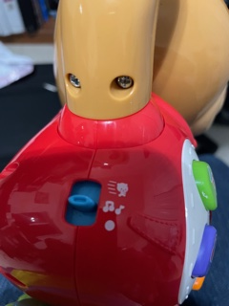Switch

Wheels

moving toy

Once this button is pressed