**Optimizing dam removal for human and environmental water use in the Bear River watershed**

Greg C. Goodrum

*Utah State University, CEE 6410 Final Report - Fall 2020*

*Instructor: Dr. David E. Rosenberg*

**1. Introduction**

Rivers provide the physical, chemical, and biological attributes to support fish and other aquatic organisms. However, humans build dams that alter natural rivers to provide societal benefits such as hydropower, water supply, and flood control that often compete with aquatic ecosystems (Bernhardt et al. 2005). Human hydro-economic needs have driven water management, with widespread consequences including river fragmentation (Nilsson et al. 2005), alteration of streamflow and channel shape (Graf 2006), degrading water quality (Stanley and Doyle 2003), disrupting biogeochemical processes (Friedl and Wüest 2002), reducing biodiversity (Nilsson and Berggren 2000), and homogenizing aquatic ecosystems (Moyle and Mount 2007) only considered after water allocation and dam construction decisions have been made. Removing dams and other instream barriers is increasingly used to restore river habitat and benefit native aquatic species (Stanley and Doyle 2003), but competes with growing human populations for water. Modeling that includes both human and environmental water demands is needed to balance competing objectives and inform water resources decision-making.

Multi-objective optimization models and include and analyze competing objectives, and are increasingly used to balance conflicting hydro-economic and environmental objectives in water resources systems analysis (Kuby et al. 2005; Neeson et al. 2015; Null et al. 2014). Despite the importance of reproducibility and repeatability in model design (Rosenberg et al. 2020), models are often system-specific and rarely transferred and tested in other systems. Testing multi-objective optimization models across systems advances our understanding of reproducibility and repeatability of model formulations and enhances our ability to extend proven methods from research to broader management application.

This paper tests the application of a publicly-available dual-objective barrier removal optimization model developed for Utah’s Weber River watershed (Kraft et al. 2019) to the Bear River watershed. The model maximizes connected aquatic habitat measured using monthly streamflow, stream temperature, and gradient, and minimizes water scarcity using economic penalty functions. Similar to the Weber River, the Bear River watershed has competing water demands between growing human populations and protected Bonneville Cutthroat Trout (*Oncorhynchus clarki utah*). Bear River model input data were developed to match Weber River data, and code was retrieved from a publicly-available GitHub repository (Kraft and Rosenberg 2019). This work has three objectives; (1) test repeatability of the Kraft et al. (2019) dual-objective barrier removal optimization model in the Bear River, (2) identify limitations to model repeatability, and (3) evaluate tradeoffs between dam removal costs, water scarcity costs, and reconnected aquatic habitat in the Bear River watershed. This work expands our understanding of model repeatability for use in management contexts, and provides information to inform dam removal habitat restoration decisions in the Bear River watershed. This report begins with a description of the Bear River watershed and target aquatic species Bonneville Cutthroat Trout, followed by a summary of previous barrier removal optimization models and rationale for the model applied here. Methods includes descriptions of the decision variables, objective function, model constraints, habitat connectivity objective, water scarcity cost objective, and model runs used in this analysis. Results and discussion focus on tradeoffs barrier removal costs, water scarcity costs, and reconnected habitat, and challenges to model repeatability in the Bear River watershed. The paper ends with a discussion of how results compare to previous applications and paths toward improving model repeatability in other systems, and concludes with a summary of the main conclusions and recommendations.

**2. Background**

*2.1 Study area and target species*

The Bear River supports ecological, agricultural, and industrial water demands as it travels across Utah, Wyoming, Idaho, until arriving as the largest tributary to Utah’s Great Salt Lake. The Bear River has undergone extensive alteration to meet human water needs (Figure 1), including extensive development of run-of-river dams to support agricultural irrigation, water supply to cities, and hydropower generation (UDWRe 2004). Agriculture is the dominant water use in the Bear River watershed, and despite conversion of agricultural to urban land uses, agricultural water use has not decreased (UDWRe 2004). Population growth in the Bear River watershed has exceeded projected estimates (UDWRe 2004), and current plans call for further development in the Bear River watershed (UDWRe 2019) to meet anticipated increasing demands for municipal and industrial water.

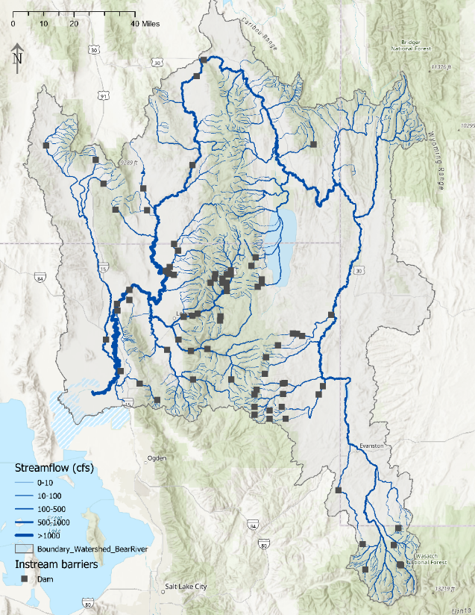

**Figure 1.** Dam locations in the Bear River watershed.

The Bear River watershed is also home to metapopulations of Bonneville Cutthroat Trout (Budy et al. 2014), Utah’s state fish. Bonneville Cutthroat Trout are native salmonids that require clear and cold water, with connected habitat between mainstem rivers where they hold for most of the year and high mountain tributaries with gravel beds where they migrate between March and July to spawn (Carlson and Rahel 2010; Schrank and Rahel 2004). In the Bear River and elsewhere, Bonneville Cutthroat Trout populations have declined or been extirpated due to the combined effects of habitat degradation, competition and hybridization with non-native salmonids, and habitat fragmentation (Budy et al. 2007). Utah, Idaho, and Wyoming manage Bonneville Cutthroat Trout populations under multi-agency conservation agreements to eliminate threats to long-term population survival and avoid listing under the Endangered Species Act (Webber et al. 2012). Restoring connected habitat is considered essential to sustaining and enhancing Bonneville Cutthroat Trout populations in the Bear River.

*2.2 Previous modeling approaches*

Instream barriers alter natural stream conditions (O’Hanley 2011), fragment aquatic habitat (King et al. 2017), and limit the distribution, abundance, and persistence of native freshwater fishes (Bourne et al. 2011). Barriers also provide human benefits such as water storage, hydropower, flood control, and transportation. Optimization models that include both human and ecological objectives can identify paths to protect and restore habitat connectivity while maintaining human water demands (Null et al. 2014).

Previous optimization approaches have included aquatic habitat and economic water supply objectives in optimization models, but often rely on simplistic, ecologically irrelevant habitat models and only consider large dams for removal (Kuby et al. 2005; Neeson et al. 2015; Null et al. 2014). Alafifi and Rosenberg (2020) used hydrologic and vegetative indices to model aquatic habitat suitability for a systems model of the Lower Bear River watershed, but the model was designed to allocate water, financial resources, and revegetation efforts instead of barrier removal. Barrier removal optimization models have been developed, but are often limited by narrow assessment criteria that ignore biological complexity and the assumption of barrier independence that ignores the cumulative effects of spatially interconnected structures (Kemp and O’Hanley 2010). Other barrier removal optimization models include species-specific and high-resolution input data that are difficult to transfer and replicate in different systems (O’Hanley et al. 2013; Zheng and Hobbs 2013).

Kraft et al. (2019) developed a dual-objective optimization model for identifying barrier removals that maximizes aquatic habitat connectivity and minimizes water scarcity. Kraft *et al.*'s approach explicitly included generalized environmental and economic metrics that make it feasible to transfer between systems, species, and formulations. Kraft et al.'s (2019) model formulation also included a specie-specific and ecologically-validated environmental objective, representing a step toward improving representation of environmental objectives in water resources systems optimization modeling. The model was also designed and applied in Utah’s Weber River watershed, which shares similar population growth, water use, and ecosystem characteristics to the Bear River watershed (Kraft et al. 2019). I chose to adapt the Kraft et al. (2019) for this study because it (1) represents a novel approach to generating ecologically meaningful environmental objectives, (2) was explicitly designed to be repeatable and reproducible in different watersheds, and (3) was tested in a watershed that shares target species, management objectives, and structural characteristics with the Bear River watershed.

**3. Methods**

I applied the Weber River stream barrier removal optimization model to the Bear River using the model’s peer-reviewed publication (Kraft et al. 2019), instructions and code available in the model’s publicly-available online repository (Kraft and Rosenberg 2019), and correspondence with the lead author (Maggi Kraft, 2020, personal communication). In this formulation, reaches are the upstream habitat between two barriers. The objective of this study was to repeat the modeling procedure in the Bear River basin to assess whether the model could be repeated and generate information to inform water resources decision-making in the Bear River. In this section, I summarize the model formulation described in Kraft et al. (2019) and describe model runs conducted for this study.

*3.1 Decision variables*

Decision variables include the decision to remove individual barriers and the decision to reconnect habitat between selected barriers (Figure 2). To improve aquatic habitat, managers can make a binary decision to remove barrier *k* from the stream network (*Bk*). Managers can also make the binary decision to reconnect habitat between barriers *i* and *j* by removing intermediary barrier (CR*ij*). In this formulation, the decision to remove individual barriers *Bk* is the base decision variable which controls the decision to reconnect reaches.

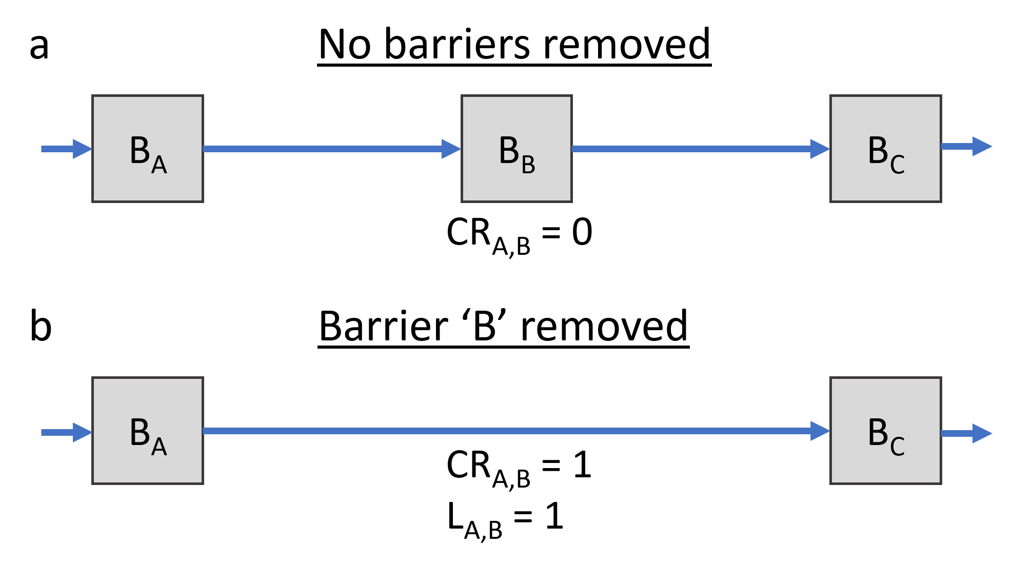

**Figure 2.** Diagram of barrier removal decisions. When no barriers are removed between barriers *A* and *C* (a), *CRi*j = 0. When barrier *B* is removed (b), a reach is created between the upstream barrier *A* and downstream barrier *C* with topological length *LA,B* =1. Figure adapted from Kraft et al. (2019).

*3.2 Objective function*

The dual-objective function maximizes quality-weighted aquatic habitat (km) and minimizes water scarcity costs for urban water uses (US$) and is constrained by a removal budget (US$). The environmental objective (Equation 1) maximizes connected aquatic habitat between barriers *i* and *j*

|  |  |
| --- | --- |
|  | (1) |

where and are the unimpeded stream length above barriers *i* and *j*, is the unitless topological distance between the two barriers, is the binary decision to reconnect habitat between the two barriers, and are unitless passability penalties on barriers where 1 indicates impassable and 0.1 and completely passable. The environmental objective Zhabitat is a unitless proportion ranging between 0 and 1, but is represented in model outputs as reconnected reach length (km) in the optimal solution.

The economic objective (Equation 2) minimizes water scarcity costs resulting when barrier removals limit water deliveries to urban users

|  |  |
| --- | --- |
|  | (2) |

where is the water scarcity cost (US$) from removing barrier *k* and is the binary decision to remove barrier *k* from the stream network. In the dual-objective formulation, the economic objective is normalized between 0 and 1 for compatibility with the environmental objective, but is represented in model outputs as economic loss (US$) in the optimal solution.

The objective functions are combined into a single objective optimization problem (Equation 3) using the weighted sum method by applying weights on each objective which sum to 1.

|  |  |
| --- | --- |
|  | (3) |

The weights represent relative valuation of each objective where 1 indicates high valuation and 0 indicates low valuation.

*3.3 Constraints*

Model constraints represent physical, habitat, and economic bounds that restrict the objective and habitat suitability functions. A reconnected reach is defined as existing only when all barriers between reaches *i* and *j* are removed (Equation 4). The parameter *Inti,j,k* is a binary parameter that indicates barrier *k* occurs between reaches *i* and *j*.

|  |  |
| --- | --- |
|  | (4) |

Barrier removals are binary decisions and may only be fully removed or not removed for all reaches (Equation 5).

|  |  |
| --- | --- |
|  | (5) |

Reconnecting reaches are binary decisions and may only be fully reconnected or not reconnected for all reaches (Equation 6).

|  |  |
| --- | --- |
|  | (6) |

Total cost of all barrier removals must be less than or equal to the barrier removal budget (Equation 7). *TC* is the barrier removal budget (US$).

|  |  |
| --- | --- |
|  | (7) |

*3.4 Environmental objective: Aquatic habitat connectivity*

Monthly discharge, water temperature, and channel gradient are intersected for each stream reach in each month to classify habitat suitability (Equation 8)

|  |  |
| --- | --- |
|  | (8) |

where *Qi* is the monthly percentage of the mean annual discharge (%), *Ti* is the reach-average water temperature (**°**C), and *Gi* is the channel gradient in reach *i*. Each habitat metric is classified as either excellent (1.0), good (0.75), fair (0.25), or poor (0.1), and *Hql* takes the value of the lowest value. The monthly quality-weighted habitat of each reach in a given month is equal to the product of the monthly habitat suitability (*Hqli*) and the longitudinal length (*Li*) in kilometers (Equation 9).

|  |  |
| --- | --- |
|  | (9) |

The environmental objective quantifies habitat connectivity using the Integral Index of Connectivity (IIC), which measures the degree of habitat connectivity at the watershed scale between a value of 0, unconnected, and 1, fully connected (Pascual-Hortal and Saura 2006). The IIC represents a graph network where nodes represent habitat patches (upstream reaches) and barriers represent links between habitat patches. Kraft et al. (2019) applied the IIC to formulate the environmental objective function.

*3.5 Economic objective: Water scarcity costs*

Monthly economic losses resulting from dam removals are estimated using seasonal urban economic loss functions (Null 2018). Economic loss functions estimate prices that water users would be willing to pay when water deliveries are less than demand, representing costs incurred to users. In this formulation, water scarcity costs are calculated as the percent change in water deliveries before and after dam removal (Kraft et al. 2019).

*3.6 Bear River model inputs and runs*

The model was tested on a simplified version of the Bear River including ten large dams and limited to perennial stream reaches (Figure 3). Perennial streams with monthly stream temperature, discharge, and gradient were generated through a previous study of aquatic habitat suitability in Utah streams (Goodrum 2020). Monthly habitat suitability was classified for Bonneville Cutthroat Trout using habitat criteria from Kraft et al. (2019). The ten largest barriers based on dam height were identified using the US Army Corps of Engineers National Inventory of Dams (USACE 2020), and included both storage reservoirs and run-of-river hydroelectric dams. All barriers were assigned passability penalties of 1 (impassible).

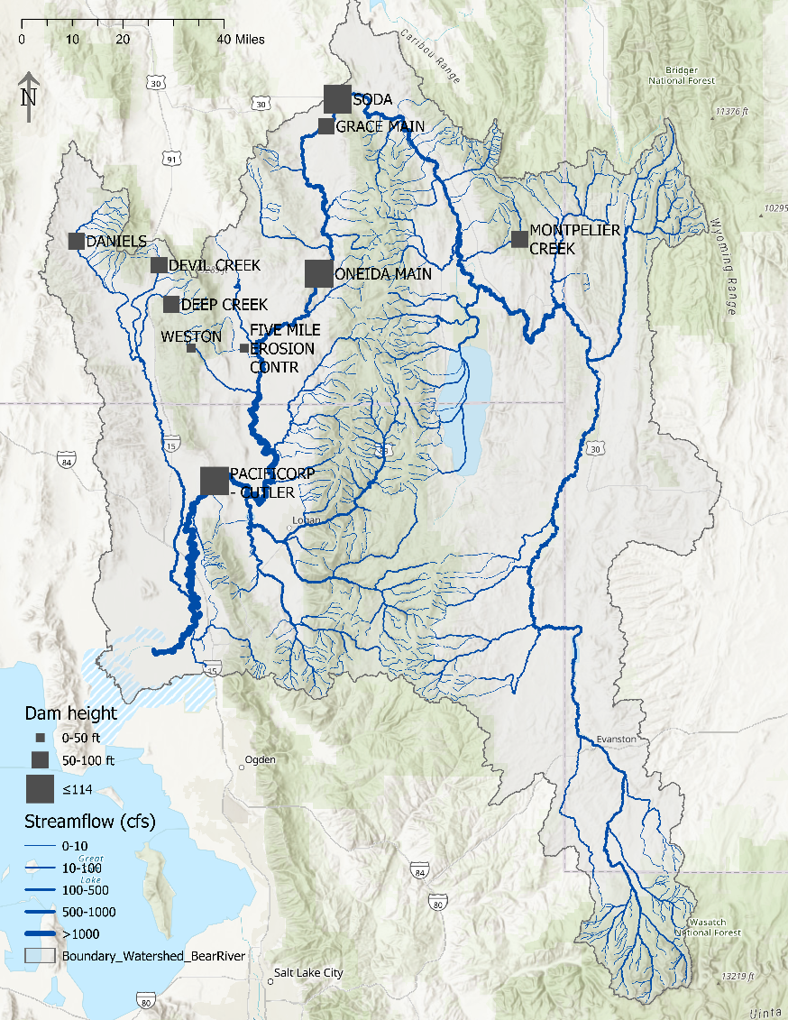

**Figure 3.** Bear River watershed streams and barriers used in this study. Note that some large dams including Hyrum Dam and Porcupine Dam on the Little Bear River do not appear because they do not have heights in the Nation Inventory of Dams (USACE 2020).

Estimating barrier removal costs, economic losses, and water scarcity costs were simplified by applying similar estimates from the Weber River (Kraft et al. 2019). Weber River dam removal costs were assigned to Bear River dams based on similar heights. Dams less than 50ft tall were estimated to cost US$ 1,000,000 to remove, dams between 50 and 100ft cost US$ 10,000,000 to remove, and dams greater than 100ft tall cost US$ 30,000,000 to remove. Similarly, Weber River dam removal economic costs were assigned to Bear River dams based on similar dam heights where removal of dams less than 50ft tall resulted in US$500,000 economic loss, removing dams between 50 and 100ft resulted in US$ 1,000,000 economic loss, and removing dams greater than 100ft resulted in US$ 5,000,000 economic loss.

Model runs were conducted for 22 budget scenarios ranging from $50,000 to $350,000,000 for dam removal, the same scenarios considered in Kraft et al. (2019), and representing a range of possible barrier removal scenarios. The dual-objective optimization model is designed to loop over months to evaluate seasonal variation in habitat suitability and economic loss, as well as weights that simulate different valuations of environmental and economic objectives. To simplify model testing, I only tested one month (August) and with equal weights. August was choses as it represents the month when quality aquatic habitat suitability is most limited by low flows and high stream temperatures, and is consistent with Kraft et al.'s (2019) approach. Weighting scenarios were set equal as evaluating different weights was beyond the scope of this study.

**4. Results**

*4.1 Habitat benefits vs. Economic costs*

Results show reconnected habitat (km) and water scarcity costs (US$) in the optimal solution for 22 budget removal scenarios ranging from US$ 50,000 to US$ 350 M for dam removal in the month of August (Figure 4). More than 400 km of connected habitat can be added in August without limiting water scarcity in urban areas and incurring water scarcity costs. This involves removing two dams (Grace Dam and GSL terminus), and does not change until budgets exceed US$ 75,000. The additional removal of smaller dams (Daniels Dam, Devil Dam, and Deep Creek Dam) reconnect an additional 105 km of habitat, but water scarcity costs increase to US$ 3 M. When a large hydropower dam (Oneida Dam) is added for removal, and additional 235 km of habitat are reconnected, but water scarcity costs rapidly rise to exceed US$ 7 M.

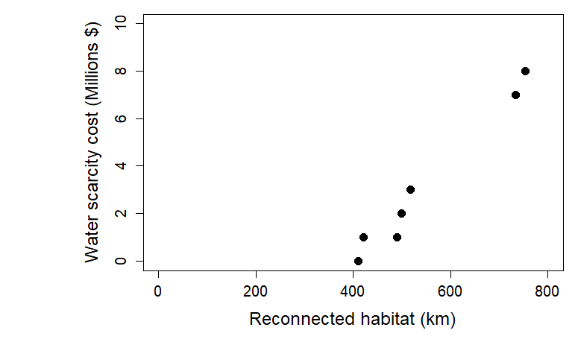

**Figure 4.** Pareto-optimal solutions for August connected habitat vs. water scarcity costs for 22 dam removal budget scenarios ranging from US$ 50,000 to $350,000,000. Some budget scenarios generate identical results, which is why only 7 of 22 are visualized.

With a budget of up to US$ 75,000, 410 km of habitat can be reconnected without incurring any water scarcity costs at the cost of US$ 182 per km. At a budget of US$ 1 M, 420 km of habitat can be reconnected by incurring US$ 1 M in water scarcity costs, resulting in a cost of US$ 5,952 per km. At a budget of US$ 70 M, 752 km of habitat can be reconnected, but incur US$ 8 M in water scarcity costs, resulting in a cost of US$ 103,723 per km. The results indicate that marginal benefits decrease when large dams are removed. After the first smaller dams are removed, costs rise substantially to reconnect additional habitat.

*4.2 Model repeatability in the Bear River watershed*

Model formulation and application were easily accessed through a peer-reviewed journal article (Kraft et al. 2019), and the Weber River GAMS model was easily accessed through a public repository (Kraft and Rosenberg, 2019). Instructions and demonstration Weber River model data were available to demonstrate model function and reproduce results analyzed in Kraft et al. (2019). The GAMS code and supplementary material described 16 model inputs, but did not describe how model inputs were generated from geospatial data described in Kraft et al. (2019). Specifically, no workflow description detailed (a) the translation of the geospatial stream and barrier network into graph network inputs used in the GAMS model, or (b) calculation of economic loss for dams. Correspondence with the lead author (Maggi Kraft, 2020, personal communication) provided additional information, but did not clarify model inputs or workflows used in published analysis. As a result, Bear River model inputs were best approximations of Weber River input data provided in the public repository, and could not be reproduced using the methods applied in Kraft et al. (2019).

Barrier removal decisions in the Bear River watershed indicated errors in model execution (Figure 5). The model removed a barrier at the Great Salt Lake (GSL) in all model solutions, although the Great Salt Lake node represents the downstream terminus of the system and does not represent a real barrier that could reconnect habitat. In addition, Grace Dam was removed in all but the first model solutions and provided an additional 10 km of connected habitat, despite three other small dams (Daniels, Devil Creek, and Deep Creek) having identical removal and water scarcity costs but greater upstream habitat and direct connection to the large connected habitat patch between the Great Salt Lake and Cutler Dam. When budgets were sufficiently high to remove the largest dams, the model removed Oneida Dam, despite Cutler Dam having the same dam removal cost and similar water scarcity costs, but connecting 200 km of additional habitat if removed.

Errors in the dam removal optimization model results likely propagated from errors in model inputs. The removal of the terminal GSL barrier, as well removal dams such as Grace Dam or Oneida Dam when better options are available, indicate incorrect formulation of the graph network used to organize input data in the GAMS code. This is re-iterated by budget removal scenarios up to $750,000, which remove the GSL barrier and reconnect 410 km of habitat, which is exactly the upstream habitat from the GSL terminal reach. However, lacking either workflows for translating geospatial networks to graph networks required in the GAMS code or a geospatial representation of the Weber River watershed used in Kraft et al. (2019), model errors were difficult to identify and validation of model inputs was unclear without a correct dataset for comparison.

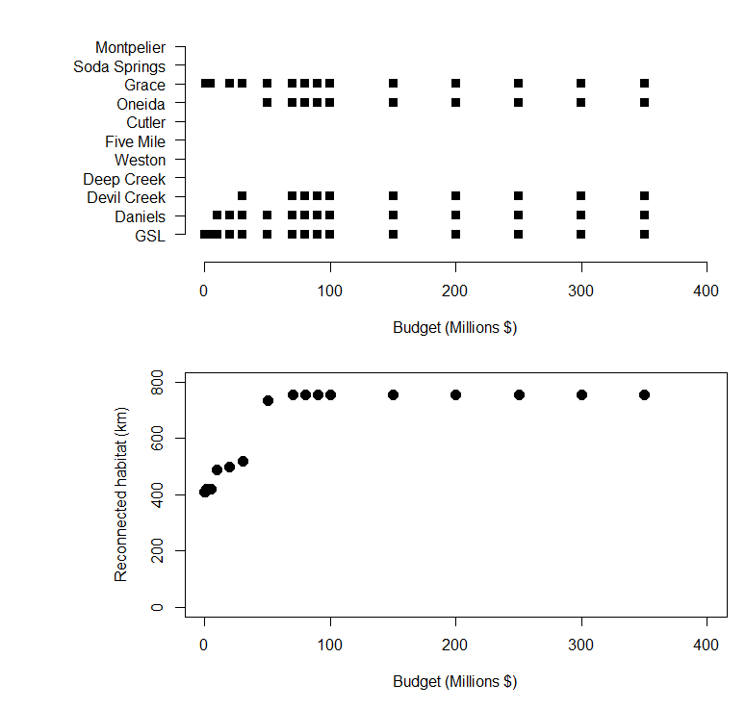

**Figure 5.** Dam removal budgets and reconnected habitat when dams are removed for 22 dam removal budget scenarios ranging from US$ 50,000 to $350,000,000. The Great Salt Lake terminus (GSL) is removed first, but is the terminal reach and does not represent a real barrier. Grace Dam is removed second, when dams with similar removal and water scarcity costs (Daniels, Devil Creek, and Deep Creek) have greater upstream habitat to connect.

**5. Discussion**

More than 400 km of habitat could be reconnected by removing the smallest dams without reducing water deliveries to users and incurring water scarcity costs. Once smaller dams were removed, cost per km of habitat reconnected rapidly rose as the only remaining barriers became large dams. The model removed the smallest dams first, and removed larger dams later because larger dams had greater removal and associated water scarcity costs. Results in the Bear River watershed were similar to Kraft et al.'s (2019) findings, which prioritized removing small barriers in the Weber River basin over more costly large dams. Results reiterate previous findings that removing smaller barriers can effectively improve habitat connectivity while minimizing water scarcity costs for human water uses.

Model testing required simplifying the large and spatially complex Bear River watershed. Only the largest dams in the watershed were considered in this study, but are often much less common and more costly to remove than culverts and other small barriers that also limit habitat connectivity (Diebel et al. 2015; Poplar-Jeffers et al. 2009). Kraft et al. (2019) found that road crossing were the most frequent type of barrier removed in the Weber River to improve habitat for Bonneville Cutthroat Trout, and that removing small barriers is optimal because they are the most common and have the lowest removal costs. A more robust test of model repeatability would include a more diverse and expansive set of barriers including culverts, diversions, and other small instream barriers that inhibit fish movement.

Model testing also focused on Bonneville Cutthroat Trout, but could be expanded to include other species of management concern in the Weber River. Bluehead Sucker (*Catostomus discobolus*) are a threatened native sucker by multi-state conservation agreements that share similar habitats with Bonneville Cutthroat Trout (Webber et al. 2012). Including Bluehead Sucker into habitat estimations could incentivize barrier removals that benefit both species, thereby increasing the benefits of habitat reconnection without removing additional barriers.

Weber River model results were replicated using provided input data, but repeating the model in the Bear River watershed was limited by poor documentation of workflows needed to generate model inputs. Designing models with reproducible results that are repeatable in other systems are critical for bridging the gap between research and practical application for management application (Rosenberg et al. 2021). However, unclear directions and missing materials are one of many factors that limit model repeatability and transfer to other systems (Rosenberg et al. 2020). Kraft et al.'s (2019) Weber River analysis required 16 model inputs from graph networks and economic loss functions, but did not describe methods or workflows used to generate model inputs. As a result, model inputs used for the Bear River watershed involved best-estimations matched to input data tables provided for the Weber River analysis, which propagated into errors in barrier removal decisions. In order to ensure this model can be applied to other systems and generate meaningful information for managers, better documentation for generating model inputs is needed to ensure that input data match optimization model structure. Reproducible results have only recently begun to be incentivized in academic research (Rosenberg et al. 2021), and this study underscores that more work is needed to translate even well-described models from academic studies to real-world management tools.

**6. Conclusions**

This study tested the repeatability of a dual-objective barrier removal optimization model design for the Weber River to maximize connected aquatic habitat and minimize water scarcity costs of reduced water delivery to urban users in the Bear River watershed. The model was successfully executed in the Bear River watershed and identified barrier removals that reconnect aquatic habitat and minimize water scarcity costs for 22 barrier removal budgets. Results indicated that cost per km increases as more barriers are removed and that smaller barriers more cost-effectively reconnect habitat than larger barriers with high removal and associated water scarcity costs. Barrier removal decisions in the Bear River were consistent with the original analysis of barrier removal in the Weber River (Kraft et al. 2019). While the optimization model was executed in the Bear River watershed, lack of documentation for producing inputs to the optimization model was a significant limitation and led to likely erroneous barrier removal recommendations. The model proved to be generalizable to other systems with different input data, but more information describing the generation and formatting of input data is needed to ensure transferability to other systems. This work demonstrates the utility of multi-objective optimization modeling for barrier removal decisions based on environmental and economic objectives, but underscores the need for incorporation of top-to-bottom reproducibility if models are to be translated from research to tools for managers and decision-makers.

**Data availability**

Data used in this analysis of the Bear River watershed are publicly available on GitHub (<https://github.com/ggoodrum/CEE_6410_Bear_River_Optimization_Model>). Data for the original model and Weber River analysis are publicly available through HydroShare (<https://www.hydroshare.org/resource/fa37f35610c34a278042d7fc93e8c47f/>) and GitHub (<https://github.com/MaggiK/Optimizing-Stream-Barrier-Removal>).

**References**

Alafifi, A. H., and Rosenberg, D. E. (2020). “Systems modeling to improve river, riparian, and wetland habitat quality and area.” *Environmental Modelling and Software*, Elsevier Ltd, 126(January), 104643.

Bernhardt, E. S., Palmer, M. A., Allan, J. D., Alexander, G., Barnas, K., Brooks, S., Carr, J., Clayton, S., Dahm, C., Galat, D., Gloss, S., Goodwin, P., Hart, D., Hassett, B., Jenkinson, R., Katz, S., Kondolf, G. M., Lake, P. S., Lave, R., Meyer, J. L., Donnell, T. K. O., Pagano, L., Powell, B., and Sudduth, E. (2005). “Ecology - synthesizing US river restoration efforts.” *Ecology*, 308(5722), 636–638.

Bourne, C. M., Kehler, D. G., Wiersma, Y. F., and Cote, D. (2011). “Barriers to fish passage and barriers to fish passage assessments: The impact of assessment methods and assumptions on barrier identification and quantification of watershed connectivity.” *Aquatic Ecology*, 45(3), 389–403.

Budy, P., Thiede, G. P., and McHugh, P. (2007). “Quantification of the Vital Rates, Abundance, and Status of a Critical, Endemic Population of Bonneville Cutthroat Trout.” *North American Journal of Fisheries Management*, 27(2), 593–604.

Budy, P., Thiede, G. P., McKell, M. D., and Thompson, P. (2014). “Weber River metapopulation and source-sink dynamics of native trout and nongame fishes.” (July 2012), 54.

Carlson, A. J., and Rahel, F. J. (2010). “Annual Intrabasin Movement and Mortality of Adult Bonneville Cutthroat Trout among Complementary Riverine Habitats.” *Transactions of the American Fisheries Society*, 139(5), 1360–1371.

Diebel, M. W., Fedora, M., Cogswell, S., and O’Hanley, J. R. (2015). “Effects of road crossings on habitat connectivity for stream-resident fish.” *River Research and Applications*, 31, 1251–1261.

Friedl, G., and Wüest, A. (2002). “Disrupting biogeochemical cycles – Consequences of damming.” *Aquatic Sciences*, 64(1), 55–65.

Goodrum, G. (2020). “Improving aquatic habitat representation using large spatial scale environmental datasets.” Utah State University.

Graf, W. L. (2006). “Downstream hydrologic and geomorphic effects of large dams on American rivers.” *Geomorphology*, 79(3), 336–360.

Kemp, P. S., and O’Hanley, J. R. (2010). “Procedures for evaluating and prioritising the removal of fish passage barriers: A synthesis.” *Fisheries Management and Ecology*, 17(4), 297–322.

King, S., O’Hanley, J. R., Newbold, L. R., Kemp, P. S., and Diebel, M. W. (2017). “A toolkit for optimizing fish passage barrier mitigation actions.” *Journal of Applied Ecology*, 54(2), 599–611.

Kraft, M., Rosenberg, D. E., and Null, S. E. (2019). “Prioritizing Stream Barrier Removal to Maximize Connected Aquatic Habitat and Minimize Water Scarcity.” *Journal of the American Water Resources Association*, 55(2), 382–400.

Kuby, M. J., Fagan, W. F., ReVelle, C. S., and Graf, W. L. (2005). “A multiobjective optimization model for dam removal: An example trading off salmon passage with hydropower and water storage in the Willamette basin.” *Advances in Water Resources*, 28(8), 845–855.

Moyle, P. B., and Mount, J. F. (2007). “Homogenous rivers, homogenous faunas.” *Proceedings of the National Academy of Sciences*, 104(14), 5711–5712.

Neeson, T. M., Ferris, M. C., Diebel, M. W., Doran, P. J., O’Hanley, J. R., and McIntyre, P. B. (2015). “Enhancing ecosystem restoration efficiency through spatial and temporal coordination.” *Proceedings of the National Academy of Sciences of the United States of America*, 112(19), 6236–6241.

Nilsson, C., and Berggren, K. (2000). “Alterations of Riparian Ecosystems Caused by River Regulation.” *BioScience*, 50(9), 783–792.

Nilsson, C., Reidy, C. A., Dynesius, M., and Revenga, C. (2005). “Fragmentation and Flow Regulation of the World’s Large River Systems.” *Science*, 308(5720), 405–408.

Null, S. E. (2018). “Economic Water Demand Functions to Value Urban Water Scarcity along Utah’s Wasatch Front.” *Hydroshare*, 1–8.

Null, S. E., Medellín-Azuara, J., Escriva-Bou, A., Lent, M., and Lund, J. R. (2014). “Optimizing the damned: Water supply losses and fish habitat gains from dam removal in California.” *Journal of Environmental Management*, 136(2014), 121–131.

O’Hanley, J. R. (2011). “Open rivers: Barrier removal planning and the restoration of free-flowing rivers.” *Journal of Environmental Management*, Elsevier Ltd, 92(12), 3112–3120.

O’Hanley, J. R., Wright, J., Diebel, M., Fedora, M. A., and Soucy, C. L. (2013). “Restoring stream habitat connectivity: A proposed method for prioritizing the removal of resident fish passage barriers.” *Journal of Environmental Management*, Elsevier Ltd, 125, 19–27.

Pascual-Hortal, L., and Saura, S. (2006). “Comparison and development of new graph-based landscape connectivity indices: towards the priorization of habitat patches and corridors for conservation.” *Landscape Ecology*, Springer, 21(7), 959–967.

Poplar-Jeffers, I. O., Petty, J. T., Anderson, J. T., Kite, S. J., Strager, M. P., and Fortney, R. H. (2009). “Culvert replacement and stream habitat restoration: Implications from Brook trout management in an Appalachian Watershed, U.S.A.” *Restoration Ecology*, 17(3), 404–413.

Rosenberg, D. E., Filion, Y., Teasley, R., Sandoval-Solis, S., Hecht, J. S., van Zyl, J. E., McMahon, G. F., Horsburgh, J. S., Kasprzyk, J. R., and Tarboton, D. G. (2020). “The Next Frontier: Making Research More Reproducible.” *Journal of Water Resources Planning and Management*, 146(6), 01820002.

Rosenberg, D. E., Jones, A. S., Filion, Y., Teasley, R., Sandoval-Solis, S., Stagge, J. H., Abdallah, A., Castronova, A., Ostfeld, A., and Watkins, D. (2021). “Reproducible Results Policy.” *Journal of Water Resources Planning and Management*, 147(2), 01620001.

Schrank, A. J., and Rahel, F. J. (2004). “Movement patterns in inland cutthroat trout (Oncorhynchus clarki utah): Management and conservation implications.” *Canadian Journal of Fisheries and Aquatic Sciences*, 61(8), 1528–1537.

Stanley, E. H., and Doyle, M. W. (2003). “Trading off : the ecological effects of dam removal.” *Frontiers in Ecology and the Environment*, 1(1), 15–22.

UDWRe. (2004). “Bear River Basin: planning for the future.” 88.

UDWRe. (2019). *Bear River Development Report Executive Summary*. Salt Lake City, Utah.

Webber, P. A., Thompson, P. D., and Budy, P. (2012). “Status and Structure of Two Populations of the Bluehead Sucker ( Catostomus discobolus ) in the Weber River, Utah.” *The Southwestern Naturalist*, 57(3), 267–276.

Zheng, P. Q., and Hobbs, B. F. (2013). “Multiobjective Portfolio Analysis of Dam Removals Addressing Dam Safety, Fish Populations, and Cost.” *Journal of Water Resources Planning and Management*, 139(1), 65–75.