Area detector data treatment (3D+2D)
Definitions for kappa-geometry as taken in thesis_98_mathias.pdf:
kappa axis has an angle α with e₃
phi axis has an angle β with e₃
NB: usually β = 0 but in principle can be variable

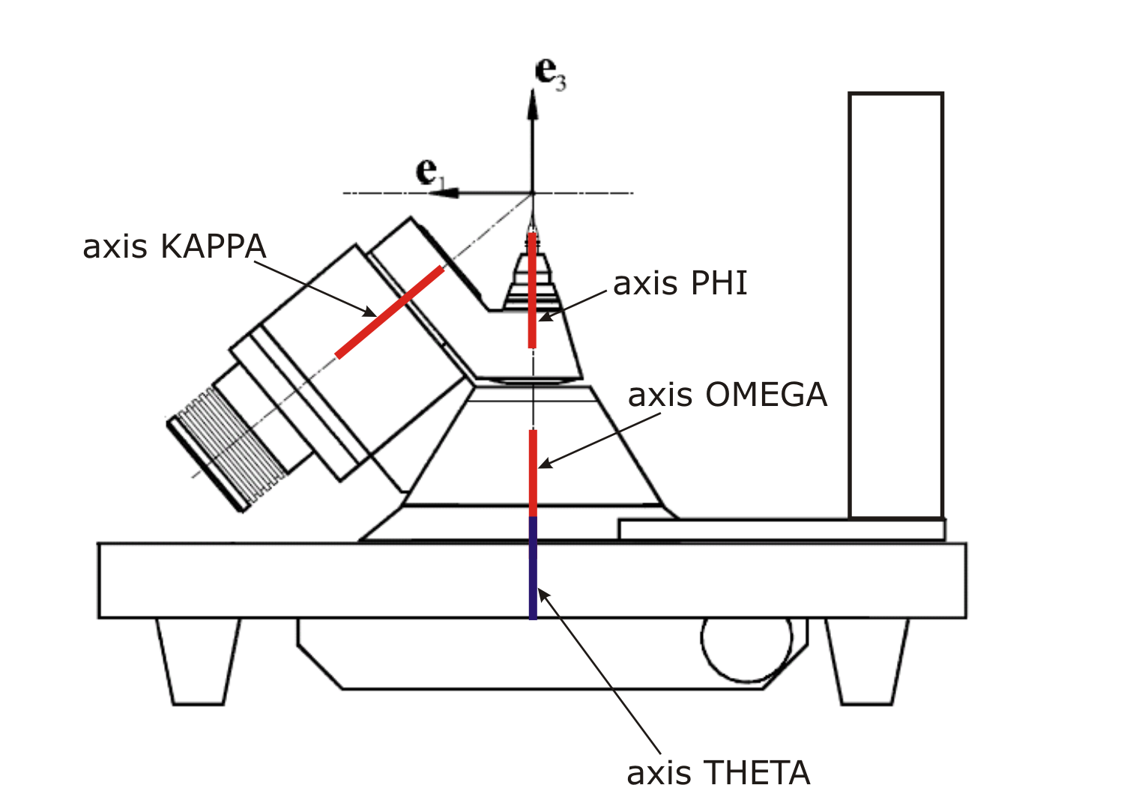
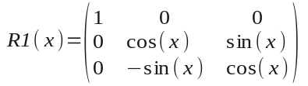
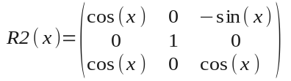
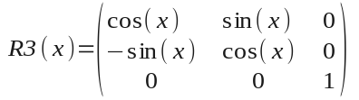
Primary rotation of reciprocal space is described by
R = R3(OMEGA+O0)R2(α)R3(KAPPA)R2(-α)R2(β)R3(PHI)R2(β)
where OMEGA, KAPPA and PHI are the nominal values of the angles and O0 is the OMEGA offset
For the arbitrary geometry of goniostat the rotation matrix will be generalized
as R(angle1,…,angleN, const1,…,constM, offset1,…,offsetN)
/generalization should be planned/

Rotation matrix for the detector is
DET = R3(THETA+T0)R2(D2)R1(D1)
where THETA is the nominal theta value, T0 is the THETA offset, D1 and D2 are the tilts of detector
For the arbitrary geometry of goniostat the rotation matrix will be generalized
as R(angle1,…,angle3, offset1,…,offset3)
/generalization should be planned/

Secondary rotation of reciprocal space to orient the crystallographic axis in a special way
U = R3(r3)R2(r2)R1(r1)
Definition in terms of Euler angles will be possible
/generalization should be planned/

Beam tilt matrix
B = R2(B2)
Can be generalized to
B = R3(B3)R2(B2)
/generalization should be planned/

Primary projection of pixel coordinates (X,Y) to the reciprocal space
Step 1: 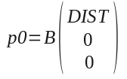
where DIST is the distance from the sample to the detector along the normal
Step 2: 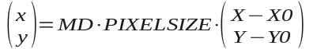
X0, Y0 – position of normal to the detector plane starting from the sample position,
PIXELSIZE is the size of pixel
MD – unit matrix by default, in a general case can be one of those:
/generalization should be planned/
Step 3: 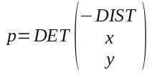
Step 4: 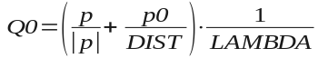
Step 1 are performed once
steps 2, 3 and 4 are performed once for each THETA value
Q0(X,Y) is stored in memory
Calculating the corrections:

Polarisation correction
n is the normal to the polarization plane (vector)
p is the degree of polarization
example (our starting configuration): for small offsets, p = 1 and n = (0 0 1)^{T}
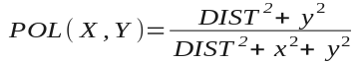

Flux density and parallax correction
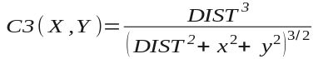
/generalization of C3(X,Y) should be planned/
Corrections are calculated once for each THETA value

Estimation of Qmax
Except for the pathological cases, Qmax can be estimated taking the maximum of |Q0| over for corners of detector for all THETA settings

Projection of given image to the reciprocal space
Q(X,Y) = R⁻¹Q0(X,Y) = R^{T}Q0(X,Y)
here R depends on the goniometer angles (PHI, KAPPA, OMEGA or generalized)
NB: Q0 for given THETA must be used

Orientation of given image in the reciprocal space
Qfin(X,Y) = U⁻¹Q(X,Y) = U^{T}Q(X,Y)

Constructing of 3D intensity distribution (non-optimized algorithm)
create float32 array A set to zero values
create int32 array B set to zero values
for given image: intensity 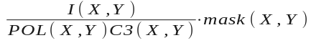 is added to the corresponding element of A
mask(X,Y) is added to the same element of B
mask(X,Y) contains 1 for pixels to treat or 0 for pixels to skip; can be constant for all the images or depend on the image if the filtering is applied
For the image i the variable angle (i.e. PHI) is (angle_{i} + angle_{i+1})/2
NB: Large angular step or large magnification will create gaps between the projections of flat images to the reciprocal space; kind of interpolation is required.
The simplest solution: the same image is projected to the reciprocal space n times with finer angular step.
angle(i,j) = angle_{i} +(j+1/2)(angle_{i+1}- angle_{i})/n, where j runs from 0 to n-1
default settings:
A and B are equivalent to (2^{N}+1)× (2^{N}+1)× (2^{N}+1) cube
Qfin = 0 in the center of cube
cube size is (2Qmax)× (2Qmax)× (2Qmax)
User-defined settings
center of cube q0x, q0y, q0z
extent of sampling ±dqx, ±dqy, ±dqz
for the 3D array the indices will be
i = floor(2^{N-1}[1+(Qxfin-q0x)/dqx])
j = floor(2^{N-1}[1+(Qyfin-q0y)/dqy])
t = floor(2^{N-1}[1+(Qzfin-q0z)/dqz])
if |Qxfin-q0x|≤dqx, |Qyfin-q0y|≤dqy, |Qzfin-q0z|≤dqz
Qxfin – x component of Qfin, Qyfin – y component of Qfin, Qzfin – z component of Qfin
normalize A by the counter B if the element of B is not zero
store A as binary array
store the restricted version (2^{N})× (2^{N})× (2^{N}) as CCP4 file (see description CCP4_format)

Constructing of 2D intensity distribution (non-optimized algorithm)
create float32 array A set to zero values
create int32 array B set to zero values
for given image: intensity is added to the corresponding element of A
mask(X,Y) is added to the same element of B
default settings:
A and B are equivalent to square matrix (i.e. 2300×2300)
User-defined settings
orientation of cut: two vectors a and b’
check if they are not collinear
a = a/|a|
generate c = a×b’; c = c/|c|
generate b = c×a
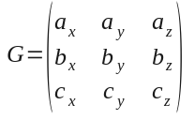
Qn = G∙Qfin
offset vector Qoff
extent of sampling dQ1, dQ2
cut thickness ±dq
for the 2D array the indices will be
i = floor(size∙[1+(Qxn-Qxoff)/(2dQ1)])
j = floor(size∙[1+(Qyn-Qyoff)/(2dQ2)])
if |Qxn-Qxoff|≤dQ1, |Qyn-Qyoff|≤dQ2, |Qzn-Qzoff|≤dq
Qxn – x component of Qn, Qyn – y component of Qn, Qzn – z component of Qn
Qxoff – x component of Qoff, Qyoff – y component of Qoff, Qzoff – z component of Qoff
normalize A by the counter B if the element of B is not zero
store A in specified format

EXPERIMENT DESCRIPTION PARAMETERS
ALPHA = α factory setting
BETA = β factory setting
O0 OMEGA offset
B2 beam tilt
X0 position of the normal from the sample on the detector
Y0 position of the normal from the sample on the detector
T0 THETA offset
R1 orientation matrix angle
R2 orientation matrix angle
R3 orientation matrix angle
D1 detector tilt
D2 detector tilt
LAMBDA wavelength
PIXELSIZE size of pixel
DIST distance sample-detector along the normal
THETA image-specific THETA value
KAPPA image-specific KAPPA value
OMEGA image-specific OMEGA value
PHI image-specific PHI value
data series

PARAMETERS FOR 3D RECONSTRUCTION
2^{N} final cube size
n number of steps in the interpolation (starting from 1)
q0x, q0y, q0z center of reconstruction cube
dqx, dqy, dqz half-extent of reconstructed volume (±dqx, ±dqy, ±dqz)
output file name

PARAMETERS FOR 2D RECONSTRUCTION
N final square size
n number of steps in the interpolation (starting from 1)
ax, ay, az components of first vector
bx, by, bz components of second vector
Qxoff, Qyoff, Qzoff components of offset vector
dQ1, dQ2 half-extent of the reconstructed cut
dq half-thickness of integrated layer (±dq)
output file name

EXTRACTION OF DESCRIPTORS FROM XCALIBUR PAR FILE
see feo1_1.par
ALPHA and BETA
§ - ALPHA (DEG) 50.00000 BETA (DEG) 0.00000
LAMBDA
§ - WAVELENGTH USERSPECIFIED (ANG): A1 0.67018 A2 0.67018 B1 0.67018
X0 = X – 1725 + vertical size
Y0 = Y – 1725 + horisontal size
§ - DETECTOR ZERO (PIX, 1X1 BINNING): X 1733.19127 Y 1712.50841
B2 = X2
§ - X-RAY BEAM ORIENTATION (DEG): X2 0.99075 X3 0.00000
D1 = X1
D2 = X2
§ - DETECTOR ROTATION (DEG): X1 -0.41144 X2 1.17097 X3 0.00000
DIST = DETECTOR DISTANCE (MM)∙1.72
§ - DETECTOR DISTANCE (MM): 174.42000
O0 = OMEGA
T0 = THETA
§ - SOFTWARE ZEROCORRECTION (DEG): OMEGA -0.19777 THETA 0.39804 KAPPA
0.00000 PHI 0.00000

REMAINING PARAMETERS
KAPPA = -134 imposed
OMEGA = 57 imposed
THETA = 0 imposed
PHI = (n-1)∙0.1 imposed, n is the number of image
r1 = -88.788 imposed, in principle can be recovered from PAR file
r2 = 2.257 imposed, in principle can be recovered from PAR file
r3 = 69.629 imposed, in principle can be recovered from PAR file
PIXELSIZE = 0,172 mm

