IXS Fitter

This program allows the extraction of the relevant information from the spec raw data file, creates an output file where the normalised intensity is reported as a function of energy transfer in meV. In a second step, the IXS spectra can be centered and fitted.

[1.1] Prepatory steps – copy experimental data & configuration file
- open a terminal on the computer “leonov”.

- go to the appropriate directory:
cd Experiments/[year]

- create the appropriate sub-directory
mkdir [hsxxxx_sample identifier]

- copy the experimental data file
cd [hsxxxx_sample identifier]
cp /data/id28/archive/galilee/runx_yz/[hsxxxx_sample identifier]/[spec file-name] .

- copy the configuration file
cp ~/Experiments/Extraction/[year]/extract.conf .

- modify the configuration file if necessary (see below)

[1.2] Data Extraction

Before fitting the IXS spectra, the relevant data from the spec file need to be extracted and converted. The first step is to convert the resistance of the back-scattering monocromator and analysers into energy transfer, and the second step is to normalise the intensity.

extract [spec filename] extract.conf

The configuration file is written as python variable definition, it includes the following options (see appendix 1):

Most of the time, the program does not ask any questions. It creates a hdf5 archive with '.h5' extension and a directory called [spec filename]_extract containing Ascii files for each IXS scan and each analyser in the following format: Energy transfer (meV), normalised intensity, normalised error, detector counts, monitor intensity, sqrt(detector counts).

[1.3] IXS Fitter

Once you have extracted your data as hdf5 archive, you can launch the second module to fit your spectra, this module is named ixs_fitter.
The intensity of an IXS spectrum is given by:

I(q,ω) = A(q)[n(ω,T) S(q,ω) ⊗ R(ω)]

A: overall intensity factor
n: detailed balance factor
S: dynamical structure factor
R: experimental resolution function

The temperature and the correct experimental resolution function is therefore required to fit the spectrum. The experimental resolution function is determined experimentally, and fitted by a Pseudo-Voigt function. The values of the best fit are stored in the configuration file (resolution.param).
If the resolution function was determined prior to the experiment, it needs to be fitted (see corresponding section in Manual). Otherwise, you can rely on the parameters, previously determined. To get the most up-to-date parameters:

- cp ~/Experiments/Resolutions/validresolutions/res[n]_pm_[beam mode].param .

[n]: 8, 9, 11, 12
[beam mode]: 16b or um

Pay attention that the temperature value corresponds to your experiment.

The ixs_fitter configuration file is also written as python variable definition (see Appendix 2).

- ixs_fitter [specfile].h5 resolution.param

The semi-automated fitter module is based on least square minimisation, a Levenberg-Marquardt algorithm, associated with a small GUI for inputs. This fitting module computes (in reciprocal space) the best function, which fits IXS spectrum (a convolution of a linear combination of a Lorentzian and the resolution function (pseudo-Voigt)).

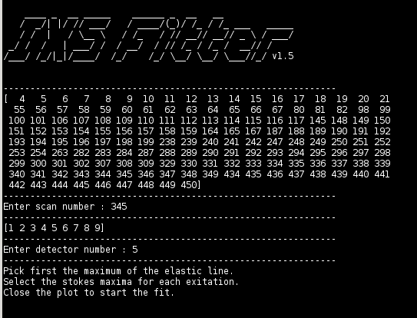

Once the program ixs_fitter is launched, it first displays the list of scans extracted from the spec file (refer to [1.2]).
- select a scan number
- select a detector number

The program opens a plot window and asks for three actions in the following order:
- To pick the maximum of the elastic line.
- To select the Stokes maxima for each exitation. The number of selected Stokes maxima defines the number of excitations used for the fit.
- To close the plot.

Press “l” for a display on a logarithmic scale

The clicks corresponding to those actions are represented by red X's in the following example :

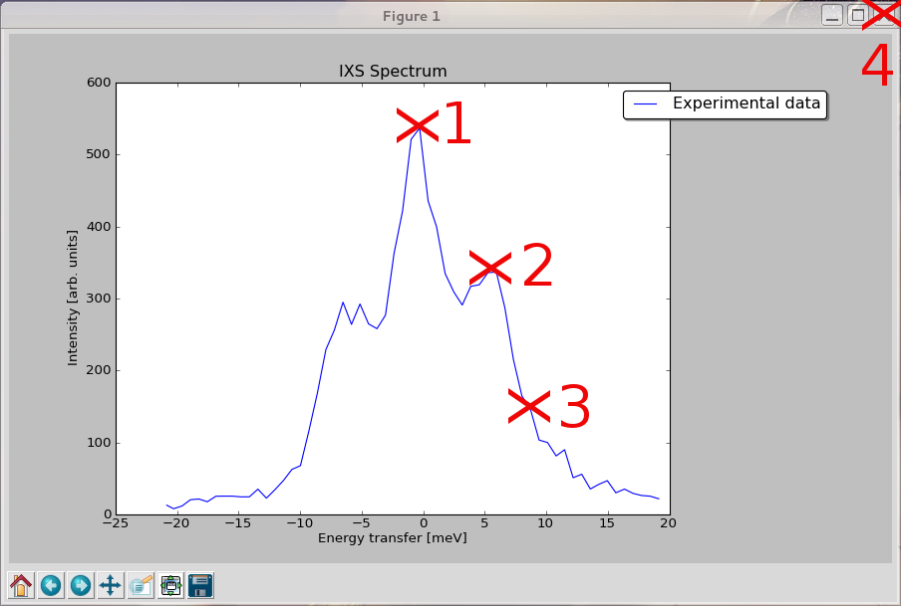

The clicks are providing the start parameters for the phonon energy and intensity in order to improve the fit convergence.

Closing the plot starts the fit.

The program minimises the difference between the experimental spectrum and the resolution function. During the optimisation, the parameters of the resolution function are constant (defined in the configuration file).

The parameters which will change are the position, the intensity, and the width of each Lorentzian modeling the elastic and the inelastic lines.

Once the optimisation is completed (a run takes usually few seconds), the program automatically opens a new plot window (see figure below) composed of the experimental spectrum (in blue) as before, a new red curve describing the fitted model which is composed of the sum of the elastic line in pink and the inelastic contributions in light blue. Press “l” for representation on a logarithmic scale.

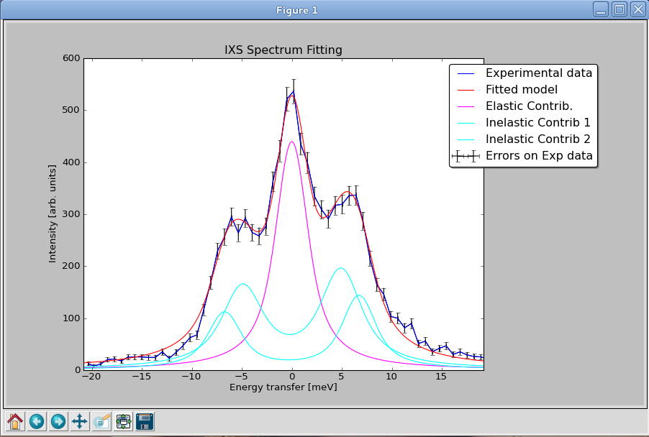

This plot window is recorded automatically in png-format into a sub-directory (named [spec filename]_fit).

The file with the fit results has the following format:

[spec filename]_[scan-number]_[detector-number]
(e.g. : tin_345_5.png).

Within the same directory (name identically but with a different extension) you also find :

- a .param file containing the final parameters for the different Lorentizans composing the fitted model.

- a .dat multi-columns file containing the values corresponding to :
- Experimental Energy - Shift
- Experimental Normalized Intensity
- Experimental Errors
- Fitted Total Model
- Elastic Line
- Inelastic Line 1
- Inelastic Line 2
...
N. Inelastic Lines #N-5 …
(Last Column) Pseudo-Voigt
Once the fit is completed, the program displays the following questions:

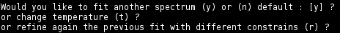

The answer can be among 'y', 'n', 't' or 'r'.

'y' → restart the fitting process at the beginning, you will have to choose a scan, a detector … etc.

'n' → close the program.

't' → allow to set a new temperature without editing the configuration file and without restarting ixs_fitter.

'r' → allow to refine the previous spectrum by keeping the final parameters as new start values and/or set new constraints.

This procedure will open a text editor (emacs by default) containing all the parameters and some numbers corresponding to the constraints imposed on each parameter. See Appendix 3 for an example.
[A1] Appendix 1 – Python configuration file extract.conf

--------------------------------------------------------------------------------
#

# Configuration file for extract.conf
#

#scan types to be extracted

scan_types = ['monot','deltaE','IXSscan']

#reference name in the file

ref = 'mono'

#association table : detectors ids are used for giving the output filenames

deta_num = {

'mono' :0,

'deta1':1,

'deta2':2,

'deta3':3,

'deta4':4,

'deta5':5,

'deta7':6,

'deta6':7,

'deta8':8,

'deta9':9

}

#association table : detectors and resistance of temperature sensors

deta = {

'mono' :'prem_ad5',

'deta1':'prem_ad6',

'deta2':'prem_ad7',

'deta3':'prem_ad8',

'deta4':'prem_ad9',

'deta5':'prem_ad10',

'deta7':'prem_ad12',

'deta6':'prema_ad13',

'deta8':'prema_ad14',

'deta9':'prem_ad15'

}

#conversion of main monochromator angle (deg) to hkl

mhkl = {

8.18:7,

7.036:8,

6.2401:9,

5.070:11,

4.635:12

}

#variation (deg) of main monochromator angle

deltaa = 0.02

#temperature offset (for earch analyser)

tcorr = {

'deta1':.146,

'deta2':-.126,

'deta3':.423,

'deta4':.090,

'deta5':.108,

'deta7':.153,

'deta6':.029,

'deta8':-.052,

'deta9':-.020

}
[A2] Appendix 2 – Python configuration file resolution.param

--------------------------------------------------------------------------------#

# Configuration file for IXS Fitter

#

# Parameters for resolution function

# usage : res_param = {detector_number:[mu,wG,wL],...,n:[mun,wGn,wLn]}

# mu is a ponderation factor between gaussian and lorenzian in the pseudo-Voigt
# wG is the gaussian width
# wL is the lorentian width
res_param ={

1:[0.6552,2.604,4.53],

2:[0.6319,2.603,4.013],

3:[0.6412,2.537,3.924],

4:[0.6097,2.735,3.596],

5:[0.5792,2.609,4.833],

6:[0.6845,2.477,3.617],

7:[0.6662,2.517,4.353],

8:[0.5879,2.575,3.878],

9:[0.6421,2.639,3.893]

}

#Temperature (important : floating type is mandatory)

T = 297.0
--------------------------------------------------------------------------------
[A3] Appendix 3 – Configuration file for fit constraints

--------------------------------------------------------------------------------
# Parameter constrains for optimization :
# 0 = Free ; 1 = Positive ; 2 = Quoted ; 3 = Fixed
# ----------------- Center_el -----------------
constrains[0][0]= 2
param_list[0],constrains[1][0],constrains[2][0] = -0.1047,-12.7584,12.7584
# ----------------- Height_el -----------------
constrains[0][1]= 2
param_list[1],constrains[1][1],constrains[2][1] = 882.6390,0.0000,1583.0929
# ----------------- Width_el -----------------
constrains[0][2]= 2
param_list[2],constrains[1][2],constrains[2][2] = 1.8559,0.0000,2.5000
# ----------------- Center_1 -----------------
constrains[0][3]= 2
param_list[3],constrains[1][3],constrains[2][3] = 3.7039,-0.2235,25.5168
# ----------------- Height_1 -----------------
constrains[0][4]= 2
param_list[4],constrains[1][4],constrains[2][4] = 105.6418,0.0000,1583.0929
# ----------------- Width_1 -----------------
constrains[0][5]= 2
param_list[5],constrains[1][5],constrains[2][5] = 0.3245,0.0000,2.5000
# ----------------- Center_2 -----------------
constrains[0][6]= 2
param_list[6],constrains[1][6],constrains[2][6] = 8.5730,-0.2235,25.5168
# ----------------- Height_2 -----------------
constrains[0][7]= 2
param_list[7],constrains[1][7],constrains[2][7] = 843.3972,0.0000,1583.0929
# ----------------- Width_2 -----------------
constrains[0][8]= 2
param_list[8],constrains[1][8],constrains[2][8] = 1.0525,0.0000,2.5000
--------------------------------------------------------------------------------

All the values in green can be set to 0, 1, 2 or 3.
These values describe the type of contraints imposed on each parameter. (0 = Free ; 1 = Positive ; 2 = Quoted ; 3 = Fixed)
The numbers in bod are (from left to right): current value of the parameter, minimum value for the parameter, maximum value for the parameter

(2. and 3. are used only if the constraints type = 2 (quoted))

/!\ WARNING : if you change the current value for a parameter, be sure that the value is included into bounds if constraints = quoted. If not the parameters value will never converge … /!\

Once you have changed values/constraints for parameters, you have to save and to close the editor for restarting the minimisation.

