Gabriel Quinones

Numerical Analysis Homework 2

Contains any explanations for problems 1 and 2 of homework 2

1)

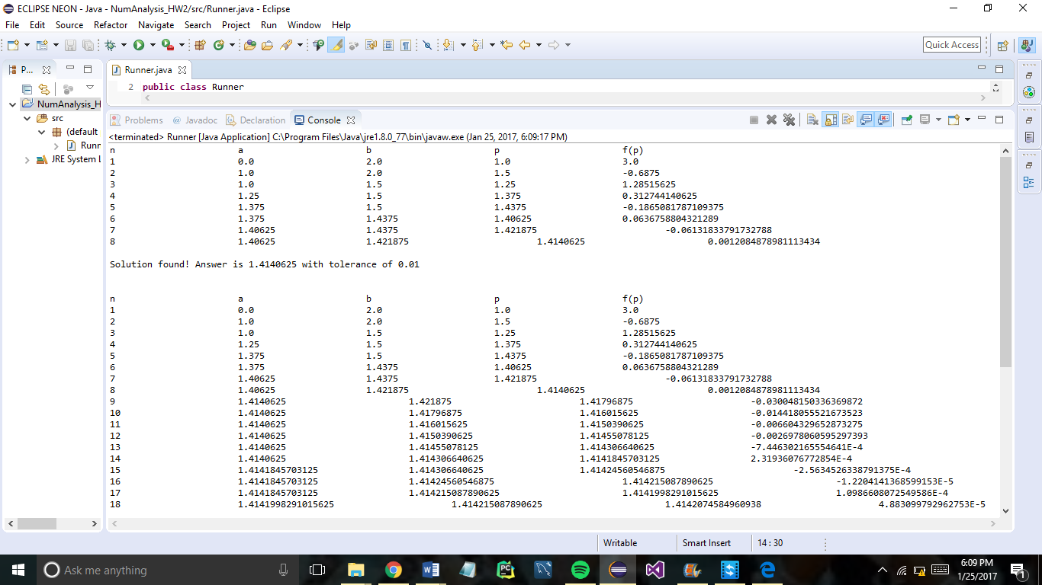

P=1.41

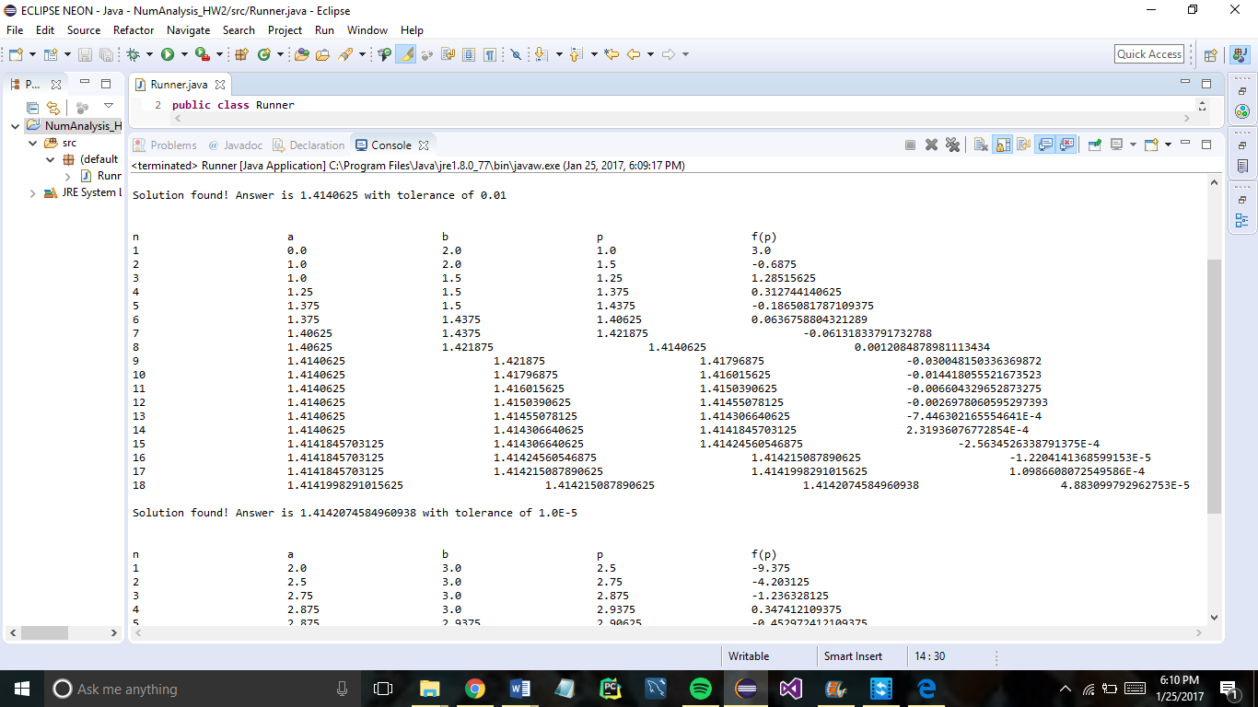

P=1.41421

Precondition check:

f(0)=4 f(2)=-4 Change in the sign of f(x) in the interval therefore Intermediate Value Theorem applies and the Bisection Method.

Step count increased significantly with the increase in accuracy. 10 more steps recorded for the higher accuracy evaluation of p.

2)

Pre-condition check:

f(2)=-17 f(3)=2 Change in the sign of f(x) in the interval therefore Intermediate Value Theorem applies and the Bisection Method.

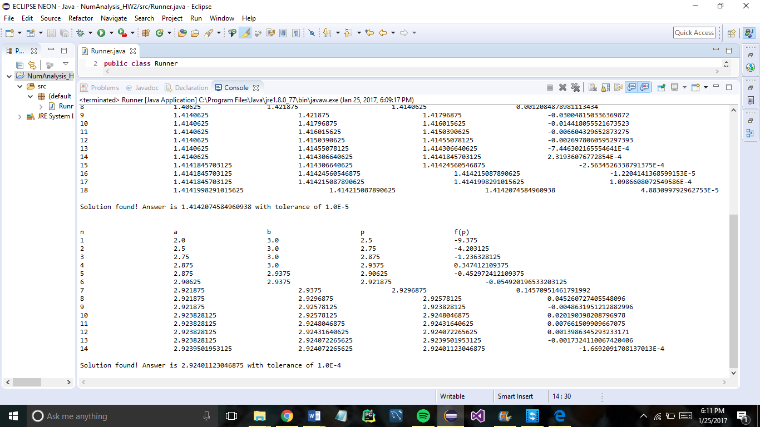

P=2.9240