Instructions to import Seurat UMAP values and clusters into Loupe Browser
Seurat UMAP values
These instructions work for both single cell/nuclei and Visium data. The screen shots below are showing Visium, but the same steps work for single cell. Additional details can be found at https://www.10xgenomics.com/support/software/loupe-browser/latest/tutorials/assay-analysis/lb-sc-interoperability

10x link:
https://www.10xgenomics.com/support/software/loupe-browser/latest/tutorials/introduction/lb-navigation-for-spatial#left-view-component-f373e6
Relevant bit for Seurat UMAP projection highlighted:
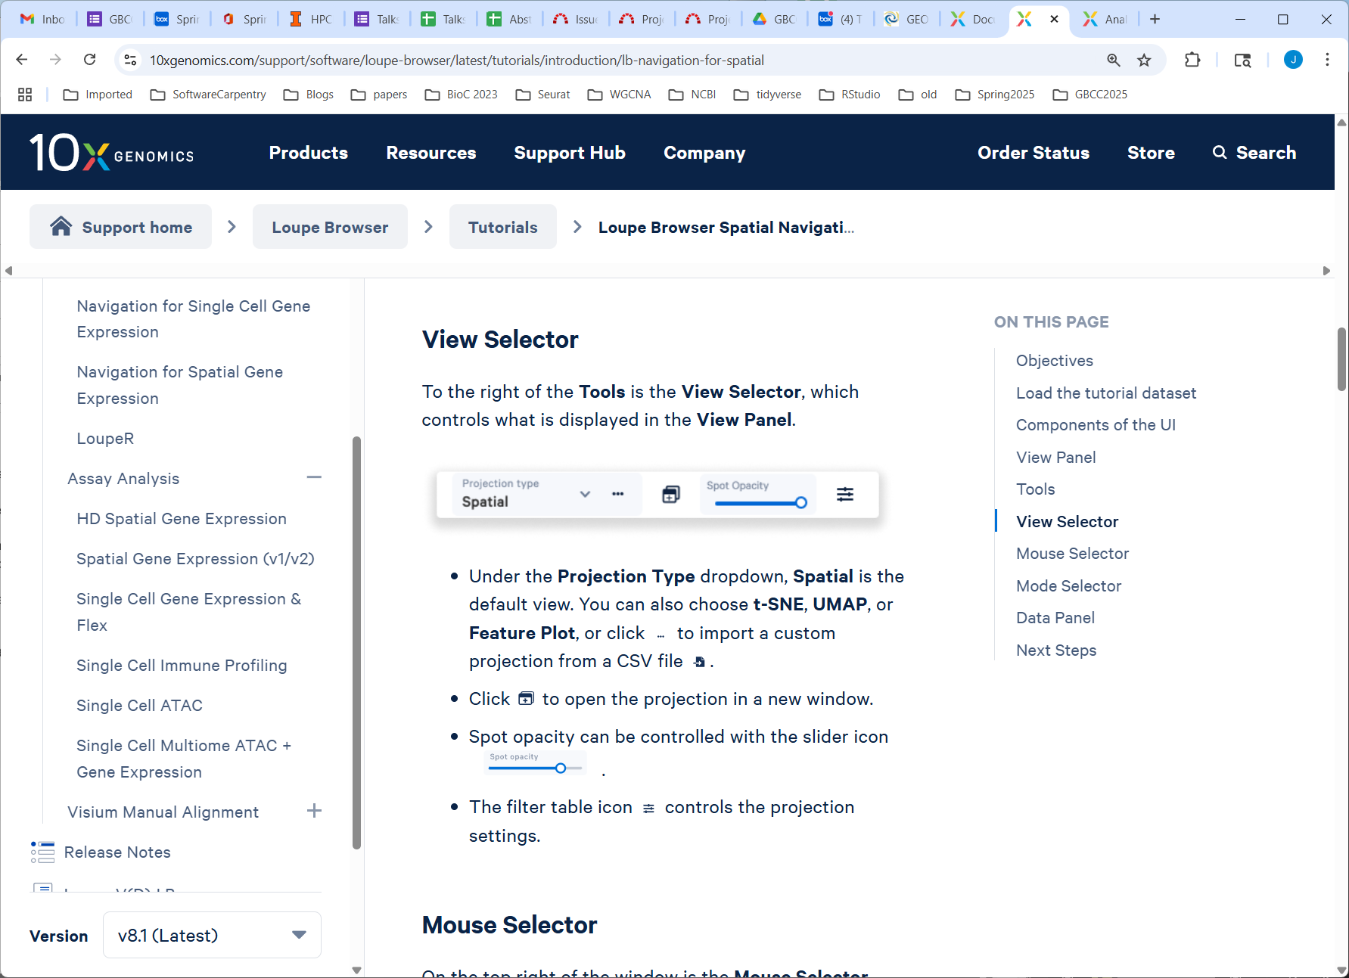
Screen shot of where to do this in Loupe:
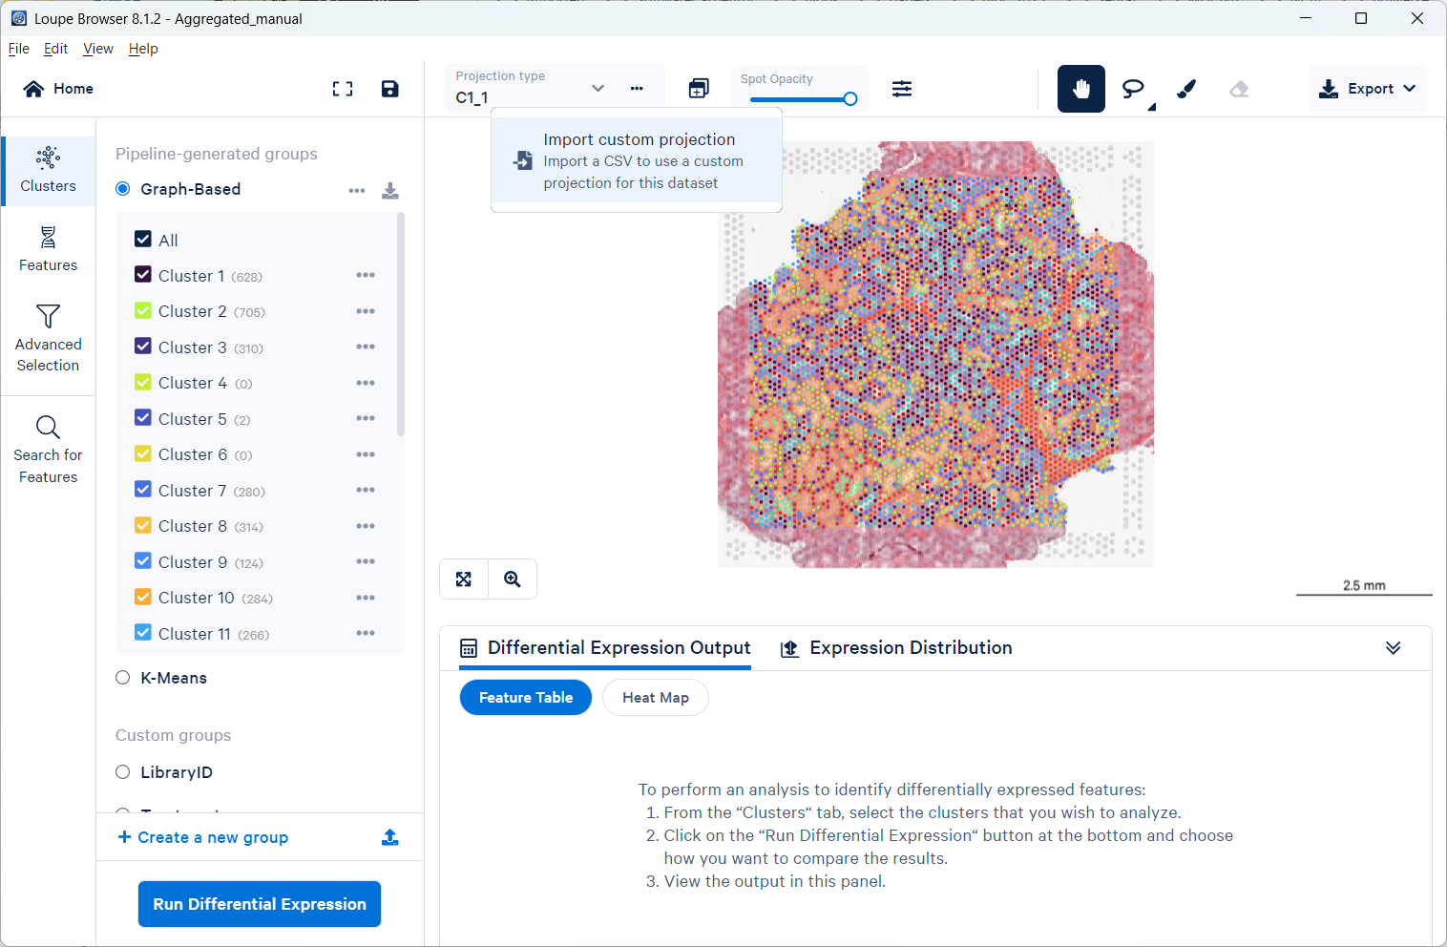

Navigate to the UMAP file we sent and click “Import Projection”:
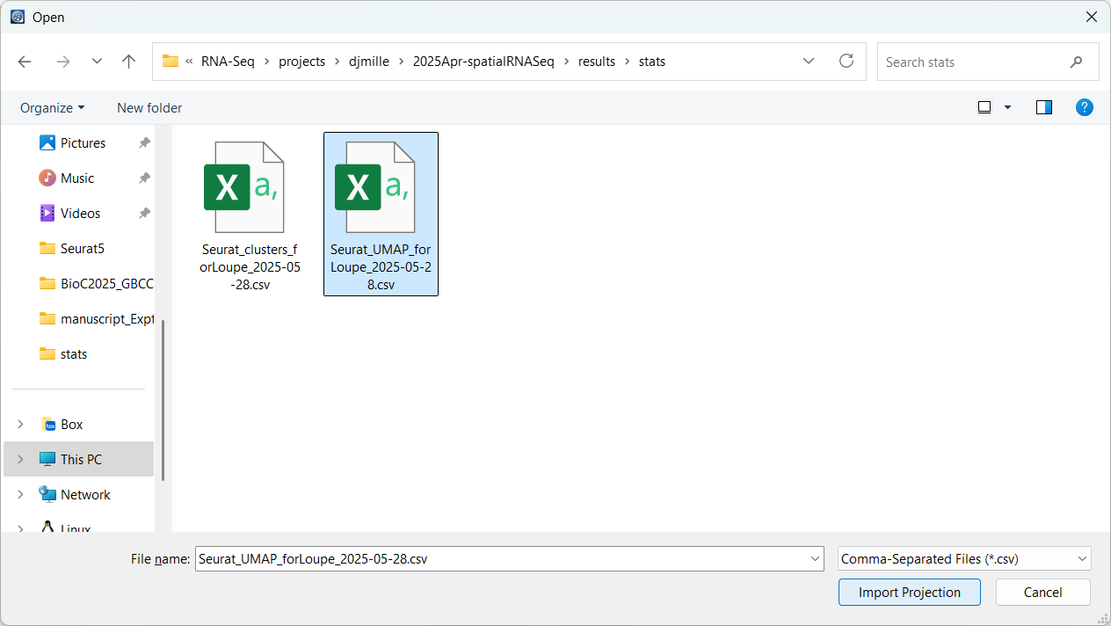
Seurat clusters
10x link:
https://www.10xgenomics.com/support/software/loupe-browser/latest/tutorials/introduction/lb-navigation-for-spatial#next-steps-9300b4

Relevant bit for Seurat clusters highlighted:
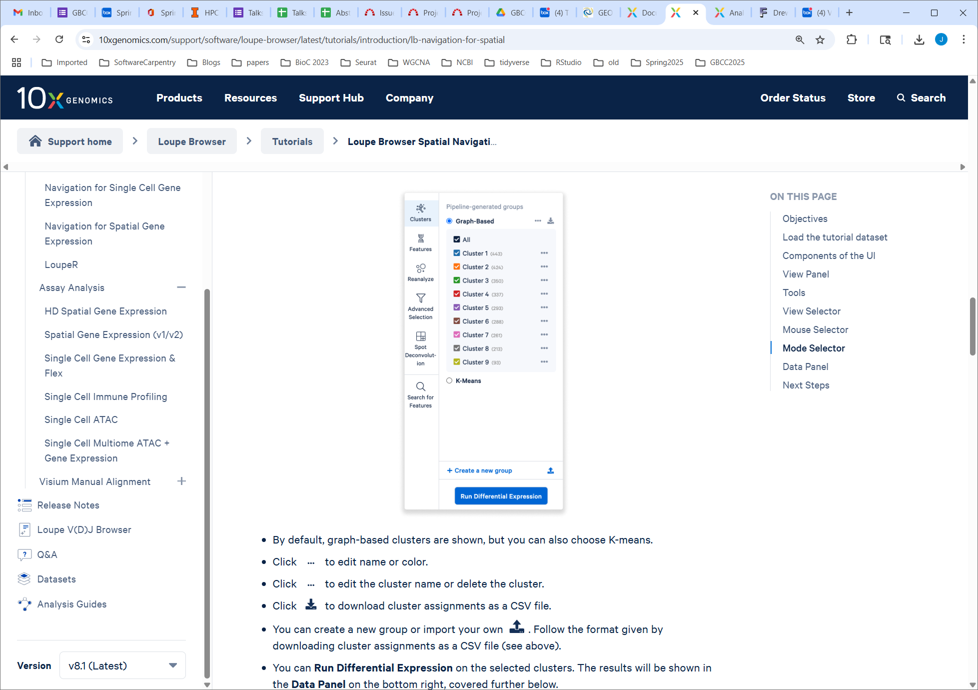
Screen shot of where to do this in Loupe:
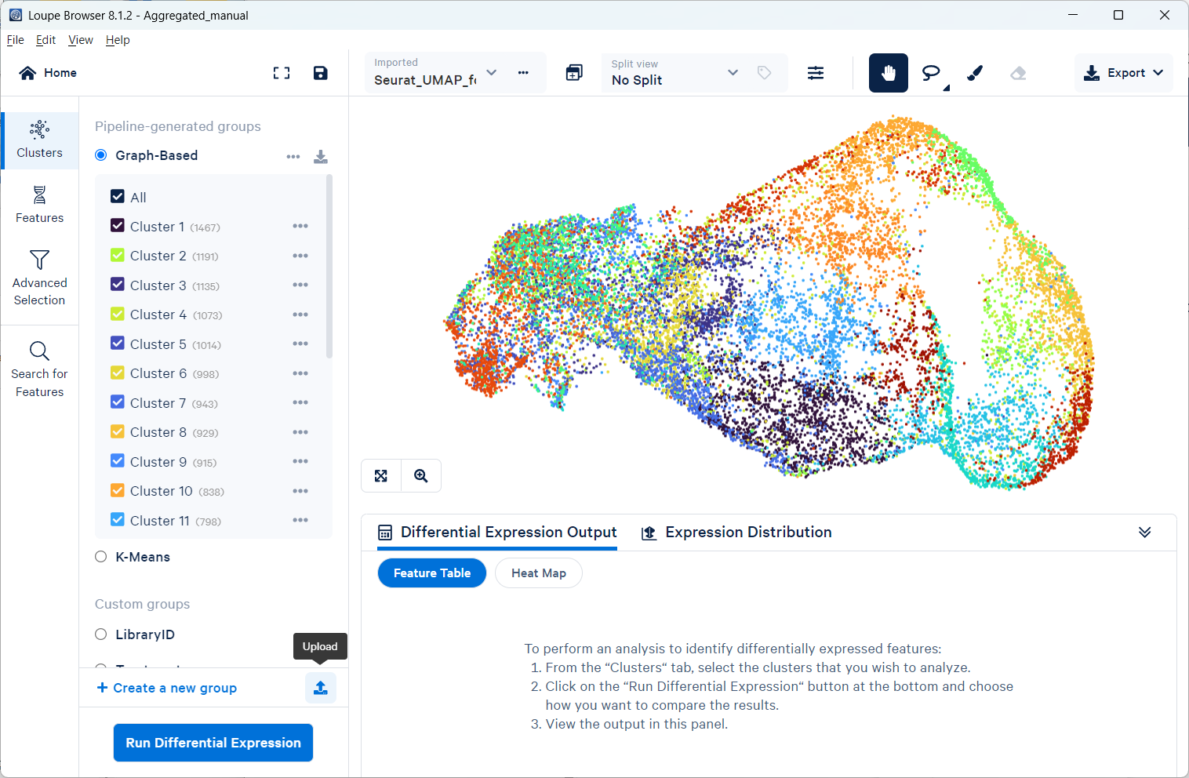

Navigate to the clusters file we sent and click “Import Groups”
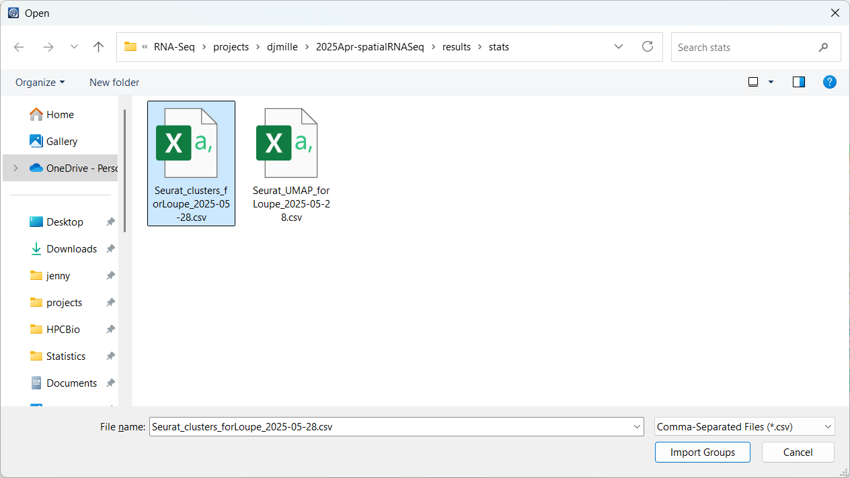

Finally, save the cloupe file:

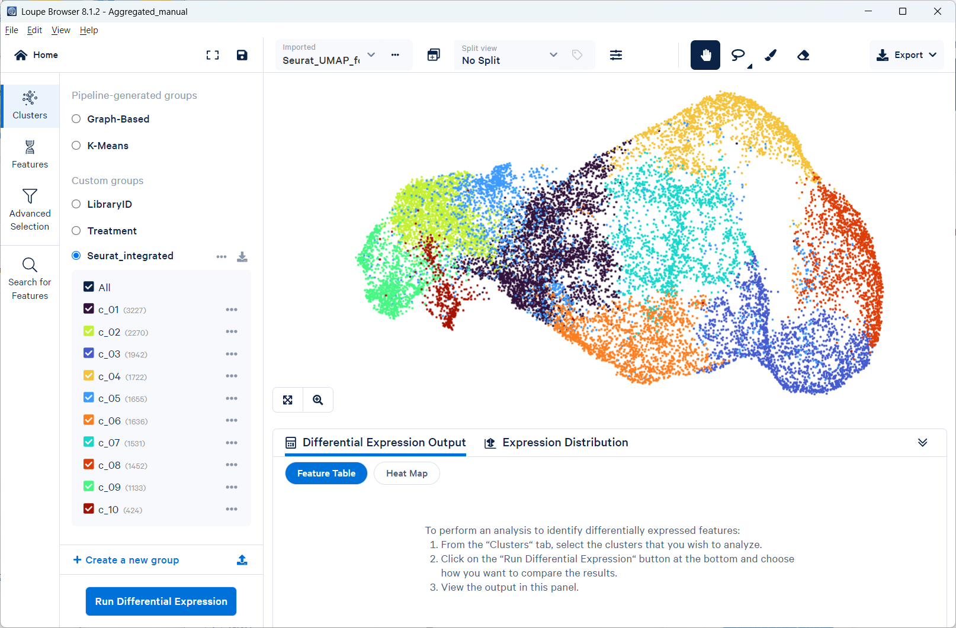

If you close/reopen the .cloupe file, you can get back to the Seurat UMAP by changing the “Projection type” (you may need to scroll down)

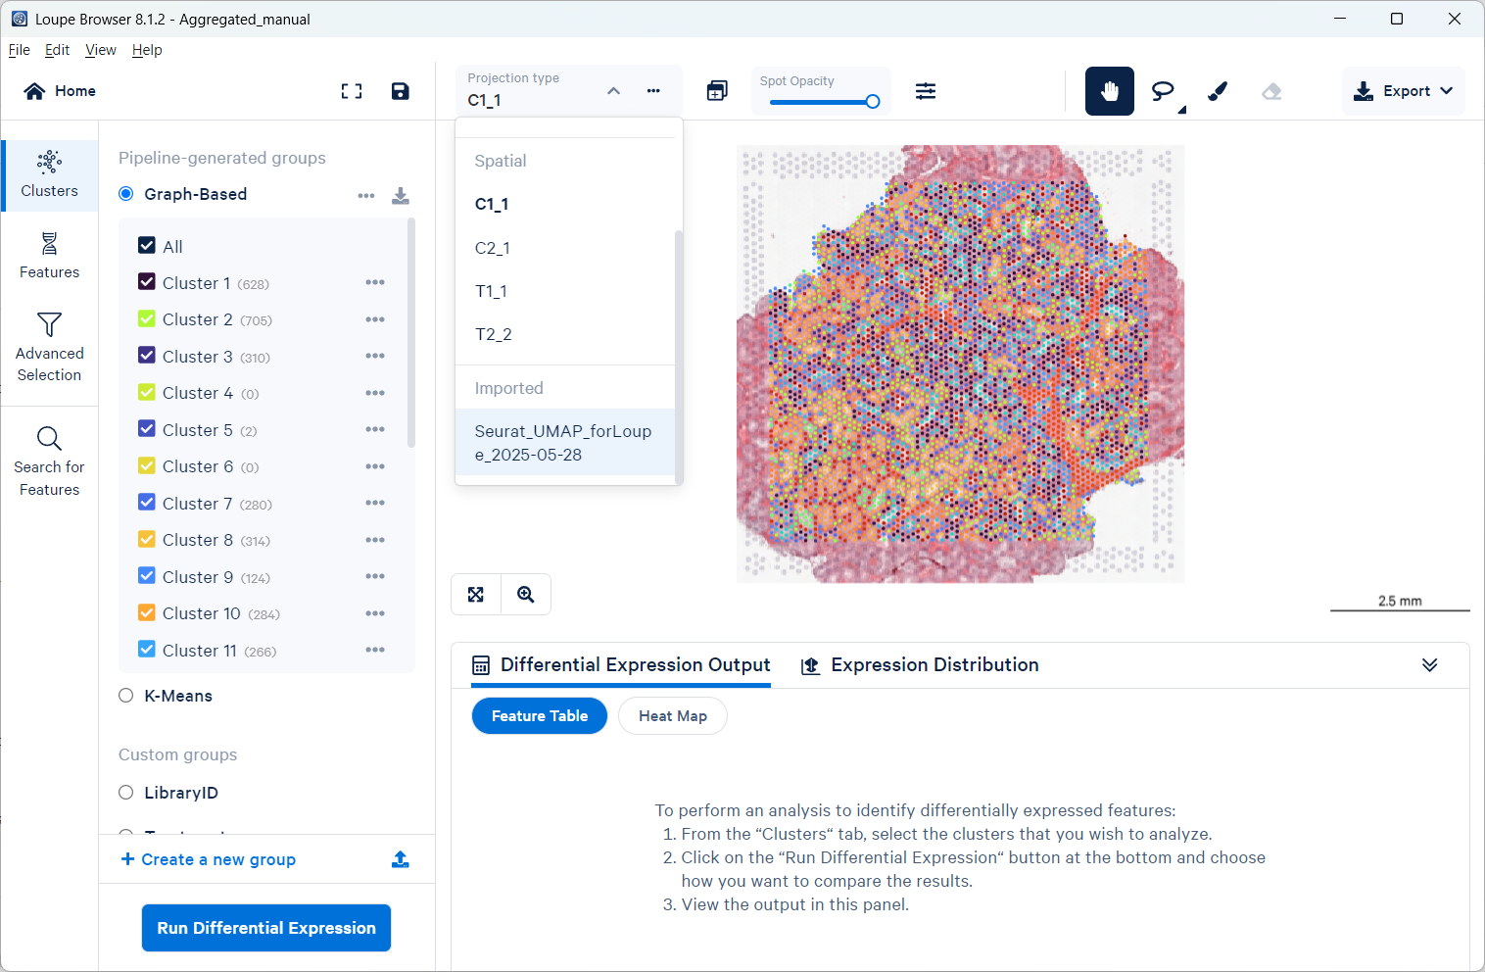

To get back to the imported clusters, on the “Clusters” tab, also scroll down (but don’t have your mouse in the Graph-Based box or it will only scroll that):

