Business Requirements Document(BRD) Template
Project/Initiative
Month 20YY
Version X.XX

Company Information

Document Revisions
Date | Version Number | Document Changes
11/08/2026 | 0.1 | Initial Draft

Approvals
Role | Name | Title | Signature | Date
Project Sponsor
Business Owner
Project Manager
System Architect
Development Lead
User Experience Lead
Quality Lead
Content Lead

Introduction

Project Summary

Objectives
The primary goal is to develop and deploy a robust self-service booking management module within the user dashboard. This solution is designed to empower customers to independently manage active reservations, thereby enhancing the user experience while significantly reducing operational bottlenecks for support staff.
High-Level Product Capabilities
Comprehensive self-service portal for booking modifications, cancellations, and history.
Alignment with Business Objectives
The development of this module is directly aligned with key strategic business targets:
- Operational Efficiency: By shifting routine reservation management to the user, the product aims to decrease the Customer Service department's workload by 40-50%.
- Revenue Protection: The system will automatically enforce hotel policies, minimizing financial losses by accurately calculating cancellation penalties (e.g., retaining 100% of the first night's fee for late cancellations) and appropriately managing rate differences for date modifications.
System Interaction Requirements
To ensure accurate data flow and operational consistency, the self-service module requires real-time integration with several internal systems:
- Property Management System (PMS) / Room Inventory: the module must pull live room availability to validate date changes and instantly trigger automated notifications to update the hotel's room grid upon any modification or cancellation.
- Financial and Payment Systems: the product must integrate with transactional back-ends to dynamically handle financial calculations, process additional payments for higher-priced dates, manage refund logic or commission retention, and generate official payment receipts (Invoices).

Background
[Provide a brief history of how the project came to be proposed and initiated, including the business issues/problems identified, and expected benefit of implementing the project/developing the product.]

Business Drivers
[List the business drivers that make development of this product important. These can be financial, operational, market or environmental.]

Project Scope

In Scope Functionality
- Booking Management (Self-Service):
  - One-click cancellation of an active booking.
  - Changing stay dates (subject to the availability of the same room type).
  - Blocking modification capabilities for "Non-refundable" rate types.
- Financial Calculations and Policies:
  - Automatic calculation of cancellation penalties according to the hotel's policy (e.g., free cancellation 24 hours in advance, 100% retention of the first night's cost for late cancellations).
  - Preliminary calculation and display of a clear "before/after" price comparison prior to the user confirming any date changes.
  - Establishing the logic for processing transactions upon date changes (requiring additional payment if the new price is higher, or calculating the refund/commission amount if it is lower).
- History and Documentation:
  - Displaying trip history clearly categorized by status: "Active," "Completed," and "Canceled."
  - Generation and download capability for payment receipts (Invoices) in PDF format.
  - Functionality to quickly leave a review after the trip is completed (Check-out).
- Notifications and Synchronization:
  - Automatic system triggers (notifications) sent to the hotel upon any booking modifications (cancellations or date changes) to instantly update the room availability grid.

Out of Scope Functionality
- Room Parameter Modifications: The ability to change the room type (Upgrade/Downgrade) while editing an existing booking. Date changes are supported exclusively for the initially booked room type.
- New Bookings: Searching for and processing entirely new bookings through this specific module. The functionality is strictly limited to managing already established records.
- OTA (Online Travel Agencies) Integration: Managing bookings made through third-party platforms (e.g., Booking.com, Expedia). The dashboard will exclusively service direct bookings.
- Loyalty Program Processing: Accruing, deducting, or displaying bonus points related to canceled or modified bookings.
- Live Support Chat: An integrated messenger or live chat with Customer Service within the personal account, as the primary objective is to encourage self-service.

System Perspective
[Provide a complete description of the factors that could prevent successful implementation or accelerate the projects, particularly factors related to legal and regulatory compliance, existing technical or operational limitations in the environment, and budget/resource constraints.]

Assumptions

Constraints

Risks

- .

Issues

Business Process Overview
[Describe how the current process(es) work, including the interactions between systems and various business units. Include visual process flow diagrams to further illustrate the processes the new product will replace or enhance.
Use case documentation and accompanying activity or process flow diagrams can be used to create the description(s) of the proposed or “To-Be” processes.]

Current Business Process (As-Is)
At any point during or after deployment of web apps or web sites (internal or external) to support business activities, development/support teams may create and deploy widgets.
- CMS / database administrators for the employee portal use the CMS tool to create widgets. They can test widgets in the designated staging environment, then register them and deploy to production.
- Development teams may deploy widgets to development and testing environments set up for their development projects. They must check widget code into and out of the source code repository according to their projects’ development schedule.
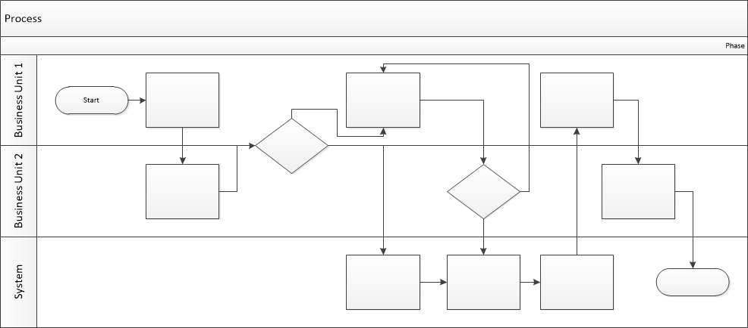

Proposed Business Process (To-Be)
- Technical Lead searches repository
- If widget is not found, user creates a new widget name record.
- WINS validates that all fields have been completed.
- WINS confirms that no similar widgets exist
- User confirms record to be created.

- User searches repository to locate existing widget description.
- WINS displays record
- User selects Edit to open and modify record
- WINS validates all fields completed correctly
- User confirms changes.
- WINS confirms changes and updates Audit table.


Stakeholder Requirements
Customer Stakeholder Requirements (SR-C):
SR-C-001: The customer requires the ability to instantly cancel an active booking directly from their dashboard.
SR-C-002: The customer requires the ability to independently modify the stay dates of an active booking.
SR-C-003: The customer requires visibility into exact penalty price difference “before”/”after” before confirming a date change.
SR-C-004: The customer requires visibility into exact penalty fees before confirming a cancellation.
SR-C-005: The customer requires the system to automatically process a card payment for the difference if the new dates are more expensive.
SR-C-006: The customer requires the system to automatically initiate a refund (or partial refund) if the new dates are cheaper.
SR-C-007: The customer requires a dedicated dashboard tab to view all "Active" trips.
SR-C-008: The customer requires a dedicated dashboard tab to view all "Completed" trips.
SR-C-009: The customer requires a dedicated dashboard tab to view all "Canceled" trips.
SR-C-010: The customer requires the ability to generate and download a PDF payment invoice for completed bookings.
SR-C-011: The customer requires the ability to generate and download a PDF payment invoice detailing penalties for canceled bookings.
SR-C-012: The customer requires an on-screen prompt/form to submit a post-stay review immediately upon checkout.

Business Owner Stakeholder Requirements:
SR-B-001: The business requires the system to automatically calculate cancellation penalties based on the timeframes defined in the hotel policy.
SR-B-002: The business requires the system to completely block self-service date changes for rates tagged as "Non-refundable."
SR-B-003: The business requires the system to completely block free cancellations for rates tagged as "Non-refundable."
SR-B-004: The business requires date modifications to be restricted solely to the originally booked room type (no self-service upgrades/downgrades).
SR-B-005: The business requires date modifications to be permitted only if the PMS shows available inventory for the new dates.
SR-B-006: The business requires the hotel's room availability grid (PMS) to be updated instantly the moment a user cancels a booking.
SR-B-007: The business requires the hotel's room availability grid (PMS) to be updated instantly the moment a user changes their dates.
SR-B-008: The business requires the system to support the retention of price differences as commission (instead of a refund) when a user changes to cheaper dates, based on policy.

Customer Service Stakeholder Requirements:
SR-CS-001: Customer Service requires the UI to route users through the automated cancellation flow before offering access to live support.
SR-CS-002: Customer Service requires the UI to route users through the automated date-change flow before offering access to live support.

The requirements in this document are prioritized as follows:
Value | Rating | Description
1 | Critical | This requirement is critical to the success of the project. The project will not be possible without this requirement.
2 | High | This requirement is high priority, but the project can be implemented at a bare minimum without this requirement.
3 | Medium | This requirement is somewhat important, as it provides some value but the project can proceed without it.
4 | Low | This is a low priority requirement, or a “nice to have” feature, if time and cost allow it.
5 | Future | This requirement is out of scope for this project, and has been included here for a possible future release.

Functional Requirements
Req# | Priority | Description | Rationale | Use Case Reference | Impacted Stakeholders
General / Base Functionality
FR-G-001 | 1 | The system shall allow users to cancel an active booking with a single click from their dashboard. | 90% of surveyed users requested instant self-service cancellation without calling support. | UC-01: Cancel Booking | Customers, Customer Service
FR-G-002 | 1 | The system shall allow users to change their stay dates, contingent on the availability of the exact same room type. | Key self-service feature to reduce support load and provide flexibility. | UC-02: Change Dates | Customers, Hotel Operations
FR-G-003 | 1 | The system shall calculate and display a clear "before/after" price comparison and any applicable fees prior to confirming date changes. | Users expressed confusion over surcharges; transparency is required before transaction commitment. | UC-03: Review Price | Customers, Business Owner
FR-G-004 | 1 | The system shall automatically calculate cancellation penalties based on the hotel's existing policy (e.g., 100% first-night penalty if canceled < 24 hrs). | Business requirement to minimize financial losses from late cancellations. | UC-04: Calculate Penalty | Business Owner, Finance
FR-G-005 | 2 | The system shall display the user's trip history categorized strictly into "Active", "Completed", and "Canceled" tabs. | Direct request from the user survey for better organization of travel history. | UC-05: View History | Customers
FR-G-006 | 1 | The system shall execute the financial transaction (charge the customer's card for a higher rate or initiate a refund/commission for a lower rate) upon user confirmation of a date change. | Showing the price difference is insufficient; the system must actually process the funds to finalize the modification. | UC-10: Process Transaction | Customers, Finance
Security Requirements
FR-S-001 | 1 | The system shall lock and prohibit any self-service date changes or free cancellations for bookings tagged as "Non-refundable". | Necessary to enforce strict rate rules and prevent revenue leakage. | UC-06: Enforce Rate Rules | Business Owner, Finance
Reporting Requirements
FR-R-001 | 2 | The system shall generate a downloadable PDF Invoice/receipt for completed or canceled transactions. | High user demand for accessible financial documentation. | UC-07: Download Invoice | Customers, Finance
Usability Requirements
FR-U-001 | 1 | The system shall prompt users with an option to leave a quick review immediately upon checking out of a "Completed" trip. | Simplifies the feedback loop as requested in user surveys. | UC-08: Submit Review | Customers, Marketing
Audit Requirements
FR-A-001 | 1 | The system shall log and instantly trigger a notification payload to the hotel's PMS whenever a booking status changes. | Ensures the hotel's room grid is kept accurate and up to date without manual entry. | UC-09: Sync PMS | Hotel Operations, IT

Non-Functional Requirements
[Include technical and operational requirements that are not specific to a function. This typically includes requirements such as processing time, concurrent users, availability, etc.]
ID | Requirement
NFR-001 | (Availability) The self-service dashboard must be available 24/7 with a guaranteed uptime of 99.9% to ensure users can manage bookings outside of Customer Service hours.
NFR-002 | (Integration/Latency) Automated triggers sent to the hotel's Property Management System (PMS) must execute and update the room grid within 3 seconds of a user confirming a change.
NFR-003 | (Accuracy) All financial calculations regarding price differences, penalties, and refunds must be processed in real-time with 100% accuracy to two decimal places.
NFR-004 | (Usability/Performance) The user interface for the "before/after" price comparison must render within 2 seconds of the user selecting new dates to prevent booking abandonment.
NFR-005 | (Scalability) The system must support up to 500 concurrent booking modification sessions (cancellations or date changes) per minute during peak load periods, maintaining an interface rendering time of under 3 seconds.

Appendices

List of Acronyms
[If needed, create a list of acronyms used throughout the BRD document to aid in comprehension.]

Glossary of Terms
[If needed, identify and define any terms that may be unfamiliar to readers, including terms that are unique to the organization, the technology to be employed, or the standards in use.]

Related Documents
[Provide a list of documents or web pages, including links, which are referenced in the BRD.]

