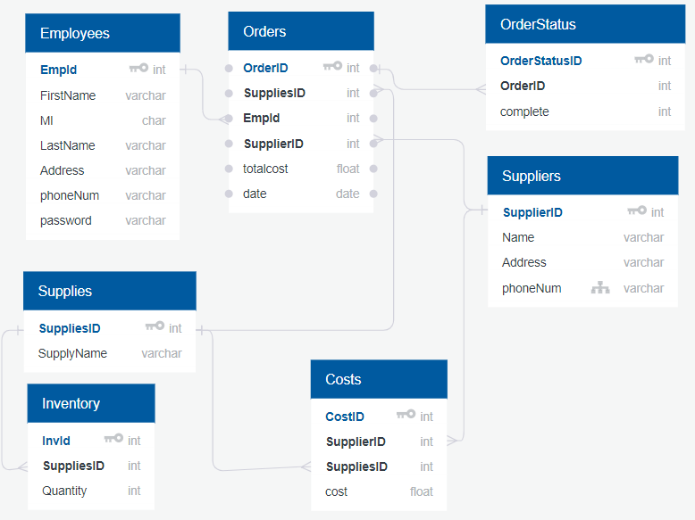

Primary key

* EmpId
* OrderId
* OrderStatusId
* SuppliesID
* InvID
* CostID

Foreign key one or more columns in a table that refer to a primary key in another table.

* EmpID in Orders table
* SupplierID in Orders table
* SuppliesID in Orders table
* OrderID in OrderStatus table
* SupplierID in Costs table
* SuppliesID in Inventory table
* SuppliesID in Costs table

Check Constraint used to limit the value range that can be placed in a column

EmpID cannot be a negative number in both employee and orders tables.

OrderID cannot be a negative number in both orders and orderstatus tables.

SuppliesID cannot be a negative number in inventory, costs, and orders table.

SupplierID cannot be a negative number in both costs and orders table.

InvId cannot be a negative number in inventory table.

CostID cannot be a negative number in costs table.

Totalcost cannot be a negative number in the orders table.

Quantity cannot be a negative number in Inventory table.

Cost cannot be a negative number in cost table.

FirstName and Last Name cannot be more than 10 characters in Employee table.

Name cannot be more than 25 characters in Suppliers table.

Not NULL constraints

There is not a single variable that should be null