Main contributor: Mark McDonough

Elijah Banks

Geoffery Greiner

Adam Deisz

CSC4500 Project documentation

**Overview:**

This project is designed for an office supplies wholesaler. It is intended to streamline the process of ordering new office supplies and keeping track of the inventory in the warehouse.

**Tools used:**

* My SQL
* Ruby on Rails
* Bootstrap

**GITHUB LINK:**

<https://github.com/ejoebanks/office>

**Database E/R MODEL:**

**pages:**

Inventory:

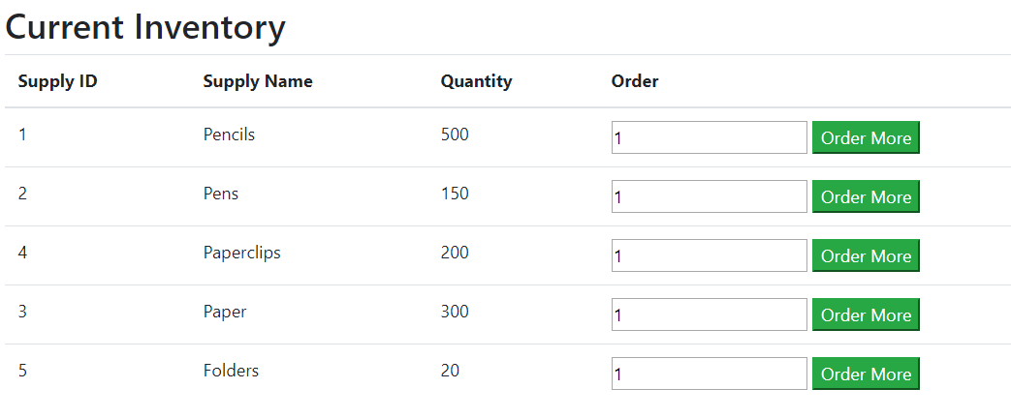

Inventory Functionality:

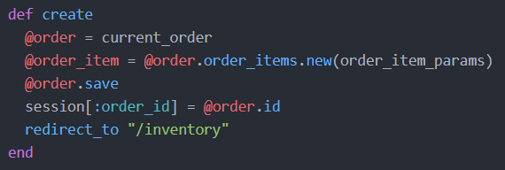

Inventory Cart:

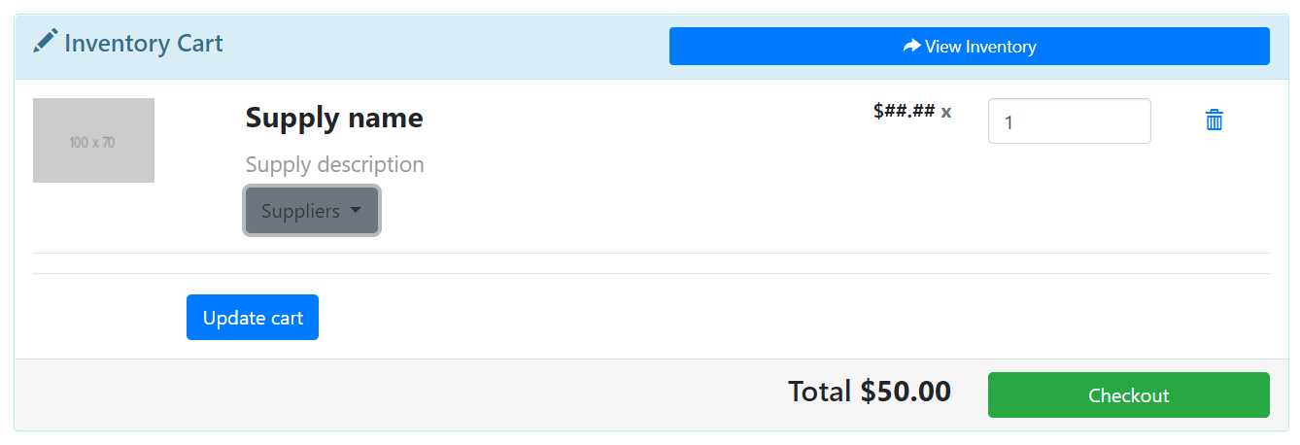

Normal User Inventory View:

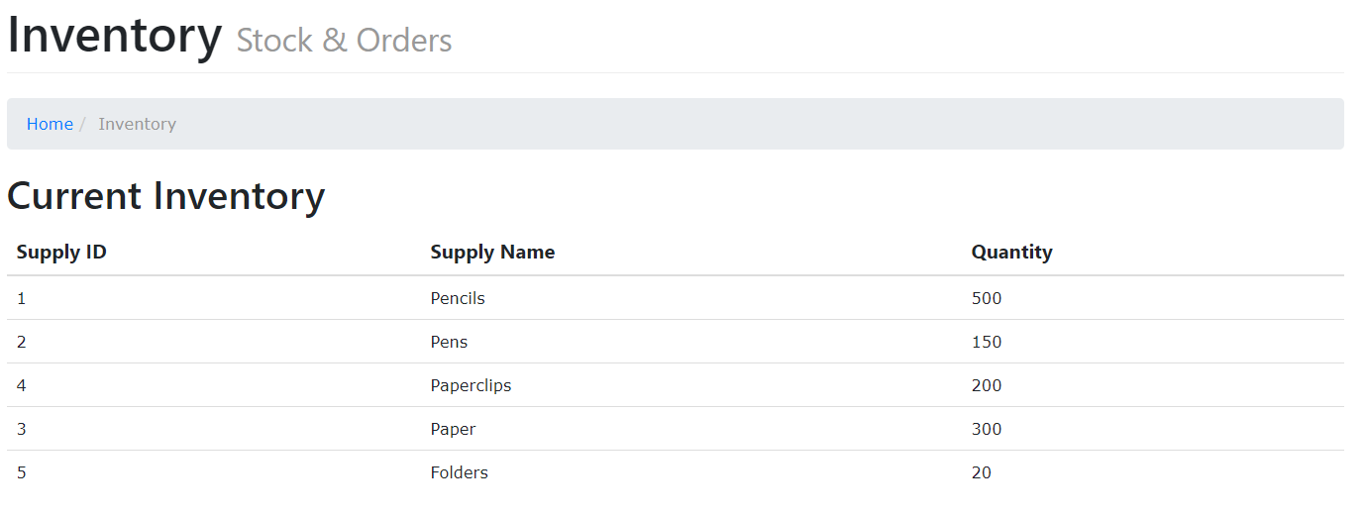

Employees:

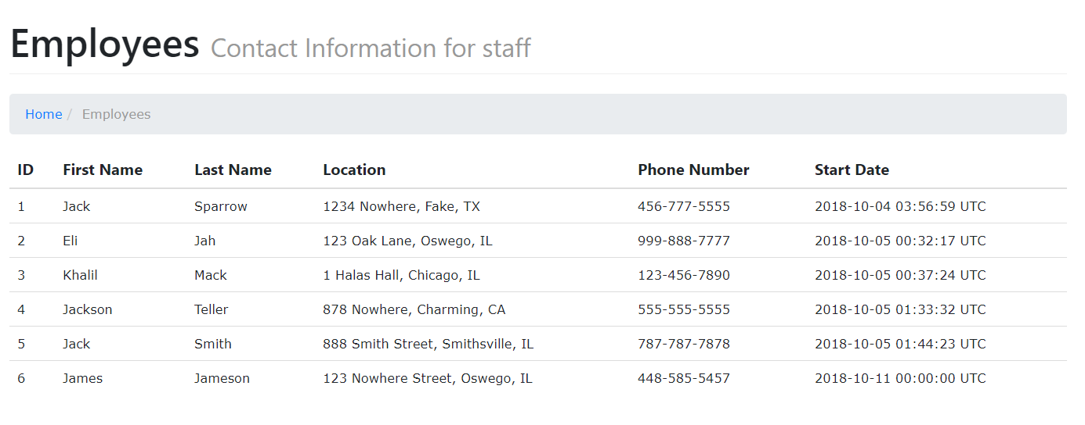

Cart:

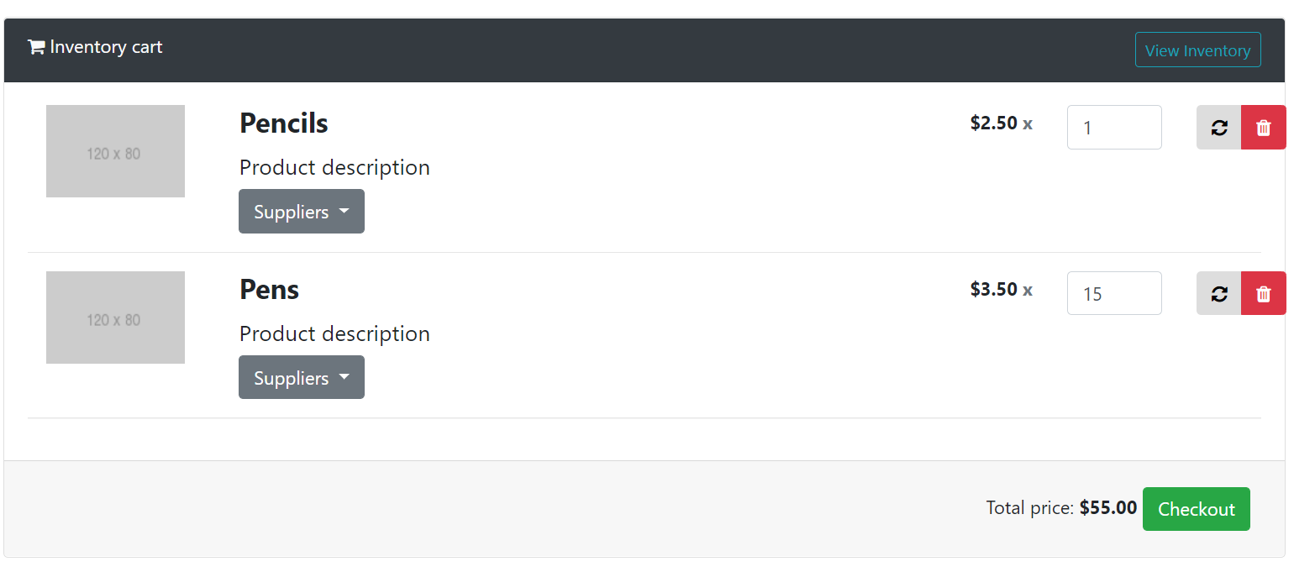

Cart Functionality:

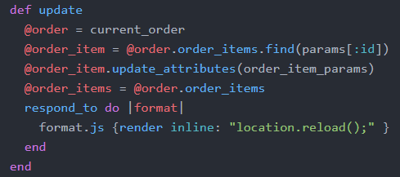

Admin Page:

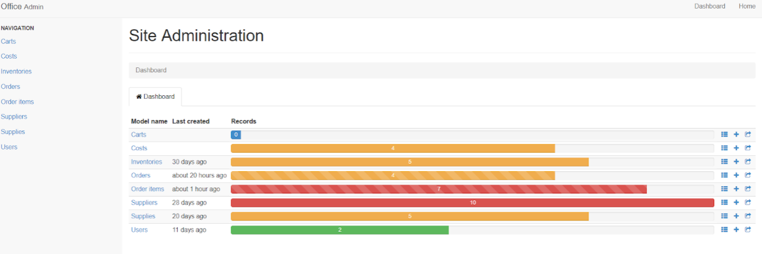

Query Page:

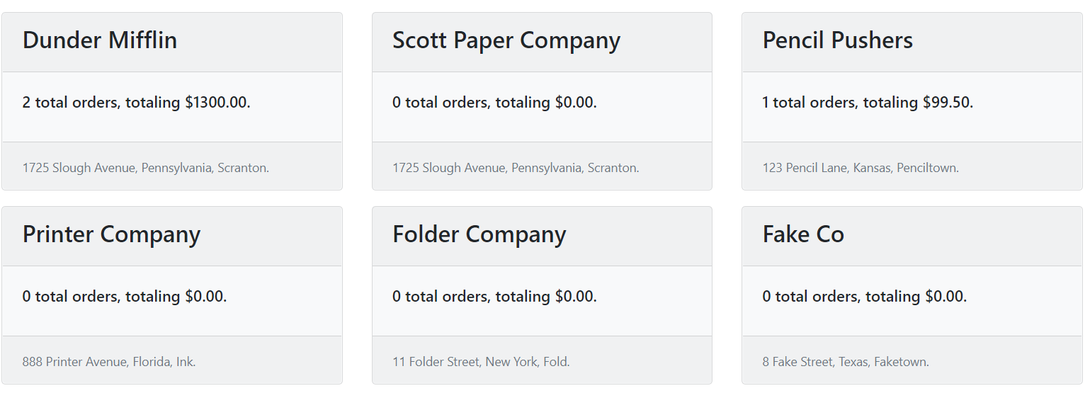

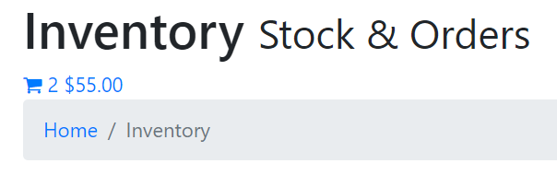 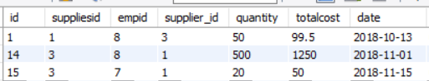

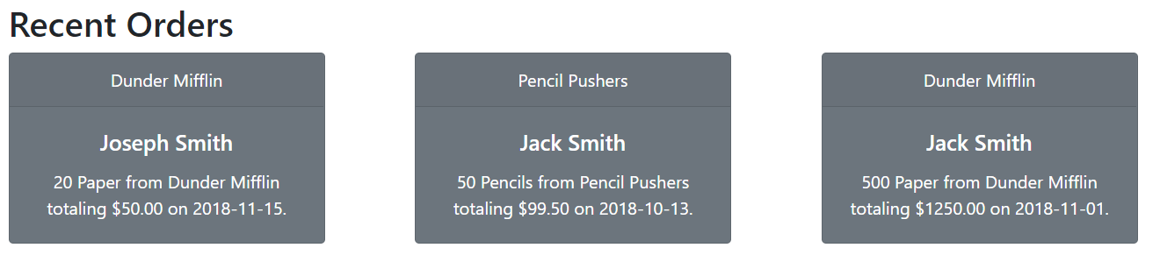

Order Functionality:

https://lh5.googleusercontent.com/DMZ3M6tWG9U5nqy5kgWYjBDd7zOstT8j-0Uyl2LVX5kKmVEpo8thg0Muia6558o1Pi44P9POJf0-BDVPADxo5sQ7jj2EM9fhZRZkI0TEo6xzh6du5qVF15LOZsnBEft7mbjh754td6Q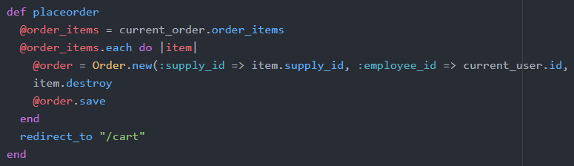

**TRIGGERS:**

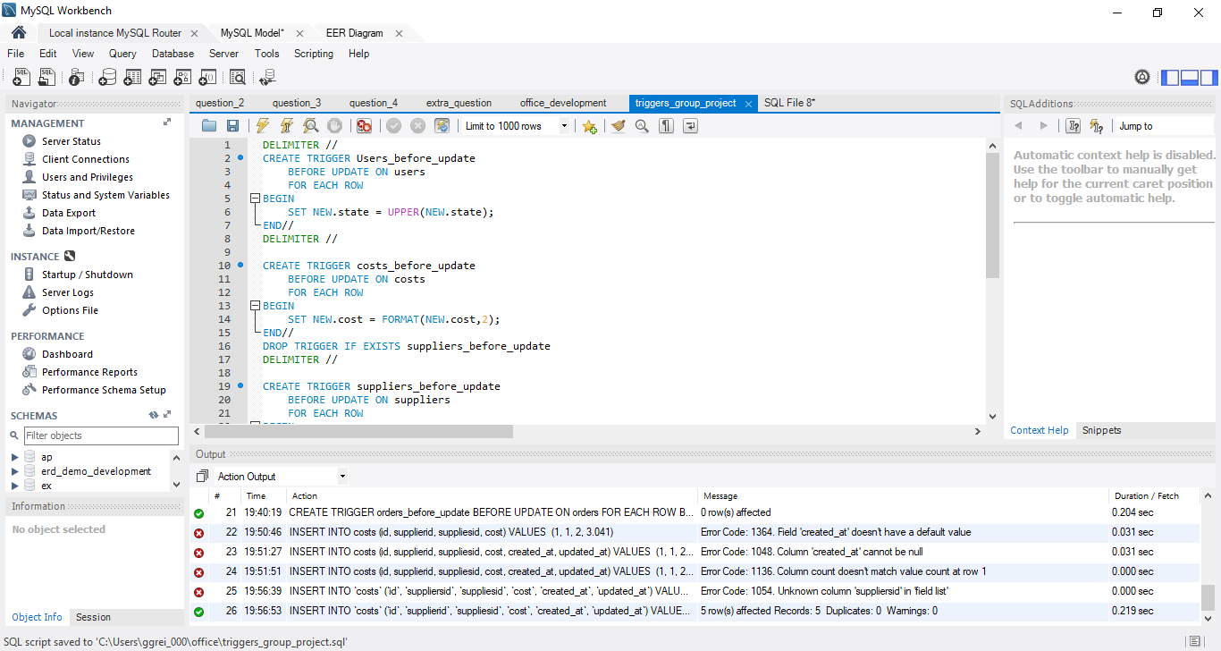

Triggers correct mixed-case state names in the users and suppliers database and format float variables to 2 decimal places for cost in the costs table and total cost in the orders table.

**EVENTS:**

Event to update inventory every 12 hours:

