# Technical Design Document: MariaGalante_ProgrammingExercise_6
# Name: Maria Galante
# Date: February 25, 2026
# Program Description: This program uses regular expressions to validate phone numbers, social security numbers, and ZIP codes entered by the user. The program contains separate functions for each validation and displays whether the input is valid or invalid.
## Function: main
Description:
This function gets user input and displays whether the phone number,
social security number, and ZIP code are valid.
Parameters:
None
Variables:
phone_number (str) - phone number entered by the user
ssn (str) - social security number entered by the user
zip_code (str) - ZIP code entered by the user
Steps:
1. Run test examples.
2. Ask the user to enter a phone number.
3. Ask the user to enter a social security number.
4. Ask the user to enter a ZIP code.
5. Validate each input.
6. Display whether each input is valid or invalid.
Returns:
None

## Function: validate_phone
This function checks if the phone number is in the format ###-###-####.
Parameters:
phone_number (str) - phone number entered by the user
Variables:
pattern (str) - regular expression pattern for a phone number
Steps:
1. Create the phone number regex pattern.
2. Use re.fullmatch() to check the entire input.
3. Return True if valid, otherwise return False.
Returns:
True if valid, False if invalid.
## Function: validate_ssn
This function checks if a social security number is valid.
The correct format is ###-##-####.
Parameters:
ssn (str) - social security number entered by the user
Variables:
pattern (str) - regular expression pattern for a social security number
Steps:
1. Create the SSN regex pattern.
2. Use re.fullmatch() to check the entire input.
3. Return True if valid, otherwise return False.
Returns:
True if valid, False if invalid.
## Function: validate_zip
This function checks if a ZIP code is valid.
It allows:
##### or #####-####
Parameters:
zip_code (str) - ZIP code entered by the user
Variables:
pattern (str) - regular expression pattern for ZIP codes
Steps:
1. Create the ZIP code regex pattern.
2. Use re.fullmatch() to check the entire input.
3. Return True if valid, otherwise return False.
Returns:
True if valid, False if invalid.
# Link to my repository: https://github.com/ggriaa/COP2373

Screenshot of invalid input:
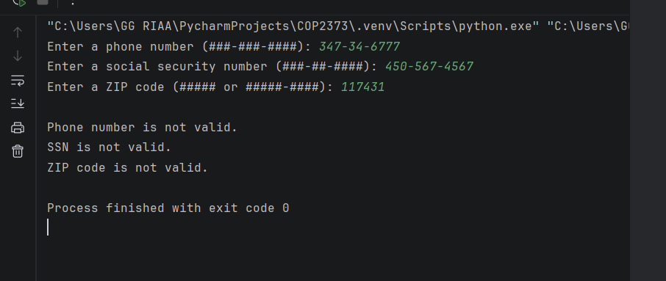

Screenshot of valid input:
