Technical Debugging Report: Debugging_Exercise.py

Name: Maria Galante
Date: January 26, 2026
Program Description: The errors happened due to inconsistent data types. The inconsistent data type was the price value for the Tablet because it was stored as a string ("500") instead of int or float. This caused the TypeErrors because the program tried to perform multiplication and subtraction using a string and floating-point values. The debugging process was used to find these errors, where to fix the code, improve error handling with error messages and verify correct program behavior.

Debugging Process

Step 1: Identify Initial Error
I placed a breakpoint on the following line inside the calculate_discount() function:
discount_amount = price * discount_rate
When the program paused in Debug mode, the Variables panel showed that the Tablet product price was stored as a string ('500') while the discount_rate value was a float (0.2). This caused a TypeError because Python cannot multiply a string by a floating-point value.
Screenshot Reference:
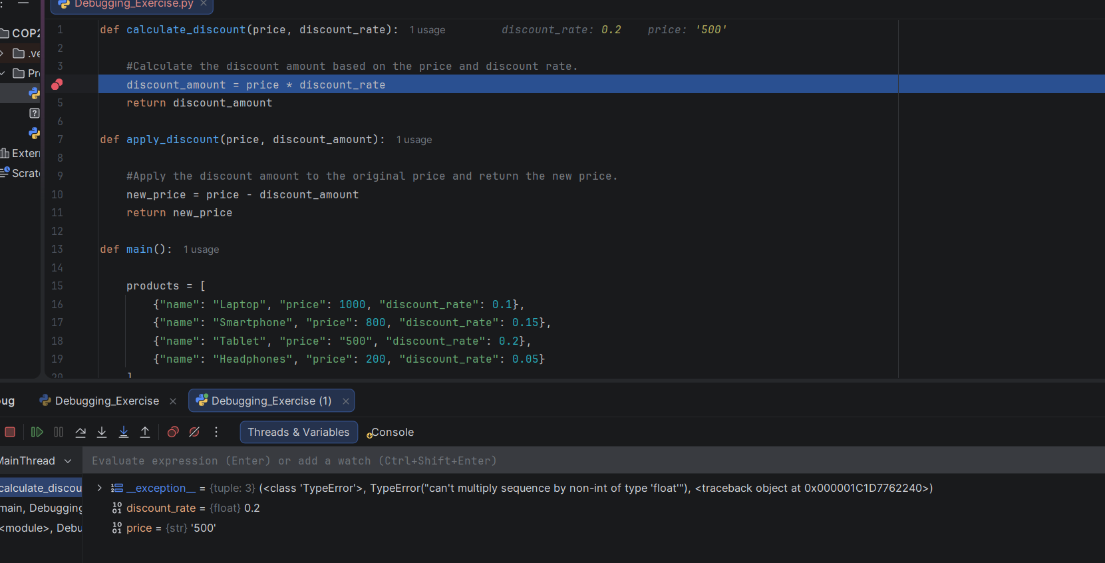

Step 2: Identify Secondary Error
After fixing the first multiplication issue, I ran the debugger again and. A second error appeared beside the apply_discount() function at the following line:
new_price = price - discount_amount
The debugger showed that price was still being passed as a string while discount_amount was a float. This caused another TypeError because subtraction between a string and float is not supported.
Screenshot Reference:
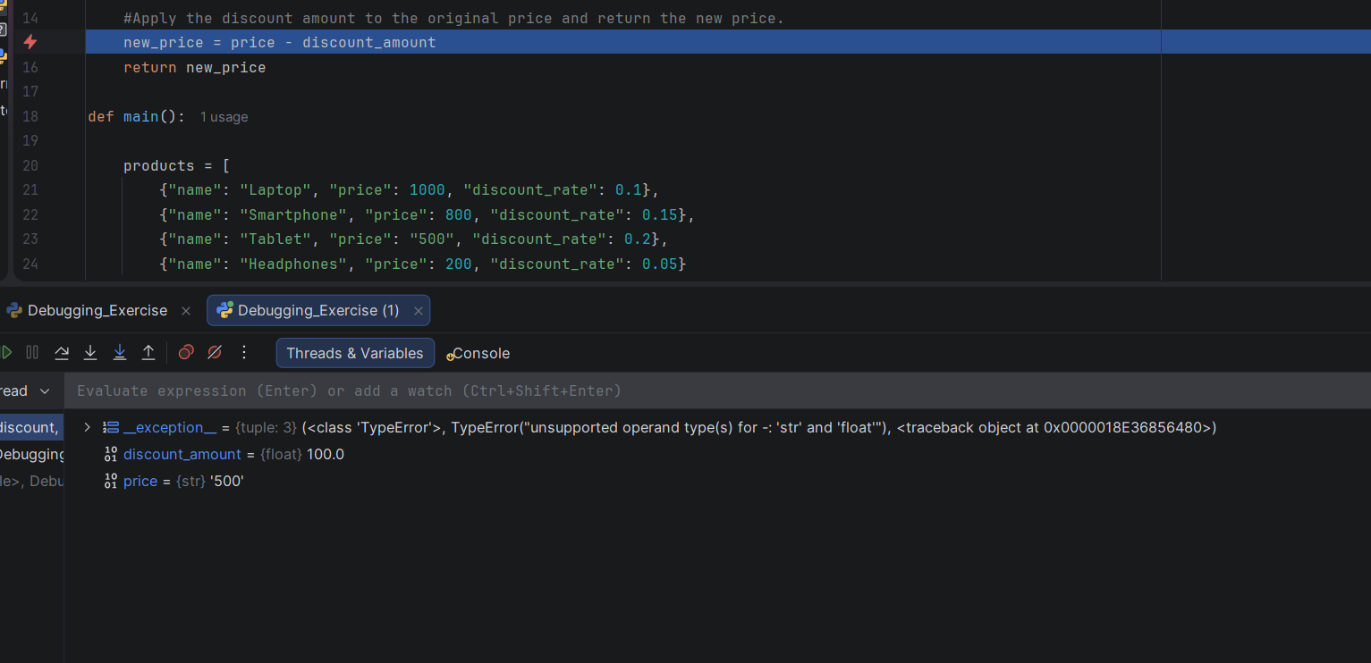

Fixes
1. Input Validation and Conversion
- Converted price and discount_rate values to float before performing calculations.
- Added error handling to detect invalid input and give error messages.
2. Discount Rate Validation
- made sure discount_rate values remain between 0 and 1.
3. Error Handling Improvements
- Added try/except to prevent the entire program from crashing.
- put in meaningful error messages for invalid inputs.
4. Consistent Type Handling
- Updated apply_discount() to convert price to float before subtraction.

Testing Results
After making all these fixes, I reran the program and all products went through successfully, including the Tablet product which had originally caused runtime errors. The program was completed without crashing.
Screenshot Reference:
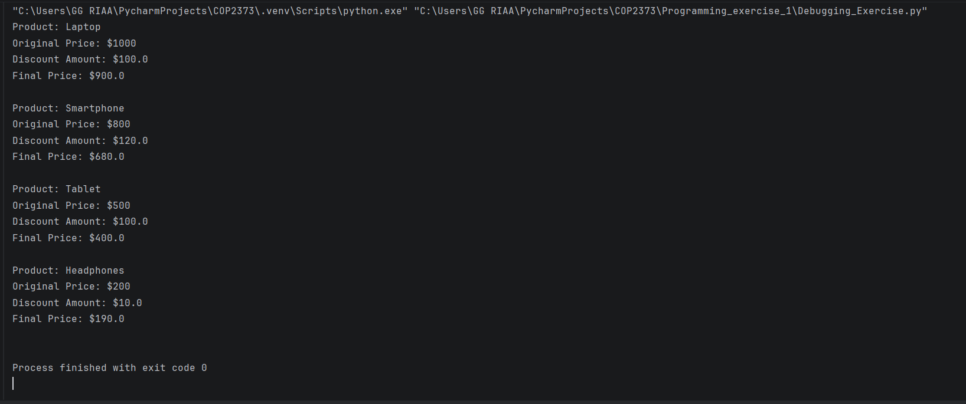

Conclusion
The debugging process identified two TypeErrors caused by the inconsistent data types (string and float) Using PyCharm’s debugging tools allowed mr to inspect the variables and find the exact error location. After putting input validation, type conversion, and error handling, the program now runs and produces the correct output.

Link to Repository
https://github.com/ggriaa/COP2373/

