Programming Exercise_4

Maria Galante
COP2373
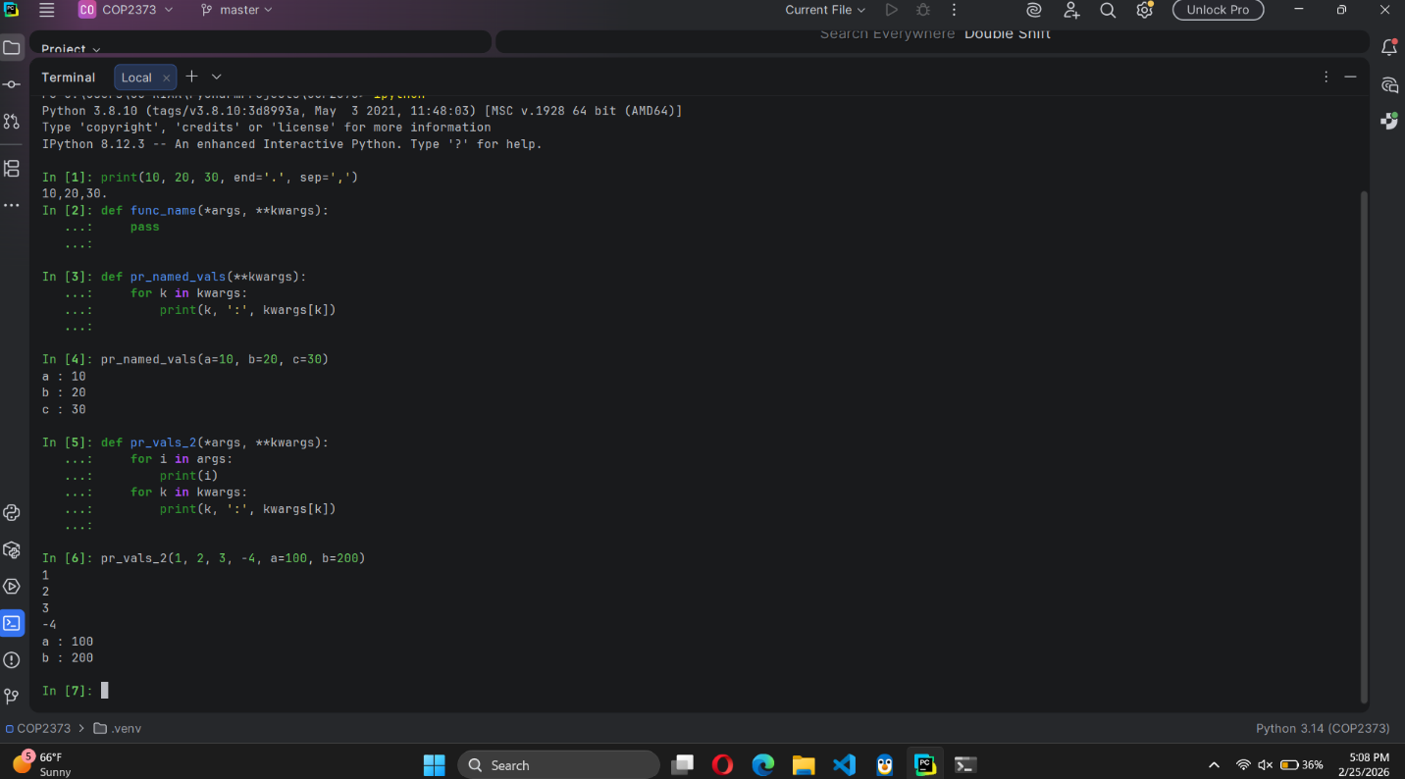
Advantages of using **kwargs
- It lets a function accept a flexible number of named arguments without rewriting the function every single time.
- It makes function calls easier to read since each value has a label.
- It helps with passing extra information between functions.
Disadvantages of using **kwargs
- It can make functions harder to understand because you don’t always know what arguments are expected.
- Mistyped keyword names might not be noticed unless you check them manually.
- Sometimes extra validation code is needed if certain keyword arguments are required.

