WELCOME
to
2024 South Bayshore Drive
at
Broadkill Beach, Delaware
We assembled this information
to help make your stay as safe and enjoyable as possible.
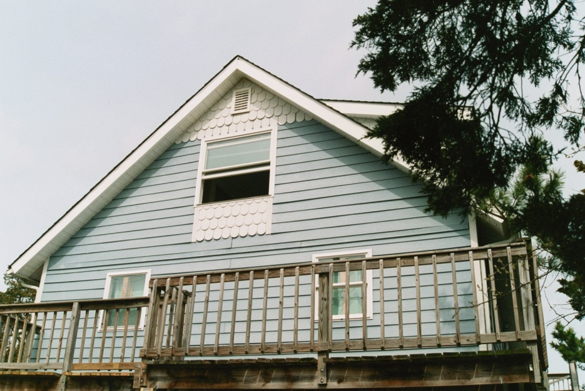
SAFETY
FIRE SAFETY
A FIRE EXTINGUISHER is located in the upper cabinet immediately adjacent to
the entrance door in the foyer. DO NOT HESITATE to use it if you see a fire
in or around the house.
Call the Milton Fire Department at 9-1-1 if you have a fire emergency.
CHILD SAFETY
For your children’s safety, we have provided child proofing devices in the kitchen cabinet drawer, including
- Outlet covers
- Cabinet locks
- Drawer locks
All of these devices are in a drawer in the kitchen.

Additionally, there are safety gates at the top and bottom of the inside stairs. Lastly, there are flotation devices for small children, located in the tall cabinet in the foyer.
FIRST AID
Band-Aids, hydrogen peroxide and rubbing alcohol may be found in the upper
cabinet to the right of the kitchen sink.
MEDICAL EMERGENCIES
Call 9-1-1 or visit the Emergency Room of Beebe Hospital; 424 Savannah Road;
Lewes, DE 19958.

Plastic Glasses and Plates
If you want to enjoy beverages at the beach, we provided dozens of unbreakable plastic glasses.
ABOUT THE HOUSE
SEPTIC SYSTEM
The house is on a septic system that is routinely maintained. Please DO NOT
flush paper towels or any sanitary products because they may clog the
system, causing unpleasant back-ups.

ELECTRONICS and APPLIANCES
There is a separate binder with copies of electronics and appliance owner’s manuals

INTERNET
The wireless account is “2024sbayshore”. The password is “oceanfront”.

TV AND STEREO
The silver Comcast remotes control the TV and the cable box in each room. These remotes are coded for the TV in the room where you will find each remote. If you try to use the Comcast remote for a TV in another room, it may not control the TV.

There is a home theatre DVD system in the living room. Use the remote with the “PHILLIPS” name to control it. If you put a DVD into the deck, it will automatically connect the sound and video signals. The Phillips deck can also used as an FM receiver by pushing the button marked “RADIO” on the remote. Additionally, your can direct the TV sound to play through the Phillips system by pushing the “TV” button. Lastly, there is an “I-POD” docking station to the right of the Phillips deck. Place your I-POD in it and push the “DOCK” button on the remote.

Pay per view programming has been blocked.

WASHER/DRYER
The washer is a high-efficiency model that requires HE detergent. We provided some Tide HE, or you may use another HE brand. Do not use regular detergent as it will create too many suds and your clothes may not rinse clean.

To put detergent into the washer, locate the small drawer on the top left of the machine. Pull it towards you while sliding the release tab to the right. Pour in your detergent and slide the drawer closed. The machine will automatically inject the detergent into the wash load.

KITCHEN
Baking pans are in the stove drawer. Pots and pans are in the corner cabinet to the left of the stove. Other kitchen hardware is in the large drawers.

TELEPHONE
The phone is for local use only. Voice mail is not accessible.
GARBAGE AND RECYCLING
Please place your garbage into the green receptacle by the street. Garbage is picked up early Wednesday mornings.

Recycling is picked up every other week. Delaware recycling is “single stream”, meaning glass, plastic and paper may be co-mingled. Please place your recycling materials in the blue bin at the street. If it is full, please place your recycling in a clear plastic bag (found under the kitchen sink) and place the bag in one of the black bins by the street labeled RECYCLING.

GAS GRILL
Open the grill cover before lighting. The grill is ignited by pushing in on the dial to the far right and slowly turning it counter-clockwise to the 9:00 position. You will hear a click, which is the igniter spark, and the grill should light. If not, wait until the gas has cleared out and try again. If the igniter doesn’t work, use the lighter stick stored above the refrigerator.

COOLING AND HEATING
There are air conditioners in each room. Use them as needed to cool off the house.
Solar Heating Effect
In the morning, the sun can heat up the living room. Closing the sliding window drapes for a few hours will help reduce this solar heating effect. Upstairs, the roof windows have shades that can be pulled shut to keep solar heat from accumulating.

Ceiling Fans
Ceiling fans will also help cool off the house. The ceiling fan and light in the first floor bedroom is controlled by a remote that is attached with VELCRO to the bedpost. Make sure the wall switch is on (up position). The wall shell sconce lamp is controlled by a touch dimmer. Each time you touch the brass chain, the light will get brighter or turn off.

Heat
If you need heat, there are baseboard heaters in the upper bedrooms. Use the thermostats on the walls by the beds to turn them on. There is another baseboard heater in the lower bath. Its thermostat is directly above it. For the lower floor bedrooms, there are portable baseboard heaters in the closet in the room with the futon. Place them in the rooms you want to warm.

Use only one portable heater per room or the electrical circuit will overload and shut off. If this happens, unplug the heater, move it and plug it to another outlet. The circuit breaker can be reset by opening the electrical panel in the foyer. It is located behind the upper cabinet door immediately to the right as you enter the house. Circuit breakers that are off will flip away from the center of the panel. Just flip them back toward the center.

FUTON
The futon can be laid flat by first sliding the mattress off. Once the mattress is off, lift and slide the back down. Guide the pins from the back frame through the groves in the seat frame. Then replace the mattress.

BLANKETS
There are extra blankets in the drawer beneath the stairs and in the upper west (road side) bedroom closet. Additionally, there are blankets in some of the dresser drawers.

JACUZZI
The Jacuzzi has two switches. One is a button on the deck of the tub. The other is on the bathroom wall to the right of the mirror.

INSECTS
Flies and mosquitoes are part of beach life. If you are opening and closing doors frequently, especially at night, mosquitoes may enter the house and gather in the ceiling corners. It’s futile to swat them as they will scatter and any you strike will leave stains on the white walls. There is a small Shop-Vac in the closet of the futon room. Use it to vacuum them from the ceiling. This avoids stains and gets all of the mosquitoes at once.

“No-see-ums” are a type of biting gnat that is small enough to get through the mesh in the screens. You can reduce their numbers by spraying the screens with an insecticide. Spray from the inside of the house toward the outside. Spraying insecticide around the deck lamps will reduce the bug population near the doors. We provided some insecticide under the sink.

While you are on the deck at night, Citronella products will help keep bugs away.

THE BEACH

BEACH CHAIRS
We provided beach chairs for your enjoyment. If you take them or any other equipment to the water, please bring them back to the house at the end of the day. The beach is public property and anything left there overnight may disappear by the next day.

BEACH TOYS
There are tubs of toys that your children are welcome to play with.

CHILD FLOTATION DEVICES
There are flotation devices for small children, located in the tall white cabinet in the foyer.
DUNES AND DUNE GRASS
Please use the marked foot path to get to the beach. Sand dunes and dune
grass are fragile and are critical to the preservation of this beautiful beach. Please avoid walking on dunes and dune grass. Wheeled or motorized vehicles are strictly prohibited on the beach.
SAND BAR
A natural sand bar has been forming in front of the house over the past
twenty years. At low tide, you may be able to wade into the water for a
distance.

HORSESHOE CRABS
The Delaware Bay is one of the most important homes of the Horseshoe Crab,
an endangered species thought to be 200-400 million years old. They are
harmless, do not bite and oblivious to your presence. Their tail is a
spike, but they do not use it as a weapon. As long as you avoid stepping on
the tail, it won't hurt you. If you see one on its back, feel free to gently flip it over.
STING RAYS
You may occasionally see fins peaking through water. If the fins are
parallel and move in cadence, they probably belong to sting rays.
DOLPHINS
These graceful creatures are easily recognized by their light gray bodies
that arch out of the water in breathing cycles. They travel in groups and may appear within 100 yards of shore.

MARINE CARCASSES ON SHORE

Occasionally, marine animals ranging from whales to loggerhead turtles to dolphins have expired and washed ashore. If you see a carcass, please call the Marine Education, Research and Rehabilitation Institute at 302-228-5029. They will investigate and dispose of it.

