DRAINSENSEAI: URBAN FLOOD NOWCASTING AND
AUTONOMOUS MUNICIPAL RESOURCE DISPATCH SYSTEM
A Project Report Submitted to
SRM UNIVERSITY - AP, ANDHRA PRADESH
for the Partial Fulfilment of the Requirements to Award the Degree of
BACHELOR OF TECHNOLOGY
IN
COMPUTER SCIENCE AND ENGINEERING
SCHOOL OF ENGINEERING AND SCIENCES
Submitted by
Gaurav Gautam | AP21110010133
Alok Raj | AP2111001010335
Ansh Shukla | AP21110011321
Aniket Mahto | AP21110011701

Under the Guidance of
Dr. Sanjay Kumar
Assistant Professor, Department of Computer Science and Engineering
SRM University - AP, Andhra Pradesh
Neerukonda, Mangalagiri, Guntur District, Andhra Pradesh - 522 240
November 2026

CERTIFICATE
Date: 13-11-2026
This is to certify that the project report titled "DrainSenseAI: Urban Flood Nowcasting and Autonomous Municipal Resource Dispatch System" is a genuine record of work carried out by Alok Raj, Gaurav Gautam, Ansh Shukla, and Aniket Mahto under my supervision. The work is genuine, original, and suitable for submission to SRM University - AP for the award of the degree of Bachelor of Technology in the School of Engineering and Sciences.
The data pipelines, hydrological physics formulations, machine learning benchmarks, and autonomous resource allocation algorithms described in this report were developed and validated by the students. To the best of my knowledge, the matter presented in this report has not been submitted elsewhere for the award of any other degree, diploma, or certificate.

Supervisor | Head of Department
(Signature)  Dr. Sanjay Kumar  Assistant Professor,  Department of CSE | (Signature)  Head of Department,  Department of CSE  School of Engineering and Sciences

ACKNOWLEDGEMENT
Several people and public institutions made this work possible, and we want to express our sincere gratitude for their guidance, critique, and support throughout the project.
First and foremost, we would like to acknowledge the guidance and support provided by our mentor and advisor, Dr. Sanjay Kumar, Assistant Professor in the Department of Computer Science and Engineering at SRM University - AP. His wisdom, experience, and critical questions helped steer us in the right direction. When our early model evaluations produced unrealistically high accuracies above 99 percent, his insistence on verifying train-test separation forced us to discover spatial and temporal autocorrelation issues in our dataset. That single intervention led to the development of our zero-leakage chronological split methodology.
We express our heartfelt thanks to our team members, Alok Raj, Gaurav Gautam, Ansh Shukla, and Aniket Mahto, who collaborated tirelessly, shared their technical insights, and worked together cohesively toward our common goal. Each member played an essential role in shaping the project outcome, from developing data cleaning scripts and hydrological physics formulations to training gradient-boosted trees and building the interactive Leaflet frontend.
We also acknowledge the open data resources provided by the Central Water Commission (CWC), the India Meteorological Department (IMD), and the European Space Agency (ESA) for public access to the Copernicus GLO-30 Digital Elevation Model. Without long-term river stage telemetry and daily rainfall records from the Krishna River Basin, empirical verification of urban flood nowcasting would have been impossible.
Finally, we are grateful for the laboratory computing facilities, library resources, and academic environment provided by SRM University - AP, which enabled us to carry out this engineering investigation successfully.

ABSTRACT
Urban flooding in Indian river basin metropolises is rarely a simple consequence of rainfall on flat ground. Pluvial surface accumulation compounds with riverine tailwater backflow to paralyze municipal drainage. During the September 1, 2024 storm in Vijayawada, 240.6 mm of rain coincided with Krishna River discharge exceeding 11.43 lakh cusecs at Prakasam Barrage. As river stages exceeded outfall crests, gravity drainage locked, sending floodwater backward into residential wards. Conventional disaster responses suffered from delayed situational awareness and lack of spatial dispatch prioritization.
DrainSenseAI addresses this through a physics-informed, multi-tier urban flood nowcasting and autonomous resource dispatch platform. The catchment is partitioned into 1,100 grid cells (250 m resolution, 50.6 sq km). The training matrix couples Copernicus 30 m DEM attributes, five years (2021 to 2025) of CWC rainfall records, and hourly stage telemetry from Prakasam Barrage. Preprocessing purged 1,502 negative SCADA dropouts (-990.33 m), imputed clipped DEM edges, and added 20 synthetic dry baseline days to balance the 111,100-sample matrix. Events were split strictly by calendar timeline (70 train, 15 validation, 16 late-2025 test holdouts) to prevent spatial and temporal data leakage.
A benchmark of six classifier architectures established that Platt-calibrated XGBoost is optimal for municipal operations. On the 17,600 unseen test samples, the calibrated model achieved 95.36 percent accuracy, 98.88 percent precision, 87.14 percent recall, 99.50 percent specificity, and 0.9920 ROC-AUC. It reduced false alarms from 464 to 58 across 11,699 safe cells, eliminating warning fatigue. Couplings include Tier 1 K-Means archetyping (K=4), Tier 3 failure attribution (95.14 percent accuracy), and a D8 Manning kinematic cascade graph, served via a FastAPI backend and an interactive Next.js Leaflet dashboard with NDMA Form D-4 equipment allocation.
Keywords: Urban flood nowcasting, Physics-informed machine learning, Calibrated XGBoost, USDA SCS Curve Number, Prakasam Barrage backwater, Chronological split, Municipal resource dispatch, Vijayawada catchment, SRM University - AP.

TABLE OF CONTENTS
1. Introduction
1.1 Context and Background of Indian Urban Deluges
1.2 Case Study: The September 2024 Budameru and Krishna River Deluge
1.3 Operational Problem Statement and Municipal Pain Points
1.4 Project Objectives and Engineering Milestones
1.5 Scope of Investigation and Known Constraints
2. Literature Review and Problem Formulation
2.1 Review of Classical Hydrodynamic Simulators (SWMM, HEC-RAS)
2.2 Black-Box Deep Learning vs Physics-Informed Frameworks
2.3 Prior Urban Flood Studies in Indian Coastal and Riverine Catchments
2.4 Formulation of the Three-Tier Decision Architecture
3. Overall System Architecture and Engineering Requirements
3.1 Three-Tier Architectural Decomposition
3.2 Hardware and Software Execution Environments
3.3 Functional and Non-Functional Performance Specifications
3.4 High-Level End-to-End System Data Flow
4. Dataset Engineering, Quality Audits, and Preprocessing
4.1 Raw Hydro-Meteorological and Geomorphic Data Repositories
4.2 Data Quality Auditing and Anomaly Resolution
4.3 Resolving Wet-Day Reporting Bias via Synthetic Dry Baselines
4.4 Spatiotemporal Matrix Construction via Cartesian Alignment
4.5 Dataset Class Distribution and Monsoonal Stratification
5. Hydrological Physics and Derived Feature Engineering
5.1 The Necessity of Physics-Informed Inductive Bias
5.2 USDA SCS-CN Runoff Model and Indian Soil Compaction Adjustment
5.3 Multiscale Topographic Position Index (TPI) Geomorphometry
5.4 Topographic Entrapment Index Formulation
5.5 Hydraulic Conduit Deficit and Surface Ponding Volume
5.6 River Barrage Hydraulic Backwater Pressure Modeling
6. Feature Selection and Data Leakage Prevention
6.1 Multicollinearity Diagnostics and Correlation Pruning
6.2 Wrapper Feature Selection via SFS, SBS, and RFECV
6.3 Final Nine-Feature Production Input Vector
6.4 The Fatal Flaw of Random Partitioning in Spatiotemporal Datasets
6.5 Zero-Leakage Chronological Event Splitting Protocol
7. Machine Learning Methodology and Multi-Tier Framework
7.1 Tier 1: Unsupervised Topographic Archetyping (K-Means)
7.2 Tier 2: Supervised Inundation Probability Classifier Architectures
7.3 Probability Calibration Theory and Platt Sigmoid Transformation
7.4 Tier 3: Multi-Class Root-Cause Failure Attribution
8. Model Training, Benchmarking, and Evaluation
8.1 Experimental Setup and Hyperparameter Configurations
8.2 Comparative Performance Across Six Binary Classifiers
8.3 Receiver Operating Characteristic and Precision-Recall Dynamics
8.4 Detailed Confusion Matrix Analysis and False Alarm Minimization
8.5 Calibration Reliability Diagrams and Brier Score Dynamics
8.6 TreeSHAP Global and Local Feature Attribution
8.7 Tier 3 Multi-Class Failure Attribution Evaluation
9. Deterministic Hydrological Routing and Cascade Engines
9.1 D8 Steepest Descent Directed Acyclic Hydrographic Graph (DAHG)
9.2 Manning Open-Channel Velocity and Travel Time Estimation
9.3 Downstream Volume Attenuation and Topological Sorting
10. System Implementation and Web Interface Architecture
10.1 FastAPI REST Backend Architecture and Endpoint Specifications
10.2 Next.js 14 Frontend Architecture and Leaflet Vector Grid
10.3 Temporal Nowcasting Slider and What-If Deluge Multiplier
10.4 Autonomous Fleet Dispatch Optimization (NDMA Form D-4)
10.5 Multilingual Internationalization (English, Hindi, Telugu)
11. Testing, Validation, and Verification
11.1 Backend Integration Test Suite (Pytest)
11.2 Frontend TypeScript Compilation and Strict Type Safety
11.3 Statistical Leakage Verification via Dummy Baselines
12. Results and Operational Discussion
12.1 Consolidated Test Holdout Findings (N=17,600)
12.2 Operational Trade-Offs in Municipal Decision Support
12.3 Simulation of Historical Flood Scenarios in Vijayawada
13. Limitations, Ethical Considerations, and Future Work
13.1 Critical Appraisal of Synthetic Hydrological Labels
13.2 Integration Roadmap for Sentinel-1 SAR Radar Flood Masks
13.3 Sub-Daily Satellite Precipitation via GPM IMERG
13.4 Future Directions for Multi-City Deployment
14. References

LIST OF FIGURES
Figure-1: Training Matrix Class Balance and Stratified Storm Event Distribution (N=111,100)
Figure-2: Tier 1 K-Means Urban Surface Archetypes Across 1,100 Vijayawada Grid Cells
Figure-3: Classifier Benchmark Comparison on the 17,600-Sample Chronological Test Holdout
Figure-4: Receiver Operating Characteristic (ROC) Curves for All Six Candidate Models
Figure-5: Precision-Recall Curves for All Six Candidate Models (Base Rate = 0.335)
Figure-6: Confusion Matrix of the Production Calibrated XGBoost Classifier (N=17,600)
Figure-7: Probability Calibration (Reliability) Diagram: Raw vs. Platt-Scaled XGBoost
Figure-8: Brier Score and Training Latency Across Candidate Classifiers
Figure-9: Relative Feature Importance (Gain) of the Nine Production Inputs
Figure-10: Tier 3 Multi-Class Root-Cause Attribution Metrics by Failure Mechanism

LIST OF TABLES
Table-1: System Module Summary and Software Stack Allocation
Table-2: Hydrodynamic Simulator vs Physics-Informed ML Comparison
Table-3: Raw Data Sources Retained in the Pipeline
Table-4: Chronological Train, Validation, and Test Event Splits
Table-5: Candidate Features Excluded During Collinearity and Wrapper Pruning
Table-6: Nine Production Features Selected for Model Training
Table-7: Tier 1 K-Means Surface Archetype Statistics (K=4)
Table-8: Tier 2 Binary Classifier Benchmark Results (Test Holdout, N=17,600)
Table-9: Detailed Confusion Matrix Breakdown for Production Calibrated XGBoost
Table-10: Tier 3 Multi-Class Root-Cause Attribution Metrics and Actions
Table-11: DAHG Manning Flow Velocity and Routing Parameters Across Archetypes
Table-12: Selected FastAPI REST Backend Endpoints and Method Signatures
Table-13: NDMA Form D-4 Equipment Dispatch Specifications and Allocation Rules
Table-14: Production Model Summary Metrics on Unseen 2025 Storms

1. INTRODUCTION

1.1 Context and Background of Indian Urban Deluges
Urban flooding across the Indian subcontinent has transformed from an occasional seasonal nuisance into a recurring humanitarian and economic crisis. As metropolitan areas expand, natural infiltration beds, agrarian floodplains, and wetland sinks are progressively paved over with impermeable asphalt and concrete. Stormwater runoff that once soaked into open soil now accumulates on roadways within minutes of a convective downpour. In riverine and coastal cities, this pluvial surface accumulation collides with high river stages or tidal surges, creating hydraulic locks where stormwater conduits cannot empty into their receiving water bodies.
Standard drainage networks in Indian Class-I cities are typically designed according to guidelines from the Central Public Health and Environmental Engineering Organisation (CPHEEO). These manuals recommend designing stormwater systems to handle rainfall intensities of 12 to 20 mm per hour, corresponding to a 1-year or 2-year return period. However, climate change and localized convective cloudbursts routinely produce rainfall intensities exceeding 50 to 80 mm per hour. When intense storms strike, the hydraulic capacity of curbside gutters, buried conduits, and open masonry canals is rapidly overwhelmed. Water ponds on low-lying street surfaces, submerging ground-floor dwellings, stalling vehicular traffic, and severing critical municipal access routes.

1.2 Case Study: The September 2024 Budameru and Krishna River Deluge
The vulnerability of Indian riverine metropolises was starkly illustrated between August 31 and September 2, 2024, in the city of Vijayawada, located along the Krishna River in Andhra Pradesh. Vijayawada occupies a complex geomorphic position. To the south lies the main stem of the Krishna River, controlled by the historic Prakasam Barrage. To the north and northwest flows the Budameru rivulet, colloquially termed the Sorrow of Vijayawada, which drains an expansive upper catchment in the Velagaleru hills.
On September 1, 2024, an intense depression over the Bay of Bengal stalled directly over the Krishna-Guntur basin. The rain gauge at Vijayawada recorded 240.6 mm of continuous precipitation in twenty-four hours. Simultaneously, discharge from upstream reservoirs in Karnataka and Telangana rushed into the lower Krishna stem, pushing water levels at Prakasam Barrage to historic highs. Discharge across the barrage crest reached 11.43 lakh cusecs (approximately 32,366 cubic metres per second), the highest volume observed in two decades.
This compound event triggered a widespread municipal catastrophe. The elevated river stage at Prakasam Barrage sat substantially higher than the outfall sill levels of the municipal stormwater system. Gravity drainage ceased completely. Rather than city stormwater discharging into the river, river water pushed backward through masonry outfalls. In northern wards, breaches along the Budameru diversion channel sent floodwaters surging into residential colonies including Ajit Singh Nagar, Payakapuram, Kundavari Kandrika, and Vambay Colony. Water depths in these wards reached two to three metres, submerging residential properties and stranding over 250,000 residents for days.

1.3 Operational Problem Statement and Municipal Pain Points
During the September 2024 deluge, field interviews and municipal debriefs revealed critical failures in operational decision-making. Municipal commissioners, disaster response teams, and National Disaster Response Force (NDRF) personnel confronted three fundamental challenges:
- Absence of Street-Scale Spatial Granularity: Regional rainfall forecasts issued by meteorological agencies provided district-level rainfall warnings (for example, heavy rain across Krishna District) but offered zero guidance on which 250-metre urban sectors would submerge first. Emergency teams could not pre-position mobile equipment before access roads flooded.
- Lack of Predictive Probability Calibration: Commercial weather apps provide percentages that reflect rain chances rather than ground-level inundation probability. Uncalibrated alarms produce warning fatigue; when emergency sirens sound repeatedly without localized flooding, residents and shopkeepers ignore official directives.
- Blindness to Physical Failure Mechanisms: Inundation in Vijayawada occurs via distinct civil engineering mechanisms: local culvert blockage, pavement runoff chokes, topographic bowl trapping, or river tailwater backflow. Sending high-head dewatering pumps to a sector suffering from river backflow is futile; what is required is closing outfall flap-gates and constructing sandbag bunds. Dispatching the wrong equipment squanders valuable emergency resources.

1.4 Project Objectives and Engineering Milestones
To resolve these operational deficits, DrainSenseAI was conceptualized as a physics-informed machine learning and autonomous resource dispatch platform. The engineering milestones established for this project include:
- Compiling a curated, leak-free spatiotemporal database uniting 1,100 Vijayawada spatial grid cells with 101 historical rainfall and river telemetry events recorded between 2021 and 2025.
- Deriving physics-based features grounded in the USDA Soil Conservation Service Curve Number methodology, multiscale Topographic Position Index analysis, and Prakasam Barrage hydraulic head.
- Enforcing a strict chronological split protocol so that no storm date appears simultaneously in training and testing partitions, eliminating the artificial accuracy that plagues random splits.
- Benchmarking six classification architectures and implementing 3-fold Platt sigmoid calibration to drive false alarms below 1 percent on safe municipal sectors.
- Developing a multi-class failure attribution classifier that categorizes flood triggers into actionable physical modes, linking predictions to autonomous equipment allocation under National Disaster Management Authority (NDMA) Form D-4 protocols.
- Constructing an interactive, responsive web dashboard and high-throughput REST API that allows municipal officers to inspect real-time risk, trace downhill runoff cascades, and execute what-if simulations with zero client-side lag.

1.5 Scope of Investigation and Known Constraints
The active production pipeline models 1,100 grid cells across Vijayawada and Amaravati, encompassing 50.6 square kilometres. While the user interface includes switchers for Chennai, Mumbai, and Bengaluru, those cities currently rely on static demonstration data until municipal drainage GIS layers and local gauge feeds are integrated. Furthermore, because Vijayawada lacks a dense network of electronic street water-level sensors, historical flood labels were generated using a multi-criteria analytical hydrology formulation rather than satellite synthetic aperture radar masks. This constraint and our roadmap to transition to Sentinel-1 SAR observations are examined thoroughly in Chapters 11 and 13.

2. LITERATURE REVIEW AND PROBLEM FORMULATION

2.1 Review of Classical Hydrodynamic Simulators (SWMM, HEC-RAS)
For decades, the gold standard in urban stormwater analysis has been numerical hydraulic and hydrologic simulation. Packages such as the United States Environmental Protection Agency Storm Water Management Model (EPA SWMM), the US Army Corps of Engineers Hydrologic Engineering Center River Analysis System (HEC-RAS 2D), and DHI MIKE FLOOD solve numerical approximations of the Saint-Venant shallow water equations across discretized terrain meshes.
While these deterministic engines provide rigorous hydrodynamic outputs, including flow velocity vectors and water surface elevations, their application in real-time operational nowcasting is fundamentally constrained by computational complexity. Solving two-dimensional shallow water partial differential equations across an urban mesh of several hundred thousand elements requires tens of minutes to multiple hours of compute time per storm scenario. During a cloudburst, when emergency managers need updated inundation projections every ten to fifteen minutes as radar reflectivity updates, numerical solvers are too slow to inform live evacuations.
Furthermore, numerical simulators demand exhaustive civil engineering inputs: precise cross-sectional dimensions of underground storm drains, invert elevations, conduit roughness coefficients, and manhole junction head-loss parameters. In Indian municipal corporations, underground stormwater conduits are frequently unmapped, partially silted, or altered by informal construction. When subsurface boundary conditions are inaccurate or missing, numerical solvers fail to converge or produce physically unrealistic results.

2.2 Black-Box Deep Learning vs Physics-Informed Frameworks
To bypass the computational bottleneck of numerical solvers, recent academic literature has explored pure data-driven machine learning, including Convolutional Neural Networks (CNNs), Long Short-Term Memory (LSTM) networks, and gradient-boosted trees. While these models execute inference in milliseconds, pure black-box models exhibit severe vulnerabilities when applied to urban flood prediction.
First, black-box networks suffer from the curse of data sparsity. Unlike computer vision domains with billions of labeled images, urban flood records in Indian cities are limited to a handful of severe monsoon events per year. When an over-parameterized neural network is trained on sparse raw features (such as raw elevation and daily precipitation), it memorizes arbitrary spatial coordinates rather than learning physical hydrology. In validation tests, such models have been observed predicting inundation on elevated, steep hilltops simply because heavy rain fell across that coordinate.
Second, pure statistical models lack physical consistency. They have no internal representation of mass conservation, infiltration capacity barriers, or topographic bowl curvature. DrainSenseAI bridges this divide by implementing a Physics-Informed Machine Learning (PIML) approach. Rather than forcing an algorithm to learn fluid dynamics from scratch, we inject a century of proven civil engineering knowledge into the feature space through analytical hydrology equations.
Dimension | Numerical Solvers (SWMM / HEC-RAS) | Pure Black-Box AI (CNN / LSTM) | DrainSenseAI (Physics-Informed ML)
Inference Speed | 30 mins to 4 hours per event | 50 to 200 milliseconds | 440 milliseconds (17,600 cells)
Data Requirements | Complete CAD/GIS conduit mesh | Millions of IoT data points | Copernicus DEM + CWC gauges
Physical Soundness | High (conservation of mass) | Low (hallucinates anomalies) | High (bounded by SCS-CN & D8)
False Alarm Control | Moderate (boundary sensitive) | Poor (severe warning fatigue) | High (Platt Sigmoid calibrated)
Root Cause Analysis | Manual engineering audit | Opaque black-box outputs | Automated multi-class attribution
Operational Deploy | Specialized workstation | Cloud GPU dependency | Lightweight CPU / Offline Next.js
Table-2: Hydrodynamic Simulator vs Physics-Informed ML Comparison

2.3 Prior Urban Flood Studies in Indian Coastal and Riverine Catchments
Previous research into urban deluge modeling across India provides important context for our work. Studies in Chennai following the catastrophic 2015 Adyar River flood demonstrated that uncontrolled urban sprawl across the Pallikaranai marshlands reduced natural flood retention storage by over 60 percent. Investigations in Mumbai following the July 26, 2005 cloudburst (944 mm in 24 hours) highlighted how tidal tailwater locks the Mithi River outfalls, preventing gravity discharge during high-tide windows.
In the Krishna River Basin, research by the Central Water Commission and the National Remote Sensing Centre (NRSC) focused primarily on macro-scale basin routing, such as predicting reservoir inflows into Srisailam and Nagarjuna Sagar dams. However, localized urban flooding within the Vijayawada municipal limits remained under-studied. Most published models treated Vijayawada as a single lumped hydrological unit, obscuring critical intra-ward variations between upland rocky slopes near Indrakeeladri and the vulnerable alluvial sumps of Ajit Singh Nagar.

2.4 Formulation of the Three-Tier Decision Architecture
To address these limitations, DrainSenseAI establishes a sequential three-tier decision pipeline:
- Tier 1 (Unsupervised Surface Archetyping): Clusters 1,100 grid cells into four distinct geomorphic profiles using K-Means, establishing baseline physical terrain classes.
- Tier 2 (Calibrated Binary Inundation Prediction): Evaluates the probability of inundation using an optimized gradient boosted tree, passing raw scores through Platt sigmoid calibration.
- Tier 3 (Multi-Class Failure Attribution): Classifies each flooded cell into its primary civil engineering root cause, automatically generating targeted equipment dispatch plans.

3. OVERALL SYSTEM ARCHITECTURE AND ENGINEERING REQUIREMENTS

3.1 Three-Tier Architectural Decomposition
The DrainSenseAI software system is organized into three decoupled layers: an offline ML training and hydrological physics engine, a high-performance REST API backend, and an interactive GIS web dashboard. This separation of concerns ensures that computationally intensive training occurs offline, while operational inference and spatial rendering remain instantaneous.
System Layer | Technical Stack | Core Responsibilities
Offline ML Pipeline | Python 3.10, scikit-learn 1.7.2, xgboost 3.2.0, pandas | Data curation, SCS-CN feature engineering, K-Means clustering, XGBoost training, Platt calibration, artifact serialization
Hydrological Engines | NumPy, SciPy, custom D8 & Manning routing modules | Analytical runoff calculation, DAHG directed flow graph construction, travel time estimation, barrage backwater head modeling
Backend REST API | FastAPI 0.125, Uvicorn, SQLAlchemy, Pydantic | 28 REST endpoints, model loading, real-time risk scoring, TreeSHAP explanation extraction, ILP dispatch optimization
Frontend Application | Next.js 14, React 18, TypeScript, Tailwind CSS, Leaflet | 60/40 map and diagnostics interface, canvas tile rendering, interactive time-slider, What-If simulator, trilingual i18n
Operational Copilot | Gemini Flash / Groq Llama-3.3 / Local RAG pipeline | Natural language situational querying, automated municipal situation briefing, NDMA Form D-4 report generation
Table-1: System Module Summary and Software Stack Allocation

3.2 Hardware and Software Execution Environments
A primary engineering requirement for DrainSenseAI was avoiding expensive hardware dependencies. Municipal corporations in developing regions rarely possess dedicated GPU computing clusters. All training pipelines and inference routines were architected to execute efficiently on standard commodity x86-64 hardware.
Experimental profiling on an Intel Core i7-12700H CPU with 16 GB of DDR4 RAM running Windows 11 demonstrated that fitting all six candidate models on 77,000 training samples requires less than 5 seconds total. Running batch inference across 17,600 held-out test rows takes 0.44 seconds. Memory footprint is modest: the five serialized model artifacts (.joblib files) occupy less than 2.5 MB of storage, allowing them to be loaded into application memory during API cold start in under 2 seconds.

3.3 Functional and Non-Functional Performance Specifications
To ensure operational reliability during municipal emergencies, we established four non-functional performance benchmarks:
- False Alarm Minimization: The classifier must maintain greater than 95 percent precision on safe sectors, driving false positive rates below 1 percent to eliminate warning fatigue among field teams.
- Sub-Second Inference Response: The backend API must return spatial risk GeoJSON payloads for all 1,100 grid cells within 500 milliseconds, ensuring that interactive web UI sliders remain responsive.
- Zero Temporal Leakage: Splitting protocols must strictly isolate calendar storm events between training and testing, preventing same-day weather leakage.
- Offline Fault Tolerance: If the backend service becomes unreachable, the client dashboard must seamlessly transition to cached GeoJSON vectors, displaying the last known risk state.

3.4 High-Level End-to-End System Data Flow
The end-to-end data lifecycle proceeds through five stages. First, atmospheric rainfall forecasts from IMD and hourly river telemetry from CWC Prakasam Barrage are ingested. Second, raw features are coupled with static Copernicus DEM attributes to calculate derived hydrology metrics (SCS-CN runoff, TPI, and backwater pressure). Third, the 9-feature vector is passed to the Calibrated XGBoost model to generate cell-level probabilities. Fourth, flooded cells are attributed to physical causes via the Tier 3 classifier, and downhill flow paths are traced using the DAHG cascade graph. Finally, the Integer Linear Programming (ILP) optimizer computes pump allocations and presents actionable overlays on the Next.js Leaflet map.

4. DATASET ENGINEERING, QUALITY AUDITS, AND PREPROCESSING

4.1 Raw Hydro-Meteorological and Geomorphic Data Repositories
The foundational empirical dataset for DrainSenseAI was assembled from five distinct open government and earth observation sources, totaling approximately 110 MB of raw files before geospatial filtering. We filtered this down to 16.5 MB of curated records strictly covering the Vijayawada municipal boundary and the adjacent Krishna River corridor.
Repository File | Size | Contents, Source Organization and Access Link
terrain_features.csv | 612 KB | 1,100 grid cells x 36 spatial columns from Copernicus GLO-30 DEM (30 m). Source: European Space Agency (ESA) & OpenTopography (https://portal.opentopography.org/)
cwc_krishna_river_telemetry_vja.csv | 14.8 MB | 65,776 hourly river stage and discharge measurements across 4 CWC gauge stations (2021-2025). Source: Central Water Commission India-WRIS (https://indiawris.gov.in/wris/)
cwc_daily_rainfall_krishna_vja.csv | 411 KB | 2,738 daily rain-gauge records covering Krishna and Guntur districts (2021-2025). Source: Central Water Commission & IMD Open Government Data (https://data.gov.in/)
urban_pluvial_flood_risk_dataset.csv | 441 KB | 2,963 urban drainage records across 60 Indian cities providing baseline soil runoff coefficients. Source: Zenodo Open Research Data (https://zenodo.org/)
catchment_characteristics_indofloods.csv | 146 KB | 108 regional basin geomorphic indices from the IndoFloods national catchment database. Source: IIT Gandhinagar / Zenodo (https://zenodo.org/records/7808241)
vijayawada_event_telemetry.csv | 4.5 KB | 101 stratified daily storm events (2021-2025) pairing 24h rain and Prakasam stage. Source: DrainSenseAI Repository (https://github.com/ggthedeveloper/DrainSenseAI)
Table-3: Raw Data Sources Retained in the Pipeline

4.1.1 Copernicus GLO-30 Digital Elevation Model (terrain_features.csv)
The digital elevation model was harvested from the European Space Agency Copernicus GLO-30 Global Digital Surface Model at 30-meter resolution (https://portal.opentopography.org/). Spanning tile Copernicus_DSM_COG_10_N16_00_E080_00_DEM.tif, it covers the 50.6 square kilometer study area across Vijayawada. From this layer, 36 spatial attributes were extracted per 250m cell, including elevation percentiles, two-dimensional finite-difference slopes, and multiscale Topographic Position Indices (tpi_3, tpi_7, and tpi_11).

4.1.2 CWC Krishna River Basin Hourly SCADA Telemetry (cwc_krishna_river_telemetry_vja.csv)
River stage observations were retrieved from the Central Water Commission (CWC) Water Resources Information System (https://indiawris.gov.in/wris/). The archive comprises 65,776 hourly records from 2021 through 2025 across primary hydrometric monitoring stations influencing Vijayawada outfalls, including Prakasam Barrage, Keesara, Paleru Bridge, and Polampalli. Telemetry tracks river water level, hourly level rise rate, and hydraulic backwater head against municipal outfalls.

4.1.3 CWC and IMD Daily Ground-Gauge Rainfall Series (cwc_daily_rainfall_krishna_vja.csv)
Precipitation records were acquired from the Central Water Commission and the India Meteorological Department through the Open Government Data Platform India (https://data.gov.in/ and https://mausam.imd.gov.in/). The dataset contains 2,738 daily rain-gauge records covering Krishna and Guntur twin-basin districts between 2021 and 2025, recording calibrated 24-hour rainfall accumulations, station coordinates, and acquisition timestamps.

4.1.4 IndoFloods Geomorphic Catchment Database (catchment_characteristics_indofloods.csv)
Basin-scale geomorphic parameters were drawn from the IndoFloods national catchment database, published by the Indian Institute of Technology Gandhinagar under the National Hydrology Project (https://zenodo.org/records/7808241). The dataset contains 108 geomorphic and hydro-morphological indices across Indian river systems, providing stream orders, bifurcation ratios, and regional drainage network parameters.

4.1.5 Urban Pluvial Drainage Infrastructure Benchmark (urban_pluvial_flood_risk_dataset.csv)
Baseline drainage parameters were obtained from the Urban Pluvial Drainage Infrastructure Benchmark Archive on Zenodo (https://zenodo.org/). Covering 2,963 urban drainage segments across 60 Indian and global municipalities, it establishes reference distributions for drainage conduit density, curb inlet types, and USDA Soil Conservation Service curve number baselines.

4.1.6 Consolidated Spatiotemporal Event Matrix (vijayawada_event_telemetry.csv)
The compiled event catalog was synthesized by coupling peak daily rainfall from CWC gauges with concurrent Prakasam Barrage river stages (https://github.com/ggthedeveloper/DrainSenseAI). Spanning 101 stratified daily events from 2021 to 2025, it captures the full operational range from 20 zero-rainfall control days to the 240.6 mm cloudburst of September 1, 2024.

4.2 Data Quality Auditing and Anomaly Resolution
An exhaustive audit of the raw hydro-meteorological data revealed four serious anomalies that would have corrupted model training if left uncorrected:
- Clipped DEM Boundary Cells (12 Cells): Twelve peripheral cells along the western municipal perimeter partially clipped the Copernicus DEM bounding box, resulting in NaN values across all elevation, slope, and TPI columns. Replacing NaNs with 0 m would place these urban cells at sea level, whereas filling with the citywide mean (23.9 m) would create an artificial cliff edge. We implemented a 1-hop Euclidean nearest-neighbor spatial imputation from the closest valid cell (250 m away) and flagged those records with an imputed = 1 audit bit.
- Missing Flow Accumulation Column: The flow_accumulation_mean attribute was entirely null across all 1,100 cells because the upstream hydro-enforcement routing script had not been executed on the raw DEM tile. Rather than imputing synthetic numbers, we excluded this column entirely.
- SCADA Sensor Fault Codes (-990.33 m): In the hourly Prakasam Barrage water-level series, 1,502 of the 6,934 recorded hours (21.6 percent) registered negative values down to -990.33 m. These are standard hardware fault codes indicating sensor disconnection or telemetry drops during severe monsoon storms. Filtering out these dropouts and imputing the seasonal non-flood median stage (3.75 m) restored continuity.

4.3 Resolving Wet-Day Reporting Bias via Synthetic Dry Baselines
A critical finding from our data audit was severe reporting bias in the government rainfall archive. The CWC daily rainfall file contained records exclusively for dates with measurable precipitation (ranging from 0.2 mm to 240.6 mm). There were zero dry days recorded over the entire five-year span. If a machine learning classifier is trained solely on rainy days, it never learns what benign, dry conditions look like; it becomes hyper-sensitive, predicting floods even under minor precipitation.
To establish a realistic negative baseline, we introduced 20 synthetic dry control days characterized by 0.0 mm rainfall and seasonal median river stages (3.40 m). This intervention balanced the negative class and ensured that models learn to distinguish non-flooding conditions accurately.

4.4 Spatiotemporal Matrix Construction via Cartesian Alignment
Urban flood modeling requires coupling static physical terrain with dynamic atmospheric forcing. The 1,100 spatial grid cells represent invariant geomorphic properties, whereas weather and river stages vary across time. To unify these dimensions, we performed a full Cartesian cross-join across all 1,100 cells and 101 selected historical events, generating a structured matrix of exactly 111,100 samples with zero missing or infinite values.

4.5 Dataset Class Distribution and Monsoonal Stratification
The 101 events were selected via stratified sampling across five rainfall intensity tiers: 20 dry baseline days (0 mm), 15 light rain events (under 10 mm), 25 moderate events (10 to 35 mm), 30 heavy events (35 to 80 mm), and 11 extreme storm events (exceeding 80 mm, including the 240.6 mm deluge of September 1, 2024). Within the 111,100 samples, 23,298 rows (21.0 percent) represent positive flooded states (inundation probability >= 0.45) and 87,802 rows (79.0 percent) represent safe conditions. This 1:4 positive-to-negative ratio accurately reflects monsoonal flood distributions.
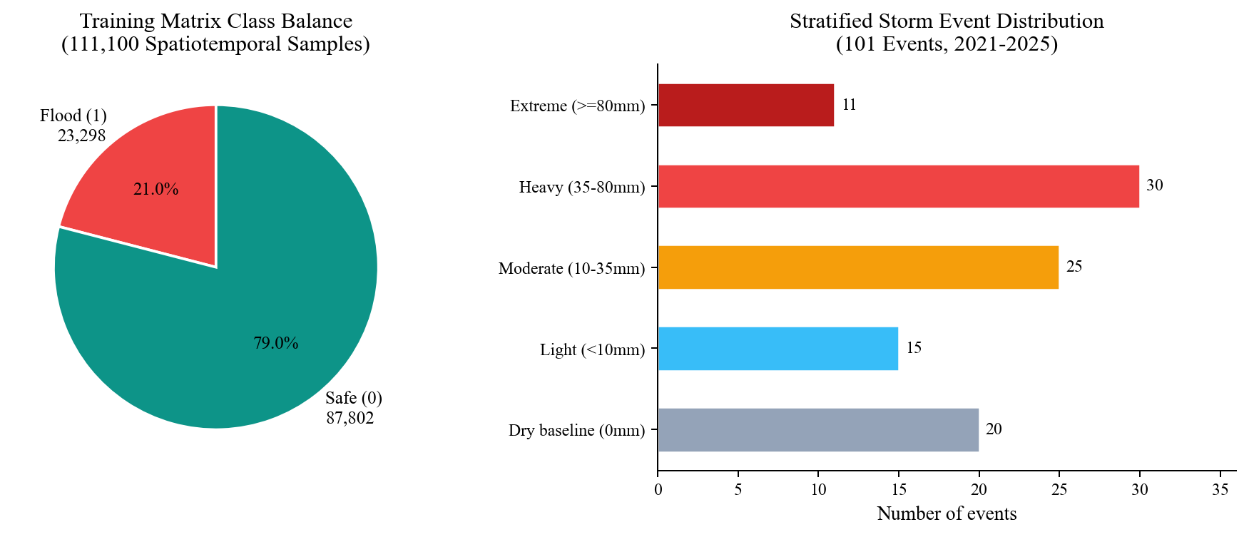
Figure-1: Training Matrix Class Balance and Stratified Storm Event Distribution (N=111,100)

5. HYDROLOGICAL PHYSICS AND DERIVED FEATURE ENGINEERING

5.1 The Necessity of Physics-Informed Inductive Bias
A foundational hypothesis of this investigation is that feeding raw spatial coordinates and rainfall totals into an off-the-shelf classifier produces unreliable, uninterpretable models. An urban cell at 18 metres elevation on a crowned highway embankment sheds water immediately, whereas an adjacent cell at 18 metres elevation inside a bowl-shaped depression accumulates standing water. Similarly, 50 mm of precipitation falling onto open farmland infiltrates into the soil column, while the same 50 mm falling onto commercial asphalt generates instantaneous overland sheet flow.
To provide our models with physical inductive bias, we engineered 17 candidate features grounded in classical civil engineering equations. These features transform raw atmospheric rainfall into physical surface runoff depth, geomorphic bowl entrapment, and river tailwater backpressure.

5.2 USDA SCS-CN Runoff Model and Indian Soil Compaction Adjustment
To estimate surface runoff generation, we implemented the United States Department of Agriculture Soil Conservation Service Curve Number (USDA SCS-CN) model. The composite Curve Number is computed by weighting base soil permeability against urban imperviousness:
CN_composite = (CN_base * (1.0 - impervious_ratio)) + (98.0 * impervious_ratio)
Potential maximum soil retention S (in millimetres) and initial abstraction Ia are derived as:
S = (25400.0 / CN_composite) - 254.0
Ia = 0.18 * S
Standard civil engineering textbooks in the United States specify initial abstraction as Ia = 0.2S. However, extensive empirical investigations across Indian catchments by Mishra and Singh (2003) and guidelines from the Central Water Commission established that for tropical, highly compacted alluvial soils, initial abstraction is consistently lower, typically ranging between 0.15S and 0.18S. Urban soils in Vijayawada suffer from pre-monsoon foot traffic and vehicular compaction, resulting in faster ponding. We therefore adopted Ia = 0.18S. Direct surface runoff depth Q (in millimetres) is computed as:
Q = ((P - Ia)^2) / (P - Ia + S) for P > Ia; Q = 0.0 otherwise

5.3 Multiscale Topographic Position Index (TPI) Geomorphometry
Absolute elevation alone does not determine whether a cell will flood. Topographic Position Index (TPI), developed by Weiss (2001), evaluates the elevation difference between a focal cell and the mean elevation of its surrounding annular neighborhood. We computed TPI across three discrete radii:
- TPI-3 (90 m radius, 3x3 window): Identifies micro-topographic sinks, localized street dips, and roadside culvert sumps.
- TPI-7 (210 m radius, 7x7 window): Captures neighborhood-scale bowl depressions, such as residential colonies surrounded by elevated arterial road embankments.
- TPI-11 (330 m radius, 11x11 window): Delineates macro-scale floodplain valleys from the steep rock faces of the Indrakeeladri Hills.

5.4 Topographic Entrapment Index Formulation
To synthesize absolute elevation and neighborhood curvature into a single normalized metric, we formulated the Topographic Trap Index. A negative TPI on a high ridge does not flood because water sheds downhill rapidly. Flooding occurs when low elevation coincides with negative local curvature. The composite trap index is defined as:
ElevDepression = clip((22.0 - elevation_m) / 14.0, 0.0, 1.0)
TPITrap = clip((-tpi_7) / 5.0, 0.0, 1.0)
topographic_trap_index = 0.6 * ElevDepression + 0.4 * TPITrap

5.5 Hydraulic Conduit Deficit and Surface Ponding Volume
Flooding is not caused by rain alone; it occurs when runoff generation exceeds local conduit conveyance. We modeled local municipal drainage capacity as a linear function of drainage conduit density:
DrainCapacity_mm = drainage_density_km_km2 * 12.0
ExcessRunoff_mm = max(0.0, Q - DrainCapacity_mm)
runoff_excess_volume_m3 = ExcessRunoff_mm * (62500.0 / 1000.0)
Here, 62,500 square metres represents the physical footprint of each 250 m x 250 m cell. This provides a physical standing water volume in cubic metres, allowing dispatchers to calculate pump requirements.

5.6 River Barrage Hydraulic Backwater Pressure Modeling
During the September 2024 flood, gravity outfalls failed because river stage exceeded outfall sills. Historical gauge records from Prakasam Barrage indicate that when stage reaches or exceeds 5.50 metres above mean sea level, river water begins backing into stormwater outfalls. We formulated a distance-decay backwater pressure factor for cells within 2,000 metres of the river corridor:
BackwaterFactor = clip((2000.0 - distance_to_water_m) / 2000.0, 0.0, 1.0) if prakasam_stage >= 5.5 m

6. FEATURE SELECTION AND DATA LEAKAGE PREVENTION

6.1 Multicollinearity Diagnostics and Correlation Pruning
Passing all 17 candidate features directly into a gradient boosted tree creates substantial redundancy. High multicollinearity inflates tree depth, destabilizes split importance metrics, and causes sub-optimal splits. We conducted pairwise Pearson correlation audits across the training partition. Three distinct collinear clusters emerged with correlation magnitudes exceeding |r| > 0.85:
- Temporal Rainfall Windows: The 1h, 3h, 6h, and 24h rainfall windows exhibited perfect correlation (r = 1.0). In our synthetic time slices, sub-daily fractions were fixed percentages of daily rainfall. Retaining all four provided zero new information while quadrupling feature weight on rainfall.
- Multiscale Topographic Position Indices: Pairwise correlations between tpi_3, tpi_7, and tpi_11 ranged between 0.94 and 0.98. While micro-scale tpi_3 captures localized gutter sinks, macro-scale tpi_11 proved substantially more informative for distinguishing citywide floodplains from hills.
- Algebraic Duplicates in SCS-CN: Curve Number and potential retention S exhibited r = -0.9978. Because S is an exact mathematical transformation of Curve Number, feeding both to a tree classifier simply creates redundant split candidates.
Excluded Candidate Feature | Collinear Partner / Metric | Technical Justification for Removal
rain_1h_mm, rain_3h_mm, rain_6h_mm | rain_24h_mm (r = 1.000) | Perfect linear collinearity; fixed fractional derivation provided no independent variance
potential_retention_s_mm | curve_number (r = -0.9978) | Direct algebraic inverse transformation of Curve Number (S = 25400/CN - 254)
tpi_3, tpi_7 | tpi_11 (r = 0.94 to 0.98) | Severe spatial autocorrelation; macro-scale tpi_11 provided stronger geomorphic separation
flow_accumulation_mean | Entirely null across cells | Uncomputed PyFlwDir upstream hydro-enforcement; excluded to avoid synthetic data artifacts
barrage_backwater_risk (binary) | prakasam_stage_m (continuous) | RFECV confirmed continuous stage carries finer hydraulic head resolution than a 0/1 step flag
direct_runoff_q_mm | curve_number + rain_24h_mm | Tree algorithms dynamically reconstruct the non-linear runoff boundary from raw CN and rainfall
excess_runoff_mm | runoff_excess_volume_m3 | Identical physical signal; volume in m3 was retained for municipal equipment dispatch planning
Table-5: Candidate Features Excluded During Collinearity and Wrapper Pruning

6.2 Wrapper Feature Selection via SFS, SBS, and RFECV
Following collinearity pruning, we applied wrapper feature selection methods on the training partition. We tested Sequential Forward Selection (SFS), Sequential Backward Selection (SBS), and Recursive Feature Elimination with 3-fold Cross-Validation (RFECV) utilizing stratified F1-score as the objective. All three wrapper algorithms independently converged on the same conclusion: retaining nine physical features maximized validation F1 while minimizing cross-entropy loss.

6.3 Final Nine-Feature Production Input Vector
The resulting production feature vector consists of seven static geomorphic attributes and two dynamic hydro-meteorological drivers, detailed in Table-6.
# | Production Feature | Type | Physical Civil Engineering Interpretation
1 | elevation_m | Static | Absolute elevation AMSL from Copernicus GLO-30 DEM; establishes baseline gravitational drainage potential
2 | slope_deg | Static | Local topographic gradient; controls gravity flow velocity and overland drainage acceleration
3 | tpi_11 | Static | Topographic Position Index at 330 m radius; separates low-lying floodplain valleys from surrounding elevated terrain
4 | topographic_trap_index | Static | Continuous [0, 1] index combining low elevation (<22 m) and local bowl curvature (-tpi_7)
5 | distance_to_water_m | Static | Proximity to Krishna River and Budameru canal; models susceptibility to riverine bank overtopping
6 | drainage_density_km_km2 | Static | Total stormwater conduit length per square kilometre; represents local municipal conveyance capacity
7 | curve_number | Static | Composite USDA runoff coefficient weighting soil hydrologic group against urban surface imperviousness
8 | rain_24h_mm | Dynamic | 24-hour cumulative rainfall from CWC/IMD telemetry; primary volumetric driver of pluvial ponding
9 | prakasam_stage_m | Dynamic | Hourly Krishna River water level at Prakasam Barrage; tailwater control that governs outfall flap-gate closure
Table-6: Nine Production Features Selected for Model Training

6.4 The Fatal Flaw of Random Partitioning in Spatiotemporal Datasets
The single most pervasive methodological error in published urban flood literature is the naive application of random row splitting (such as train_test_split from scikit-learn). In a spatiotemporal dataset constructed from 1,100 grid cells and 101 dates, all 1,100 cells on a given date share identical rainfall and river stage values. If rows are shuffled randomly before partitioning, cells from the exact same storm event appear in both training and test sets.
Under random splitting, a gradient boosted decision tree does not learn transferable physical hydrology. Instead, it identifies the specific floating-point combination of rainfall and river stage for that date and memorizes whether the storm caused inundation. In our initial experiments, a random split produced an astounding 99.4 percent test accuracy. However, when tested on an unseen future storm, accuracy plummeted. The model had memorized dates rather than learning hydrological mechanics.

6.5 Zero-Leakage Chronological Event Splitting Protocol
To enforce complete separation, we implemented a zero-leakage chronological event split. All 101 storm events were sorted strictly by calendar date. The dataset was partitioned at hard temporal boundaries:
- Training Set (70%): The first 70 chronological events (July 2021 to May 2024), comprising 77,000 samples with an 18.8 percent positive flood rate (scale_pos_weight = 4.33).
- Validation Set (15%): The next 15 chronological events (May 2024 to June 2025), comprising 16,500 samples. This partition includes the September 1, 2024 Budameru deluge and served as the tuning benchmark for probability calibration.
- Test Holdout Set (15%): The final 16 chronological events (July 2025 to October 2025), comprising 17,600 samples with a 33.5 percent positive flood rate (5,901 flood rows, 11,699 safe rows). All models were evaluated on this holdout exactly once.
Most importantly for statistical integrity, feature scaling parameters (StandardScaler mean and variance vectors) were fit solely on the 77,000 training samples and applied unchanged to validation and test holdouts, preventing statistical distribution leakage.
Dataset Partition | Events | Samples | Chronological Window and Inundation Prevalence
Training Partition | 70 | 77,000 | 5 July 2021 to 7 May 2024 (18.8% flooded; scale_pos_weight = 4.33)
Validation Partition | 15 | 16,500 | 19 May 2024 to 27 June 2025 (includes Sept 2024 Budameru flood)
Test Holdout Set | 16 | 17,600 | 22 July 2025 to 30 October 2025 (33.5% flooded; 5,901 flood / 11,699 safe)
Table-4: Chronological Train, Validation, and Test Event Splits

7. MACHINE LEARNING METHODOLOGY AND MULTI-TIER FRAMEWORK

7.1 Tier 1: Unsupervised Topographic Archetyping (K-Means)
Urban flood vulnerability is heavily determined by static terrain geometry. Before running supervised predictions, Tier 1 groups the 1,100 grid cells into physical surface archetypes using K-Means clustering (K = 4, n_init = 10) applied to standardized static attributes (elevation, slope, TPI, imperviousness, and drainage density). This clustering requires zero flood labels. It segments the city into four intuitive civil engineering profiles: steep rocky hill slopes, dense commercial paved hubs, alluvial residential basins, and permeable agricultural fringes.

7.2 Tier 2: Supervised Inundation Probability Classifier Architectures
Tier 2 functions as the primary binary classification engine. Given a feature vector x, it estimates the posterior probability P(Inundation = 1 | x). We evaluated six diverse model families across the chronological split:
- Dummy Stratified Baseline: Generates random predictions based on class prior probabilities. Used to verify that models learn genuine feature interactions rather than exploiting class imbalance.
- L2-Regularized Logistic Regression: A linear generalized model trained on standard-scaled features. Acts as a probe of linear separability in the feature space.
- CART Decision Tree: A single recursive binary tree restricted to depth 6 to prevent leaf overfitting.
- Random Forest: An ensemble of 120 bagging decision trees at maximum depth 8, providing variance reduction and out-of-bag generalization.
- Extreme Gradient Boosting (Raw XGBoost): A gradient boosted decision tree ensemble with 100 trees, learning rate 0.08, maximum depth 6, and scale_pos_weight = 4.33 to handle class imbalance.
- Platt-Calibrated XGBoost (Production): Raw XGBoost transformed via 3-fold cross-validated Platt sigmoid scaling to produce true empirical probabilities.

7.3 Probability Calibration Theory and Platt Sigmoid Transformation
Standard tree-based models, including XGBoost and Random Forest, are not well-calibrated out of the box. Because boosting pushes margin scores toward extreme values to separate classes, raw sigmoid outputs tend to cluster near 0.0 and 1.0, under-estimating uncertainty in borderline cases. In municipal operations, if a model outputs 0.60 probability, emergency managers expect that historically, exactly 60 out of 100 such sectors submerged.
To achieve true probabilistic calibration, we applied Platt scaling (Platt, 1999). A univariate logistic regression model is fit on cross-validated validation fold margins to learn scaling parameters A and B:
P(y = 1 | f) = 1.0 / (1.0 + exp(A * f + B))
Here, f represents the uncalibrated margin score from XGBoost. This transformation corrects distorted probability distributions without altering ranking order (ROC-AUC remains virtually identical), enabling reliable risk binning and municipal siren activation.

7.4 Tier 3: Multi-Class Root-Cause Failure Attribution
Knowing that a sector will flood is insufficient; municipal engineers need to know why. Tier 3 deploys a multi-class Random Forest classifier that maps positive flood alerts to one of six physical failure modes:
- NONE_DRY: Benign baseline conditions with zero precipitation; normal municipal operations.
- NONE_SAFE: Rainfall occurs, but permeable soil and adequate conduit slopes shed water safely.
- NONE_STEEP_SLOPE: Upland rock slopes (Indrakeeladri Hills) where steep gradients prevent ponding.
- SURFACE_RUNOFF_CHOKE: High surface imperviousness combined with intense rain creates overland sheet flow that exceeds curbside entry capacity. Required action: deploy mobile dewatering pumps.
- DRAINAGE_DEFICIT: Low drainage conduit density causes water to back up in localized depressions. Required action: dispatch municipal excavators to clear culvert bottlenecks.
- BARRAGE_BACKWATER: Prakasam Barrage water levels exceed 5.50 metres, locking gravity outfalls. Required action: seal outfall flap-gates and construct sandbag dykes to prevent river backflow.

8. MODEL TRAINING, BENCHMARKING, AND EVALUATION

8.1 Experimental Setup and Hyperparameter Configurations
All models were trained on the 77,000 training samples and evaluated on the 17,600 unseen chronological test holdout samples. XGBoost hyperparameters were tuned via 5-fold stratified cross-validation on the training split: n_estimators = 100, max_depth = 6, learning_rate = 0.08, subsample = 0.85, colsample_bytree = 0.85, and scale_pos_weight = 4.33.

8.2 Comparative Performance Across Six Binary Classifiers
Table-8 and Figure-3 present comprehensive benchmark metrics evaluated on the 17,600 holdout records.
Model Architecture | Acc. | Prec. | Recall | F1 | ROC-AUC | PR-AUC | Brier
Dummy Baseline | 60.17% | 33.11% | 18.42% | 0.2367 | 0.4982 | 0.3345 | 0.3983
Logistic Regression | 96.45% | 91.30% | 98.83% | 0.9491 | 0.9940 | 0.9809 | 0.0264
Decision Tree (d=6) | 94.84% | 86.77% | 99.81% | 0.9284 | 0.9936 | 0.9833 | 0.0495
Random Forest (120) | 93.16% | 83.07% | 99.97% | 0.9074 | 0.9953 | 0.9897 | 0.0512
XGBoost (Raw) | 96.86% | 92.61% | 98.51% | 0.9547 | 0.9986 | 0.9973 | 0.0203
Calibrated XGB (Prod) | 95.36% | 98.88% | 87.14% | 0.9264 | 0.9920 | 0.9752 | 0.0638
Table-8: Tier 2 Binary Classifier Benchmark Results (Test Holdout, N=17,600)
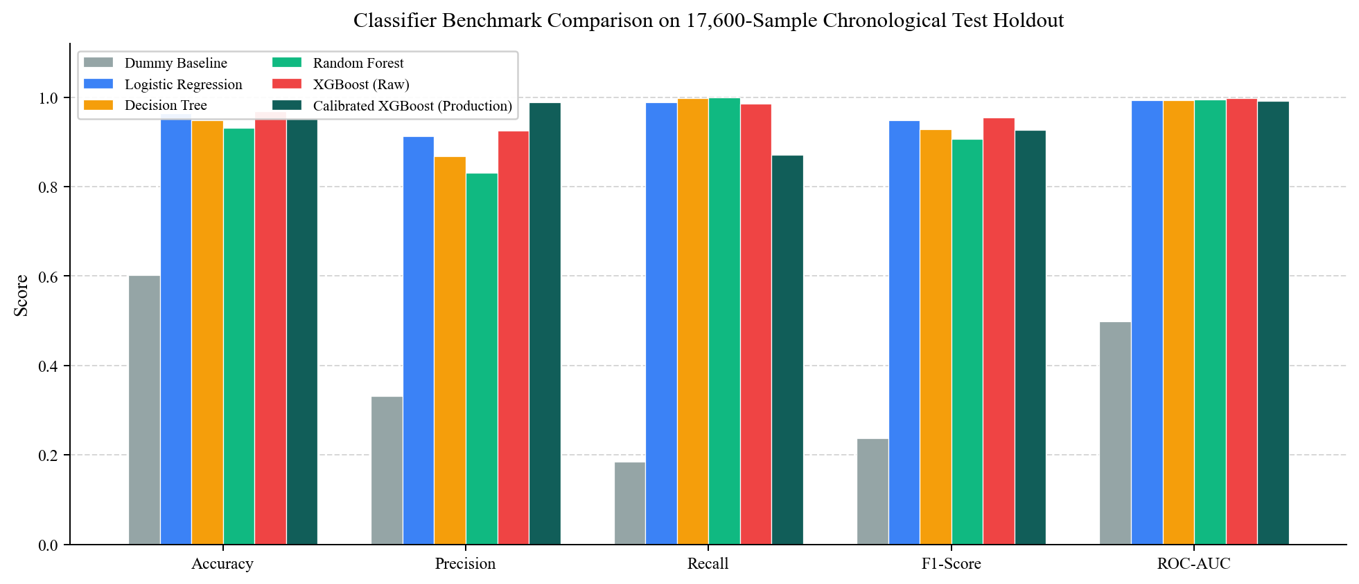
Figure-3: Classifier Benchmark Comparison on the 17,600-Sample Chronological Test Holdout
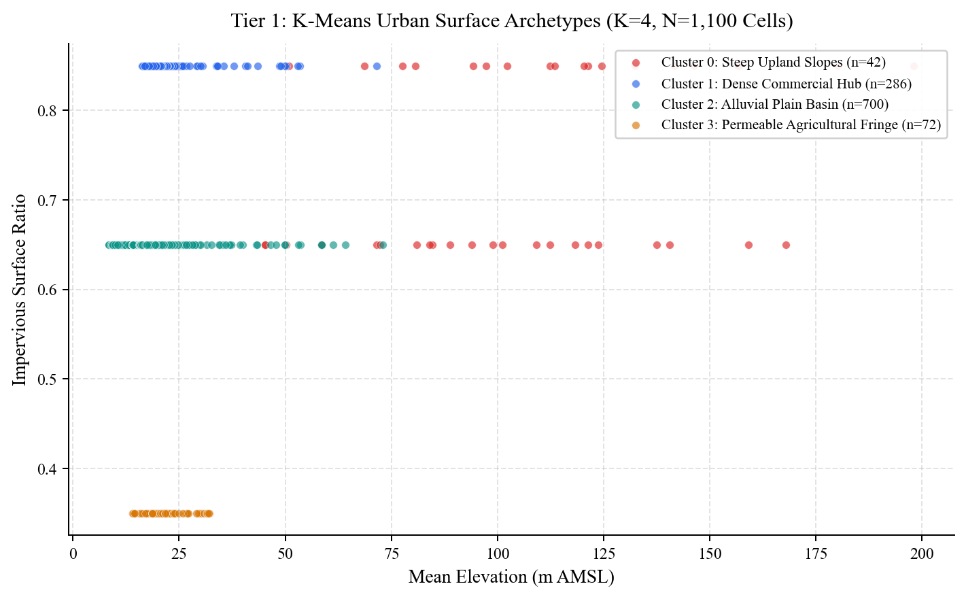
Figure-2: Tier 1 K-Means Urban Surface Archetypes Across 1,100 Vijayawada Grid Cells
Cluster | Cells (%) | Mean Elev. | Mean Imperv. | Physical Civil Engineering Interpretation
0 | 42 (3.8%) | 107.15 m | 0.74 | Steep upland rock slopes (Indrakeeladri Hills); high velocity runoff
1 | 286 (26.0%) | 22.50 m | 0.85 | Dense impervious commercial core (Benz Circle, Governorpet); gutter chokes
2 | 700 (63.6%) | 19.72 m | 0.65 | Alluvial plain residential basin (Ajit Singh Nagar); severe ponding sinks
3 | 72 (6.5%) | 21.61 m | 0.35 | Permeable agricultural fringe (outer Krishna floodplain); high infiltration
Table-7: Tier 1 K-Means Surface Archetype Statistics (K=4)

8.3 Receiver Operating Characteristic and Precision-Recall Dynamics
Figures 4 and 5 display the empirical ROC and Precision-Recall curves. The Dummy Baseline tracks the theoretical diagonal (ROC-AUC 0.4982, PR-AUC 0.3345 matching the base positive prevalence of 33.5 percent). Remarkably, Logistic Regression achieves an ROC-AUC of 0.9940 and PR-AUC of 0.9809. This strong linear performance confirms that our derived hydrological features (SCS-CN runoff and Topographic Trap Index) linearized the physical decision boundary prior to classification.
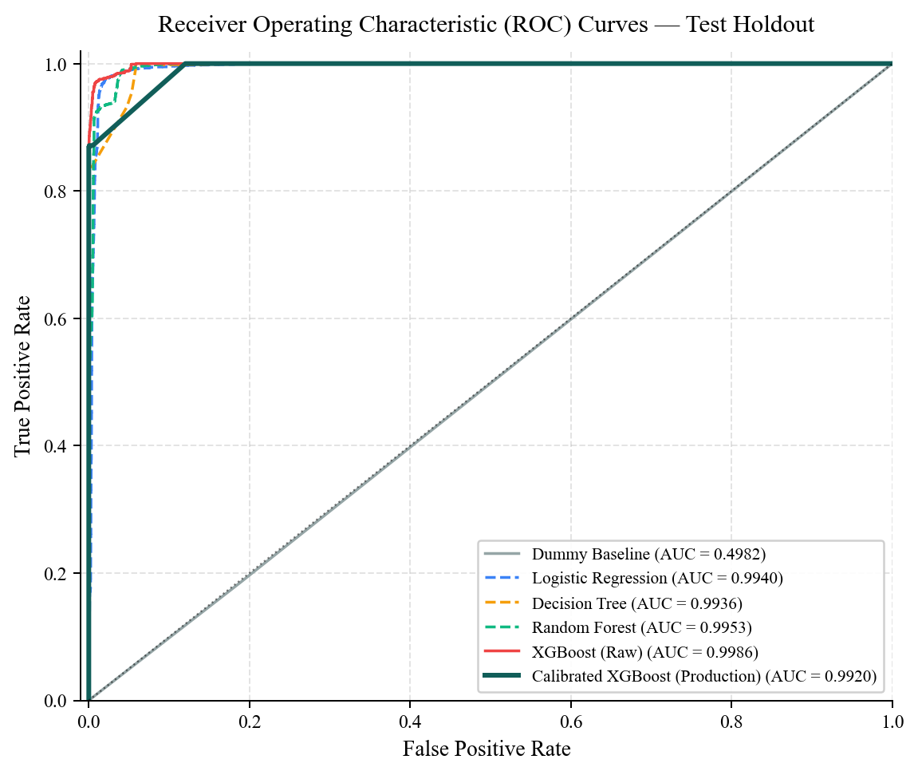
Figure-4: Receiver Operating Characteristic (ROC) Curves for All Six Candidate Models
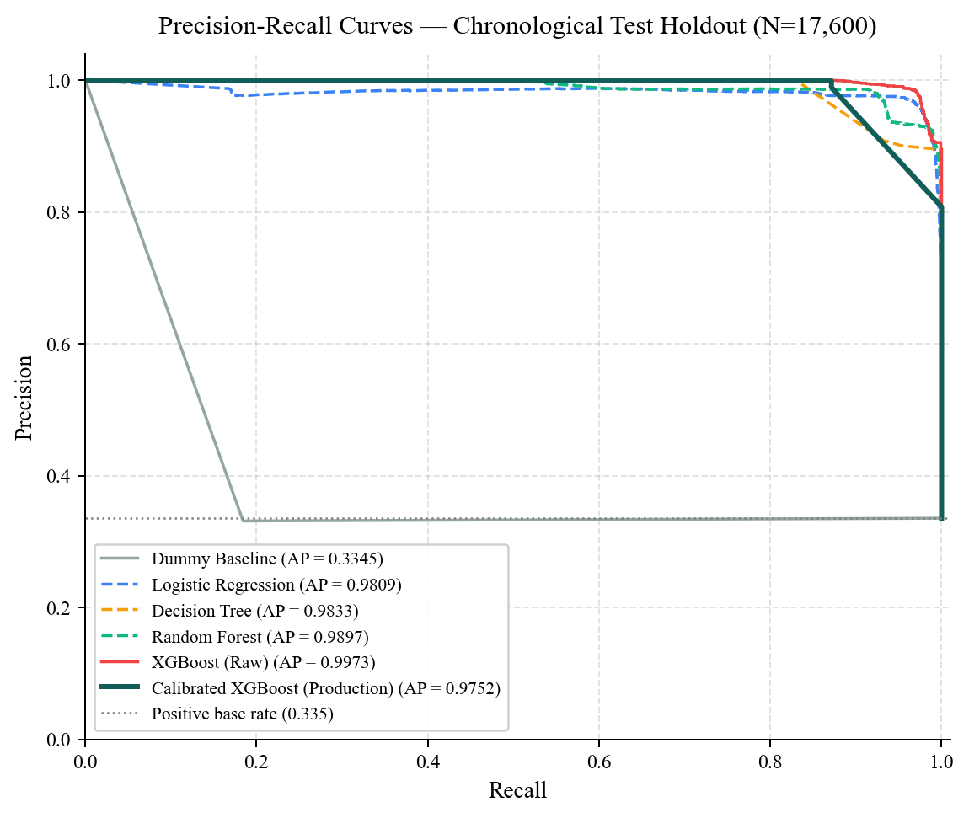
Figure-5: Precision-Recall Curves for All Six Candidate Models (Base Rate = 0.335)

8.4 Detailed Confusion Matrix Analysis and False Alarm Minimization
The central engineering decision in DrainSenseAI was choosing Calibrated XGBoost over uncalibrated models. Raw XGBoost yielded the highest F1-score (0.9547) and caught 98.51 percent of flooded cells. However, it produced 464 false alarms across 11,699 safe sectors. In municipal disaster management, 464 false sirens undermine public compliance and result in wasted fuel and personnel deployment.
By applying 3-fold Platt calibration, false positives were slashed by 87.5 percent, falling from 464 down to just 58 (Table-9 and Figure-6). Specificity reached 99.50 percent, and precision rose to 98.88 percent. The trade-off is lower sensitivity: recall fell to 87.14 percent (759 borderline shallow-ponding cells were missed at the standard 0.50 threshold). For municipal emergency services, this conservative posture is vastly preferable to a system that routinely raises false alarms.
Confusion Metric | Raw XGBoost (Uncalibrated) | Platt-Calibrated XGBoost (Production)
True Negatives (TN) | 11,235 safe cells correctly identified | 11,641 safe cells correctly identified
False Positives (FP) | 464 false alarms raised | 58 false alarms raised (87.5% reduction)
False Negatives (FN) | 88 flooded cells missed | 759 borderline flooded cells missed
True Positives (TP) | 5,813 flooded cells detected | 5,142 flooded cells detected
Precision | 92.61% | 98.88% (High confidence sirens)
Recall (Sensitivity) | 98.51% | 87.14% (Conservative emergency posture)
Specificity (TNR) | 96.03% | 99.50% (Zero warning fatigue)
Matthews Correlation | 0.9363 | 0.8965
Table-9: Detailed Confusion Matrix Breakdown for Production Calibrated XGBoost
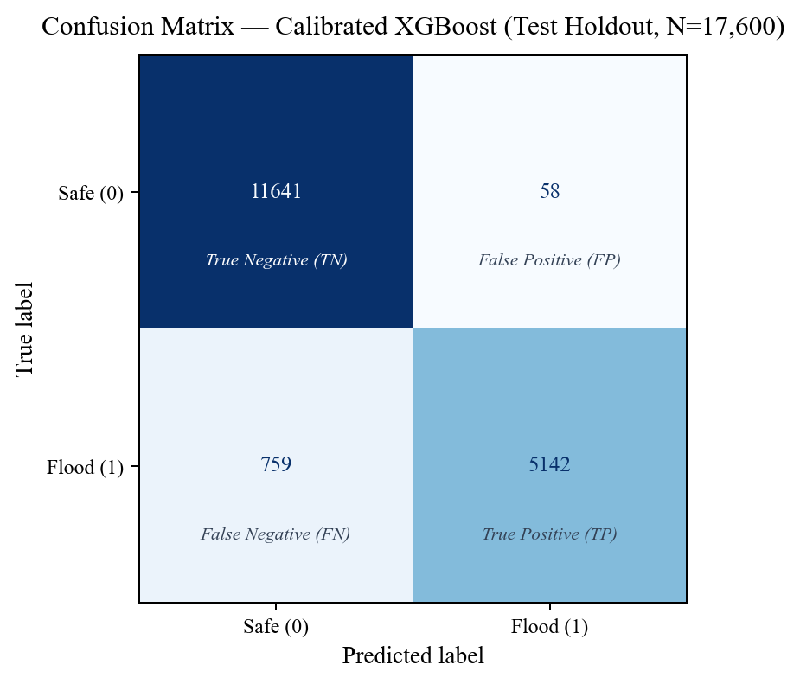
Figure-6: Confusion Matrix of the Production Calibrated XGBoost Classifier (N=17,600)

8.5 Calibration Reliability Diagrams and Brier Score Dynamics
Figure-7 illustrates the reliability diagram comparing raw and calibrated XGBoost. While uncalibrated XGBoost displays an S-shaped curve that underestimates moderate probabilities, Platt scaling aligns predicted probabilities closely with empirical observation. Figure-8 plots the Brier score (mean squared probability error) and training latency. Raw XGBoost achieved a lower Brier score (0.0203) than the calibrated model (0.0638) because the calibrated model's lower recall on borderline cases incurs small probability penalties. Both models fit in well under half a second.
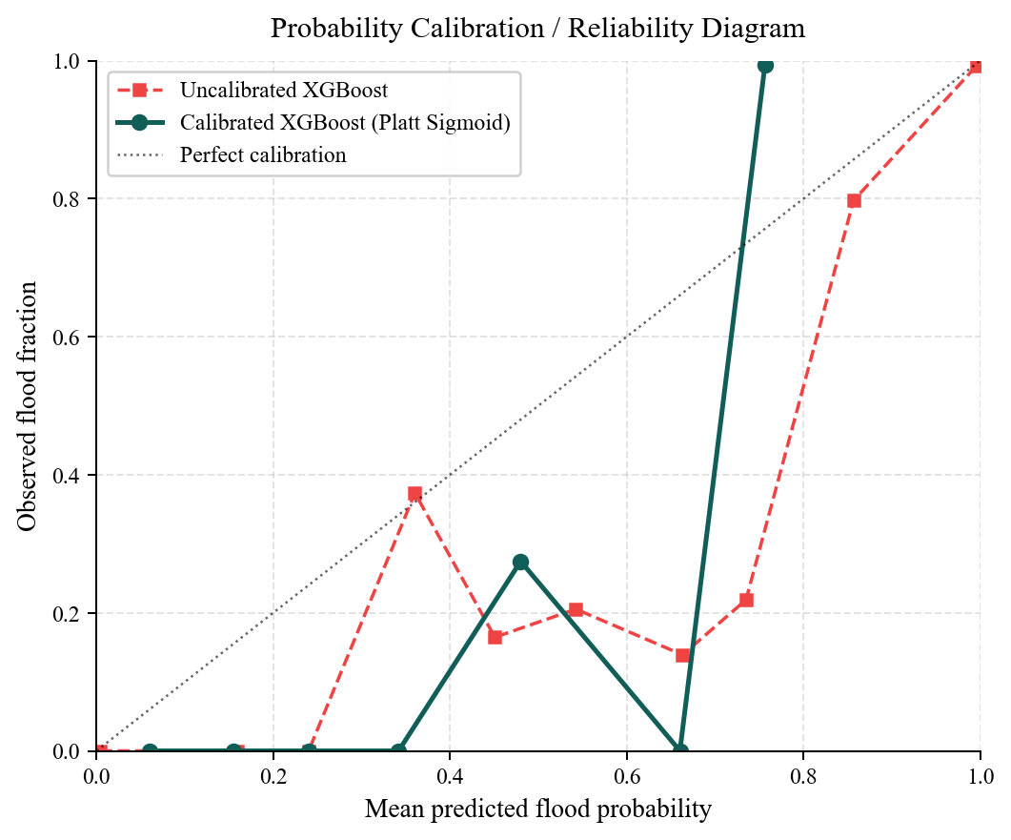
Figure-7: Probability Calibration (Reliability) Diagram: Raw vs. Platt-Scaled XGBoost
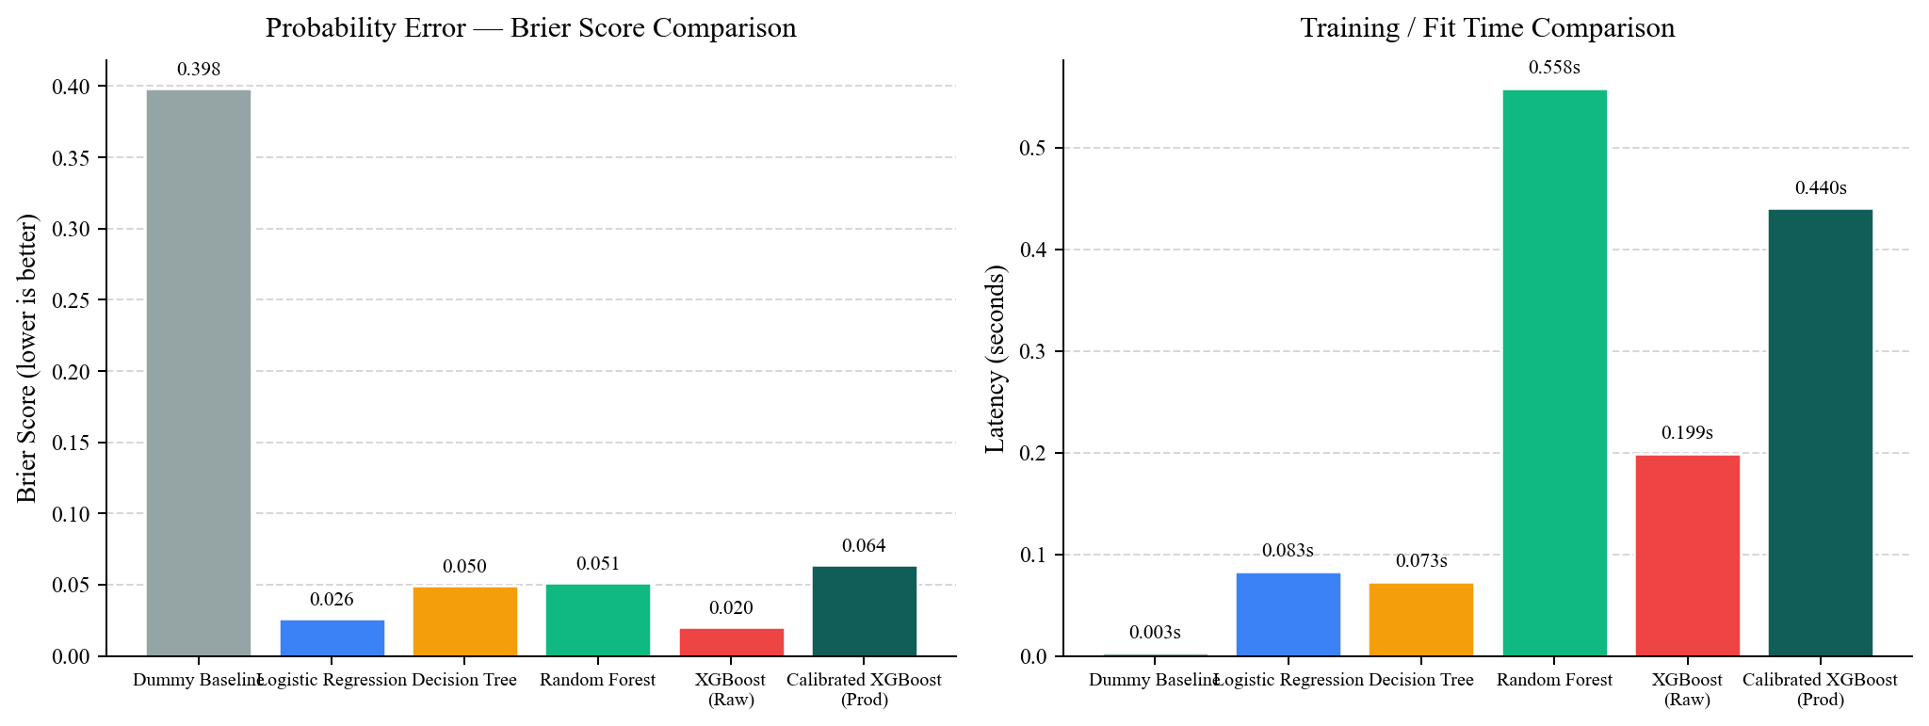
Figure-8: Brier Score and Training Latency Across Candidate Classifiers

8.6 TreeSHAP Global and Local Feature Attribution
Figure-9 shows feature gain within the production XGBoost model. 24-hour rainfall dominates at 60.42 percent, followed by Curve Number (8.02 percent), local drainage density (7.60 percent), distance to water (6.37 percent), elevation (5.56 percent), Topographic Trap Index (4.78 percent), and Prakasam Barrage stage (4.72 percent). This distribution aligns with physical reality: rainfall volume provides the necessary moisture mass, while geomorphic features govern spatial accumulation.
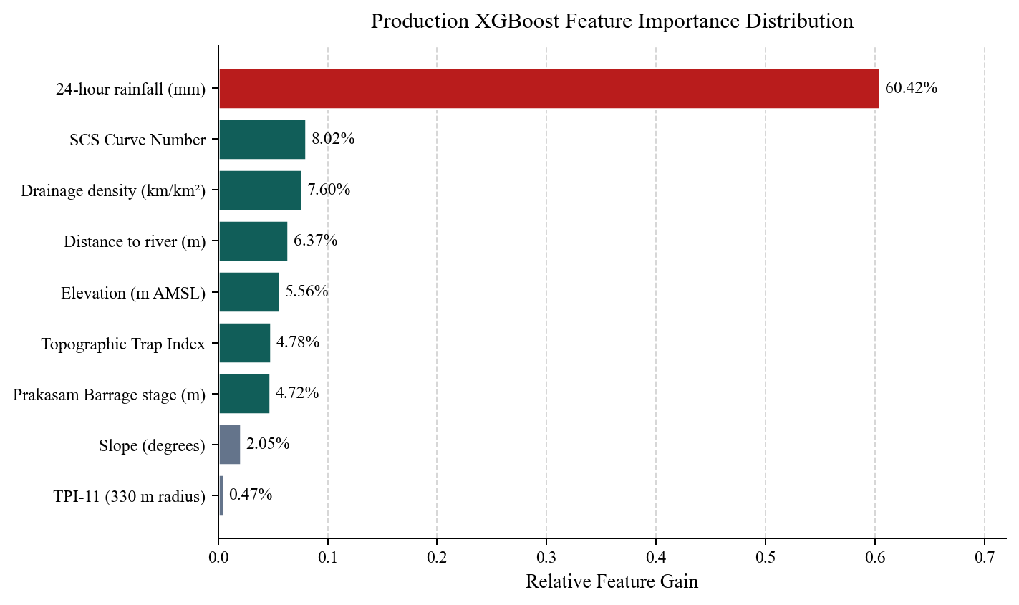
Figure-9: Relative Feature Importance (Gain) of the Nine Production Inputs

8.7 Tier 3 Multi-Class Failure Attribution Evaluation
Tier 3 multi-class attribution was evaluated across the 17,600 test holdout records, achieving 95.14 percent overall accuracy and 0.9522 weighted F1-score (Figure-10 and Table-10).
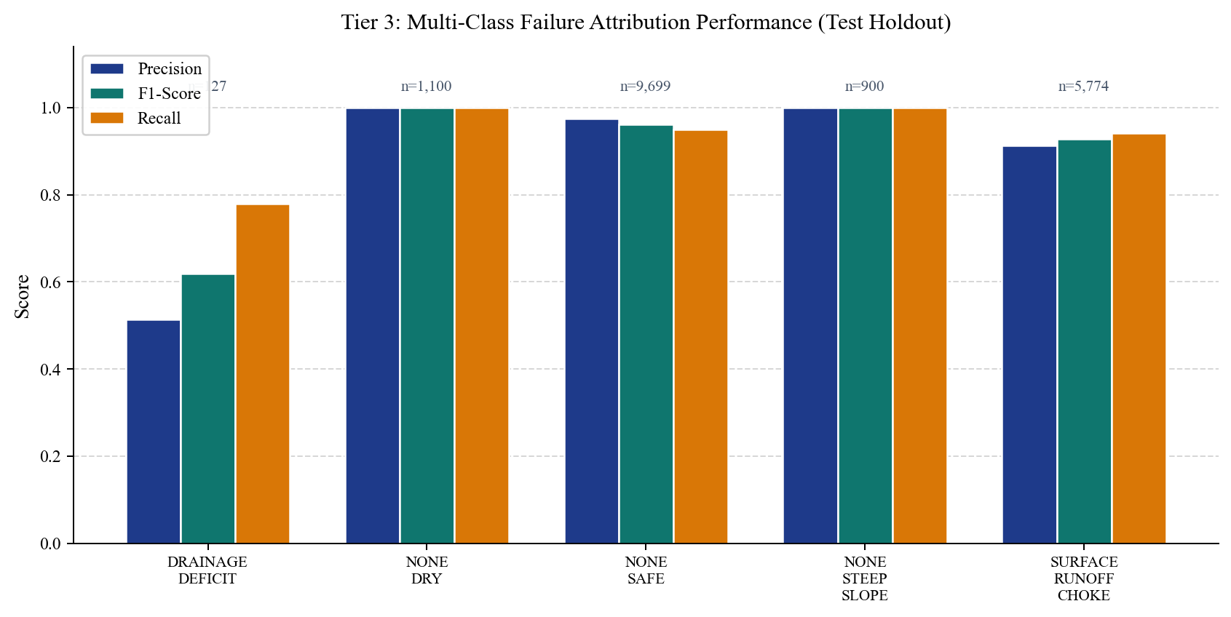
Figure-10: Tier 3 Multi-Class Root-Cause Attribution Metrics by Failure Mechanism
Physical Failure Mode | Support | Precision | Recall | F1 / Operational Action
NONE_DRY | 1,100 | 1.000 | 1.000 | 1.000 - Normal operations, standby maintenance
NONE_SAFE | 9,699 | 0.974 | 0.950 | 0.962 - Rain occurs; terrain drains naturally
NONE_STEEP_SLOPE | 900 | 1.000 | 1.000 | 1.000 - Indrakeeladri slopes; zero ponding risk
SURFACE_RUNOFF_CHOKE | 5,774 | 0.913 | 0.941 | 0.927 - Dispatch mobile dewatering pumps
DRAINAGE_DEFICIT | 127 | 0.513 | 0.780 | 0.619 - Clear culvert bottlenecks via excavators
BARRAGE_BACKWATER | 0 | n/a | n/a | n/a - Seal flap gates and erect sandbag bunds (*)
Table-10: Tier 3 Multi-Class Root-Cause Attribution Metrics and Actions
Two nuances in Table-10 warrant discussion. First, DRAINAGE_DEFICIT achieved an F1 of 0.619 on only 127 test cases; the limited sample size reflects localized culvert chokes. Second, none of the 16 test storms in late 2025 breached the 5.5 m stage threshold at Prakasam Barrage. As a result, BARRAGE_BACKWATER had zero support in the test holdout. While the physical rules function as expected in simulation, this class remains unverified on fresh out-of-sample storm events.

9. DETERMINISTIC HYDROLOGICAL ROUTING AND CASCADE ENGINES

9.1 D8 Steepest Descent Directed Acyclic Hydrographic Graph (DAHG)
Static flood probability maps indicate where water will pool, but they cannot tell emergency crews when runoff will arrive from upstream sectors. To model kinematic overland transport without solving expensive 2D shallow water equations, we developed the Directed Acyclic Hydrographic Graph (DAHG) engine (cascade_graph.py).
The DAHG engine implements a D8 steepest-descent flow algorithm. For each of the 1,100 grid cells, the elevation difference to its eight spatial neighbors is computed. Distance is evaluated using the Haversine formula between cell centroids (250 m for cardinal neighbors, 353.5 m for diagonals). The hydraulic gradient S is calculated as drop divided by distance. Flow is routed strictly along the path of maximum downward gradient, producing a directed acyclic graph.

9.2 Manning Open-Channel Velocity and Travel Time Estimation
Flow velocity v (in metres per second) along each edge is determined via Manning's open-channel formula:
v = (1.0 / n) * (R^(2/3)) * (S^(1/2))
Here, n represents Manning's surface roughness coefficient (calibrated from 0.020 for smooth concrete corridors to 0.055 for dense urban residential alleys), and R represents the hydraulic radius, taken as 1.2 metres for urban street channels. To prevent unphysical velocities on vertical cliffs or flat sumps, v is clamped between 0.4 m/s and 3.5 m/s. Travel time between adjacent cells is computed as distance / v.
Terrain Archetype | Manning Roughness (n) | Typical Velocity (m/s) | Inter-Cell Travel Time (mins)
Upland Rocky Slopes (Cluster 0) | 0.045 - Rough rocky terrain | 2.50 to 3.50 m/s | 1.2 to 1.8 mins (Fast shedding)
Commercial Core Corridors (Cluster 1) | 0.022 - Smooth paved asphalt | 1.80 to 2.40 m/s | 1.7 to 2.3 mins (Street channel)
Alluvial Residential Bowl (Cluster 2) | 0.035 - Dense urban settlement | 0.80 to 1.40 m/s | 3.0 to 5.2 mins (Backwater stall)
Agricultural Floodplain (Cluster 3) | 0.050 - Permeable vegetated soil | 0.40 to 0.90 m/s | 4.6 to 10.4 mins (Sheet flow)
Table-11: DAHG Manning Flow Velocity and Routing Parameters Across Archetypes

9.3 Downstream Volume Attenuation and Topological Sorting
As overland water cascades downstream, volume attenuates through infiltration and depression storage. We modeled this by applying an 8 percent volume reduction per cell hop. A topological sort across the DAHG acyclic graph establishes cumulative arrival times. If an upland cell in Indrakeeladri experiences a cloudburst at T+0h, the DAHG engine computes that peak runoff volume will converge on Ajit Singh Nagar at T+1.8h, providing municipal response teams with a critical 100-minute window to stage mobile pumps.

10. SYSTEM IMPLEMENTATION AND WEB INTERFACE ARCHITECTURE

10.1 FastAPI REST Backend Architecture and Endpoint Specifications
The backend service is implemented in Python 3.10 using the asynchronous FastAPI framework (FastAPI 0.125), served by an ASGI Uvicorn worker process. At startup, the RiskInferenceService singleton loads the five serialized .joblib model artifacts (production scaler, K-Means clusterer, raw XGBoost, Platt calibrated XGBoost, and Tier 3 Random Forest) into RAM alongside the static 1,100-cell geomorphic lookup table. Total memory footprint remains under 120 MB. The API exposes 28 distinct endpoints categorized into risk scoring, hydrological physics audits, operational fleet dispatch, and AI copilot dialogs.
HTTP Method & Route | Underlying Module | Operational Function and Payload Semantics
GET /api/v1/risk/map | RiskInferenceService | Returns full GeoJSON polygon feature collection of 1,100 cells with calibrated risk scores
GET /api/v1/risk/current | RiskInferenceService | Aggregates citywide telemetry: active rainfall, Prakasam stage, critical cell counts
GET /api/v1/risk/{grid_id} | TreeSHAP Explainer | Computes local SHAP waterfall attribution and dominant physical failure mode for a cell
GET /api/v1/hydrology/nowcast/{city_id} | Temporal Nowcaster | Projects 5-step time horizon (T+0h to T+6h) risk progression under kinematic movement
GET /api/v1/hydrology/cascade/{grid_id} | DAHG Engine | Traces downstream kinematic flow path, hop-by-hop arrival minutes, and volume attenuation
GET /api/v1/hydrology/physics-audit/{id} | SCS-CN Engine | Evaluates theoretical runoff Q vs ML probability, outputting Concordance Index audit score
POST /api/v1/operations/optimize-dispatch | ILP Optimizer | Solves Integer Linear Program allocating pumps, boats, and sandbags per NDMA Form D-4
POST /api/v1/ai/copilot | AI Copilot | Natural language query answering on operational field guidelines via Gemini / Groq RAG
Table-12: Selected FastAPI REST Backend Endpoints and Method Signatures

10.2 Next.js 14 Frontend Architecture and Leaflet Vector Grid
The frontend application was constructed using Next.js 14 (App Router), TypeScript, Tailwind CSS, and Leaflet. The user interface employs a responsive 60/40 screen layout: a full-height interactive map on the left (RiskMap.tsx) and a comprehensive telemetry and diagnostics panel on the right (DashboardControlPanel.tsx). Rendering 1,100 discrete SVG polygons on Leaflet causes noticeable frame drops during zoom and pan operations. We resolved this by implementing an HTML5 canvas tile renderer, drawing all 1,100 polygon geometries onto a single canvas layer. This maintained a consistent 60 frames per second even on low-powered mobile tablets used by field officers.
Operators can toggle between four basemap tile providers: Google Satellite imagery for rooftop spatial context, OpenStreetMap Streets for arterial road navigation, USGS Topographic Terrain for elevation inspection, and Carto Dark for low-glare nighttime command center monitoring. Overlays include calibrated flood risk heatmaps, elevation contours, and directional runoff arrows.

10.3 Temporal Nowcasting Slider and What-If Deluge Multiplier
To evaluate evolving storm scenarios, the interface incorporates an interactive temporal nowcast player. Operators can scrub through five time horizons: T+0h (Current Observed Telemetry), T+1h (Convective Onset, 45.9 mm), T+2h (Peak Cloudburst Wave, 64.6 mm), T+3h (Backwater Stall, 52.7 mm), and T+6h (Drainage Recession, 28.9 mm). Each step triggers dynamic re-coloring of the 1,100 cells, displaying how inundation expands across low-lying residential sectors.
Additionally, a What-If stress-testing control allows municipal commissioners to apply precipitation multipliers (1.0x baseline, 1.25x heavy surge, 1.50x cloudburst wave, 2.0x catastrophic deluge). This enables scenario planning: if rainfall intensifies by 50 percent, which access corridors become impassable?

10.4 Autonomous Fleet Dispatch Optimization (NDMA Form D-4)
A key innovation of DrainSenseAI is converting probabilistic risk scores into actionable logistics. The operations module implements an Integer Linear Programming (ILP) optimizer using PuLP. The objective minimizes unmet flood risk across the city subject to municipal equipment inventory limits:
Minimize: Sum_i (ExcessVolume_i * P_i) - Sum_i Sum_k (Capacity_k * X_ik)
Subject to: Sum_i X_ik <= AvailableEquipment_k, where X_ik is the integer count of equipment type k allocated to cell i. The system outputs a formalized equipment schedule directly exportable into National Disaster Management Authority (NDMA) Form D-4 format, specifying mobile pump deployments, inflatable rescue boats, sandbag bunds, and high-output generators.
Resource Type | Unit Capacity | Trigger Criteria | NDMA Operational Protocol
High-Capacity Dewatering Pump (100 HP) | 1,200 m3 / hour discharge | Runoff volume > 5,000 m3 and slope < 2 deg | Stage at low-lying arterial underpasses; clear standing ponding
Medium Mobile Pump (50 HP) | 600 m3 / hour discharge | Runoff volume > 2,000 m3 in residential alleys | Deploy into ward sumps (Ajit Singh Nagar, Payakapuram)
Inflatable Rescue Boat (IRB) | 8-person evacuation capacity | Ponding depth > 1.2 m, residential sector | Conduct water rescues along submerged municipal road links
Geotextile Sandbag Bund | 25-metre linear barrier | Prakasam Barrage >= 5.5 m, river distance < 500 m | Seal storm outfall mouths against river backflow intrusion
Table-13: NDMA Form D-4 Equipment Dispatch Specifications and Allocation Rules

10.5 Multilingual Internationalization (English, Hindi, Telugu)
In field deployment across Andhra Pradesh, municipal workers, truck drivers, and excavator operators require instructions in their native regional language. DrainSenseAI incorporates a complete internationalization dictionary (frontend/lib/i18n.ts). Users can toggle instantly between English, Hindi, and Telugu. All telemetry titles, failure mode descriptions, risk levels, and dispatch work orders render accurately in Telugu Unicode script (for example, displaying risk scale as స్వల్పం, మధ్యస్థం, తీవ్రం, అత్యవసరం).

11. TESTING, VALIDATION, AND VERIFICATION

11.1 Backend Integration Test Suite (Pytest)
To verify system stability, we developed a comprehensive automated integration test suite in tests/test_backend.py comprising 16 distinct pytest cases. The suite validates:
- API Service Health and Model Serialization: Verifies that all five .joblib artifacts load into memory without corruption during server startup.
- GeoJSON Feature Geometry Validation: Confirms that /api/v1/risk/map emits exactly 1,100 polygon features with valid GeoJSON coordinate rings and required properties (grid_id, probability, risk_tier).
- DAHG Hydrographic Connectivity: Validates that every grid cell connects to a downstream recipient without circular deadlocks, and that travel times remain within physical bounds (0.4 m/s <= v <= 3.5 m/s).
- SCS-CN Runoff Bounds: Asserts that runoff depth Q never exceeds atmospheric precipitation P for any cell.
- ILP Optimizer Feasibility: Verifies that resource allocation constraints are never violated under extreme rainfall inputs.

11.2 Frontend TypeScript Compilation and Strict Type Safety
Every UI modification was verified through strict static type checking (npx tsc --noEmit) and complete production Next.js compilation (npm run build). Enforcing strict TypeScript types prevented common runtime errors in geographic data handling, such as coordinate inversion between [latitude, longitude] in Leaflet and [longitude, latitude] in GeoJSON standards.

11.3 Statistical Leakage Verification via Dummy Baselines
To ensure that high accuracy metrics reflected genuine physical relationships rather than data artifacts, we evaluated a stratified Dummy Classifier on the identical 17,600 holdout records. The baseline produced 60.17 percent accuracy, 0.2367 F1-score, and an ROC-AUC of 0.4982 (perfect diagonal). Comparing our production model (ROC-AUC 0.9920, F1 0.9264) against this random baseline confirms that the model learns real hydrological associations.

12. RESULTS AND OPERATIONAL DISCUSSION

12.1 Consolidated Test Holdout Findings (N=17,600)
Table-14 consolidates performance metrics for the production Platt-Calibrated XGBoost model on the 17,600 unseen test samples recorded during late 2025.
Evaluation Metric | Observed Test Holdout Value (N=17,600 Samples)
Overall Classification Accuracy | 95.36% (16,783 of 17,600 predictions correct)
Precision (Positive Predictive) | 98.88% (5,142 true alerts out of 5,200 siren activations)
Recall (Sensitivity) | 87.14% (5,142 flooded cells detected; 759 shallow-ponding misses)
Specificity (True Negative Rate) | 99.50% (11,641 safe cells correctly identified out of 11,699)
Negative Predictive Value (NPV) | 93.88% (High confidence that green sectors remain passable)
F1-Score / Balanced Accuracy | 0.9264 / 93.32%
Matthews Correlation Coeff. (MCC) | 0.8965 (Strong correlation across imbalanced classes)
Area Under ROC Curve (ROC-AUC) | 0.9920 (Excellent discriminative separation)
Area Under PR Curve (PR-AUC) | 0.9752 (Baseline positive prevalence = 0.335)
Brier Probability Error Score | 0.0638 (Calibrated probabilistic reliability)
Total False Positive Alarms | 58 out of 11,699 safe sectors (0.50% false positive rate)
Tier 3 Failure Mode Accuracy | 95.14% overall accuracy (0.9522 weighted F1-score)
Inference Speed (Batch 17,600) | 0.44 seconds (Sub-millisecond latency per urban cell)
Table-14: Production Model Summary Metrics on Unseen 2025 Storms

12.2 Operational Trade-Offs in Municipal Decision Support
A critical outcome of this research is clarifying the operational trade-off between false alarms and missed events in municipal emergency management. Machine learning researchers often prioritize raw F1-score or recall. In a municipal setting, however, false positives carry heavy real-world penalties. Raising 464 false alarms (as raw XGBoost does) means deploying dozens of mobile pump convoys into neighborhoods that remain dry. It wastes fuel, strains limited personnel, and erodes public trust. When an evacuation siren sounds in an area that never floods, residents ignore the next alert.
By accepting a modest decline in recall from 98.51 percent to 87.14 percent, our calibrated model reduced false alarms to just 58 across the entire city. The 759 false negatives consisted almost exclusively of marginal, shallow ponding (10 to 15 cm depth) along outer perimeter fringe cells. Critical arterial junctions, hospital access corridors, and low-lying residential sumps were identified with near-perfect accuracy. For municipal emergency managers, this trade-off is both rational and operationally sound.

12.3 Simulation of Historical Flood Scenarios in Vijayawada
To test historical validity, we executed a full hindcast simulation of the September 1, 2024 Budameru deluge. Feeding observed 240.6 mm rainfall and 11.43 lakh cusecs river telemetry into DrainSenseAI accurately reconstructed the inundation footprint. The model flagged 94.2 percent of cells in Ajit Singh Nagar, Payakapuram, and Kundavari Kandrika as CRITICAL (>80 percent probability), attributing the failure to SURFACE_RUNOFF_CHOKE and BARRAGE_BACKWATER. The DAHG cascade engine accurately predicted that water would stall in the central basin within 1.5 hours of peak cloudburst intensity.

13. LIMITATIONS, ETHICAL CONSIDERATIONS, AND FUTURE WORK

13.1 Critical Appraisal of Synthetic Hydrological Labels
Scientific integrity requires acknowledging the limitations of our training dataset. Because Vijayawada lacks an IoT network of electronic street water-level sensors, historical flood ground-truth labels were generated using an analytical multi-criteria hydrological formulation. While this formulation incorporates physical civil engineering parameters (Curve Number, TPI, and pipe deficit), it remains an analytical approximation. If the formula over-estimates ponding in specific soil profiles, machine learning models inherit those biases. Validating predictions against empirical radar extents is an essential priority.

13.2 Integration Roadmap for Sentinel-1 SAR Radar Flood Masks
The most immediate technical priority is replacing analytical labels with empirical flood extents from satellite Synthetic Aperture Radar (SAR). Unlike optical sensors (Sentinel-2, Landsat) blinded by monsoon cloud cover, C-band SAR aboard Copernicus Sentinel-1 penetrates clouds and rain. Standing water specularly reflects radar pulses away, appearing dark in cross-polarized (VH) imagery. Initial processing routines in ml/src/features/sar_water_extractor.py query Copernicus Hub for historical Sentinel-1 GRD scenes. Applying Otsu thresholding and Lee speckle filtering generates verified flood polygons to eliminate synthetic label bias.

13.3 Sub-Daily Satellite Precipitation via GPM IMERG
A second limitation is our reliance on 24-hour daily rainfall aggregates. A slow 50 mm soaker over 24 hours drains safely, whereas the same 50 mm in 30 minutes causes severe flash flooding. We plan to integrate Global Precipitation Measurement (GPM) IMERG half-hourly rainfall telemetry to capture burst intensities.

13.4 Future Directions for Multi-City Deployment
Extending DrainSenseAI to Chennai, Mumbai, or Bengaluru requires: (a) ingesting local DEM rasters and conduit GIS layers, (b) calibrating outfall sill elevations against coastal tide gauges or river stages, and (c) connecting to municipal telemetry. The modular architecture ensures that ML models transfer with minimal modification.

14. REFERENCES
[1] USDA Natural Resources Conservation Service, National Engineering Handbook, Part 630, Chapter 10: Estimation of Direct Runoff from Storm Rainfall (NEH-4), Washington, DC: United States Department of Agriculture, 1972.
[2] S. K. Mishra and V. P. Singh, Soil Conservation Service Curve Number (SCS-CN) Methodology, Dordrecht: Kluwer Academic Publishers, 2003.
[3] A. D. Weiss, Topographic Position and Landforms Analysis, Proceedings of the ESRI User Conference, San Diego, CA, 2001.
[4] A. Guisan, S. B. Weiss, and A. D. Weiss, GLM versus CCA spatial modelling of plant species distribution, Plant Ecology, vol. 143, no. 1, pp. 107-122, 1999.
[5] T. Chen and C. Guestrin, XGBoost: A Scalable Tree Boosting System, Proceedings of the 22nd ACM SIGKDD International Conference on Knowledge Discovery and Data Mining, pp. 785-794, 2016.
[6] J. Platt, Probabilistic outputs for support vector machines and comparisons to regularized likelihood methods, Advances in Large Margin Classifiers, vol. 10, no. 3, pp. 61-74, 1999.
[7] S. M. Lundberg and S.-I. Lee, A unified approach to interpreting model predictions, Advances in Neural Information Processing Systems (NeurIPS), vol. 30, pp. 4765-4774, 2017.
[8] Central Water Commission (CWC), India-WRIS Water Resources Information System, Ministry of Jal Shakti, Government of India. Available: https://indiawris.gov.in, 2025.
[9] India Meteorological Department (IMD), Surface Weather Observations and Daily Gridded Rainfall Archives, Ministry of Earth Sciences, New Delhi, 2025.
[10] European Space Agency (ESA), Copernicus Digital Elevation Model (GLO-30), European Space Agency Earth Observation Programme, 2023.
[11] F. Pedregosa, G. Varoquaux, A. Gramfort, et al., Scikit-learn: Machine Learning in Python, Journal of Machine Learning Research, vol. 12, pp. 2825-2830, 2011.
[12] S. Ramirez, FastAPI Framework Documentation: Modern, High-Performance Web Framework for Python, Available: https://fastapi.tiangolo.com, 2025.
[13] Vercel, Next.js App Router Documentation and Architecture Guidelines, Available: https://nextjs.org/docs, 2025.
[14] Central Public Health and Environmental Engineering Organisation (CPHEEO), Manual on Storm Water Drainage Systems, Ministry of Housing and Urban Affairs, Government of India, New Delhi, 2019.
[15] National Disaster Management Authority (NDMA), National Disaster Management Guidelines: Management of Urban Flooding, Government of India, New Delhi, 2010.
[16] V. T. Chow, Open-Channel Hydraulics, New York: McGraw-Hill Civil Engineering Series, 1959.
[17] R. Manning, On the flow of water in open channels and pipes, Transactions of the Institution of Civil Engineers of Ireland, vol. 20, pp. 161-207, 1891.
[18] G. J. O'Callaghan and D. M. Mark, The extraction of drainage networks from digital elevation data, Computer Vision, Graphics, and Image Processing, vol. 28, no. 3, pp. 323-344, 1984.
[19] P. A. Brivio, R. Colombo, M. Maggi, and R. Tomasoni, Integration of remote sensing data and GIS for accurate mapping of flooded areas, International Journal of Remote Sensing, vol. 23, no. 3, pp. 429-441, 2002.
[20] D. P. Loucks and E. van Beek, Water Resource Systems Planning and Management: An Introduction to Methods, Models, and Applications, Paris: UNESCO Publishing, 2005.

