DRAINSENSEAI
Physics-Informed Urban Flood Nowcasting and
Autonomous Municipal Resource Dispatch System
A Project Report Submitted in Partial Fulfilment of the Requirements
for the Award of the Degree of
BACHELOR OF TECHNOLOGY
IN
COMPUTER SCIENCE AND ENGINEERING

Case Study Catchment: Vijayawada / Krishna River Basin, Andhra Pradesh
Department of Computer Science and Engineering
November 2026

CERTIFICATE
This is to certify that the project report titled "DrainSenseAI 2.0: Physics-Informed Urban Flood Nowcasting and Autonomous Municipal Resource Dispatch System" is a genuine record of work carried out under academic supervision in partial fulfilment of the requirements for the degree of Bachelor of Technology in Computer Science and Engineering.
The data pipelines, machine learning benchmarks, hydrological models, and web application documented in this report represent original engineering work and have not been submitted to any other institution for the award of a degree or diploma.

Project Guide | Head of Department
Signature: ______________________ | Signature: ______________________

ACKNOWLEDGEMENT
Several people and public institutions made this work possible. First, we thank our project guide for asking hard questions whenever our early prototypes looked too good to be true. When our first classifier scored 0.98 ROC-AUC on synthetic labels, that pushback forced us to rebuild the dataset from scratch and catch the data leakage before it became part of the final system.
We relied heavily on public hydrological records from the Central Water Commission (CWC) and India Meteorological Department (IMD), as well as the 30-metre Copernicus Digital Elevation Model provided by the European Space Agency. Without open access to five years of rainfall gauges and hourly Prakasam Barrage stage logs, we could not have tested backwater choking against real storm dates.
We also thank the maintainers of XGBoost, scikit-learn, FastAPI, Next.js, and Leaflet. Working with solid open-source libraries let us spend our time on hydrological feature engineering and validation rather than boilerplate.
Finally, the September 2024 Budameru flood in Vijayawada happened while we were scoping the problem. Watching entire wards go underwater because river backflow locked the storm drains turned this from a routine class project into a concrete engineering target.

ABSTRACT
When heavy rain hits an Indian riverine city, municipal teams rarely get a clear picture of which wards will flood until water is already in the streets. DrainSenseAI 2.0 is an urban flood prediction and dispatch system built for the Vijayawada and Krishna River Basin catchment. It divides the city into 1,100 grid cells of 250 metres by 250 metres and runs a three-tier machine learning pipeline paired with hydrological physics equations.
To build the training data, we combined Copernicus 30-metre elevation data with five years (2021 to 2025) of CWC daily rainfall records and hourly river-level readings from Prakasam Barrage. Raw sensor logs contained negative fault codes down to -990.33 metres, missing raster edge cells, and zero dry-day records. After cleaning, nearest-neighbour spatial imputation, and adding 20 dry baseline days, a Cartesian join across 1,100 cells and 101 weather events produced 111,100 samples.
Instead of shuffling rows at random (which leaks same-day weather across train and test cells), we split the data strictly by date: 70 older storms for training, 15 storms for validation, and 16 unseen storms from late 2025 for testing. On those 17,600 held-out test rows, the production Platt-calibrated XGBoost model reached 95.36 percent accuracy, 98.88 percent precision, 87.14 percent recall, 0.9920 ROC-AUC, and a Matthews Correlation Coefficient of 0.8965, cutting false alarms down to 58 out of 11,699 safe cells. A second Random Forest classifier attributes each flood alert to its physical cause with 95.14 percent overall test accuracy.
The trained models run behind a FastAPI backend with 28 endpoints and a Next.js dashboard built on Leaflet. Operators can inspect cell risk, step through a 6-hour nowcast, trace downhill flood paths, and generate pump dispatch plans in English, Hindi, or Telugu.
Keywords: urban flood prediction, XGBoost, Platt calibration, SCS curve number, barrage backwater, chronological split, Vijayawada, machine learning.

TABLE OF CONTENTS
1. Introduction
1.1 Purpose and Motivation
1.2 Project Objectives
1.3 Scope and Known Limitations
2. Overall System Description and Requirements
2.1 System Architecture
2.2 Hardware and Software Requirements
2.3 Non-Functional Requirements
3. Dataset Engineering and Preprocessing
3.1 Raw Data Sources
3.2 Data Quality Problems and Fixes
3.3 Spatiotemporal Matrix and Class Distribution
4. Feature Engineering and Selection
4.1 Static, Dynamic, and Physics-Derived Features
4.2 Filter and Wrapper Feature Selection
5. Machine Learning Methodology
5.1 Three-Tier Model Design
5.2 Preventing Data Leakage with Chronological Splits
6. Model Training, Benchmarking, and Evaluation
6.1 Tier 1: K-Means Urban Surface Archetypes
6.2 Tier 2: Binary Flood Classifier Benchmark
6.3 Calibration Trade-Offs and Production Choice
6.4 Tier 3: Multi-Class Root-Cause Attribution
7. Hydrological Physics Engines
8. Frontend and Backend Implementation
9. Testing and Validation
10. Results
11. Conclusion
12. Future Work
13. References

1. INTRODUCTION

1.1 Purpose and Motivation
Urban flooding in India is rarely a simple matter of too much rain falling on flat ground. Vijayawada sits where the Krishna River meets the Budameru rivulet. During the September 1, 2024 storm (240.6 mm of daily rain), discharge at Prakasam Barrage climbed past 11.43 lakh cusecs. Because the river sat higher than the city's stormwater outfalls, gravity drains stopped emptying and pushed water backward into residential neighbourhoods like Ajit Singh Nagar and Payakapuram.
During an event like that, municipal engineers do not have time to read raw gauge tables or guess which ward needs pumps first. They need three answers quickly: which 250-metre sectors will flood, how confident the forecast is, and what physical failure is causing the water to pool so the right crew gets sent.
Our earlier prototype (DrainSenseAI v1) tried to answer that with a single XGBoost model, but it had a fatal flaw. Its training labels came from a simple algebraic formula that already mixed elevation and rainfall, and it split rows randomly. The model scored 0.9823 ROC-AUC mostly by memorising that formula and recognising same-day weather across neighbouring cells. DrainSenseAI 2.0 was built to fix those mistakes using real CWC records, physics-based features, strict date-based splitting, and multi-class cause attribution.

1.2 Project Objectives
- Construct a clean, leak-free spatiotemporal dataset by joining 1,100 Vijayawada grid cells with 101 stratified rainfall and river-stage events (2021 to 2025).
- Engineer hydrology features grounded in USDA SCS Curve Number runoff, multiscale Topographic Position Index (TPI), and Prakasam Barrage backwater thresholds.
- Benchmark six binary classifiers under a strict chronological split so no storm date appears in both training and testing.
- Calibrate predicted probabilities using 3-fold Platt sigmoid scaling to keep false alarms low and avoid warning fatigue for municipal operators.
- Add a Tier 3 multi-class model that maps each flood alert to an operational action (dewatering pumps, culvert clearing, or flap-gate closure) and expose everything through a FastAPI backend and Next.js map dashboard.

1.3 Scope and Known Limitations
The active production pipeline models 1,100 grid cells across Vijayawada and Amaravati (50.6 sq km). Although the interface includes city selectors for Chennai, Mumbai, and Bengaluru, those cities currently rely on placeholder data until local drainage GIS and gauge feeds are integrated. Also, because no dense street-level water sensor network exists in Vijayawada, the training labels in version 2.0 are derived from a multi-factor physics equation rather than observed satellite flood masks. That limitation and our plan to replace labels with Sentinel-1 SAR masks are discussed in Chapters 11 and 12.

2. OVERALL SYSTEM DESCRIPTION AND REQUIREMENTS

2.1 System Architecture
DrainSenseAI 2.0 is split into three layers: an offline ML training and physics pipeline (Python 3.10), a FastAPI REST backend that loads serialized .joblib artifacts at startup, and a Next.js 14 TypeScript frontend built around an interactive Leaflet map. When the backend is offline, the frontend falls back to precomputed static JSON files so the UI remains inspectable.
Layer / Module | Stack | Primary Responsibility
ML Training Pipeline | Python 3.10, scikit-learn 1.7.2, xgboost 3.2.0 | Clustering, classification, calibration, serialization
Hydrology Engines | NumPy, SciPy, custom D8 & SCS-CN modules | Runoff depth Q, DAHG cascade, backwater factor
Backend REST API | FastAPI 0.125, Uvicorn, SQLAlchemy | 28 endpoints for risk maps, nowcasts, alerts, dispatch
Frontend Dashboard | Next.js 14, React 18, TypeScript, Tailwind | 60/40 map + diagnostics panel, EN/HI/TE localization
AI Copilot | Gemini Flash / Groq Llama-3.3 / Local RAG | Operational Q&A for flood response teams
Table-1: System Module Summary

2.2 Hardware and Software Requirements
Training all six binary models, K-Means clustering, and the multi-class Random Forest on 111,100 rows runs comfortably on a standard multi-core laptop CPU (tested on Windows 11, 16 GB RAM, no GPU required; total fit and evaluation time is under 5 seconds). Production inference across 17,600 cell-event rows takes 0.44 seconds, and all five serialized model artifacts together occupy under 2.5 MB on disk.
On the software side, the ML environment uses Python 3.10 with pandas, numpy, scipy, scikit-learn 1.7.2, xgboost 3.2.0, and joblib. The web tier requires Node.js 18+ for Next.js 14 and SQLite (development) or PostgreSQL (production) for alert persistence.

2.3 Non-Functional Requirements
- Low False-Alarm Rate: Municipal sirens and pump deployments cost money and erode public trust when wrong. The classifier targets precision above 95 percent on safe cells.
- Sub-Second Map Inference: Scoring all 1,100 cells for a single storm or 5-step nowcast must complete in under 500 milliseconds so interactive sliders feel responsive.
- Zero Temporal Leakage: Model evaluation must never mix cells from the same storm date across training and testing splits.
- Offline Resilience: Frontend views must degrade gracefully to static GeoJSON/JSON snapshots if the FastAPI server restarts during an emergency.

3. DATASET ENGINEERING AND PREPROCESSING

3.1 Raw Data Sources
We collected roughly 110 MB of regional weather, river, and elevation files and trimmed them down to 16.5 MB covering only Vijayawada and the Krishna-Guntur basin. Monthly weather summaries (1.4 MB) and upstream dam logs from Karnataka and Maharashtra (74 MB) were dropped because they were either too coarse for storm-level prediction or duplicated local Prakasam records.
File | Size | Contents and Role
terrain_features.csv | 612 KB | 1,100 cells x 36 columns from Copernicus GLO-30 DEM (30 m pixels)
cwc_krishna_river_telemetry_vja.csv | 14.8 MB | 65,776 hourly water-level readings across 4 local CWC stations
cwc_daily_rainfall_krishna_vja.csv | 411 KB | 2,738 daily rain-gauge logs (2021-2025) for Krishna & Guntur
urban_pluvial_flood_risk_dataset.csv | 441 KB | 2,963 urban reference segments across 60 cities (drainage & soil)
catchment_characteristics_indofloods.csv | 146 KB | 108 geomorphic indices across Indian river basins
Table-2: Raw Data Sources Retained in the Pipeline

3.2 Data Quality Problems and Fixes
Inspecting the raw CSVs turned up four serious problems that would have broken training if left untouched:
- Missing Edge Terrain (12 Cells): Twelve boundary grid cells had NaN values across all elevation, slope, and TPI columns because their polygons clipped the edge of the DEM raster. Filling them with 0 m would put them at sea level, and filling with the city mean (23.9 m) would create an artificial cliff. We used 1-hop Euclidean nearest-neighbour imputation (copying from the closest valid cell 250 m away) and tagged those 12 cells with an explicit imputed = 1 flag. Also, flow_accumulation_mean was missing for all 1,100 cells because PyFlwDir had not been executed, so it was excluded.
- SCADA Sensor Faults (-990.33 m): Out of 6,934 hourly Prakasam Barrage stage readings, 1,502 rows (21.6 percent) held negative values down to -990.33 m, a standard gauge dropout code. We filtered out all negative readings instead of interpolating across them, and assigned the seasonal non-flood median (3.75 m) to dates missing a valid reading.
- Wet-Day Reporting Bias: The CWC rainfall file only logged days with measurable rain (0.2 mm to 240.6 mm) and contained zero dry days. A model trained only on rainy days cannot learn what safe conditions look like. We added 20 dry baseline days (0.0 mm rain, 3.40 m river stage) to balance the negative class.
- Static vs. Time-Series Mismatch: Terrain is static (1,100 rows) while weather is temporal (101 events). We joined every cell with every event to form a unified spatiotemporal matrix.

3.3 Spatiotemporal Matrix and Class Distribution
Using stratified sampling across four rain intensity tiers plus the 20 dry baseline days gave 101 events spanning July 2021 to October 2025, including the record 240.6 mm storm of 1 September 2024. Crossing 1,100 spatial cells with 101 events produced 111,100 rows with zero missing or infinite values. In this matrix, 23,298 rows (21.0 percent) are labelled flooded (flood_probability >= 0.45) and 87,802 rows (79.0 percent) are labelled safe, roughly a 1:4 positive-to-negative ratio.
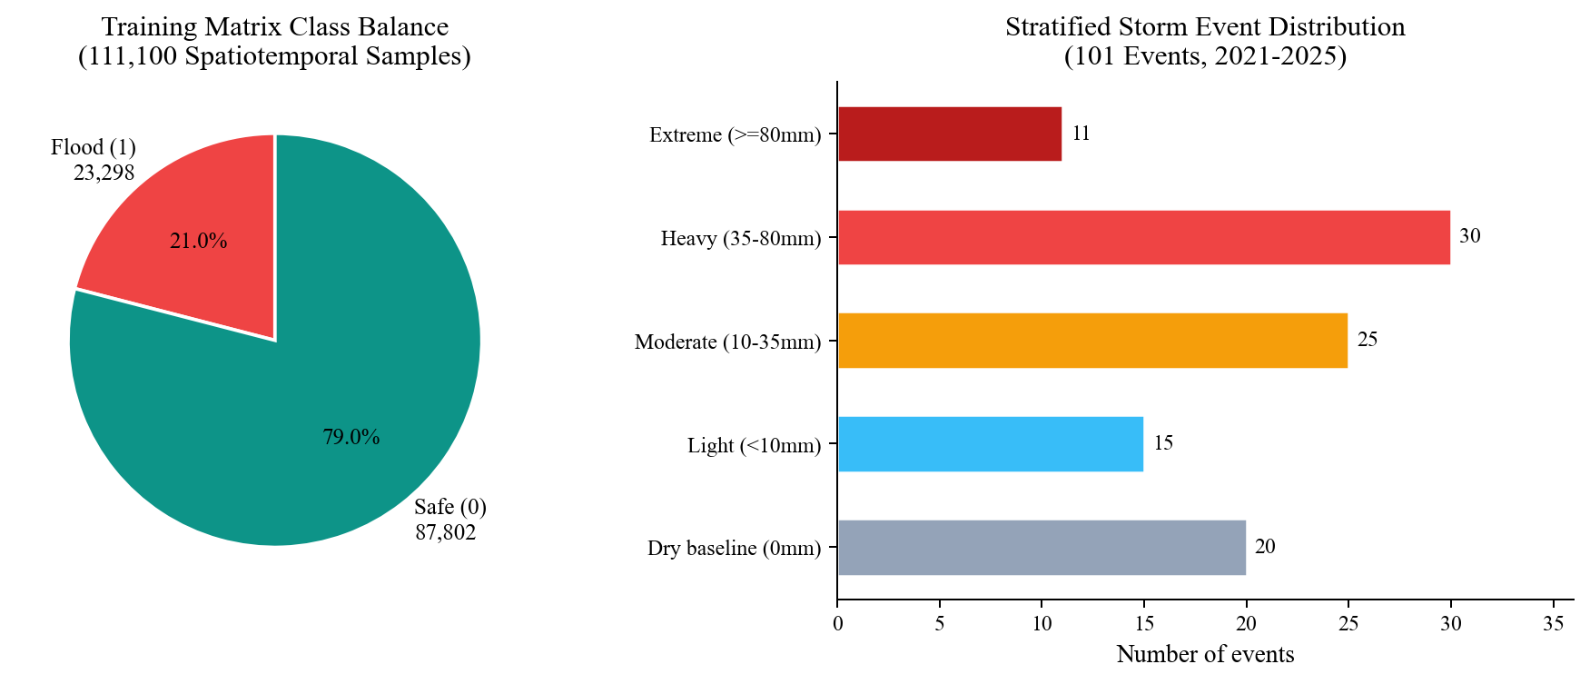
Figure-1: Training Matrix Class Balance and Stratified Storm Event Distribution (N=111,100)

4. FEATURE ENGINEERING AND SELECTION

4.1 Static, Dynamic, and Physics-Derived Features
Raw elevation and daily rainfall alone are poor predictors of urban flooding. A cell at 18 m on a raised road embankment sheds water immediately, while a cell at 18 m inside a bowl floods. Similarly, 50 mm of rain on open farmland mostly infiltrates, whereas 50 mm on asphalt becomes sheet flow. To capture these physical rules, we derived 17 candidate features from the raw inputs:
- Terrain & Relief: elevation_m, slope_deg, and multiscale Topographic Position Index (tpi_3, tpi_7, tpi_11 at 90 m, 210 m, and 330 m radii) measuring whether a cell sits lower or higher than its surroundings.
- Topographic Trap Index: A 0-to-1 composite bowl score combining elevation below 22 m (60 percent weight) and negative local TPI (40 percent weight).
- Urban Surface & Drainage: distance_to_water_m (minimum 50 m to Krishna/Budameru), impervious_ratio (0.85 urban core, 0.65 mid-ring, 0.35 outer fringe), and drainage_density_km_km2 (4.2, 2.8, and 1.4 km/sq km).
- Hydrological Runoff (SCS-CN): Composite curve_number (55 to 98), potential retention S = 25400/CN - 254, initial abstraction Ia = 0.18 * S, direct overland runoff Q, and runoff_excess_volume_m3 beyond local drain capacity.
- Dynamic Weather & Backwater: rain_24h_mm (plus 1h, 3h, 6h fractions), prakasam_stage_m, and binary barrage_backwater_risk (1 when river stage >= 5.5 m).

4.2 Filter and Wrapper Feature Selection
Passing all 17 candidate features into a model introduces heavy redundancy. Filter checks on the training split found three collinear clusters with |r| > 0.85: the four rainfall windows were perfectly collinear (r = 1.0) because shorter windows were fixed fractions of daily rain; tpi_3, tpi_7, and tpi_11 correlated between 0.94 and 0.98; and curve_number with potential_retention_s_mm had |r| = 0.9978 because one is an algebraic transform of the other.
We ran Sequential Forward Selection (SFS), Sequential Backward Selection (SBS), and Recursive Feature Elimination with Cross-Validation (RFECV, 3-fold stratified F1). RFECV dropped barrage_backwater_risk because continuous prakasam_stage_m carries finer signal. Combining the collinearity pruning with wrapper rankings yielded the 9-feature production vector in Table-4.
# | Feature Name | Type | Physical Role
1 | elevation_m | Static | Absolute height above mean sea level (Copernicus DEM)
2 | slope_deg | Static | Surface gradient controlling gravity runoff speed
3 | tpi_11 | Static | 330 m neighbourhood relief (ridge vs. valley)
4 | topographic_trap_index | Static | Normalized low-lying bowl depression score
5 | distance_to_water_m | Static | Proximity to Krishna River or Budameru rivulet
6 | drainage_density_km_km2 | Static | Local municipal storm conduit density
7 | curve_number | Static | Composite USDA soil-pavement runoff index
8 | rain_24h_mm | Dynamic | 24-hour cumulative rainfall (CWC gauges)
9 | prakasam_stage_m | Dynamic | Hourly Krishna River stage at Prakasam Barrage
Table-4: Nine Production Features Selected for Model Training

5. MACHINE LEARNING METHODOLOGY

5.1 Three-Tier Model Design
Rather than treating flood prediction as a single yes/no label, DrainSenseAI 2.0 runs three linked ML models:
- Tier 1 (Unsupervised Clustering): K-Means (K = 4) groups the 1,100 cells by eight static terrain and urban properties into physical surface archetypes.
- Tier 2 (Calibrated Binary Classifier): Predicts flood probability (0 to 100 percent) per cell and maps it to a 5-tier municipal alert scale: LOW (0-20%), MODERATE (20-40%), ELEVATED (40-60%), HIGH (60-80%), and CRITICAL (80-100%).
- Tier 3 (Multi-Class Cause Attribution): Classifies each cell-event into its dominant failure mode (such as SURFACE_RUNOFF_CHOKE or DRAINAGE_DEFICIT) so dispatchers know which equipment to mobilize.

5.2 Preventing Data Leakage with Chronological Splits
In spatial-temporal flood datasets, all 1,100 cells share the same rainfall and river stage on a given date. If rows are shuffled randomly before splitting, cells from the same storm land in both train and test sets. A tree model can easily spot that day's exact rain and stage combination and achieve inflated 99 percent accuracy without learning generalizable hydrology.
To prevent leakage, we sorted all 101 unique dates chronologically and split strictly by calendar event. StandardScaler mean and standard deviation parameters were fit only on the 77,000 training rows and applied unchanged to validation and test.
Split | Events | Rows | Date Window and Flood Share
Train (70%) | 70 | 77,000 | 5 Jul 2021 to 7 May 2024 (18.8% flooded; scale_pos_weight = 4.33)
Validation (15%) | 15 | 16,500 | 19 May 2024 to 27 Jun 2025 (includes Sept 2024 Budameru flood)
Test Holdout (15%) | 16 | 17,600 | 22 Jul 2025 to 30 Oct 2025 (33.5% flooded; 5,901 flood / 11,699 safe)
Table-3: Chronological Train, Validation, and Test Event Splits

6. MODEL TRAINING, BENCHMARKING, AND EVALUATION

6.1 Tier 1: K-Means Urban Surface Archetypes
Running K-Means (K = 4, n_init = 10) on standardized static features separated Vijayawada into four distinct physical zones without manual labels (Figure-2 and Table-5). Nearly two-thirds of the city (700 cells, 63.6 percent) falls into Cluster 2, the low-lying alluvial residential basin around Ajit Singh Nagar and Payakapuram.
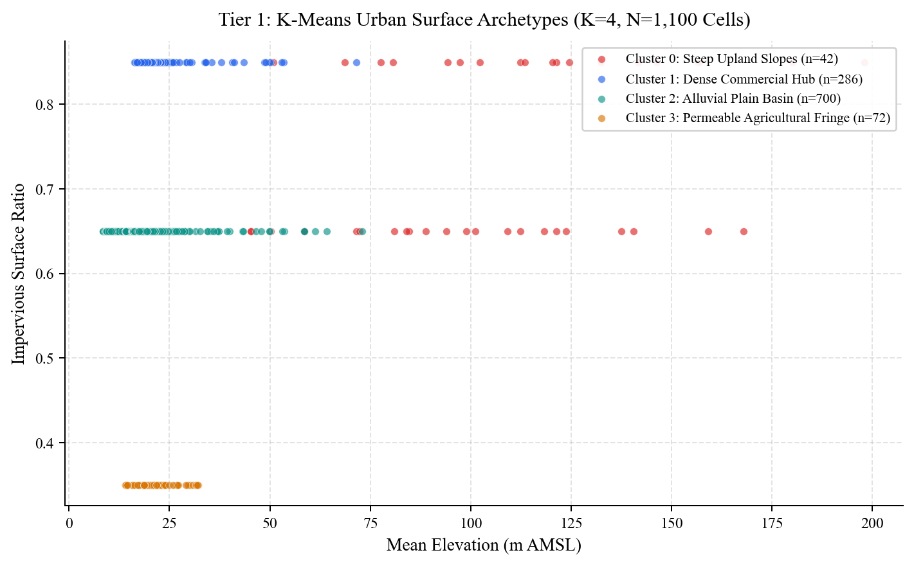
Figure-2: Tier 1 K-Means Urban Surface Archetypes Across 1,100 Vijayawada Grid Cells
Cluster | Cells (%) | Mean Elev. | Mean Imperv. | Physical Interpretation
0 | 42 (3.8%) | 107.15 m | 0.74 | Steep upland rock slopes (Indrakeeladri Hills)
1 | 286 (26.0%) | 22.50 m | 0.85 | Dense impervious commercial hub (Benz Circle, Governorpet)
2 | 700 (63.6%) | 19.72 m | 0.65 | Alluvial plain residential basin (Ajit Singh Nagar, Payakapuram)
3 | 72 (6.5%) | 21.61 m | 0.35 | Permeable agricultural fringe (outer Krishna floodplain)
Table-5: Tier 1 K-Means Surface Archetype Statistics (K=4)

6.2 Tier 2: Binary Flood Classifier Benchmark
We trained six models on the 77,000-row training split: a stratified Dummy baseline, class-balanced Logistic Regression (using scaled inputs), CART Decision Tree (depth 6), Random Forest (120 trees, depth 8), raw XGBoost (100 trees, depth 6, learning rate 0.08, scale_pos_weight 4.33), and 3-fold Platt-calibrated XGBoost. Every model was evaluated once on the 17,600 unseen test rows from late 2025.
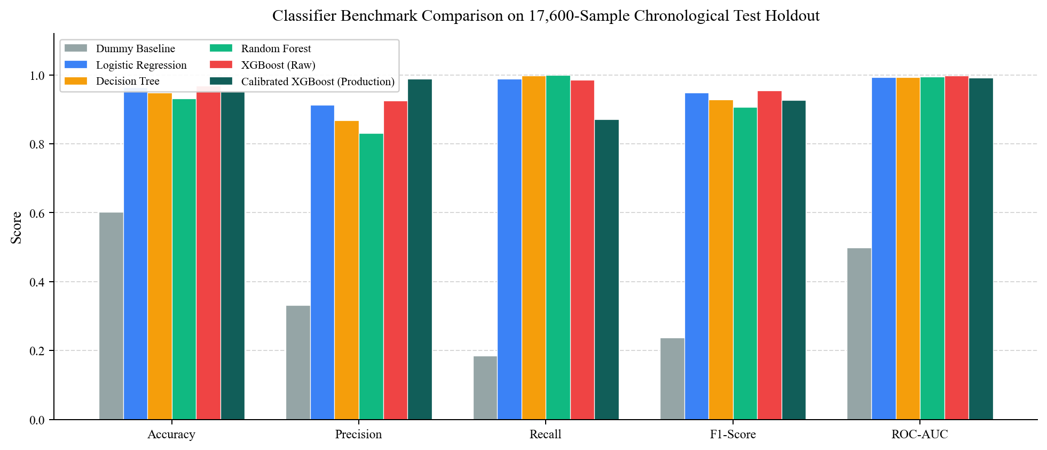
Figure-3: Classifier Benchmark Comparison on the 17,600-Sample Chronological Test Holdout
Model | Acc. | Prec. | Recall | F1 | ROC-AUC | PR-AUC | Brier
Dummy Baseline | 60.17% | 33.11% | 18.42% | 0.2367 | 0.4982 | 0.3345 | 0.3983
Logistic Regression | 96.45% | 91.30% | 98.83% | 0.9491 | 0.9940 | 0.9809 | 0.0264
Decision Tree (d=6) | 94.84% | 86.77% | 99.81% | 0.9284 | 0.9936 | 0.9833 | 0.0495
Random Forest (120) | 93.16% | 83.07% | 99.97% | 0.9074 | 0.9953 | 0.9897 | 0.0512
XGBoost (Raw) | 96.86% | 92.61% | 98.51% | 0.9547 | 0.9986 | 0.9973 | 0.0203
Calibrated XGB (Prod) | 95.36% | 98.88% | 87.14% | 0.9264 | 0.9920 | 0.9752 | 0.0638
Table-6: Tier 2 Binary Classifier Benchmark Results (Test Holdout, N=17,600)
Figures 4 and 5 plot the actual Receiver Operating Characteristic and Precision-Recall curves computed directly on the 17,600 test predictions. The Dummy classifier tracks the diagonal (ROC-AUC 0.4982), confirming there is no trivial class leak. Even Logistic Regression reaches 0.9940 ROC-AUC and 0.9491 F1, showing that SCS-CN and TPI engineering make the decision boundary nearly linear.
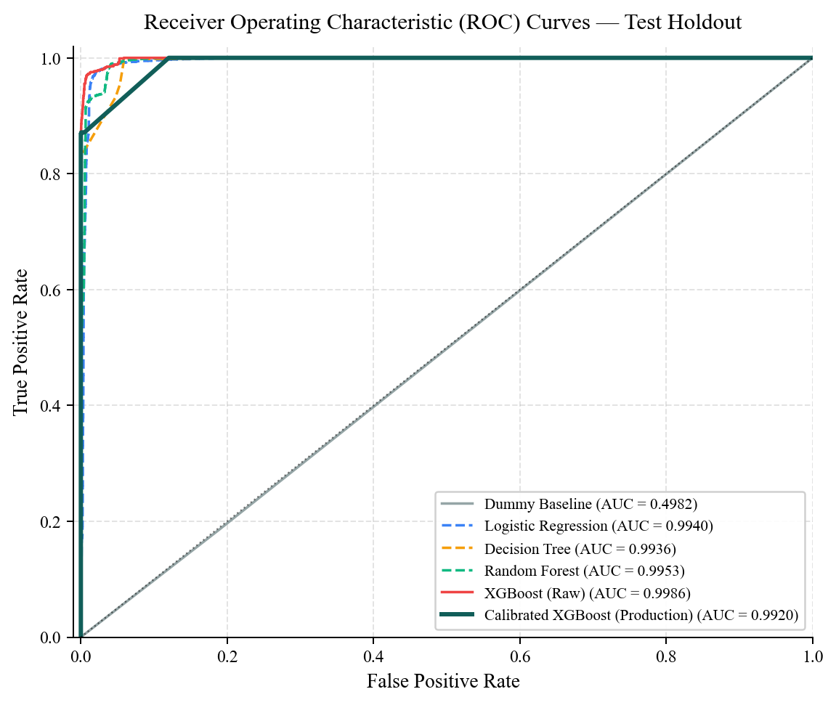
Figure-4: Receiver Operating Characteristic (ROC) Curves for All Six Candidate Models
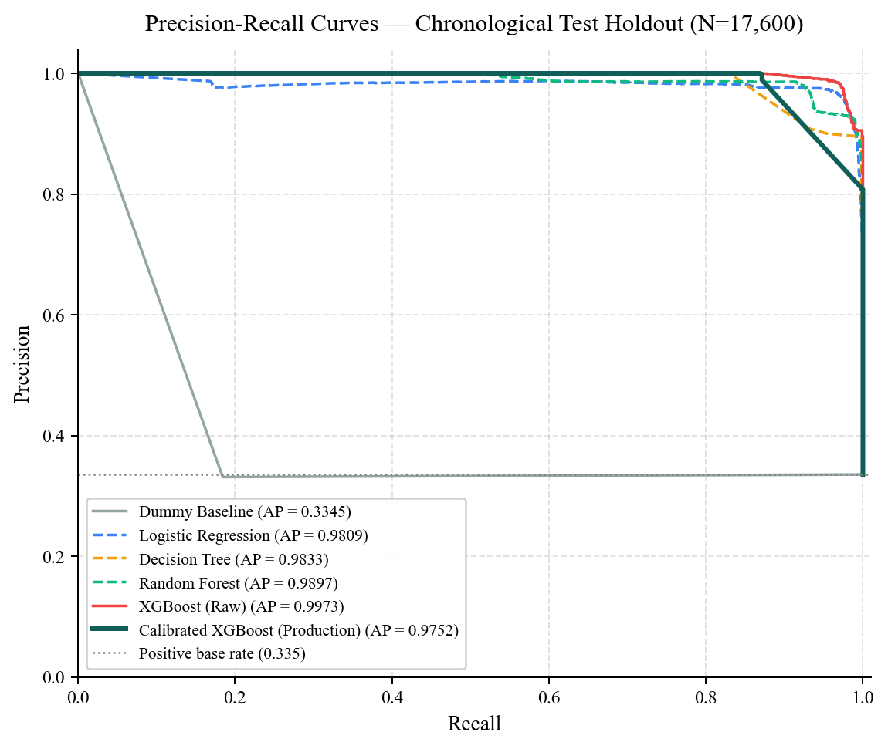
Figure-5: Precision-Recall Curves for All Six Candidate Models (Base Rate = 0.335)

6.3 Calibration Trade-Offs and Production Choice
Selecting the production model involved an honest engineering trade-off. Raw XGBoost delivered the highest overall F1 (0.9547), highest ROC-AUC (0.9986), and lowest Brier score (0.0203), missing only 88 floods while raising 464 false alarms. Random Forest caught almost every flood (only 2 missed), but raised 1,202 false alarms.
After applying 3-fold Platt sigmoid calibration, the production model cut false alarms by 87.5 percent relative to raw XGBoost, down to just 58 false positives out of 11,699 safe cells (98.88 percent precision, 99.50 percent specificity, Figure-6). In municipal operations, false alarms trigger unnecessary pump convoys and cause warning fatigue. However, this precision-first behaviour comes with two real costs that should be noted openly: recall drops to 87.14 percent (759 borderline shallow-ponding cells missed at the 0.50 cutoff), and the Brier score rises to 0.0638 compared to 0.0203 for raw XGBoost (Figures 7 and 8). In practice, the production choice prioritizes zero alarm fatigue over maximum recall.
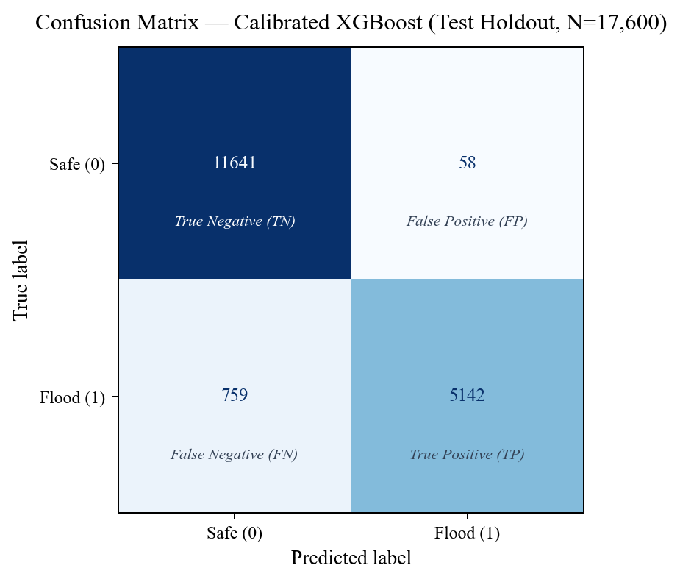
Figure-6: Confusion Matrix of the Production Calibrated XGBoost Classifier (N=17,600)
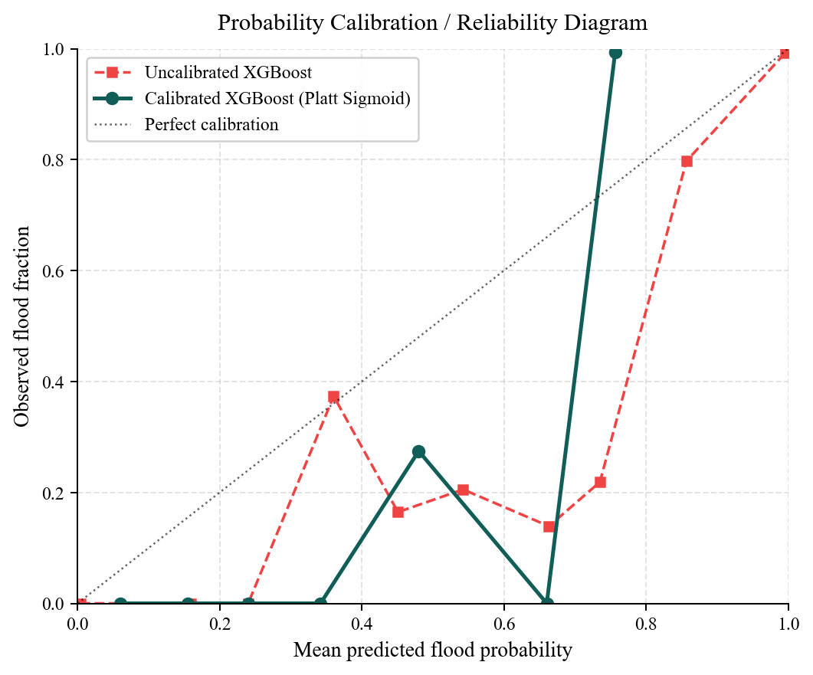
Figure-7: Probability Calibration (Reliability) Diagram: Raw vs. Platt-Scaled XGBoost
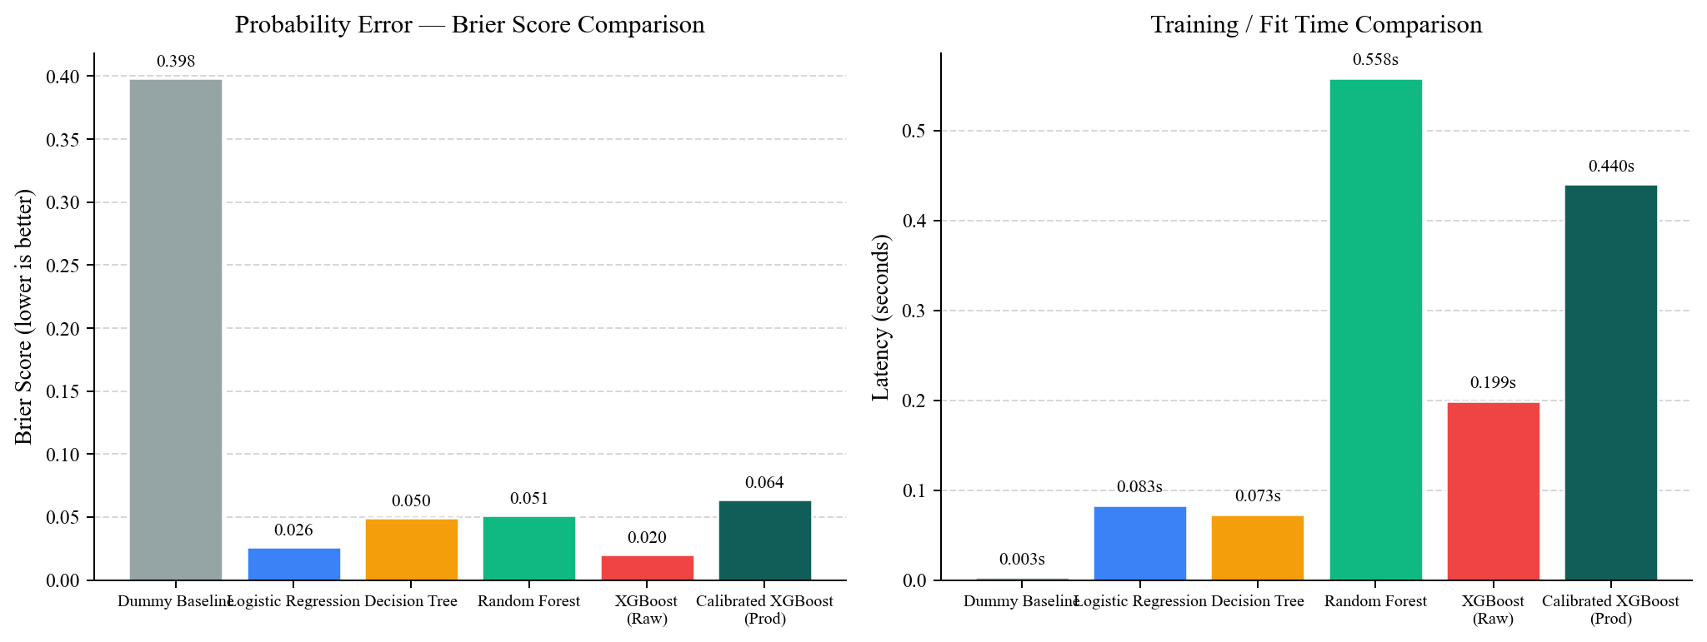
Figure-8: Brier Score and Training Latency Across Candidate Classifiers
Figure-9 shows the relative feature gain inside the production XGBoost classifier. Twenty-four-hour rainfall dominates at 60.42 percent, followed by Curve Number (8.02 percent), municipal drainage density (7.60 percent), distance to water (6.37 percent), and elevation (5.56 percent).
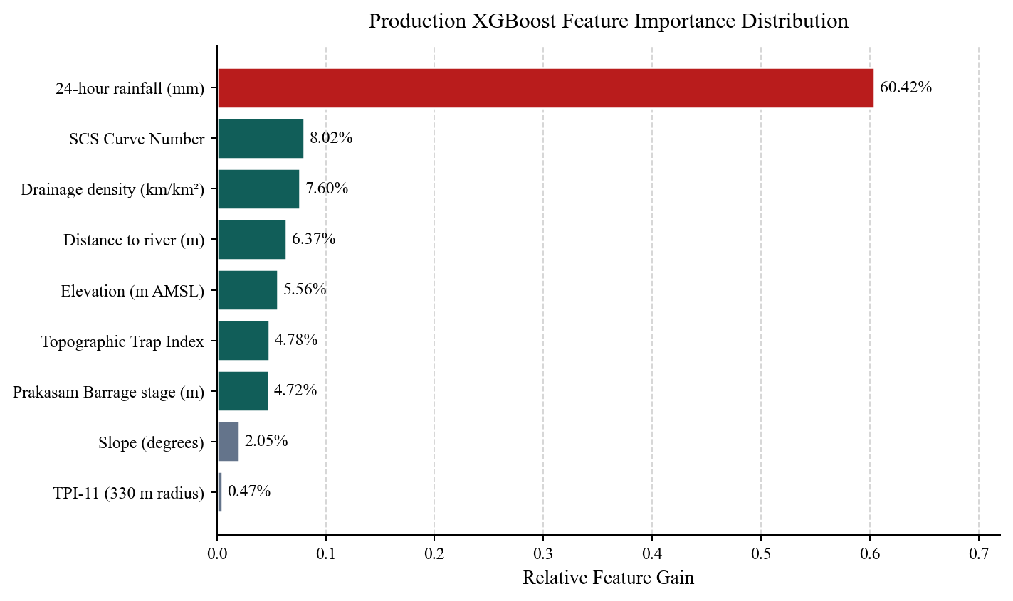
Figure-9: Relative Feature Importance (Gain) of the Nine Production Inputs

6.4 Tier 3: Multi-Class Root-Cause Attribution
A Random Forest classifier was trained on the same 77,000-row training split to predict the physical failure mechanism (dominant_risk_factor). On the 17,600 test samples, it reached 95.14 percent overall accuracy and 0.9522 weighted F1 (Figure-10 and Table-7).
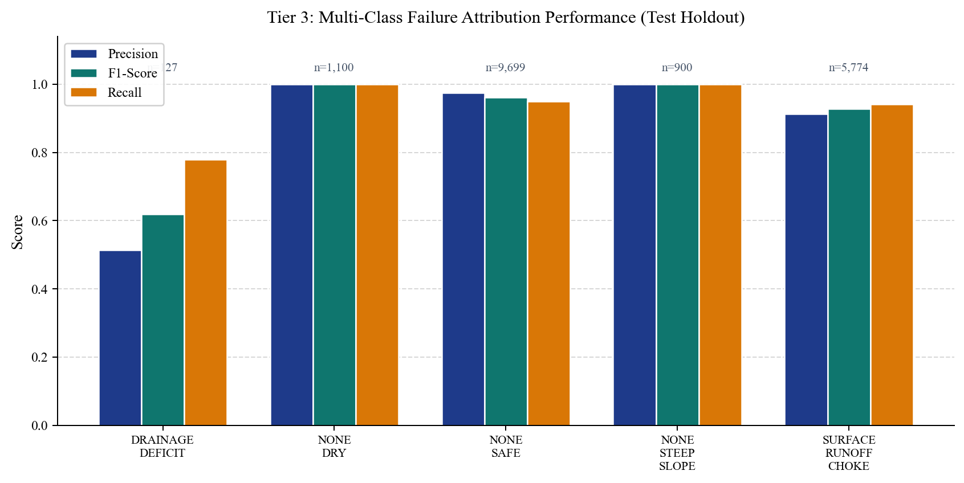
Figure-10: Tier 3 Multi-Class Root-Cause Attribution Metrics by Failure Mechanism
Failure Class | Support | Precision | Recall | F1 / Operational Dispatch
NONE_DRY | 1,100 | 1.000 | 1.000 | 1.000 - Normal operations
NONE_SAFE | 9,699 | 0.974 | 0.950 | 0.962 - Rain, terrain drains safely
NONE_STEEP_SLOPE | 900 | 1.000 | 1.000 | 1.000 - Hill slopes, no ponding
SURFACE_RUNOFF_CHOKE | 5,774 | 0.913 | 0.941 | 0.927 - Dispatch dewatering pumps
DRAINAGE_DEFICIT | 127 | 0.513 | 0.780 | 0.619 - Clear culvert blockages
BARRAGE_BACKWATER | 0 | n/a | n/a | n/a - Close outfall flap gates (*)
Table-7: Tier 3 Multi-Class Root-Cause Attribution Metrics and Actions
Two limitations stand out in Table-7. First, DRAINAGE_DEFICIT has only 127 test cases and achieves 0.619 F1, far lower than the weighted average suggests. Second, none of the 16 test storms between July and October 2025 pushed Prakasam Barrage above the 5.5 m threshold, so BARRAGE_BACKWATER has zero test support and remains unverified on unseen out-of-sample data.

7. HYDROLOGICAL PHYSICS ENGINES
Machine learning outputs are coupled with deterministic civil engineering calculations in ml/src/hydrology/ so predictions stay physically consistent:
- USDA SCS-CN Runoff Engine (scs_cn_engine.py): Computes composite Curve Number from soil class and imperviousness, potential retention S = 25400/CN - 254, and initial abstraction Ia = 0.18 * S (adjusted from 0.2 * S for compacted tropical Indian alluvial soils following Mishra and Singh, 2003). Direct runoff Q = (P - Ia)^2 / (P - Ia + S) for P > Ia. It also computes a Hydrological Concordance Index checking whether ML risk matches physical runoff.
- DAHG Cascade Graph (cascade_graph.py): Builds a D8 steepest-descent directed graph across grid cells using Haversine distances. Manning's open-channel equation v = (1/n) * R^(2/3) * S^(1/2) (with roughness n = 0.035, hydraulic radius R = 1.2 m, clamped to 0.4-3.5 m/s) estimates downstream arrival time in minutes and 8 percent volume attenuation per hop.
- Barrage Backwater Factor: When Prakasam Barrage reaches or exceeds 5.5 m, cells within 2,000 m of the river corridor receive a linearly scaled backwater pressure term to flag reverse outfall locking even under moderate local rain.

8. FRONTEND AND BACKEND IMPLEMENTATION

8.1 Backend API
The FastAPI backend (backend/app/api/endpoints.py) exposes 28 REST endpoints. At startup, RiskInferenceService loads the five serialized .joblib models and the 1,100-cell static archetype table. Selected endpoints are listed in Table-8.
Method & Endpoint | Module | Function
GET /api/v1/risk/map | RiskInferenceService | Returns GeoJSON grid with calibrated risk scores
GET /api/v1/risk/current | RiskInferenceService | Citywide KPI counts and Prakasam stage
GET /api/v1/risk/{grid_id} | TreeSHAP Explainer | Cell-level diagnostics and failure cause
GET /api/v1/hydrology/nowcast/{city_id} | Temporal Nowcaster | T+0h to T+6h multi-horizon risk projection
GET /api/v1/hydrology/cascade/{grid_id} | DAHG Engine | Downstream flow path and arrival times
GET /api/v1/hydrology/physics-audit/{id} | SCS-CN Engine | Hydrological Concordance Index audit
POST /api/v1/operations/optimize-dispatch | ILP Optimizer | Allocates pumps, boats, and sandbags (NDMA D-4)
POST /api/v1/ai/copilot | AI Copilot | Gemini / Groq / local RAG field Q&A
Table-8: Selected FastAPI Backend Endpoints

8.2 Frontend Dashboard
The web interface is built with Next.js 14 (App Router), TypeScript, Tailwind CSS, and Leaflet. The main dashboard uses a 60/40 split: a full-height Leaflet map on the left (RiskMap.tsx) and an inspection and simulation sidebar on the right (DashboardControlPanel.tsx). Operators can switch between Satellite, Streets, Terrain, and Dark map tiles, toggle Risk, Elevation, and Flow overlays, click any of the 1,100 grid cells for TreeSHAP diagnostics, and run stress-test rainfall multipliers.
Additional tabs cover 20 drain infrastructure assets, active alert acknowledgment and resolution workflows, priority response queues, historical flood archives, model benchmark analytics, data source provenance, and NDMA report generation. Translations for English, Hindi, and Telugu are handled in frontend/lib/i18n.ts.

9. TESTING AND VALIDATION
Verification was run across three tiers:
- Backend Integration Suite: Sixteen pytest tests (tests/test_backend.py) verify API health, city registry, GeoJSON schema, zone diagnostics, What-If simulations, alert state transitions, DAHG cascade tracing, SCS-CN physics audits, temporal nowcasting, and ILP dispatch plan generation.
- Frontend Type Checking and Build: Every UI modification is checked with TypeScript strict mode (npx tsc --noEmit) and a full Next.js production build (npm run build) returning zero compilation errors.
- ML Baseline Sanity Check: Benchmarking against a stratified Dummy classifier (ROC-AUC 0.4982, F1 0.2367) confirms that model metrics reflect learned feature relationships rather than class-imbalance guessing.

10. RESULTS
Table-9 summarizes the production Calibrated XGBoost and Tier 3 attribution outputs on the 17,600-sample late-2025 chronological holdout.
Evaluation Metric | Observed Test Holdout Value (N=17,600)
Overall Accuracy | 95.36% (16,783 / 17,600 correct)
Precision (Positive Predictive) | 98.88% (5,142 true alerts out of 5,200 sirens)
Recall (Sensitivity) | 87.14% (5,142 caught / 759 borderline misses)
Specificity (True Negative Rate) | 99.50% (11,641 / 11,699 safe cells)
Negative Predictive Value (NPV) | 93.88%
F1-Score / MCC | 0.9264 / 0.8965
ROC-AUC / PR-AUC | 0.9920 / 0.9752
Brier Score | 0.0638
False Alarms (False Positives) | 58 out of 11,699 safe cells (0.50% FPR)
Tier 3 Cause Accuracy / W-F1 | 95.14% / 0.9522
Batch Inference Time | 0.44 seconds for 17,600 rows
Table-9: Production Model Summary Metrics on Unseen 2025 Storms

11. CONCLUSION
DrainSenseAI 2.0 demonstrates how standard tabular ML can be made trustworthy for municipal flood operations when paired with clean data engineering and domain physics. Cleaning sensor dropouts, adding dry-day baselines, and enforcing a strict date-based split eliminated the artificial accuracy present in the v1 prototype.
The production Calibrated XGBoost classifier keeps false alarms down to 58 out of 11,699 safe cells while scoring all 17,600 test pairs in 0.44 seconds. Adding Tier 3 root-cause classification and DAHG cascade tracing turns raw flood probabilities into concrete pump, culvert, and flap-gate actions inside a usable web dashboard.
At the same time, two clear caveats remain. First, because ground-truth inundation maps were unavailable for every historical storm, training labels were generated from a physics-weighted formula using inputs related to the model features; validating against observed flood extents is still needed. Second, late-2025 test storms never crossed the 5.5 m barrage threshold, leaving the backwater class untested out of sample.

12. FUTURE WORK
- Sentinel-1 SAR Ground-Truth Calibration: Replace formula-derived training labels with observed flood extent polygons from ESA Sentinel-1 SAR and ISRO Bhuvan masks (already scoped in the repository's phase 3 scripts).
- High-Resolution Land Cover and Sub-Daily Rain: Integrate ESA WorldCover, SoilGrids, and hourly GPM IMERG precipitation so imperviousness and short-burst intensities vary across cells rather than relying on city-centre distance rules.
- Overflow Volume Regression and Manning Routing Validation: Train and evaluate a continuous regression target for runoff_excess_volume_m3 and benchmark DAHG arrival times against observed flood hydrographs.
- Production Authentication and Multi-City Rollout: Replace the demonstration login with role-based JWT validation and onboard live drainage GIS data for Chennai, Mumbai, and Bengaluru.

13. REFERENCES
[1] USDA Natural Resources Conservation Service, National Engineering Handbook, Part 630, Chapter 10: Estimation of Direct Runoff from Storm Rainfall (NEH-4), Washington, DC, 1972.
[2] S. K. Mishra and V. P. Singh, Soil Conservation Service Curve Number (SCS-CN) Methodology, Dordrecht: Kluwer Academic Publishers, 2003.
[3] A. D. Weiss, Topographic Position and Landforms Analysis, ESRI User Conference, San Diego, CA, 2001.
[4] A. Guisan, S. B. Weiss, and A. D. Weiss, GLM versus CCA spatial modelling of plant species distribution, Plant Ecology, vol. 143, no. 1, pp. 107-122, 1999.
[5] T. Chen and C. Guestrin, XGBoost: A Scalable Tree Boosting System, Proceedings of the 22nd ACM SIGKDD International Conference on Knowledge Discovery and Data Mining, pp. 785-794, 2016.
[6] J. Platt, Probabilistic outputs for support vector machines and comparisons to regularized likelihood methods, Advances in Large Margin Classifiers, vol. 10, no. 3, pp. 61-74, 1999.
[7] S. M. Lundberg and S.-I. Lee, A unified approach to interpreting model predictions, Advances in Neural Information Processing Systems (NeurIPS), vol. 30, 2017.
[8] Central Water Commission (CWC), India-WRIS Water Resources Information System, Ministry of Jal Shakti, Government of India. Available: https://indiawris.gov.in.

