**Assignment 1.1**

**Step 1: Import Appliance**

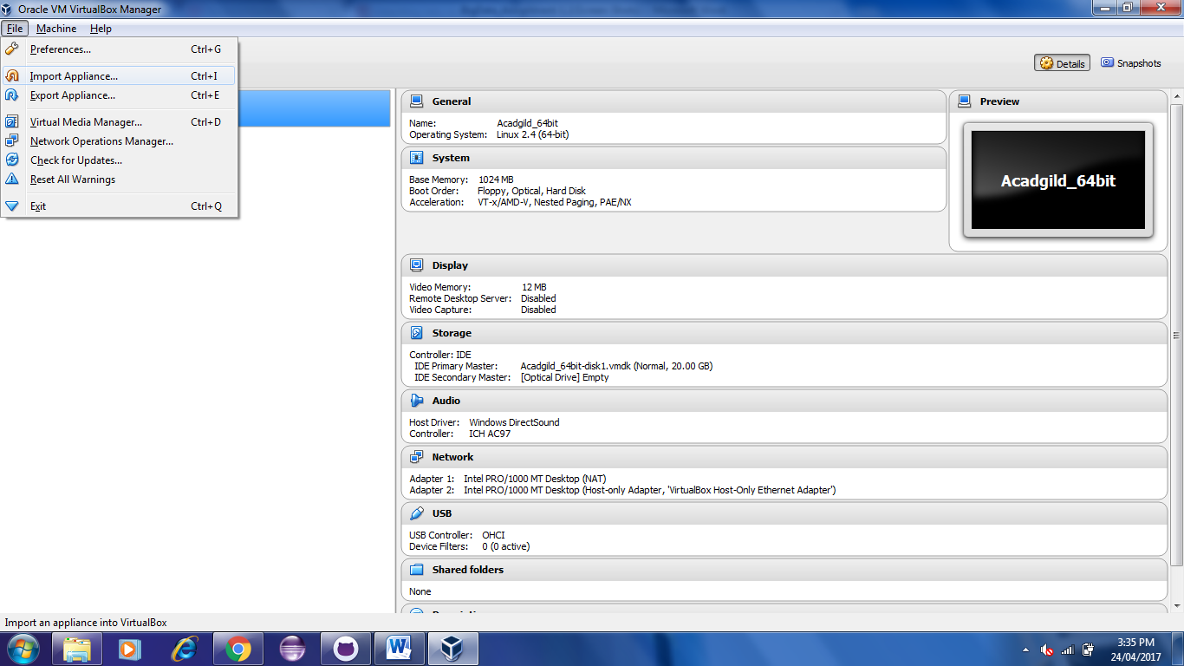

**Step 2: Select the Appliance to Import**

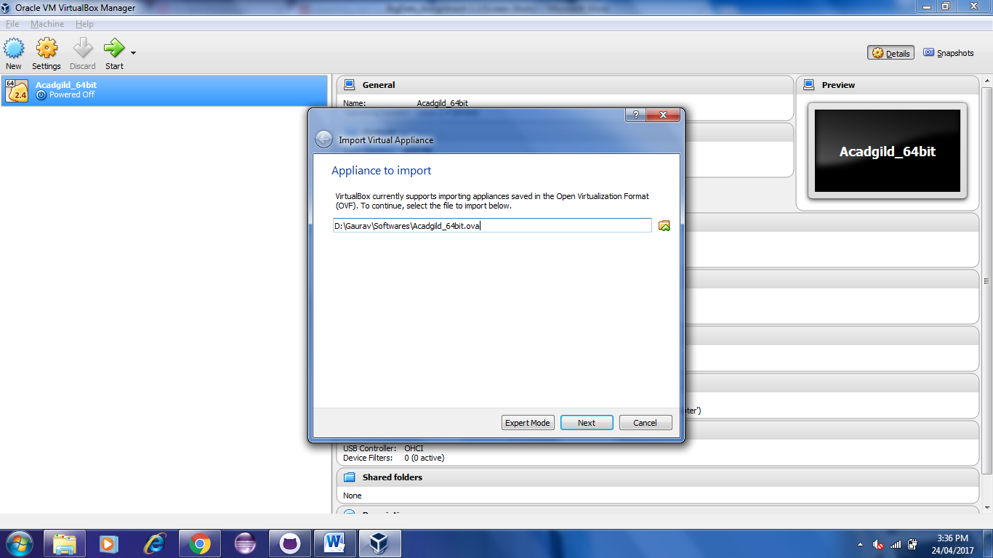

**Step 3: Click on Import Button to start importing Acadgild VM**

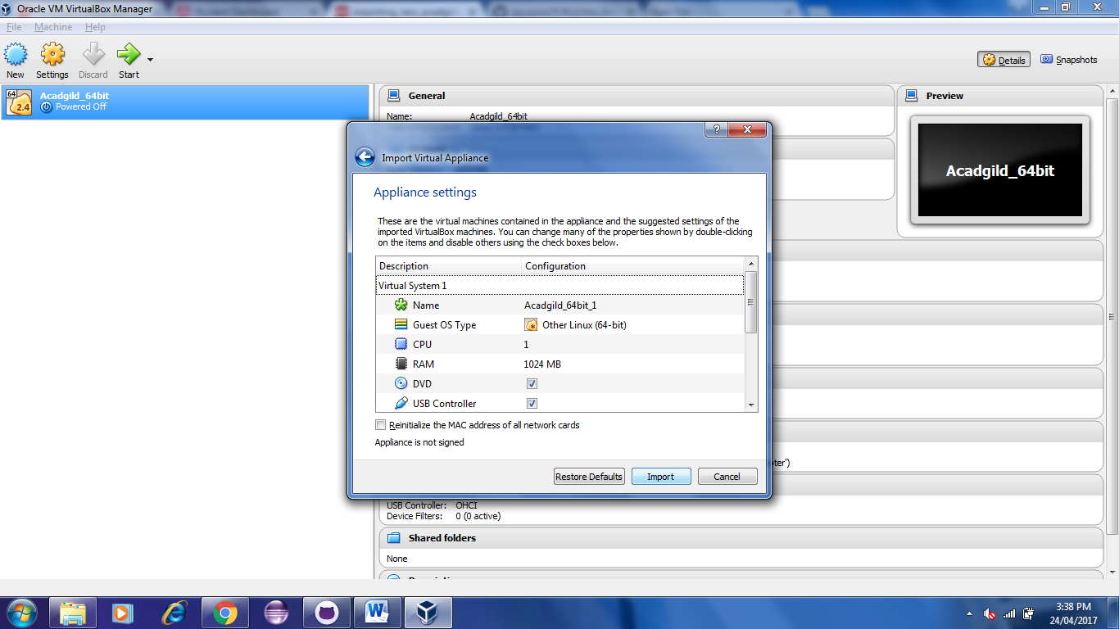

**Step 4: Click the Start Button to initiate the Acadgild VM**

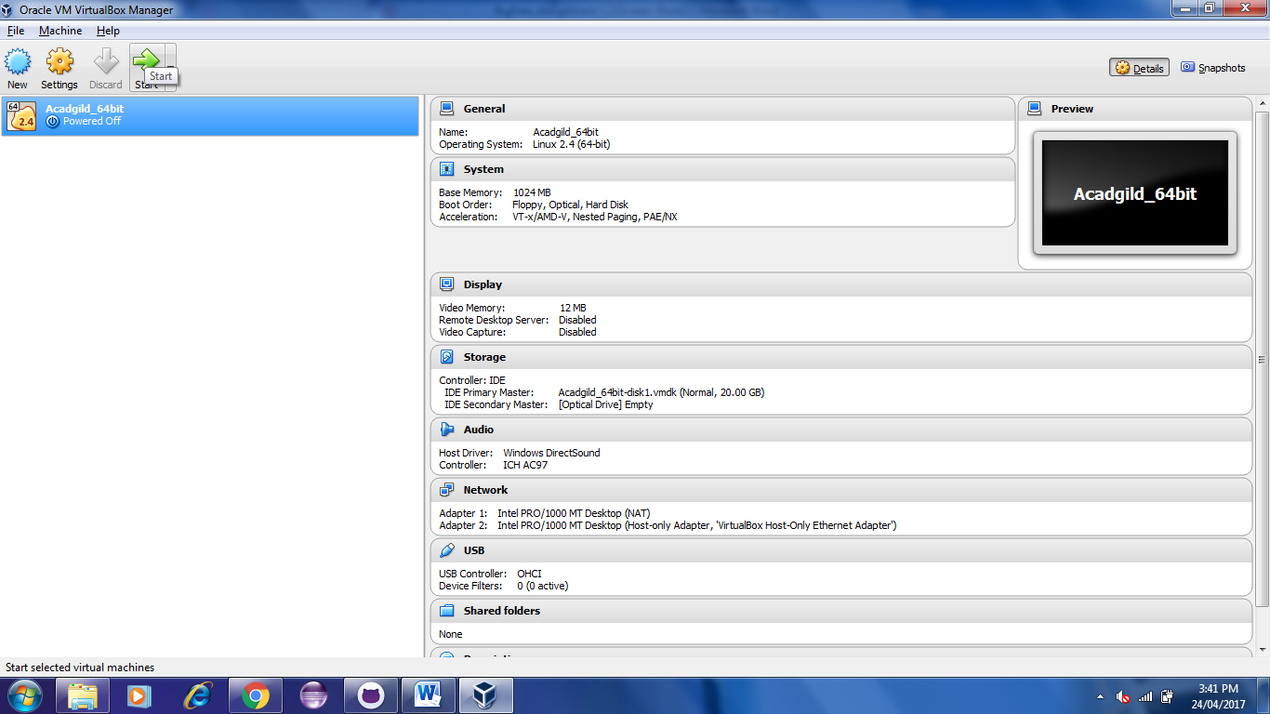

**Step 5: Give the Password as Acadgild**

