**Assignment 2.2**

**Task 1**

Command for creating file in local is **gedit max-temp.txt**

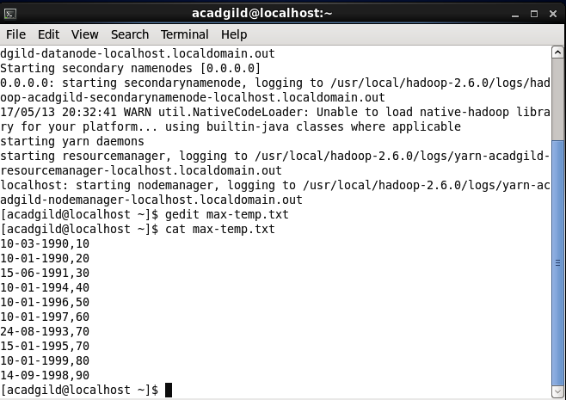

Command for moving file from local to HDFS

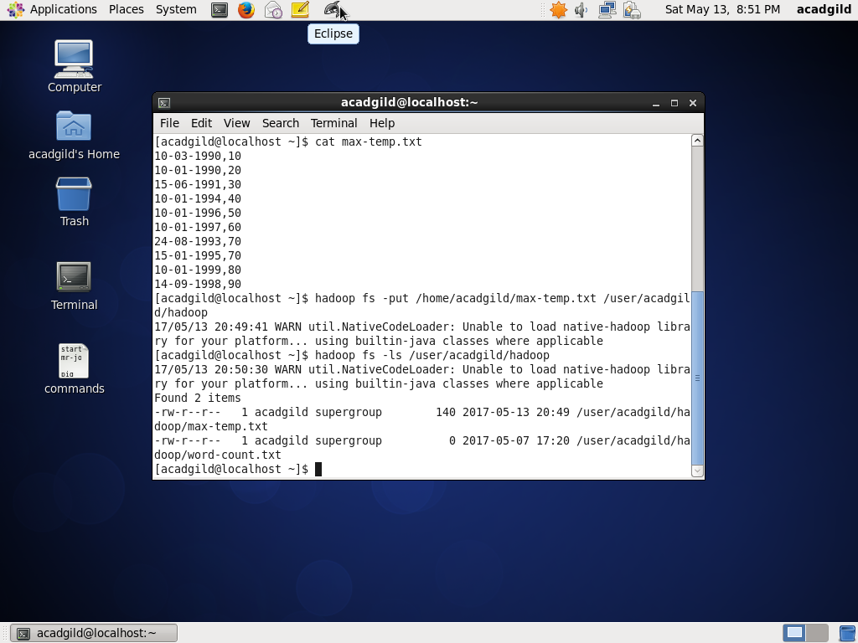**hadoop fs –put /home/acadgild/max-temp.txt /user/acadgild/hadoop/**

**Task 2**

For revoking permission for all:

**hadoop fs –chmod ugo-rwx /user/acadgild/hadoop/max-temp.txt**

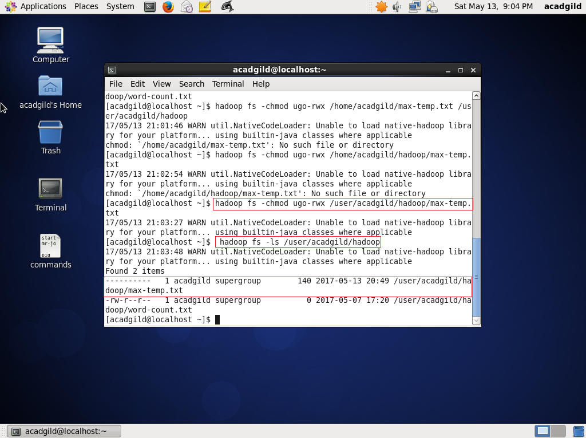

For granting full permission to owner and group:

**hadoop fs –chmod ug=rwx /user/acadgild/hadoop/max-temp.txt**

