API: Storefront - NOAH Integration Buyer Information
Systems Involved
- Storefront: Handles booking, buyer portal, and LPW (buyer profile)
- NOAH (CRM): Manages leads and client information
- Funnel / Referral Partner: Source of lead data
1. Create Lead
Description: Creates a new lead from Funnel or Referral Partner to NOAH CRM.
Data Sample:
• First Name
• Last Name
• Mobile Number
• Email Address
• Birthdate
• Gross Monthly Income
• Preferred Project

2. View Lead Details
Description: Get lead details and status from NOAH CRM to proceed in Storefront booking.
Data Sample:
• First Name
• Last Name
• Mobile Number
• Email Address
• Birthdate
• Gross Monthly Income
• Preferred Project
• CRM Lead Code

3. Create Client Information
Description: Creates client information record after payment in NOAH.
• First Name
• Last Name
• Mobile Number
• Email Address
• Birthdate
• Gross Monthly Income
• Preferred Project
• Homeful ID

4. Update Buyer Profile
Description: Updates buyer profile.
• Contact Information
• Customer Address
• Employment Information
• Spouse Information
• Co-Buyer
• Attorney-In-Fact Information
• Business Information (Self Employed/Business Owner)
• Customer Gross Monthly Income

5. View Buyer Profile
Description: Get client information record in NOAH.
• Contact Information
• Customer Address
• Employment Information
• Spouse Information
• Co-Buyer
• Attorney-In-Fact Information
• Business Information (Self Employed/Business Owner)
• Customer Gross Monthly Income
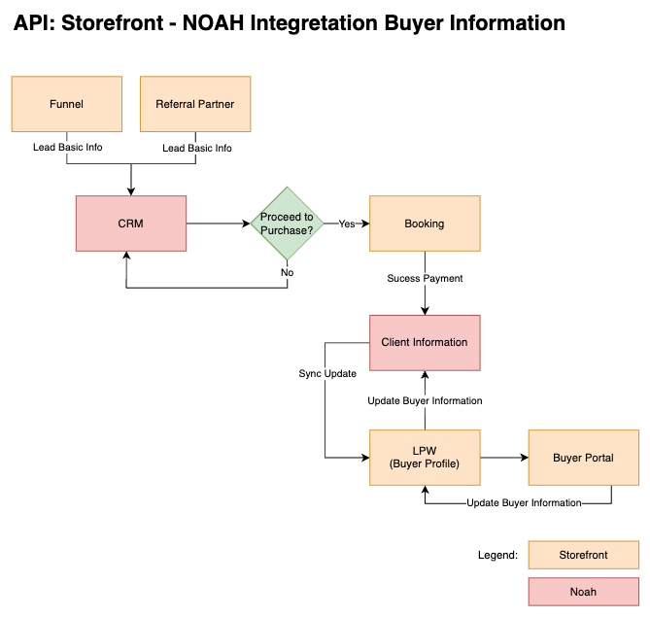
Proposed Workflow

Prepared by: Reviewed by: Approved by:

Celina Erica Beltran Renzo Carianga Gari Vivar John Walvine Rata
Business Analyst Lead Programmer Lead Programmer DDU Head

