API: Storefront - NOAH Integration Buyer Information
Systems Involved
- Storefront: Handles booking, buyer portal, and LPW (buyer profile)
- NOAH (CRM): Manages leads and client information
- Funnel / Referral Partner: Source of lead data
Note:
- Use proper http code. Ex. 404 – not found, 200 – successful , 201 – created.
- Ensure that all data has data type.
- Return code and description.
- Include API calls for Data Set-up table.

1. Create Lead
Description: Creates a new lead from Funnel or Referral Partner to NOAH CRM.
Data Sample:
- First Name
- Middle Name (Optional)
- Last Name
- Mobile Number
- Email Address
- Birthdate
- Gross Monthly Income
- Preferred Project
Sample Return:
- Successful
- Lead Code
- Error with verbose description

2. View Lead Details
Description: Search and retrieve lead details and status from NOAH CRM to proceed in Storefront booking.
Data Sample:
- First Name
- Middle Name (Optional)
- Last Name
- Mobile Number
- Email Address
- Birthdate
- Gross Monthly Income
- Preferred Project
- CRM Lead Code
Sample Return:
- Search Parameter:
  - From and To
  - Name
  - Email Address
  - Birthday
  - Gross Monthly Income
  - Preferred Project
  - Lead Code
  - Return list same as data sample

3. Create Client Information
Description: Creates client information record after payment in NOAH.
- First Name
- Middle Name (Optional)
- Last Name
- Mobile Number
- Email Address
- Birthdate
- Gross Monthly Income
- Preferred Project
- Homeful ID
Sample Return:
- Successful
- Client Code generated in NOAH
- Error with verbose description

4. Update Buyer Profile
Description: Updates buyer profile.
- Contact Information
- Customer Address
- Employment Information
- Spouse Information
- Co-Buyer
- Attorney-In-Fact Information
- Business Information (Self Employed/Business Owner)
- Customer Gross Monthly Income
Sample Return:
- All fields
- Transaction Status: Success or Failed with verbose description

5. View Buyer Profile
Description: Get client information record in NOAH.
- Contact Information
- Customer Address
- Employment Information
- Spouse Information
- Co-Buyer
- Attorney-In-Fact Information
- Business Information (Self Employed/Business Owner)
- Customer Gross Monthly Income
Sample Return:
- All field is searchable
- Return list of buyers

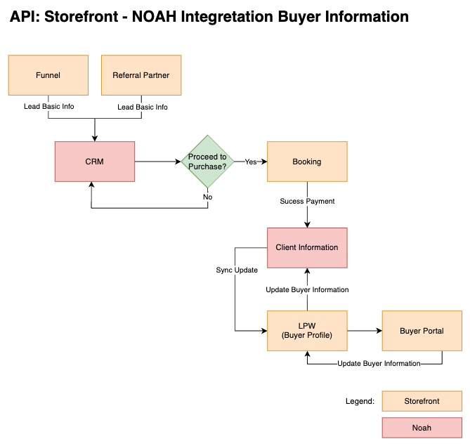
Proposed Workflow

Prepared by: Reviewed by:

Celina Erica Beltran Renzo Carianga Gari Vivar
Business Analyst Lead Programmer Lead Programmer

Approved by:

John Walvine Rata
DDU Head

