Install Docker Desktop on Windows

This page contains the download URL, information about system requirements, and instructions on how to install Docker Desktop for Windows.

[Docker Desktop for Windows](https://desktop.docker.com/win/main/amd64/Docker%20Desktop%20Installer.exe)

*For checksums, see*[*Release notes*](https://docs.docker.com/desktop/release-notes/)

**Docker Desktop terms**

Commercial use of Docker Desktop in larger enterprises (more than 250 employees OR more than $10 million USD in annual revenue) requires a paid subscription.

[System requirements](https://docs.docker.com/desktop/install/windows-install/#system-requirements)

WSL 2 backend Hyper-V backend and Windows containers

* WSL version 1.1.3.0 or later.
* Windows 11 64-bit: Home or Pro version 21H2 or higher, or Enterprise or Education version 21H2 or higher.
* Windows 10 64-bit:
  + We recommend Home or Pro 22H2 (build 19045) or higher, or Enterprise or Education 22H2 (build 19045) or higher.
  + Minimum required is Home or Pro 21H2 (build 19044) or higher, or Enterprise or Education 21H2 (build 19044) or higher.
* Turn on the WSL 2 feature on Windows. For detailed instructions, refer to the [Microsoft documentation](https://docs.microsoft.com/en-us/windows/wsl/install-win10).
* The following hardware prerequisites are required to successfully run WSL 2 on Windows 10 or Windows 11:
  + 64-bit processor with [Second Level Address Translation (SLAT)](https://en.wikipedia.org/wiki/Second_Level_Address_Translation)
  + 4GB system RAM
  + Enable hardware virtualization in BIOS. For more information, see [Virtualization](https://docs.docker.com/desktop/troubleshoot/topics/#virtualization).

**Important**

To run Windows containers, you need Windows 10 or Windows 11 Professional or Enterprise edition. Windows Home or Education editions only allow you to run Linux containers.

**Note**

Docker only supports Docker Desktop on Windows for those versions of Windows that are still within [Microsoft’s servicing timeline](https://support.microsoft.com/en-us/help/13853/windows-lifecycle-fact-sheet).

**Should I use Hyper-V or WSL?**

Docker Desktop's functionality remains consistent on both WSL and Hyper-V, without a preference for either architecture. Hyper-V and WSL have their own advantages and disadvantages, depending on your specific set up and your planned use case.

Containers and images created with Docker Desktop are shared between all user accounts on machines where it is installed. This is because all Windows accounts use the same VM to build and run containers. Note that it is not possible to share containers and images between user accounts when using the Docker Desktop WSL 2 backend.

Running Docker Desktop inside a VMware ESXi or Azure VM is supported for Docker Business customers. It requires enabling nested virtualization on the hypervisor first. For more information, see [Running Docker Desktop in a VM or VDI environment](https://docs.docker.com/desktop/vm-vdi/).

About Windows containersexpand_more

[Install Docker Desktop on Windows](https://docs.docker.com/desktop/install/windows-install/#install-docker-desktop-on-windows)

Install interactively Install from the command line

1. Download the installer using the download button at the top of the page, or from the [release notes](https://docs.docker.com/desktop/release-notes/).
2. Double-click Docker Desktop Installer.exe to run the installer.
3. When prompted, ensure the **Use WSL 2 instead of Hyper-V** option on the Configuration page is selected or not depending on your choice of backend.

If your system only supports one of the two options, you will not be able to select which backend to use.

1. Follow the instructions on the installation wizard to authorize the installer and proceed with the install.
2. When the installation is successful, select **Close** to complete the installation process.

If your admin account is different to your user account, you must add the user to the **docker-users** group:

1. Run **Computer Management** as an **administrator**.
2. Navigate to **Local Users and Groups** > **Groups** > **docker-users**.
3. Right-click to add the user to the group.
4. Sign out and sign back in for the changes to take effect.

[Start Docker Desktop](https://docs.docker.com/desktop/install/windows-install/#start-docker-desktop)

Docker Desktop does not start automatically after installation. To start Docker Desktop:

1. Search for Docker, and select **Docker Desktop** in the search results.

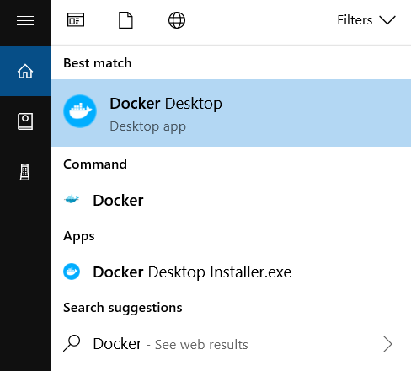

1. The Docker menu (  ) displays the Docker Subscription Service Agreement.

Here’s a summary of the key points:

* + Docker Desktop is free for small businesses (fewer than 250 employees AND less than $10 million in annual revenue), personal use, education, and non-commercial open source projects.
  + Otherwise, it requires a paid subscription for professional use.
  + Paid subscriptions are also required for government entities.
  + The Docker Pro, Team, and Business subscriptions include commercial use of Docker Desktop.

1. Select **Accept** to continue. Docker Desktop starts after you accept the terms.

Note that Docker Desktop won't run if you do not agree to the terms. You can choose to accept the terms at a later date by opening Docker Desktop.

For more information, see [Docker Desktop Subscription Service Agreement](https://www.docker.com/legal/docker-subscription-service-agreement/). We recommend that you also read the [FAQs](https://www.docker.com/pricing/faq).

[Where to go next](https://docs.docker.com/desktop/install/windows-install/#where-to-go-next)

* [Get started with Docker](https://docs.docker.com/guides/get-started/).
* [Explore Docker Desktop](https://docs.docker.com/desktop/use-desktop/) and all its features.
* [Troubleshooting](https://docs.docker.com/desktop/troubleshoot/overview/) describes common problems, workarounds, and how to get support.
* [FAQs](https://docs.docker.com/desktop/faqs/general/) provide answers to frequently asked questions.
* [Release notes](https://docs.docker.com/desktop/release-notes/) lists component updates, new features, and improvements associated with Docker Desktop releases.
* [Back up and restore data](https://docs.docker.com/desktop/backup-and-restore/) provides instructions on backing up and restoring data related to Docker.