1. Introduction

Using EEGNet and DeepConvNet to solve a classification problem, the training data is from BCI competition and has a shape of (C=1, H=2, W=750).

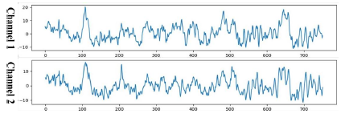

1. Experiment set up
2. The detail of your model

EEG model:

EEGNet is a relatively simple Convolutional Neural Network (CNN) architecture optimized for the characteristics of EEG data. It combines depth-wise separable convolutions and spatial convolutions to reduce the number of parameters in the model while effectively capturing spatial information. This allows EEGNet to have lower computational costs when processing EEG data while maintaining good performance. The advantages of EEGNet lie in its ability to efficiently handle time-series EEG data and its ability to achieve good generalization with relatively fewer training samples.

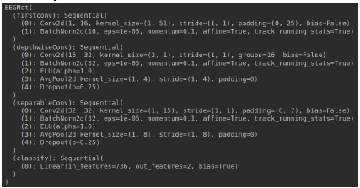

DeepConvNet:

DeepConvNet is a more complex CNN architecture compared to EEGNet. It consists of multiple layers of convolutional, pooling, and batch normalization layers, followed by a fully connected layer and a softmax output layer for classification. The network is designed to automatically learn hierarchical and spatial features from EEG signals, allowing it to capture more complex patterns and representations.The advantage of DeepConvNet lies in its ability to effectively capture spatial and temporal dependencies within EEG data due to its deeper architecture. However, it may require more computational resources and training data compared to EEGNet.

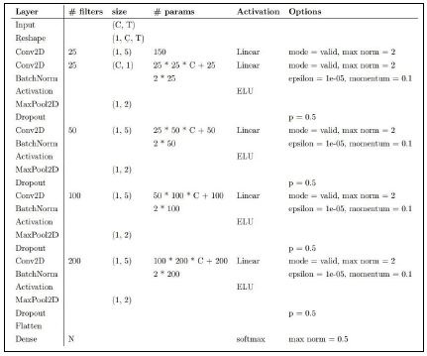

1. Explain the activation function

ReLU:

 

Advantage:

The ReLU function is computationally efficient and addresses the vanishing gradient problem in deep neural networks, making it widely used in various architectures. it speeds up the convergence during training since it allows the neuron to be active (outputting a non-zero value) for positive inputs.

Disadvantage:

it can suffer from a problem called "dying ReLU," where neurons might get stuck and stop learning if they consistently output zero.

Leaky ReLU:

 

Advantage:

Can solve dying ReLU problem. (x<0 != 0)

Disadvantage:

When x<0 that is linear, it can’t be used in the complex classification.

ELU:

 

Advantage:

It introduces a slight curvature for negative inputs, which helps alleviate the vanishing gradient problem and allows for faster learning.

Disadvantage:

the main downside of ELU is its computational cost, as it involves the exponential function, which is more computationally expensive than simple linear operations like ReLU and Leaky ReLU.

1. Experiment results
2. The highest testing accuracy

EEGNet:

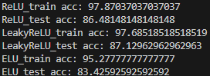

DeepConvNet:

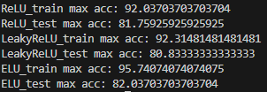

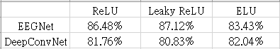

1. Comparison figures

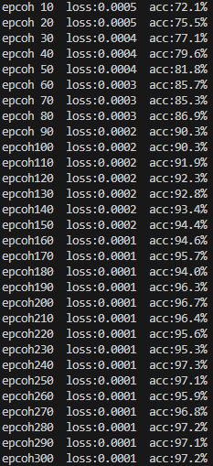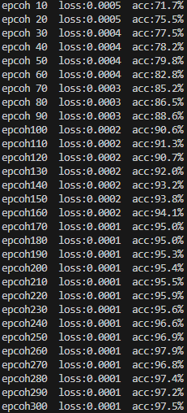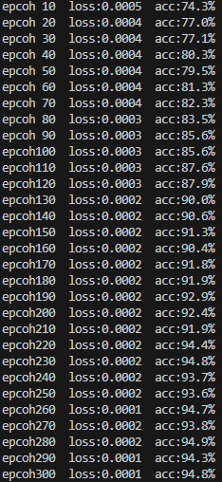EEGNet:

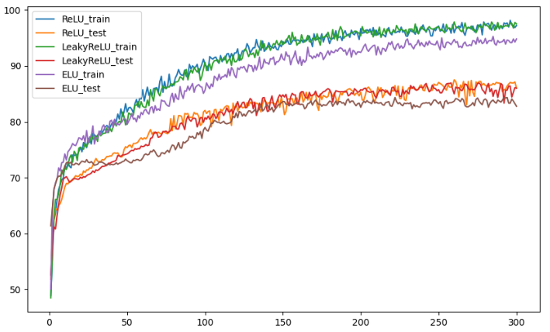

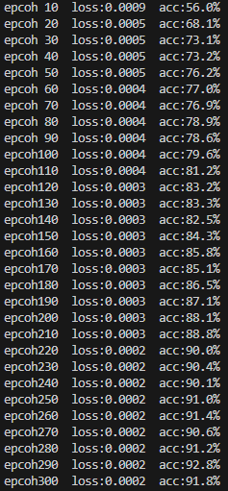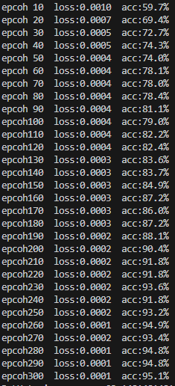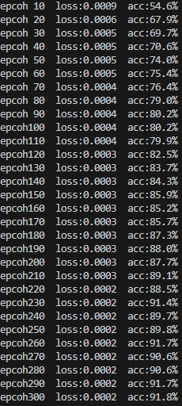DeepConvNet:

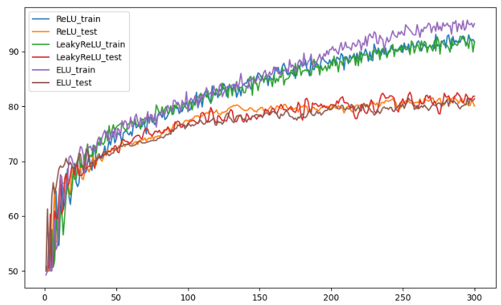

1. Discussion
2. Anything you want to share

Different Dropout: Dropout is a regularization technique commonly used in neural networks to prevent overfitting. It works by randomly setting a fraction of the neurons to zero during training, effectively dropping them out of the network for that particular forward and backward pass. This helps the network to become more robust and less reliant on specific neurons, reducing the risk of overfitting the training data.

0.1

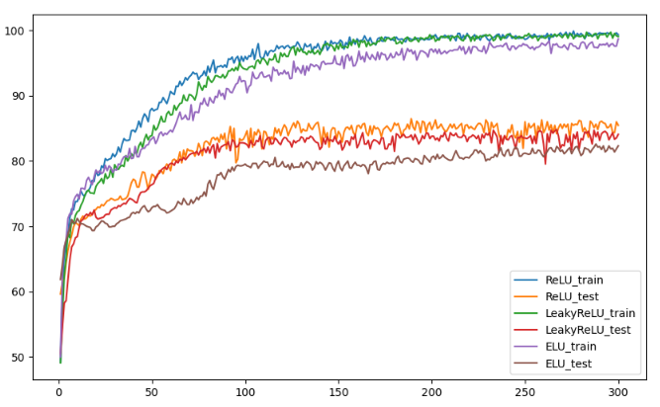

0.25

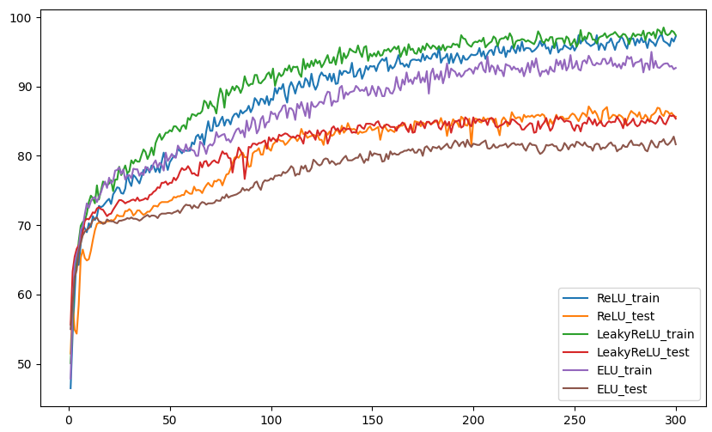

0.8

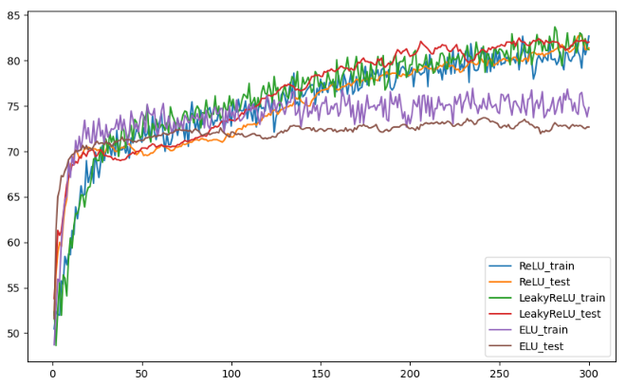

Different optimizer:

SGD:

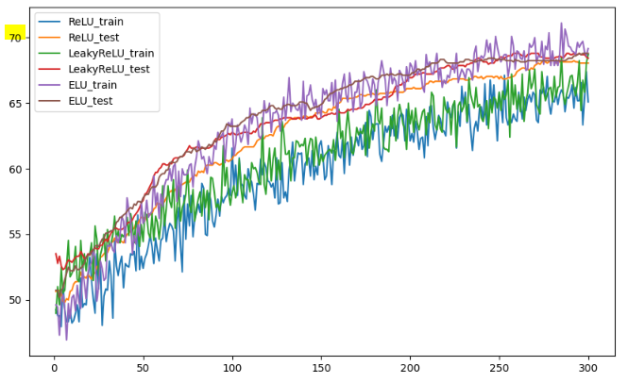

Adagrad:

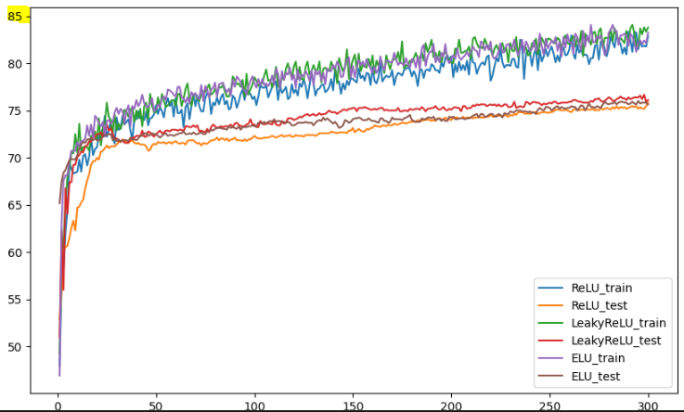

RMSprop:

