Q1:transform strInput to strTransactions and strLineItems

- Analysis: I think this is a CSV(Comma-Separated Values) file manipulation question using Dictionary data structure in Python.

- Steps:
- Create a CSV file to store the strInput (Attached in email strInput.csv).

- Sorting out Entries for strTransactions and strLineItems which to be generate later,
the way i categorize Entry is

- strTransactions:
'Date','Time','Transaction No.'(Primary Key),'Status','Store No.','Location Code','POS Terminal No.','Receipt No.','Line Net PMount','Line Discount PMount','Line GST PMount',
'Cashier Staff ID','Sales Staff ID'

- strLineItems:
'Transaction No.'(Foreign Key),'Item ID','Item Description','Item Quantity','Item Unit Price'

Because strTransactions and strLineItems is “One to Many relationship”.

- Write Python code using CSV module with Dictionary data structure to :
read date from sourceData file -> generate output file -> write content into output file

- Source Code (Attached in email EntryCategorization.py):

import csv

with open('strInput.csv', 'r') as csv_file:
csv_reader=csv.DictReader(csv_file) #read from the strInput csv file

with open('strTransactions.csv', 'w', newline='') as new_file:
fieldnames = ['Date', 'Time', 'Transaction No.', 'Status', 'Store No.', 'Location Code', 'POS Terminal No.',
'Receipt No.', 'Cashier Staff ID', 'Sales Staff ID','Line Net PMount',
'Line Discount PMount','Line GST PMount']
csv_writer = csv.DictWriter(new_file, fieldnames=fieldnames) #DictWriter function allows to manipulate content using Dictionary datas tructure
csv_writer.writeheader() #write coloumn entry to strTransactions.csv

for line in csv_reader:
csv_writer.writerow({'Date': line['Date'], 'Time': line['Time'], 'Transaction No.': line['Transaction No.'],
'Status': line['Status'], 'Store No.': line['Store No.'],
'Location Code': line['Location Code'],
'POS Terminal No.': line['POS Terminal No.'], 'Receipt No.': line['Receipt No.'],
'Line Net PMount':line['Line Net PMount'],'Line Discount PMount':line['Line Discount PMount'],
'Line GST PMount':line['Line GST PMount'],'Cashier Staff ID': line['Cashier Staff ID'],
'Sales Staff ID': line['Sales Staff ID']}) #write content from strInput to according entry in strTransactions.csv use Dictionary data structure

with open('strInput.csv', 'r') as csv_file: #read from the strInput csv file
csv_reader = csv.DictReader(csv_file)

with open('strLineItems.csv', 'w',newline='') as newfile:
fieldnames=['Transaction No.','Item ID','Item Description','Item Quantity','Item Unit Price']
csv_writer=csv.DictWriter(newfile,fieldnames=fieldnames) #DictWriter function allows to manipulate content using Dictionary datas tructure
csv_writer.writeheader() #write coloumn entry to strLineItems.csv

for line in csv_reader:
csv_writer.writerow({'Transaction No.': line['Transaction No.'],'Item ID':line['Item ID'],
'Item Description':line['Item Description'],
'Item Quantity':line['Item Quantity'],
'Item Unit Price':line['Item Unit Price']}) #write content from strInput to according entry in strLineItems.csv use Dictionary data structure

- Results (Attached in email strTransactions.csv and strLineItems.csv):

strTransactions.csv:
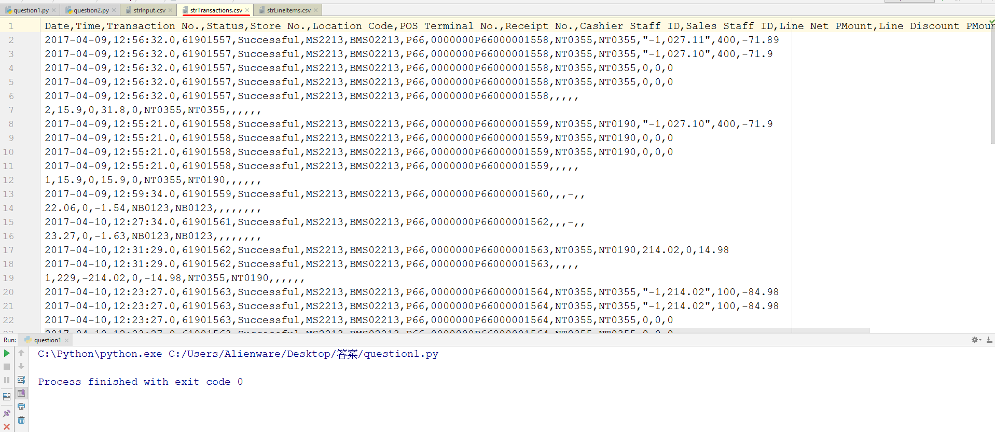

strLineItems.csv:
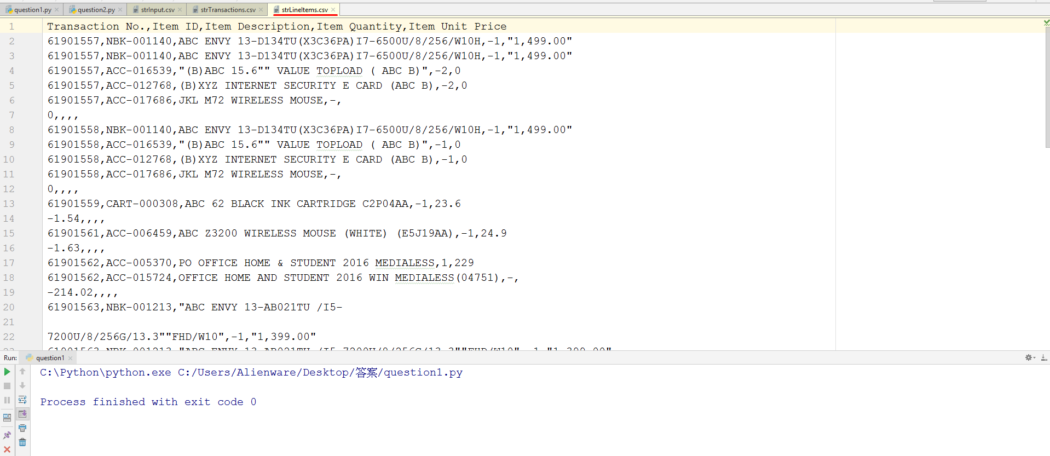

____________________________________________________________________________________________________________________________________

Q2:Tally function
- Analysis: I think it’s a CSV(Comma-Separated Values) data processing function using pandas module in Python

- Pseudo code:
Import pandas
def Tally(Transaction No.){
Sum Items price in Transaction No. group and stores in variable Item_price_sum
Sum Line Net Amount in Transaction No. Group and stores in variable Line_Net_price_sum

If(Item_price_sum==Line_Net_price_sum){print “It’s Equal”}
Else {print “It’s not Equal”}
}

- Source Code (Attached in email TallyFunction.py):

import pandas

def Tally(Transaction_No): #Pass a sepecific Transaction_No which want to check as argument

csv_file=pandas.read_csv('strLineItems.csv',delimiter=',')
Item_price=csv_file['Item Unit Price'].groupby(csv_file['Transaction No.']) #extract Item Unit Price list and group by Transaction No. from strLineItems.csv using pandas module
Item_price_sum=dict(list(Item_price))[Transaction_No].dropna().sum() #get the sum of all the Items price in the sepecific Transaction No. group
print('price_list_sum is : ',Item_price_sum) #print the sum of all the Items price in the sepecific Transaction No. group

csv_file2=pandas.read_csv('strTransactions.csv',delimiter=',')
Line_Net_price=csv_file2['Line Net PMount'].groupby(csv_file2['Transaction No.']) #extract Line Net PMount and group by Transaction No. from strTransactions.csv using pandas module
Line_Net_price_sum=dict(list(Line_Net_price))[Transaction_No].dropna().sum() #get the sum of Line Net PMount in the sepecific Transaction No. group
print('price_transaction_sum is : ',Line_Net_price_sum) #print the sum of Line Net PMount in the sepecific Transaction No. group

if(Item_price_sum==Line_Net_price_sum): print('Line Items Total and sum of each Item Price in Transaction No: ',Transaction_No,' is Equal ')
else: print('Line Items Total and sum of each Item Price in Transaction No ',Transaction_No,' is Not equal')

Tally(61901557)

- Results:
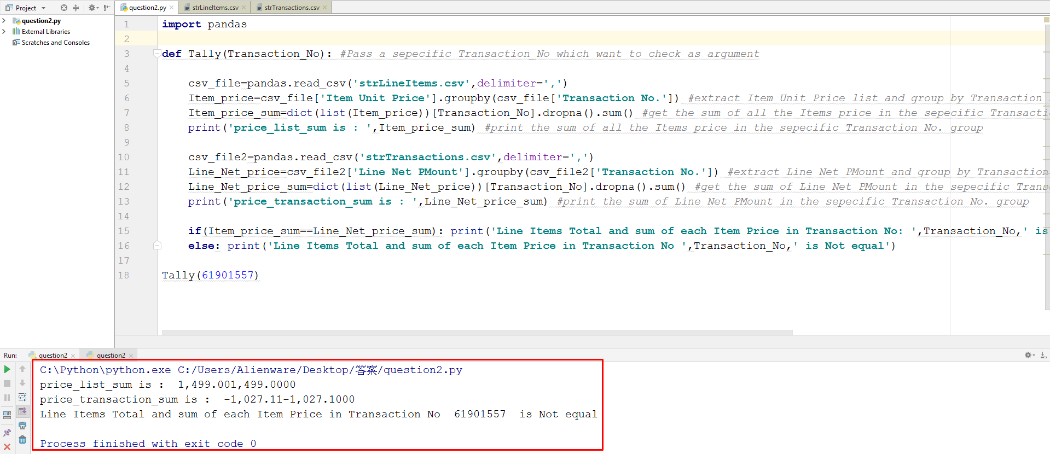
//the sum function may not working properly ,i think it’s because the data under price columns in strInput are not all in numeric format , i could have cast it to numeric but i think that affects the accuracy of the results.

