Document title

Subtitle of document

Author name(s)

2025-05-23

# 1. Dynamic Report

Here is my regression model:

## xvar: cyl

|  |  |  |  |  |  |  |  |  |  |  |  |  |  |  |  |
| --- | --- | --- | --- | --- | --- | --- | --- | --- | --- | --- | --- | --- | --- | --- | --- |
| Table 1: This is a table of mtcars   |  | Estimate | Std. Error | t value | Pr(>|t|) | | --- | --- | --- | --- | --- | | (Intercept) | 37.885 | 2.0738 | 18.27 | 0 | | cyl | -2.876 | 0.3224 | -8.92 | 0 | |

The fitting result is $mpg=37.8846+−2.8758cyl$. Below is a scatter plot with the regression line.

Notice I can reference above using Table 1.

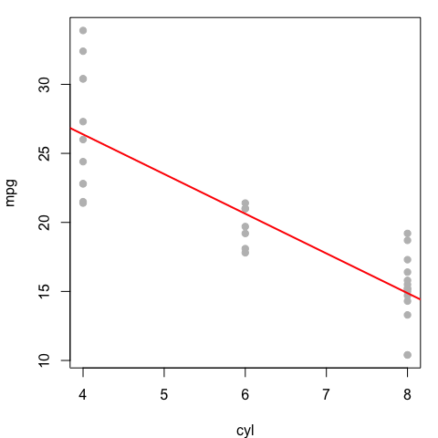

Next in in Section 1.1 we will look at Callouts. Note you can also reference code chunks ie see Listing 1.

|  |
| --- |
| Listing 1: Example for a referenceable code block  4+4 |

## 1.1 Callout blocks

Quarto provides five different types of callouts that are an excellent way to draw extra attention to certain concepts.

|  |
| --- |
| Note |
| The color and icon will be different depending upon the type that you select. You can choose between: note, warning, important, tip, and caution. |

|  |
| --- |
| Tip With Caption |
| This is an example of a callout with a caption. |

## 1.2 Mathematical equations

Use mathematics as usual with the dollar sign $ at the beginning and end of the equation; either in **inline mode** with one dollar sign such as $E=mc^{2}$ or in **display mode** with two dollar signs:

$$E=mc^{2}$$

Important to note: do not leave a space between the ‘$’ and your mathematical notation.

Alternatively, you can use LaTeX for more control and when equations are more complicated. LaTeX equations are also automatically numbered if you define a label within the equation environment, which is useful if you have many equations and want to cross-reference them. The equation label needs to be written with ‘#eq:label’ before the end of the equation (see Equation 1):

$$\overset{‾}{X}=\frac{\sum_{i=1}^{n}{X_{i}}}{n} \left(1\right)$$

Formulas and corresponding explanations should be integrated into the sentence and, thus, end with a comma or period. Here comes an example:

If the random variable $Y$ follows a standard normal distribution, i.e. $Y∼N\left(0,1\right)$ , it’s density function can be described with

$$f_{Y}\left(y\right)=φ\left(y\right)\overset{def}{=}\frac{1}{\sqrt{2π}}exp\left\{−\frac{y^{2}}{2}\right\}, y∈R. \left(2\right)$$

$π$ represents the circle number or Ludolph’s number. The function

$$F_{Y}\left(y\right)=Φ\left(y\right)\overset{def}{=}\int_{−∞}^{y}{φ}\left(x\right) dx, y∈R \left(3\right)$$

represents then the distribution function of Equation 2.

The numbering of equations, as in Equation 2, should only be done if they are referred to in the rest of the text. Especially if there are many equations in the thesis, the use of LaTeX seems to make more sense.

## 1.3 Images

Quarto includes several features aimed at making it easier to work with figures and subfigures, as well as for laying out panels that contain multiple figures, tables, or other content.

|  |
| --- |
|  |

Single image of Iris setosa with URL link but no cross-reference.

For instance, if you have several figures that appear as a group, you can create a figure div to enclose them (see Fig. 1 and Fig. 2).

|  |  |  |
| --- | --- | --- |
| |  | | --- | | Figure 1: Iris versicolor | |  |

|  |  |
| --- | --- |
| |  | | --- | | Figure 2: Iris virginica | |

The layout attribute enables the creation of much more complex layouts. Fig. 3 provides an example with a common figure caption and one identifier for all three.

|  |  |  |  |  |
| --- | --- | --- | --- | --- |
| Iris setosa  Iris setosa |  | Iris versicolor  Iris versicolor |  | Iris virginica  Iris virginica |

Figure 3: Custom layout of images