**a. Conditions**

i. Challenge

1. URL: <https://edabit.com/challenge/PKiTjA7SLK99ZZ8GK>

2. 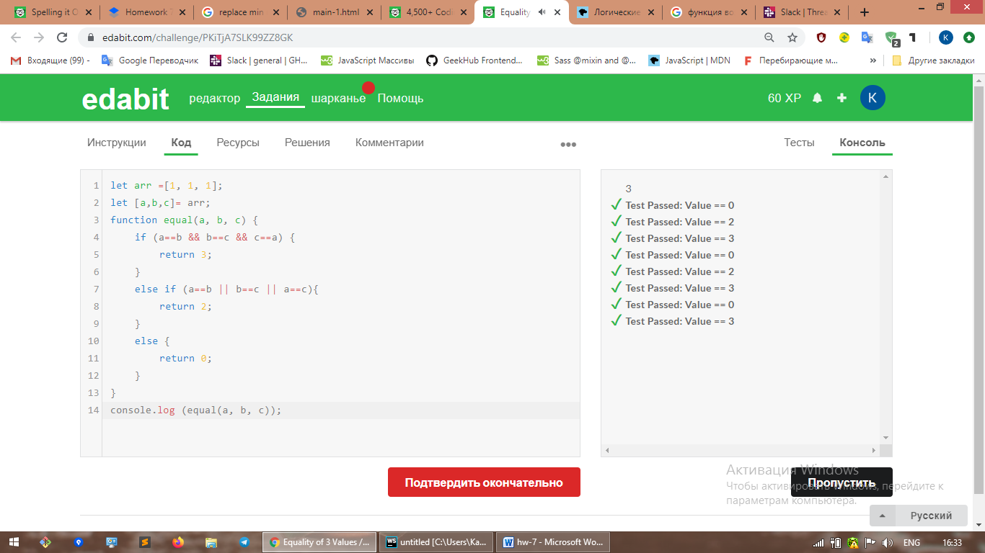

ii. Challenge 2

1. URL: <https://edabit.com/challenge/kLa2w7m4h849k8rmW>

2. Solution: 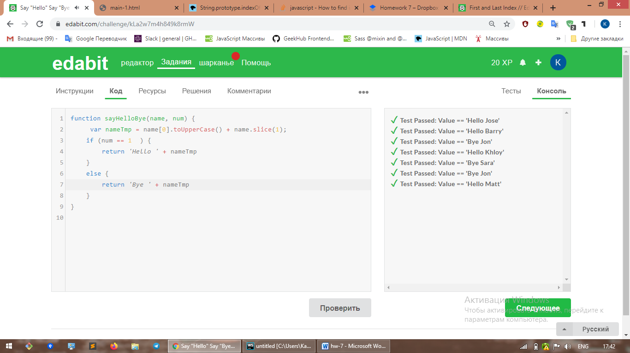

iii. Challenge 3

1. URL: <https://edabit.com/challenge/8q54MKnRrm89pSLmW>

2. Solution: 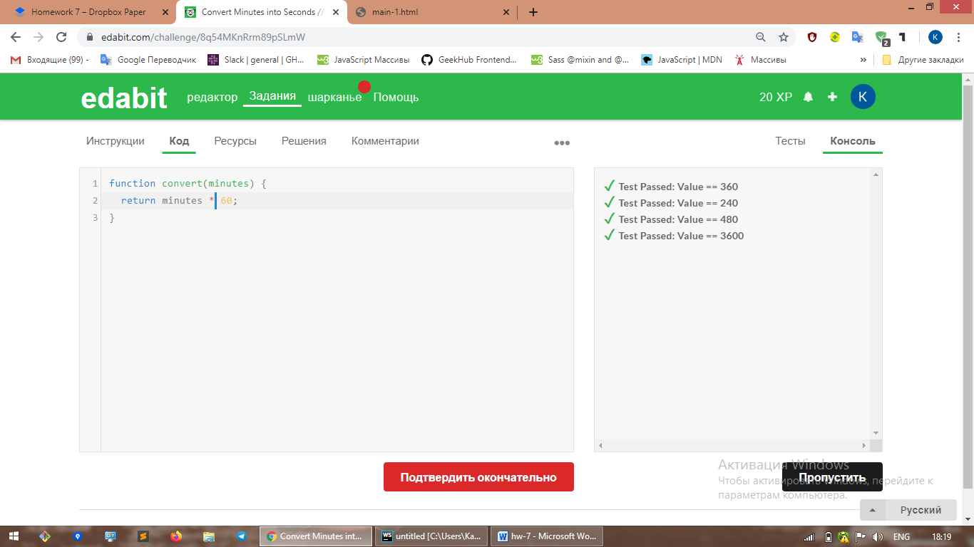

iiii. Challenge 4

1. URL: <https://edabit.com/challenge/PTiLYyb4A69KZtBCg>

2. Solution: 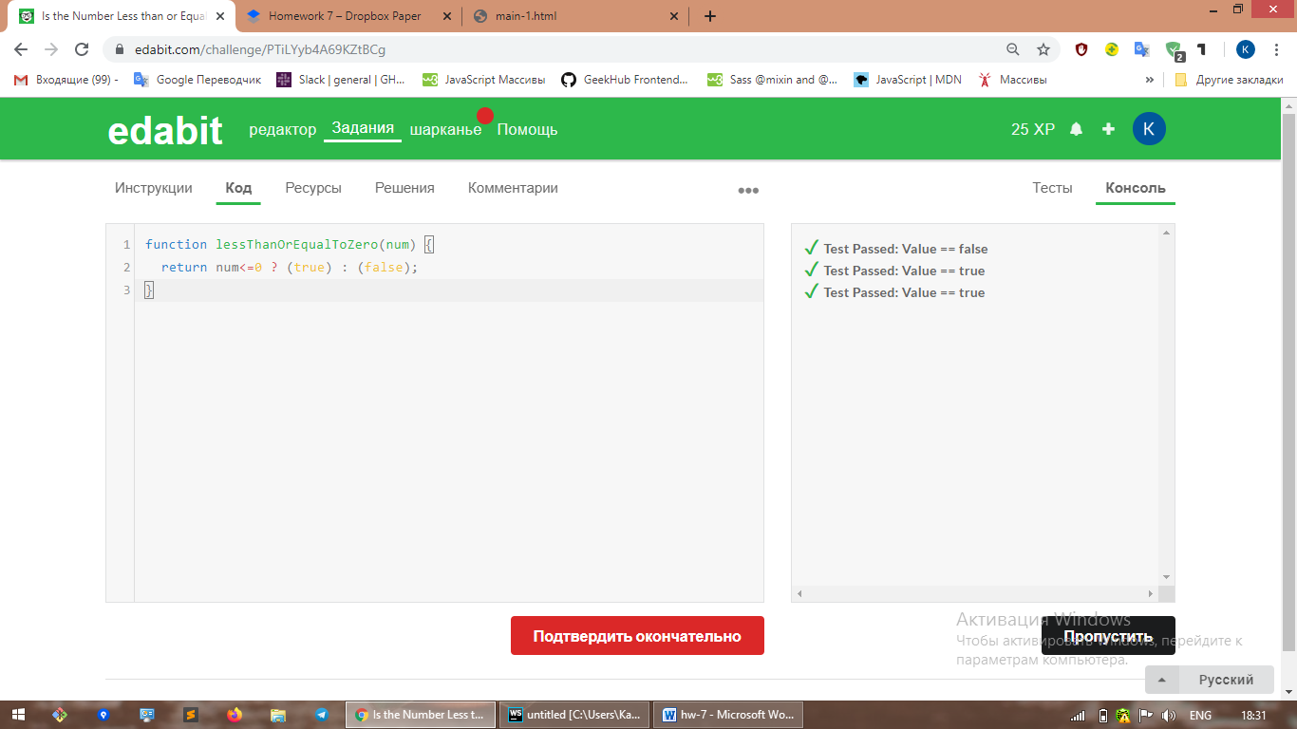

iiiii. Challenge 5

1. URL: <https://edabit.com/challenge/Ju7AK9rAGjz86hjxo>

2. Solution: 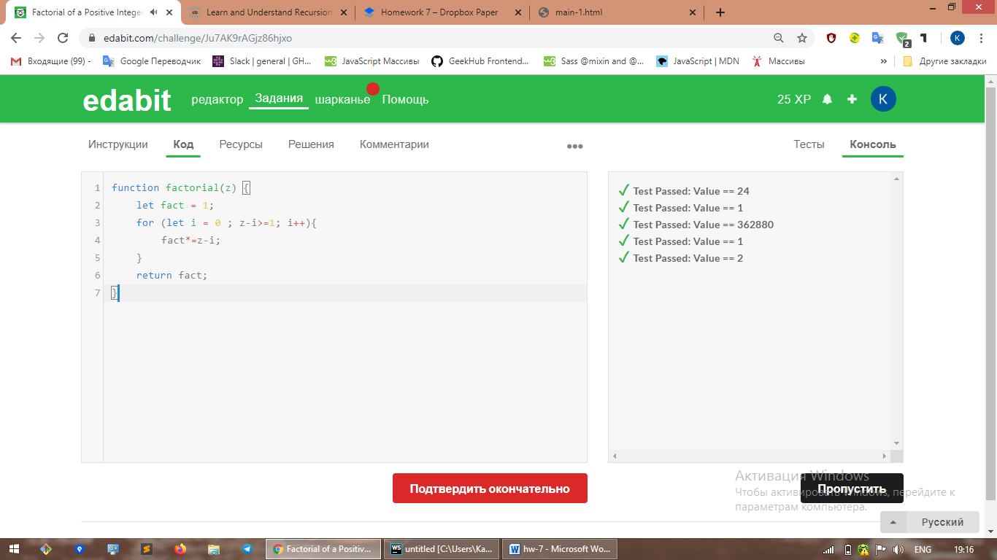

**b.Arrays**

i. Challenge 1

1. URL: <https://edabit.com/challenge/AYpxyzbnbS7BGSgvd>

2. 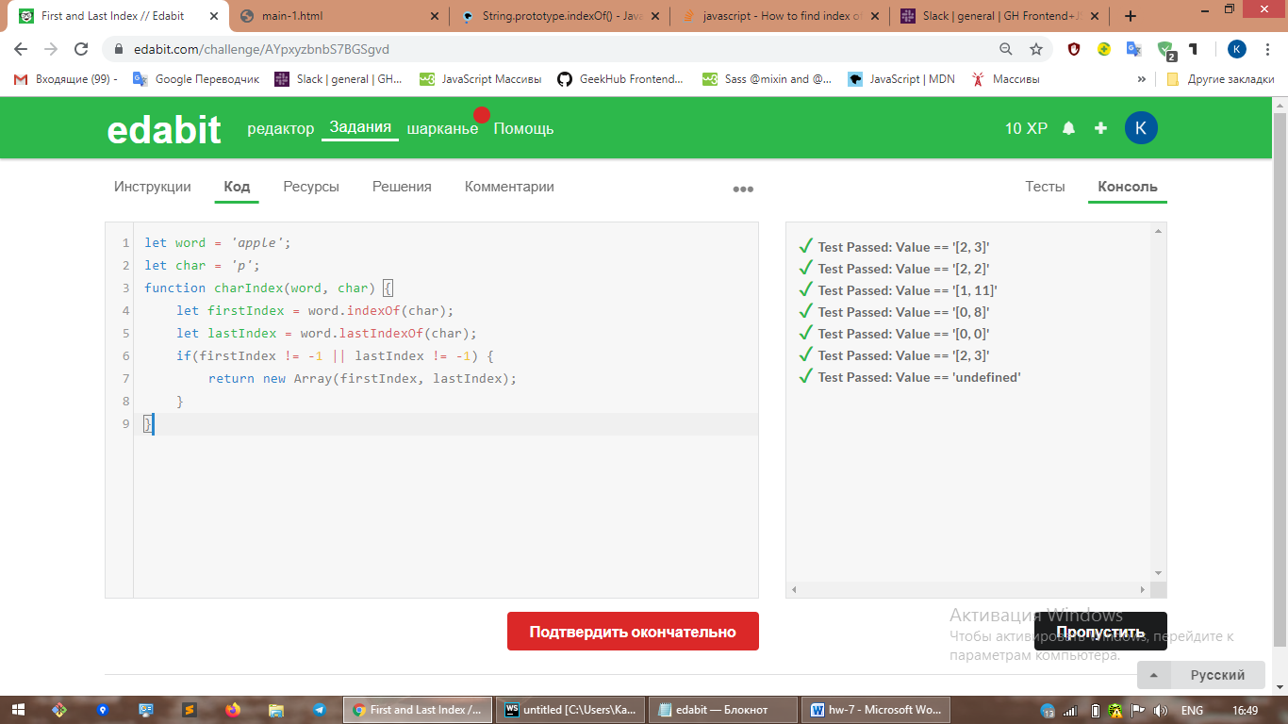

ii. Challenge 2

1. URL: <https://edabit.com/challenge/Q3n42rEWanZSTmsJm>

2. Solution: 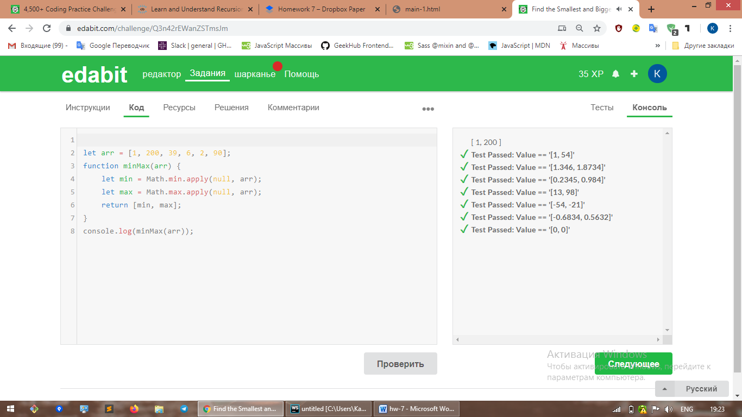

iii. Challenge 3

1. URL: <https://edabit.com/challenge/QaApgtePE6QrCZ64o>

2. Solution: 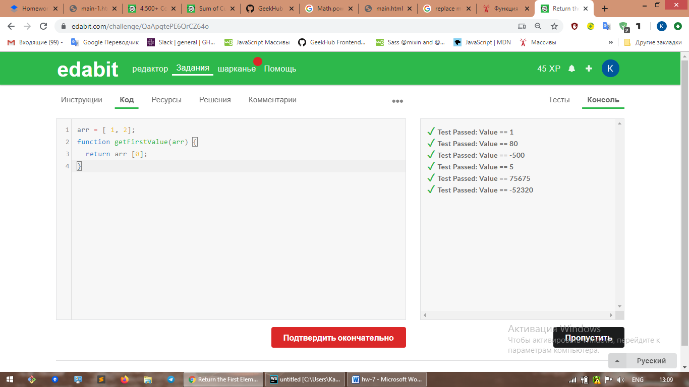

iiiii. Challenge 4

1. URL: <https://edabit.com/challenge/XdAR3KohR5w7rjrFg>

2. Solution:

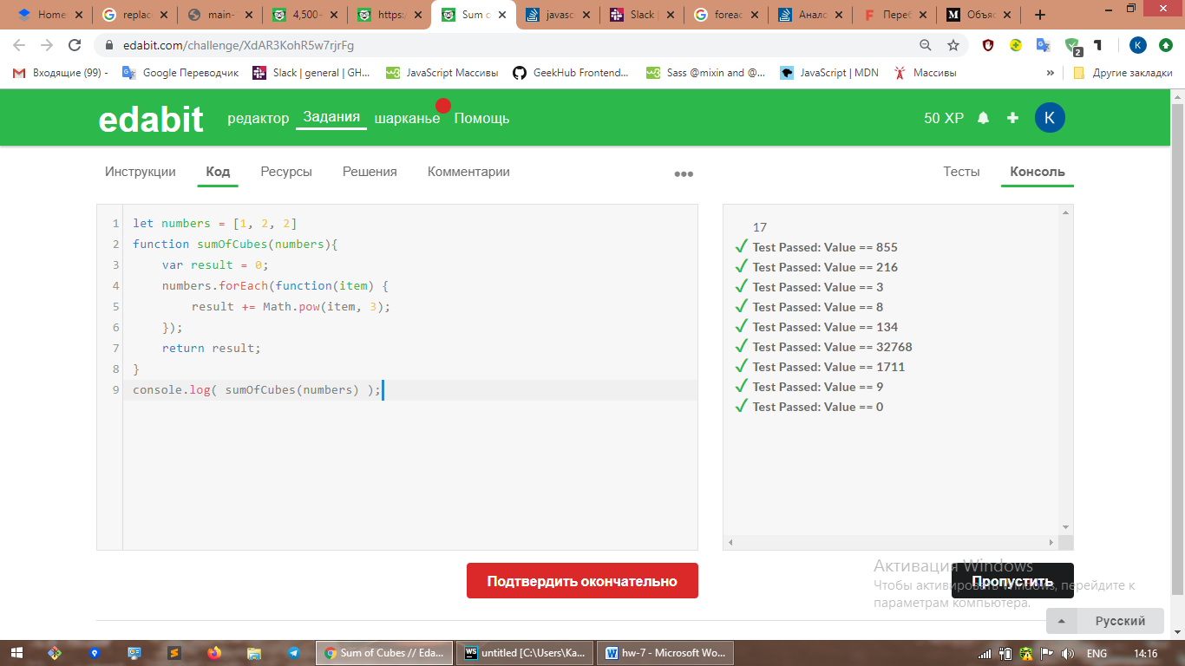

iiiii. Challenge 5

1. URL: <https://edabit.com/challenge/Akgh37c6dccEsNBt6>

2. Solution: 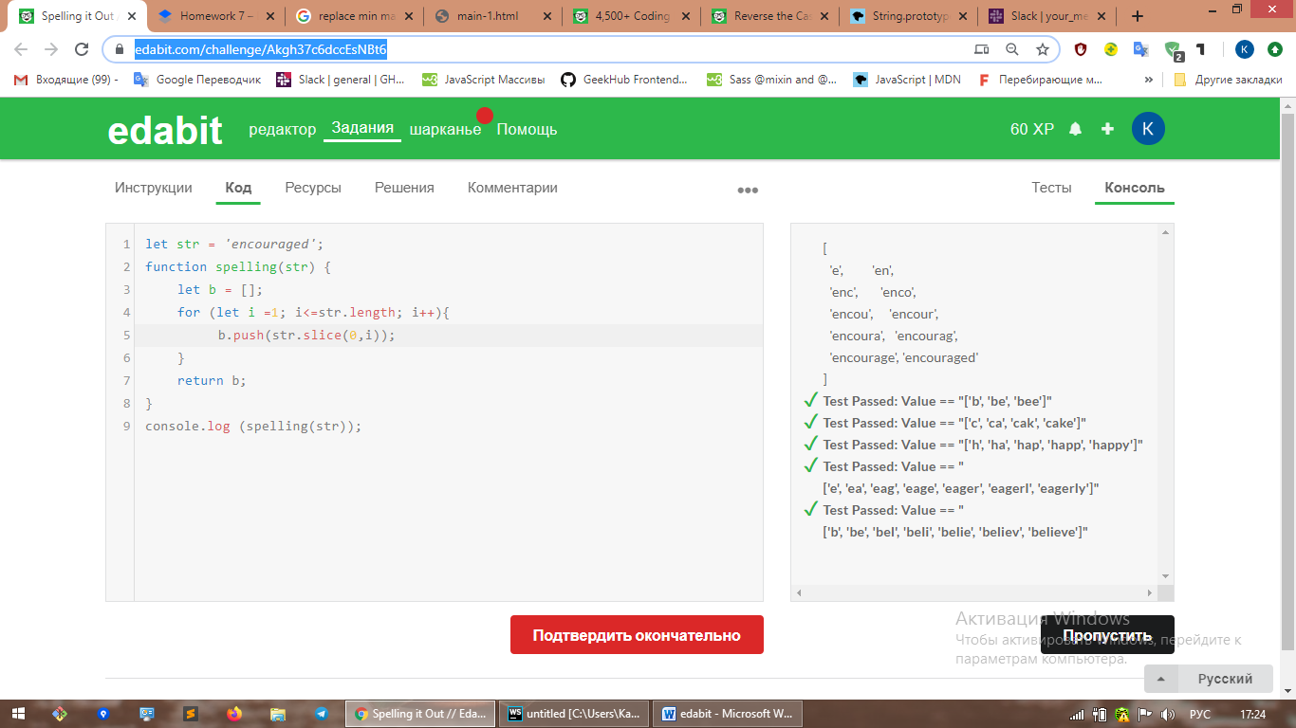

**c.Loops**

i. Challenge 1

1. URL: <https://edabit.com/challenge/b2NdDSdkjqFnCTfS8>

2. Solution: 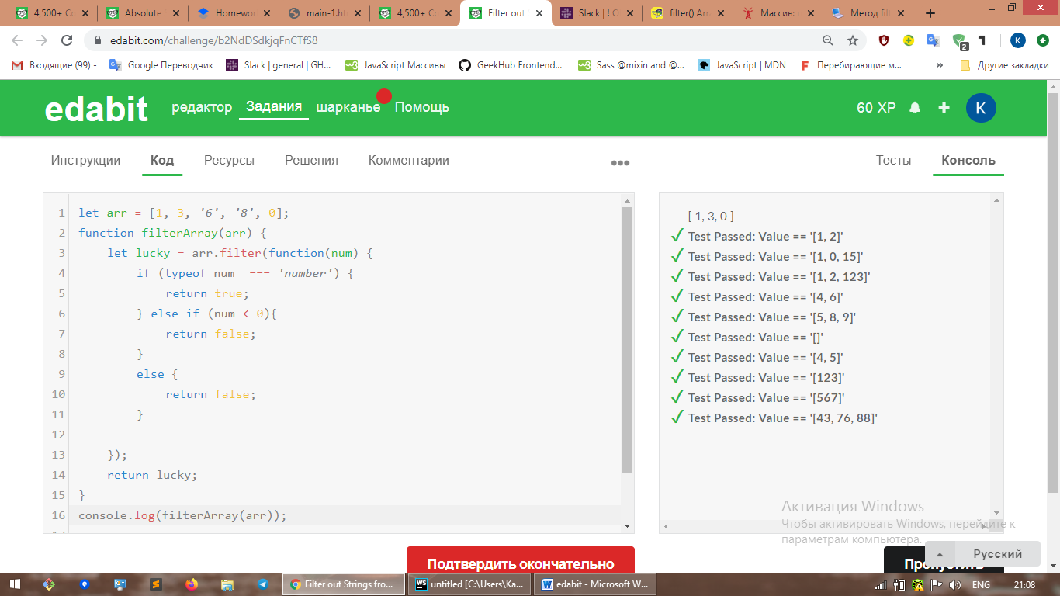

ii. Challenge 2

1. URL: <https://edabit.com/challenge/Mo6Coy4PpTbZgtDKd>

2. Solution: 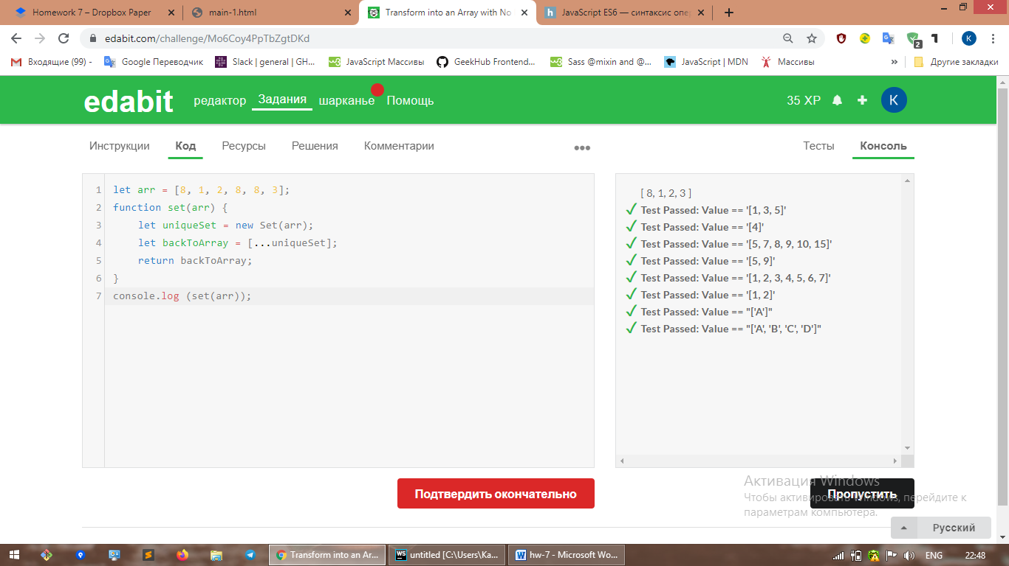

iii. Challenge 3

1. URL: <https://edabit.com/challenge/rCmEy2AQYLbRGgKyL>

2. Solution: 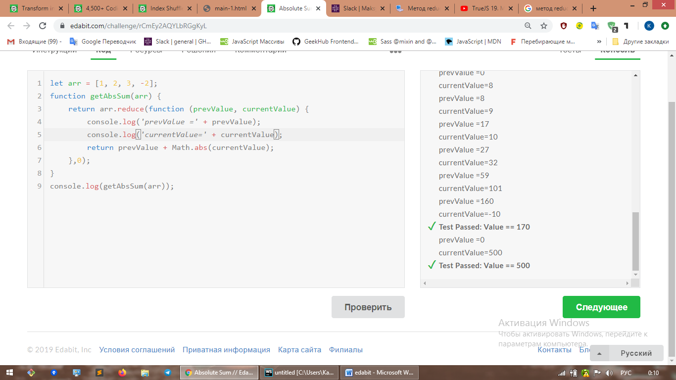

iiii. Challenge 4

1. URL: <https://edabit.com/challenge/ATbswTsEaMJb37Ez2>

2. Solution: 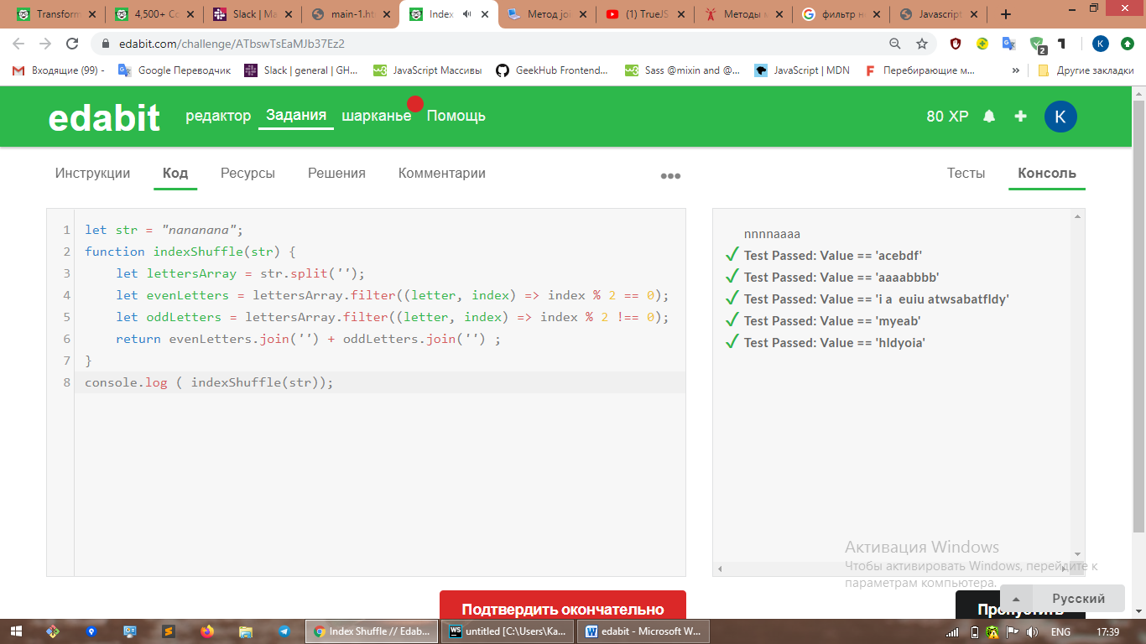

iiiii. Challenge 5

1. URL: <https://edabit.com/challenge/LvtsCQNpx7CwHGubf>

2. Solution: 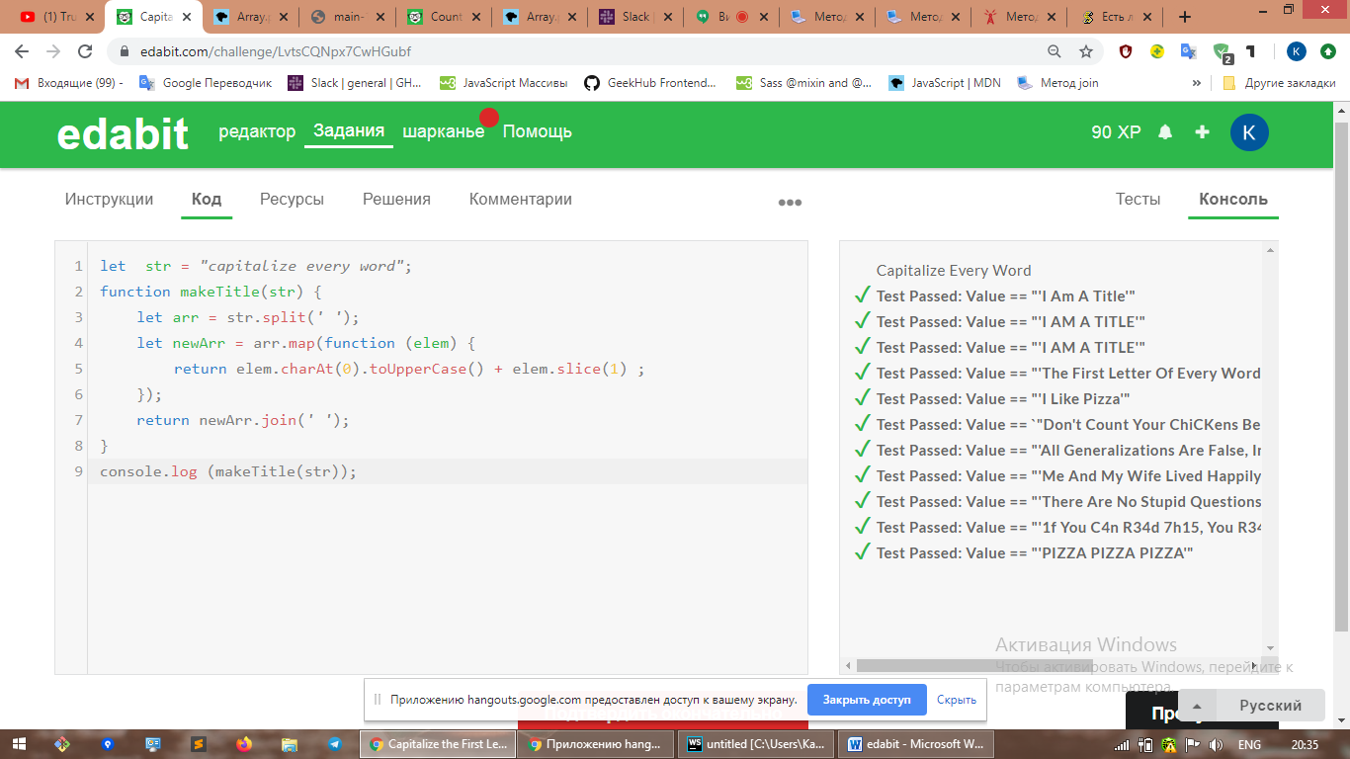

**d.Functional Programming**

i. Challenge 1

1. URL: <https://edabit.com/challenge/hzxN9bAebBPNqdQto>

2. Solution: 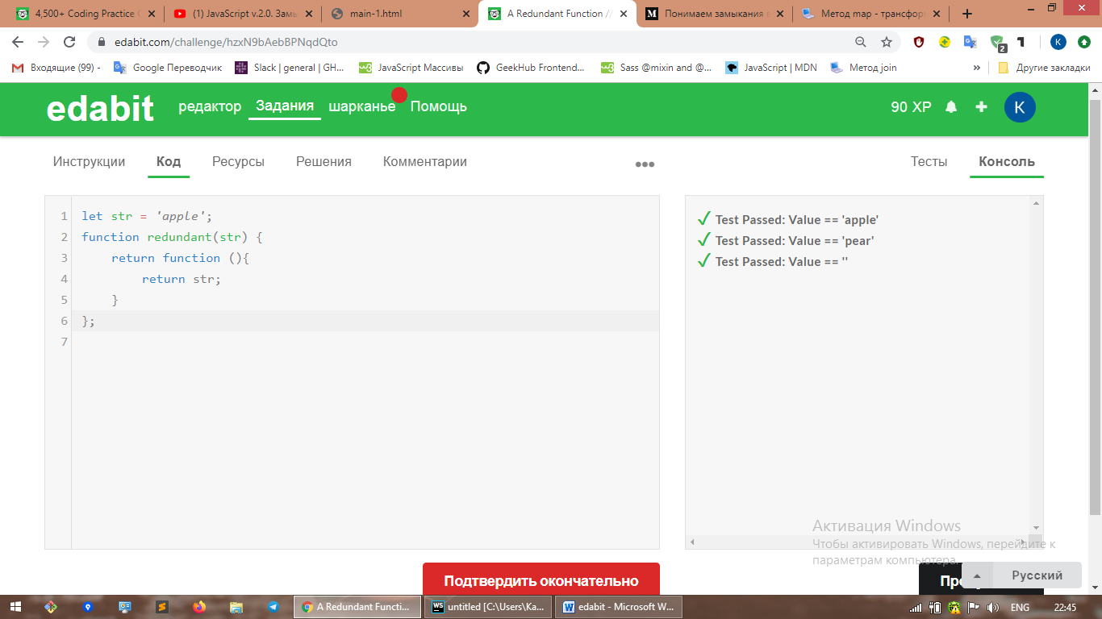

ii. Challenge 2

1. URL: <https://edabit.com/challenge/cada8J3AWGRhwQhkk>

2. Solution: 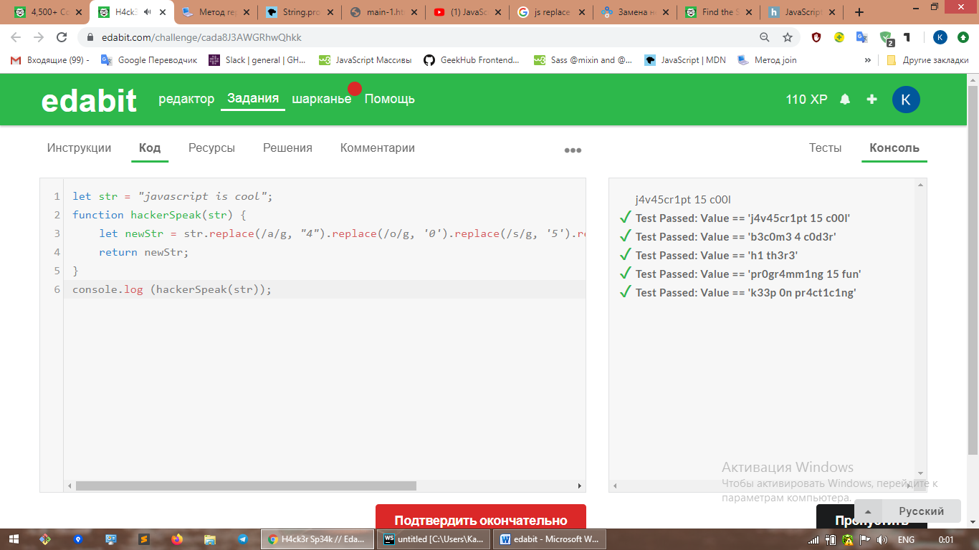

iii. Challenge 3

1. URL:

2. Solution:

iiii. Challenge 4

1. URL:

2. Solution:

iiiii. Challenge 5

1. URL:

2. Solution:

**e.Scope**

i. Challenge 1

1. URL:

2. Solution:

ii. Challenge 2

1. URL:

2. Solution:

iii. Challenge 3

1. URL:

2. Solution:

iiii. Challenge 4

1. URL:

2. Solution:

iiiii. Challenge 5

1. URL:

2. Solution:

**f.Objects**

i. Challenge 1

1. URL: <https://edabit.com/challenge/pPNAs5PvB3WvnDwDM>

2. Solution: 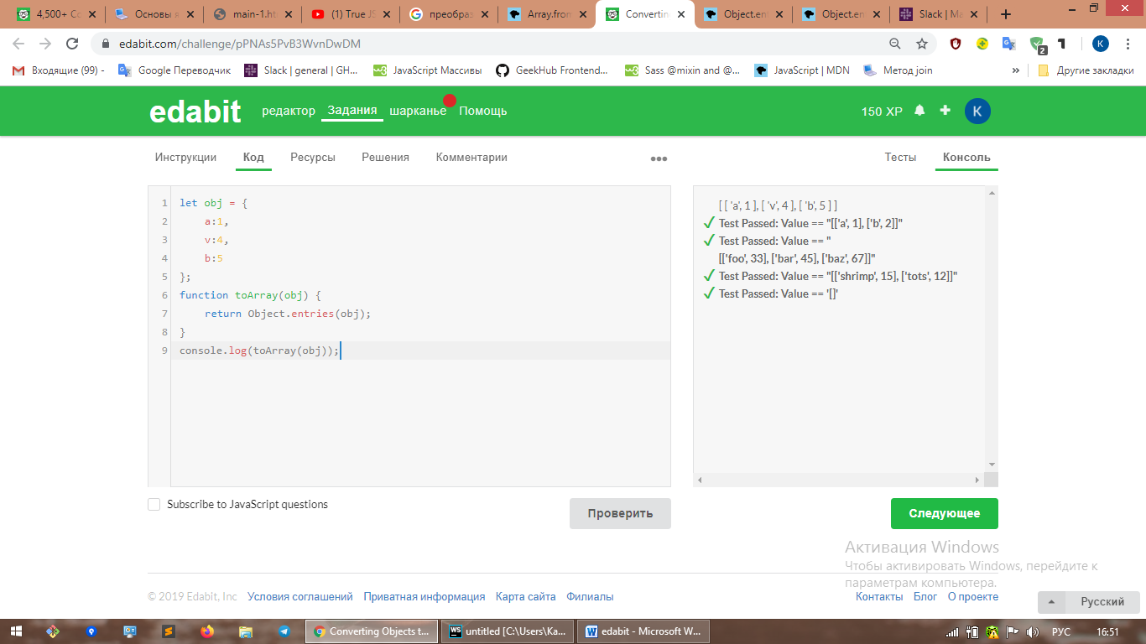

ii. Challenge 2

1. URL:

2. Solution:

iii. Challenge 3

1. URL: <https://edabit.com/challenge/4aaBNPnFMc3bzR7JR>

2. Solution: 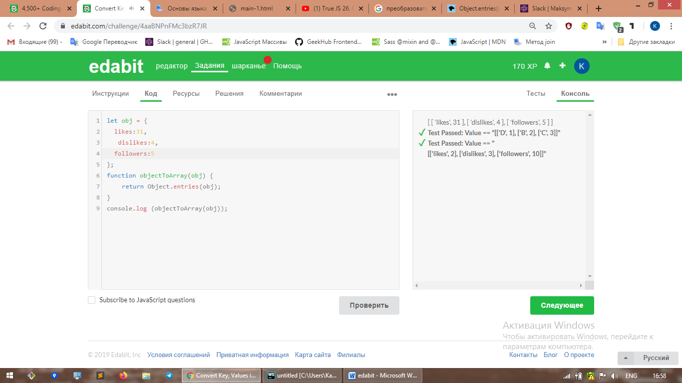

iiii. Challenge 4

1. URL:

2. Solution:

iiiii. Challenge 5

1. URL:

2. Solution:

**g.Classes**

i. Challenge 1

1. URL:

2. Solution:

ii. Challenge 2

1. URL:

2. Solution:

iii. Challenge 3

1. URL:

2. Solution:

iiii. Challenge 4

1. URL:

2. Solution:

iiiii. Challenge 5

1. URL:

2. Solution: