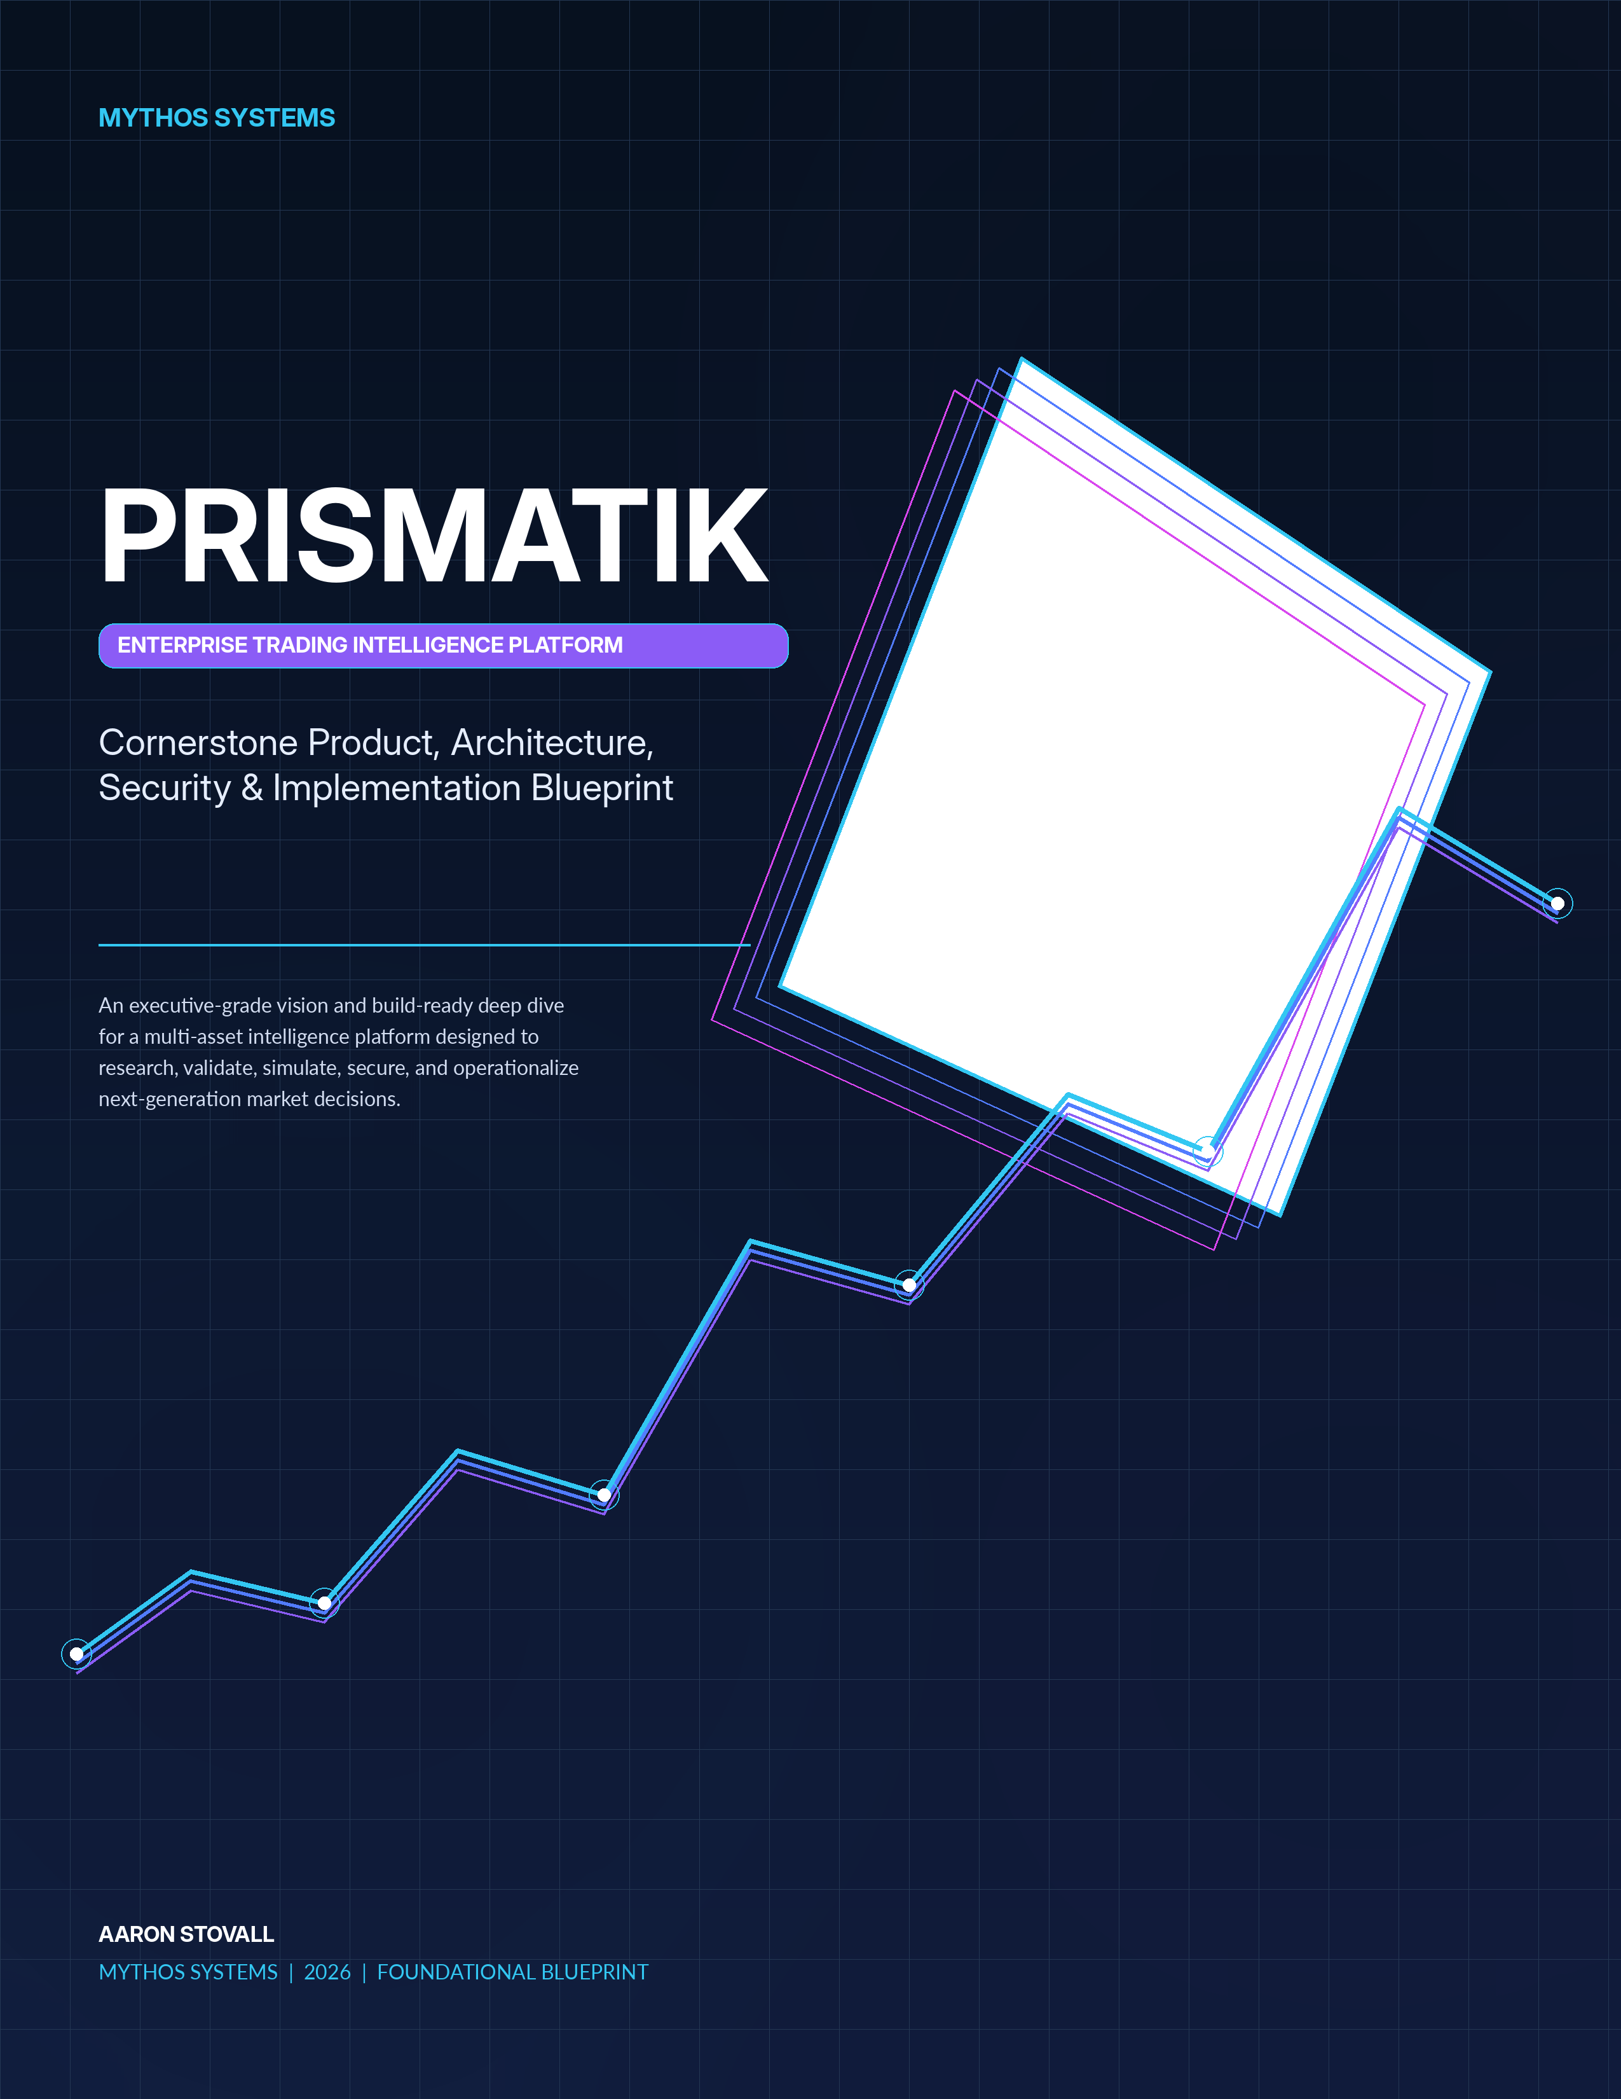
FOUNDATIONAL BLUEPRINT
PRISMATIK
Enterprise Trading Intelligence Platform
Executive Product Vision, Granular Architecture, Security Doctrine, and Phased Implementation Plan
CORNERSTONE INTENT This document is designed to function as the durable north-star blueprint for product, engineering, security, quantitative research, operations, partnerships, and future fundraising. It integrates the complete v0.1 product architecture with the build-ready v0.2 evolution contracts without discarding the underlying technical detail.

DOCUMENT CONTROL
DOCUMENT | PRISMATIK Cornerstone Product, Architecture, Security & Implementation Blueprint
ORGANIZATION | Mythos Systems
AUTHOR | Aaron Stovall
YEAR | 2026
STATUS | Foundational Blueprint / Executive Architecture Deep Dive
INTEGRATED SOURCES | PRISMATIK Overview v0.1 and Architecture Evolution v0.2
INTENDED AUDIENCE | Founders, engineering leadership, quantitative research, security, product, investors, partners, and future implementation teams

EXECUTIVE THESIS
PRISMATIK is a multi-asset market intelligence operating system built to convert fragmented data into evidence-backed, probabilistic, reproducible, and risk-aware decisions. It begins with a powerful crypto intelligence foundation through CoinGecko, expands into U.S. equity, institutional, filing, macro, and options intelligence, and matures into a governed research-to-execution platform.
CORE WEDGE  Event-aware options opportunity intelligence informed by flow, volatility, institutional activity, market regime, and quantitative validation. | PRIMARY FOUNDATION  CoinGecko-powered crypto intelligence delivered through a provider-neutral Rust data gateway with provenance, caching, and rate governance.
TRUST MODEL  Evidence before conclusion, probability instead of prophecy, deterministic controls, explainable models, and secure local or enterprise deployment. | DELIVERY MODEL  A phased journey from crypto MVP to options, quant, simulation, paper trading, controlled execution, enterprise, and a signed ecosystem.

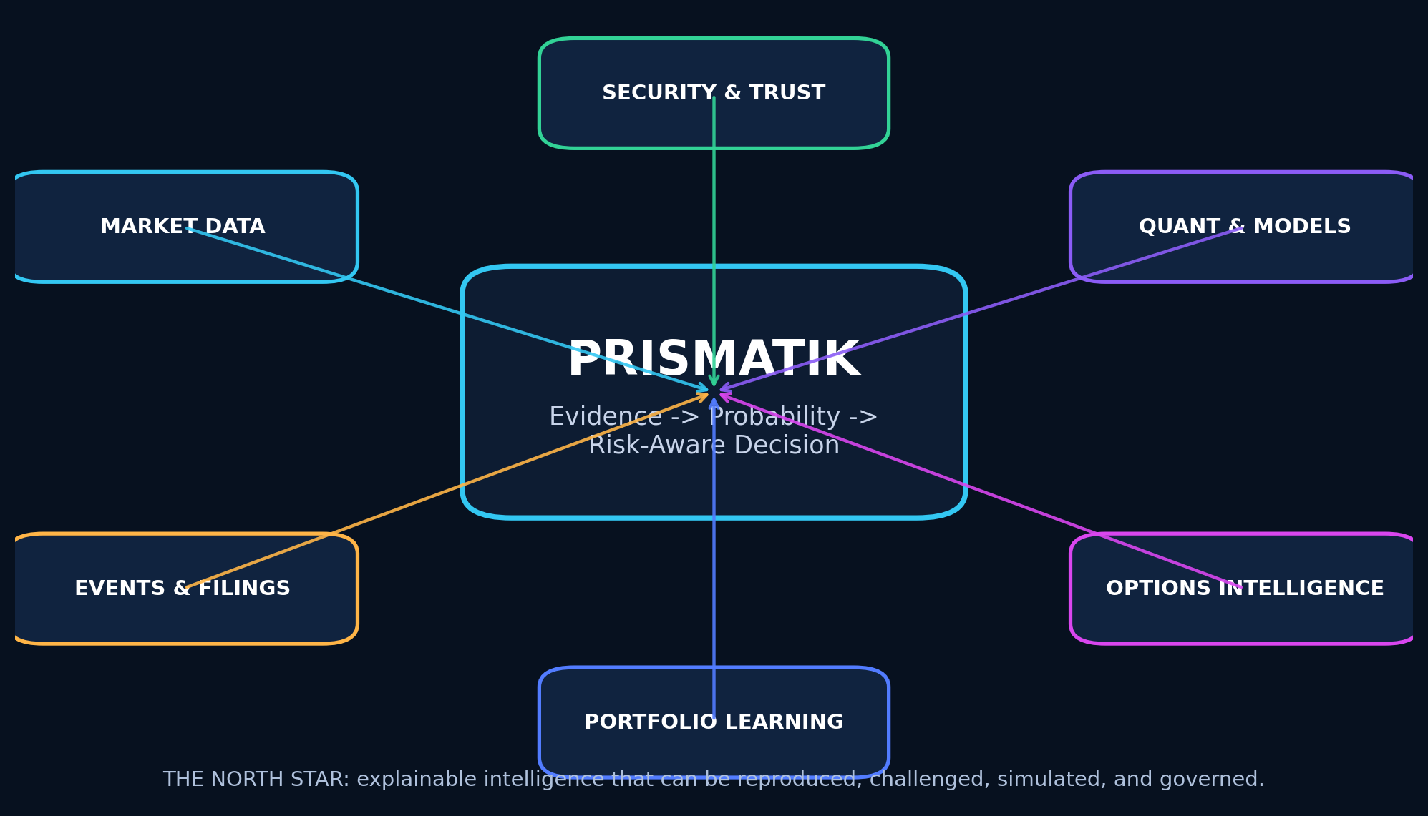
Figure 1 - PRISMATIK north-star system: evidence, quantitative validation, risk, security, and learning converge in one decision platform.
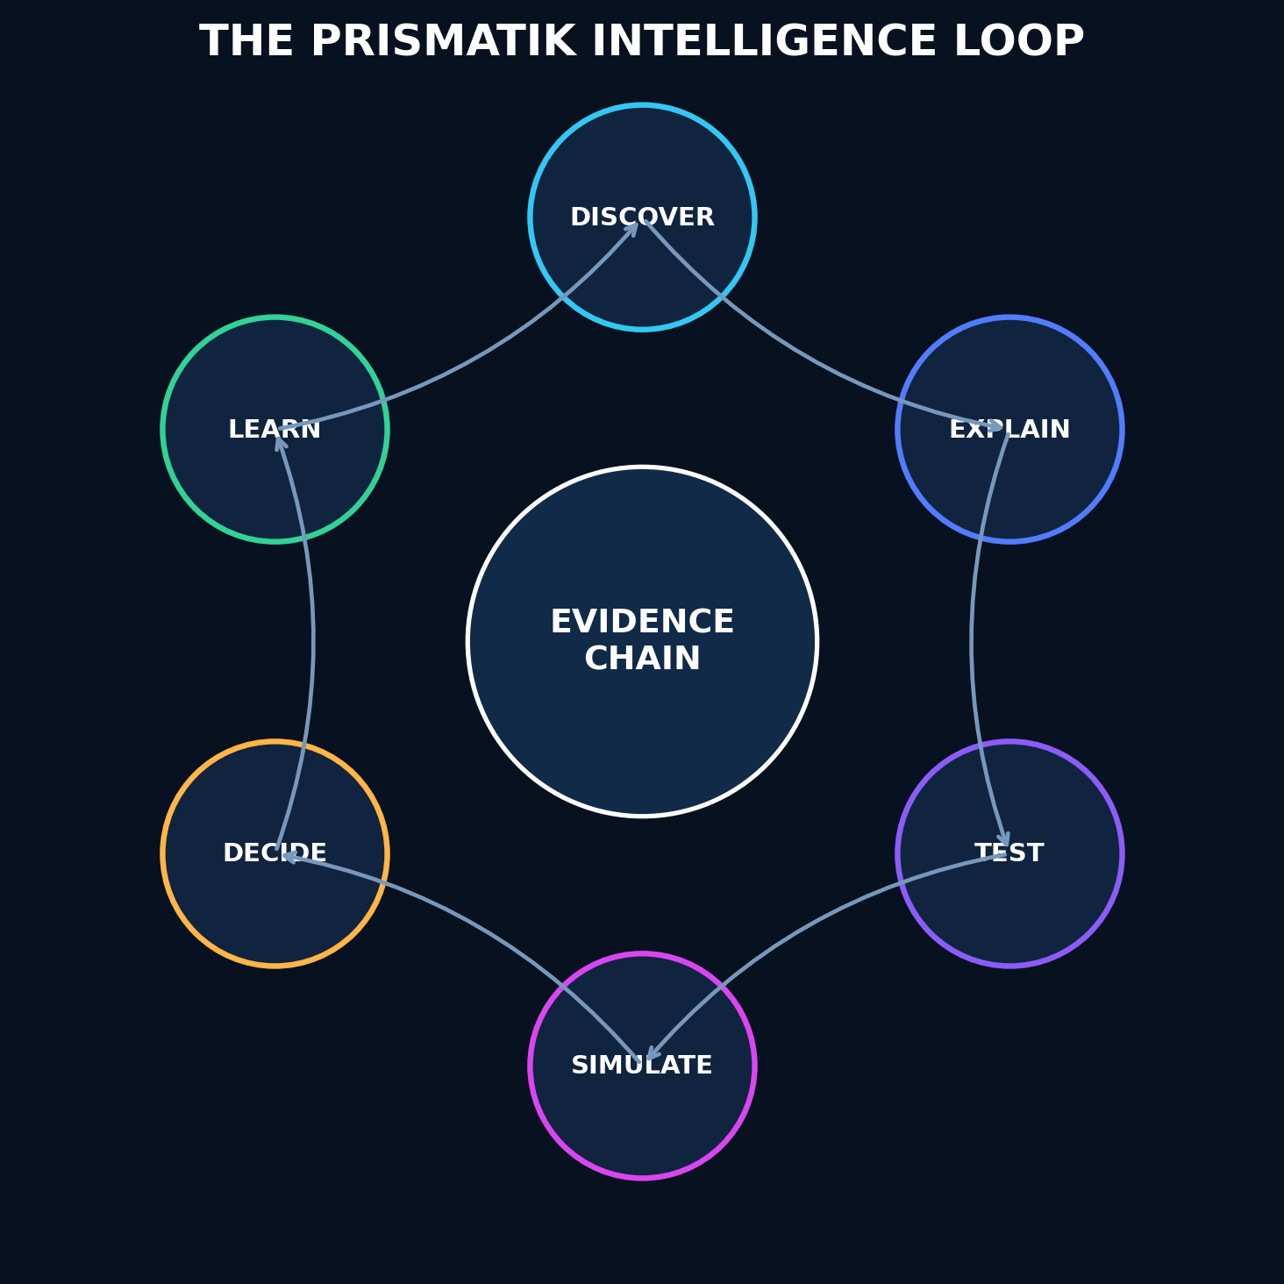
Figure 2 - The PRISMATIK intelligence loop: discover, explain, test, simulate, decide, and learn.

CONTENTS

Table of Contents
DOCUMENT CONTROL 2
EXECUTIVE THESIS 2
Table of Contents 5
DOCUMENT CONVENTIONS 14
How to Use This Report 14
1. Executive Summary 16
2. Product Mission, Positioning, and Guardrails 17
2.1 Mission 17
2.2 Positioning 17
2.3 Initial Market Wedge 17
2.4 Product Guardrails 17
3. User Personas and Primary Jobs to Be Done 18
3.1 Advanced Retail Options Trader 18
3.2 Quantitative Researcher 18
3.3 Crypto Trader 18
3.4 Long-Term Investor 18
3.5 Risk Manager or Trading Team Lead 18
3.6 Platform Administrator 19
4. Product Principles 20
4.1 Evidence Before Conclusion 20
4.2 Probability, Not Prophecy 20
4.3 Provider Independence 20
4.4 Local-First Where Valuable 20
4.5 Security as Architecture 20
4.6 Professional Density Without Confusion 20
4.7 Reproducibility 20
4.8 Graceful Degradation 20
5. Scope and Asset Coverage 21
5.1 Phase-One Asset Classes 21
5.2 Later Asset Classes 21
5.3 Data Rights and Entitlements 21
6. Experience and Visual Design System 22
6.1 Design Vision 22
6.2 Visual Characteristics 22
6.3 Motion System 22
6.4 Workspace Model 22
6.5 Primary Navigation 23
7. Functional Capability Map 24
7.1 Market Command Center 24
7.2 Opportunity Engine 24
7.3 Options Intelligence 25
7.4 Institutional Intelligence 25
7.5 Crypto Intelligence 25
7.6 Research and Quant Lab 25
7.7 Risk and Portfolio 26
7.8 Journal and Learning 26
7.9 Automation 26
8. Detailed Feature Design 28
8.1 Command Center 28
Functional Design 28
Advanced Enhancement 28
8.2 Universal Instrument Workspace 28
8.3 Advanced Charting 29
Required Capabilities 29
Chart Data Integrity 29
8.4 Market Scanner 29
8.5 Event and Catalyst Engine 30
8.6 Opportunity Card 30
8.7 Historical Analog Engine 31
8.8 Alerting 31
9. Data Provider and API Strategy 33
9.1 Provider Philosophy 33
9.2 CoinGecko — Primary Crypto Aggregation Provider 33
Intended Uses 33
Architecture Requirements 34
CoinGecko Functional Modules 34
9.3 Unusual Whales — Equity and Options Intelligence 34
Intended Uses 34
Design Requirements 35
9.4 SEC EDGAR — Regulatory and Filing Intelligence 35
Intended Uses 35
Design Requirements 35
9.5 CFTC Public Reporting Environment — Commitments of Traders 35
Intended Uses 35
Feature Design 35
9.6 FRED — Macroeconomic Data 36
9.7 Additional Recommended Providers 36
Public or Government 36
Optional Paid/Commercial 36
Critical Principle 36
10. Unified Market Data Architecture 37
10.1 Canonical Data Layers 37
10.2 Provider Port Example 37
10.3 Canonical Identity Service 38
10.4 Data Quality Score 38
10.5 Rate-Limit and Budget Governor 38
11. Quantitative Research and Simulation Architecture 40
11.1 Strategy Definition Modes 40
Visual Builder 40
Strategy DSL 40
Python 40
Rust SDK 40
11.2 Backtesting Engine 41
11.3 Validation Modes 41
11.4 Metrics 41
11.5 Monte Carlo Lab 42
12. Predictive Intelligence Architecture 43
12.1 Forecast Types 43
12.2 Model Hierarchy 43
12.3 Feature Families 43
12.4 Explainability 43
12.5 Model Governance 44
12.6 Avoiding False Precision 44
13. Options Intelligence Architecture 45
13.1 Chain Explorer 45
13.2 Flow Classification 45
13.3 Flow Clustering 45
13.4 Volatility Lab 46
13.5 Strategy Constructor 46
13.6 Trade Quality Score 46
13.7 Dealer Exposure 47
14. Institutional and Regulatory Intelligence 48
14.1 13F Intelligence 48
14.2 Ownership Intelligence 48
14.3 Insider Intelligence 48
14.4 Material Event Intelligence 48
14.5 Institutional Relationship Graph 49
15. Crypto Intelligence 50
15.1 Crypto Market Command 50
15.2 Asset Profile 50
15.3 Category and Narrative Explorer 50
15.4 Exchange Explorer 50
15.5 Exchange-Native Extensions 51
15.6 Crypto Risk Engine 51
16. AI and Agentic Intelligence 52
16.1 AI Analyst 52
16.2 Tool Architecture 52
16.3 MCP Integration 52
16.4 Retrieval and Knowledge 52
16.5 AI Output Contract 53
17. Portfolio, Risk, Journal, and Execution 54
17.1 Portfolio Model 54
17.2 Risk Measures 54
17.3 Pre-Trade Checks 54
17.4 Journal 55
17.5 Execution Roadmap 55
18. System Architecture 57
18.1 Recommended Architecture Style 57
18.2 High-Level Components 58
18.3 Rust Responsibilities 58
18.4 TypeScript/Svelte Responsibilities 58
18.5 wgpu Responsibilities 58
19. Repository and Workspace Architecture 60
20. Core Domain Model 61
20.1 Key Aggregates 61
20.2 Opportunity Aggregate 61
20.3 Immutable Evidence 61
21. Storage and Data Lifecycle 62
21.1 Storage Roles 62
PostgreSQL 62
ClickHouse 62
DuckDB 62
SQLite 62
Arrow/Parquet 62
Object Storage 62
21.2 Retention Classes 63
21.3 Local Encryption 63
22. Real-Time Streaming and Event Architecture 64
22.1 Event Bus 64
22.2 Event Envelope 64
22.3 Reliability 64
23. Security Architecture 66
23.1 Threat Model Assets 66
23.2 Primary Threats 67
23.3 Authentication 67
23.4 Authorization 67
23.5 Tauri Security 67
23.6 API Security 68
23.7 Secret Management 68
23.8 In-Memory Security 68
23.9 Database Security 69
23.10 Data Poisoning Defenses 69
24. Post-Quantum and Cryptographic Agility Program 70
24.1 Scope 70
24.2 Approved Direction 70
24.3 Migration Strategy 70
Near Term 70
Hybrid Phase 70
Mature Phase 70
24.4 Crypto Bill of Materials 71
24.5 Artifact Signing 71
24.6 Local Vault 71
24.7 PQC Exception Process 71
25. On-Premises, Air-Gapped, and Enterprise Deployment 73
25.1 Deployment Profiles 73
Personal Desktop 73
Team Cloud 73
Enterprise On-Prem 73
Disconnected Research Environment 74
25.2 On-Prem Security 74
25.3 Tenant Isolation 74
26. Observability, Reliability, and Operations 75
26.1 OpenTelemetry 75
26.2 Required Metrics 75
26.3 SLO Examples 75
26.4 Health Model 75
26.5 Runbooks 76
27. Testing and Quality Engineering 77
27.1 Test Layers 77
27.2 High-Value Property Tests 77
27.3 Provider Contract Tests 77
27.4 Quant Validation 77
27.5 Security Testing 78
28. Supply-Chain and Release Security 79
29. Performance Engineering 80
29.1 Performance Budgets 80
29.2 Numeric Computing 80
29.3 Decimal Precision 80
29.4 UI Performance 80
30. Accessibility, Localization, and Responsible UX 81
31. API, Plugin, MCP, and SDK Platform 82
31.1 Public API 82
31.2 Plugin Types 82
31.3 Plugin Security 82
31.4 SDKs 82
31.5 MCP Gateway 82
32. Phased Implementation Roadmap 85
Phase 0 — Foundation and Product Proof 85
Phase 1 — Crypto Intelligence MVP 86
Phase 2 — U.S. Equity, Filing, and Macro Foundation 86
Phase 3 — Options Intelligence MVP 87
Phase 4 — Quant Research and Backtesting 87
Phase 5 — Monte Carlo and Predictive Intelligence 88
Phase 6 — Portfolio, Journal, and Paper Trading 88
Phase 7 — Broker/Exchange Connectivity and Controlled Execution 88
Phase 8 — Enterprise, On-Prem, and Team Collaboration 89
Phase 9 — Ecosystem and Marketplace 89
33. Team Model and Delivery Workstreams 90
34. Acceptance Criteria and Product Metrics 91
34.1 User Value 91
34.2 Data Quality 91
34.3 Quant Quality 91
34.4 Reliability 91
34.5 Security 91
35. Risk Register and Mitigations 92
35.1 Market Data Licensing 92
35.2 Free-Tier Dependency 92
35.3 False Predictive Confidence 92
35.4 Backtest Overfitting 92
35.5 Uncertain Option Flow Meaning 92
35.6 Unauthorized Execution 92
35.7 Plugin Supply Chain 92
35.8 Data Poisoning 92
35.9 Complexity 92
35.10 Regulatory Exposure 93
36. Recommended Technology Decisions 94
Core 94
Security 94
Frontend 94
37. Future Advancements Beyond the Initial Vision 95
37.1 Causal Market Graph 95
37.2 Market Digital Twin 95
37.3 Federated Strategy Learning 95
37.4 Confidential Computing 95
37.5 Verifiable Research Artifacts 95
37.6 Natural-Language-to-Research Compiler 96
37.7 Multi-Agent Research Council 96
37.8 Opportunity “Contrarian Mode” 96
37.9 Privacy-Preserving Community Intelligence 96
37.10 Strategy Lineage Graph 96
37.11 Temporal Knowledge Graph 96
37.12 Adaptive Interface 96
37.13 Resilient Multi-Provider Consensus 97
38. Initial Backlog 98
Epic A — Repository and Governance 98
Epic B — Desktop Shell 98
Epic C — CoinGecko Adapter 98
Epic D — Crypto UI 98
Epic E — Data Foundation 99
Epic F — Security 99
Epic G — Observability 99
39. Reference Architecture Diagrams 100
39.1 Data Flow 100
39.2 Execution Boundary 100
39.3 Security Zones 100
40. Source and Standards References 101
Product Engineering Standards 101
Official External References 101
Closing Direction 102
Architecture Evolution v0.2 - Integrated Build-Ready Contracts 104
How to Use This Document 104
Part I — Load-Bearing Trait Surfaces 105
1. Strategy and Strategy Runtime 105
1.1 Strategy Intermediate Representation 105
1.2 The Strategy Trait 105
1.3 Why This Design 106
2. Risk Policy and Pre-Trade Checks 106
2.1 Risk Trait 106
2.2 Check Catalog 107
3. Broker Gateway and Execution Boundary 108
4. AI Tool Gateway 109
Tool Catalog with Trust Levels 109
5. Alert Rule Evaluator 109
Streaming vs Scheduled Boundary 110
6. Repository Port Pattern 110
Part II — Pipeline Orchestration and Lineage 111
7. Orchestrator Architecture 111
7.1 Design Decision 111
7.2 Core Types 111
7.3 Task Types Mapped to v0.1 Layers 111
8. Lineage Schema 112
9. Invalidation Model 112
9.1 Invalidation Propagation 112
9.2 Stale-vs-Source vs Recompute 113
10. Per-Layer Freshness Targets 113
Part III — Provider Cost Model 114
11. Cost Unit and Budget Architecture 114
11.1 Cost Units 114
11.2 Budget Policy and Priority Classes 114
11.3 Rate-Budget UI Specification 114
Part IV — First-Run, Demo, and Suitability 116
12. First-Run Experience 116
12.1 Flow State Machine 116
12.2 Demo Mode Architecture 116
12.3 Suitability Profile Aggregate 117
Part V — Notification Service 118
13. Notification Service Design 118
13.1 Delivery Channel Abstraction 119
13.2 Dedup and Escalation 119
Part VI — Compliance Architecture 120
14. Jurisdiction Gating 120
15. Disclosure Registry 120
Part VII — Model Serving and Feature Store 121
16. Feature Store 121
16.1 Online vs Offline Serving 121
16.2 Materialization 121
17. Model Serving 121
Part VIII — Reproducibility Manifest Schema 123
18. Manifest Schema 123
Verification Protocol 124
Part IX — Market Infrastructure Services 125
19. Trading Calendar Service 125
20. Corporate Action Service 125
Adjustment Propagation 125
21. Symbology Resolution 126
Part X — Desktop Backup, Restore, and Migration 127
22. Backup Bundle 127
Restore Protocol 127
Cross-Version Migration 127
Closing 128
Engineering Operating Doctrine 130
Minimum Definition of Done 130
Implementation Readiness Index 130
Glossary of Core Terms 131
Document Lineage and Stewardship 132
The table is generated from Heading 1-3 styles. Microsoft Word may prompt to refresh fields when the document is opened.

DOCUMENT CONVENTIONS
NORMATIVE LANGUAGE MUST indicates a mandatory architectural or engineering requirement. SHOULD identifies the default expectation. MAY indicates an optional capability. NEVER identifies prohibited behavior without explicit senior risk approval.

MUST | Mandatory. A deviation requires an explicit architecture or risk decision.
SHOULD | The expected default. Deviations require a practical reason.
MAY | Optional and acceptable when it increases value without violating stronger requirements.
NEVER | Prohibited unless a senior reviewer explicitly accepts and records the risk.
Evidence language | Forecasts, scores, and signals are estimates with provenance and uncertainty - never guarantees.

How to Use This Report
- Executives and partners should begin with the Executive Thesis, Mission, Capability Map, System Architecture, Security Doctrine, and Roadmap.
- Product and design teams should focus on the Experience and Visual Design System, Detailed Feature Design, Opportunity Engine, AI Analyst, and workspace model.
- Engineering teams should treat the provider ports, canonical domain model, data pipeline, storage, streaming, trait surfaces, and repository boundaries as implementation contracts.
- Quantitative research teams should focus on the strategy runtime, backtesting, validation, simulation, model serving, feature store, and reproducibility manifest.
- Security and operations teams should treat the security, cryptographic agility, on-premises deployment, observability, supply-chain, backup, and release sections as foundational controls.
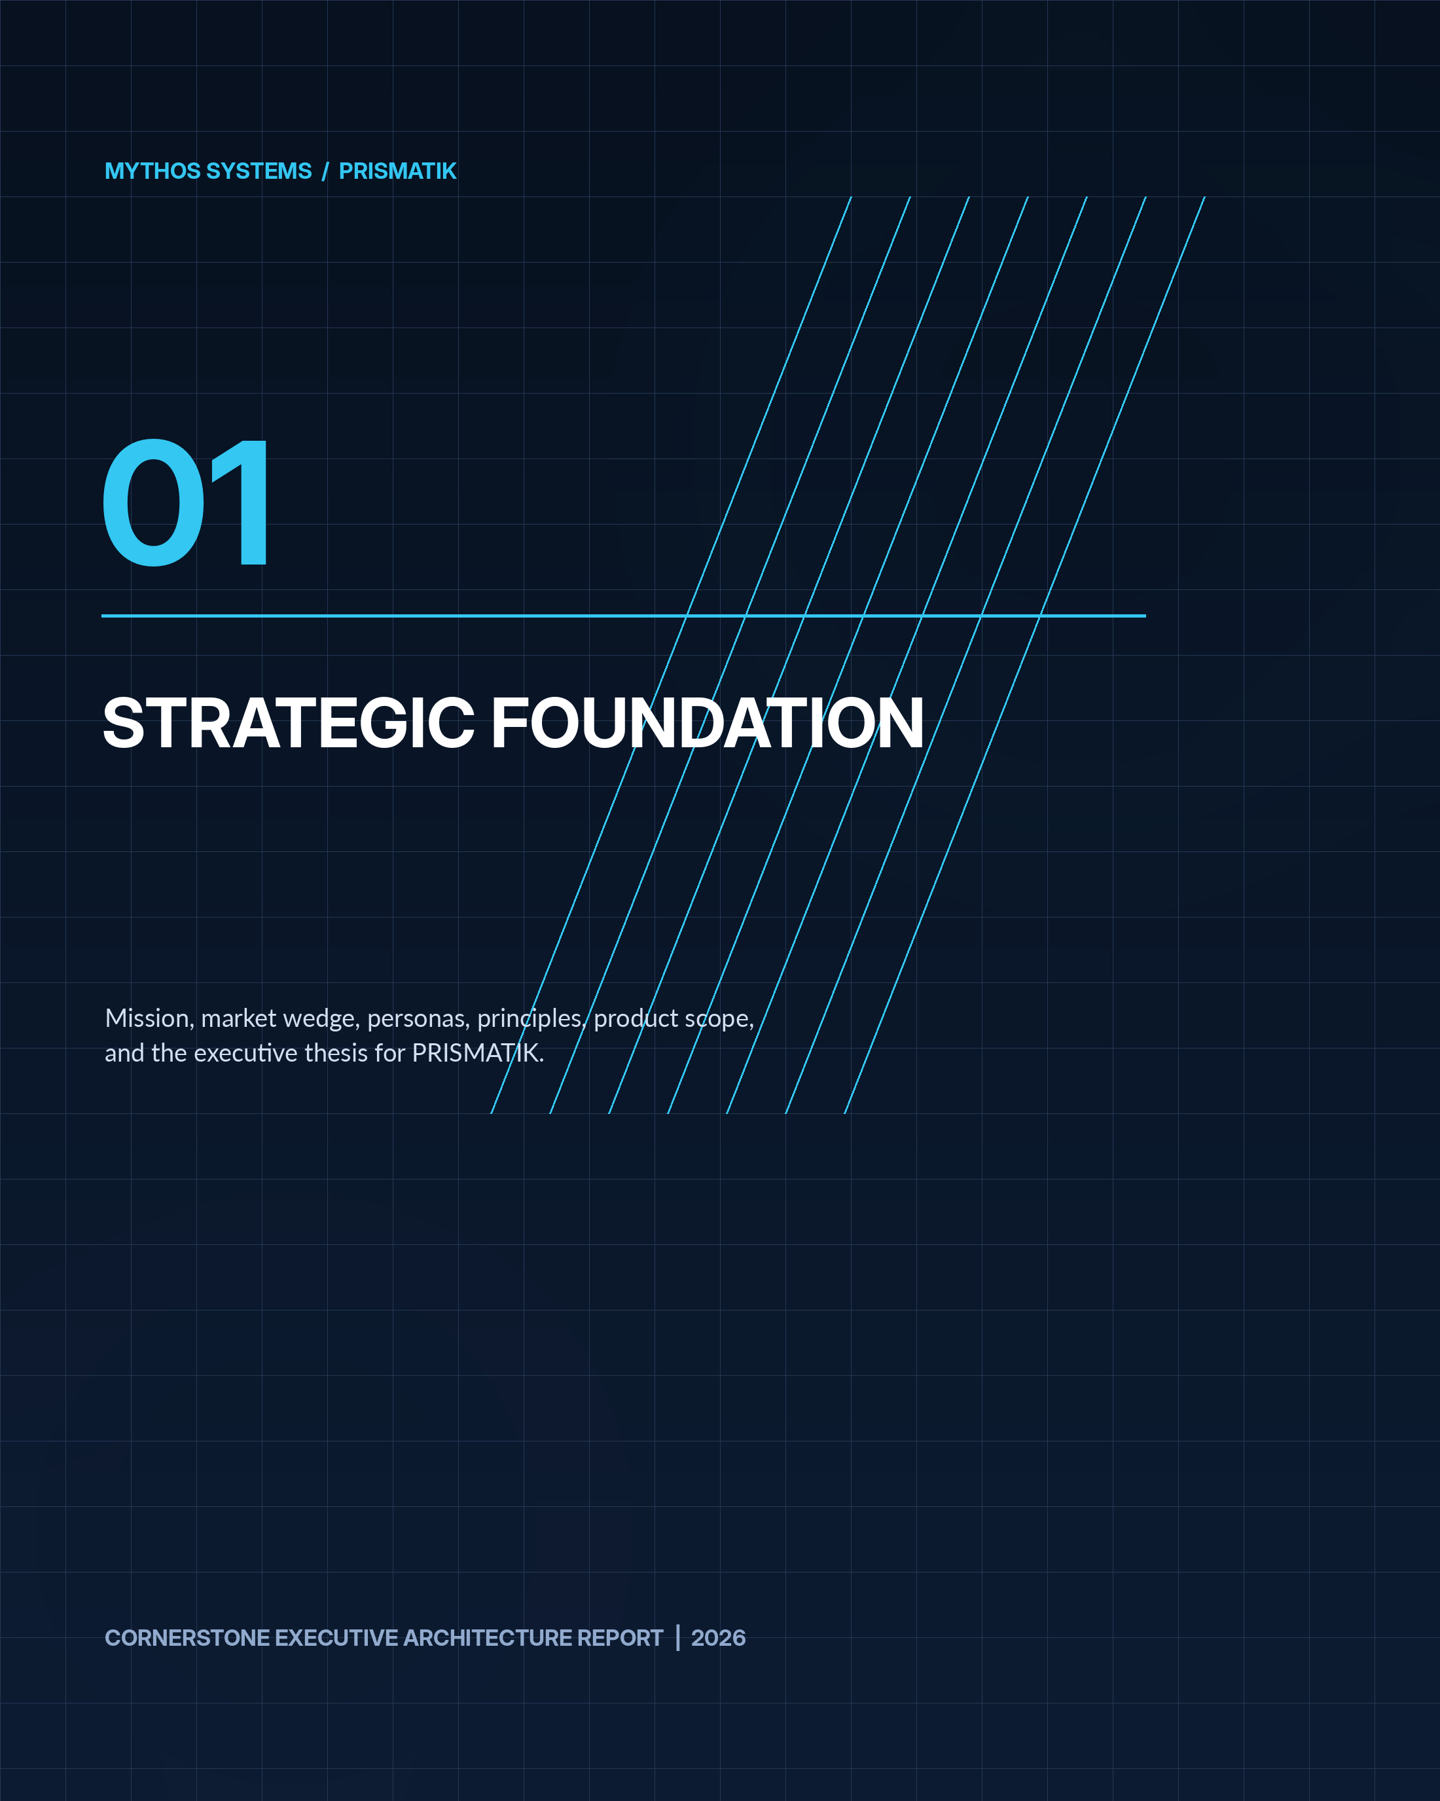

1. Executive Summary
PRISMATIK is an advanced, multi-asset trading intelligence platform centered on decision quality, not unsupported promises of guaranteed returns. Its purpose is to transform fragmented market information into structured, testable, risk-aware trade hypotheses.
The solution converges:
- U.S. equity and ETF intelligence.
- Listed options flow, chain analytics, volatility analysis, and strategy construction.
- Cryptocurrency market, token, exchange, category, derivative, and on-chain-adjacent intelligence.
- SEC filing intelligence, including institutional holdings, insider transactions, ownership disclosures, and material corporate events.
- CFTC Commitments of Traders positioning.
- Macroeconomic data and event awareness.
- Quantitative strategy definition, backtesting, validation, optimization, and Monte Carlo simulation.
- Explainable probabilistic forecasts.
- Portfolio risk, scenario analysis, journaling, and post-trade learning.
- AI-assisted investigation through controlled tools and signed MCP integrations.
- A premium desktop interface with refined animation, soft spectral glows, GPU-accelerated visualizations, and dense professional workflows.
PRISMATIK MUST not represent probabilistic model output as certainty. Every signal, forecast, and recommended structure MUST show:
- The evidence used.
- Data freshness and provider provenance.
- Model or rule version.
- Confidence and uncertainty.
- Known blind spots.
- Historical validation context.
- Liquidity and execution constraints.
- Risk of loss and invalidation conditions.
The platform begins as a modular monolith with hard architectural boundaries, not an early microservice maze. Rust owns the trusted core, ingestion, quantitative computation, security, persistence, orchestration, and native integrations. SvelteKit/Svelte 5 and TypeScript own the presentation layer and interaction model. Tauri 2 delivers the secure desktop shell. WebGPU/wgpu powers visualizations and selected compute workloads where profiling proves value.

2. Product Mission, Positioning, and Guardrails

2.1 Mission
DESIGN PRINCIPLE Help serious traders discover meaningful market setups, understand why they matter, test whether the thesis has historically held, choose an appropriate trade structure, quantify possible outcomes, and learn from actual results.

2.2 Positioning
PRISMATIK is not merely:
- A charting terminal.
- A brokerage client.
- An options-flow feed.
- A cryptocurrency tracker.
- A black-box “AI picks” product.
- A social trading feed.
- A strategy backtester.
- A filing reader.
It is a market intelligence and quantitative decision operating system that integrates all of those functions behind one typed, explainable, provider-independent architecture.

2.3 Initial Market Wedge
The first defensible wedge SHOULD be:
DESIGN PRINCIPLE Event-aware options opportunity intelligence informed by flow, volatility, institutional activity, technical structure, macro regime, and quantitative validation.

This wedge is focused enough to produce differentiated value while the broader multi-asset platform matures.

2.4 Product Guardrails
PRISMATIK MUST:
- Distinguish research, simulation, paper trading, alerts, and live execution.
- Default new accounts to research and paper-trading mode.
- Require explicit enablement and step-up authorization for live execution.
- Clearly mark delayed, derived, estimated, and incomplete data.
- Never invent unavailable exchange, options, filing, or market data.
- Preserve source provenance down to the provider endpoint and retrieval timestamp.
- Detect stale feeds and fail closed for automation that depends on timely data.
- Avoid dark patterns that encourage overtrading.
- Support risk limits that cannot be bypassed casually.
- Keep AI tool permissions narrowly scoped.
- Record immutable audit events for sensitive operations.
- Make all automated actions cancellable, bounded, idempotent, and observable.

3. User Personas and Primary Jobs to Be Done

3.1 Advanced Retail Options Trader
Needs to:
- Detect unusual options activity.
- Determine whether activity is directional, hedging, closing, or part of a spread.
- Compare implied movement with historical movement.
- Select a structure with acceptable liquidity, break-even, theta, and volatility exposure.
- Understand upcoming catalysts.
- Test similar setups.
- Receive alerts when thesis conditions align or invalidate.

3.2 Quantitative Researcher
Needs to:
- Create strategies using a visual DSL, SQL, Python, or Rust.
- Run reproducible backtests.
- Control survivorship, look-ahead, and corporate-action handling.
- Run walk-forward and out-of-sample validation.
- Compare parameter stability.
- Simulate portfolio-level risk.
- Export notebooks, datasets, and signed result manifests.

3.3 Crypto Trader
Needs to:
- View broad market and category conditions.
- Analyze price, volume, market capitalization, liquidity, exchanges, and historical OHLCV.
- Track trending assets, categories, and market dominance.
- Compare centralized and decentralized market information.
- Monitor derivatives and exchange-native data through optional adapters.
- Analyze cross-asset correlation and regime effects.

3.4 Long-Term Investor
Needs to:
- Follow institutional ownership changes.
- Read and summarize filings.
- Track insiders and major holders.
- Understand portfolio concentration, factor exposure, and drawdown risk.
- Separate short-term noise from long-term thesis changes.

3.5 Risk Manager or Trading Team Lead
Needs to:
- Define account and strategy limits.
- Review aggregate exposures and correlated risk.
- Enforce approval workflows.
- Audit model changes and automated actions.
- Run stress scenarios and emergency stop procedures.

3.6 Platform Administrator
Needs to:
- Configure providers, credentials, entitlements, retention, and deployment.
- Monitor health, rate limits, costs, errors, and latency.
- Enforce RBAC/ABAC policies.
- Rotate secrets and cryptographic material.
- Manage signed plugins and MCP servers.
- Export compliance and audit records.

4. Product Principles

4.1 Evidence Before Conclusion
Every opportunity MUST expose the evidence chain that produced it.

4.2 Probability, Not Prophecy
Model output MUST be expressed as a distribution, interval, calibrated probability, ranking, or scenario set—not a guaranteed prediction.

4.3 Provider Independence
Business logic MUST depend on domain ports, never directly on a vendor SDK or endpoint.

4.4 Local-First Where Valuable
Watchlists, layouts, journals, cached research, model metadata, and selected datasets SHOULD remain available offline. Cloud sync is optional and encrypted.

4.5 Security as Architecture
Secrets, execution credentials, personal financial data, strategy intellectual property, model artifacts, and audit logs are high-value assets.

4.6 Professional Density Without Confusion
The interface can be information-rich, but every screen MUST support progressive disclosure, keyboard navigation, saved layouts, and clear provenance.

4.7 Reproducibility
A backtest or forecast MUST be reproducible from:
- Dataset snapshot.
- Data-cleaning policy.
- Strategy/model version.
- Parameters.
- Random seed.
- Execution assumptions.
- Code and dependency versions.

4.8 Graceful Degradation
If advanced GPU rendering, a provider, AI model, or streaming feed is unavailable, the application MUST preserve core workflows in a reduced-capability mode.

5. Scope and Asset Coverage

5.1 Phase-One Asset Classes
- U.S. common stocks.
- U.S. ETFs.
- Listed equity and ETF options.
- Cryptocurrency spot-market intelligence.
- Cryptocurrency reference, category, exchange, and historical data.
- Macro instruments relevant to risk regime analysis.
- Futures-positioning intelligence from CFTC COT reports.

5.2 Later Asset Classes
- Crypto perpetual futures and options through exchange-specific adapters.
- U.S. index options.
- Futures and options on futures.
- Foreign exchange.
- Fixed income and yield curves.
- Commodities.
- Prediction markets.
- International equities where licensing permits.

5.3 Data Rights and Entitlements
The platform MUST maintain a data-entitlement registry that records:
- Provider.
- Plan/tier.
- Licensed use.
- Redistribution restrictions.
- Display rights.
- Historical retention rights.
- Derived-data rights.
- User or organization scope.
- Expiration.
- Required attribution.
- Audit owner.
No endpoint integration is production-ready until legal and licensing constraints are documented.

6. Experience and Visual Design System

6.1 Design Vision
The visual language should feel like a fusion of:
- A professional trading terminal.
- A high-end scientific instrument.
- A cinematic observatory.
- A modern security operations center.
- A restrained, premium, spectral interface.
The interface MUST be captivating without undermining readability or making motion distracting.

6.2 Visual Characteristics
- Deep graphite, obsidian, and midnight surfaces.
- Layered translucent panels with subtle depth.
- Soft spectral glows rather than harsh neon borders.
- Prismatic accents that change by domain:
- Cyan: data and neutral intelligence.
- Emerald: favorable or positive conditions.
- Amber: uncertainty, catalyst proximity, or caution.
- Magenta/violet: AI and model-derived intelligence.
- Red: actual risk, failure, or invalidation—not decoration.
- Fine grid textures and subtle star-field/noise effects at low opacity.
- Responsive light refraction on focus changes.
- Controlled bloom around high-value active elements.
- Smooth panel docking and tab transitions.
- GPU-rendered heatmaps, risk surfaces, network graphs, and time-series layers.
- Reduced-motion and high-contrast modes.

6.3 Motion System
Motion MUST communicate state.
Approved motion categories:
- Focus motion: subtle glow and 100–180 ms elevation.
- Context transition: 180–280 ms crossfade/slide with preserved spatial orientation.
- Streaming pulse: low-amplitude pulse when fresh data arrives.
- Alert emergence: staged reveal that communicates severity without flashing.
- Simulation playback: timeline scrub, scenario paths, and distribution evolution.
- Execution state: explicit pending, acknowledged, partially filled, filled, cancelled, or rejected animation.
- Background ambience: optional, GPU-cheap, slow, and disabled by reduced-motion settings.
Animation budgets MUST be measured. No animation may block input, delay risk information, or reduce chart accuracy.

6.4 Workspace Model
The application SHOULD support:
- Dockable panels.
- Resizable regions.
- Multi-monitor workspaces.
- Named layouts.
- Per-strategy workspaces.
- Keyboard command palette.
- Quick symbol switcher.
- Linked panels by symbol, timeframe, strategy, or account.
- Pop-out native windows.
- Layout snapshots and restore.
- Role-based default workspaces.

6.5 Primary Navigation
Recommended sections:
- Command
- Markets
- Options
- Crypto
- Institutions
- Events
- Research
- Strategies
- Simulations
- Portfolio
- Journal
- Automations
- AI Analyst
- Data
- Administration

7. Functional Capability Map
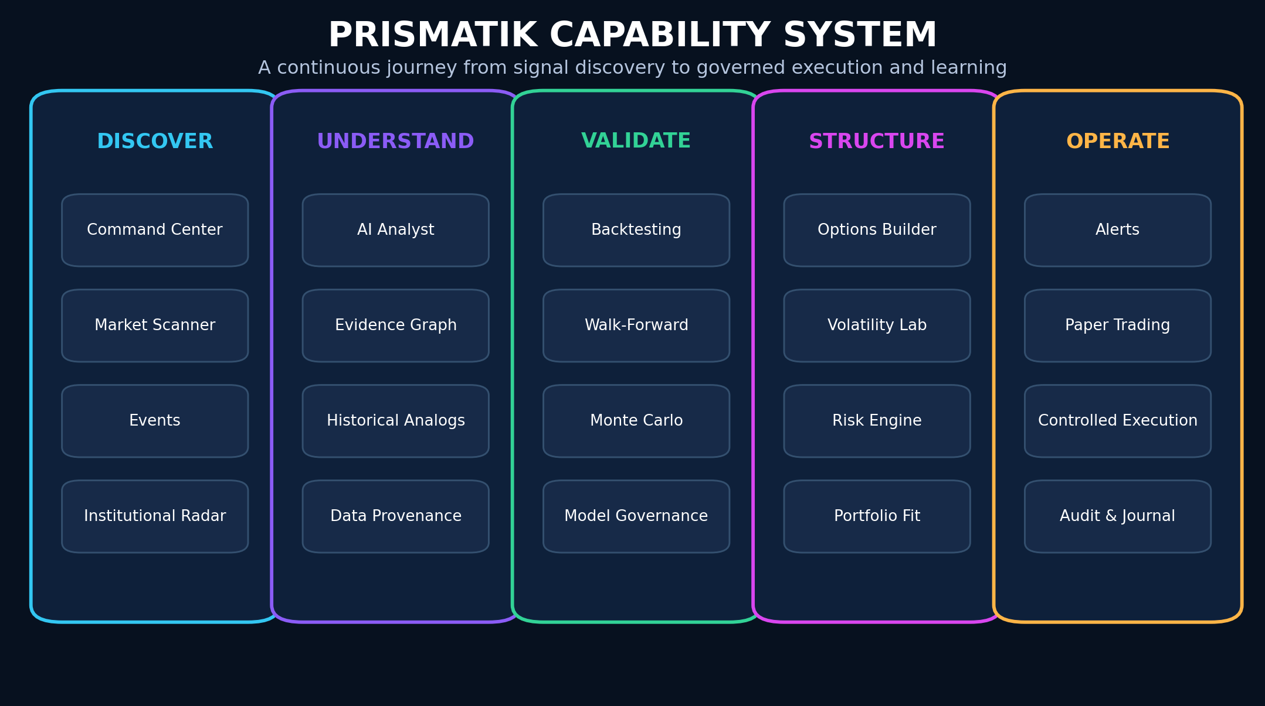
Figure 3 - PRISMATIK capability system from discovery through governed operation.

7.1 Market Command Center
- Global market state.
- U.S. equity index overview.
- Sector and industry performance.
- Crypto market overview.
- Volatility and breadth.
- Macro calendar.
- Event risk.
- Watchlists.
- Top opportunities.
- Portfolio alerts.
- Feed health and freshness.

7.2 Opportunity Engine
- Candidate generation.
- Rule/model scoring.
- Evidence fusion.
- Liquidity filtering.
- Event-aware ranking.
- Risk-adjusted ranking.
- Duplicate thesis collapse.
- User-specific suitability filters.
- Explainable opportunity cards.

7.3 Options Intelligence
- Chains.
- Greeks.
- Open interest and volume.
- Flow.
- Sweeps and blocks.
- Volatility surface.
- Skew and term structure.
- Implied move.
- Dealer-exposure estimates.
- Strategy builder.
- Scenario P/L.
- Monte Carlo distribution.
- Liquidity and fill-quality scoring.

7.4 Institutional Intelligence
- 13F holdings and deltas.
- 13D/13G ownership.
- Form 4 insider activity.
- 8-K event extraction.
- CFTC COT positioning.
- Congressional data where legally and contractually available.
- Dark-pool and block activity where available.
- Institution/company relationship graph.

7.5 Crypto Intelligence
- Prices and market data.
- Categories and narratives.
- Market dominance.
- Trending assets.
- Exchange metadata.
- Historical market charts.
- OHLC.
- Token metadata.
- Derivative summaries where provider coverage allows.
- DEX/pool intelligence where covered.
- Optional exchange-native order-book adapters.

7.6 Research and Quant Lab
- Visual rule builder.
- Strategy DSL.
- Python research environment.
- Rust strategy SDK.
- SQL analytics.
- Backtesting.
- Walk-forward validation.
- Monte Carlo.
- Parameter sensitivity.
- Regime analysis.
- Portfolio simulation.
- Reproducibility manifests.

7.7 Risk and Portfolio
- Positions and transactions.
- Exposure.
- Greeks.
- Concentration.
- Correlation.
- Factor exposure.
- Drawdown.
- Stress tests.
- VaR/CVaR as supplemental measures.
- Scenario analysis.
- Pre-trade guardrails.
- Portfolio kill switches.

7.8 Journal and Learning
- Automatic trade capture.
- Manual thesis.
- Screenshots and chart state.
- Emotional/behavior tags.
- Planned versus actual execution.
- Post-trade review.
- Mistake taxonomy.
- AI pattern discovery.
- Strategy-specific scorecards.

7.9 Automation
- Alerts.
- Scheduled scans.
- Data refresh.
- Strategy runs.
- Paper execution.
- Conditional live execution in later phases.
- Human approval gates.
- Emergency disablement.
- Full auditability.
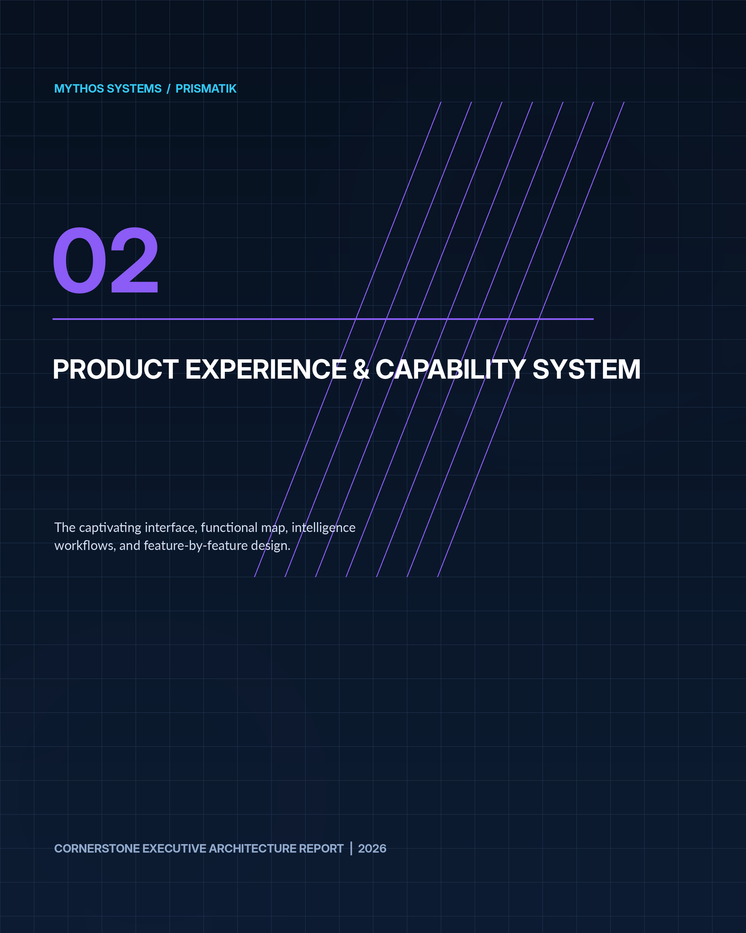

8. Detailed Feature Design

8.1 Command Center

Functional Design
The Command Center is a personalized, role-aware operational overview. It MUST not become an unstructured wall of widgets.
Recommended regions:
- Market regime: trend, volatility, liquidity, breadth, correlation, macro risk.
- Today’s catalysts: earnings, macro releases, filings, options expirations, token events.
- Priority opportunities: ranked by expected value, confidence, liquidity, and user strategy fit.
- Risk posture: account exposure, portfolio Greeks, drawdown, concentration, upcoming event exposure.
- Institutional activity: meaningful ownership and positioning changes.
- Crypto state: market cap, volume, dominance, category movement, exchange anomalies.
- System status: provider freshness, API budget, queue lag, model status.
Each card MUST include:
- Timestamp.
- Source.
- Freshness state.
- Data quality grade.
- Confidence.
- Click-through evidence.
- Dismiss/snooze behavior.
- Personalization reason.

Advanced Enhancement
Add an attention governor that limits repeated low-value alerts and prioritizes information based on:
- Portfolio exposure.
- Watchlist relevance.
- User strategy.
- Event proximity.
- Severity.
- Novelty.
- Historical usefulness.

8.2 Universal Instrument Workspace
Each asset page SHOULD contain linked modules:
- Price chart.
- Market metadata.
- News/events.
- Technical state.
- Options state.
- Institutional state.
- Filing state.
- Crypto-specific token/exchange data.
- AI thesis.
- Historical analogs.
- Strategy candidates.
- Journal history.
- Alerts and automations.
A symbol context object SHOULD be passed between panels, not reconstructed independently.

8.3 Advanced Charting

Required Capabilities
- Candlestick, bar, line, area.
- Heikin-Ashi.
- Volume and volume profile.
- VWAP and anchored VWAP.
- Corporate-action-aware history.
- Multi-timeframe overlays.
- Compare mode.
- Drawing tools.
- Saved annotations.
- Event markers.
- Filing and institutional markers.
- Options-flow markers.
- Crypto market and category overlays.
- Replay mode.
- Synchronized crosshair.
- GPU-accelerated rendering for large series.

Chart Data Integrity
Every point MUST preserve:
- Provider.
- Venue or aggregation scope.
- Timestamp resolution.
- Timezone.
- Adjustment policy.
- Currency.
- Missing-data state.
- Data version.
The chart MUST visually distinguish:
- Live.
- Delayed.
- Derived.
- Interpolated.
- Backfilled.
- Stale.

8.4 Market Scanner
The scanner MUST support:
- Saved scans.
- Streaming updates.
- Compound conditions.
- Explainable scoring.
- Preview counts.
- Historical hit rate.
- Alert conversion.
- Export.
- Strategy handoff.
Condition groups:
- Price/return.
- Volume and relative volume.
- Volatility.
- Technical indicators.
- Fundamental metrics.
- Filing activity.
- Institutional activity.
- Options activity.
- Event proximity.
- Market regime.
- Crypto category/exchange metrics.
- User-defined factors.

8.5 Event and Catalyst Engine
The event engine normalizes all relevant events into a common schema.
Examples:
- Earnings.
- Guidance.
- SEC filing.
- Insider transaction.
- Ownership disclosure.
- CFTC report.
- Federal Reserve decision.
- Inflation and employment release.
- FDA or regulatory event.
- Merger or acquisition.
- Product event.
- Dividend.
- Split.
- Options expiration.
- Token unlock.
- Network upgrade.
- Exchange listing/delisting.
- Governance vote.
Every event SHOULD have:
TEXT
event_id
event_type
source
source_reference
entities
symbols
scheduled_at
observed_at
effective_at
severity
confidence
expected_impact_window
historical_impact_distribution
user_exposure
freshness
raw_document_hash
parser_version
The event engine MUST support revisions and corrections without overwriting prior facts.

8.6 Opportunity Card
An opportunity is not a trade instruction. It is a ranked hypothesis.
Recommended fields:
- Asset and direction.
- Suggested expression.
- Opportunity score.
- Expected-value estimate.
- Confidence interval.
- Time horizon.
- Catalyst.
- Evidence summary.
- Contradicting evidence.
- Liquidity score.
- Volatility state.
- Risk and invalidation.
- Similar historical samples.
- Backtest status.
- Simulation status.
- Data freshness.
- Model/rule version.
- “Why shown to me.”
- “What would change this score.”

8.7 Historical Analog Engine
The analog engine finds prior periods with similar:
- Trend.
- Volatility.
- Breadth.
- Macro state.
- Options state.
- Event type.
- Institutional positioning.
- Cross-asset correlations.
It MUST expose the distance metric and avoid presenting a small or biased sample as authoritative.

8.8 Alerting
Alerts can target:
- Price.
- Technical condition.
- Volume.
- Options flow.
- Implied volatility.
- Filing.
- Institutional position.
- COT extreme.
- Event proximity.
- Strategy condition.
- Portfolio risk.
- Data health.
- Model drift.
Alert execution MUST be idempotent and use deduplication windows. Delivery channels may include:
- Desktop.
- Mobile companion.
- Email.
- SMS through an optional provider.
- Slack/Teams.
- Webhook.
- MCP/agent event.
- PagerDuty for enterprise operational alerts.
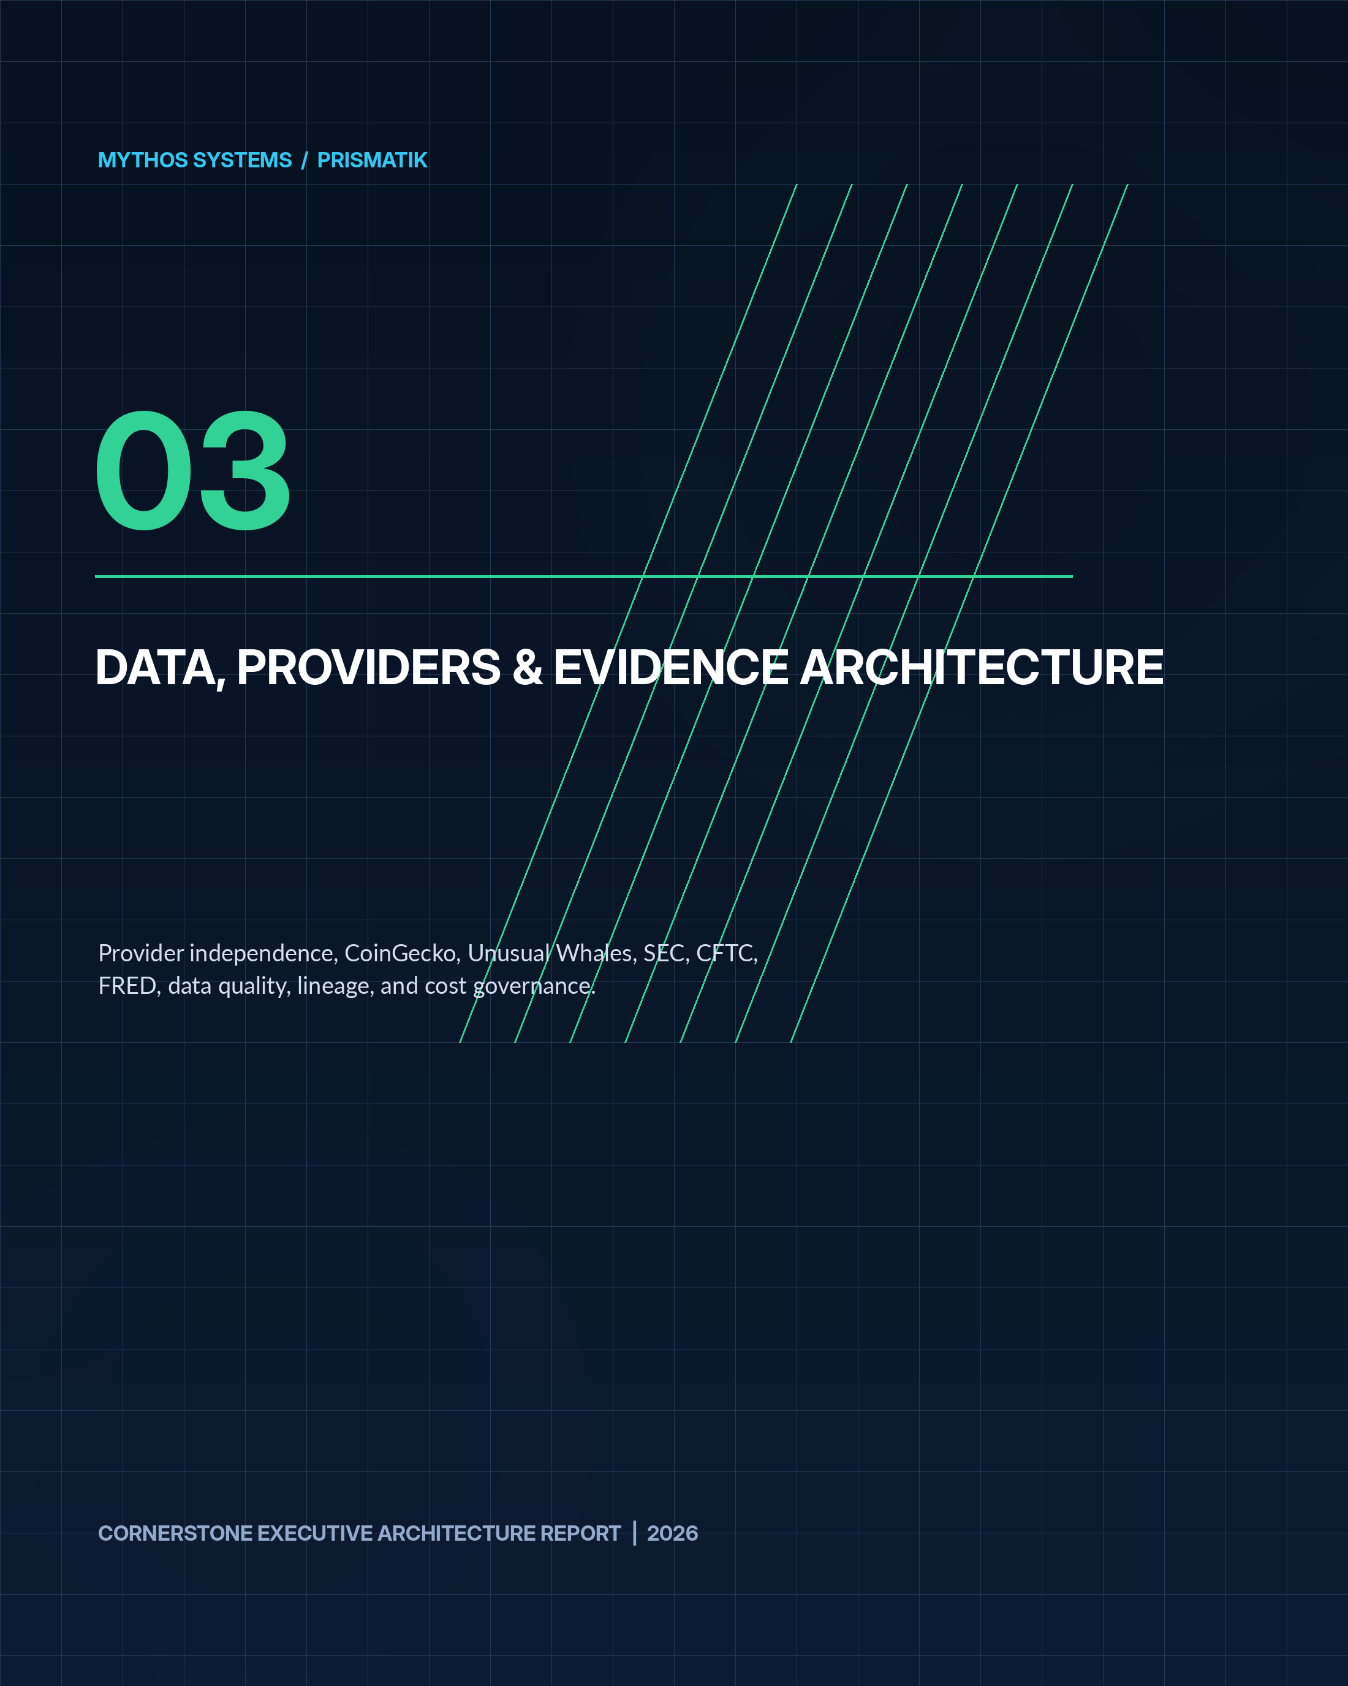

9. Data Provider and API Strategy
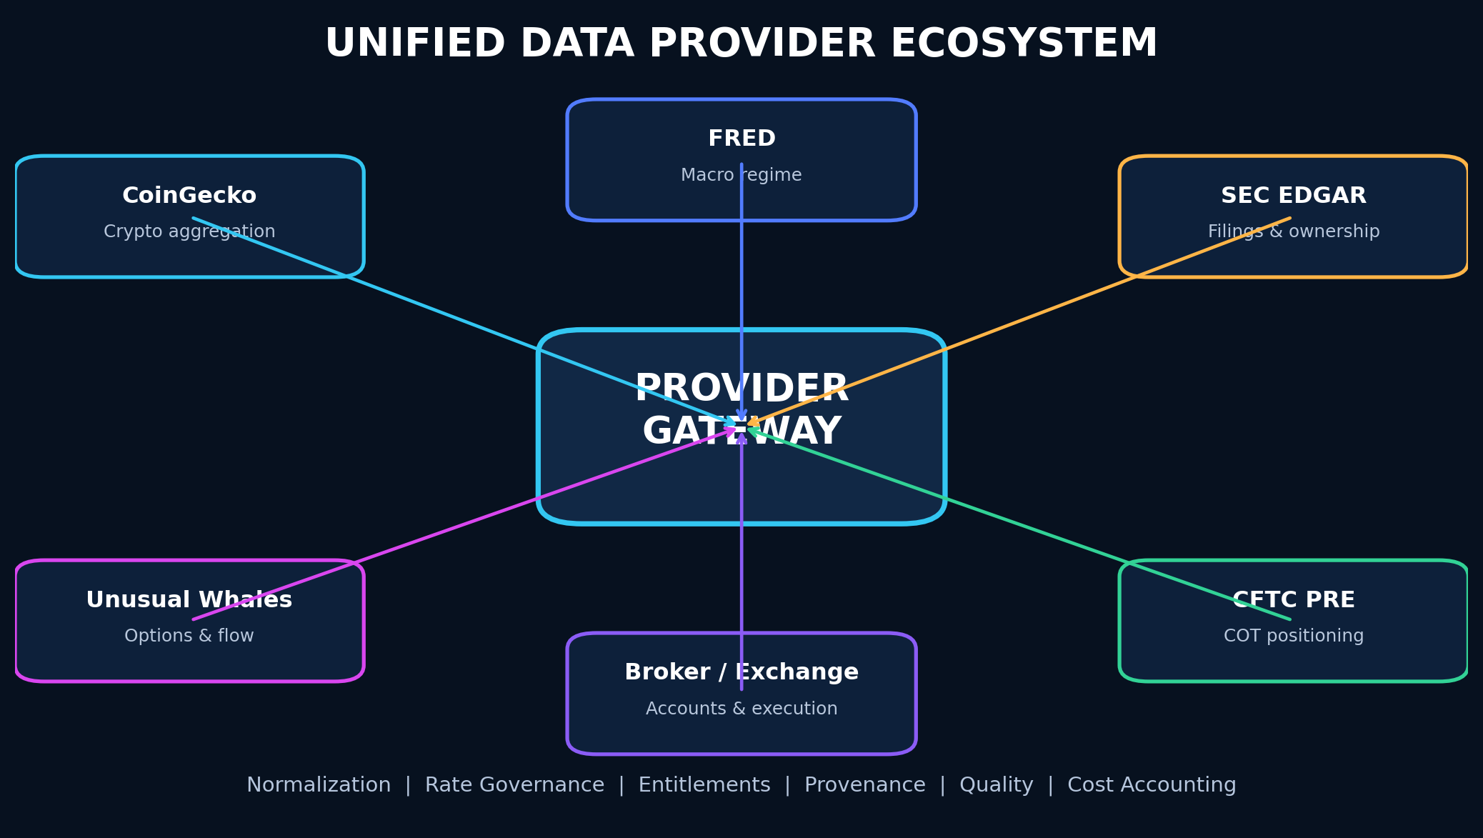
Figure 4 - Provider ecosystem behind a normalized, entitlement-aware gateway.

9.1 Provider Philosophy
No single provider should define the platform’s domain model. Adapters MUST normalize provider data into canonical contracts.
Each adapter MUST implement:
- Authentication.
- Rate limiting.
- Pagination.
- Retries with capped exponential backoff and jitter.
- Circuit breaking.
- Freshness tracking.
- Provenance.
- Schema validation.
- Contract tests.
- Cost accounting.
- Entitlement enforcement.
- Provider-specific error translation.
- Health checks.

9.2 CoinGecko — Primary Crypto Aggregation Provider

Intended Uses
CoinGecko should serve as the primary cryptocurrency reference and broad market data provider for:
- Coin identifiers and metadata.
- Current prices.
- Market capitalization.
- Volume.
- Market rankings.
- Categories.
- Trending data.
- Exchanges.
- Historical market charts.
- OHLC.
- Global crypto market data.
- Derivative summaries when available by endpoint/tier.
- On-chain/GeckoTerminal-related market and pool discovery where licensed.
- News where plan access permits.
- Token and asset discovery.

Architecture Requirements
- Store CoinGecko coin IDs as provider identifiers; never rely on ticker symbols as unique keys.
- Maintain a canonical asset identity service that maps symbols, contracts, chains, exchange pairs, and provider IDs.
- Keep API keys exclusively in the Rust backend or server-side infrastructure.
- Add a request-budget service that tracks rate limits and credits.
- Use cache policies by endpoint class:
- Metadata: long TTL.
- Market snapshots: short TTL.
- Historical candles: immutable segments after finalization.
- Trending data: moderate TTL.
- Introduce stale-while-revalidate behavior for non-critical UI reads.
- Do not use a demo/free endpoint as the sole source for latency-sensitive production trading.
- Add optional exchange-native adapters for order books, trades, private account data, and execution because an aggregator is not a substitute for venue-native execution data.

CoinGecko Functional Modules
- Crypto market overview.
- Asset search.
- Asset profile.
- Categories and narratives.
- Global market state.
- Exchange explorer.
- Historical charts.
- Cross-asset correlations.
- Portfolio valuation.
- Market dominance.
- Trend/ranking scanner.
- Token watchlists.
- Data provenance inspector.

9.3 Unusual Whales — Equity and Options Intelligence

Intended Uses
Subject to plan and licensing:
- Options flow.
- Options chains and derived data.
- Dark-pool data.
- Open interest.
- Greek exposure.
- Volatility.
- Institutional and congressional datasets.
- Insider data.
- Market and ticker analytics.
- MCP-based AI access for approved use cases.

Design Requirements
- Prefer REST/OpenAPI-generated clients for deterministic production workflows.
- Treat MCP as an AI tool interface, not the canonical ingestion pipeline.
- Preserve raw provider payloads for replay only when licensing permits.
- Build field-level provenance for all derived scores.
- Separate “trade observed” from “trade interpretation.”
- Explicitly model uncertainty around opening/closing and directional inference.
- Add a provider kill switch if schemas or entitlements change.

9.4 SEC EDGAR — Regulatory and Filing Intelligence

Intended Uses
- Company submissions history.
- Filing metadata.
- XBRL company facts.
- 10-K.
- 10-Q.
- 8-K.
- 13F.
- 13D/13G.
- Forms 3, 4, and 5.
- Form 144.
- Filing documents and exhibits where permitted.
- RSS or polling-based recent filing discovery.

Design Requirements
- Respect SEC fair-access requirements and identify the application appropriately.
- Cache immutable filings.
- Hash original documents.
- Store parser and extraction version.
- Preserve raw text separately from AI-generated summaries.
- Build deterministic parsers before relying on language models.
- Extract entities, holdings, changes, risks, and material events.
- Provide links back to original filings.
- Reprocess historical filings when extraction improves, while retaining prior outputs.

9.5 CFTC Public Reporting Environment — Commitments of Traders

Intended Uses
- Legacy COT.
- Disaggregated COT.
- Traders in Financial Futures.
- Futures-only.
- Futures-and-options combined.
- Historical positioning.
- Managed-money, dealer, asset-manager, leveraged-fund, producer, and other category analysis as supported by report type.

Feature Design
- Normalize contracts and report categories.
- Calculate net positioning.
- Weekly change.
- Z-score.
- Historical percentile.
- Crowding score.
- Price-position divergence.
- Reversal alerts.
- Cross-market positioning map.
- Regime overlays.
COT data is weekly and delayed relative to the reporting date; the interface MUST communicate this clearly.

9.6 FRED — Macroeconomic Data
Recommended uses:
- Interest rates.
- Yield curve.
- Inflation.
- Employment.
- Liquidity and monetary aggregates.
- Credit conditions.
- Financial stress.
- Economic regime classification.
Macro series MUST retain revision/vintage awareness where practical to prevent look-ahead bias.

9.7 Additional Recommended Providers

Public or Government
- U.S. Treasury fiscal and yield data.
- Bureau of Labor Statistics.
- Bureau of Economic Analysis.
- Federal Reserve calendars and releases.
- FINRA public datasets where applicable.
- OCC and exchange calendars where permitted.

Optional Paid/Commercial
- A licensed consolidated equity/option quote provider.
- Exchange-grade historical tick/options data.
- Corporate actions and reference data.
- News with machine-readable entitlements.
- Broker APIs for accounts and execution.
- Crypto exchange-native feeds.
- Institutional on-chain analytics.

Critical Principle
PRISMATIK MUST display the distinction between:
- Official public data.
- Licensed commercial data.
- User-connected broker data.
- Exchange-native data.
- Model-derived data.
- Community-contributed data.

10. Unified Market Data Architecture
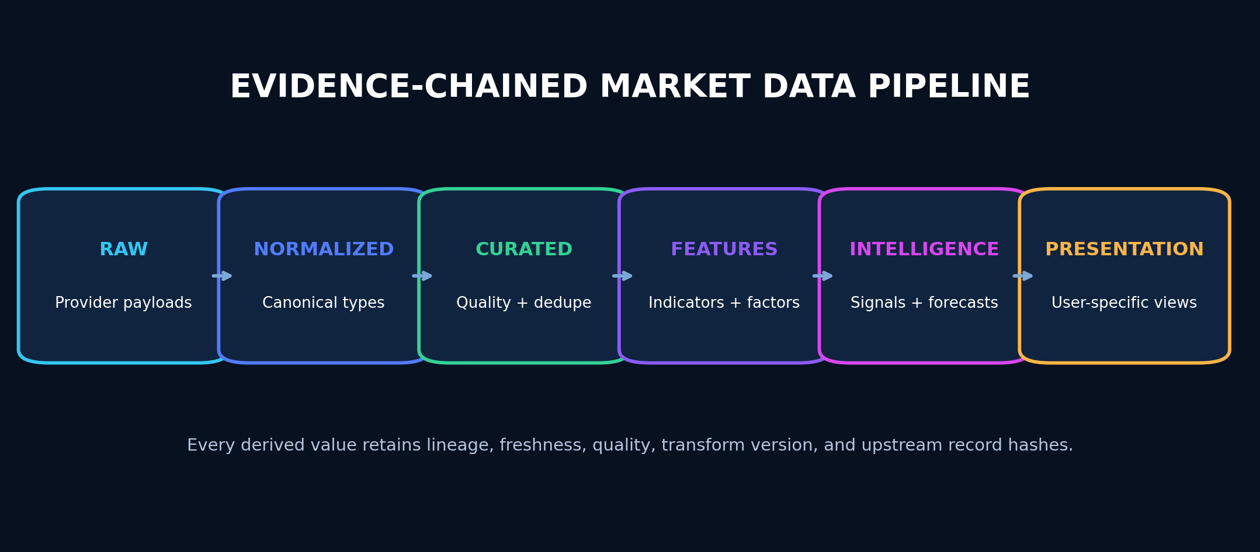
Figure 5 - Evidence-chained market-data pipeline and intelligence layers.

10.1 Canonical Data Layers
- Raw layer: provider payloads, immutable where licensing permits.
- Normalized layer: canonical typed records.
- Curated layer: cleaned, deduplicated, adjusted, and quality-scored.
- Feature layer: indicators, factors, model features.
- Intelligence layer: opportunities, forecasts, anomalies, explanations.
- Presentation layer: user-specific views and aggregations.

10.2 Provider Port Example
RUST
#[async_trait::async_trait]
pub trait MarketDataProvider: Send + Sync {
fn provider_id(&self) -> ProviderId;
async fn health(
&self,
ctx: &RequestContext,
) -> Result<ProviderHealth, ProviderError>;
async fn resolve_assets(
&self,
ctx: &RequestContext,
query: AssetQuery,
) -> Result<Vec<ProviderAsset>, ProviderError>;
async fn market_snapshot(
&self,
ctx: &RequestContext,
request: MarketSnapshotRequest,
) -> Result<MarketSnapshot, ProviderError>;
async fn historical_bars(
&self,
ctx: &RequestContext,
request: HistoricalBarsRequest,
) -> Result<HistoricalBars, ProviderError>;
}
Provider capabilities MUST be discoverable rather than assumed.

10.3 Canonical Identity Service
The system MUST solve symbol ambiguity.
Canonical asset records SHOULD include:
- Internal immutable ID.
- Asset type.
- Legal issuer/entity.
- Display symbol.
- Exchange/venue.
- Currency.
- FIGI/CUSIP/ISIN when licensed and applicable.
- SEC CIK.
- CoinGecko ID.
- Chain.
- Contract address.
- Token decimals.
- Provider aliases.
- Valid-from and valid-to dates.
- Corporate-action lineage.

10.4 Data Quality Score
Each dataset and record SHOULD be scored using:
- Freshness.
- Completeness.
- Consistency.
- Provider confidence.
- Cross-provider agreement.
- Schema validity.
- Outlier status.
- Adjustment status.
- Venue coverage.
Low-quality data MUST not silently drive high-confidence recommendations.

10.5 Rate-Limit and Budget Governor
A centralized governor MUST:
- Track provider quotas.
- Reserve capacity for critical workflows.
- Coalesce duplicate requests.
- Cache responses.
- Apply adaptive polling.
- Shed low-priority load.
- Respect Retry-After.
- Record spend and credits.
- Alert before exhaustion.
- Prevent N parallel UI components from independently calling the same endpoint.
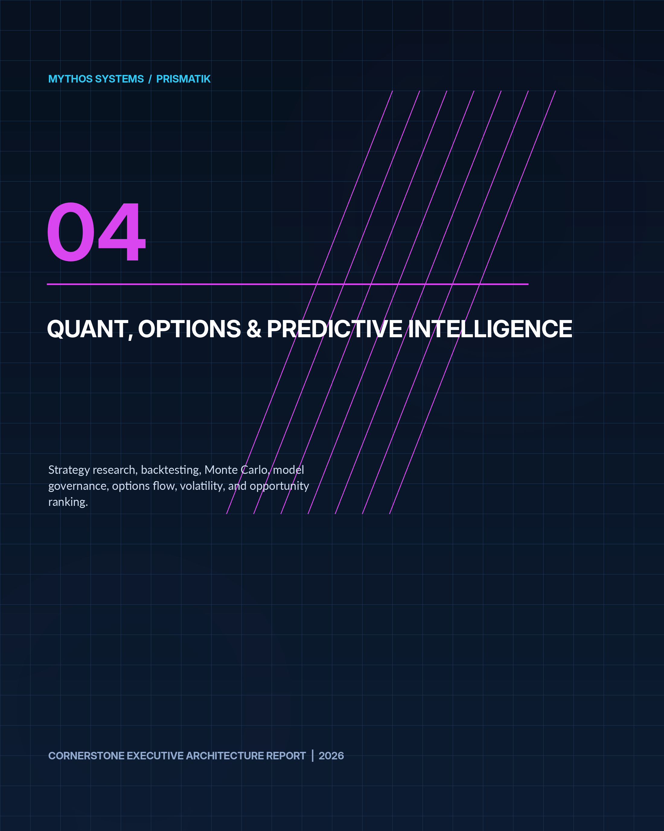

11. Quantitative Research and Simulation Architecture

11.1 Strategy Definition Modes

Visual Builder
For non-programmers:
- Condition groups.
- Indicators.
- Events.
- Position rules.
- Option-selection rules.
- Entry/exit.
- Risk limits.
- Time windows.
- Execution assumptions.

Strategy DSL
A typed, versioned domain language:
TEXT
strategy "EventFlowMomentum" version 1 {
universe = us_equities
when:
relative_volume > 2.0
and options.call_put_premium_ratio > 2.5
and iv_rank < 45
and days_to_earnings between 10 and 30
and regime.volatility != "crisis"
enter:
structure = call_debit_spread
dte between 30 and 60
long_delta between 0.55 and 0.70
risk:
max_premium_at_risk = 0.50% of portfolio
max_sector_exposure = 15%
exit:
profit_target = 50% of max_profit
stop = 40% of debit
max_holding_days = 15
}
The DSL MUST compile to a typed intermediate representation.

Python
Use a sandboxed research service for exploratory analysis. Python MUST not become the trusted execution core.
Recommended libraries:
- Polars.
- PyArrow.
- NumPy.
- SciPy.
- statsmodels.
- scikit-learn.
- Jupyter-compatible environment where appropriate.

Rust SDK
For production-grade strategies:
- Typed events.
- Deterministic clock.
- Explicit state.
- Bounded memory.
- Reproducible random sources.
- No direct network access.
- Capability-scoped data access.

11.2 Backtesting Engine
The engine MUST model:
- Corporate actions.
- Delistings.
- Survivorship.
- Symbol changes.
- Trading calendars.
- Session boundaries.
- Timezones.
- Bid/ask where available.
- Spread.
- Slippage.
- Commission.
- Market impact approximation.
- Liquidity constraints.
- Partial fills.
- Option expiration.
- Assignment/exercise assumptions.
- Missing or stale data.
- Event publication time.
- Filing availability time.
- Data revisions.

11.3 Validation Modes
- In-sample.
- Holdout.
- Rolling out-of-sample.
- Walk-forward.
- Anchored walk-forward.
- Purged cross-validation for overlapping labels.
- Monte Carlo resampling.
- Parameter perturbation.
- Regime split.
- Sector split.
- Timeframe split.
- Reality-check/multiple-hypothesis controls.

11.4 Metrics
- Total and annualized return.
- Win rate.
- Expectancy.
- Profit factor.
- Max drawdown.
- Ulcer index.
- Sharpe and Sortino, with assumptions.
- Calmar.
- Tail loss.
- CVaR/expected shortfall.
- Exposure.
- Turnover.
- Capacity approximation.
- Maximum favorable/adverse excursion.
- Time under water.
- Slippage sensitivity.
- Regime-specific performance.
- Confidence intervals.

11.5 Monte Carlo Lab
Simulation modes:
- Historical bootstrap.
- Block bootstrap.
- Parametric return distribution.
- Geometric Brownian motion.
- Jump diffusion.
- Stochastic volatility.
- Regime switching.
- Correlated multi-asset simulation.
- Volatility-surface-aware option simulation.
- Trade-sequence reshuffling.
Outputs:
- Terminal-value distribution.
- Probability of profit.
- Probability of ruin.
- Drawdown distribution.
- Expected shortfall.
- Strike-touch probability.
- Path-dependent stop/target outcomes.
- Time-to-target distribution.
- Volatility shock sensitivity.
- Theta decay scenarios.
- Portfolio breach probability.
Every simulation MUST record its assumptions and seed.

12. Predictive Intelligence Architecture

12.1 Forecast Types
- Direction probability.
- Return distribution.
- Volatility forecast.
- Range forecast.
- Event reaction distribution.
- Liquidity forecast.
- Regime probability.
- Anomaly score.
- Opportunity ranking.
- Risk of thesis invalidation.

12.2 Model Hierarchy
Start simple and earn complexity:
- Baseline historical frequencies.
- Linear/logistic models.
- Tree ensembles.
- Time-series models.
- Calibrated gradient boosting.
- Deep temporal models only where they outperform robust baselines.
- Regime ensembles.
- Bayesian models where uncertainty is central.

12.3 Feature Families
- Price and return.
- Volume and liquidity.
- Volatility.
- Options flow and surface.
- Market breadth.
- Sector/industry state.
- Institutional activity.
- COT positioning.
- Filing events.
- Macro regime.
- Crypto category and dominance.
- Cross-asset correlation.
- Sentiment and news where licensed.
- User strategy context.

12.4 Explainability
For each prediction:
- Top positive contributors.
- Top negative contributors.
- Feature freshness.
- Missing features.
- Similar examples.
- Calibration curve.
- Training window.
- Model version.
- Known limitations.
- Data drift status.

12.5 Model Governance
Models MUST have:
- Owner.
- Intended use.
- Prohibited use.
- Dataset lineage.
- Training code version.
- Validation report.
- Bias/leakage review.
- Calibration report.
- Promotion approval.
- Drift thresholds.
- Rollback.
- Retirement plan.

12.6 Avoiding False Precision
The UI SHOULD prefer:
- “Estimated 58–66% probability range”over
- “62.37% chance.”
Confidence must widen when data is sparse, stale, out-of-domain, or contradictory.

13. Options Intelligence Architecture

13.1 Chain Explorer
Capabilities:
- Expiration matrix.
- Strike ladder.
- Calls and puts.
- Bid/ask.
- Last.
- Volume.
- Open interest.
- Implied volatility.
- Greeks.
- Intrinsic/extrinsic value.
- Break-even.
- Probability estimates.
- Liquidity score.
- Spread width.
- Event markers.
- Historical IV context.

13.2 Flow Classification
Each observed trade or aggregate MUST separate facts from inference.
Facts:
- Timestamp.
- Contract.
- Size.
- Price.
- Bid/ask context.
- Premium.
- Venue if available.
- Volume and open interest.
- Underlying state.
Inferences:
- Buy/sell side likelihood.
- Opening/closing likelihood.
- Spread membership likelihood.
- Directional/hedging likelihood.
- Urgency.
- Repeat accumulation.
- Confidence.

13.3 Flow Clustering
Cluster trades by:
- Underlying.
- Actor-like timing pattern.
- Expiration.
- Strike.
- Side.
- Premium.
- Venue.
- Repeated sequence.
- Multi-leg relationship.
The UI SHOULD present both individual prints and inferred parent activity.

13.4 Volatility Lab
- IV rank.
- IV percentile.
- Realized volatility.
- Term structure.
- Skew.
- Smile.
- Event IV.
- Forward volatility.
- Volatility cone.
- Surface interpolation.
- Surface change.
- Relative-value comparisons.

13.5 Strategy Constructor
Inputs:
- Thesis direction.
- Expected move.
- Time horizon.
- Volatility view.
- Risk budget.
- Probability preference.
- Liquidity threshold.
- Event exposure.
- Account constraints.
Candidate structures are ranked by:
- Expected value.
- Probability of profit.
- Maximum loss.
- Capital efficiency.
- Liquidity.
- Theta.
- Vega.
- Gamma.
- Assignment complexity.
- Tail risk.
- Scenario stability.

13.6 Trade Quality Score
Suggested dimensions:
- Evidence confluence.
- Flow quality.
- Catalyst quality.
- Volatility value.
- Technical structure.
- Institutional alignment.
- Liquidity.
- Execution cost.
- Risk/reward.
- Historical validation.
- Model confidence.
- Data quality.
- Portfolio fit.
The final score MUST not hide dimension-level disagreement.

13.7 Dealer Exposure
Gamma and related dealer-exposure estimates SHOULD be clearly labeled as estimates because open-interest ownership and dealer positioning are not directly observable in full.

14. Institutional and Regulatory Intelligence

14.1 13F Intelligence
Functions:
- Filing calendar.
- Manager profiles.
- Current holdings.
- New positions.
- Increases.
- Decreases.
- Exits.
- Concentration.
- Sector changes.
- Manager consensus.
- Position novelty.
- Historical manager behavior.
Limitations MUST be explicit:
- Reporting delay.
- Quarter-end snapshot.
- Long holdings emphasis.
- Incomplete short/derivative picture.
- Unknown intra-quarter transaction timing.

14.2 Ownership Intelligence
13D/13G features:
- Ownership threshold events.
- Amendment history.
- Activist indicators.
- Holder relationships.
- Change magnitude.
- Related news and filings.

14.3 Insider Intelligence
Forms 3/4/5:
- Open-market buys/sells.
- Grants.
- Option exercises.
- Tax-related dispositions.
- 10b5-1 indicators where reported.
- Cluster buying.
- Role and ownership context.
- Historical insider behavior.
The system MUST not treat all insider transactions equally.

14.4 Material Event Intelligence
8-K extraction:
- Earnings and guidance.
- Leadership changes.
- Material agreements.
- Debt events.
- Acquisitions.
- Cybersecurity incidents.
- Restatements.
- Bankruptcy.
- Auditor changes.

14.5 Institutional Relationship Graph
Graph nodes:
- Institution.
- Fund.
- Manager.
- Company.
- Executive.
- Filing.
- Security.
- Sector.
- Event.
Edges MUST retain source, effective date, confidence, and validity interval.

15. Crypto Intelligence

15.1 Crypto Market Command
- Total market capitalization.
- Volume.
- BTC/ETH dominance.
- Stablecoin context where available.
- Category performance.
- Trending assets.
- Largest movers.
- Liquidity warnings.
- Exchange conditions.
- Market regime.

15.2 Asset Profile
- Canonical token identity.
- Chain and contract addresses.
- Market data.
- Supply metrics.
- Market capitalization and fully diluted valuation.
- Historical chart.
- Categories.
- Exchange listings.
- Community/developer metadata where available.
- Related assets.
- Risk flags.
- Data freshness.

15.3 Category and Narrative Explorer
- Category constituents.
- Weighted performance.
- Dispersion.
- Volume.
- Leadership rotation.
- Correlation.
- New entrants.
- Historical cycles.

15.4 Exchange Explorer
- Exchange metadata.
- Trust/quality information supplied by provider.
- Pair availability.
- Volume.
- Geographic or access notes where known.
- User-connected account adapters in later phases.

15.5 Exchange-Native Extensions
CoinGecko is the aggregation foundation, but optional adapters SHOULD provide:
- Order books.
- Trades.
- Funding rates.
- Open interest.
- Liquidations.
- Private balances.
- Orders.
- Execution.
Potential adapters:
- Coinbase.
- Kraken.
- Binance where legally and geographically appropriate.
- Hyperliquid.
- Bybit where legally appropriate.
These are separate security and compliance boundaries.

15.6 Crypto Risk Engine
- Liquidity concentration.
- Exchange concentration.
- Volatility.
- Drawdown.
- Correlation.
- Token age.
- Supply concentration where data exists.
- Contract/chain mapping warnings.
- Stablecoin depeg scenarios.
- Bridge/protocol exposure through later providers.
- Venue outage scenarios.

16. AI and Agentic Intelligence

16.1 AI Analyst
Supported questions:
- Why did this asset move?
- What upcoming events matter?
- What changed in the options surface?
- Which institutional filings are significant?
- Find similar historical conditions.
- Construct and compare option structures.
- Explain this strategy’s failure.
- Summarize portfolio risks.
- Generate a research plan.
- Translate natural language into a scan or strategy draft.

16.2 Tool Architecture
The AI MUST use a controlled tool layer:
- Read-only market query.
- Filing query.
- COT query.
- Backtest request.
- Simulation request.
- Chart snapshot.
- Portfolio analysis.
- Journal search.
- Draft alert.
- Draft strategy.
- Draft order.
Live order submission MUST not be directly available to a general conversational model. It requires a deterministic execution workflow and explicit user approval.

16.3 MCP Integration
MCP servers MUST be:
- Explicitly installed.
- Signed where possible.
- Version pinned.
- Capability scoped.
- Network restricted.
- Audited.
- Disableable.
- Assigned a trust level.
- Prevented from reading unrelated local files or secrets.
A remote MCP server SHOULD be treated as an external dependency, not trusted local code.

16.4 Retrieval and Knowledge
The AI retrieval layer may index:
- User notes.
- Strategy definitions.
- Backtest reports.
- Journal entries.
- Filings.
- Provider documentation.
- Internal help.
- Model cards.
- Runbooks.
Sensitive indices MUST be encrypted, tenant-scoped, and covered by retention policy.

16.5 AI Output Contract
Every market answer SHOULD provide:
- Direct answer.
- Evidence.
- Source timestamps.
- Uncertainty.
- Contradicting evidence.
- Suggested next verification.
- Risk note.
- Tool calls used.
- Model/version metadata when appropriate.

17. Portfolio, Risk, Journal, and Execution

17.1 Portfolio Model
Support:
- Multiple accounts.
- Manual portfolios.
- Paper portfolios.
- Broker-linked portfolios.
- Tax lots where data permits.
- Cash.
- Equities.
- Options.
- Crypto.
- Strategies and sleeves.

17.2 Risk Measures
- Gross and net exposure.
- Delta-adjusted exposure.
- Greeks.
- Sector/industry concentration.
- Asset and venue concentration.
- Correlation clusters.
- Beta.
- Volatility.
- Drawdown.
- Scenario P/L.
- Event exposure.
- Liquidity.
- Margin approximation where appropriate.
- Tail-risk indicators.
VaR MUST not be the sole risk representation.

17.3 Pre-Trade Checks
- Max position.
- Max premium at risk.
- Max account loss.
- Sector concentration.
- Correlation.
- Event proximity.
- Spread width.
- Volume/open interest.
- Account permissions.
- Market status.
- Stale data.
- Duplicate order.
- Strategy conflict.
- Daily loss limit.

17.4 Journal
Automatic fields:
- Order and fill.
- Chart snapshot.
- Market regime.
- Options state.
- Event state.
- Strategy version.
- Risk plan.
- Outcome.
Manual fields:
- Thesis.
- Confidence.
- Emotional state.
- Mistake tags.
- What would invalidate.
- Review notes.
AI analysis SHOULD identify patterns but MUST not make unsupported psychological diagnoses.

17.5 Execution Roadmap
Execution SHOULD be deferred until research and paper trading are reliable.
Stages:
- Draft orders.
- Paper execution.
- Read-only broker account sync.
- User-approved live orders.
- Rule-based automation with approval.
- Limited unattended automation with strict controls.
Every order workflow MUST use idempotency keys and reconcile broker state after uncertain outcomes.
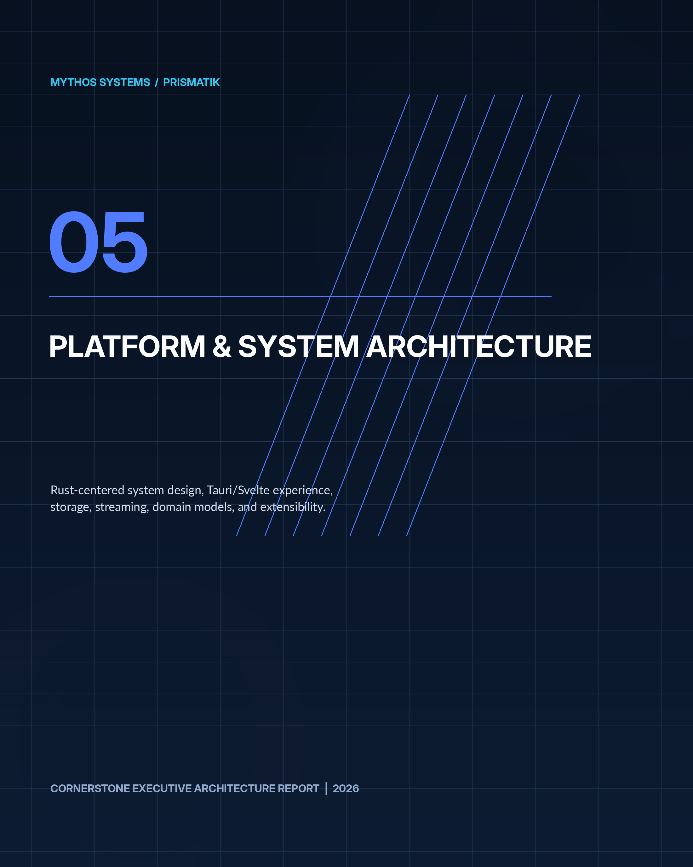

18. System Architecture
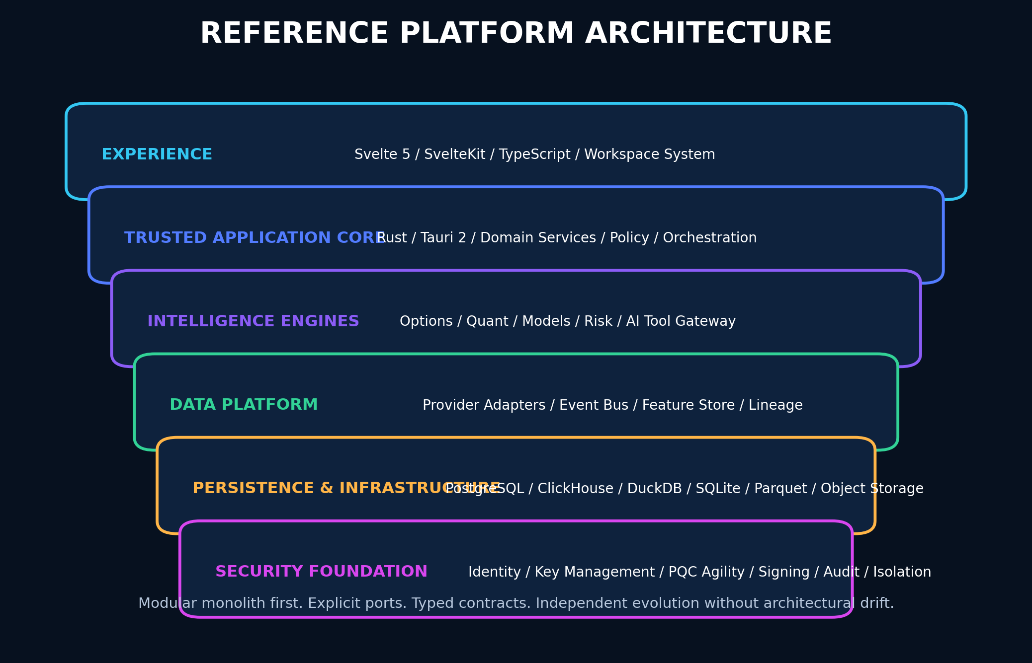
Figure 6 - Reference platform architecture for the desktop, cloud, and on-premises product.

18.1 Recommended Architecture Style
Begin as a modular monolith with isolated crates and process boundaries where risk or scale justifies them.
Primary processes:
- Desktop UI process — Tauri WebView running Svelte.
- Trusted Rust core — Tauri commands, local orchestration, security, domain services.
- Ingestion workers — provider adapters and schedulers.
- Quant worker — backtests and simulation jobs.
- GPU renderer/compute module — wgpu.
- Optional local AI runtime connector.
- Optional cloud control plane.

18.2 High-Level Components
TEXT
┌──────────────────────────────────────────────────────────────────────┐
│ PRISMATIK Desktop / Web │
│ Svelte 5 + TypeScript + SvelteKit + Design System │
└──────────────────────────────┬───────────────────────────────────────┘
│ Typed IPC / HTTPS / WebSocket
┌──────────────────────────────▼───────────────────────────────────────┐
│ Rust Application Core │
│ Identity | Workspaces | Market | Options | Crypto | Events | Risk │
│ Strategies | Simulation | Portfolio | Journal | AI Tool Gateway │
└─────────────┬────────────────┬──────────────────┬────────────────────┘
│ │ │
┌──────▼───────┐ ┌─────▼────────┐ ┌──────▼────────┐
│ Data Gateway │ │ Quant Engine │ │ Security Core │
│ Adapters │ │ Backtest/MC │ │ Keys/Policy │
└──────┬───────┘ └─────┬────────┘ └──────┬────────┘
│ │ │
┌─────────────▼────────────────▼─────────────────▼─────────────────────┐
│ PostgreSQL | ClickHouse | DuckDB | SQLite | Arrow/Parquet | Cache │
└──────────────────────────────────────────────────────────────────────┘

18.3 Rust Responsibilities
- Domain models.
- Provider clients.
- Authentication and authorization.
- Secret management.
- Persistence.
- Scheduling.
- Event processing.
- Quantitative engine.
- Risk engine.
- Order orchestration.
- File import/export.
- Cryptography.
- Audit.
- Native notifications.
- Auto-update verification.
- Plugin validation.
- System health.

18.4 TypeScript/Svelte Responsibilities
- Presentation.
- Interaction.
- Layout.
- Accessibility.
- Local ephemeral UI state.
- Typed API consumption.
- Visualization orchestration.
- Form validation in addition to backend validation.
- Offline UI.
- Command palette.
- Workspace composition.
TypeScript MUST not own authoritative trading, authorization, risk, or cryptographic decisions.

18.5 wgpu Responsibilities
Use wgpu selectively for:
- Large candlestick datasets.
- Order-flow heatmaps.
- Volatility surfaces.
- Monte Carlo path visualization.
- Correlation matrices.
- Institutional graphs.
- Dense scatter/point clouds.
- Animated market maps.
- Selected parallel numerical kernels after benchmarking.
Maintain CPU and Canvas/SVG fallbacks.

19. Repository and Workspace Architecture
TEXT
/
├─ apps/
│ ├─ desktop/ # Tauri 2 + SvelteKit
│ ├─ web/ # Optional browser companion
│ └─ admin/ # Enterprise operations console
├─ crates/
│ ├─ prismatik-domain/
│ ├─ prismatik-application/
│ ├─ prismatik-market-data/
│ ├─ prismatik-options/
│ ├─ prismatik-crypto/
│ ├─ prismatik-filings/
│ ├─ prismatik-cot/
│ ├─ prismatik-events/
│ ├─ prismatik-strategy/
│ ├─ prismatik-backtest/
│ ├─ prismatik-simulation/
│ ├─ prismatik-risk/
│ ├─ prismatik-portfolio/
│ ├─ prismatik-journal/
│ ├─ prismatik-ai-tools/
│ ├─ prismatik-security/
│ ├─ prismatik-storage/
│ ├─ prismatik-observability/
│ ├─ prismatik-renderer/
│ └─ prismatik-cli/
├─ packages/
│ ├─ ui/
│ ├─ design-tokens/
│ ├─ api-client/
│ ├─ schemas/
│ └─ chart-contracts/
├─ services/
│ ├─ ingest/
│ ├─ quant-worker/
│ ├─ notification/
│ └─ cloud-api/
├─ schemas/
│ ├─ openapi/
│ ├─ json-schema/
│ ├─ events/
│ └─ database/
├─ infra/
│ ├─ containers/
│ ├─ kubernetes/
│ ├─ terraform/
│ └─ on-prem/
├─ docs/
│ ├─ ENGINEERING_STANDARDS.md
│ ├─ architecture.md
│ ├─ security.md
│ ├─ api.md
│ ├─ data-model.md
│ ├─ observability.md
│ ├─ testing.md
│ ├─ threat-model/
│ ├─ runbooks/
│ ├─ adr/
│ ├─ diagrams/
│ ├─ model-cards/
│ └─ workbook/
├─ tests/
├─ scripts/
├─ .github/workflows/
├─ README.md
├─ CONTRIBUTING.md
├─ SECURITY.md
├─ CHANGELOG.md
└─ Cargo.toml

20. Core Domain Model

20.1 Key Aggregates
- Asset.
- Venue.
- MarketSnapshot.
- BarSeries.
- OptionContract.
- OptionChain.
- FlowObservation.
- Event.
- Filing.
- Institution.
- PositionDisclosure.
- Strategy.
- BacktestRun.
- SimulationRun.
- Opportunity.
- Portfolio.
- Position.
- OrderIntent.
- Order.
- Fill.
- RiskPolicy.
- JournalEntry.
- ProviderAccount.
- DataEntitlement.
- Model.
- ModelPrediction.
- Workspace.
- AlertRule.
- Automation.

20.2 Opportunity Aggregate
RUST
pub struct Opportunity {
pub id: OpportunityId,
pub asset_id: AssetId,
pub thesis: Thesis,
pub horizon: TimeHorizon,
pub evidence: Vec<EvidenceRef>,
pub contradictions: Vec<EvidenceRef>,
pub score: OpportunityScore,
pub expected_value: Option<DistributionSummary>,
pub liquidity: LiquidityAssessment,
pub risk: RiskAssessment,
pub freshness: FreshnessSummary,
pub provenance: ProvenanceBundle,
pub model_versions: Vec<ModelVersionId>,
pub created_at: time::OffsetDateTime,
pub expires_at: Option<time::OffsetDateTime>,
}

20.3 Immutable Evidence
Evidence SHOULD be immutable and content-addressed. Corrections create superseding records rather than destructive edits.

21. Storage and Data Lifecycle

21.1 Storage Roles

PostgreSQL
- Users.
- Organizations.
- Accounts.
- Configuration.
- Strategies.
- Portfolios.
- Orders.
- Journals.
- Audit metadata.
- Entitlements.
- Model registry.

ClickHouse
- High-volume time series.
- Options observations.
- Market events.
- Flow records.
- Analytics aggregates.
- Telemetry.

DuckDB
- Local analytics.
- Offline research.
- Parquet query.
- Portable project bundles.
- Fast embedded aggregations.

SQLite
- Desktop configuration.
- Cached metadata.
- Offline queue.
- Workspace state.
- Local audit buffer.

Arrow/Parquet
- Columnar interchange.
- Historical datasets.
- Backtest snapshots.
- Export.
- Reproducible research artifacts.

Object Storage
- Filing documents.
- Model artifacts.
- Backtest manifests.
- Simulation outputs.
- Chart snapshots.
- Signed exports.
- Encrypted backups.

21.2 Retention Classes
- Ephemeral cache.
- Operational data.
- Market history.
- User content.
- Regulatory source documents.
- Audit.
- Security logs.
- Model artifacts.
- Backups.
Each class MUST define:
- Owner.
- Retention.
- Encryption.
- Access.
- Export.
- Deletion.
- Legal hold.
- Backup.
- Restore objective.

21.3 Local Encryption
Local databases SHOULD use application-layer envelope encryption for sensitive columns in addition to platform disk encryption.

22. Real-Time Streaming and Event Architecture

22.1 Event Bus
For local/modular deployment:
- Tokio channels for intra-process messaging.
- Durable outbox for state changes.
- SQLite/PostgreSQL job queue where sufficient.
For scaled deployment:
- NATS JetStream SHOULD be evaluated first.
- Kafka/Redpanda MAY be used for large sustained event volume and replay requirements.

22.2 Event Envelope
JSON
{
"event_id": "01J...",
"event_type": "MarketSnapshotUpdated",
"schema_version": 1,
"produced_at": "2026-07-13T15:00:00Z",
"producer": "coingecko-adapter",
"correlation_id": "01J...",
"tenant_id": null,
"data_classification": "public-market-data",
"payload": {}
}

22.3 Reliability
- Transactional outbox.
- Idempotent consumers.
- Dead-letter queues.
- Replay controls.
- Schema compatibility.
- Bounded queues.
- Backpressure.
- Per-provider concurrency limits.
- Poison-message quarantine.
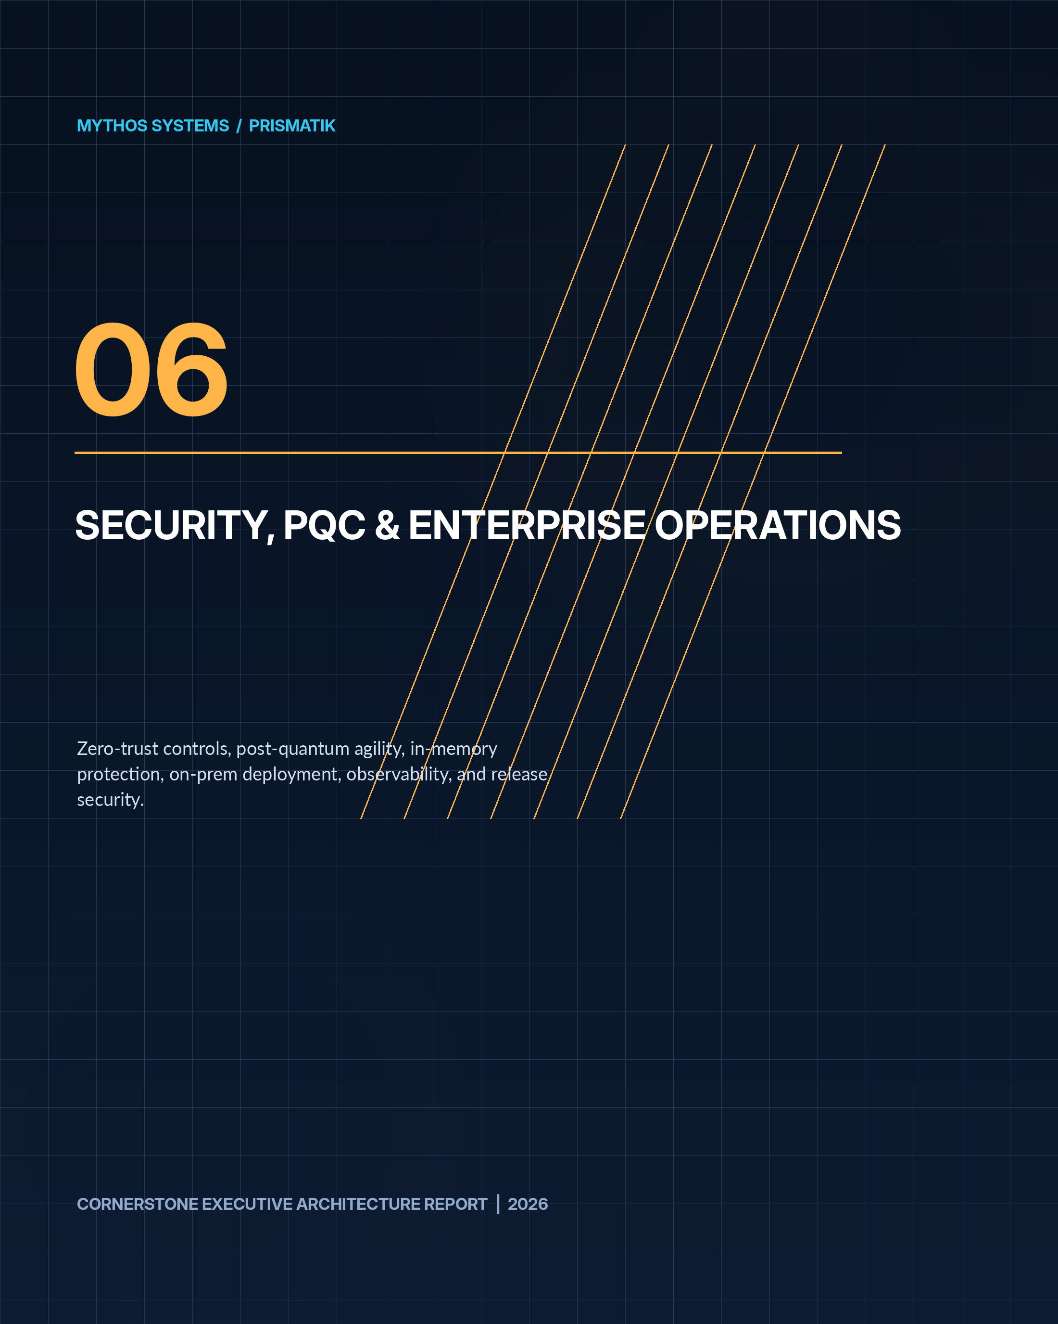

23. Security Architecture
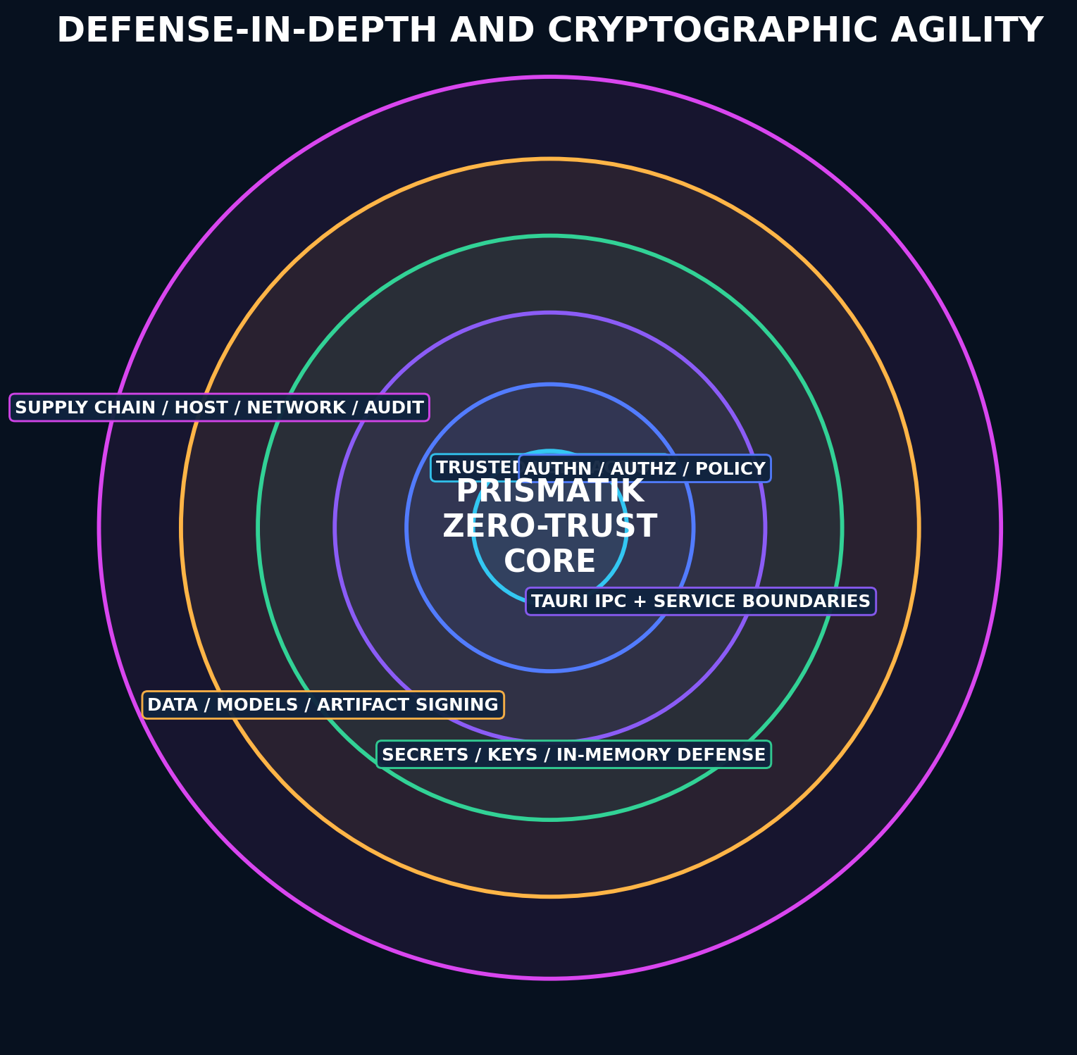
Figure 7 - Defense-in-depth security model protecting user action, keys, services, data, models, and the supply chain.

23.1 Threat Model Assets
- Broker credentials.
- Exchange API keys.
- User identity.
- Portfolio data.
- Trade history.
- Strategy IP.
- AI context.
- Provider API keys.
- Cryptographic keys.
- Update trust roots.
- Plugin/MCP permissions.
- Audit logs.
- Model artifacts.

23.2 Primary Threats
- Credential theft.
- Unauthorized trading.
- Malicious plugin or MCP server.
- Supply-chain compromise.
- IPC abuse.
- WebView injection.
- XSS and content injection from filings/news.
- SSRF through provider connectors.
- Replay and duplicate orders.
- Data poisoning.
- Model manipulation.
- Stale-data execution.
- Privilege escalation.
- Memory scraping.
- Local database theft.
- Update hijacking.
- Insider misuse.
- Denial of service.
- Dependency compromise.

23.3 Authentication
Recommended:
- OIDC/OAuth 2.1 for cloud identities.
- Passkeys/WebAuthn.
- MFA.
- Device-bound sessions.
- Short-lived access tokens.
- Rotating refresh tokens.
- Step-up authentication for:
- Adding broker credentials.
- Enabling live execution.
- Changing risk limits.
- Exporting sensitive data.
- Installing plugins.
- Disabling audit/security controls.

23.4 Authorization
- Organization.
- Workspace.
- Account.
- Strategy.
- Dataset.
- Execution permission.
- Administration.
- Audit access.
Use RBAC plus ABAC for account, environment, device posture, and risk context.

23.5 Tauri Security
- Minimal capabilities per window/webview.
- Strict Content Security Policy.
- No arbitrary shell access.
- Validate all IPC payloads in Rust.
- Explicit command allowlist.
- Separate high-risk administrative window capability.
- Signed updater.
- Restricted asset/file protocols.
- No secrets in frontend state.
- Disable unnecessary plugins.
- Origin checks.
- Secure deep-link handling.

23.6 API Security
- TLS 1.3.
- mTLS for service-to-service where appropriate.
- OAuth scopes.
- Request signing for high-risk integrations where supported.
- Rate limits.
- Idempotency keys.
- Replay windows.
- Nonces where appropriate.
- Input schemas.
- Output encoding.
- Safe error envelopes.
- Audit records.
- Correlation IDs.

23.7 Secret Management
Desktop:
- Windows Credential Manager/DPAPI.
- macOS Keychain/Secure Enclave-backed storage where supported.
- Linux Secret Service/keyring.
- TPM-backed wrapping where feasible.
Server/on-prem:
- HashiCorp Vault or cloud secret manager.
- HSM/KMS-backed master keys.
- Dynamic credentials where possible.
- Short-lived broker/exchange tokens when supported.
Secrets MUST never enter browser JavaScript bundles, logs, crash reports, analytics, or workbooks.

23.8 In-Memory Security
- Use secrecy types for secret material.
- Zeroize buffers with zeroize.
- Minimize copies.
- Avoid long-lived String values for secrets.
- Disable or restrict core dumps.
- Lock sensitive pages where practical and justified.
- Protect swap/hibernation through OS controls and disk encryption.
- Avoid secrets in exception/context chains.
- Constant-time comparisons for secret values.
- Separate execution credentials into a dedicated process in high-security deployments.
- Use short token lifetimes.
- Clear clipboard after timed secret copy.
- Redact screenshots and diagnostics.

23.9 Database Security
- Encryption in transit.
- Encryption at rest.
- Row-level security for multi-tenant deployments.
- Tenant keys where required.
- Least-privilege service accounts.
- Query allowlists for agent tools.
- Migration signing/checksums.
- Point-in-time recovery.
- Backup encryption.
- Restore drills.

23.10 Data Poisoning Defenses
- Provider provenance.
- Cross-source comparison.
- Outlier detection.
- Signed dataset manifests.
- Immutable raw snapshots.
- Parser versioning.
- Quarantine suspicious data.
- Human review for model-training datasets.
- Feature-level quality flags.
- No silent correction.

24. Post-Quantum and Cryptographic Agility Program

24.1 Scope
Post-quantum readiness applies primarily to:
- Key establishment.
- Public-key encryption/wrapping.
- Digital signatures.
- Long-lived data confidentiality.
- Software/update signing.
- Service identity.
- Backup/export protection.
- Plugin and model artifact verification.
It does not replace modern symmetric encryption, access control, memory protection, or secure operations.

24.2 Approved Direction
Use NIST-standardized algorithms through maintained, reviewed implementations:
- ML-KEM for key establishment.
- ML-DSA for general digital signatures.
- SLH-DSA where a stateless hash-based signature is appropriate.

24.3 Migration Strategy

Near Term
- Maintain a crypto bill of materials.
- Use TLS 1.3.
- Use X25519/P-256 ECDHE with AES-256-GCM or ChaCha20-Poly1305 when PQ hybrid modes are unavailable.
- Use Ed25519/ECDSA for signatures where required today.
- Version all key and signature formats.
- Support multiple algorithms per trust policy.
- Design dual-signature manifests.
- Protect long-lived data keys through envelope encryption.

Hybrid Phase
Where runtime and ecosystem support are proven:
- Hybrid classical + ML-KEM key establishment.
- Dual-sign release and plugin manifests using classical + ML-DSA.
- PQC-capable internal tunnels or service mesh where supported.
- Interoperability and downgrade testing.

Mature Phase
- PQC-primary profiles.
- Classical compatibility fallback only by explicit policy.
- PQ-aware certificate and identity lifecycle.
- Automated algorithm deprecation.

24.4 Crypto Bill of Materials
Track:
- Component.
- Protocol.
- Algorithm.
- Parameters.
- Library.
- Key owner.
- Storage.
- Rotation.
- Expiration.
- Data lifetime.
- Quantum risk.
- Migration trigger.
- Fallback.
- Verification evidence.

24.5 Artifact Signing
Sign:
- Desktop releases.
- Installers.
- Update manifests.
- Containers.
- SBOMs.
- Plugin packages.
- MCP bundles.
- Model artifacts.
- Strategy packages.
- Dataset manifests.
- Migration bundles.
Design manifests for dual signatures.

24.6 Local Vault
A local encrypted vault MAY use:
- Random data-encryption keys.
- AES-256-GCM or XChaCha20-Poly1305.
- Per-record or per-domain keys.
- OS/hardware-backed key-encryption keys.
- Optional recovery key protected by a user-held secret.
- Versioned envelope format.
- Rotation and rewrap without re-encrypting all data where possible.
Do not invent a custom cipher or protocol.

24.7 PQC Exception Process
Every boundary without practical PQC support MUST document:
- Missing capability.
- Reason.
- Classical fallback.
- Data lifetime.
- Harvest-now/decrypt-later risk.
- Owner.
- Review date.
- Migration trigger.

25. On-Premises, Air-Gapped, and Enterprise Deployment
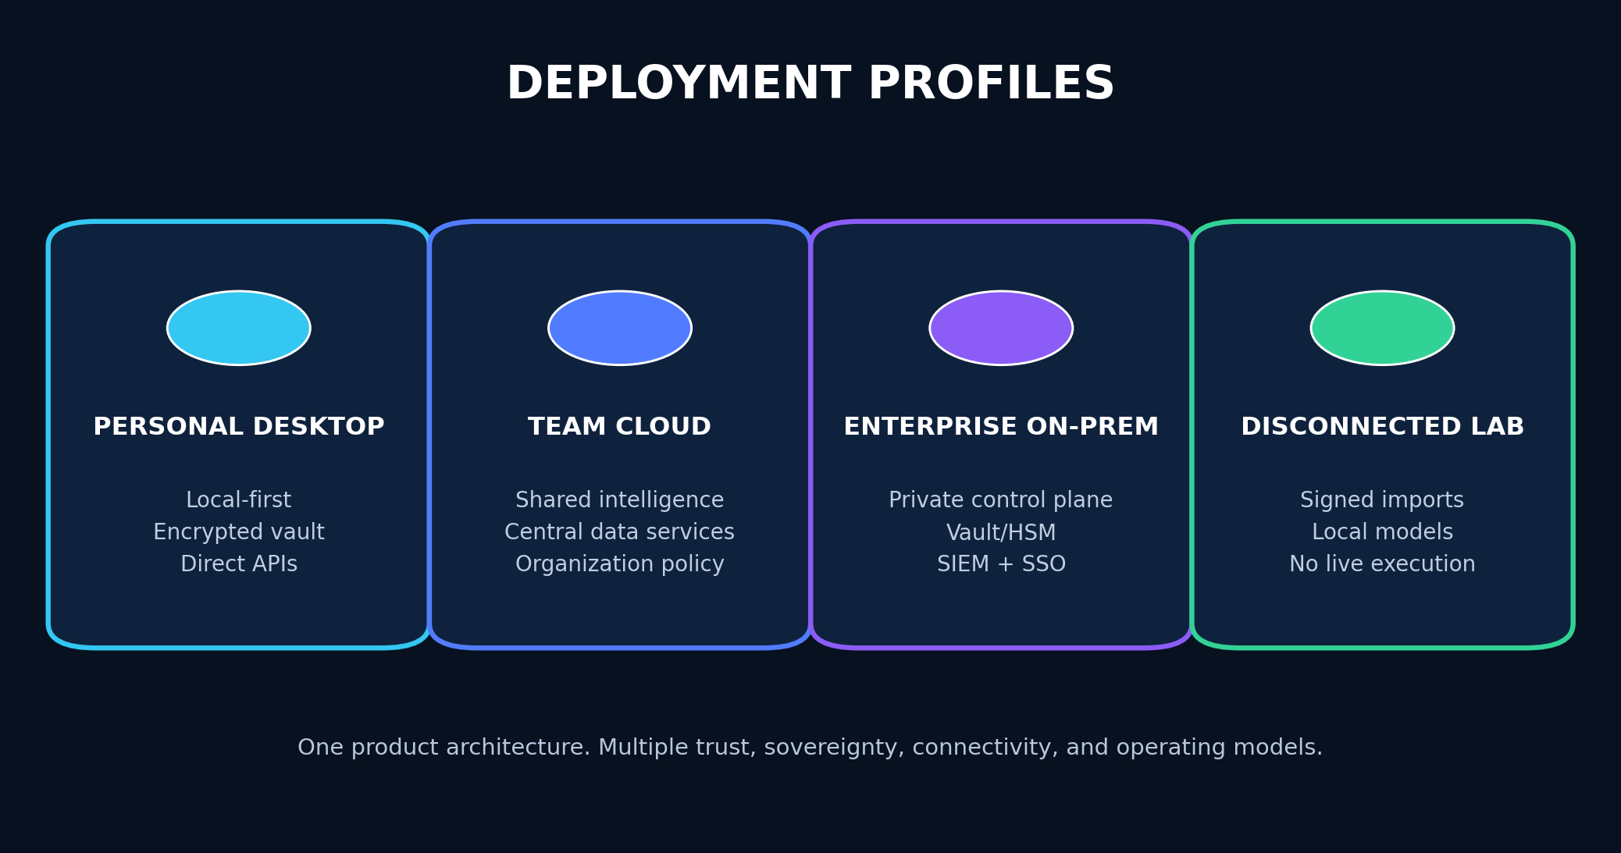
Figure 8 - Deployment profiles sharing one core architecture with different trust and connectivity models.

25.1 Deployment Profiles

Personal Desktop
- Local database.
- Local encrypted vault.
- Direct provider APIs.
- Optional cloud sync.
- Local or remote AI.

Team Cloud
- Central API.
- Shared datasets.
- PostgreSQL/ClickHouse.
- Organization policy.
- Central observability.
- Shared research and audit.

Enterprise On-Prem
- Kubernetes or hardened VM deployment.
- Private registry.
- Vault/HSM.
- Enterprise IdP.
- Proxy support.
- Internal CA.
- SIEM export.
- Restricted egress.
- Data residency controls.

Disconnected Research Environment
- Signed dataset imports.
- Offline research.
- No live execution.
- Signed export bundles.
- Local AI models.
- Local license/entitlement cache with defined expiration.

25.2 On-Prem Security
- Network segmentation.
- Private service endpoints.
- Management-plane isolation.
- Bastion or zero-trust access.
- mTLS.
- HSM/Vault.
- Immutable audit export.
- SIEM integration.
- EDR compatibility.
- Host hardening.
- CIS-aligned configuration.
- Signed container admission.
- Egress allowlists.
- Backup isolation.
- Disaster recovery exercises.

25.3 Tenant Isolation
Options:
- Shared database with RLS for standard SaaS.
- Schema-per-tenant for stronger logical separation.
- Database-per-tenant for regulated or large enterprise.
- Dedicated deployment for highest assurance.

26. Observability, Reliability, and Operations

26.1 OpenTelemetry
Use OpenTelemetry-compatible:
- Traces.
- Metrics.
- Logs.
- Context propagation.

26.2 Required Metrics
- Provider request count/latency/errors.
- Rate-limit remaining.
- Cache hit rate.
- Freshness lag.
- Stream disconnects.
- Queue depth.
- Job duration.
- Backtest throughput.
- Simulation throughput.
- Model inference latency.
- UI frame time.
- GPU fallback rate.
- Database latency.
- Order reconciliation latency.
- Alert delivery success.
- Security events.

26.3 SLO Examples
- Cached dashboard availability.
- Critical provider freshness.
- Alert delivery.
- Order-state reconciliation.
- Backtest completion.
- Desktop crash-free sessions.
- Update success.

26.4 Health Model
- Liveness.
- Readiness.
- Provider dependency status.
- Database status.
- Clock skew.
- Entitlement status.
- Crypto key status.
- Model status.
- Queue status.
- Version/build.
- Data freshness.

26.5 Runbooks
- Provider outage.
- Rate-limit exhaustion.
- Schema change.
- Stale data.
- Broker timeout.
- Unknown order state.
- Database failover.
- Restore.
- Key rotation.
- Certificate expiration.
- Plugin compromise.
- Model rollback.
- Emergency execution disablement.
- Corrupted cache.
- GPU device loss.

27. Testing and Quality Engineering

27.1 Test Layers
- Unit.
- Property.
- Integration.
- Contract.
- End-to-end.
- Golden.
- Fuzz.
- Performance.
- Chaos/failure injection.
- Security.
- Accessibility.
- Visual regression.
- Model validation.

27.2 High-Value Property Tests
- Option payoff invariants.
- Portfolio accounting conservation.
- Corporate-action adjustment.
- Order idempotency.
- Event deduplication.
- Timezone boundaries.
- Simulation reproducibility.
- Risk-limit monotonicity.
- Encryption round-trip.
- Parser robustness.
- Provider normalization.

27.3 Provider Contract Tests
- Recorded fixtures.
- Schema validation.
- Pagination.
- Rate-limit behavior.
- Error mapping.
- Missing fields.
- Decimal precision.
- Timestamp interpretation.
- Identifier mapping.
- Sandbox/live parity where available.

27.4 Quant Validation
- Known synthetic datasets.
- Golden strategy results.
- Independent calculation comparisons.
- Bias tests.
- Leakage tests.
- Random-seed reproducibility.
- Numeric tolerance policy.
- Cross-language parity for critical math.

27.5 Security Testing
- SAST.
- Dependency audit.
- Secret scanning.
- DAST for cloud APIs.
- Fuzzing parsers.
- IPC abuse tests.
- CSP tests.
- Plugin sandbox tests.
- Update verification tests.
- Authz matrix tests.
- Replay/idempotency tests.
- Threat-model regression tests.

28. Supply-Chain and Release Security
Required:
- Cargo and JavaScript lockfiles.
- Dependency pinning policy.
- cargo audit.
- cargo deny.
- npm/pnpm audit strategy.
- License scanning.
- SBOM: CycloneDX or SPDX.
- SLSA-style provenance.
- Reproducible release pipeline where feasible.
- Sigstore/cosign for containers.
- Platform code signing.
- Tauri updater signing.
- Protected release keys.
- Two-person release approval for production.
- Signed plugin registry metadata.
- Dependency allow/deny list.
- Renovation with staged testing.
- No AI-added dependency without justification.

29. Performance Engineering

29.1 Performance Budgets
Define budgets for:
- Cold start.
- Warm start.
- Workspace restore.
- Search.
- Chart pan/zoom.
- Streaming update.
- Scan execution.
- Backtest throughput.
- Simulation latency.
- Memory.
- Disk cache.
- Network usage.
- Battery on laptops.

29.2 Numeric Computing
Recommended:
- Polars for dataframe operations.
- Arrow for zero-copy interchange.
- Rayon for CPU parallelism where appropriate.
- Tokio for asynchronous I/O, not CPU work.
- Dedicated compute pools.
- SIMD through maintained crates where profiling supports it.
- GPU compute only after benchmark validation.

29.3 Decimal Precision
Financial quantities MUST use explicit decimal or fixed-point representations where exact monetary arithmetic is required. Floating point is acceptable for statistical models with documented tolerances, not for authoritative cash accounting.

29.4 UI Performance
- Virtualize large lists.
- Batch streaming updates.
- Avoid global reactive fan-out.
- Use derived state.
- Keep chart data outside DOM.
- Progressive loading.
- Worker threads where available.
- GPU resource reuse.
- Device-loss recovery.

30. Accessibility, Localization, and Responsible UX
- WCAG 2.2 AA target.
- Complete keyboard operation.
- Screen-reader semantics.
- High contrast.
- Reduced motion.
- Color-blind-safe modes.
- No red/green-only meaning.
- Adjustable density.
- Local time and UTC views.
- Locale-aware numbers.
- Explicit currency.
- Plain-language risk disclosures.
- Confirmation for irreversible actions.
- Cooling-off option after large losses.
- Configurable daily loss warnings.
- No celebratory animation for risky trades.

31. API, Plugin, MCP, and SDK Platform

31.1 Public API
- REST/OpenAPI for broad interoperability.
- WebSocket for live updates.
- gRPC for selected internal services.
- Versioned schemas.
- OAuth scopes.
- Idempotency.
- Pagination.
- Correlation IDs.
- Signed webhooks.

31.2 Plugin Types
- Data provider.
- Indicator.
- Strategy.
- Visualization.
- Exporter.
- Notification.
- Broker/exchange.
- AI tool.
- Workspace panel.

31.3 Plugin Security
- Signed package.
- Manifest.
- Declared capabilities.
- Version constraints.
- Network allowlist.
- Filesystem scope.
- CPU/memory budget.
- Revocation.
- Audit.
- User/admin approval.
- Sandboxed execution, preferably WebAssembly/WASI for untrusted extensions.

31.4 SDKs
- Rust.
- Python.
- TypeScript.
- CLI.
- OpenAPI-generated clients.

31.5 MCP Gateway
Instead of letting every MCP server connect directly to the desktop, route approved servers through a gateway that enforces:
- Tool allowlist.
- Schema validation.
- Secret isolation.
- Rate limit.
- Audit.
- Output size limit.
- Content filtering.
- Timeout.
- Network policy.
- Human approval for sensitive tools.
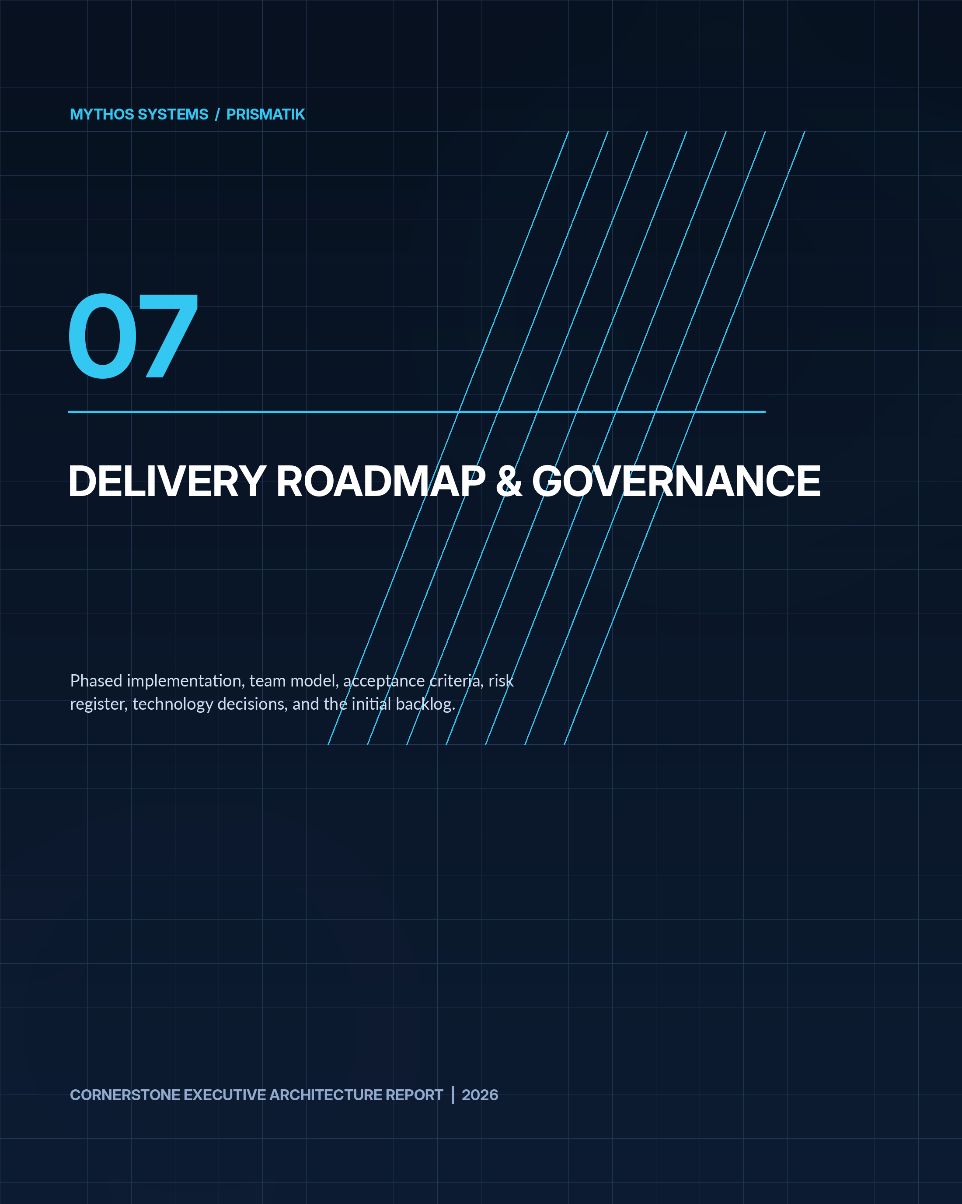

32. Phased Implementation Roadmap
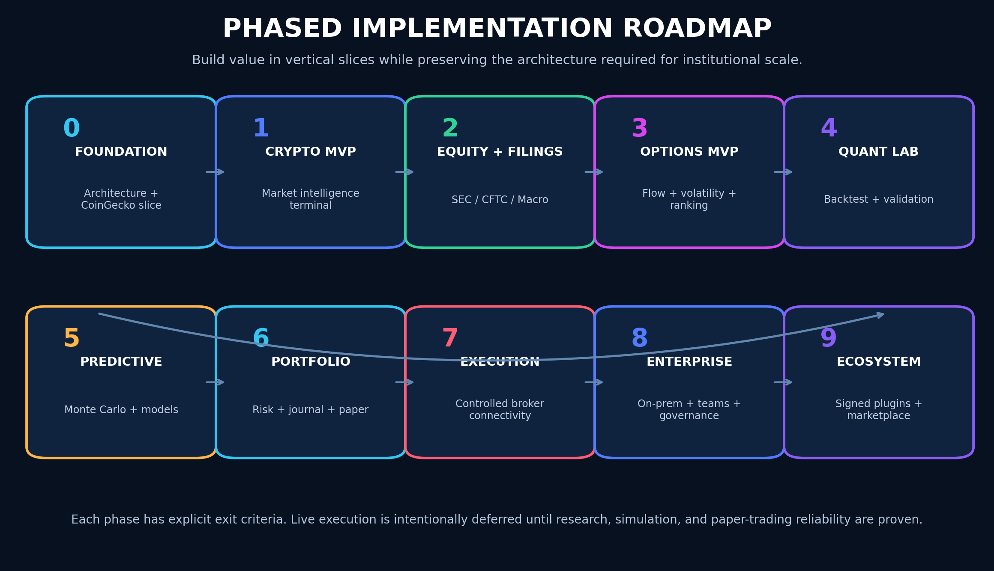
Figure 9 - Phase 0 through Phase 9 implementation roadmap.

Phase 0 — Foundation and Product Proof
Objective: Establish architecture, standards, identity, and a functioning vertical slice.
Deliverables:
- Confirm working product name and namespace policy.
- Repository baseline.
- Engineering standards.
- ADR process.
- Workbook process.
- Threat model.
- Tauri 2 + SvelteKit shell.
- Design tokens and motion system.
- Rust domain/application boundaries.
- Local encrypted configuration.
- CoinGecko demo integration.
- Canonical crypto asset identity.
- Market overview.
- Asset search and detail.
- Basic historical chart.
- Provider health and rate-budget UI.
- OpenTelemetry baseline.
- CI gates.
- Signed development builds.
Exit criteria:
- Desktop app starts reliably on Windows.
- CoinGecko data is cached, validated, and provenance-marked.
- No API key reaches the frontend.
- Core contracts have tests.
- UI meets initial performance and accessibility budgets.

Phase 1 — Crypto Intelligence MVP
Objective: Deliver a polished crypto research terminal using CoinGecko.
Deliverables:
- Global market dashboard.
- Watchlists.
- Asset profiles.
- Categories.
- Trending.
- Exchanges.
- Historical OHLC/market chart.
- Market scanner.
- Alerts.
- Portfolio tracking.
- Correlation and volatility.
- Crypto news where plan permits.
- Local-first workspaces.
- Data-quality inspector.
- Export to CSV/Parquet.
- AI read-only crypto analyst.
Advanced additions:
- Narrative rotation map.
- Category breadth.
- Liquidity-risk scoring.
- Regime classifier.
- Historical analogs.
Exit criteria:
- Product is genuinely useful without equity/options features.
- Rate limits and cache operate under realistic load.
- AI answers show sources, freshness, and uncertainty.
- Offline workspace remains functional with cached data.

Phase 2 — U.S. Equity, Filing, and Macro Foundation
Objective: Add the context needed for institutional and event-driven research.
Deliverables:
- Equity instrument registry.
- SEC EDGAR ingestion.
- Company filings.
- 8-K event extraction.
- 13F holdings.
- 13D/13G.
- Form 4.
- CFTC COT.
- FRED macro.
- Event calendar.
- Filing diff and summary.
- Institutional graph.
- Market regime.
- Equity watchlists and scanner.
- Licensed quote provider evaluation/integration.
Exit criteria:
- Filing records are reproducible and linked to originals.
- COT timing and limitations are clearly shown.
- Event engine supports revisions.
- No model uses data before it was publicly available.

Phase 3 — Options Intelligence MVP
Objective: Establish the primary product wedge.
Deliverables:
- Unusual Whales integration.
- Option chain.
- Flow feed.
- Sweep/block clustering.
- Open interest.
- Volatility lab.
- Implied move.
- Strategy constructor.
- Payoff diagrams.
- Liquidity score.
- Event-aware option ranking.
- Opportunity cards.
- Alert rules.
- Provider entitlement registry.
Exit criteria:
- Every option opportunity is explainable.
- Flow inference is confidence-scored.
- Strategy P/L math passes independent golden tests.
- Delayed/stale data cannot trigger live workflows.

Phase 4 — Quant Research and Backtesting
Objective: Allow users to test ideas credibly.
Deliverables:
- Strategy DSL.
- Visual strategy builder.
- Dataset snapshots.
- Backtest engine.
- Execution simulation.
- Walk-forward validation.
- Parameter analysis.
- Regime testing.
- Reproducibility manifests.
- Python research bridge.
- Rust production strategy SDK.
- Research report generator.
Exit criteria:
- Bias and leakage test suite passes.
- Results reproduce from manifest.
- Corporate actions and event timestamps are handled.
- Baseline performance is competitive for target workloads.

Phase 5 — Monte Carlo and Predictive Intelligence
Objective: Quantify uncertainty and rank opportunities probabilistically.
Deliverables:
- Monte Carlo lab.
- Historical/bootstrap simulation.
- Stochastic models.
- Portfolio simulations.
- Forecast registry.
- Model cards.
- Calibration.
- Drift monitoring.
- Explainability.
- Opportunity fusion.
- Contradiction detection.
- Historical analog engine.
Exit criteria:
- Probabilities are calibrated on held-out data.
- Every model has an owner and rollback.
- Out-of-domain conditions widen uncertainty or suppress output.
- Simulation assumptions are transparent.

Phase 6 — Portfolio, Journal, and Paper Trading
Objective: Close the learning loop.
Deliverables:
- Multi-account portfolio.
- Position ingestion.
- Risk dashboard.
- Greeks.
- Scenario stress.
- Journal.
- Automatic context snapshots.
- Paper broker.
- Simulated fills.
- Pre-trade guardrails.
- Strategy attribution.
- Behavioral pattern analysis.
Exit criteria:
- Accounting reconciles.
- Duplicate events/orders are safe.
- Risk limits are enforced in the backend.
- Journal can reconstruct the full trade context.

Phase 7 — Broker/Exchange Connectivity and Controlled Execution
Objective: Add secure, governed execution.
Deliverables:
- Read-only broker sync.
- Draft orders.
- User-approved live orders.
- Reconciliation.
- Partial-fill handling.
- Idempotency.
- Step-up auth.
- Kill switch.
- Daily loss limits.
- Approval workflow.
- Exchange adapter sandbox.
- Incident runbooks.
Exit criteria:
- Independent security review.
- Chaos tests for timeout/unknown order state.
- Audit completeness.
- Emergency disablement tested.
- No conversational AI direct-submit path.

Phase 8 — Enterprise, On-Prem, and Team Collaboration
Objective: Support professional teams.
Deliverables:
- Organizations.
- RBAC/ABAC.
- SSO.
- Team workspaces.
- Review/approval.
- Central data services.
- On-prem deployment.
- HSM/Vault.
- SIEM integration.
- Retention policy.
- Dedicated tenant options.
- Compliance exports.
- Enterprise support tooling.

Phase 9 — Ecosystem and Marketplace
Objective: Become an extensible platform.
Deliverables:
- Signed plugin SDK.
- Strategy packages.
- Indicator packages.
- MCP registry.
- Extension review.
- WASM sandbox.
- Marketplace governance.
- Revenue sharing.
- Reproducible package builds.
- Revocation and emergency disablement.

33. Team Model and Delivery Workstreams
Recommended workstreams:
- Product and market domain.
- Rust platform/core.
- Market data and provider integrations.
- Quantitative research.
- Options analytics.
- Frontend/design system.
- GPU visualization.
- AI/tooling.
- Security/identity.
- SRE/data operations.
- QA/model validation.
- Compliance/licensing.
For a small founding team, combine roles but preserve review separation for execution, cryptography, and model validation.

34. Acceptance Criteria and Product Metrics

34.1 User Value
- Time from question to evidence-backed answer.
- Opportunity review completion.
- Alert usefulness.
- Backtest-to-paper-trade conversion.
- Journal completion.
- Reduction in repeated mistakes.
- User trust in provenance.
- Workspace retention.

34.2 Data Quality
- Freshness.
- Completeness.
- Provider agreement.
- Schema failure.
- Identifier resolution.
- Event deduplication.
- Filing parsing accuracy.

34.3 Quant Quality
- Reproducibility.
- Calibration.
- Drift.
- False discovery.
- Slippage sensitivity.
- Out-of-sample performance.
- Strategy stability.

34.4 Reliability
- Crash-free sessions.
- API success.
- Alert delivery.
- Queue lag.
- Restore success.
- Update success.
- Order reconciliation.

34.5 Security
- Secrets leaked: zero.
- Unauthorized execution: zero.
- Critical unpatched vulnerabilities.
- Key rotation compliance.
- Signed artifact coverage.
- Plugin violations.
- Audit completeness.

35. Risk Register and Mitigations

35.1 Market Data Licensing
Risk: Data cannot legally be stored, displayed, or redistributed as assumed.
Mitigation: Entitlement registry, legal review, adapter-specific retention rules.

35.2 Free-Tier Dependency
Risk: Demo/free APIs are rate-limited or changed.
Mitigation: Cache, budget governor, paid upgrade path, provider abstraction.

35.3 False Predictive Confidence
Risk: Users interpret estimates as guarantees.
Mitigation: Calibration, intervals, evidence, warnings, model governance.

35.4 Backtest Overfitting
Risk: Strategies appear profitable due to leakage or repeated experimentation.
Mitigation: Holdouts, walk-forward, purging, multiple-hypothesis controls, immutable manifests.

35.5 Uncertain Option Flow Meaning
Risk: Flow is misclassified.
Mitigation: Fact/inference split, confidence, spread clustering, contradictory evidence.

35.6 Unauthorized Execution
Risk: Credential compromise or AI/tool abuse.
Mitigation: Dedicated execution boundary, step-up auth, approvals, scoped credentials, kill switch.

35.7 Plugin Supply Chain
Risk: Malicious or compromised extension.
Mitigation: Signing, sandbox, capabilities, review, revocation.

35.8 Data Poisoning
Risk: Bad data corrupts models or signals.
Mitigation: Provenance, cross-checks, quarantine, immutable snapshots.

35.9 Complexity
Risk: Product attempts too much too early.
Mitigation: Crypto MVP, options wedge, phase gates, modular monolith.

35.10 Regulatory Exposure
Risk: Product behavior crosses into regulated advice, brokerage, or automated trading obligations.
Mitigation: Specialized legal review, clear role definition, disclosures, licensing analysis, geographic controls.

36. Recommended Technology Decisions

Core
- Rust stable toolchain.
- Tokio.
- Axum.
- SQLx.
- Serde.
- thiserror/anyhow by layer.
- tracing/OpenTelemetry.
- reqwest.
- rust_decimal for authoritative monetary amounts where appropriate.
- Polars/Arrow.
- Rayon.
- Tauri 2.
- SvelteKit and Svelte 5.
- TypeScript strict mode.
- Valibot or Zod at UI boundaries.
- pnpm.
- wgpu and WGSL.
- PostgreSQL.
- ClickHouse.
- DuckDB.
- SQLite.
- NATS JetStream when durable event streaming is needed.
- Object storage compatible with S3 APIs.

Security
- OS keychain integration.
- secrecy.
- zeroize.
- rustls.
- Argon2id for password-derived keys where required.
- AES-256-GCM or XChaCha20-Poly1305 for authenticated local encryption.
- OIDC/passkeys.
- Vault/KMS/HSM for server keys.
- Sigstore/cosign for supply-chain artifacts where applicable.
- NIST-standardized PQC through maintained and verified implementations as ecosystem maturity allows.

Frontend
- Design-token package.
- CSS variables.
- Svelte transitions used sparingly.
- Web Animations API where appropriate.
- Canvas/WebGPU for dense visuals.
- SVG for accessible low-density graphics.
- Floating UI for overlays.
- Accessible headless primitives with careful dependency review.
- Playwright.
- Vitest.

37. Future Advancements Beyond the Initial Vision

37.1 Causal Market Graph
Move beyond correlation by representing hypothesized causal pathways among:
- Macro releases.
- Rates.
- Sectors.
- Companies.
- Options.
- Crypto.
- Institutional flows.
- Events.
The system must distinguish learned association from validated causality.

37.2 Market Digital Twin
Create a replayable market environment containing:
- Historical order/quote approximations.
- Events.
- Portfolios.
- Strategies.
- Agent behavior.
- Liquidity shocks.
- Correlation transitions.

37.3 Federated Strategy Learning
Allow organizations to improve models across isolated environments without centralizing raw strategy data, subject to rigorous privacy and security review.

37.4 Confidential Computing
Evaluate hardware-backed confidential VMs/enclaves for:
- Strategy execution.
- Sensitive model inference.
- Key operations.
- Shared institutional research.

37.5 Verifiable Research Artifacts
Produce signed result bundles that contain:
- Dataset hashes.
- Code hash.
- Model hash.
- Parameters.
- Environment.
- Metrics.
- Signature.

37.6 Natural-Language-to-Research Compiler
Convert a user thesis into:
- Formal hypothesis.
- Required data.
- Bias checklist.
- Strategy draft.
- Validation plan.
- Backtest.
- Simulation.
- Research report.
No automatic promotion to live trading.

37.7 Multi-Agent Research Council
Use specialized constrained agents:
- Filing analyst.
- Options analyst.
- Macro analyst.
- Crypto analyst.
- Quant reviewer.
- Risk critic.
- Data-quality reviewer.
A synthesis agent may summarize disagreements rather than forcing consensus.

37.8 Opportunity “Contrarian Mode”
Actively search for evidence that disproves the leading thesis and quantify fragility.

37.9 Privacy-Preserving Community Intelligence
Users may opt into aggregated, anonymized research statistics without sharing positions, identity, or proprietary strategy logic.

37.10 Strategy Lineage Graph
Track every strategy fork, parameter change, test, promotion, trade, and retirement.

37.11 Temporal Knowledge Graph
Maintain validity intervals so the platform can answer:
DESIGN PRINCIPLE “What did the system know at 10:03 a.m. on that date?”

This is crucial for audit and look-ahead prevention.

37.12 Adaptive Interface
The workspace can adapt based on task and expertise, but all automated layout changes must be predictable, reversible, and user-controlled.

37.13 Resilient Multi-Provider Consensus
For critical fields, use quorum-like policies:
- Preferred source.
- Secondary verification.
- Tolerance.
- Conflict alert.
- No-trade state if disagreement exceeds policy.

38. Initial Backlog

Epic A — Repository and Governance
- Create workspace.
- Add standards.
- Add ADR templates.
- Add workbook.
- Add CI.
- Add SBOM.
- Add threat model.
- Add crypto inventory.

Epic B — Desktop Shell
- Tauri setup.
- Capability policy.
- CSP.
- Secure IPC.
- Window management.
- Auto updater.
- Crash recovery.
- Design system.

Epic C — CoinGecko Adapter
- Auth.
- Rate governor.
- Asset identity.
- Search.
- Global.
- Markets.
- Coin detail.
- Market chart.
- OHLC.
- Categories.
- Exchanges.
- Contract tests.
- Cache.

Epic D — Crypto UI
- Command dashboard.
- Watchlist.
- Asset workspace.
- Chart.
- Category map.
- Scanner.
- Alerts.
- Portfolio.

Epic E — Data Foundation
- PostgreSQL.
- SQLite.
- DuckDB.
- Parquet.
- Migrations.
- Encryption.
- Provenance.
- Data-quality service.

Epic F — Security
- Keychain.
- Secret types.
- Session policy.
- Audit.
- Redaction.
- Update signing.
- PQC exception register.
- Plugin trust model.

Epic G — Observability
- Tracing.
- Metrics.
- Health.
- Provider dashboard.
- Local diagnostics package.
- Privacy controls.

39. Reference Architecture Diagrams

39.1 Data Flow
MERMAID SOURCE
flowchart LR
CG[CoinGecko] --> GW[Provider Gateway]
UW[Unusual Whales] --> GW
SEC[SEC EDGAR] --> GW
CFTC[CFTC PRE] --> GW
FRED[FRED] --> GW
GW --> RAW[Raw / Immutable Layer]
RAW --> NORM[Normalization]
NORM --> QUALITY[Quality + Provenance]
QUALITY --> STORE[(PostgreSQL / ClickHouse / Parquet)]
STORE --> FEATURES[Feature Engine]
FEATURES --> QUANT[Backtest / Simulation / Models]
QUANT --> OPP[Opportunity Engine]
OPP --> API[Rust Application API]
API --> UI[Svelte / Tauri UI]

39.2 Execution Boundary
MERMAID SOURCE
flowchart TD
UI[User Interface] --> DRAFT[Order Draft]
AI[AI Analyst] --> DRAFT
DRAFT --> CHECKS[Deterministic Pre-Trade Checks]
CHECKS --> APPROVAL[User Approval + Step-Up Auth]
APPROVAL --> EXEC[Execution Service]
EXEC --> BROKER[Broker / Exchange]
BROKER --> RECON[State Reconciliation]
RECON --> AUDIT[Immutable Audit]
RECON --> PORT[Portfolio]

39.3 Security Zones
MERMAID SOURCE
flowchart LR
WEBVIEW[Svelte WebView<br/>No Secrets] -->|Validated IPC| CORE[Rust Trusted Core]
CORE --> VAULT[OS Keychain / Vault]
CORE --> DATA[(Encrypted Data)]
CORE --> GATEWAY[Provider Gateway]
CORE --> TOOL[AI Tool Gateway]
TOOL --> MCP[Approved MCP Servers]
CORE --> EXEC[Isolated Execution Boundary]

40. Source and Standards References

Product Engineering Standards
This design is intended to follow the supplied engineering standards emphasizing production readiness, typed contracts, idempotency, bounded concurrency, observability, secure defaults, testing, documentation, project workbooks, supply-chain security, and cryptographic agility.

Official External References
- CoinGecko API documentation: https://docs.coingecko.com/
- CoinGecko endpoint overview: https://docs.coingecko.com/reference/endpoint-overview
- CoinGecko rate-limit guidance: https://docs.coingecko.com/docs/common-errors-rate-limit
- CoinGecko data-delivery guidance: https://docs.coingecko.com/docs/data-delivery-methods
- Unusual Whales API documentation: https://api.unusualwhales.com/docs
- Unusual Whales public API: https://unusualwhales.com/public-api
- Unusual Whales MCP guidance: https://unusualwhales.com/public-api/mcp
- SEC EDGAR APIs: https://www.sec.gov/search-filings/edgar-application-programming-interfaces
- SEC developer resources: https://www.sec.gov/about/developer-resources
- CFTC Commitments of Traders: https://www.cftc.gov/MarketReports/CommitmentsofTraders/index.htm
- CFTC Public Reporting Environment guide: https://publicreporting.cftc.gov/stories/s/User-s-Guide/p2fg-u73y/
- NIST Post-Quantum Cryptography: https://csrc.nist.gov/projects/post-quantum-cryptography
- NIST FIPS 203, ML-KEM: https://csrc.nist.gov/pubs/fips/203/final
- NIST FIPS 204, ML-DSA: https://csrc.nist.gov/pubs/fips/204/final
- Tauri security: https://v2.tauri.app/security/
- Tauri capabilities: https://v2.tauri.app/security/capabilities/
- Svelte documentation: https://svelte.dev/docs/svelte
- wgpu: https://wgpu.rs/

Closing Direction
PRISMATIK should be built as a disciplined intelligence platform, not a decorative dashboard and not a black-box signal seller. Its strongest identity will come from combining:
- Broad but provenance-aware market data.
- Institutional and event context.
- Deep options intelligence.
- Credible quantitative validation.
- Transparent uncertainty.
- Secure local and enterprise deployment.
- A captivating but operationally responsible interface.
- A provider-neutral, Rust-centered architecture that can evolve for decades.
The first implementation should prove that architecture through CoinGecko-powered crypto intelligence, then add SEC/CFTC context, then establish the core options wedge with Unusual Whales, followed by quant validation, simulations, paper trading, and only later controlled execution.
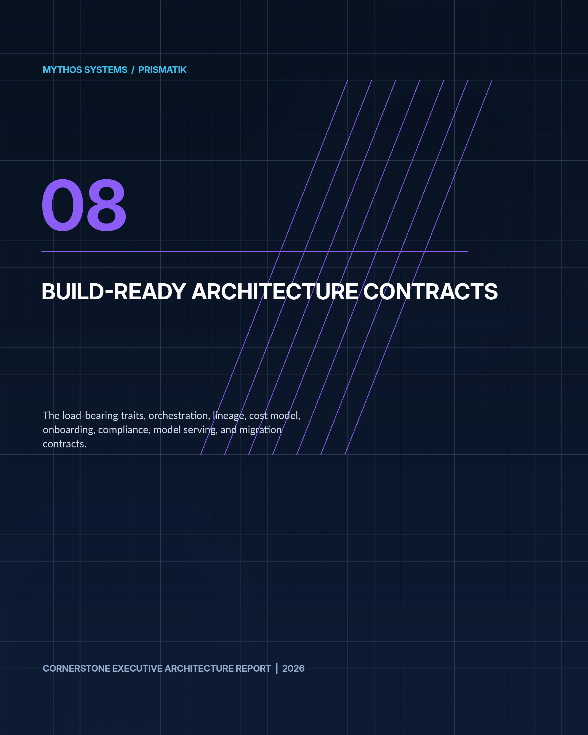

Architecture Evolution v0.2 - Integrated Build-Ready Contracts
INTEGRATION NOTE The following material preserves the complete Architecture Evolution v0.2 companion and integrates it into this cornerstone report as the implementation contract for strategy runtimes, risk, brokers, AI tools, data lineage, model serving, compliance, notifications, backup, and migration.

How to Use This Document
Each section maps to a gap in the v0.1 overview. They are ordered by implementation leverage, not document order. The Rust trait definitions in Part I are the single highest-priority addition — they are the actual architectural contract that every workstream in v0.1 §33 depends on.

Part I — Load-Bearing Trait Surfaces
DESIGN PRINCIPLE The v0.1 overview defines one Rust trait (MarketDataProvider) out of approximately twelve load-bearing interfaces. This part defines the rest. Each trait is written to be reviewable as a standalone ADR.

1. Strategy and Strategy Runtime
The v0.1 overview (§11.1) mandates a typed DSL that "MUST compile to a typed intermediate representation" but never defines the IR or the trait a strategy must implement to be runnable by the backtest engine, paper broker, and live execution boundary. This is the contract that makes a strategy portable across all three runtimes.

1.1 Strategy Intermediate Representation
RUST
/// A compiled, type-checked strategy in intermediate representation form.
/// Produced by the DSL compiler, the visual builder codegen, or hand-written
/// Rust strategies via the SDK. All strategies — regardless of origin —
/// converge to this type before they touch a runtime.
#[derive(Clone, Debug, Serialize, Deserialize)]
pub struct StrategyIR {
pub id: StrategyId,
pub name: String,
pub version: SemanticVersion,
pub universe: UniverseSpec,
pub entry: Vec<EntryRule>,
pub exit: Vec<ExitRule>,
pub risk: RiskBinding,
pub parameters: ParameterSet,
pub capabilities: StrategyCapabilities,
pub source_hash: ContentHash,
pub compiled_at: OffsetDateTime,
pub compiler_version: SemanticVersion,
}
/// What a strategy is allowed to do. The runtime enforces these.
/// A backtest strategy gets data access; a live strategy additionally
/// gets order draft access — but never direct submit.
#[derive(Clone, Debug, Serialize, Deserialize)]
pub struct StrategyCapabilities {
pub data_access: DataAccessScope,
pub can_read_options: bool,
pub can_read_filings: bool,
pub can_read_crypto: bool,
pub can_draft_orders: bool,
pub can_access_network: bool, // always false in backtest
pub max_position_concentration: Option<Ratio>,
pub max_premium_at_risk: Option<Ratio>,
}

1.2 The Strategy Trait
RUST
/// The core trait every strategy implements, regardless of authoring mode.
/// The runtime calls `on_event` with a deterministic clock and scoped data.
/// Strategies are stateful but must be reproducible: same events + same
/// seed = same decisions.
#[async_trait::async_trait]
pub trait Strategy: Send + Sync {
/// Unique identity for this strategy instance.
fn id(&self) -> StrategyId;
/// The compiled IR this instance was created from.
fn ir(&self) -> &StrategyIR;
/// Called once at the start of a run (backtest, paper, or live).
/// Provides the deterministic clock, scoped data reader, and seed.
async fn initialize(
&mut self,
ctx: &StrategyContext,
) -> Result<(), StrategyError>;
/// Called for every event the strategy's universe produces.
/// Market data, option prints, filings, and scheduled triggers
/// all arrive as typed events. The strategy returns zero or more
/// order intents — never orders directly.
async fn on_event(
&mut self,
event: &MarketEvent,
ctx: &StrategyContext,
) -> Result<Vec<OrderIntent>, StrategyError>;
/// Called once at the end of a run. Allows the strategy to
/// emit summary metadata, close state, and record final
/// decisions for the journal and audit log.
async fn finalize(
&mut self,
ctx: &StrategyContext,
) -> Result<StrategySummary, StrategyError>;
}
/// Scoped context passed to every strategy call. Prevents direct
/// access to the network, the broker, or data outside the strategy's
/// declared universe and capabilities.
pub struct StrategyContext {
clock: DeterministicClock,
data: ScopedDataReader,
rng: SeededRng,
run_id: RunId,
manifest: ManifestBuilder, // accumulates reproducibility metadata
}

1.3 Why This Design
- One trait, three runtimes. The backtest engine, paper broker, and live execution boundary all call on_event. The difference is what the StrategyContext permits and what happens to the returned OrderIntent — in backtest it is simulated, in paper it is recorded against the paper broker, in live it enters the deterministic execution workflow (v0.1 §17.5).
- Capabilities are structural, not advisory. can_access_network is enforced by the runtime, not by convention. A backtest cannot accidentally call a live API.
- OrderIntent, not Order. Strategies never produce orders. They produce intents that pass through risk checks (§3 below), user approval, and the execution boundary before becoming orders. This is the architectural enforcement of v0.1 §16.2: "Live order submission MUST not be directly available to a general conversational model."

2. Risk Policy and Pre-Trade Checks
The v0.1 overview (§17.3) lists 13 pre-trade checks but defines no trait, no evaluation model, and no fail-closed return type. Risk enforcement must be structural — a strategy or AI tool cannot bypass it by construction.

2.1 Risk Trait
RUST
/// A risk policy is a collection of checks evaluated before any order
/// leaves the system. Checks are short-circuiting: the first hard deny
/// stops evaluation. All checks (including those that passed) are
/// recorded in the audit log.
pub trait RiskPolicy: Send + Sync {
/// Evaluate an order intent against all applicable checks.
/// Returns a decision with the full evidence chain.
fn evaluate(
&self,
intent: &OrderIntent,
portfolio: &PortfolioState,
ctx: &RiskContext,
) -> RiskDecision;
}
/// The decision returned by risk evaluation. Never silent.
#[derive(Clone, Debug, Serialize, Deserialize)]
pub enum RiskDecision {
/// All checks passed. The intent may proceed to the execution boundary.
Allow {
checks_evaluated: Vec<CheckResult>,
},
/// A soft warning fired but did not block. The intent proceeds,
/// but the warning is recorded and surfaced to the user.
Warn {
warning: CheckWarning,
checks_evaluated: Vec<CheckResult>,
},
/// A hard deny. The intent is blocked. No further processing.
/// The reason, the check that triggered, and the portfolio state
/// at evaluation time are all captured for audit.
Deny {
reason: DenyReason,
blocking_check: CheckId,
portfolio_snapshot: PortfolioSnapshot,
checks_evaluated: Vec<CheckResult>,
},
}
/// Individual pre-trade check. Each is a pure function of
/// (intent, portfolio, context) -> CheckResult.
pub trait PreTradeCheck: Send + Sync {
fn id(&self) -> CheckId;
fn severity(&self) -> CheckSeverity; // HardDeny | SoftWarn
fn evaluate(
&self,
intent: &OrderIntent,
portfolio: &PortfolioState,
ctx: &RiskContext,
) -> CheckResult;
}

2.2 Check Catalog
Mapping the 13 checks from v0.1 §17.3 to concrete implementations:
Check ID | Severity | Rule
max_position | HardDeny | Position notional > RiskPolicy.max_position
max_premium | HardDeny | Premium at risk > RiskPolicy.max_premium_pct of account
max_account_loss | HardDeny | Realized + unrealized loss > daily limit
sector_concentration | HardDeny | Sector exposure > RiskPolicy.max_sector_pct
correlation_cluster | SoftWarn | Adding position raises portfolio correlation > threshold
event_proximity | SoftWarn | Earnings/macro event within N hours
spread_width | SoftWarn | Bid-ask spread > RiskPolicy.max_spread_pct
liquidity_volume | SoftWarn | 30-day avg volume < threshold
open_interest | SoftWarn | Open interest < threshold
account_permissions | HardDeny | Account not enabled for this asset/strategy type
market_status | HardDeny | Market closed, halted, or in pre/post with no permission
stale_data | HardDeny | Quote/filing/IV data older than RiskPolicy.max_data_age
duplicate_order | HardDeny | Idempotency key collision or same-contract intent within window

3. Broker Gateway and Execution Boundary
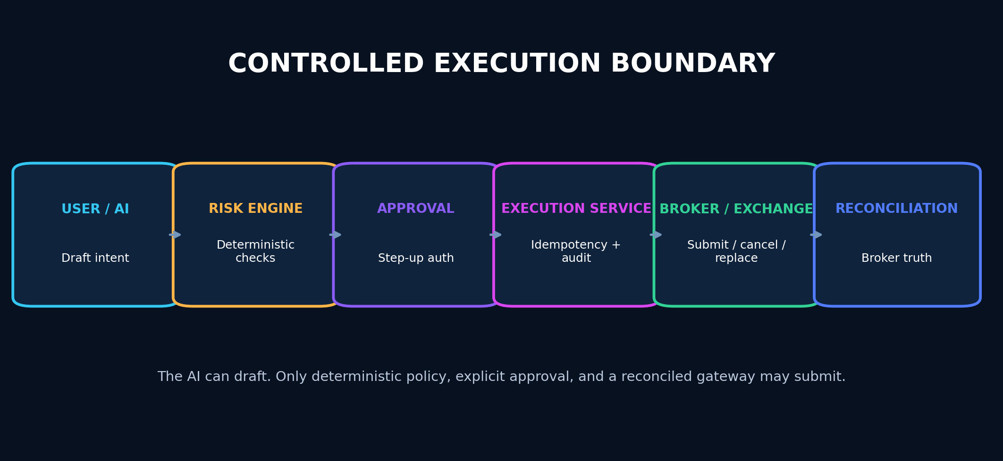
Figure 10 - The controlled execution boundary: AI and users draft; deterministic policy and explicit approval govern submission.
The v0.1 overview (§17.5, §39.2) mandates idempotency keys, reconciliation, and an isolated execution boundary, but defines no gateway trait. This is the contract between PRISMATIK and any broker or exchange.
RUST
/// The execution gateway abstraction. Broker adapters implement this.
/// The execution service wraps every call with idempotency, audit,
/// reconciliation, and the step-up auth gate from v0.1 §17.5.
#[async_trait::async_trait]
pub trait BrokerGateway: Send + Sync {
fn broker_id(&self) -> BrokerId;
fn capabilities(&self) -> BrokerCapabilities;
/// Submit an order that has passed risk checks and user approval.
/// Uses the idempotency key from the OrderIntent — a retry with
/// the same key returns the original result, never creates a duplicate.
async fn submit(
&self,
order: ApprovedOrder,
) -> Result<SubmissionResult, BrokerError>;
/// Cancel a working order. Must be idempotent.
async fn cancel(
&self,
order_id: BrokerOrderId,
) -> Result<CancelResult, BrokerError>;
/// Replace a working order (modify quantity, price, or stop).
/// Not all brokers support this. Check capabilities first.
async fn replace(
&self,
order_id: BrokerOrderId,
modification: OrderModification,
) -> Result<ReplaceResult, BrokerError>;
/// Reconcile local state with broker state. Called after
/// timeouts, unknown results, disconnections, and periodically
/// as a safety net. Returns the delta between local belief
/// and broker truth.
async fn reconcile(
&self,
local_state: &LocalOrderState,
) -> Result<ReconciliationDelta, BrokerError>;
/// Stream fills and order state changes.
async fn stream_events(
&self,
) -> BoxStream<'static, BrokerEvent>;
}

4. AI Tool Gateway
The v0.1 overview (§16.2, §31.5) lists 11 controlled tools and 10 gateway enforcement points, but the dispatch trait is undefined. This is the boundary between the conversational AI and the platform's controlled surface area.
RUST
/// The AI tool gateway. Every tool the AI can invoke passes through
/// this trait. The gateway enforces schema validation, rate limits,
/// approval hooks, output filtering, and audit logging — not the tool.
#[async_trait::async_trait]
pub trait ToolGateway: Send + Sync {
/// Dispatch a tool call from the AI. The gateway validates
/// the input schema, checks rate limits, optionally requests
/// human approval, executes the tool, filters the output,
/// and returns a controlled result.
async fn dispatch(
&self,
call: ToolCall,
ctx: &ToolContext,
) -> Result<ToolResult, ToolError>;
/// List the tools available to the current session,
/// respecting trust level and capability scope.
fn available_tools(&self, trust: TrustLevel) -> Vec<ToolDescriptor>;
}
/// A single tool in the gateway registry.
pub trait ControlledTool: Send + Sync {
fn descriptor(&self) -> ToolDescriptor;
fn trust_level(&self) -> TrustLevel; // ReadOnly | DraftOnly | Sensitive
fn requires_approval(&self) -> bool;
async fn execute(
&self,
input: ToolInput,
ctx: &ToolContext,
) -> Result<ToolOutput, ToolError>;
}

Tool Catalog with Trust Levels
Tool | Trust Level | Approval? | Maps to v0.1 §16.2
market_query | ReadOnly | No | Read-only market query
filing_query | ReadOnly | No | Filing query
cot_query | ReadOnly | No | COT query
backtest_request | ReadOnly | No | Backtest request
simulation_request | ReadOnly | No | Simulation request
chart_snapshot | ReadOnly | No | Chart snapshot
portfolio_analysis | ReadOnly | No | Portfolio analysis
journal_search | ReadOnly | No | Journal search
draft_alert | DraftOnly | No | Draft alert
draft_strategy | DraftOnly | No | Draft strategy
draft_order | Sensitive | Yes — user must approve | Draft order

Live order submission is intentionally absent from this table. It is not a tool. It is a deterministic workflow (v0.1 §17.5) that the draft_order tool feeds into, but the AI never calls submit directly.

5. Alert Rule Evaluator
The v0.1 overview (§8.8) lists 12 alert targets and 9 delivery channels but defines no rule schema, no evaluator trait, and no streaming-vs-polling boundary.
RUST
/// An alert rule. Compiled from the rule DSL into a typed, evaluable form.
/// Rules are either streaming (evaluated on every event) or scheduled
/// (evaluated on a cron-like trigger).
pub trait AlertRule: Send + Sync {
fn id(&self) -> AlertRuleId;
fn evaluation_mode(&self) -> EvaluationMode; // Streaming | Scheduled
fn dedup_key(&self, event: &MarketEvent) -> Option<DedupKey>;
/// Evaluate against the current state. Returns Some(AlertFiring)
/// if the condition is met, None otherwise.
fn evaluate(&self, state: &AlertContext) -> Option<AlertFiring>;
}
pub enum EvaluationMode {
/// Evaluated on every incoming market event. Used for price,
/// volume, IV, and flow conditions.
Streaming,
/// Evaluated on a schedule. Used for filings, COT releases,
/// and daily risk summaries.
Scheduled(Schedule),
}

Streaming vs Scheduled Boundary
Condition | Mode | Rationale
Price threshold | Streaming | Sub-second relevance
Technical indicator | Streaming | Recomputed on every tick/bar
Volume / relative volume | Streaming | Intraday signal
Options flow | Streaming | Print-level detection
Implied volatility | Streaming | Updated with chain refresh
Filing arrival | Scheduled | SEC RSS poll or webhook
COT extreme | Scheduled | Weekly data, no intraday value
Event proximity | Scheduled | Calendar-driven
Portfolio risk threshold | Scheduled | Recompute on fill + periodic

6. Repository Port Pattern
The v0.1 overview (§18.3) lists "Persistence" as a Rust responsibility but defines no repository traits, leaving domain crates coupled to concrete stores. This is the hexagonal port that keeps the domain pure.
RUST
/// Generic repository port. Domain crates depend on this trait,
/// never on SQLx or a concrete store. The application layer wires
/// concrete implementations (PostgresUserRepository, SqliteUserRepository).
#[async_trait::async_trait]
pub trait Repository<T: Aggregate>: Send + Sync {
async fn get(&self, id: &T::Id) -> Result<Option<T>, RepoError>;
async fn save(&self, aggregate: &T) -> Result<(), RepoError>;
async fn delete(&self, id: &T::Id) -> Result<(), RepoError>;
async fn exists(&self, id: &T::Id) -> Result<bool, RepoError>;
}
/// Marker trait for domain aggregates that can be persisted.
pub trait Aggregate: Send + Sync + Clone {
type Id: Clone + Send + Sync;
fn id(&self) -> Self::Id;
fn version(&self) -> AggregateVersion; // optimistic concurrency
}

Part II — Pipeline Orchestration and Lineage
DESIGN PRINCIPLE The v0.1 overview (§10.1, §22.1) defines six data layers and lists bus candidates, but never specifies the orchestrator, lineage schema, invalidation model, or freshness targets. This part fills those gaps.

7. Orchestrator Architecture

7.1 Design Decision
For the desktop deployment (Phase 0–1), use an in-process Tokio task graph. No external orchestrator (Temporal, Airflow) is needed for a single-user local-first application. The task graph persists its state to SQLite so it survives restarts.
For the enterprise deployment (Phase 8), evaluate Temporal for durable cross-service workflows, keeping the same TaskRunner trait so the domain logic is portable.

7.2 Core Types
RUST
/// A pipeline task. Idempotent: running it twice with the same inputs
/// produces the same result (or a no-op if already complete).
#[async_trait::async_trait]
pub trait PipelineTask: Send + Sync {
fn id(&self) -> TaskId;
fn task_type(&self) -> TaskType;
fn input_hash(&self) -> ContentHash;
async fn run(&self, ctx: &PipelineContext) -> Result<TaskOutput, TaskError>;
/// Whether this task can be safely retried after a partial failure.
fn idempotent(&self) -> bool { true }
}
/// The task graph. Tasks declare their dependencies; the scheduler
/// resolves execution order. State persists to SQLite for crash recovery.
pub struct TaskGraph {
tasks: Vec<TaskNode>,
edges: Vec<(TaskId, TaskId)>, // (dependency, dependent)
}
pub struct TaskNode {
task: Box<dyn PipelineTask>,
trigger: Trigger,
status: TaskStatus,
last_run: Option<OffsetDateTime>,
last_output: Option<TaskOutput>,
}
pub enum Trigger {
/// Runs on a schedule (cron-like).
Scheduled(Schedule),
/// Runs when an upstream task completes.
Dependency(TaskId),
/// Runs when new data arrives from a provider.
DataEvent(ProviderId, EventPattern),
/// Runs on explicit user request.
OnDemand,
}

7.3 Task Types Mapped to v0.1 Layers
Task Type | Input Layer | Output Layer | Example
Ingest | (external) | Raw | Fetch CoinGecko markets snapshot
Normalize | Raw | Normalized | Parse CoinGecko JSON → canonical MarketSnapshot
QualityCheck | Normalized | Curated | Score freshness, detect outliers, deduplicate
FeatureCompute | Curated | Feature | Compute RSI, IV rank, relative volume
IntelligenceCompute | Feature | Intelligence | Score opportunity, run model prediction
Materialize | Curated/Feature | Presentation | Build user-specific watchlist view
Backfill | (external) | Raw | Fetch historical OHLC for a new asset

8. Lineage Schema
Every record in the curated, feature, and intelligence layers carries lineage back to its raw sources. This is the enforcement of v0.1 §4.1 ("Evidence Before Conclusion") at the data level.
RUST
/// Attached to every curated, feature, and intelligence record.
/// Allows tracing any derived value back to its raw source(s).
#[derive(Clone, Debug, Serialize, Deserialize)]
pub struct Lineage {
/// The raw record IDs this record was computed from.
pub upstream_record_ids: Vec<RecordId>,
/// The transform that produced this record.
pub transform_id: TransformId,
/// The version of the transform code.
pub transform_version: SemanticVersion,
/// When this record was computed.
pub computed_at: OffsetDateTime,
/// Hash of all upstream record IDs + transform + version.
/// If any input changes, this hash changes, and the record
/// is considered stale.
pub inputs_hash: ContentHash,
}

9. Invalidation Model
When a raw record is corrected (e.g., a restated 13F, a corrected macro series, a CoinGecko metadata fix), the system must determine which downstream records are affected and whether they need recomputation.

9.1 Invalidation Propagation
CODE
Raw record corrected
│
▼
Find all curated records with this raw ID in upstream_record_ids
│
▼
Mark those curated records as STALE (do not delete — preserve for audit)
│
▼
Find all feature records depending on those curated records
│
▼
Mark feature records as STALE
│
▼
Find all intelligence records (opportunities, predictions) depending on those features
│
▼
Mark intelligence records as STALE
│
▼
Re-trigger the pipeline tasks that produced the stale records
│
▼
New records created with new lineage; old records retained for audit

9.2 Stale-vs-Source vs Recompute
Not every correction requires recomputation:
Correction Type | Action | Reason
Metadata fix (name, description) | Recompute downstream | Low cost, high correctness value
Price/bar correction | Recompute + flag affected backtests | Critical — backtest results may change
Filing amendment | Recompute intelligence | Opportunities may be invalidated
COT revision | Recompute positioning metrics | Crowding scores change
Delayed-but-unchanged data | No action | Same data, later arrival — no invalidation

10. Per-Layer Freshness Targets
The v0.1 overview (§26.3) lists "Critical provider freshness" as an SLO but does not map targets per dataset. These are the targets for the Phase 0/1 data set:
Dataset | Layer | Target Freshness | Degradation Behavior
CoinGecko market snapshot (prices, cap, volume) | Raw | ≤ 60 seconds | Show "delayed" badge at 120s; stop scoring at 300s
CoinGecko trending | Raw | ≤ 5 minutes | Acceptable to be stale; no degradation
CoinGecko metadata | Raw | ≤ 24 hours | Very low change rate; no degradation
CoinGecko OHLC (historical) | Raw | Immutable after finalization | N/A — never goes stale
SEC filings RSS | Raw | ≤ 5 minutes after publication | Critical for event trading
CFTC COT | Raw | ≤ 1 day after Tuesday release | Weekly data; no intraday value
FRED macro | Raw | ≤ 1 day after release | Quarterly/monthly cadence
Normalized market snapshot | Normalized | ≤ 5 seconds behind raw | Pipeline must be fast
Feature: RSI / indicators | Feature | ≤ 10 seconds behind normalized | Recomputed on each bar close
Feature: IV rank | Feature | ≤ 30 seconds behind normalized | Depends on chain refresh
Intelligence: opportunity score | Intelligence | ≤ 30 seconds behind feature | Recomputed when inputs change

Part III — Provider Cost Model
DESIGN PRINCIPLE The v0.1 overview (§10.5) lists what the budget governor MUST do but defines no cost unit, no budget policy, and no UI. This part makes it concrete.

11. Cost Unit and Budget Architecture

11.1 Cost Units
Providers charge in different units. The governor normalizes all of them to a common CostUnit for tracking, while preserving the native unit for display.
RUST
/// The native cost unit of a provider.
pub enum CostUnit {
/// API calls (SEC EDGAR, FRED — free but rate-limited).
ApiCalls,
/// Credits (CoinGecko paid tiers — credits per endpoint).
Credits,
/// Plan-based (Unusual Whales — flat plan, soft rate limits).
PlanIncluded,
/// Dollars (paid per-call providers in later phases).
Dollars,
}
/// A single provider's cost model.
pub struct ProviderCostModel {
pub provider_id: ProviderId,
pub unit: CostUnit,
pub period: BudgetPeriod, // Hourly | Daily | Monthly
pub budget: u64, // calls, credits, or cents
pub remaining: u64,
pub reservation_pool: u64, // reserved for critical workflows
pub endpoints: Vec<EndpointWeight>, // credit weight per endpoint
}
pub struct EndpointWeight {
pub endpoint: EndpointPath,
pub weight: u32, // e.g., CoinGecko /coins/{id} = 1 credit, /coins/markets = 1, historical = 5
}

11.2 Budget Policy and Priority Classes
RUST
/// Workflows are classified by priority. When the budget is under
/// pressure, lower-priority requests are shed first.
pub enum PriorityClass {
/// User-facing dashboard refresh, alert evaluation, live execution.
/// These always run, even if they exhaust the budget.
Critical,
/// Watchlist updates, scanner runs, chart data.
/// Run unless budget is below 20% remaining.
Standard,
/// Background data refresh, historical backfill, model retraining.
/// Run only when budget is above 50% remaining.
Background,
/// Prefetch, warm cache, pre-compute.
/// Run only when budget is above 80% remaining.
Opportunistic,
}

11.3 Rate-Budget UI Specification
The Phase 0 exit criteria require a "Provider health and rate-budget UI." This is what it shows:
Panel 1 — Provider Health Card (one per connected provider):
- Provider name and plan tier
- Current status: Healthy / Degraded / Rate-Limited / Down
- Requests in current period / budget
- Credits remaining (for credit-based providers)
- Average latency (p50, p95)
- Error rate
- Last successful request timestamp
- Next reset time
Panel 2 — Spend Trend:
- Sparkline of request/credit consumption over the current period
- Projected burn rate (linear extrapolation)
- "At current rate, budget exhausted in X hours" warning
Panel 3 — Priority Breakdown:
- Bar chart of requests by PriorityClass (Critical / Standard / Background / Opportunistic)
- Shed count (how many Background/Opportunistic requests were rejected)
Panel 4 — Endpoint Breakdown (expandable per provider):
- Table: endpoint path, call count, credit weight, total credits consumed
Controls:
- Per-provider pause/resume toggle
- Per-provider budget override (with confirmation)
- "Reserve N credits for critical workflows" slider

Part IV — First-Run, Demo, and Suitability
DESIGN PRINCIPLE The v0.1 overview has no onboarding architecture despite Phase 0 requiring "CoinGecko demo integration" and §17.3 requiring "user-specific suitability filters."

12. First-Run Experience

12.1 Flow State Machine
CODE
[Launch]
│
▼
[Welcome Screen]
│
├── "Get Started" ─────────────────▶ [Provider Setup]
│ │
│ ├── Enter CoinGecko key (optional)
│ │ (demo key pre-filled; user can upgrade later)
│ │
│ └── "Skip — use demo mode" ──▶ [Demo Mode Active]
│
▼
[Suitability Profile]
│
├── Experience level: Novice / Intermediate / Advanced / Professional
├── Risk tolerance: Conservative / Moderate / Aggressive
├── Jurisdiction: Country + State (for feature gating)
├── Primary asset interest: Crypto / Equities / Options / Multi-asset
└── Time horizon: Scalping / Day / Swing / Position / Long-term
│
▼
[Default Workspace Seeded]
│
├── Watchlist: BTC, ETH, SPY, QQQ (+ top 10 by user interest)
├── Sample strategy: "EventFlowMomentum" (read-only, for learning)
├── Risk policy: Conservative defaults (max 2% per position, max 15% sector)
└── Layout: "First-Run" named layout with Command Center + one chart + watchlist
│
▼
[Guided Tour (skippable)]
│
├── "This is your Command Center. Cards show..."
├── "Every card links to its evidence. Click any source."
├── "Probabilities are ranges, not predictions. See how..."
└── "Your risk limits are set. Here's how to change them."
│
▼
[Ready — Main Application]

12.2 Demo Mode Architecture
Demo mode allows full exploration without API keys. It is not a separate app — it is a degraded-capability mode that is transparent to the user.
RUST
pub struct DemoMode {
/// Pre-recorded provider responses, replayed deterministically.
/// Recorded from CoinGecko demo endpoints with a known timestamp.
fixtures: FixtureStore,
/// The "simulation clock" — demo data appears to advance in real-time
/// but is actually replayed from recorded snapshots at 1-minute granularity.
sim_clock: DemoClock,
/// Watermark shown on all data: "DEMO — Data as of 2026-07-10"
watermark: DemoWatermark,
/// Features disabled in demo: live execution, real broker sync, alerts to SMS.
disabled_features: Vec<FeatureGate>,
}
Demo mode rules:
- Market data shows a watermark on every chart and table: "DEMO — Data as of [date]"
- No data is older than 7 days at time of recording
- Alerts fire against demo data but cannot deliver to SMS, email, or webhooks
- Paper trading works fully against demo data
- The user can enter real API keys at any time to transition out of demo mode seamlessly
- No real credentials are ever stored during demo mode

12.3 Suitability Profile Aggregate
RUST
/// Captured during first-run and editable in settings.
/// Consumed by the scanner (filters out unsuitable strategies),
/// the opportunity engine (ranks by user fit), and the compliance
/// layer (gates features by jurisdiction and experience).
pub struct SuitabilityProfile {
pub experience_level: ExperienceLevel,
pub risk_tolerance: RiskTolerance,
pub jurisdiction: Jurisdiction,
pub primary_interests: Vec<AssetClass>,
pub time_horizon: TimeHorizon,
pub acknowledged_disclosures: Vec<DisclosureAcknowledgment>,
pub created_at: OffsetDateTime,
pub updated_at: OffsetDateTime,
}

Part V — Notification Service
DESIGN PRINCIPLE The v0.1 overview (§8.8) lists alert targets and delivery channels with no service architecture.

13. Notification Service Design
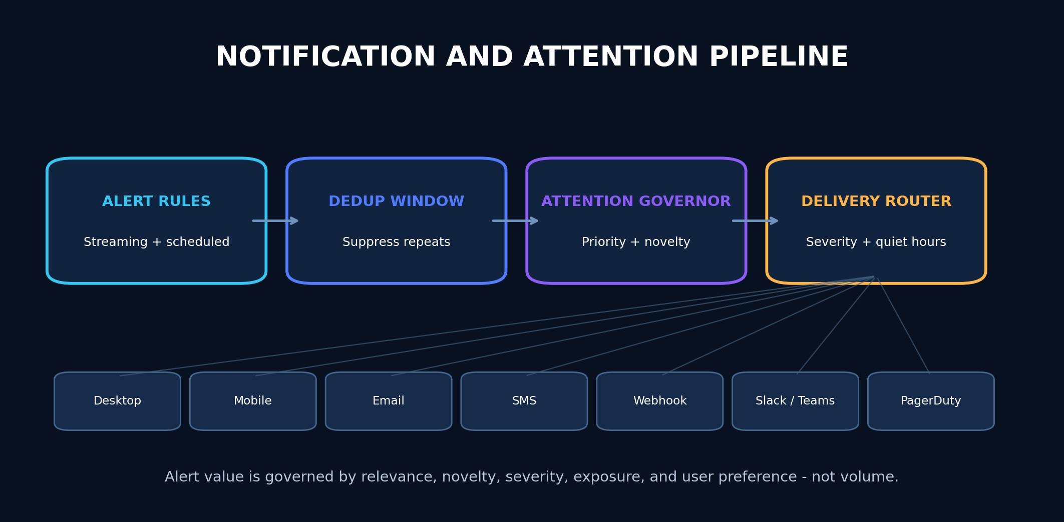
Figure 11 - Notification pipeline with deduplication, attention governance, severity routing, and quiet-hour controls.
CODE
┌─────────────────────────────────────────────────────────┐
│ Alert Rules │
│ (Streaming evaluator + Scheduled evaluator) │
└──────────────────────────┬──────────────────────────────┘
│ AlertFiring
▼
┌─────────────────────────────────────────────────────────┐
│ Dedup Window │
│ Key = (rule_id, entity, direction, severity) │
│ If duplicate within window → suppress │
│ If same entity, higher severity → escalate │
└──────────────────────────┬──────────────────────────────┘
│ Unique AlertFiring
▼
┌─────────────────────────────────────────────────────────┐
│ Attention Governor │
│ Prioritizes based on: portfolio exposure, watchlist │
│ relevance, strategy fit, event proximity, severity, │
│ novelty, historical usefulness. │
│ Limits repeated low-value alerts. │
└──────────────────────────┬──────────────────────────────┘
│ Governed AlertFiring
▼
┌─────────────────────────────────────────────────────────┐
│ Delivery Router │
│ Routes to user-preferred channels by severity and time. │
│ Quiet hours suppress non-critical. │
│ Critical alerts bypass quiet hours. │
└──────┬──────┬──────┬──────┬──────┬──────┬──────┬────────┘
│ │ │ │ │ │ │
▼ ▼ ▼ ▼ ▼ ▼ ▼
Desktop Mobile Email SMS Webhook Slack PagerDuty
Toast Push /Teams

13.1 Delivery Channel Abstraction
RUST
#[async_trait::async_trait]
pub trait DeliveryChannel: Send + Sync {
fn channel_id(&self) -> ChannelId;
fn min_severity(&self) -> AlertSeverity;
async fn deliver(
&self,
alert: &AlertFiring,
user_prefs: &NotificationPreferences,
) -> Result<DeliveryReceipt, DeliveryError>;
/// Whether this channel is available (has credentials, is connected).
async fn is_available(&self) -> bool;
}

13.2 Dedup and Escalation
Scenario | Action
Same rule fires for same entity within dedup window | Suppress (count incremented on original)
Same entity, higher severity than existing alert | Escalate (replace original, notify)
Rule fires for entity already alerted → condition clears → refires | New alert (dedup window reset on clear)
User dismisses alert; condition persists | Snooze for user-set duration, then re-fire if still active
User disables rule | No alerts fire; rule state preserved for re-enable
Quiet hours active, severity < Critical | Queue for delivery at quiet-hours end
Quiet hours active, severity = Critical | Deliver immediately, bypass quiet hours

Part VI — Compliance Architecture
DESIGN PRINCIPLE The v0.1 overview (§35.10) treats compliance as legal review. This makes it architecture.

14. Jurisdiction Gating
RUST
/// Determined at first-run and verified periodically via IP check
/// (server-side for cloud deployments) or self-declaration (desktop).
/// Gates features that are legally restricted by jurisdiction.
pub struct JurisdictionGate {
pub jurisdiction: Jurisdiction,
pub feature_overrides: HashMap<FeatureId, FeatureState>,
pub last_verified: OffsetDateTime,
}
pub enum FeatureState {
Enabled,
Disabled { reason: String },
RequiresDisclosure { disclosure_id: DisclosureId },
}
Example gating rules:
Feature | US | EU | UK | Restricted jurisdictions
Crypto market data | Enabled | Enabled | Enabled | Disabled if under OFAC sanctions
Options flow | Enabled | Requires disclosure | Requires disclosure | Disabled
Congressional trading data | Enabled | Disabled (data licensing) | Disabled | Disabled
Live broker execution | Enabled (US brokers) | Enabled (EU brokers) | Enabled (UK brokers) | Disabled
AI investment analysis | Requires disclaimer | Requires MiDIS disclaimer | Requires FCA disclaimer | Disabled

15. Disclosure Registry
RUST
/// Every disclosure in the system is registered with an ID,
/// context (where it appears), text, and version. When a
/// disclosure is shown to a user, an audit event records it.
pub struct Disclosure {
pub id: DisclosureId,
pub context: DisclosureContext, // Onboarding | OpportunityCard | RiskPanel | AIResponse | ...
pub text: DisclosureText,
pub version: SemanticVersion,
pub jurisdiction: Option<Jurisdiction>, // None = all jurisdictions
pub required_acknowledgment: bool,
}
/// When a disclosure is rendered, this event is emitted.
/// It proves the user saw the disclosure for audit and compliance.
pub struct DisclosureShownEvent {
pub disclosure_id: DisclosureId,
pub user_id: UserId,
pub shown_at: OffsetDateTime,
pub context: DisclosureContext,
pub acknowledged: bool,
}

Part VII — Model Serving and Feature Store
DESIGN PRINCIPLE The v0.1 overview (§12) thoroughly covers model governance but has no runtime serving or feature store architecture.

16. Feature Store
The single most important property of a feature store for a trading platform is point-in-time correctness — a feature value used in training or inference must reflect exactly what was known at that timestamp, with no look-ahead.
RUST
/// Point-in-time feature query. Returns the feature value as it
/// existed at `as_of`, not the current value. This is the
/// mechanism that prevents look-ahead bias in backtests and
/// ensures reproducibility in live inference.
pub struct FeatureQuery {
pub feature_view: FeatureViewId,
pub entity_keys: Vec<EntityKey>,
pub as_of: OffsetDateTime, // the point in time
pub feature_names: Vec<String>, // which features to return
}
pub struct FeatureView {
pub id: FeatureViewId,
pub entities: Vec<EntityKeySchema>,
pub features: Vec<FeatureSchema>,
pub online_store: OnlineStore, // SQLite (desktop) / Redis (enterprise)
pub offline_store: OfflineStore, // Parquet/DuckDB
pub materialization: MaterializationSchedule,
pub version: SemanticVersion,
}

16.1 Online vs Offline Serving
Store | Used By | Latency Target | Data
Online (SQLite / Redis) | Live inference, streaming alerts, real-time scoring | ≤ 5ms | Latest feature values, ~7 day window
Offline (Parquet / DuckDB) | Backtest, model training, batch research | Seconds acceptable | Full history, point-in-time queryable

16.2 Materialization
Features are computed by pipeline tasks (Part II) and written to both stores. The online store retains only the latest value per entity. The offline store retains the full time-series with lineage.

17. Model Serving
RUST
/// A registered model in the model registry.
pub struct ModelArtifact {
pub id: ModelId,
pub name: String,
pub version: SemanticVersion,
pub artifact_uri: String, // local path or object storage
pub content_hash: ContentHash,
pub signature: ModelSignature, // input/output schema
pub runtime: ModelRuntime, // Onnx | LlamaCpp | CloudApi
pub owner: UserId,
pub validation_report: ValidationReportId,
pub calibration_report: Option<CalibrationReportId>,
pub status: ModelStatus, // Draft | Validated | Promoted | Retired
}
/// Inference trait. The runtime binds the model version to every
/// prediction so that v0.1 §12.4's "model version" requirement
/// is enforced structurally.
#[async_trait::async_trait]
pub trait ModelRuntime: Send + Sync {
async fn predict(
&self,
features: FeatureSet,
) -> Result<Prediction, ModelError>;
/// Metadata bound to every prediction for audit and reproducibility.
fn metadata(&self) -> ModelMetadata;
}
pub struct Prediction {
pub model_id: ModelId,
pub model_version: SemanticVersion,
pub value: PredictionValue, // Distribution | Probability | Ranking
pub confidence_interval: Option<Interval>,
pub feature_contributions: Vec<FeatureContribution>, // explainability
pub training_window: DateRange,
pub drift_status: DriftStatus,
pub predicted_at: OffsetDateTime,
}

Part VIII — Reproducibility Manifest Schema
DESIGN PRINCIPLE The v0.1 overview mandates "signed result manifests" in sections 4.7, 11, 37.5, and Phase 4 exit criteria, but never defines the format.

18. Manifest Schema
JSON
{
"manifest_type": "backtest",
"manifest_version": 1,
"manifest_id": "01J...",
"created_at": "2026-07-13T15:00:00Z",
"created_by": "user_id",
"dataset": {
"snapshot_id": "snap_01J...",
"snapshot_hash": "sha256:...",
"as_of": "2026-07-10T00:00:00Z",
"adjustment_policy": "TOTAL_RETURN",
"calendar_version": "2026.1",
"provider_versions": {
"coingecko": "2026-07-10",
"sec_edgar": "2026-07-10"
}
},
"strategy": {
"strategy_id": "strat_01J...",
"strategy_hash": "sha256:...",
"strategy_version": "1.2.0",
"compiler_version": "0.3.0",
"parameters": { "rsi_period": 14, "iv_rank_max": 45 }
},
"execution_assumptions": {
"commission": "0.65 per contract",
"slippage_model": "quarter_spread",
"fill_assumption": "market_open",
"partial_fill_policy": "proportional"
},
"random_seed": 42,
"code": {
"commit_hash": "abc123def456",
"dependency_hash": "sha256:Cargo.lock hash",
"build_flags": []
},
"metrics": {
"total_return": 0.234,
"sharpe": 1.82,
"max_drawdown": -0.087,
"win_rate": 0.61
},
"signatures": [
{
"algorithm": "ML-DSA",
"key_id": "key_01J...",
"signature": "base64..."
},
{
"algorithm": "Ed25519",
"key_id": "key_01J...",
"signature": "base64..."
}
]
}

Verification Protocol
To verify a result reproduces from its manifest:
- Reconstruct the dataset snapshot from snapshot_hash.
- Load the strategy from strategy_hash (content-addressed).
- Check out code at commit_hash.
- Verify dependency_hash matches Cargo.lock.
- Run the backtest with the same parameters, seed, and execution assumptions.
- Compare metrics within the documented numeric tolerance.
- Verify both signatures against the trusted key store.

Part IX — Market Infrastructure Services
DESIGN PRINCIPLE The v0.1 overview requires trading calendars, corporate actions, and symbology (§8.3, §10.3, §11.2) but names no sources or services.

19. Trading Calendar Service
RUST
/// Provides session boundaries, holidays, and half-days per venue.
/// Used by the backtest engine (replay only on valid sessions),
/// the execution boundary (block orders when market closed),
/// and the chart (show session breaks).
pub trait TradingCalendar: Send + Sync {
fn is_open(&self, venue: Venue, at: OffsetDateTime) -> bool;
fn next_open(&self, venue: Venue, from: OffsetDateTime) -> OffsetDateTime;
fn next_close(&self, venue: Venue, from: OffsetDateTime) -> OffsetDateTime;
fn session_for(&self, venue: Venue, at: OffsetDateTime) -> Option<Session>;
fn holidays(&self, venue: Venue, year: i32) -> Vec<Holiday>;
}
Source: Self-hosted calendar data generated from exchange-published schedules, stored as versioned JSON, updated via signed data patches. Version pinned in reproducibility manifests.

20. Corporate Action Service
RUST
/// Corporate actions that affect price series and backtest integrity.
/// Every action specifies how it propagates to historical bars.
pub struct CorporateAction {
pub id: CorporateActionId,
pub asset_id: AssetId,
pub action_type: ActionType, // Split | Dividend | Spinoff | Merger | Delisting
pub ex_date: Date,
pub record_date: Option<Date>,
pub payable_date: Option<Date>,
pub ratio: Option<Ratio>, // split ratio, dividend amount
pub adjustment_policy: AdjustmentPolicy,
pub source: ProviderId,
pub source_reference: String,
pub parser_version: SemanticVersion,
}

Adjustment Propagation
Action | Raw bars | Split-adj | Div-adj | Total-return
2:1 split | Unchanged | Price ÷ 2, volume × 2 | Same as split-adj | Same as split-adj + dividend reinvestment
$0.50 dividend | Unchanged | Unchanged | Price − $0.50 on ex-date | Dividend reinvested at ex-date close
Delisting | Unchanged | Unchanged | Unchanged | Position removed at last available price

The backtest engine and chart system default to TotalReturn adjustment but expose the policy as a parameter. Every reproducibility manifest pins the adjustment policy used.

21. Symbology Resolution
RUST
/// Resolves user input ("AAPL", "apple inc", a CUSIP, a FIGI)
/// to a canonical asset ID. Handles ambiguity, delistings, and
/// ticker changes over time.
pub struct SymbologyService {
/// Tries to resolve a user query to exactly one canonical asset.
/// Returns multiple candidates if ambiguous, requiring disambiguation.
pub fn resolve(
&self,
query: &str,
at: Option<OffsetDateTime>, // None = current; Some = point in time
) -> ResolutionResult;
}
pub enum ResolutionResult {
Unique(AssetId),
Ambiguous(Vec<AssetCandidate>), // user must pick
NotFound,
Delisted {
asset_id: AssetId,
last_valid_date: Date,
successor: Option<AssetId>, // if ticker changed
},
}

Part X — Desktop Backup, Restore, and Migration
DESIGN PRINCIPLE For a local-first application, the user's machine is the system of record. Backup and restore must be first-class.

22. Backup Bundle
RUST
/// A complete backup of the local-first store. Signed and encrypted.
/// Contains all local databases, the vault (rewrapped to a backup key),
/// configuration, and a manifest of contents.
pub struct BackupBundle {
pub manifest: BackupManifest,
pub stores: Vec<StoreBackup>, // SQLite, DuckDB, Parquet dirs
pub vault: VaultBackup, // rewrapped, not re-encrypted
pub config: ConfigBackup,
pub signature: BackupSignature,
}
pub struct BackupManifest {
pub app_version: SemanticVersion,
pub schema_versions: HashMap<StoreId, SemanticVersion>,
pub created_at: OffsetDateTime,
pub total_size_bytes: u64,
pub item_counts: HashMap<String, u64>, // {"strategies": 42, "journal_entries": 318}
pub encryption: EncryptionInfo,
}

Restore Protocol
- User provides backup file + recovery key (or OS keychain unlock).
- App verifies backup signature.
- App checks schema versions against current app version.
- If schemas differ, run migration sequence (old → current).
- Restore stores to local paths.
- Restore vault (rewrap from backup key to device key).
- Validate integrity (record counts, hash checks).
- App restarts with restored data.

Cross-Version Migration
Every local store (SQLite, DuckDB, Parquet layouts) has a schema_version table. On app launch, the migration runner checks the stored version against the app's expected version and runs sequential migrations (N → N+1 → N+2 → current). Migrations are signed and idempotent. If a migration fails partway, the runner rolls back to the pre-migration state and surfaces the error — never leaves the store in a half-migrated state.

Closing
This evolution document fills the gaps that would block or degrade implementation of the v0.1 overview. The priority order for implementation is:
- Part I — Trait Surfaces (Strategy, Risk, BrokerGateway, ToolGateway, AlertEvaluator, Repository) — these are the architectural contract. Nothing else can be built correctly until these exist as reviewed ADRs.
- Part II — Pipeline Orchestration — the data pipeline is the backbone of evidence-chained intelligence.
- Part III — Cost Model — required for the Phase 0 exit criteria.
- Part IV — First-Run and Suitability — determines whether the product's pitch lands.
- Parts V–X — fill the remaining gaps as phases progress.
The v0.1 overview remains the authoritative product and security document. This document is its build-ready companion.
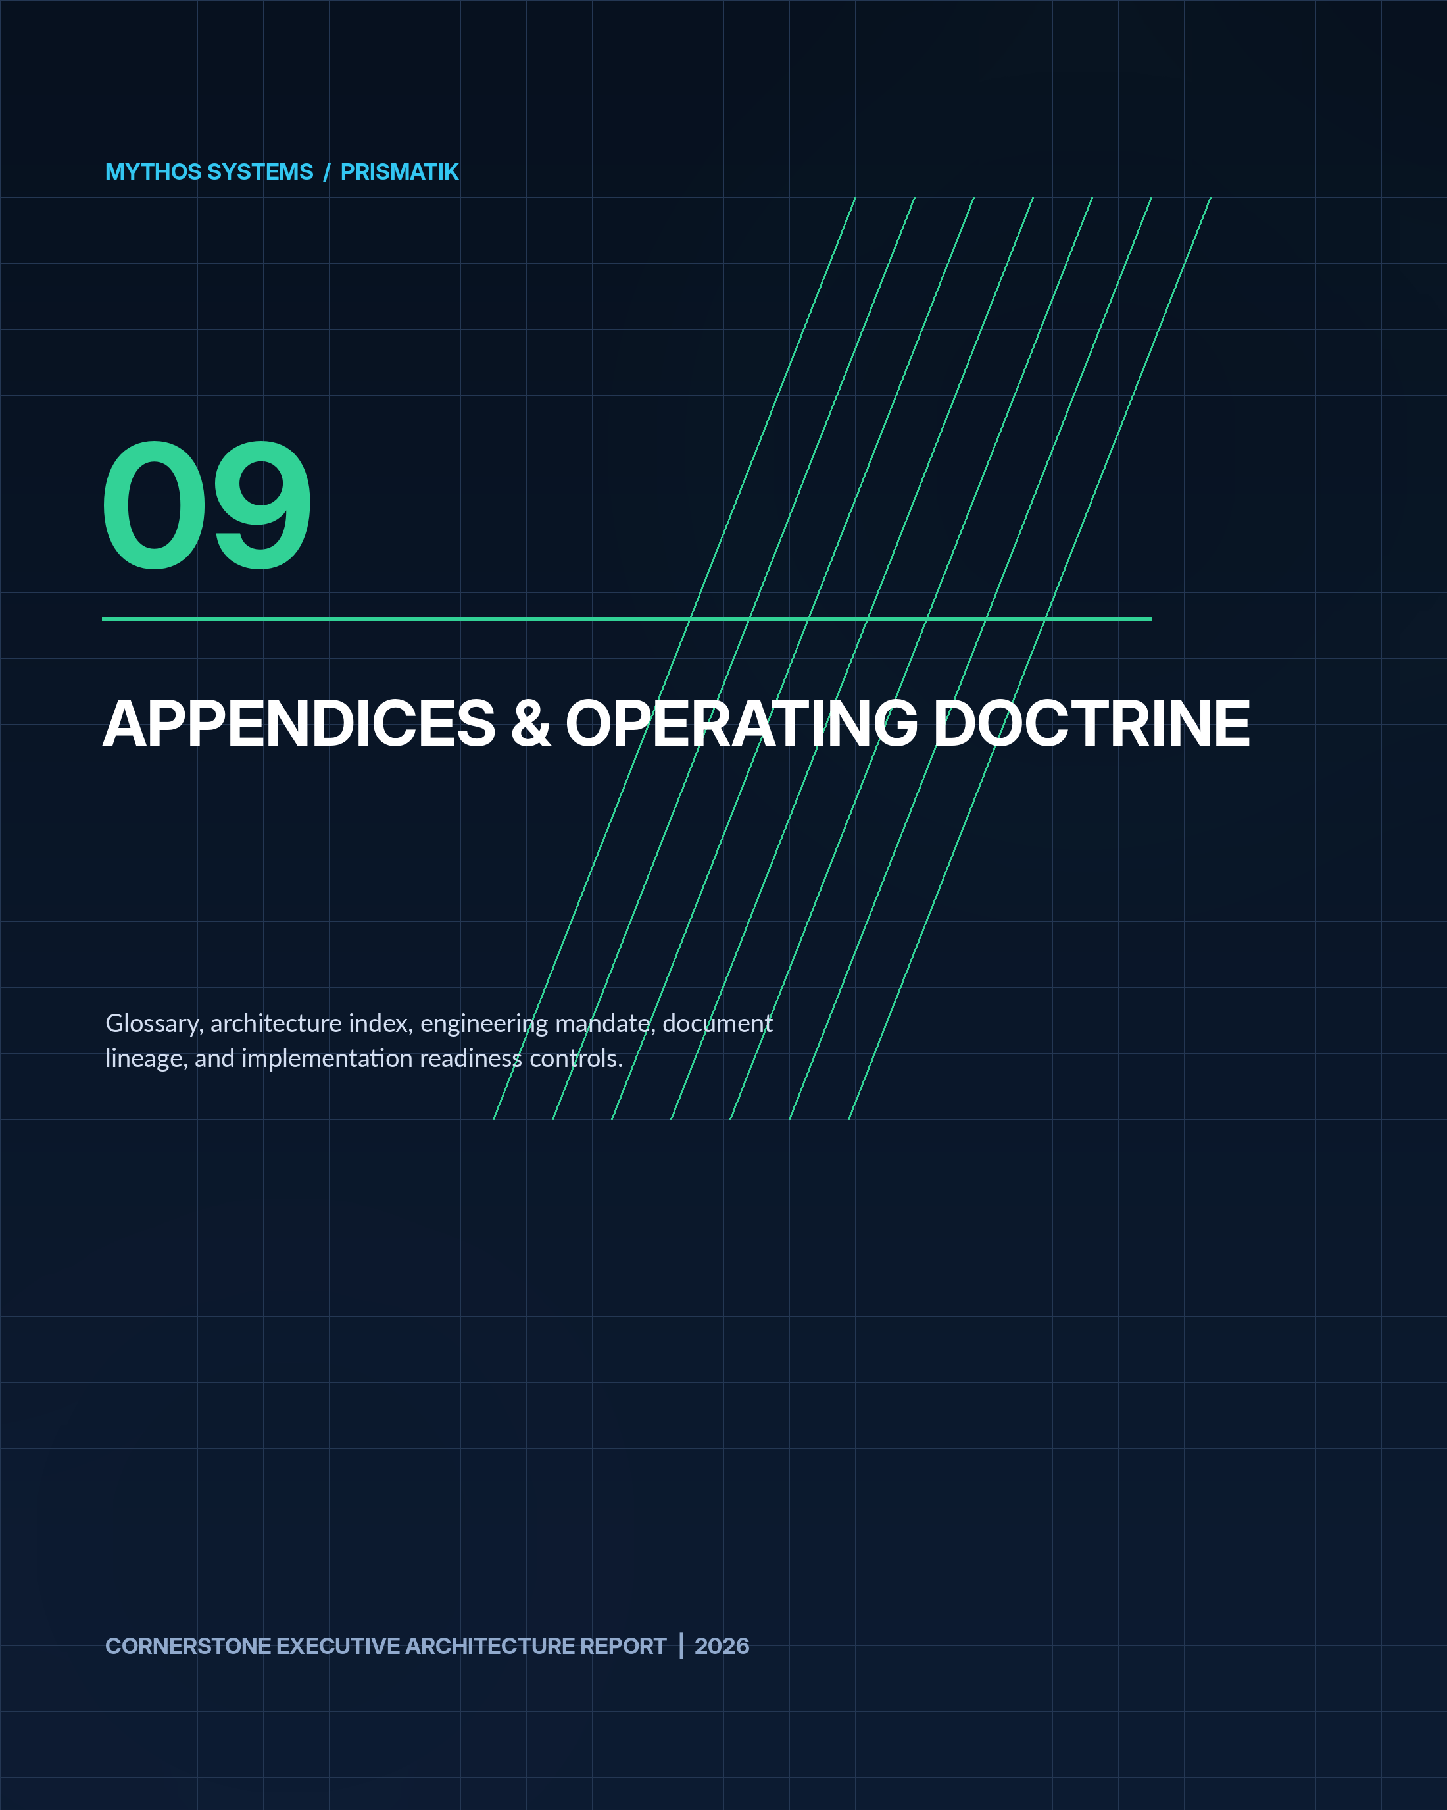

Engineering Operating Doctrine
PRIME DIRECTIVE PRISMATIK is production software, not a demonstration. Every change must increase correctness, security, maintainability, observability, reproducibility, and operational confidence.

Correctness before cleverness  Encode invariants in domain types, validate every untrusted boundary, and prefer explicit behavior. | Security by default  Least privilege, safe defaults, abuse-case thinking, secret isolation, signed artifacts, and fail-closed controls. | Idempotency by design  Retries, redelivery, double-clicks, and uncertain network outcomes must not create duplicated trades or state. | Bounded concurrency  Every task, queue, scan, worker, and fan-out has ownership, cancellation, timeouts, limits, and backpressure.
Evidence and observability  Logs, metrics, traces, health, correlation IDs, provenance, and audit records explain important state transitions. | Reproducibility  Builds, datasets, models, strategies, simulations, migrations, and releases are versioned and repeatable. | AI as accelerator, not authority  AI output is untrusted until validated, tested, reviewed, and constrained by deterministic policy. | Cryptographic agility  Use strong modern protection now and preserve a documented migration path to hybrid and post-quantum profiles.

Minimum Definition of Done
- Requirements and acceptance criteria are explicit.
- Threat-model impact and abuse cases are considered.
- Contracts and migrations are versioned.
- Code formats, lints, compiles, and tests successfully.
- Failure paths and rollback are tested.
- Observability and runbooks exist.
- Secrets and sensitive data are protected.
- PQC posture and strongest-available fallback are documented.
- AI-generated portions are reviewed as untrusted.
- The project workbook is updated with actions, validation, risks, and continuation handoff.

Implementation Readiness Index
DOMAIN | LOAD-BEARING DELIVERABLE | TARGET
Product identity | Working name isolated from schemas and package contracts | Defined
Crypto foundation | CoinGecko provider adapter, identity service, cache, rate governor | Phase 0-1
Equity/options | Licensed quote feed and Unusual Whales adapter | Phase 2-3
Regulatory intelligence | SEC EDGAR and CFTC PRE pipelines | Phase 2
Quant runtime | Strategy IR, deterministic context, backtest, validation | Phase 4
Simulation | Bootstrap, parametric, jump, stochastic volatility, portfolio paths | Phase 5
AI controls | Tool gateway, read/draft permissions, no direct submit | Phase 1 onward
Execution | Broker gateway, risk policy, approval, idempotency, reconciliation | Phase 7
Security | Tauri boundaries, keychain/Vault, signed updates, audit, zero trust | Foundation
PQC agility | Crypto inventory, hybrid readiness, dual-sign manifests | Foundation onward
Enterprise | SSO, RBAC/ABAC, on-prem, SIEM, HSM/Vault | Phase 8
Ecosystem | Signed WASM plugins, MCP registry, review and revocation | Phase 9

Glossary of Core Terms
TERM | DEFINITION
ABAC | Attribute-Based Access Control; authorization based on attributes such as role, account, environment, device posture, and risk context.
ADR | Architecture Decision Record; a durable record of a significant technical decision, alternatives, consequences, security impact, and rollback plan.
Alpha | Return or value attributable to a strategy beyond its benchmark or modeled systematic exposure.
Backtest | A deterministic historical simulation of a strategy using point-in-time data and explicit execution assumptions.
CFTC | U.S. Commodity Futures Trading Commission.
COT | Commitments of Traders reports describing aggregated positioning in futures and options on futures.
CVaR | Conditional Value at Risk, also called expected shortfall; the expected loss in the tail beyond a VaR threshold.
Data lineage | The traceable chain from a derived value back to raw records, transformations, versions, and timestamps.
Delta | The sensitivity of an option price to a unit change in the underlying asset.
Gamma | The rate of change of delta as the underlying price changes.
Greeks | Option sensitivity measures including delta, gamma, theta, vega, and rho.
HSM | Hardware Security Module used to protect cryptographic keys and operations.
Idempotency | The property that safely repeating an operation produces the same intended final state instead of duplicates or corruption.
Implied volatility | The volatility level embedded in an option price under an option-pricing model.
IV rank | A comparison of current implied volatility with its historical range.
MCP | Model Context Protocol; a standard interface through which AI systems invoke external tools and data sources.
ML-DSA | NIST-standardized post-quantum digital signature algorithm derived from Dilithium.
ML-KEM | NIST-standardized post-quantum key-establishment mechanism derived from Kyber.
Monte Carlo simulation | Repeated simulation of possible paths or trade sequences to estimate distributions of returns, drawdowns, and risk.
Opportunity | A ranked, evidence-backed market hypothesis - not a guaranteed trade instruction.
Order intent | A proposed trade expression that must pass deterministic risk, authorization, and approval controls before becoming an order.
PQC | Post-quantum cryptography designed to resist attacks from sufficiently capable quantum computers.
Provenance | Metadata identifying the source, endpoint, retrieval time, parser, transformation, and quality of data.
RBAC | Role-Based Access Control.
SEC EDGAR | The SEC filing and disclosure system used for company submissions and regulatory documents.
Sharpe ratio | A risk-adjusted return measure based on excess return divided by return volatility.
SLH-DSA | NIST-standardized stateless hash-based post-quantum signature algorithm.
Slippage | The difference between an assumed or quoted execution price and the realized fill price.
Sortino ratio | A risk-adjusted return measure that penalizes downside volatility rather than total volatility.
Strategy IR | A typed intermediate representation to which visual, DSL, Python-generated, or Rust strategies compile before execution.
Tauri | A Rust-centered framework for secure, cross-platform desktop applications using a web frontend.
Theta | The sensitivity of an option price to passage of time.
Value at Risk | A percentile estimate of potential loss over a defined horizon; insufficient as the sole measure of risk.
Vega | The sensitivity of an option price to implied volatility.
Walk-forward validation | Repeated train/validate/test windows that approximate how a strategy or model would have evolved through time.
WebGPU / wgpu | Cross-platform GPU graphics and compute technologies used for dense visualizations and selected parallel workloads.
Zero trust | A security model that continuously verifies identity, device, context, and authorization rather than assuming trust by network location.

Document Lineage and Stewardship
This cornerstone report integrates and preserves the complete product architecture from PRISMATIK Overview v0.1 together with the build-ready contracts in PRISMATIK Architecture Evolution v0.2. It is intended to become the governing product and architecture reference until superseded through an explicit versioned decision.
VERSION | ROLE | STEWARDSHIP
v0.1 | Product, experience, security, platform, and roadmap baseline | Preserved in Parts 1-7
v0.2 | Load-bearing implementation contracts and missing architecture detail | Preserved in Part 8
Cornerstone 2026 | Integrated executive and engineering reference | Mythos Systems / Aaron Stovall
STEWARDSHIP RULE Future revisions should preserve traceability to this document, record decisions in ADRs, update the architecture and security models, and maintain a continuation trail in /docs/workbook/.

