**TASK 1**

**A: print('peshawar islamabad lahore karachi'.title())**

**output:**

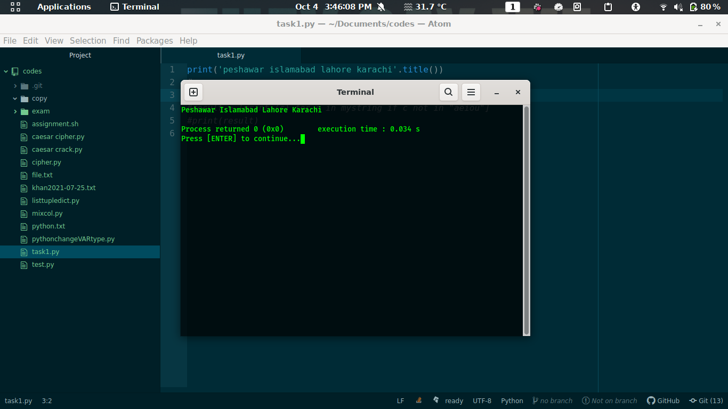

print command prints the output and with concatenation of title() function it makes first letter of every name capital.

--------------------------------------------------------------------------------

**B: result = [print (c) for c in mystring if c not in "aeiou"]**

**print(result)**

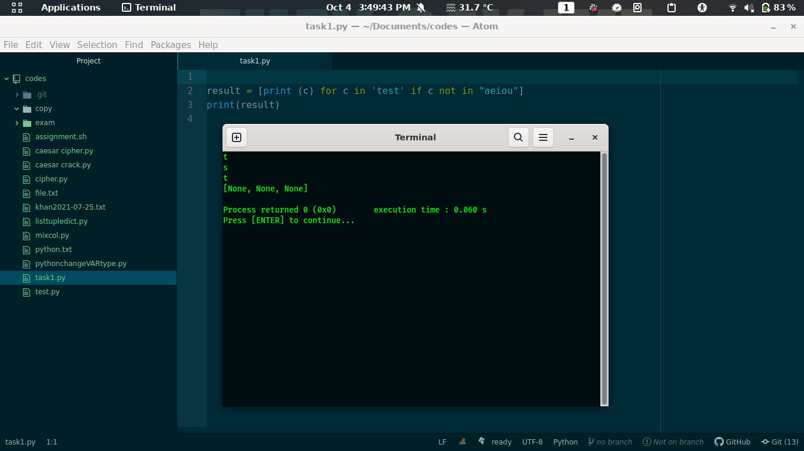

in result variable we declare inline loop and condition where print from string if the character of string does not in ‘aeiou’ string otherwise skip if exist

print result variable