CSE 3200 Software Quality Testing
Practical Project Test 1
Testing TicketHub: what I did and what I found

Student name | <Your name>
Student ID | <StudentID>
System tested | tickethub.py, TicketHub Order Module v0.9 (not modified)
Date | 9 October 2026

In short: I designed 72 tests from the specification and ran 64 of them. 48 passed, 16 failed, and 8 could not run because an earlier bug blocked them. Behind those failures are 8 separate bugs. Two of them are serious enough to hurt customers' money directly, so my advice is not to release yet.

About this report
The organiser wants to know whether TicketHub's pricing and order module is ready for next week. My job was to test it, not fix it. I planned the work, designed tests from the requirements in Appendix A, automated them with pytest, ran them locally and in CI, and wrote up every bug I found.
I kept one rule throughout: I designed every test from the specification only. I opened the source code once, after all the tests had run, and only to write the "suspected cause" line in each bug report.
Everything has an ID so it can be traced: requirements (REQ-F1 to REQ-N2), test cases (TC-01 to TC-72) and defects (DEF-01 to DEF-08). The full test case sheet, the diagrams, the test code and the bug reports are in the submission folder. This report summarises them.

Part A: Quality foundations

A1 Four views of quality
View | What quality means for TicketHub | How I would measure it | Activity that supports it
Product | Every price is right to the cent: discounts, the 25% cap and rounding all follow the spec. | Share of pricing tests that pass (29 of 41 this week). | QC: running the pricing test suite.
Process | Bugs are caught early, and every requirement has a test before release. | Requirements with at least one test (7 of 7); the phase each bug came from. | QA: requirement reviews, traceability, CI on every change.
User | Buyers see the right total and clear error messages, and a cancelled paid order always gets refunded. | Feedback from a student pilot; error messages that name the problem field. | QC: acceptance testing with students and the organiser.
Value-based | No money is lost to wrong discounts, at a testing cost that fits one week. | Money lost per order to pricing bugs; cost of fixing by phase. | QA: testing the money paths first (risk-based).

A2 Classifying the activities
Activity | Verification or validation | QA or QC | Testing or debugging
1. Reviewing requirements with the organiser | Validation | QC | Neither
2. Running the suite in CI on every push | Verification | QC | Testing
3. No merge without peer review | Verification | QA | Neither
4. Stepping through code in an IDE to find a fault | Neither | QC | Debugging
5. Checking requirements for ambiguity | Verification | QC | Neither
6. Piloting with ten students | Validation | QC | Testing
7. Auditing whether the test procedure was followed | Neither | QA | Neither
8. Changing the code once the cause is found | Neither | Neither | Debugging
Three of these deserve a word of explanation:
- Rows 1 and 5 look at the same document but ask different questions. Row 1 asks the organiser whether it describes the right product (validation). Row 5 checks whether it is written well enough to build from (verification).
- Row 4 is debugging, not testing. The test has already shown the failure; stepping through code is how you find the fault behind it.
- Row 7 is QA because it checks the process, not the product. No software is run.

A3 Where testing sits in different process models
In the V-model, each development stage has a matching test level. Tests are designed early, as soon as each specification is ready, but they are only run once the code is finished, level by level. Testers, developers and the organiser have separate roles and sign-offs.
In agile/DevOps, the team writes tests alongside the code in short cycles. Automated tests run on every commit, and the organiser reviews each small increment.
 | V-model | Agile / DevOps
Test design starts | When each spec is approved | During planning, with or before the code
Tests are run | After coding, one level at a time | Continuously, in CI on every push
Who is involved | Separate QA team, developers, organiser at sign-off | The whole team; the pipeline runs the tests
My week followed a short V-model with a CI loop added. The code and spec arrived finished, so I designed the tests first (Days 2 to 4), then ran them in CI from Day 5.

A4 Environment and CI
A marker can unzip the folder and run everything with one command: make install && make test. The project has the expected layout (src/, tests/), a requirements.txt file, a README with the run command, and a Makefile. The GitHub Actions pipeline (.github/workflows/ci.yml) installs dependencies on Python 3.10 and 3.12, checks that tickethub.py is unchanged, runs the tests on every push and publishes the JUnit XML reports. The run logs and reports are in the ci/ folder.

Part B: Testing process and test levels

B1 Problems I found in the requirements
I reviewed Appendix A before writing any tests. These are the issues I raised, with the assumption I used where no answer came back.
Req. | Problem | Why it matters for testing | What I suggest (or assumed)
REQ-N1 | "Fast and user-friendly" has no measure. | Nobody can say whether it passed or failed. | Rewrite it (below).
REQ-N2 | 500 users for a library function, with no hardware, setup or measurement point. | Can't be tested at unit level; results wouldn't be repeatable. | Make it a system load test on a stated staging setup. Out of scope this week.
REQ-F4/F5 | It doesn't say whether anything is rounded before the final total. | Expected totals could be a cent out. | Round once, at the end. (Assumed.)
REQ-F1 vs F2/F6 | A wrong-type quantity gives TypeError, but a wrong-type customer type or promo gives ValueError. | Unclear which error to expect for None. | Follow the text literally: ValueError. (Assumed.)
REQ-F1/F2/F6 | No rule for which error wins when several inputs are wrong. | No single expected result. | Test one invalid input at a time.
REQ-F7 | Doesn't say whether Order() checks its inputs, or what happens if a refund fails. | Order's behaviour is a guess. | Order() raises the same errors as calculate_total. (Assumed.)
REQ-N1 rewritten so it can be tested:
- N1a: For valid inputs, calculate_total returns in under 10 ms for 95% of 2,000 calls in a row on the CI runner. (TC-71)
- N1b: For invalid inputs, the error message names the field that is wrong: quantity, customer type or promo code. (TC-72)

B2 Test levels and types
ID | Feature | Level | Type | Why
F1 | Price calculation | Unit | Functional | Pure functions with no dependencies, so they're quick to test in isolation.
F2 | Order life cycle | Unit, plus integration with pricing | Functional | A state machine in one class; Order also calls the pricing code.
F3 | Checkout page showing the total | Integration, system | Functional | Bugs here sit between the page and the module.
F4 | pay() calling a payment gateway | Integration, system | Functional and non-functional | Needs the real or a simulated gateway, including time-outs and declines.
F5 | 500 students buying at once | System | Non-functional | Only the full deployed system under load can show this.
F6 | Organiser confirms the discount policy | Acceptance | Functional | Only the organiser can say the rules match what was agreed.
The page sends "3" instead of 3. This should be caught at integration level. A unit test of calculate_total on its own wouldn't help, because the module is behaving correctly: it rejects "3" with a TypeError, exactly as REQ-F1 says (my TC-05 passes). The mistake is in the page that calls it. You only see the problem when the page and module run together and the buyer gets an error instead of a price.

B3 Test plan
What I'm testing | tickethub.py v0.9: calculate_discount, calculate_total and Order, against REQ-F1 to F7 and the rewritten REQ-N1.
Not in scope | The REQ-N2 load test, the checkout page, the payment gateway, security, and fixing the code.
How | Unit-level black-box tests using equivalence partitioning, boundary values, decision tables and state transitions. A light integration check that Order uses the pricing code. A review of the requirements before testing. The full suite runs in CI on every push.
Start when | The spec has been reviewed and its issues logged; the module is received and its checksum recorded; CI runs; the test cases are designed.
Finish when | Every designed test has run (or is blocked by a logged bug); every functional requirement has a test; every failure is logged as a bug; no Critical or Major bugs are open; the summary report is written.
Who | Me as QA engineer: plan, design, automate, run, report. The lecturer approves the plan, answers questions on the organiser's behalf and makes the release call.
Environment | Python 3.10 to 3.13 with pytest on Linux; GitHub Actions; no external services.
Schedule | Day 1 setup and Part A; Day 2 review and plan; Day 3 EP and BVA; Day 4 decision table and state model; Day 5 automate and run; Day 6 bug reports and summary; Day 7 buffer and packaging.
Risks | Unclear requirements (log assumptions). Designing from the code by accident (only open it after testing). One bug hiding others (mark tests as blocked, re-run after the fix). Float errors in money checks (use Decimal). CI being down (run the same commands locally).
What I'll hand in | Test case sheet, diagrams, pytest suite, CI config and logs, bug reports, this report.

B4 Traceability
Req. | About | Test cases | Bugs found
REQ-F1 | Quantity 1..10; ValueError / TypeError | TC-01 to 07, TC-19 to 24, TC-43 | DEF-01
REQ-F2 | Customer type STUDENT/STAFF/PUBLIC | TC-08 to 13 | none
REQ-F3 | Unit price 19.99 | TC-01, TC-20 | none
REQ-F4 | Discount rule and 25% cap | TC-08, TC-09, TC-14, TC-22, TC-23, TC-25 to 39 | DEF-01, DEF-02, DEF-03, DEF-05, DEF-08
REQ-F5 | Total, half-up rounding | TC-01, TC-22, TC-23, TC-26 to 42 | DEF-01, DEF-02, DEF-03, DEF-05, DEF-08
REQ-F6 | Promo code SAVE10, case-sensitive | TC-14 to 18 | DEF-04
REQ-F7 | Order life cycle | TC-42, TC-44 to 70 | DEF-06, DEF-07
REQ-N1 | Fast and user-friendly | TC-71, TC-72 (rewritten version) | none
REQ-N2 | p95 < 200 ms at 500 concurrent users | Not tested: needs a deployed system and a load tool. Planned for system testing. | –
All seven functional requirements have tests, each including at least one invalid or boundary case.

Part C: Designing the tests
All 72 test cases are in test_design/test_cases.xlsx. I worked out every expected result by hand from the spec, using:
total = quantity × 19.99 × (1 − rate), rounded half-up to 2 decimals
rate = type discount + (10% with SAVE10, else 5% if 5+ tickets, else 0), capped at 25%

C1 Equivalence partitioning
Input | Valid classes | Invalid classes (all should be rejected)
Quantity | Whole number 1 to 10 (used 3) → TC-01 | Below 1 (−5), above 10 (15) → ValueError: TC-02, 03  2.5, "3", None, True → TypeError: TC-04 to 07
Customer type | STUDENT, STAFF, PUBLIC, each a separate class because each gives a different discount → TC-08, 09, 01 | "student", "ALUMNI", "", None → ValueError: TC-10 to 13
Promo code | None (no promo), "SAVE10" → TC-01, 14 | "save10", "BADCODE", "", "SAVE10 " → ValueError: TC-15 to 18
That's 18 tests: 4 cover all the valid classes together, and 14 test the invalid classes one at a time, so a failure points to one cause. For valid values I picked numbers from the middle (2 and 3) so they wouldn't be affected by boundary bugs. For invalid values I picked the mistakes a real user or web form is likely to make: typing in lower case, sending text instead of a number, leaving a field empty. All passed except TC-15: "save10" was accepted (DEF-04).

C2 Boundary values
TC | Boundary | Value | Expected (PUBLIC, no promo) | Result
TC-19 | Lowest quantity, 1 | 0 | ValueError | Pass
TC-20 |  | 1 | 19.99 | Pass
TC-21 |  | 2 | 39.98 | Pass
TC-22 | Highest quantity, 10 | 9 | 170.91 (179.91 × 0.95 = 170.9145) | Pass
TC-23 |  | 10 | 189.91 (199.90 × 0.95 = 189.905, rounds up) | Fail - DEF-01
TC-24 |  | 11 | ValueError | Pass
TC-25 | Bulk discount from 5 | 4 | No discount: 79.96 | Pass
TC-26 |  | 5 | 5% off: 94.95 (99.95 × 0.95 = 94.9525) | Fail - DEF-02
TC-27 |  | 6 | 5% off: 113.94 (119.94 × 0.95 = 113.943) | Pass
For each boundary I tested the value itself and one on each side. Customer type and promo code don't have boundaries, because they are names, not numbers: there is no "next" value after STAFF. Equivalence partitioning covers them instead.

C3 Decision table and cause-effect graph
The discount depends on three things: customer type (3 options), whether 5 or more tickets are bought, and whether SAVE10 is used. That gives 3 × 2 × 2 = 12 combinations.
Full table | F1 | F2 | F3 | F4 | F5 | F6 | F7 | F8 | F9 | F10 | F11 | F12
Customer type | STU | STU | STU | STU | STA | STA | STA | STA | PUB | PUB | PUB | PUB
5+ tickets | Y | N | Y | N | Y | N | Y | N | Y | N | Y | N
SAVE10 | Y | Y | N | N | Y | Y | N | N | Y | Y | N | N
Discount | 25% | 25% | 25% | 20% | 20% | 20% | 15% | 10% | 10% | 10% | 5% | 0%
When SAVE10 is used, the number of tickets makes no difference, because the promo and bulk discounts never combine. So each pair of promo columns (F1/F2, F5/F6, F9/F10) collapses into one, giving 9 rules. Expanding the "–" back into Y and N gives the original 12 columns with the same discounts, so nothing is lost.
Collapsed | R1 | R2 | R3 | R4 | R5 | R6 | R7 | R8 | R9
Customer type | STU | STU | STU | STA | STA | STA | PUB | PUB | PUB
5+ tickets | – | Y | N | – | Y | N | – | Y | N
SAVE10 | Y | N | N | Y | N | N | Y | N | N
Discount | 25% | 25% | 20% | 20% | 15% | 10% | 10% | 5% | 0%
Test case | TC-28 | TC-29 | TC-30 | TC-31 | TC-32 | TC-33 | TC-34 | TC-35 | TC-36

Cause-effect graph
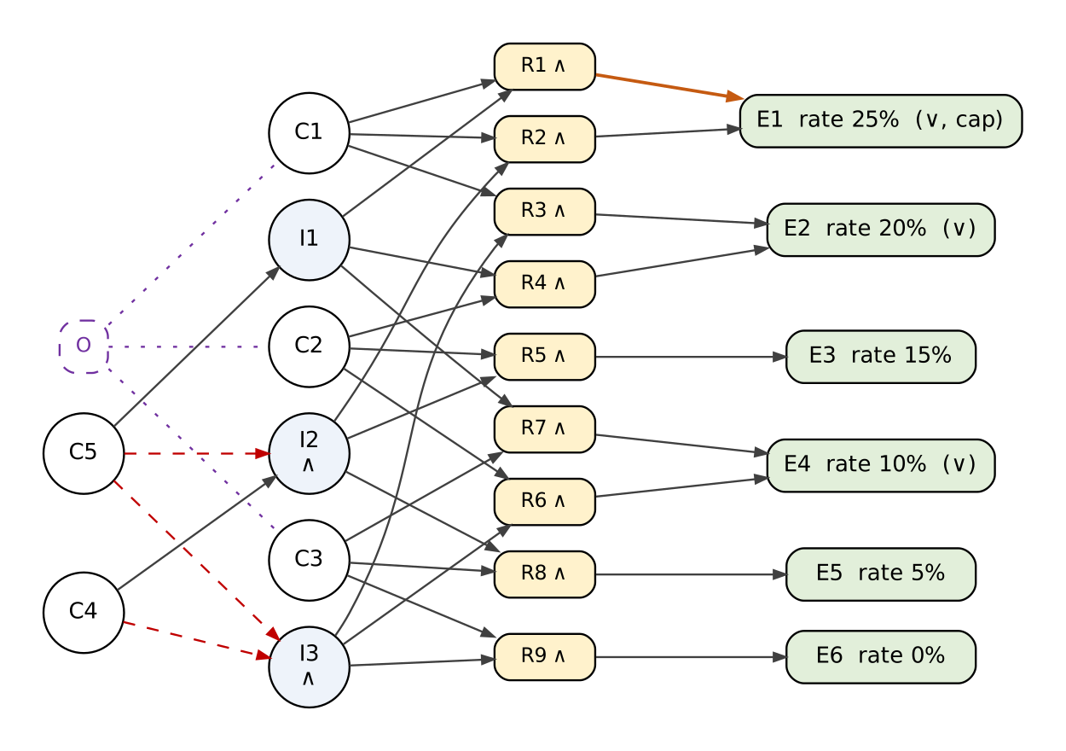
Figure 1: Cause-effect graph for the discount rule
C1 to C3 are the customer types (exactly one can be true), C4 is "5 or more tickets" and C5 is "SAVE10 used". The middle nodes decide the extra discount: I1 is the promo, I2 is bulk only when there is no promo (the red dashed NOT line is what stops the two combining), and I3 is no extra discount. Each R node joins one customer type with one of these, matching rules R1 to R9 in the table. The effects on the right are the six possible discounts; R1 and R2 both lead to 25% because of the cap.

One test per rule
I used 3 tickets for rules below the bulk threshold and 7 for rules above it, so no test sits on a boundary and each one checks a single rule.
TC | Rule | Input | Expected discount and total | Result
TC-28 | R1 | 3, STUDENT, SAVE10 | 20 + 10 = 30%, capped to 25%. 59.97 × 0.75 = 44.9775 → 44.98 | Fail - DEF-03
TC-29 | R2 | 7, STUDENT | 20 + 5 = 25% (right at the cap). 139.93 × 0.75 = 104.9475 → 104.95 | Fail - DEF-08
TC-30 | R3 | 3, STUDENT | 20%. 59.97 × 0.80 = 47.976 → 47.98 | Fail - DEF-08
TC-31 | R4 | 3, STAFF, SAVE10 | 20%. 59.97 × 0.80 = 47.976 → 47.98 | Fail - DEF-08
TC-32 | R5 | 7, STAFF | 15%. 139.93 × 0.85 = 118.9405 → 118.94 | Pass
TC-33 | R6 | 3, STAFF | 10%. 59.97 × 0.90 = 53.973 → 53.97 | Pass
TC-34 | R7 | 3, PUBLIC, SAVE10 | 10%. 59.97 × 0.90 = 53.973 → 53.97 | Pass
TC-35 | R8 | 7, PUBLIC | 5%. 139.93 × 0.95 = 132.9335 → 132.93 | Pass
TC-36 | R9 | 3, PUBLIC | 0%. 59.97 | Pass
TC-28 and TC-29 test the cap from both sides: one sum goes over 25% and must be cut back; the other lands exactly on it. I added three more tests with 7 tickets and SAVE10 (TC-37 to 39) to check that the two discounts don't combine, and two rounding tests (TC-40 and 41), one of which lands exactly on a half cent.

C4 State transition testing
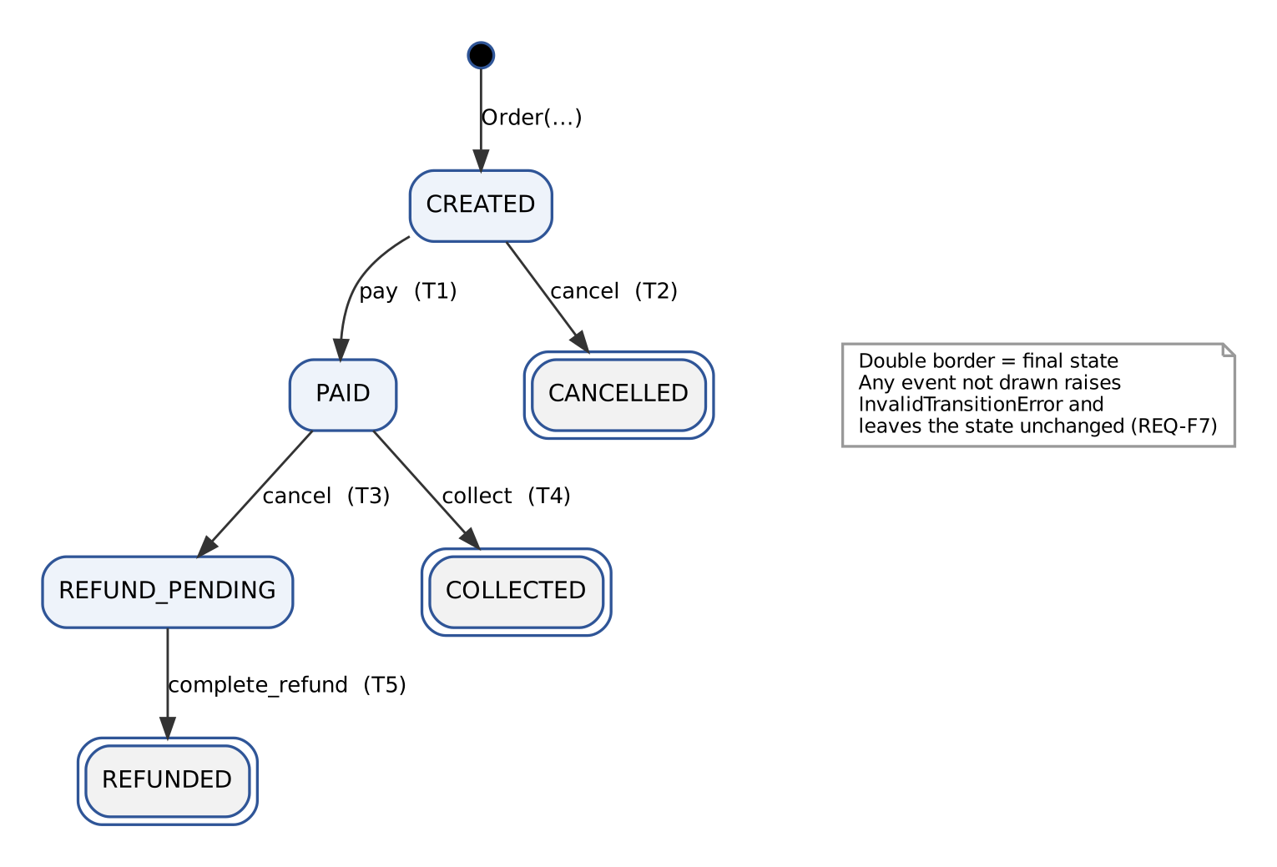
Figure 2: Order life cycle (REQ-F7). Double borders mark final states.
State / event | pay | cancel | collect | complete_refund
CREATED | PAID TC-44 | CANCELLED TC-45 | invalid TC-49 | invalid TC-50
PAID | invalid TC-51 | REFUND_PENDING TC-46 | COLLECTED TC-47 | invalid TC-52
COLLECTED | invalid TC-53 | invalid TC-54 | invalid TC-55 | invalid TC-56
REFUND_PENDING | invalid TC-57 | invalid TC-58 | invalid TC-59 | REFUNDED TC-48
REFUNDED | invalid TC-60 | invalid TC-61 | invalid TC-62 | invalid TC-63
CANCELLED | invalid TC-64 | invalid TC-65 | invalid TC-66 | invalid TC-67
There are 24 combinations of state and event. Only 5 are allowed; the other 19 must raise InvalidTransitionError and leave the order as it was. I wrote one test for every cell, so I covered all valid transitions and every invalid combination. I also tested three longer journeys:
- TC-68: pay, then collect. The order should end COLLECTED and refuse any further event.
- TC-69: pay, cancel, then complete the refund. The order should end REFUNDED.
- TC-70: a rejected event first, then pay and collect. The rejected event shouldn't break anything.
Each test builds a fresh order and gets it into the starting state by the normal route. When that route itself broke, I marked the test as blocked rather than failed. That happened to 8 tests, because cancelling a paid order never reached REFUND_PENDING (DEF-06).

Part D: Automation, results and bugs

D1 The automated suite
The 72 test cases became 74 pytest tests in three files: pricing, order life cycle and non-functional. A few choices are worth explaining:
- Traceable. Every test name contains its TC ID (for example test_bva_quantity_range[TC-23-qty-10]), and the suite refuses to run a test without one.
- Independent. No test depends on another or on the order they run in. Each order test starts from a new Order.
- Parameterised. Where the same check runs over many inputs (EP classes, boundaries, the 9 rules, the 24 state cells), I used one test with a row per case.
- Exact money checks. I compare amounts as Decimal("44.98"), never as floats. A float can't store 19.99 exactly, and a tolerance would have hidden the one-cent rounding bug.
- Clear failures. Every message says what was expected, for example: TC-26 REQ-F4: calculate_discount(5, 'PUBLIC', None) expected rate 0.05, got 0.

D2 Running it locally and in CI
Run | Result | Evidence
Raw run (bugs visible) | 50 passed, 24 failed | ci/run1_raw_local.log, junit_report_raw.xml
Normal run (bugs logged) | 50 passed, 24 expected failures | ci/run2_gated_local.log, junit_report.xml
Check against a fixed version | The 24 marked tests turn red | ci/run3_fixed_build_check.log
Once a bug was logged, I marked its tests as expected failures linked to the bug ID (xfail(strict=True, reason="DEF-06")). With 8 known bugs, a build that is always red would hide any new problem; this way the pipeline stays green until something new breaks. The "strict" setting also turns the build red when a bug gets fixed, so the marker can't be forgotten. I proved this with the third run above. The pipeline still runs a raw step on every push, so the failures are never hidden.

D3 Bug reports
I logged one report per root cause, not one per failing test. All of them can be reproduced in under a minute from a Python prompt in the src/ folder. Environment for all reports: Python 3.13 (local) and 3.10/3.12 (CI), pytest 9.1, Linux, tickethub.py unchanged (sha256 71e842b2…f722c4a3). The full reports are in the defects/ folder.
ID | Bug | Req. | Severity | Priority
DEF-01 | Maximum quantity 10 is rejected with ValueError | REQ-F1 | Major | P1: fix before release
DEF-02 | Bulk discount is not applied when exactly 5 tickets are bought | REQ-F4 | Major | P1: fix before release
DEF-03 | Discount cap is 30% instead of 25% | REQ-F4 | Major | P1: fix before release
DEF-04 | Promo code is accepted regardless of letter case | REQ-F6 | Minor | P2: fix if possible
DEF-05 | Promo discount and bulk discount are added together | REQ-F4 | Major | P1: fix before release
DEF-06 | Cancelling a paid order goes to CANCELLED, so the refund is never started | REQ-F7 | Critical | P1: fix before release
DEF-07 | Cancel is accepted on a COLLECTED (final) order and starts a refund | REQ-F7 | Critical | P1: fix before release
DEF-08 | Totals are truncated instead of rounded half-up | REQ-F5 | Minor | P2: fix if possible

DEF-01: Maximum quantity 10 is rejected with ValueError
Requirement | REQ-F1: quantity is a whole number from 1 to 10 inclusive
To reproduce | from tickethub import *  calculate_total(10, 'PUBLIC')
Expected | 189.91
Actual | ValueError: quantity must be between 1 and 10. Order(10, 'PUBLIC') fails the same way.
Severity / priority | Major / P1. Nobody can buy the maximum of 10 tickets, which will come up with group bookings on day one.
Likely cause | _validate() tests quantity >= MAX_QTY instead of quantity > MAX_QTY (off-by-one on the upper limit).
Tests affected | TC-23 (fails). Found by three-value BVA; EP (TC-01) alone would not find it.

DEF-02: Bulk discount is not applied when exactly 5 tickets are bought
Requirement | REQ-F4: additional 5% if the quantity is 5 or more
To reproduce | from tickethub import *  calculate_discount(5, 'PUBLIC'); calculate_total(5, 'PUBLIC')
Expected | Rate 0.05, total 94.95
Actual | Rate 0, total 99.95. Six tickets get the discount correctly.
Severity / priority | Major / P1. Everyone buying exactly 5 tickets is overcharged by about 5.
Likely cause | calculate_discount() uses quantity > BULK_THRESHOLD instead of >=.
Tests affected | TC-26 (fails). TC-25 and TC-27 either side of the threshold pass.

DEF-03: Discount cap is 30% instead of 25%
Requirement | REQ-F4: discount rate = min(type discount + additional discount, 25%)
To reproduce | from tickethub import *  calculate_discount(3, 'STUDENT', 'SAVE10')
Expected | Rate 0.25 (30% capped to 25%), total 44.98
Actual | Rate 0.30, total 41.97
Severity / priority | Major / P1. Every student using SAVE10 gets 5% too much off, and students are the main audience.
Likely cause | Constant DISCOUNT_CAP = Decimal('0.30'); the spec value is 0.25.
Tests affected | TC-28 (fails); TC-39 also fails partly because of it (see DEF-05).

DEF-04: Promo code is accepted regardless of letter case
Requirement | REQ-F6: the only valid promo code is SAVE10 and it is case-sensitive; any other value raises ValueError
To reproduce | from tickethub import *  calculate_total(2, 'PUBLIC', 'save10')
Expected | ValueError (the code is case-sensitive)
Actual | 35.98: the promo is accepted
Severity / priority | Minor / P2. The discount is the same as the real code gives, so little money is lost, but the rule is broken.
Likely cause | _validate() and calculate_discount() normalise the code with .upper() before looking it up.
Tests affected | TC-15 (fails). TC-16, TC-17, TC-18 (other invalid codes) pass.

DEF-05: Promo discount and bulk discount are added together
Requirement | REQ-F4: additional 10% if a valid promo code is supplied; otherwise 5% for 5 or more. The two never combine
To reproduce | from tickethub import *  calculate_discount(7, 'PUBLIC', 'SAVE10')
Expected | Rate 0.10, total 125.94
Actual | Rate 0.15, total 118.94. STAFF gives 0.25 instead of 0.20.
Severity / priority | Major / P1. Every promo order of 6 or more tickets loses 5% of its value.
Likely cause | calculate_discount() accumulates both additions (extra += promo; extra += bulk) instead of if / elif.
Tests affected | TC-37, TC-38, TC-39 (fail). TC-39 (STUDENT) shows 0.30 because of DEF-05 and DEF-03 together.

DEF-06: Cancelling a paid order goes to CANCELLED, so the refund is never started
Requirement | REQ-F7: PAID --cancel--> REFUND_PENDING (money must be returned)
To reproduce | from tickethub import *  o = Order(2, 'PUBLIC'); o.pay(); o.cancel(); print(o.state)
Expected | REFUND_PENDING
Actual | CANCELLED. complete_refund() then raises InvalidTransitionError, so the refund can never happen.
Severity / priority | Critical / P1. A customer who pays and then cancels loses their money. It also blocked 8 of my tests.
Likely cause | _TRANSITIONS maps ('PAID', 'cancel') to 'CANCELLED' instead of 'REFUND_PENDING'.
Tests affected | TC-46, TC-69 (fail). Blocked by it: TC-48, TC-57, TC-58, TC-59, TC-60, TC-61, TC-62, TC-63.

DEF-07: Cancel is accepted on a COLLECTED (final) order and starts a refund
Requirement | REQ-F7: COLLECTED is a final state; every non-listed state/event pair raises InvalidTransitionError and leaves the state unchanged
To reproduce | from tickethub import *  o = Order(2, 'PUBLIC'); o.pay(); o.collect(); o.cancel()
Expected | InvalidTransitionError; order stays COLLECTED
Actual | No error. The order goes to REFUND_PENDING and can then be refunded.
Severity / priority | Critical / P1. Someone can collect their tickets, attend the event and still get their money back.
Likely cause | _TRANSITIONS contains an extra entry ('COLLECTED', 'cancel') -> 'REFUND_PENDING'.
Tests affected | TC-54, TC-68 (fail). The other 17 invalid-pair tests that could run pass.

DEF-08: Totals are truncated instead of rounded half-up
Requirement | REQ-F5: total rounded half-up to two decimal places
To reproduce | from tickethub import *  calculate_total(3, 'STUDENT')
Expected | 47.98 (47.976 rounded half-up)
Actual | 47.97. The extra decimals are cut off instead of rounded.
Severity / priority | Minor / P2. At most one cent per order, but totals won't match receipts or the accounts.
Likely cause | calculate_total() quantizes with ROUND_DOWN instead of ROUND_HALF_UP.
Tests affected | TC-29, TC-30, TC-31, TC-40, TC-41 (fail). Totals whose 3rd decimal is < 5 (e.g. TC-33) pass.

Part E: Test summary

E1 What ran and what it covered
Area | Planned | Ran | Passed | Failed | Blocked
Equivalence partitioning | 18 | 18 | 17 | 1 | 0
Boundary values | 9 | 9 | 7 | 2 | 0
Decision table and rounding | 14 | 14 | 5 | 9 | 0
State transitions | 29 | 21 | 17 | 4 | 8
Non-functional checks | 2 | 2 | 2 | 0 | 0
Total | 72 | 64 | 48 | 16 | 8
Every functional requirement was tested. REQ-F2 (customer type) and REQ-F3 (unit price) passed completely; the other five each had at least one bug. The rewritten REQ-N1 passed. REQ-N2 wasn't tested because it needs a deployed system.

E2 Where the bugs came from
Bug | Most likely introduced in | Found in | Cheapest place to catch it
DEF-01 (Major) | Coding | Unit testing | Coding: unit test with BVA, or code review against REQ-F1
DEF-02 (Major) | Coding | Unit testing | Coding: unit test with BVA on the threshold
DEF-03 (Major) | Coding | Unit testing | Coding: decision-table unit test or review of constants against spec
DEF-04 (Minor) | Design / coding | Unit testing | Coding: EP unit test with an invalid-case class
DEF-05 (Major) | Design | Unit testing | Design: cause-effect graph / decision table review before coding
DEF-06 (Critical) | Design | Unit testing | Design: state-transition model walkthrough against REQ-F7
DEF-07 (Critical) | Design | Unit testing | Design: state x event table review (every cell, not only valid ones)
DEF-08 (Minor) | Coding | Unit testing | Coding: unit test with EP on the third decimal (< 5, = 5, > 5)
What if DEF-06 had reached customers? Every buyer who paid and then cancelled would lose their ticket and their money, with no refund on record. With a few hundred orders in launch week, even a small cancellation rate could leave dozens of people out of pocket. Finance would have to match payments against orders by hand and refund each one. Support would be flooded, card chargebacks would add fees, and the organiser could face consumer-protection complaints. The fix would go out as a rushed hotfix, plus a clean-up of the orders already stuck. Worse still, with DEF-07 the only working way to get a refund would be for people who had already collected their tickets. Caught in a design review, this was a one-line correction. In production, it would cost many times more in money and in trust.

E3 Should it be released? No, not yet.
My test plan said to stop when there were no open Critical or Major bugs. Right now there are two Critical and four Major bugs open, so that condition isn't met. The other exit conditions are met: every test ran or was blocked by a logged bug, every requirement was covered, and every failure was reported.
The problems aren't cosmetic. Paying customers who cancel don't get refunded, collected tickets can be refunded, some buyers are overcharged, and the most valuable promo orders lose revenue. There's no workaround at checkout that avoids these paths, so even a conditional release isn't safe.
The good news is that each bug looks small and isolated. If DEF-01 to DEF-07 are fixed, the blocked tests are run and the full suite passes on the release build, next week is still realistic. DEF-04 and DEF-08 could be accepted as known issues if the organiser agrees.

E4 Reflection: is testing the same as QA?
No, and this week made the difference clear to me. My testing was quality control: I checked a finished module and found eight bugs that were already in it. Testing can show that bugs exist, but it can never show there are none, and on its own it doesn't improve anything until someone fixes the code.
The quality assurance work was different. Reviewing the requirements, writing a plan with clear exit criteria, building the traceability matrix and setting up CI to check every change are all about the process. They try to stop bugs from getting in, or catch them sooner. Three of my bugs (DEF-05, 06 and 07) were design mistakes. A quick review of the state table and discount logic before coding would have prevented them more cheaply than my tests found them.
There is one kind of problem my approach could never catch: a mistake in the specification itself. All my expected results came from Appendix A. If the organiser had actually agreed that promo and bulk discounts should stack, my tests would have happily confirmed the wrong rule. Only checking with the organiser can catch that.

Part F: The submission package
The folder runs as described with make install && make test. Any item can be traced from end to end. For example, REQ-F7 leads to the (PAID, cancel) cell of the state table, then to test TC-46, its failure message, bug DEF-06, and the 8 tests DEF-06 blocked.
Folder | What's in it
report/ | This report
test_design/ | test_cases.xlsx (all 72 cases, traceability, decision and state tables), cause-effect graph, state diagram
src/ | tickethub.py, unchanged
tests/ | The pytest suite
defects/ | DEF-01 to DEF-08 and a defect log
ci/ | Pipeline config, run logs and JUnit XML reports
README.md | How to run it, and why logged bugs are marked as expected failures

