Addressing the complexity of modeling building energy dynamics using a component-based approach

**Muhammad Anas Munir** and **Georg Hackenberg**  
Chair for Software and Systems Engineering, Technische Universität München  
anas.munir@tum.de, hackenbe@in.tum.de

# Abstract

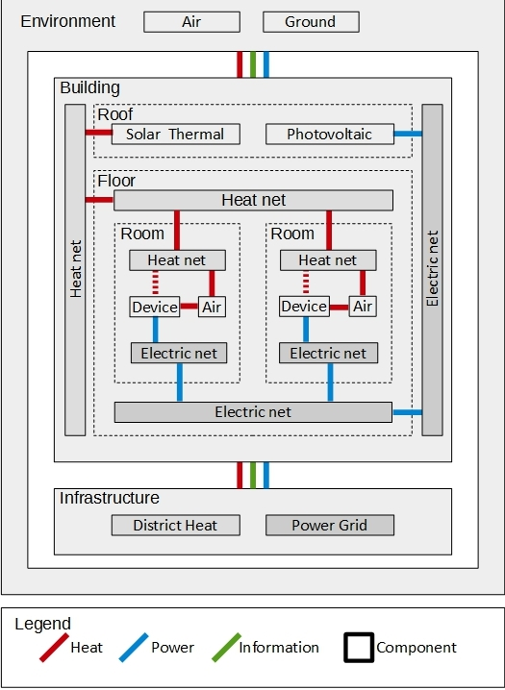Efficient building energy management is becoming increasingly important. Existing building energy management approaches range from classic optimal control techniques [1, 2] to dedicated control architectures [3]. Optimal control techniques [1, 2] typically include some form of building energy dynamics modeling, while the models usually are represented by sets of differential equations. This model representation allows precisely to describe the interactions between the physical variables (e.g. room temperature and heat exchange), but with increasing building complexity managing the variables and interactions can become difficult. Control architectures [3], on the other hand, focus on the structure of respective controller systems, e.g. using a three-layered approach including device drivers (e.g. for washing machines), prevention measures (e.g. circuit breaker activation) and anticipation strategies (e.g. user demand forecast and weather forecast). Together, optimal control techniques and control architectures already provide powerful tools for efficient building energy management. However, existing approaches typically are limited to a single form of energy (i.e. electricity or heat) [1, 2] and are restricted in complexity due to the underlying model representation. In this paper we address these problems using a component-based approach for modeling of buildings (see Figure 1), which can be combined with existing model representations for expressing building energy dynamics. The approach allows one to model not only the building, but also the surrounding infrastructure (e.g. the power grid and district heating) and the environment using respective components with heat, power and information interfaces. Furthermore, the building can be decomposed into the roof, floors and rooms with supporting heat, power and communication infrastructure components. Finally, the rooms contain air and device components, while devices interact with the air as well as infrastructure components. We evaluate the presented approach with respect to comprehensibility and completeness. To evaluate comprehensibility we perform a user study asking for advantages and disadvantages of the presented approach. To evaluate completeness, on the other hand, we map the features of existing building models to the features of the proposed approach. We conclude that the component-based approach indeed provides a comprehensive and complete building model with focus on energy dynamics.

Figure 1: Overview of the component-based modeling approach including building, infrastructure and environment components as well as heat and electricity interfaces.

# References

[1] Gregory De Oliveira, Mireille Jacomino, Duy Long Ha, Stephane Ploix (2011). Optimal power control for smart homes. In: 18th IFAC World Congress Milano (Italy)

[2] Mireille Jacomino, Minh Hoang Le (2011). Robust energy planning in buildings with energy and comfort costs. In: Springer-Verlag

[3] Ha DL, Ploix S, Zamai E, Jacomino M (2006). A home automation system to improve the household energy control. In: INCOM2006 12th IFAC symposium on information control problems in manufacturing

# Notes

* [2] uses the framework proposed by [3] for his study.
  + Okay, did you address this issue already?
* I think there is no need to show the interface between Device and Heat Net components. Since Device is running on electricity and is interacting with air in terms of heat rejection or addition to air. And air is communicating with heat net to see if it needs heating or not to maintain the reference temperature. That’s why I have drawn the interface in dotted lines between Device and Heat net. Tell me what’s your approach on that and then I will adjust the diagram based on our decision.
  + I thought, space heaters would be devices connected to the heat pipes (i.e. heat net) inside the building. I guess what you propose is to connect the heat pipes to the room air directly. Not sure what is the more accurate and intuitive approach. I thought, we should use devices for the intended interactions and infrastructure components (i.e. heat net, power net, etc.) as enablers.
* About communication/information interface, should we show it inside building as well or just showing it between the three main components will do so. The present standing is also fine. But if we want to show picture in more detail then communication/information interface can be added between components at every level, since there is flow of information between every component based on which decision is made.
  + Well, I think it depends on what we would like to model here. Either, we would like to model the information flow between software components, then the flow depends on the way software components are distributed onto our building components. Another option would be to model the communication components (e.g. lan/wlan router, gateway, Internet). I think I prefer the second option, because our model focuses on building hardware and not on the software.
  + Now the question, if we should show some components there. I believe yes. Maybe you could add some Ethernet at the bottom of the building and the internet as part of the infrastructure. Then I would leave out the concrete connections between the building components and the Ethernet. What do you think about this idea?
* I have shown power interface with the environment because we have Solar Panels, which are extracting electricity from sun light. But its only one way interface i.e. from sun to our battery banks or devices.
  + I am not sure, power is the right term. Isn’t heat also a form of power? Therefore maybe we should use the terms electricity and heat. Then light should also be a form of power/energy, right? Also I was wondering whether we should distinguish between the different types of heat interfaces (i.e. convection, conduction, radiation)? But we should not overload the figure with information such that nobody can follow anymore.