**Jordan University of Science and Technology**  
Software Engineering Department  
SE321: Software Requirements Engineering  
First Semester 2023

**Final Project - Part 1**

Domain Understanding & Elicitation

|  |  |
| --- | --- |
| Name | ID |
| Ghada Ziad Musallam | **144155** |
| Rana Ahmad Hazaimeh | **145419** |
| Farah Mohannad Al Mahmoud | **144156** |
| Ayaa Mohammad Khalid Obeidat | **146842** |

# **Upcycled Food System (UCFS)**

**Every year, more than 30% of food that has passed its expiration date is thrown away. So, this is very wasteful and bad for the environment that can contribute to global warming, and food waste also contributes to emissions.**

**Also, according to the United States Department of Agriculture, food waste is the main contributor to solid waste landfills. “Highlighting food loss along the food supply chain, the minister said that globally, an estimated 14 per cent of the food produced is lost or wasted in the post-harvest phase before reaching the retail stage.**

**In Jordan, on a per capita basis, an individual wastes 93kg of food each year, while on a global per capita level, 121 kilograms of food is wasted per year at the consumer level, he said.**

**He added that a total of 935,000 tons of food are wasted each year in the Kingdom, noting that agricultural production waste could reach 41 per cent in produce, and 34 per cent in grain products.”**

**Food lost and wasted food could feed 1.26 billion hungry people each year. Moreover, food loss and waste accounts for 10% of global greenhouse gas emissions and contributes to climate instability and extreme weather events such as droughts and floods.**

**Also, a lot of food is wasted due to improper storage. Additionally, food waste accounts for more than 25% of Jordan's total freshwater consumption each year, making it one of the leading sources of freshwater pollution.**

**“Upcycled foods use ingredients that otherwise would not have gone to human consumption, are procured and produced using verifiable supply chains, and have a positive impact on the environment.”**

**We have developed a program to make the best use of food products, so that we agree with stores and shops that sell vegetables and fruits to use the damaged materials in a way that makes them usable and produce new ones.**

**Our program will be the best solution for every supermarket or vegetable market that doesn’t know what to do with their wasted food they could communicate through this application to provide us with their information and take the expired food to places that can recycle it and make new products from it. Also, the application is not only limited for expired food but also for the wasted food that comes from the restaurants.**

**The system will open new ways to communicate with stores and restaurants to collect the food and recycle it and protect our environment from many things such as, global warming, water loss and floods.**

**There are many ways to recycle the wasted and expired food and one is that we crush the food with packaging in special factories and then used as an additive for cement production. Part of the expired products can be used as animal feed in the initial form or after processing. Meat, sausage products, bakery products, confectionery and other products are fed.**

**Recycled products prevent food waste by turning expired food into new, high-quality products. It is a revolutionary approach to food waste and the first consumer product-based solution that makes it highly scalable and economically sustainable.**

**The main objectives in the system-to-be (new system):**

1. **First application to combine the wasted food from the restaurants and the expired food from stores.**
2. **There will be a communication between restaurants and recycling factories also, between stores.**
3. **There will be a points counter that will increase every time the restaurants or the stores communicate with us eventually, they will turn into money depending on the points.**
4. **We will make new products from the wasted or expired food.**
5. **The factories which will recycle the wasted or expired food will also have an account on the application to communicate also they will have point along with the users when they accept the order.**
6. **We will protect the environment and help climate change and the global warming.**
7. **Upcycled foods are made from ingredients that would otherwise have ended up in a food waste destination.**

# **Upcycled Food System (UCFS) : SRS:**

**Purpose of the Document:**

**The purpose of this Software Requirements Specification (SRS) is to provide a detailed description of the requirements for Upcycled Food System. The SRS outlines the functional and nonfunctional requirements for the system, as well as the external interfaces and other requirements that must be met in order to develop and implement the system.**

**This SRS is intended for use by the development team, stakeholders, and other parties involved in the development, testing, and maintenance of the system. It serves as a reference for the design and implementation of the system, and it provides a common understanding of the requirements among all stakeholders.**

**By documenting the requirements in this SRS, we aim to ensure that the system meets the needs and expectations of the users and that it is developed and delivered in a consistent and reliable manner.**

**Introduction**:

**The Upcycled Food System is a software platform that aims to reduce food waste and provide an alternative source of nutrition by creating and selling food products made from upcycled ingredients. The system will provide an online marketplace for consumers to purchase upcycled food products, as well as a tool for producers to manage the sourcing, production, and distribution of those products. The system will also include features for inventory management, customer relationship management, recipe management, and sustainability tracking. This SRS document outlines the functional and non-functional requirements for the Upcycled Food System, as well as the constraints and assumptions that have been made during its development.**

**Scope:**

* **The types of upcycled food products that will be available on the platform.**
* **The functionality of the online marketplace, including the ability to browse and purchase products, track orders, and manage customer accounts.**
* **The tools and features that will be provided to producers to manage the sourcing, production, and distribution of upcycled food products.**
* **The security measures that will be implemented to protect sensitive data and prevent unauthorized access**
* **Any specific hardware or software dependencies that the system will have.**

**Definitions. Acronyms, and Abbreviations:**

**Here are some acronyms and abbreviations that are commonly used in the context of the upcycled food system:**

* **Upcycled food: food that has been transformed from its original form into a new product with a higher nutritional value or functional benefit**
* **FSMA: Food Safety Modernization Act**
* **FDA: Food and Drug Administration**
* **USDA: United States Department of Agriculture**
* **HACCP: Hazard Analysis and Critical Control Points**
* **GFSI: Global Food Safety Initiative**

**Requirements overview**

* **The upcycled food system shall transform surplus or waste food into high-quality products with a higher nutritional value or functional benefit.**
* **The upcycled food system shall comply with all relevant food safety regulations, including the FSMA, FDA regulations, and FSIS regulations.**
* **The upcycled food system shall have a HACCP plan in place to identify and control potential hazards in the production, processing, and distribution of upcycled food products.**
* **The upcycled food system shall be certified to at least one of the following standards: GFSI Global Markets Program, ISO 22000, or BRC Global Standard for Food Safety.**
* **The upcycled food system shall have a traceability system in place to track the origin and movement of upcycled food products through the supply chain.**
* **The upcycled food system shall have a quality management system in place to ensure the consistent production of high-quality upcycled food products.**
* **The upcycled food system shall have a sustainability plan in place to minimize waste and environmental impacts.**

**User Requirement:**

1. **Consumers:**

* **The system should provide an easy-to-use online marketplace for consumers to browse, and purchase upcycled food products.**
* **The system should allow consumers to create and manage their own accounts, including the ability to save payment information and track their order history.**
* **The system should provide clear and concise product descriptions, including information about the ingredients and nutritional content of the products.**
* **The system should allow consumers to search for products based on various criteria, such as dietary preferences or allergen information.**
* **The upcycled food system should allow consumers to customize their orders and choose from a wide variety of ingredients and flavors.**

1. **Producers:**

* **The system should provide tools and features to help producers manage the sourcing, production, and distribution of upcycled food products.**
* **The system should allow producers to input and track information about their upcycled food products, including expiration dates, storage requirements, and quantities available.**
* **The system should provide tools for managing the supply chain, including the ability to track orders and deliveries.**
* **The upcycled food system should have standardized recipes and ingredients to streamline production and reduce costs.**

1. **Administrators:**

* **The system should provide tools for managing and maintaining the platform, including the ability to add or remove users, products, and recipes.**
* **The system should provide tools for tracking and analyzing the sustainability impact of the upcycled food system, including metrics such as food waste reduction and carbon emissions.**
* **The system should provide tools for managing customer accounts and orders, including the ability to process refunds or returns.**

**References:**

* **IEEE 830 Standard for Software Requirements Specification**
* **FSMA regulations**
* **FDA Food Safety Modernization Act: Title 21 Code of Federal Regulations (CFR) Part 117**
* **USDA Food Safety and Inspection Service (FSIS) regulations**
* **GFSI Global Markets Program**
* **ISO 22000: Food safety management systems - Requirements for any organization in the food chain**

**Functional Requirement:**

1. **Online marketplace:**

* **The system should allow users to browse and search for upcycled food products.**
* **The system should allow users to view detailed product descriptions, including information about ingredients, nutritional content, and allergen information.**
* **The system should allow users to add products to their cart and place orders.**
* **The system should provide a secure payment gateway for users to complete their purchases.**

1. **Customer accounts:**

* **The system should allow users to create and manage their own accounts, including the ability to save payment information and track their order history.**
* **The system should allow users to update their account information, including their contact details and delivery address.**
* **The system should allow users to view their order history and track the status of their current orders.**

1. **Supply chain management:**

* **The system should allow producers to input and track information about their upcycled food products, including expiration dates, storage requirements, and quantities available.**
* **The system should provide tools for managing the supply chain, including the ability to track orders and deliveries.**
* **The system should provide tools for forecasting demand and managing inventory levels.**

1. **Sustainability tracking:**

* **The system should provide tools for tracking and analyzing the sustainability impact of the upcycled food system, including metrics such as food waste reduction and carbon emissions.**
* **The system should provide tools for reporting on the sustainability impact of individual products or producers.**

**NoN-Functional Requirement:**

1. **Usability:**

* **The system should be easy to use and navigate for all users, regardless of their technical expertise.**
* **The system should provide clear and concise instructions and prompts to guide users through tasks.**
* **The system should use intuitive design principles and common industry standards to make it easy for users to find and use the features they need.**

1. **Performance:**

* **The system should be able to handle a high volume of transactions and requests without experiencing delays or performance issues.**
* **The system should have a fast response time and low latency.**
* **The system should have high uptime and availability.**

1. **Security:**

* **The system should use industry-standard security practices to protect sensitive data and prevent unauthorized access.**
* **The system should encrypt data storage and transmission to protect against data breaches.**
* **The system should require user authentication and authorize access to specific features and data.**

1. **Maintainability:**

* **The system should be easy to maintain and update over time.**
* **The system should have clear documentation and a modular design to allow for easy updates and maintenance.**
* **The system should use industry-standard coding practices to ensure that it is easy to understand and maintain.**

1. **Scalability:**

* **The system should be able to handle an increase in users or data without experiencing performance issues.**
* **The system should be able to easily add additional hardware or software resources as needed.**

1. **Accessibility:**

* **The system should be accessible to all users, including those with disabilities.**
* **The system should comply with web accessibility standards and support assistive technologies.**

**Constraints:**

* **Budget: There may be a limited budget available for the development and maintenance of the Upcycled Food System. This could impact the scope and features of the system.**
* **Timeline: There may be a specific timeline for the development and launch of the Upcycled Food System. This could impact the scope and features of the system.**
* **Legal: There may be legal constraints that impact the development and operation of the Upcycled Food System, such as food safety regulations or data privacy laws.**

**Assumptions:**

* **Availability of upcycled food products: It is assumed that there will be a sufficient supply of upcycled food products available to meet the demand of the system.**
* **Interest in upcycled food products: It is assumed that there will be sufficient demand for upcycled food products to make the system viable.**
* **Internet access: It is assumed that users of the system will have access to the internet.**

# **Upcycled Food System (UCFS) : Context diagram:**

Payment



# **Upcycled Food System (UCFS) : Use Case:**

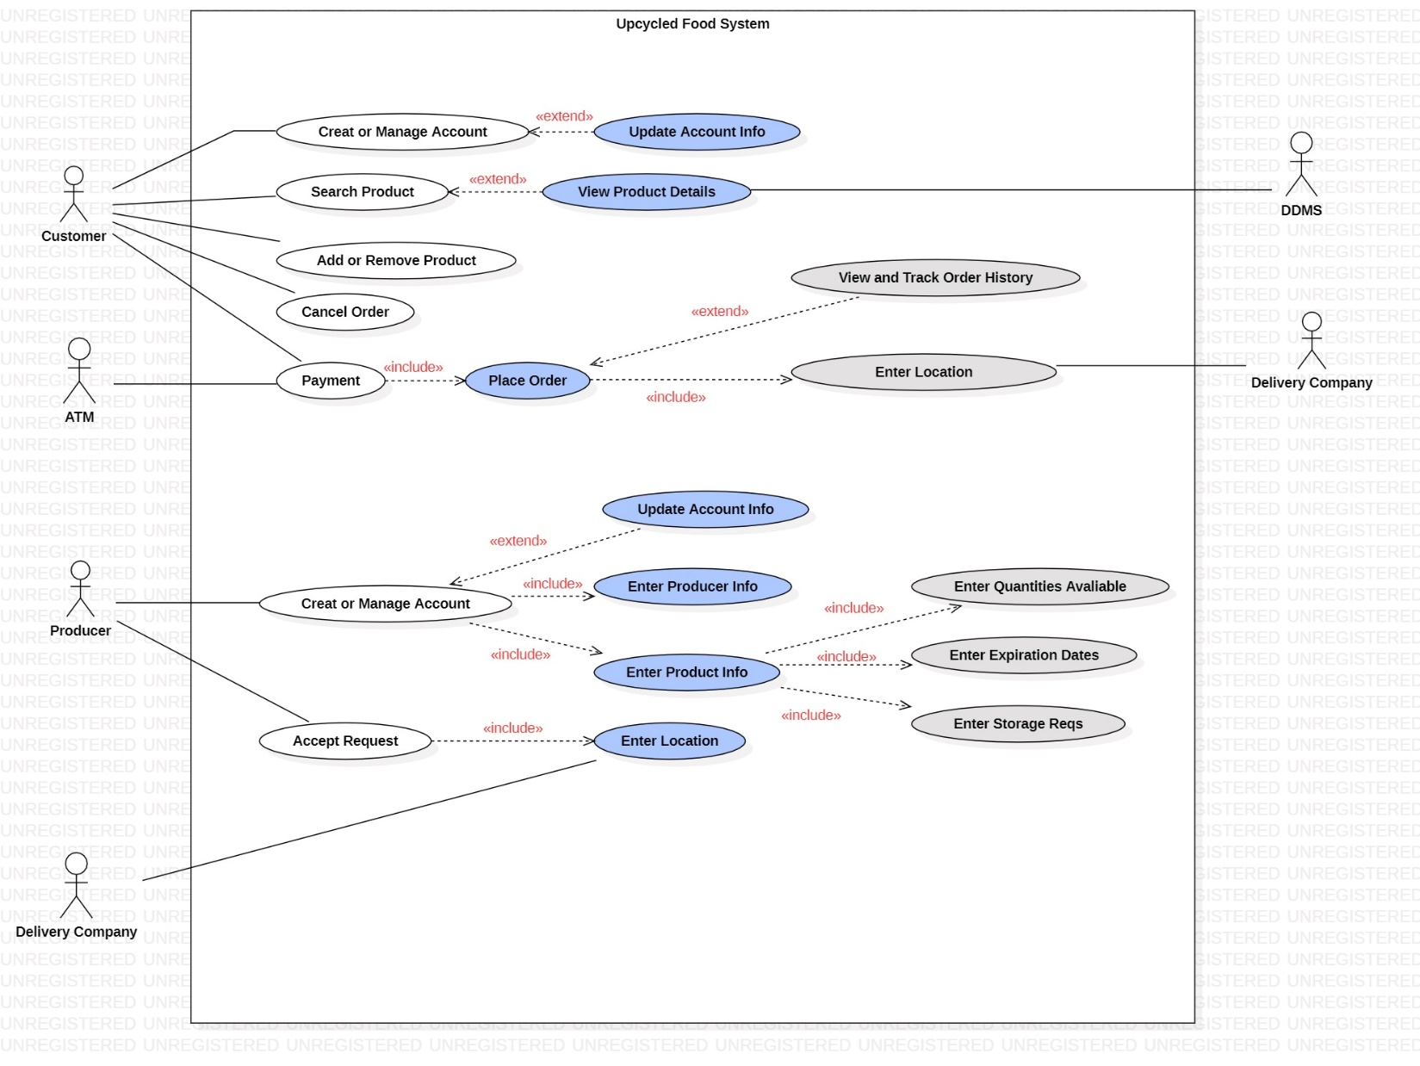

# **Upcycled Food System (UCFS) :**

**User interface prototypes for the main screens**

**in the system-to-be:**

**Mockup:**

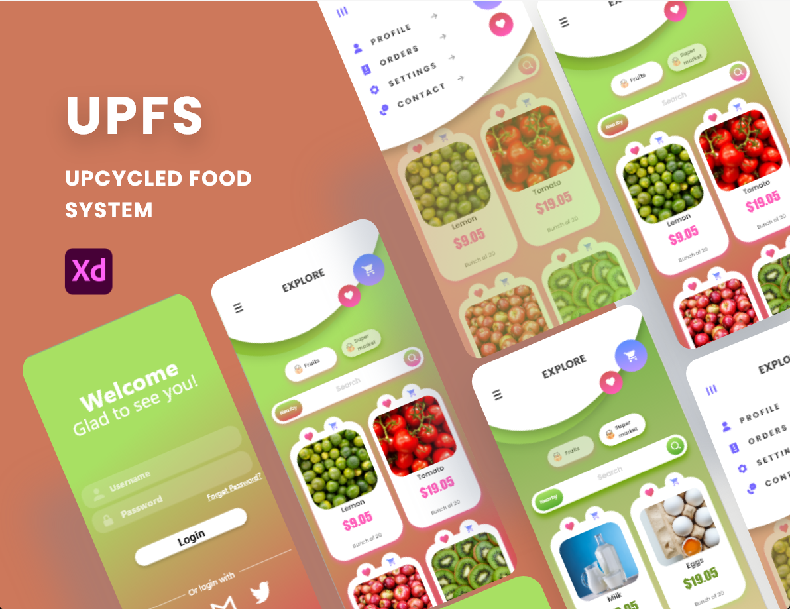

**Xd file:**

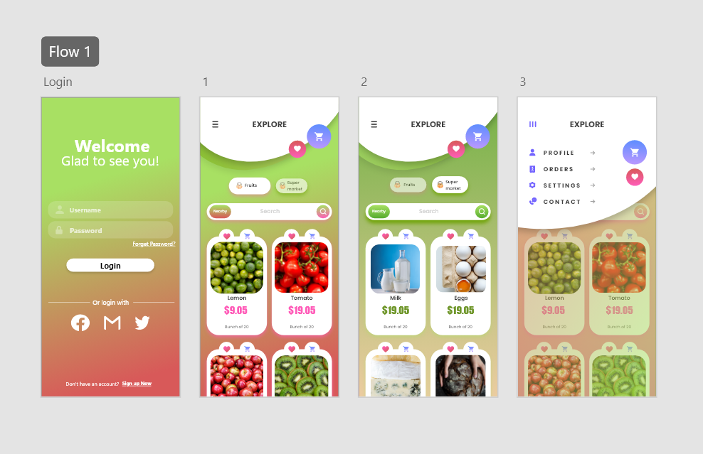

**Drive:**

<https://drive.google.com/file/d/1i4dkME9Gi2EhdF1s-vnlDOqqR2ZktxjX/view?usp=share_link\>

# **Upcycled Food System (UCFS) :**

**Inconsistency management:**

**– Types of inconsistency:**

1. **Terminology clash:**

**Consumers and Customers same concept named differently in different statements.**

1. **Weak conflict:**

**(Customer viewpoint)**

**“The upcycled food system should allow consumers to customize their orders and choose**

**from a wide variety of ingredients and flavors.”**

**vs. (Producer viewpoint)**

**“The upcycled food system should have standardized recipes and ingredients to streamline production**

**and reduce costs.”**

**– Handling inconsistencies:**

**Solution: Providing a limited number of customizable options within a framework of standardized recipes and ingredients or finding a way to streamline production without sacrificing the ability to offer a wide variety of ingredients and flavors.**

**– Managing conflicts: a systematic process:**

|  |  |  |  |  |
| --- | --- | --- | --- | --- |
| Statement | S1 | S2 | S3 | Total |
| **S**1 | **0** | **1000** | **1** | **1001** |
| **S**2 | **1000** | **0** | **0** | **1000** |
| **S**3 | **1** | **0** | **0** | **1** |
| **T**otal | **1001** | **1000** | **1** | **2002** |

**#Conflicts(S1) = remainder of (1001 div 1000)= 1**

**#nonConflictingOverlaps(S1) = quotient of (1001 div 1000)= 0**

# **Upcycled Food System (UCFS) :**

**Risk analysis:**

**– Types of risk:**

1. **Product-related risks:**

* **Food safety risk: This refers to the risk that the upcycled food products may not meet food safety standards or regulations, which could lead to negative consequences such as product recalls or legal liability.**
* **Quality risk: This refers to the risk that the upcycled food products may not meet the quality standards or expectations of customers, which could lead to negative impacts on customer satisfaction and brand reputation.**
* **Regulatory risk: This refers to the risk that the upcycled food system may not comply with relevant regulations, such as food safety regulations or sustainability standards, which could lead to negative consequences such as fines or penalties.**

1. **Process-related risks:**

* **Supply chain risk: This refers to the risk that disruptions or issues in the supply chain, such as delays, shortages, or quality problems, could impact the availability or reliability of upcycled food products.**
* **Technology risk: This refers to the risk that the upcycled food system may rely on technology that is unreliable, outdated, or incompatible with other systems, which could impact the efficiency and effectiveness of the system.**
* **Human resource risk: This refers to the risk that the upcycled food system may not have sufficient skilled personnel to operate and maintain the system, or that personnel may not be trained or motivated to perform their duties effectively.**

**– Risk management**

**Qualitative risk assessment table:**

**Risk: “Technical failure during the recycling process”**

|  |  |  |  |
| --- | --- | --- | --- |
| Risk likelihood | | | |
| Consequences | **Likely** | **Possible** | **Unlikely** |
| Financial losses | **Catastrophic** | **Catastrophic** | ***Severe*** |
| harmful products | ***Catastrophic*** | **Severe** | **high** |
| Customer anger | **High** | **Moderate** | **Moderate** |
| decrease in quality | **Catastrophic** | **Severe** | **High** |

**Reduce risk likelihood: Periodic maintenance work**

**– Risk documentation:**

**Risk Tree:**

**– DDP: quantitative risk management for RE:**

**Step 1: Elaborate the Impact matrix:**

|  |  |  |  |  |
| --- | --- | --- | --- | --- |
|  | ****Risks**** | | |  |
| **Objectives** | **brand reputation (Likelihood: 0.7)** | **Technology risk (Likelihood: 0.3)** | **Production delays (Likelihood: 0.5)** | ***Loss obj.*** |
| Regular availability of Upcycled food  (Weight: 0.4) | **0.4** | **0.5** | **0.2** | **0.212** |
| Comprehensive system coverage (weight: 0.3) | **0** | **0.4** | **0** | **0.036** |
| Operational costs decreased  (Weight: 0.2) | **0.1** | **0.2** | **0.3** | **0.056** |
| Risk criticality | **0.072** | **0.108** | **0.07** |  |

**Step 2: Elaborate the Effectiveness matrix:**

|  |  |  |  |  |
| --- | --- | --- | --- | --- |
|  | Weighted risks | | |  |
| Countermeasures | **Brand reputation (Likelihood: 0.7)** | **Technology risk (Likelihood: 0.3)** | **Production delays (Likelihood: 0.5)** | **Overall effect of countermeasure** |
| An email sent to the consumer | **0.7** | **0** | **0.6** | **0.0924** |
| ***purchase insurance to cover the costs of any delays or shortages*** | **0.9** | **0.2** | **0** | **0.0864** |
| ***implement a quality management system*** | **0** | **1** | **0** | **0.108** |
| Combined risk reduction | **0.03** | **0** | **0.4** |  |

* **Requirements prioritization:**
* **Evaluating alternative options for decision making:**

**Step 1: Compare requirements pairwise:**

|  |  |  |  |  |  |  |
| --- | --- | --- | --- | --- | --- | --- |
|  | ***Food safety risk*** | ***Quality risk*** | ***Regulatory risk*** | ***Supply chain risk*** | ***Technology risk*** | ***Human resource risk*** |
| ***Food safety risk*** | **1** | **3** | **5** | **7** | **9** | **5** |
| ***Quality risk*** | **1/3** | **1** | **3** | **5** | **5** | **7** |
| ***Regulatory risk*** | **1/5** | **1/3** | **1** | **7** | **3** | **5** |
| ***Supply chain risk*** | **1/7** | **1/5** | **1/7** | **1** | **3** | **9** |
| ***Technology risk*** | **1/9** | **1/5** | **1/3** | **1/3** | **1** | **3** |
| ***Human resource risk*** | **1/5** | **1/7** | **1/5** | **1/9** | **1/3** | **1** |

**Step 2: Evaluate how the criterion distributes among all requirements:**

|  |  |  |  |  |  |  |  |
| --- | --- | --- | --- | --- | --- | --- | --- |
|  | ***Food safety risk*** | ***Quality risk*** | ***Regulatory risk*** | ***Supply chain risk*** | ***Technology risk*** | ***Human resource risk*** | **Relative value** |
| ***Food safety risk*** | **0.03** | **0.10** | **0.16** | **0.23** | **0.30** | **0.16** | **0.16** |
| ***Quality risk*** | **0.01** | **0.04** | **0.14** | **0.23** | **0.23** | **0.32** | **0.61** |
| ***Regulatory risk*** | **0.01** | **0.02** | **0.06** | **0.42** | **0.18** | **0.30** | **0.17** |
| ***Supply chain risk*** | **0.01** | **0.01** | **0.01** | **0.07** | **0.22** | **0.66** | **0.20** |
| ***Technology risk*** | **0.02** | **0.04** | **0.06** | **0.06** | **0.20** | **0.60** | **0.13** |
| ***Human resource risk*** | **0.10** | **0.07** | **0.10** | **0.05** | **0.16** | **0.50** | **0.28** |

* **Evaluating alternative options for decision making (cost) :**

**Step 1: Compare requirements pairwise:**

|  |  |  |  |  |  |  |
| --- | --- | --- | --- | --- | --- | --- |
|  | ***Food safety risk*** | ***Quality risk*** | ***Regulatory risk*** | ***Supply chain risk*** | ***Technology risk*** | ***Human resource risk*** |
| ***Food safety risk*** | **1** | **1/3** | **1/5** | **1/5** | **1/9** | **1/7** |
| ***Quality risk*** | **3** | **1** | **1/5** | **1/7** | **1/3** | **1/7** |
| ***Regulatory risk*** | **5** | **5** | **1** | **1/7** | **1/3** | **1/5** |
| ***Supply chain risk*** | **5** | **7** | **7** | **1** | **1/3** | **1/9** |
| ***Technology risk*** | **9** | **3** | **3** | **3** | **1** | **1/5** |
| ***Human resource risk*** | **7** | **7** | **5** | **9** | **5** | **1** |

**Step 2: Evaluate how the criterion distributes among all requirements:**

|  |  |  |  |  |  |  |  |
| --- | --- | --- | --- | --- | --- | --- | --- |
|  | ***Food safety risk*** | ***Quality risk*** | ***Regulatory risk*** | ***Supply chain risk*** | ***Technology risk*** | ***Human resource risk*** | **Relative value** |
| ***Food safety risk*** | **0.03** | **0.56** | **0.19** | **0.23** | **0.31** | **0.21** | **0.25** |
| ***Quality risk*** | **0.19** | **0.22** | **0.51** | **0.32** | **0.27** | **0.45** | **0.32** |
| ***Regulatory risk*** | **0.11** | **0.02** | **0.45** | **0.28** | **0.17** | **0.41** | **0.24** |
| ***Supply chain risk*** | **0.11** | **0.05** | **0.31** | **0.20** | **0.26** | **0.71** | **0.27** |
| ***Technology risk*** | **0.08** | **0.09** | **0.06** | **0.04** | **0.34** | **0.56** | **0.19** |
| ***Human resource risk*** | **0.56** | **0.10** | **0.03** | **0.13** | **0.16** | **0.63** | **0.26** |

* Diagram, engineering drawing

  Description automatically generated**Class Diagram:**
* **OCL Statements:**

1. **Customer must be older than 18:**

**Context customer**

**inv: self.Age > 18**

1. **Every user must have a unique username:**

**Context customer**

**Inv: self.users->forAll(u1, u2 | u1.username <> u2.username)**

1. **A customer must have at least one item in their cart:**

**Context customer**

**Inv: R8.items ->forAll(o | o.items->size() > 0)**

1. **A payment must have a valid amount:**

**Context Payment**

**Inv: self.payments->forAll(p | p.amount > 0)**

1. **An item must have a unique item code:**

**Context item**

**Inv: self.item ->forAll(i1, i2 | i1.itemCode <> i2.itemCode)**

1. **An item must have a price greater than zero:**

**Context item**

**Inv: self.item ->forAll(i | i.price > 0)**

1. **A customer must have a valid address.**

**Context Customer**

**Inv: self.customer->forAll(c | c.address <> null)**

1. **A customer must have a password that is at least 8 characters long:**

**Context Customer**

**Inv: self.Customer ->forAll(c | c.password.size() >= 8)**

1. **An order must have a valid status.:**

**Context Order**

**Inv: self.order->forAll(o | o.status = 'pending' or o.status = 'processing' or o.status = 'shipped' or o.status = 'delivered')**

1. **A Customer must have a first and last name:**

**Context Customer**

**Inv: self.customer->forAll(c | c.Fname <> null and c.Lname <> null)**