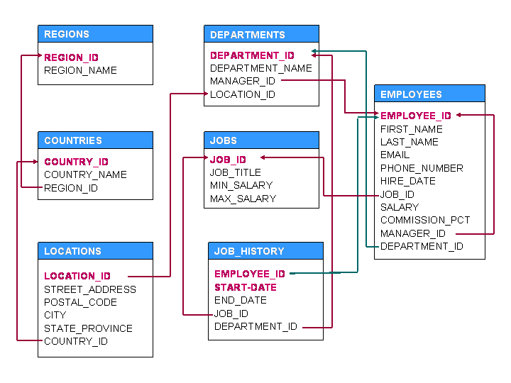

**Queries**

1. Display details of jobs where the minimum salary is greater than 10000.
2. Display the first name and join date of the employees who joined between 2002 and 2005.
3. Display first name and join date of the employees who is either IT Programmer or Sales Man.
4. Display employees who joined after 1st January 2008.
5. Display details of employee with ID 150 or 160.
6. Display first name, salary, commission pct, and hire date for employees with salary less than 10000.
7. Display job Title, the difference between minimum and maximum salaries for jobs with max salary in the range 10000 to 20000.
8. Display first name, salary, and round the salary to thousands.
9. Display details of jobs in the descending order of the title.
10. Display employees where the first name or last name starts with S.
11. Display employees who joined in the month of May.
12. Display details of the employees where commission percentage is null and salary

in the range 5000 to 10000 and department is 30.

1. Display first name and date of first salary of the employees.
2. Display first name and experience of the employees.
3. Display first name of employees who joined in 2001.
4. Display first name and last name after converting the first letter of each name to

upper case and the rest to lower case.

1. Display the first word in job title.
2. Display the length of first name for employees where last name contain character

‘b’ after 3rd position.

1. Display first name in upper case and email address in lower case for employees

where the first name and email address are same irrespective of the case.

1. Display employees who joined in the current year.
2. Display the number of days between system date and 1st January 2011.
3. Display how many employees joined in each month of the current year.
4. Display manager ID and number of employees managed by the manager.
5. Display employee ID and the date on which he ended his previous job.
6. Display number of employees joined after 15th of the month.
7. Display the country ID and number of cities we have in the country.
8. Display average salary of employees in each department who have commission

percentage.

1. Display job ID, number of employees, sum of salary, and difference between

highest salary and lowest salary of the employees of the job.

1. Display job ID for jobs with average salary more than 10000.
2. Display years in which more than 10 employees joined.
3. Display departments in which more than five employees have commission

percentage.

1. Display employee ID for employees who did more than one job in the past.
2. Display job ID of jobs that were done by more than 3 employees for more than

100 days.

1. Display department ID, year, and Number of employees joined.
2. Display departments where any manager is managing more than 5 employees.
3. Change salary of employee 115 to 8000 if the existing salary is less than 6000.
4. Insert a new employee into employees with all the required details.
5. Delete department 20.
6. Change job ID of employee 110 to IT_PROG if the employee belongs to

department 10 and the existing job ID does not start with IT.

1. Insert a row into departments table with manager ID 120 and location ID in any

location ID for city Tokyo.

1. Display department name and number of employees in the department.
2. Display job title, employee ID, number of days between ending date and starting

date for all jobs in department 30 from job history.

1. Display department name and manager first name.
2. Display department name, manager name, and city.
3. Display country name, city, and department name.
4. Display job title, department name, employee last name, starting date for all jobs

from 2000 to 2005.

1. Display job title and average salary of employees
2. Display job title, employee name, and the difference between maximum salary

for the job and salary of the employee.

1. Display last name, job title of employees who have commission percentage and

belongs to department 30.

1. Display details of jobs that were done by any employee who is currently drawing

more than 15000 of salary.

1. Display department name, manager name, and salary of the manager for all

managers whose experience is more than 5 years.

1. Display employee name if the employee joined before his manager.
2. Display employee name, job title for the jobs employee did in the past where the

job was done less than six months.

1. Display employee name and country in which he is working.
2. Display department name, average salary and number of employees with

commission within the department.

1. Display the month in which more than 5 employees joined in any department

located in Sydney.

1. Display details of departments in which the maximum salary is more than 10000.
2. Display details of departments managed by ‘Smith’.
3. Display jobs into which employees joined in the current year.
4. Display employees who did not do any job in the past.
5. Display job title and average salary for employees who did a job in the past.
6. Display country name, city, and number of departments where department has

more than 5 employees.

1. Display details of manager who manages more than 5 employees.
2. Display employee name, job title, start date, and end date of past jobs of all

employees with commission percentage null.

1. Display the departments into which no employee joined in last two years.
2. Display the details of departments in which the max salary is greater than 10000

for employees who did a job in the past.

1. Display details of current job for employees who worked as IT Programmers in

the past.

1. Display the details of employees drawing the highest salary in the department.
2. Display the city of employee whose employee ID is 105.
3. Display third highest salary of all employees