**entity relationship model**

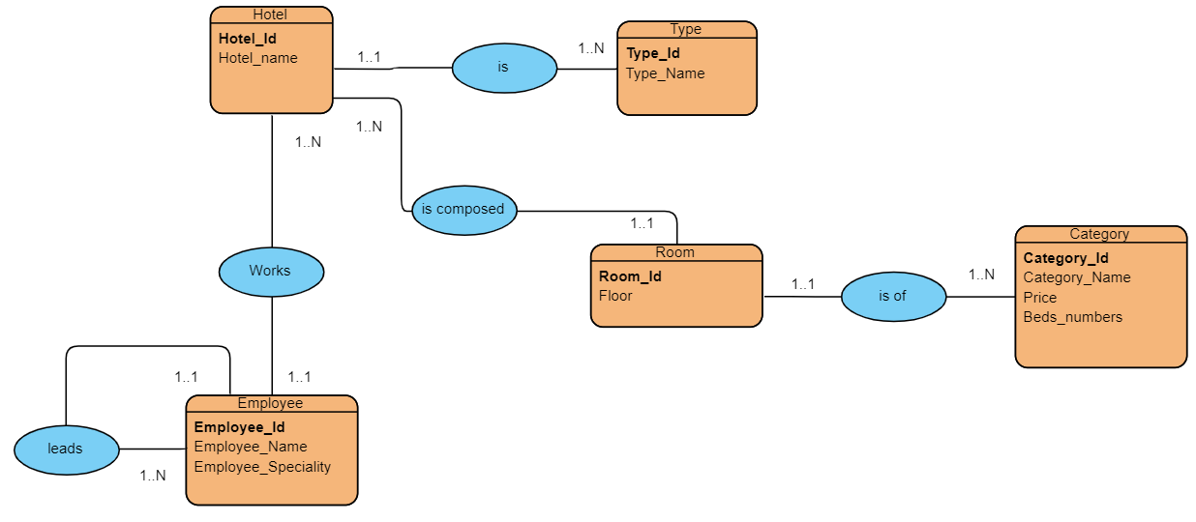

* **Convert the entity relationship model to a relational diagram:**

**Solution : relational-model diagram**

Hotel (**Hotel_id** ,Hotel_name,**#Type_id** )

Type (**Type_id,**Type_name)

Employee (**Employee_id**, Employee_Name, Employee_Specialty,**#Hotel_id**,**#leader_id**)

Room (Room_id,Floor,#Hotel_id,#Category_id)

Category (**Category_id**,Category_Name,Price,Beds_numbers)