Final Year Project Report
Full Unit – Final Report

Clustering Android Application Behaviour

Ghadah Alshehri

A report submitted in part fulfilment of the degree of
BSc (Hons) in Computer Science
Supervisor: Lorenzo Cavallaro

Department of Computer Science
Royal Holloway, University of London

Declaration
This report has been prepared on the basis of my own work. Where other published and unpublished source materials have been used, these have been acknowledged.

Word Count:

Student Name: Ghadah Alshehri

Date of Submission: 30/11/2017

Signature: GhadaShehri
Table of Contents
Abstract 4
Chapter 1: Introduction 5
1.1 Malware: 5
Chapter 2: Android 6
2.1 CopperDroid: 6
Chapter 3: Clustering 8
3.1 K-means Clustering Algorithm: 9
3.2 Hierarchal Clustering Algorithm: 10
3.3 Density-Based Spatial Clustering of Applications with Noise (DBSCAN): 12
Chapter 4: Machine Learning 15
4.1 Unsupervised Learning: 15
Bibliography 17

Abstract
Android platforms are emerging more widely every year. Consequently, the number of Applications in their Marketplace (Google Play) is significantly increasing. As a result, Cybercriminals are more focused on producing malicious applications that would affect the user. In this paper, using behavioural traces produced by CopperDroid System, as a starting point in analysing malicious behaviour. Extracting features that yield such behaviour, and using that, as the input for our clustering algorithm, will allow us to expose clusters of malicious behaviour. Each cluster, is representing a malware family, that shares a common set of behaviours among its members.

Introduction
Nowadays, Android has become one of the leading mobile operating system platforms, it recently reached two billion active devices on monthly basis. Android devices are mostly popular, since users are easily able to interact with the system, to access their personal data, and has a number of desired features [4].
In recent study conducted by Kaspersky, which proves the evolution of malware in 2016, “From the beginning of January till the end of December 2016, Kaspersky Lab registered nearly 40 million attacks by malicious mobile software and protected 4,018,234 unique users of Android-based devices”. Undoubtedly, with such huge growth in number of active devices, it is apparent that it will attract several malware authors targeting these devices [3]. However, the ultimate method to affect Android devices, is by inserting crafted malicious applications in their marketplace (Google Play), since it is the absolute way in which users can obtain a vast amount of applications [1]. Due to large number of uploads made to Google Play marketplace by different developers, with insufficient amount of checking, which lead to an increase in the number of Android malware [2]. On the other hand, Apple application store follow a strict approach, when adding new applications to their store, which effectively reduce the percentage of malware found in their store. Moreover, Android permit users to install applications form third-party sources, which are used to distribute malware, hence increase percentage [7].

Malware:
Malicious software (Malware) is considered to be a significant threat that opposes on the Internet and devices these days. Malware can appear in many extensive forms and variations, such as viruses, worms, Trojan horses, botnets and rootkits [5]. Its main objective, is to primarily act against the user’s interest. Thus, it can perform many harmful activities, which includes, spam, Denial of Service (DoS), gain access to user’s information. also, it can cause some hardware related problems by reducing the efficiency of the device which can be achieved, for example, by draining the battery [6]. Malware spread itself by exploiting vulnerabilities or social engineering techniques that deceive both the user and operating system to perform the activities mentioned earlier, for example, by downloading a malicious application and running it, which may eventually lead to compromising login information and commit fraud, or by sending spam that will affect other users [6].
Analysing malware samples, is an important step, to determine the actions performed and how much these actions affect the underlying system. In addition, the resulting information is valuable, since it eases the process of writing removal procedures and producing signatures for each simple [6].

Android
Android applications are written in java language, and then deployed to Android Packages archives, known as APK’s. Each APK contains multiple components, which can be described as a program in whole. Each component is designed to accomplish a certain task, for example, user-interface interactions. In every APK file there must be a manifest included, which contains a list of components, permissions, software and hardware features an application has and probably will use. Interestingly, the applications manifest can reveal some information about whether the application is malicious or not.
Each android application run in a separate userspace process, which in fact is assigned a unique user and group ID. Thus, each application has an isolated environment. However, applications are able to communicate thoroughly using clearly defined application programming interface(API) [1]. Via, inter-process communication(IPC) and remote procedure calls(RPC), which are main mechanisms in which applications interact. Using the Binder protocol, a process is allowed to invoke several methods of another object, through synchronous calls. Hence, the Binder protocol mostly handles these remote calls [1].

CopperDroid:
CopperDroid is VMI-based System, where a user can upload an APK file to get analysed, and will reconstructs a JavaScript object notation file (.json extension), and .syscalls file. Generated files, include highly detailed behavioural profile on the submitted application. The analysis that CopperDroid outputs, consist of operating system specific(low-level), and Android specific(high-level) behaviours. Some examples on low, high level behaviour, is writing to a file or executing a program, and as for high-level, making a phone call or sending an SMS. Moreover, since CopperDroid depends on tracking system calls made, it is able to remain resistant, when there’re changes made in the Android environment [1]. Another benefit of using CopperDroid, that It can explicitly indicate where the malicious application will initiate its behaviour from, either from java, or native code execution [2].
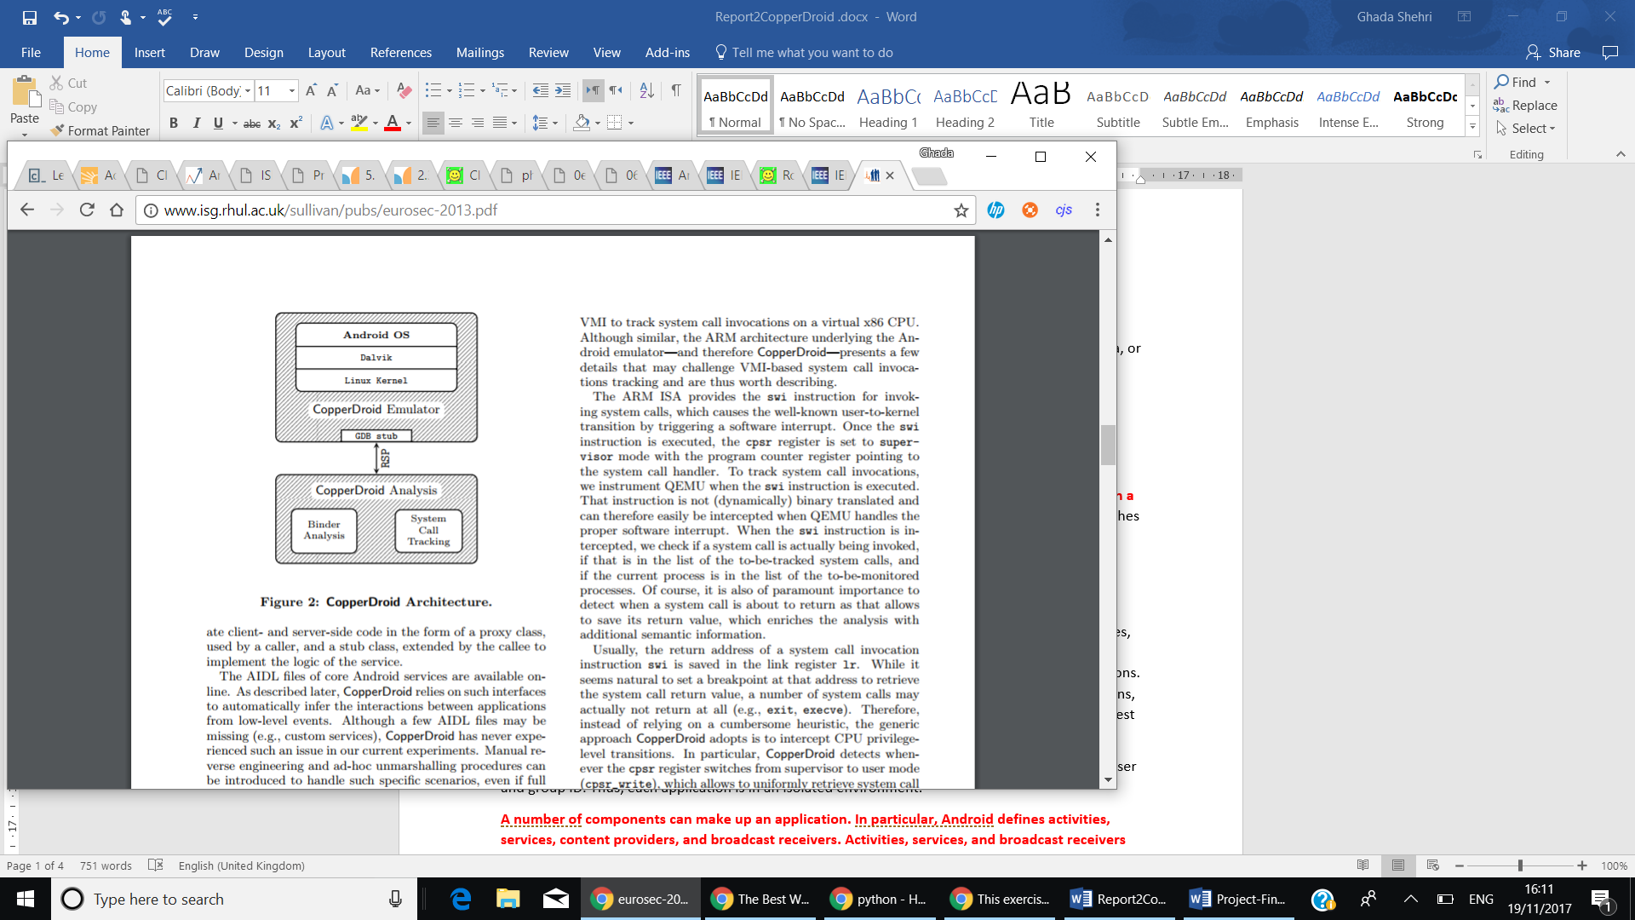
Nonetheless, the structure of CopperDroid, is that the Android system is built on top of CopperDroid’s emulator, which is built on top of QEMU. Some improvements were made to CopperDroid’s emulator to inspect systems calls made, in order to perform the required analysis. All The analysis take place apart from CooperDroid’s emulator, and it distinguishes Binder analysis from system call tracking. Additionally, to obtain a subtle communication between host and emulator, remote serial protocol (RSP) of the GNU debugger are used along with GDB stub provided by Android’s emulator [1].
CopperDroid use two mechanisms that helps in analysing applications, one way is by tracking system calls invocations. Unlike other systems, it focuses on intercepting transitions logged in cpsr register, between supervisor and user modes. Thus, allows it to recover all system calls made whether it returned values or not (e.g., exit, execve) [1].
Dissecting Inter-process communication (IPC) and remote procedure calls (RPC), is the second mechanism CopperDroid adopts. The Binder kernel driver, handles ioctl system calls, which allows two components of an application to communicate [2]. By examining communication that occurs over these channels, it can distinguish the characteristics of a malicious application [1]. By combining both system calls and, and its parameters, obtained from Binder unmarshalled data. CopperDroid is capable of reconstructing the behaviours accurately. Introducing a unmarshalling Oracle, that runs on top unmodified Android Emulator. It purpose is to deserialize Binder Communication, and make IPC communication more readable [2].

Accuracy of CopperDroid:
CopperDroid has been evaluated over 2900 samples, that are taken from public datasets, Android Malware Genome Project, Contagio and McAfee. It indicates that it is capable of behavioural reconstruction at a significant rate. However, more than 60% of the analysed samples had approximately 25% additional behaviours, which prove the system’s capabilities by using app stimulation technique [2].
To assess CopperDroid’s effectiveness, analysing all the samples without external stimulation, then applied it on the same malware dataset... [2]

Clustering
Clustering can be viewed as the set of algorithms, which used in order to find similar subgroups within dataset. Each cluster, contains number of observations in which they’re found similar to each other, whereas observations in other groups are found dissimilar. A partitioning rule, is used to determine what observations can be included at an exact cluster, in other words, what it means for two items to be similar or different.
Nonetheless, Clustering is unsupervised dilemma(problem), because it’s applied to determine different clusters, in a set of unlabelled data.
(https://home.deib.polimi.it/matteucc/Clustering/tutorial_html/)
There are quite a few requirements that each clustering algorithm, should satisfy, such as, ability to deal with noise and outliers, high dimensionality, insensitivity to order of data provided and scalability.
Some of issues faced when using clustering include, the difficulty in specifying a distance measurement, which is used to indicate the partition between clusters. Time complexity is also considered, since datasets have high dimensionality, and the results of clustering algorithms can be viewed in different ways.
However, since every clustering type follows a different set of rules for determining the similarity measure between points. It’ll be mentioned, 3 of the most popular algorithms used, which are, K-means, Hierarchal and Density-based Algorithms.
(include a bit on the differen types of algorithms? )
(bit on hard and soft clusters? http://www.ims.uni-stuttgart.de/institut/mitarbeiter/schulte/theses/phd/algorithm.pdf)

K-means Clustering Algorithm:
This algorithm uses a set value of K, which specifies the number of distinct clusters dataset should divided to. Choosing value of K is significant, since the algorithm assign each observation to only one of K-clusters.

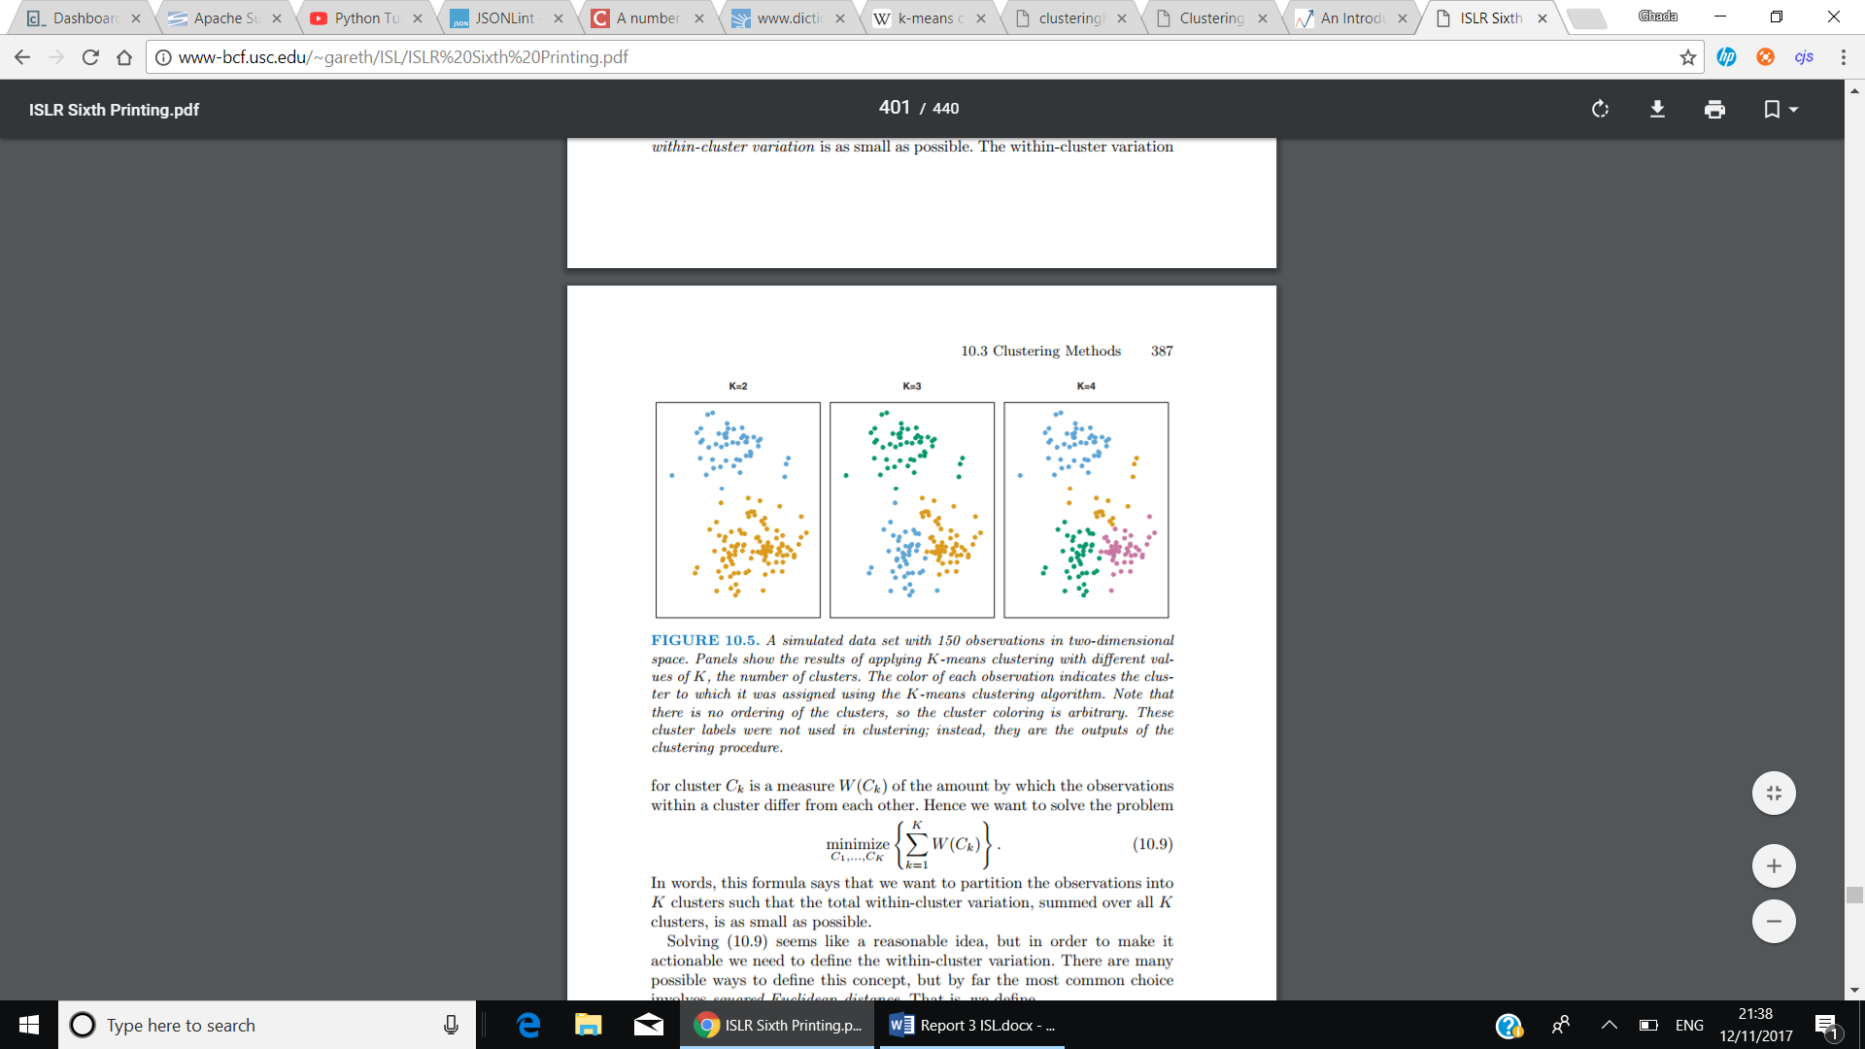

Moreover, K-means successfully achieve two main conditions, that are, each data point should belong to 1 cluster, and there is no overlapping found in clusters.
An important point that should be as well considered is, minimizing the within-cluster variation. The within-cluster variation, measures how tightly grouped the clusters are and can in fact be determined using several options, such as, Euclidian’s distance … etc.

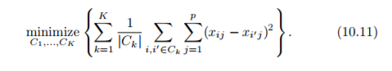

The above method, describes the optimisation problem which defines k-means clustering. The within-cluster variation of the k^{th} cluster can be described as, the sum of all pairwise squared Euclidean distances between data points in the k^{th} cluster, divided by |Ck| the number of data points in the k^{th} cluster.

An abstract way to describe K-means clustering algorithms, used from ISLR book, is as follows:
- For each observation in dataset, assign a random number from 1 to K.
- Iterate until clusters, stop changing.
  - For each cluster K, compute cluster centroid.
  - Allocate each observation to the cluster, that has the nearest centroid.
Centroid, is the mean of observations assigned to each cluster.
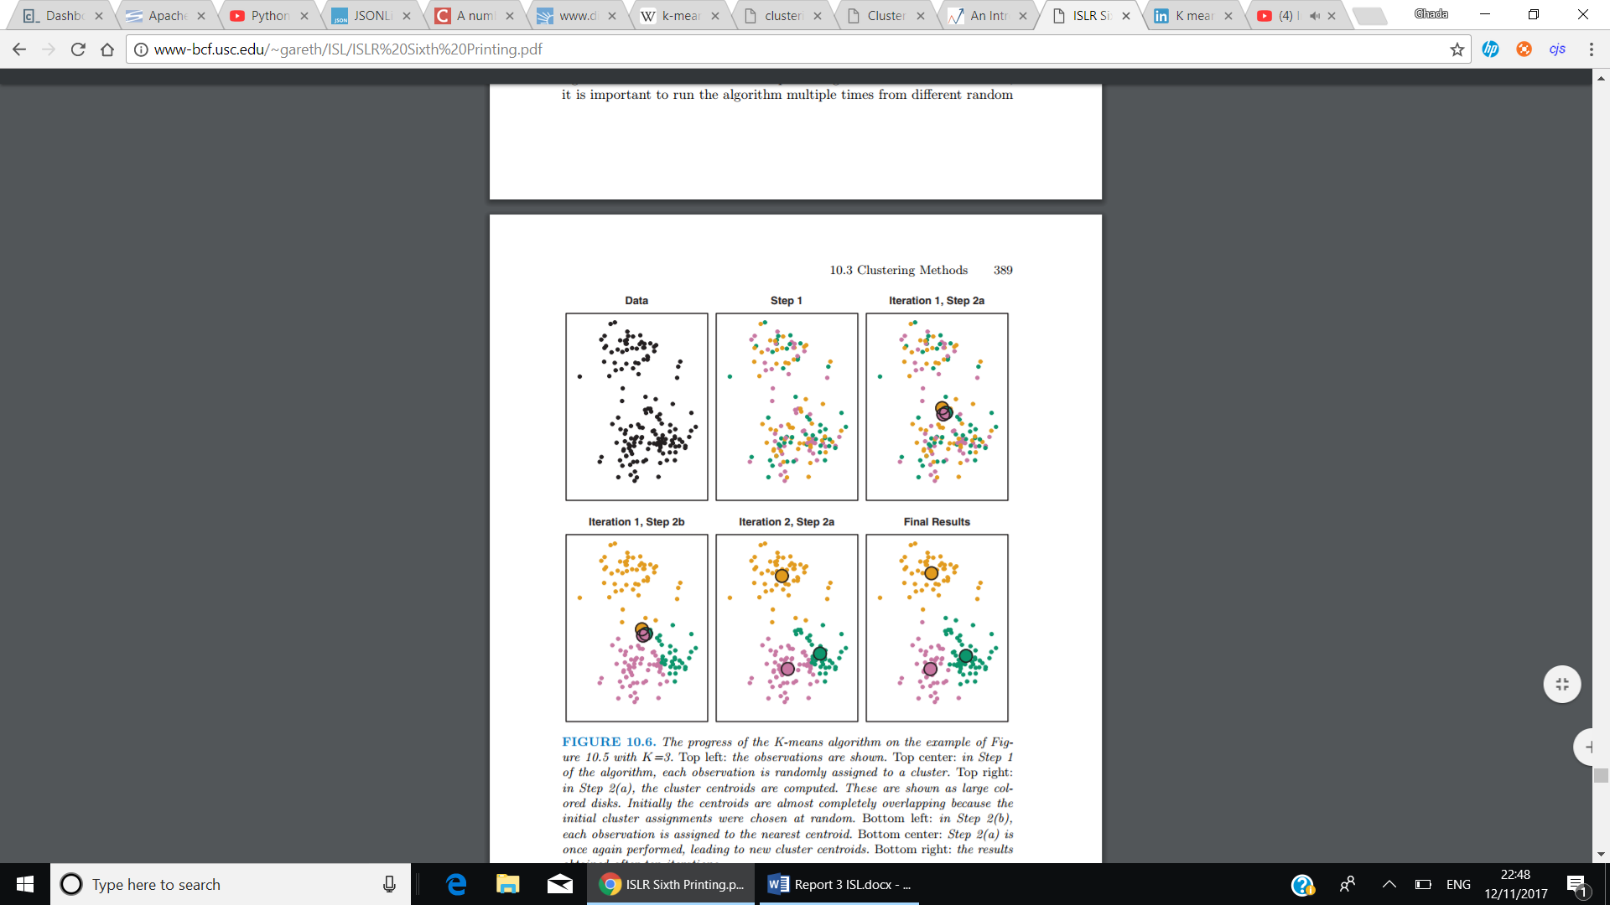

Advantages:
However, using K-means is found to be efficient with datasets of high dimensionality, and considered to be easy to implement, and has high performance(fast). Very understandable problem( fs).
https://pdfs.semanticscholar.org/b0a2/0ecaf9398990bf552c0bd02e1799235a986f.pdf

Disadvantages:
There are several difficulties encountered when using K-means, which include, choosing the value of K (number of clusters) beforehand, portioning data into K clusters while keeping the within-cluster variation minimized, since there are K^{n} different ways to portion data.

Hierarchal Clustering Algorithm:
Another algorithm that doesn’t require the user’s prior knowledge to specify the number of clusters beforehand. Instead it creates a tree-based representation of data observations (builds hierarchy of clusters), which is known as dendrogram. It has two types, Agglomerative, and Divisive.
Agglomerative, which is known as “bottom-up, the way it works is that each observation initiates its own cluster, and merging pairs of clusters as moving upwards (the top). Whereas, Divisive “top-down”, all clusters are in the same cluster, and it starts splitting them up, while moving down the hierarchy. However, using Agglomerative is less problematic, since Divisive needs to consider all possible divisions. (http://www.ims.uni-stuttgart.de/institut/mitarbeiter/schulte/theses/phd/algorithm.pdf)

The height in the dendrogram at which two clusters are merged represents the distance between two clusters in the data space. In addition, mainly observations that fuse near the bottom in dendrogram, tend to be similar, whereas, observations that fuse near the top of tree are quite different.
To discover number of clusters a dendrogram contain, a horizontal cut at the relevant depth, and depending on where the horizontal line is, the below sets (major branches), are the clusters made (see above).
Different values of the depth of horizontal line would indicate a different number of clusters, i.e. diagram () in middle () the horizontal line is at height = 9, and divides dataset to 2 distinct clusters, while on the diagram in left hand side (), height=5, thus, clusters are set to 3 in that case.

Dissimilarity measure:
is calculated using variety of methods. i.e. Euclidean distance. Where it considers the distance between two data points. Computed as the square root of the sum of the squared differences of distance between two variables. Another example, is correlation-based distance, which computes the correlation between features of 2 observations to be high, if they’re found similar. (https://arxiv.org/ftp/arxiv/papers/1205/1205.1117.pdf)

Linkage:
on the other hand, describe the dissimilarity between two sets of data points(groups) (two groups of observations), by using one of the following four different types to achieve, the required output, which are complete, average, single and centroid.
Single linkage: measures the closest pair of points.
Complete linkage: measures the farthest pair of points
Average linkage: measures the average dissimilarity over all pairs
Centroid linkage, measures the distance between the group centroids (i.e., group averages).

Advantages:
It’s not required to specify the value of K before starting the algorithm. When using Agglomerative clustering, there is some flexibility given to the user, to choose the number of clusters. On the other hand, using Divisive clustering, result in best possible solution, since the user has access to all data. https://pdfs.semanticscholar.org/b0a2/0ecaf9398990bf552c0bd02e1799235a986f.pdf

Disadvantages:
(terminating condition, which determines when the algorithm(division or merge process) needs to stop, in either one of the types. Implementing it can be found challenging, as it needs to be small enough to separate the clusters and large enough to prevent splitting the same cluster into two clusters) (DB.)
Where to cut the dendrogram counts as a disadvantage, as it is in many cases, seem to be uncertain. When using Divisive, several computational difficulties emerge particularly when splitting the clusters. https://pdfs.semanticscholar.org/b0a2/0ecaf9398990bf552c0bd02e1799235a986f.pdf
Using Centroid linkage, can cause an inversion, where, which will result in more difficulties, especially in visualising and analysing data.
Sometimes can lead to less accuracy rather than K-means (ISLR,394). Depending on the distance metric used, the results would vary. Furthermore, if the data grouping is incorrectly done in earlier stages, the results cannot be altered after. https://pdfs.semanticscholar.org/b0a2/0ecaf9398990bf552c0bd02e1799235a986f.pdf

Comparison between K-means and hierarchal?
Similarities, the horizontal line that cuts through dendrogram in hierarchal algorithm, is equivalent to the K value set in K-means, which both specify the number of clusters included.

Density-Based Spatial Clustering of Applications with Noise (DBSCAN):
According to Kreigel et el. explanation of Density-based clustering,” in density-based clustering, a cluster is a set of data objects spread in the dataspace over a contiguous region of high density of objects. Density-based clusters are separated from each other by contiguous regions of low density of objects.”. The resulting clusters, unlike previously mentioned algorithms, would have an arbitrary-shape, that’s determined by high density areas, where number of data points exceeds threshold value. Moreover, data points that exist in low-density areas, are considered either noise, or outlier clusters.
(pic:https://www.google.co.uk/search?q=DBSCAN&rlz=1C1DSGZ_enGB609GB609&source=lnms&tbm=isch&sa=X&ved=0ahUKEwju6LfDn7_XAhUEDMAKHSd_DKkQ_AUICygC&biw=1536&bih=759#imgdii=_AL2Yk1_e0U9WM:&imgrc=TGZdwFQpGnJe_M:)
The DBSCAN Algorithm 2 parameters to preform clustering, which are:
https://arxiv.org/ftp/arxiv/papers/1205/1205.1117.pdf

Eps (ε), that describes the radius of neighbourhood for a given point; serves as distance threshold.
MinPts, which defines, the minimum number of points that must exist in eps radius to form a cluster, serves as density threshold.
Nevertheless, each observation could be categorized, as a core point, border point or an outlier (noise point), using value of Eps threshold parameter.
In addition, there are some significant definitions in DBSCAN, via the definition of density-reachability, which states that in order for 2 data points, a core and border point, p and q, to be density-reachable, the following criteria should be met:
p ∈Eps(q) , point p is within Eps threshold of q
| Eps(q)|≥MinPts, the number of points in q’s neighbourhood is greater than or equal to MinPts(Core point condition).
This relation, is guaranteed to be transitive.

Density-Connectivity, is another definition, that implies:
For points p, q and o, to determine if p is density-connected to q, the following condition apply:
There exists a point o, where p and q are both density-reachable from o, with respect to Eps and MinPts. (if they have a distance of less than r)
Density-Connectivity is a symmetric relation, and for density-reachable point its considered reflexive as well.(DB)

(pic:https://www.google.co.uk/search?q=density+reachability&rlz=1C1DSGZ_enGB609GB609&source=lnms&tbm=isch&sa=X&ved=0ahUKEwjr667ywb_XAhXFCBoKHfACCUsQ_AUICigB&biw=1536&bih=759#imgrc=08yB0_Rinqs51M

An abstract approach to illustrate DBSCAN clustering algorithm:
DBSCAN Revisited, Revisited:
Compute neighbours of each point and identify core points
Join neighbouring core points into clusters
foreach non-core point do:
Add to a neighbouring core point if possible // Assign border points
Otherwise, add to noise

Using the definitions of density-reachability and density-connectivity, if two clusters A and B, of different density, are found close to each other, using a distance method, which will compute the distance between all data points in cluster A, B. Hence, two clusters remain separated if the distance between their points is larger than Eps. (DB)

Determining values of MinPts and Eps:
Determining the values of MinPts and Eps parameters are essential for DBSCAN. Starting with MinPts parameter, depending on whether dataset contains a lot of noise or not. Sander et al. [40] suggest setting it to twice the dataset dimensionality, i.e., MinPts = 2·dim(dataset). However, when dataset is large or consists of a large number of dimensions, or contains noise, it is preferred to increase MinPts value. (file:///C:/Users/Ghadah/Desktop/ContentServer.pdf)

Moreover, setting value of Eps is considered harder than MinPts, an appropriate way to set Eps value, is using k-distance graph. Ester et al. [16] provide a heuristic to compute its value, that is, “. When sorting the points of the database in descending order of their k-dist values, the graph of this function gives some hints concerning the density distribution in the database. We call this graph the sorted k-dist graph. If we choose an arbitrary point p, set the parameter Eps to k-dist(p) and set the parameter MinPts to k, all points with an equal or smaller k-dist value will be core points. If we could find a threshold point with the maximal k-dist value in the "thinnest" cluster of D we would have the desired parameter values. The threshold point is the first point in the first "valley" of the sorted k-dist graph (see figure 4). All points with a higher k-dist value (left of the threshold) are considered to be noise, all other points (right of the threshold) are assigned to some cluster.”

Advantages:
In this approach, a lot of advantages arise, such as, efficiency when used on high dimensional datasets, user not required to determine number of clusters beforehand, Moreover, the algorithm is more effective in defining clusters of arbitrary-shape, and the algorithm is considered to be resistant to noise has the ability to distinguish noise points.
The algorithm uses 2 parameters, Eps and MinPts, which are not affected of order in which data is provided and if computed appropriately, will result in high performance.(DB) It can even find a cluster completely surrounded by (but not connected to) a different cluster.
Only asks the user to provide a well-computed parameter?

Disadvantages:
On the contrary, the algorithm has some drawbacks when clustering datasets, that has a great difference in densities, since MinPts and Eps parameters cannot possibly be computed correctly for all clusters. (Revisited). A minor point to consider as well, is the order in which data is processed, sometimes may result in different changes in the outcome of clustering algorithm. (Revisited) In the case of ambiguous dataset (that are not understood in terms of data and scale used.), the process of computing Eps parameter can be found difficult.
http://ijcseonline.org/pub_paper/11-IJCSE-01380.pdf

Machine Learning
Statistical learning, is the whole set of tools, that helps in understanding data. These tools can be categorized to supervised, and unsupervised. Supervised learning, acquire data inputs, and provide estimation(prediction) of their output. This method is broadly used; however, in this section, our primarily focus will be on unsupervised statistical learning, which is recognised as having variety of inputs, without having their corresponding supervised outputs (no labels provided) [20].
By means of unsupervised learning, inspecting each element characteristics, can guide us to discover a way, which eases the process of grouping data. Using a similarity measure, applying it to a certain dataset, can result in assembling data to different groups. Its fundamental goal, is to discover significant aspects about the observations given. Thus, Clustering, is a technique, that simplifies the process of determining subgroups in dataset [20].
In case of large datasets (High dimensionality), Principle Components Analysis, which is a technique of unsupervised learning, is considered a useful tool that aids in visualising data, and pre-processing it, as its reduces the number of dimensions [20].

Unsupervised Learning:

Principal Components Analysis (PCA)

PCA Is a widely known technique, that’s used for reducing dimensionality, and decomposing a large dataset, that has a huge number of dimensions (to a lower dimensional space). The data points will be displayed, as orthogonal components, which describes the maximum amount of the variance. In general, instead of using all parameters of a dataset, using PCA will result in using, for example, 2 values at most that will eventually provide a precise representation of data [20].
Some of the benefits of using PCA can be summarised in few points,
- It clearly decreases the requirement of capacity and memory used.
- Decrease complexity of system.
- Less sensitive to noise than other algorithms.
However, it can be argued that, evaluation of the covariance matrix result in less accuracy. Which can be viewed as a disadvantage of PCA [21].
Requirements to perform PCA:
- Scaling the variables. Before performing PCA on observations, all data, should be scaled (using a certain method, such as standard deviation = 1). It is important since; different variables are measured in different units, so when calculating the variance of each variable, it will result in first principal component loading vector to have, for example, large loading, since it had the largest variance. Mostly, each variable is scaled to have unit standard deviation when the possibility of them having different units is high [20]. Hence, scaling has a substantial impact on obtained results, and should be performed beforehand.

- The minimum number of Principal Components to use is calculated via, min(n-1, p), where n is the number of observations and p is the number of variables. However, it is crucial that we use the very first PC’s to help in visualising data. 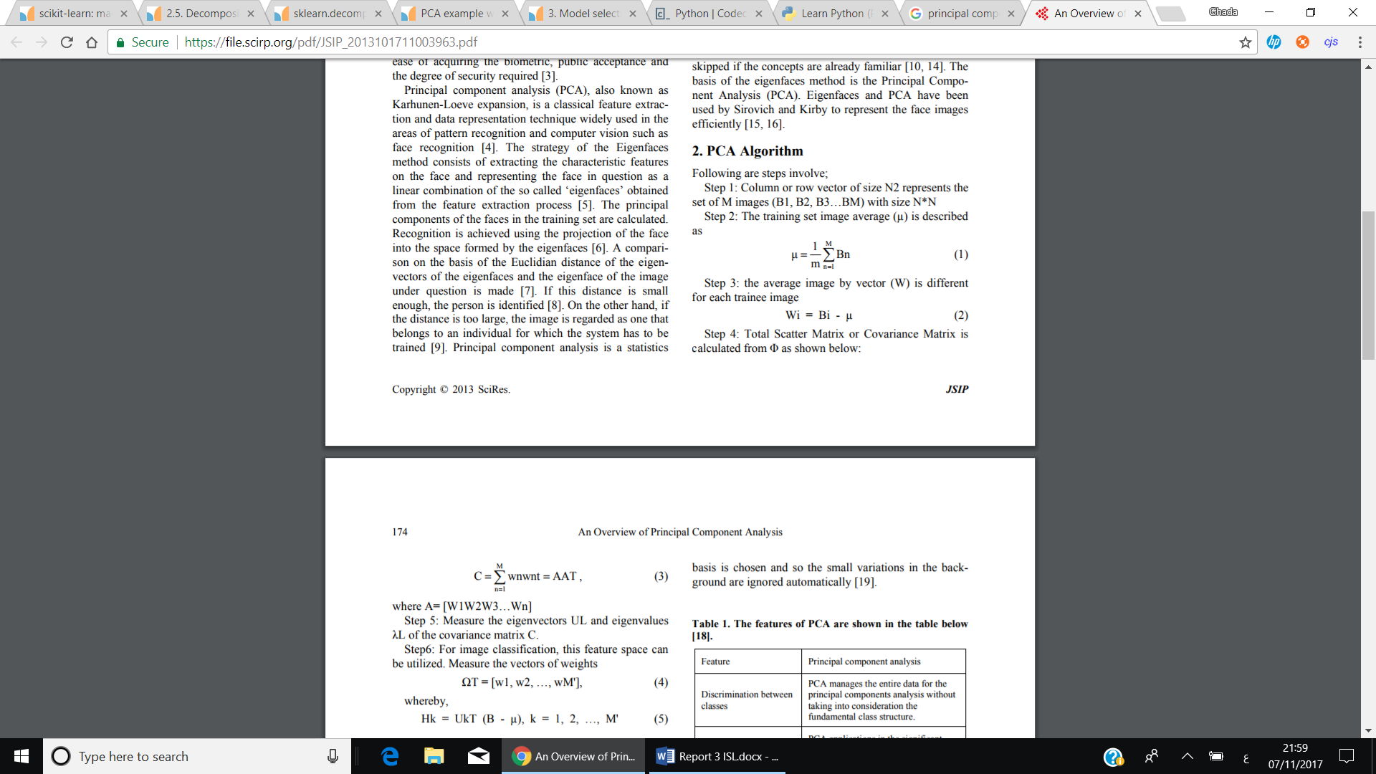

Bibliography
- Dave Cohen and Carlos Matos. Third Year Projects – Rules and Guidelines. Royal Holloway, University of London, 2013.

- [1] Lorenzo’s 1st paper
- [2] CopperDroid

- //////////////////////////
- (Evaluating Malware Mitigation by Android Market Operators) ,https://www.usenix.org/system/files/conference/cset16/cset16-paper-kikuchi.pdf

- http://delivery.acm.org/10.1145/2600000/2592003/p221-viennot.pdf?ip=134.219.227.35&id=2592003&acc=ACTIVE%20SERVICE&key=BF07A2EE685417C5%2E8B22AE30E01D0947%2E4D4702B0C3E38B35%2E4D4702B0C3E38B35&CFID=830564948&CFTOKEN=18903361&__acm__=1510926050_b4466a1a3f21dcf1a362f231ad3e151c
- https://venturebeat.com/2017/05/17/android-passes-2-billion-monthly-active-devices/
- Lorenzo 1st paper
- Scalable, Behavior-Based Malware Clustering
- an empirical study of malware evolution)
- Sophos. When Malware Goes Mobile. http://www.sophos.com/en-us/ security-news-trends/security-trends/malware-goes-mobile/ why-ios-is-safer-than-android.aspx. Accessed: 19-08-2014.
- ///////////////////////////////////////////////////
- [40] Jörg Sander, Martin Ester, Hans-Peter Kriegel, and Xiaowei Xu. 1998. Density-based clustering in spatial databases: The algorithm GDBSCAN and its applications. Data Mining and Knowledge Discovery 2, 2 (1998), 169–194. DOI:http: //dx.doi.org/10.1023/A:1009745219419
- [20] ISLR chapter 10 and 1
- [21] https://file.scirp.org/pdf/JSIP_2013101711003963.pdf

