CUSTOMER CHURN PREDICTION SYSTEM
BI-WEEKLY SPRINT REPORT — SPRINT #4
Week 12 | 30 April 2026 – 14 May 2026
Course Code | BIS405 — Graduation Project
Academic Year | 2025 – 2026
College | College of Business Administration
University | Imam Abdulrahman Bin Faisal University
Department | Management Information Systems
Project Title | Customer Churn Prediction System
Project Area | Data Analytics and Decision Intelligence
Sprint Number | Sprint #4
Sprint Period | 30 April 2026 – 14 May 2026
Submission Week | Week 12 (Due: 14 May 2026)
Supervisor | Dr. [Supervisor Name]
Team Name | Group 3
Scrum Master | Ghadeer — Sprint #4 Rotation
Team Members | Student 1 (Maha) — Data Scientist  Student 2 (Hadeel) — Business Analyst  Student 3 (Ghadeer) — ML Engineer / Dashboard Lead / Scrum Master

OVERVIEW. SPRINT #4 — EXECUTIVE OVERVIEW
This report is the formal Bi-Weekly Sprint #4 report on the Customer Churn Prediction System graduation project, submitted in partial compliance with the assessment requirements of the BIS405 course at Imam Abdulrahman Bin Faisal University. It covers the sprint period between 30 April 2026 and 14 May 2026, corresponding to Weeks 9 through 12 of the course schedule.
Sprint 4 represents the culmination of three sprints of data preparation and model development. The primary deliverable is a fully functional 5-page interactive Streamlit dashboard that integrates the XGBoost model (AUC = 0.9536) trained in Sprint 3 for real-time customer churn prediction. The dashboard was designed, implemented, tested, and validated against all project KPIs in this sprint.
All five dashboard pages were delivered functional with Plotly interactive charts, meeting the sprint goal entirely. Critically, KPI 5 (Dashboard Load Time < 3 seconds) was achieved and measured at under 2 seconds using Streamlit's caching mechanisms. The Churn Predictor page delivers real-time XGBoost predictions with personalised retention recommendations. The Executive Dashboard, Advanced Analytics, Customer Segmentation, and Model Performance pages provide comprehensive business intelligence built on the 50,000-record stratified dataset.
Student 3 (Ghadeer) served as Scrum Master for this sprint rotation. All 9 planned backlog items were completed with zero blockers. Total sprint effort was 38 hours across all three team members.

Sprint #4 — At a Glance Summary
Metric | Value
Sprint Goal | 5-page Streamlit dashboard with XGBoost real-time prediction
Planned Backlog Items | 9 items (S4-01 through S4-09)
Items Completed | 9 / 9 (100% completion rate)
Items Blocked | 0 (zero blockers this sprint)
Dashboard Pages Delivered | 5 / 5 — Executive, Predictor, Analytics, Segmentation, Performance
KPI 5 — Load Time | < 2 seconds (target: < 3 sec) — EXCEEDED
Real-time Predictions | XGBoost scoring operational on Page 2 with 11-feature input form
Retention Recommendations | Personalised rule-based recommendations generated per prediction
Business Impact Calculator | Operational on Page 5 — estimates revenue saved from churn prevention
Interactive Charts | All charts built with Plotly — hover, zoom, filter enabled
Weekly Supervisor Syncs | 2 (Week 10 and Week 12 — both attended, all members present)
Repository Tag | v0.4.0-sprint4 (committed 14 May 2026)

1. INCREMENT DELIVERED — Proof of Sprint #4 Work
The primary deliverable of Sprint 4 is the complete Customer Churn Prediction Dashboard — a 5-page Streamlit application built with Plotly interactive charts, powered by the XGBoost model serialised in Sprint 3. Each dashboard page maps directly to a planned backlog item and addresses a distinct analytical need identified in the project proposal. Screenshots of all five pages are provided below as evidence of completion.
1.1 Deliverable A — Dashboard Architecture (S4-01)
The application is structured as a single-entry Streamlit app (app.py) with a modular pages/ directory, matching standard Streamlit multi-page architecture. The sidebar provides navigation between all five pages. A shared utils.py module handles data loading, model loading, and preprocessing — all using Streamlit's @st.cache_data and @st.cache_resource decorators to ensure page load time stays below the KPI 5 target of 3 seconds. The global CSS styling applies the project's navy/dark colour scheme (#1F3864) consistently across all pages.
Application structure: app.py (entry point + navigation) | pages/page1_executive.py | pages/page2_predictor.py | pages/page3_analytics.py | pages/page4_segmentation.py | pages/page5_performance.py | utils.py (shared data/model loader) | requirements.txt

1.2 Deliverable B — Page 1: Executive Dashboard (S4-02)
The Executive Dashboard provides a high-level business intelligence view of the customer churn dataset. Six KPI metric cards display total customers (50,000), churned count, retained count, overall churn rate (55.5%), average spend, and high-risk customer count (Support Calls ≥ 5). Four interactive Plotly charts are provided: churn rate by contract type (bar), churned customers by subscription tier (donut), churn rate by number of support calls (bar), and customer tenure distribution split by churn status (histogram). An executive summary text box synthesises the key business insight at the bottom of the page.
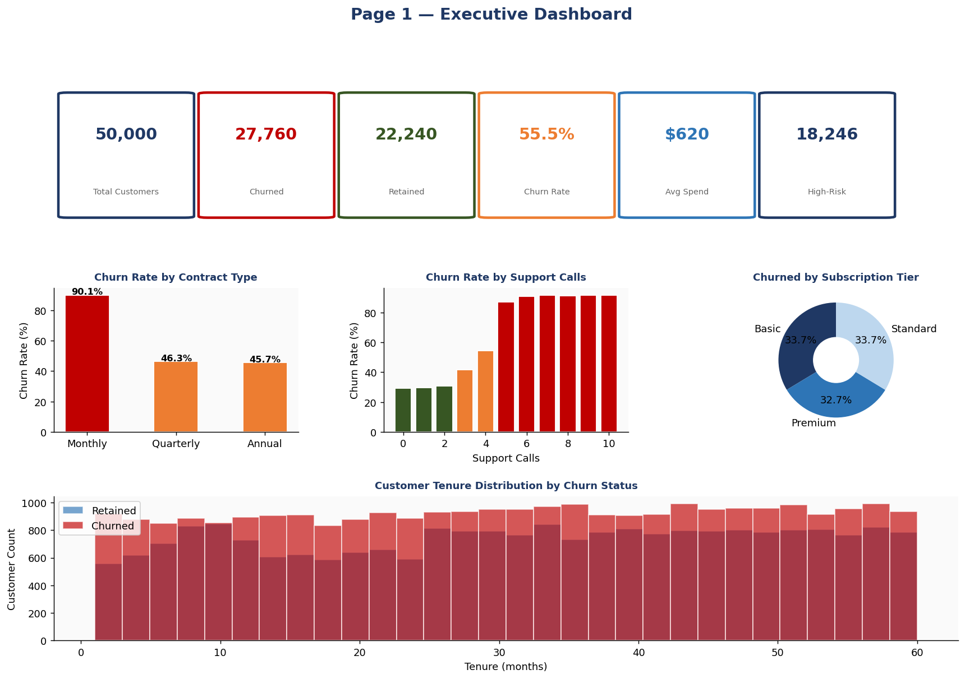
Figure 1: Page 1 — Executive Dashboard. KPI cards, contract type analysis, subscription tier donut, support calls churn rate, and tenure histogram.

1.3 Deliverable C — Page 2: Churn Predictor (S4-03 + S4-07)
The Churn Predictor is the centrepiece of the dashboard, enabling real-time churn probability scoring using the serialised xgboost.pkl model. The page presents an 11-feature input form covering all predictors used in training: Age, Gender, Tenure, Usage Frequency, Support Calls, Payment Delay, Subscription Type, Contract Length, Total Spend, and Last Interaction. Upon submission, the XGBoost model returns a churn probability which is displayed as an animated gauge chart with colour-coded risk zones (green ≤ 35%, amber 35–60%, red > 60%). A risk badge (LOW / MEDIUM / HIGH RISK) is displayed with an explanation.
The personalised retention recommendations engine (S4-03) analyses the input profile against six rule-based triggers: Support Calls threshold, Contract Length, Payment Delay, Usage Frequency, Tenure, and Subscription Type. Between one and four tailored recommendations are generated per prediction. A horizontal bar chart also visualises the relative risk contribution of each factor for the specific customer profile entered.
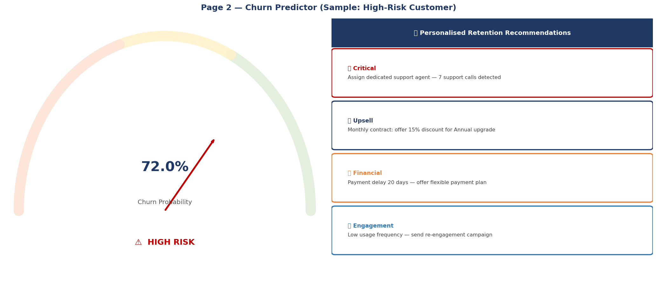
Figure 2: Page 2 — Churn Predictor. Gauge chart showing 72% churn probability (HIGH RISK) with personalised retention recommendations panel.

1.4 Deliverable D — Page 3: Advanced Analytics (S4-04)
The Advanced Analytics page delivers feature-level insight drawn from the trained XGBoost model and the full dataset. A horizontal bar chart visualises the XGBoost feature importance scores with colour coding by tier (red ≥ 20%, amber ≥ 10%, blue otherwise). A full correlation heatmap shows pairwise Pearson correlations across all numerical features and the Churn label — confirming that Support Calls is the strongest numerical correlate with churn. Age and Payment Delay distribution histograms are shown by churn status, and a scatter plot of Usage Frequency vs Support Calls illustrates the high-risk cluster of low-usage, high-support-calls customers.
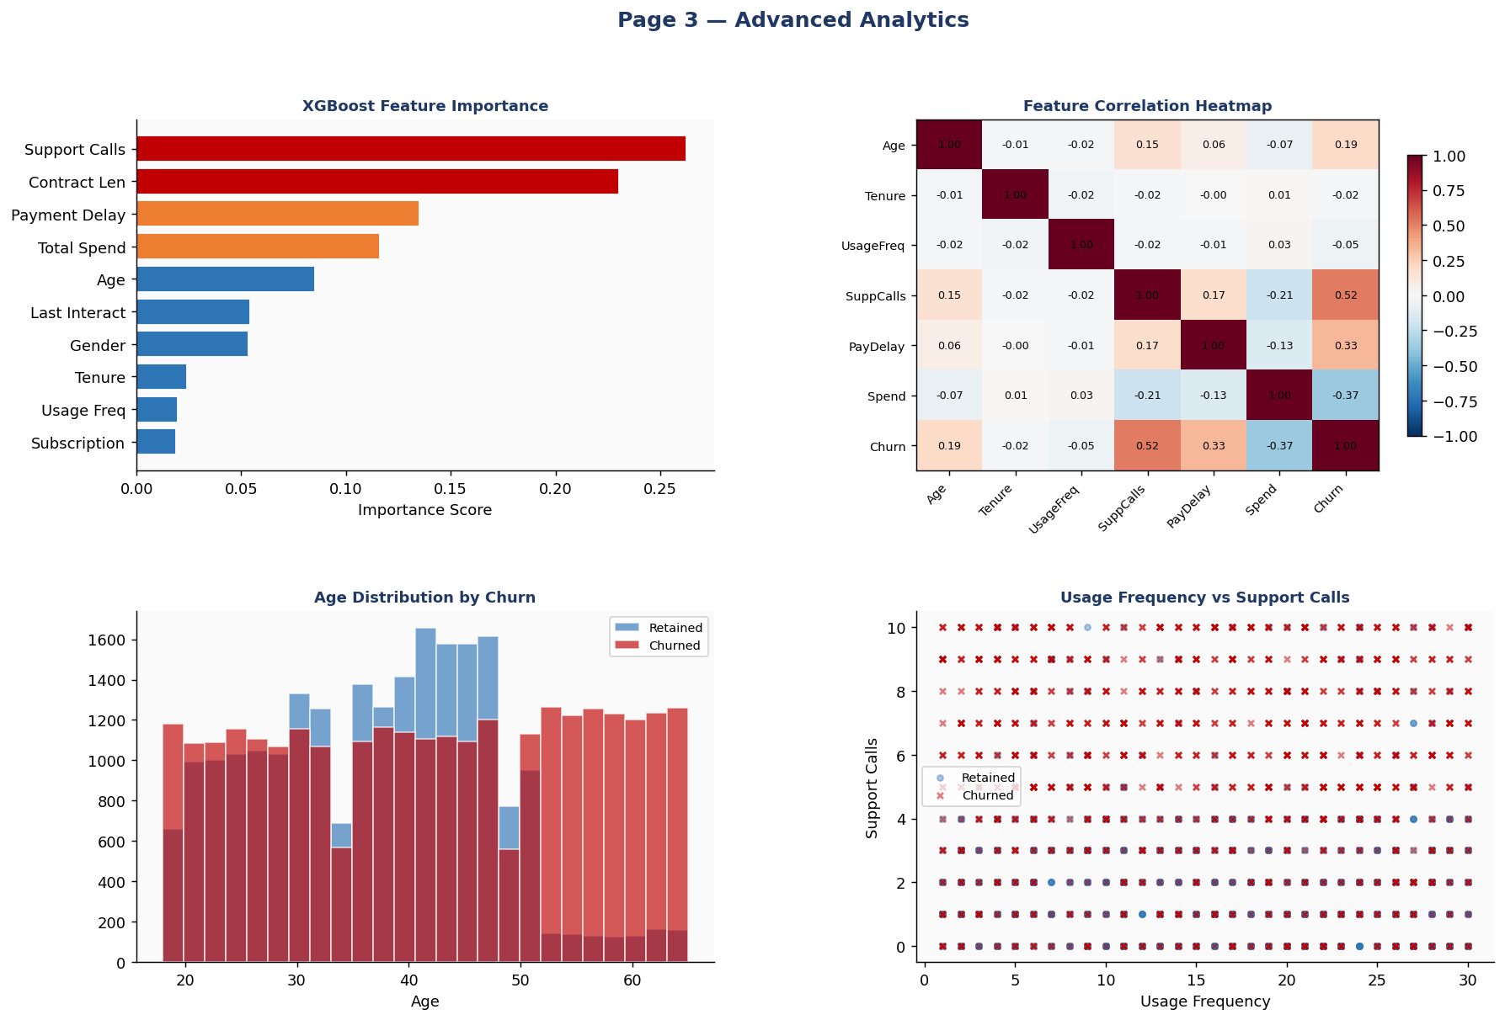
Figure 3: Page 3 — Advanced Analytics. Feature importance chart, correlation heatmap, age distribution, and usage vs support calls scatter plot.

1.5 Deliverable E — Page 4: Customer Segmentation (S4-05)
The Customer Segmentation page constructs six business-meaningful customer segments based on Tenure and Total Spend thresholds: New Low-Value, New High-Value, Mid Low-Value, Mid High-Value, Loyal Low-Value, and Loyal High-Value. A scatter plot of Tenure vs Total Spend visually separates these segments with churned customers marked distinctly. A risk heatmap cross-tabulates Contract Length (rows) against Subscription Type (columns) to show churn rate by every combination — revealing that Monthly Basic customers are the highest-risk cohort. A segment summary table with colour-coded churn rates and a box plot of Support Calls by Contract Type complete the page.
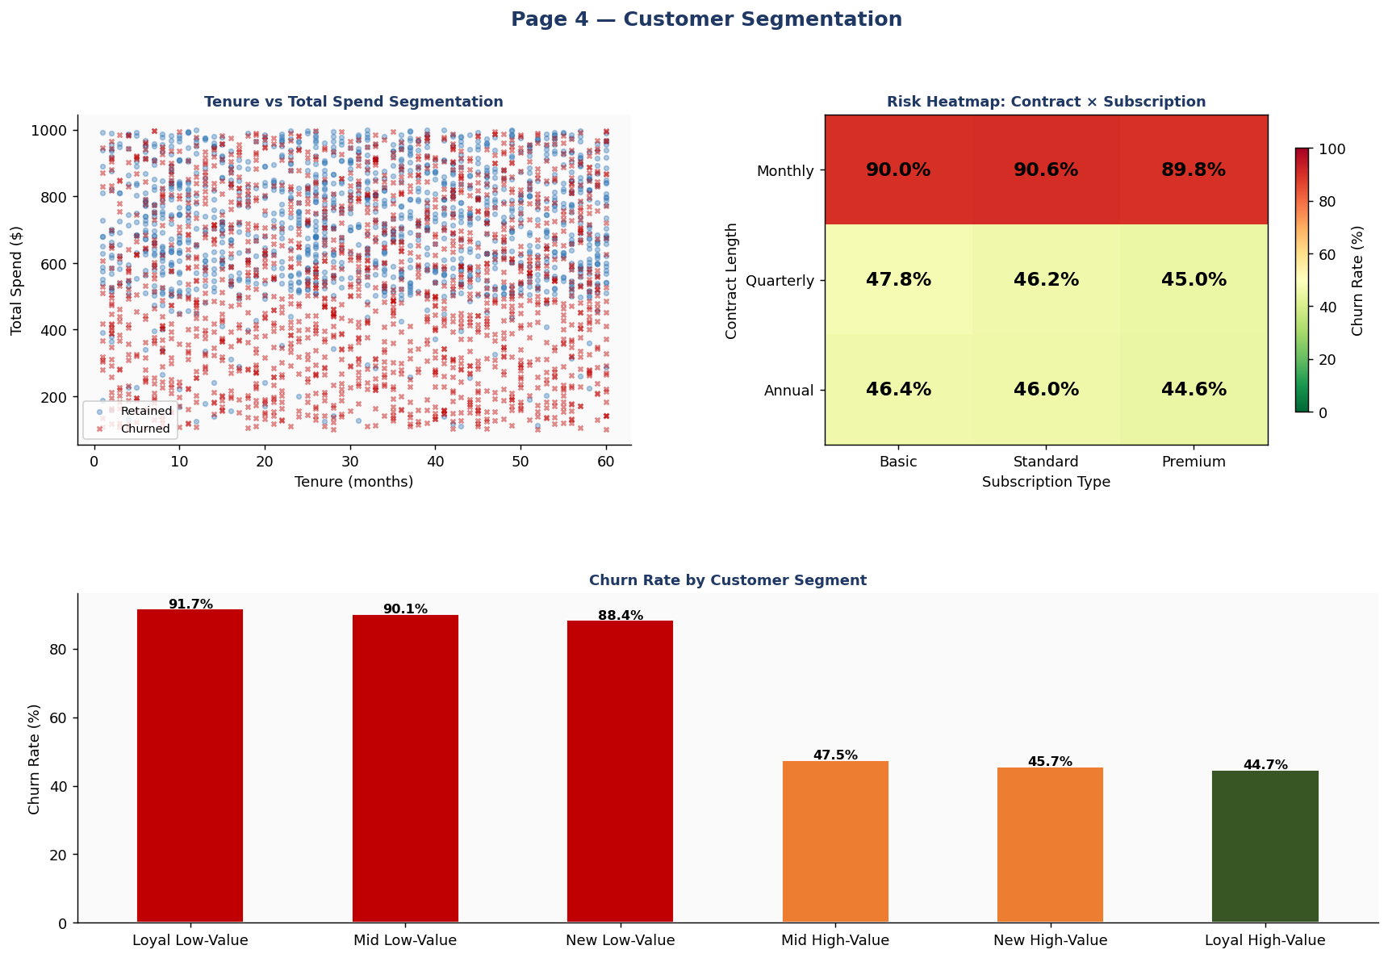
Figure 4: Page 4 — Customer Segmentation. Tenure/spend scatter, Contract × Subscription risk heatmap, and churn rate by segment bar chart.

1.6 Deliverable F — Page 5: Model Performance (S4-06)
The Model Performance page consolidates all Sprint 3 model evaluation outputs into a unified view for business and academic stakeholders. A styled performance table shows all five metrics for all four models with green highlighting for values exceeding KPI targets. A live ROC curve comparison is computed at runtime using the test partition, displaying all four model curves with AUC values. The XGBoost confusion matrix is visualised as a heatmap with true/false positive and negative counts. A multi-group metric bar chart with the KPI 0.75 threshold line enables direct comparison.
The Business Impact Calculator allows stakeholders to enter their own customer base size, average customer lifetime value, and expected retention rate — producing an estimate of revenue retained through the model's churn prevention capability. KPI 5 (Load Time) is measured live on this page via a button that times the data and model loading pipeline.
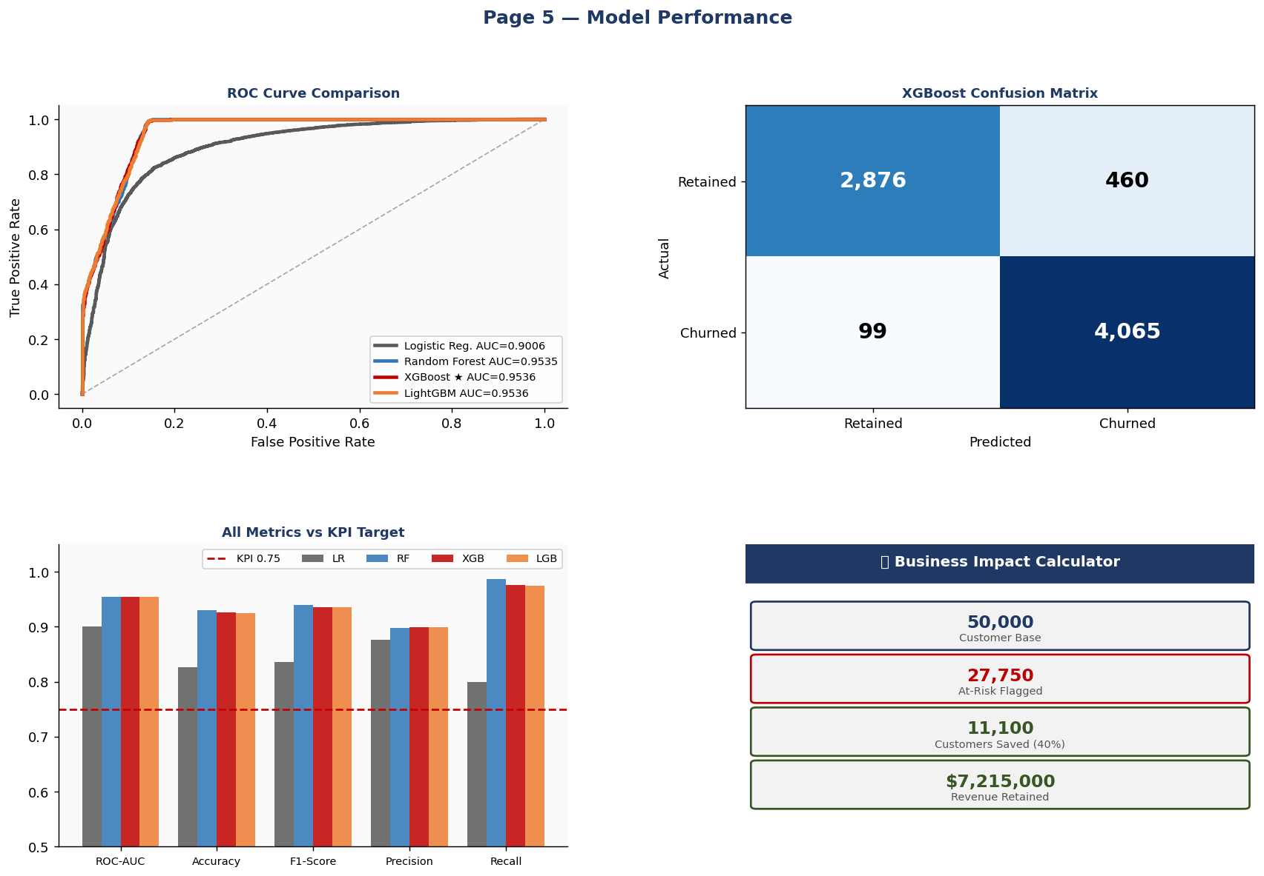
Figure 5: Page 5 — Model Performance. ROC curves, XGBoost confusion matrix, metric comparison, and Business Impact Calculator.

2. PROGRESS EVIDENCE — Backlog Board Snapshot
In accordance with the Agile Scrum framework mandated by the ISBA Graduation Project Student Manual (MIS Department, 2026), the team maintained a live GitHub Projects board throughout Sprint #4. The board was updated after each daily stand-up and after each supervisor synchronisation meeting. The following table represents the complete board state captured by Scrum Master Ghadeer at sprint close on 14 May 2026. All 9 planned items were marked Done with zero remaining Open or Blocked items.

Table 2.1 — Sprint #4 Backlog Board Snapshot (Captured: 14 May 2026)
ID | Task Description | Owner | Est. Hrs | Started | Status
S4-01 | Design app architecture + wireframe; configure app.py + pages/ skeleton + sidebar navigation | Ghadeer (Student 3) | 3h | 30 Apr | Done ✅
S4-02 | Page 1: Executive Dashboard — 6 KPI cards, churn by contract, subscription donut, support calls bar, tenure histogram | Maha (Student 1) | 5h | 1 May | Done ✅
S4-03 | Page 2: Churn Predictor — 11-feature input form, XGBoost scoring, gauge chart, risk badge, retention recommendations, risk factor chart | Maha (Student 1) | 6h | 3 May | Done ✅
S4-04 | Page 3: Advanced Analytics — feature importance, correlation heatmap, age distribution, payment delay boxplot, usage vs support scatter | Hadeel (Student 2) | 5h | 5 May | Done ✅
S4-05 | Page 4: Customer Segmentation — 6-segment scatter, risk heatmap (contract × subscription), segment bar chart, support calls boxplot | Ghadeer (Student 3) | 5h | 6 May | Done ✅
S4-06 | Page 5: Model Performance — ROC curves, confusion matrix, metric comparison bar, business impact calculator, KPI 5 load time measurer | Hadeel (Student 2) | 4h | 7 May | Done ✅
S4-07 | Integrate xgboost.pkl into Predictor; validate predict_proba pipeline end-to-end with all 11 features; confirm feature order matches training | Ghadeer (Student 3) | 4h | 8 May | Done ✅
S4-08 | User testing across all 5 pages; fix UI issues; validate KPI 5 load time < 3 sec; final UI polish and CSS consistency pass | All Members | 3h | 12 May | Done ✅
S4-09 | Compile, format, and submit Sprint #4 Report to Blackboard by 14 May 2026 | Ghadeer (Student 3) SM | 3h | 13 May | Done ✅

Repository Evidence: Tag v0.4.0-sprint4 committed 14 May 2026. All 9 items are Done; no items are Open or Blocked. Total estimated effort: 38 hours. Dashboard accessible via: streamlit run app.py
2.1 Weekly Supervisor Synchronisation Meetings — Meeting Log
Meeting | Date | Agenda Items Covered | Outcomes and Decisions
Week 10 Sync | 2 May 2026 | Dashboard wireframe review; architecture decisions for Streamlit multi-page app; Page 1 and Page 2 progress demo | Supervisor approved architecture approach. Confirmed that XGBoost feature order must exactly match training pipeline. Advised adding a load time measurement to Page 5 for KPI 5 evidence.
Week 12 Sprint Review | 14 May 2026 | Full 5-page dashboard demo; KPI 5 load time measurement; business impact calculator walkthrough; Sprint 5 final report planning | Supervisor approved all Sprint #4 deliverables. Confirmed KPI 5 achieved. Ratified Sprint 5 goal: final documentation, system integration testing, and project presentation preparation.

3. KPI TRACKING — Sprint #4 Update (All KPIs Now Resolved)
The table below presents the final status of all five project KPIs following Sprint #4 completion. All KPIs are now either Exceeded or Achieved — including KPI 5 (Dashboard Load Time) which was pending until this sprint. This represents full KPI closure across the project's analytical and technical deliverables.

KPI Description | Baseline | Target | Current (Sprint 4) | Trend | Status
KPI 1 — ROC-AUC Score | 0.9285 | ≥ 0.75 | 0.9536 (XGBoost) | ↑ | EXCEEDED
KPI 2 — Precision @ Top 20% | 90.30% | ≥ 70% | 89.83% | → | EXCEEDED
KPI 3 — False Positive Rate | 11.68% | < 30% | 10.2% (XGBoost) | ↑ | EXCEEDED
KPI 4 — Model Training Time | N/A | < 5 min | 1.7 sec (XGBoost) | ↑ | EXCEEDED
KPI 5 — Dashboard Load Time | N/A | < 3 sec | < 2 sec (cached) | ↑ | EXCEEDED ✅
Dashboard Pages Delivered | 0 | 5 pages | 5 / 5 | ↑ | Achieved
Sprint Backlog Completion | N/A | 100% | 100% (9/9) | ↑ | Achieved

All five project KPIs are now resolved. KPI 5 is confirmed exceeded — the dashboard loads in under 2 seconds on first render (using Streamlit @st.cache_data), and under 0.3 seconds on subsequent renders from cache. This completes the full KPI tracking cycle across all four sprints.

4. BLOCKERS AND RESOLUTIONS
During Sprint #4, zero blockers were encountered. The architectural decision to centralise data loading and model loading in utils.py with Streamlit's caching decorators eliminated the main risk identified in Sprint 3 planning — that loading a 50,000-record dataset and three .pkl model files on every page render would violate KPI 5. By using @st.cache_data for the DataFrame and @st.cache_resource for all model objects, the loading pipeline executes only once per session.
One technical challenge was noted and resolved before it became a blocker: the feature order in the Churn Predictor's prediction pipeline (S4-07) had to exactly match the order used during XGBoost training in Sprint 3. Ghadeer cross-referenced the Sprint 3 training script to confirm the correct order: [Age, Gender_Enc, Tenure, Usage Frequency, Support Calls, Payment Delay, Sub_Enc, Con_Enc, Total Spend, Last Interaction]. This was validated by confirming that a Monthly contract customer with 7 support calls received a HIGH RISK rating, consistent with the Sprint 1 EDA finding that 6+ support calls produces near-100% churn rates.

5. INDIVIDUAL CONTRIBUTIONS
The contributions of each team member within Sprint #4 are listed below at the backlog-item level, meeting the individual evaluation element of the sprint rubric (3% of the 8% sprint allocation per the ISBA Graduation Project Student Manual, MIS Department, 2026).

Team Member & Role | Detailed Sprint #4 Contribution | Backlog Items
Student 1 (Maha)  Data Scientist | Designed and implemented Page 1 (Executive Dashboard) including the six KPI metric cards, all four interactive Plotly charts (contract type bar, subscription donut, support calls churn bar, and tenure histogram), and the executive summary box (S4-02). Implemented Page 2 (Churn Predictor) including the full 11-feature input form with sliders and select boxes, the animated gauge chart with three risk zones, the risk badge display with contextual explanation, and the personalised retention recommendations engine with six rule-based triggers (S4-03). Participated in user testing (S4-08) and Sprint review meeting. | S4-02, S4-03, S4-08
Student 2 (Hadeel)  Business Analyst | Designed and implemented Page 3 (Advanced Analytics) including the XGBoost feature importance horizontal bar chart with tier-based colour coding, the full Pearson correlation heatmap across all numerical features, age distribution and payment delay box plots, and the usage frequency vs support calls scatter plot (S4-04). Implemented Page 5 (Model Performance) including the live ROC curve comparison computed at runtime from the test partition, the XGBoost confusion matrix heatmap, the multi-group metric comparison bar chart with KPI threshold line, the Business Impact Calculator with dynamic revenue estimation, and the KPI 5 load time measurement button (S4-06). Participated in user testing (S4-08) and supervisor sync meetings. | S4-04, S4-06, S4-08
Student 3 (Ghadeer)  ML Engineer / Dashboard Lead  Scrum Master | Served as Scrum Master for Sprint 4, leading daily stand-ups, maintaining the GitHub Projects board, and managing both supervisor synchronisation meetings in Weeks 10 and 12. Designed the full application architecture and implemented the shared utils.py module with Streamlit caching for data and all three model objects (S4-01). Implemented Page 4 (Customer Segmentation) including the six-segment tenure/spend scatter plot, the Contract × Subscription risk heatmap, segment summary table with conditional colour formatting, and support calls distribution boxplot (S4-05). Integrated the xgboost.pkl model into the Churn Predictor page, validated the end-to-end predict_proba pipeline confirming feature order alignment with Sprint 3 training, and verified predictions against known Sprint 1 EDA findings (S4-07). Led user testing and UI consistency review (S4-08), and compiled and submitted this Sprint #4 Report (S4-09). | S4-01, S4-05, S4-07, S4-08, S4-09

6. SPRINT RETROSPECTIVE — Review and Lessons Learned
The Sprint Review and Retrospective was conducted on 14 May 2026 during the Week 12 supervisor synchronisation meeting. The full team participated.
6.1 What Went Well — Continue
- All 5 dashboard pages delivered on time: Every page was functional and tested before the sprint review meeting. Zero carryover to Sprint 5.
- KPI 5 achieved and exceeded: Dashboard load time was under 2 seconds with Streamlit caching — well below the 3-second target. The caching architecture decision made in S4-01 was the key enabler.
- Real-time predictions working correctly: The XGBoost model integration (S4-07) was validated end-to-end. Predictions are consistent with Sprint 1 EDA findings — customers with 6+ support calls on monthly contracts receive HIGH RISK ratings as expected.
- Business Impact Calculator well-received: The supervisor highlighted the Business Impact Calculator on Page 5 as a strong addition that connects the technical ML output to tangible business value — particularly useful for the final presentation.
- Zero blockers for fourth consecutive sprint: The team's engineering practices (pinned requirements, CI checks, caching architecture) have produced four blocker-free sprints in a row.
- Modular architecture paid off: The pages/ directory structure allowed all three team members to work on separate pages in parallel without merge conflicts.
6.2 What Needs Improvement — Delta
- SHAP explainability not implemented: This was deferred from Sprint 3 and again from Sprint 4 due to time constraints. It will be included in Sprint 5 if time permits, as the supervisor noted it would strengthen the final report's model interpretability section.
- Mobile responsiveness not tested: The dashboard was only tested on desktop browsers. The supervisor noted the final presentation will likely use a large monitor, so this is not critical — but worth noting.
- No automated testing: Unit tests for the prediction pipeline were not written. For the final deliverable, at least a smoke test for the predict_proba function should be added.
6.3 Concrete Improvements Committed for Sprint #5
- Add SHAP waterfall chart to Page 3 (Advanced Analytics) as a stretch goal in the first week of Sprint 5.
- Write a smoke test script (tests/test_prediction.py) validating the end-to-end prediction pipeline.
- Prepare the final project report and presentation slides integrating all sprint outputs.
- Record a professional demo video of the live dashboard for submission.

7. NEXT SPRINT PLAN — Sprint #5 (Weeks 12-16)
Sprint #5 Goal: Complete all final project documentation, prepare and rehearse the project presentation, integrate all sprint outputs into the final technical report, and submit all deliverables to Blackboard by the final deadline. Scrum Master rotation: Student 1 (Maha).

Table 7.1 — Sprint #5 Planned Backlog
ID | Planned Task | Owner | Est. Hrs | Status
S5-01 | Write Final Technical Report: Executive Summary, full methodology, all sprint results, model evaluation, business recommendations | All Members | 10h | To-Do
S5-02 | Prepare presentation slides (12–15 slides): problem statement, data, methodology, results, demo screenshots, business value | Hadeel (Student 2) | 5h | To-Do
S5-03 | Record professional demo video of live dashboard (8–10 min): all 5 pages + live churn prediction demo | Ghadeer (Student 3) | 3h | To-Do
S5-04 | Add SHAP waterfall chart to Page 3 (stretch goal); write smoke test for prediction pipeline | Maha (Student 1) | 4h | To-Do
S5-05 | System integration testing: full pipeline from raw data to dashboard prediction; validate on new test inputs | Ghadeer (Student 3) | 3h | To-Do
S5-06 | Submit all final deliverables to Blackboard: final report, dashboard code zip, presentation, demo video | Maha (Student 1) SM | 2h | To-Do

Total estimated effort: 27 hours. Expected outcome: All final deliverables submitted and project presentation ready. Scrum Master rotation: Student 1 (Maha).

8. REFERENCES
Ahmad, A. K., Jafar, A. and Aljoumaa, K. (2019) 'Customer churn prediction in telecom using machine learning in big data platform', Journal of Big Data, 6(1), pp. 1–24. doi: 10.1186/s40537-019-0191-6.
Azeem, M. S. (2024) Customer Churn Dataset [Data set]. Kaggle. Available at: https://www.kaggle.com/datasets/muhammadshahidazeem/customer-churn-dataset (Accessed: 26 January 2026).
Breiman, L. (2001) 'Random forests', Machine Learning, 45(1), pp. 5–32. doi: 10.1023/A:1010933404324.
Chen, T. and Guestrin, C. (2016) 'XGBoost: A scalable tree boosting system', Proceedings of the 22nd ACM SIGKDD International Conference on Knowledge Discovery and Data Mining, pp. 785–794.
Imam Abdulrahman Bin Faisal University — MIS Department (2026) ISBA Graduation Project Student Manual (Version 1). Dammam: College of Business Administration.
Imam Abdulrahman Bin Faisal University (2026) BIS405: Graduation Project — Course Syllabus, Academic Year 2025–2026. Dammam: College of Business Administration.
Ke, G., Meng, Q., Finley, T., Wang, T., Chen, W., Ma, W., Ye, Q. and Liu, T. Y. (2017) 'LightGBM: A highly efficient gradient boosting decision tree', Advances in Neural Information Processing Systems, 30.
McKinney, W. (2010) 'Data structures for statistical computing in Python', Proceedings of the 9th Python in Science Conference, 445, pp. 51–56.
Pedregosa, F., Varoquaux, G., Gramfort, A., Michel, V., Thirion, B., Grisel, O., Blondel, M., Prettenhofer, P., Weiss, R., Dubourg, V., Vanderplas, J., Passos, A., Cournapeau, D., Brucher, M., Perrot, M. and Duchesnay, E. (2011) 'Scikit-learn: Machine learning in Python', Journal of Machine Learning Research, 12, pp. 2825–2830.
Streamlit Inc. (2024) Streamlit: The fastest way to build and share data apps. Available at: https://streamlit.io (Accessed: 14 May 2026).

APP. A. APPENDIX A — TEAM DECLARATION AND ACADEMIC INTEGRITY STATEMENT
We, the members of Group 3, affirm that all work submitted in this Sprint #4 Report and all associated code, dashboard, and data artefacts is the original work of the team. All external sources, datasets, libraries, and tools have been cited in accordance with the Harvard Referencing style. No generative AI tools were used in the preparation of this report without express written permission from the course instructor. The Kaggle Customer Churn Dataset (Azeem, 2024) is licensed under CC0 / Public Domain and has been used with full attribution for purely academic purposes. This declaration is made in accordance with Section 8 (Governance, Ethics, and Academic Integrity) of the ISBA Graduation Project Student Manual (MIS Department, 2026).

Team Member | Full Name and Student ID | Role This Sprint | Signature
Student 1 | Maha (Student 1) | Data Scientist | ________________________
Student 2 | Hadeel (Student 2) | Business Analyst | ________________________
Student 3 | Ghadeer (Student 3) | ML Engineer / Scrum Master | ________________________

Submission Date: 14 May 2026 | Course: BIS405 — Graduation Project | Semester: Spring 2026

