Team | Analytics Team Alpha
Members & Roles | Student 1 (ID: XXXXX) – Data Scientist | Student 2 (ID: XXXXX) – Business Analyst | Student 3 (ID: XXXXX) – Scrum Master
Sprint # | Sprint 1 – Data Foundation & EDA
Period | Week 4–5 (February 8 – February 19, 2026)
Supervisor | Dr. [Supervisor Name]
Area | Data Analytics and Decision Intelligence

1. Increment Delivered (Proof)
• Loaded and validated the Kaggle customer churn dataset (440,832 training records, 12 features, 1 null row cleaned). Confirmed a 56.7% overall churn rate with 249,999 churned and 190,833 retained customers.
• Completed comprehensive EDA generating 11 publication-quality visualizations: churn distribution, contract length analysis, tenure patterns, support calls vs churn, subscription type, payment delay, age groups, correlation heatmap, spend-tenure scatter, gender analysis, and summary dashboard.
• Key finding: Support Calls is the strongest churn predictor — customers with 6+ support calls have 100% churn rate. Monthly contract customers churn at 100% vs ~46% for Annual/Quarterly. Churners have lower usage frequency (avg 10.4 vs 20.0) and lower total spend ($541 vs $750).

Figure 1: EDA Summary Dashboard
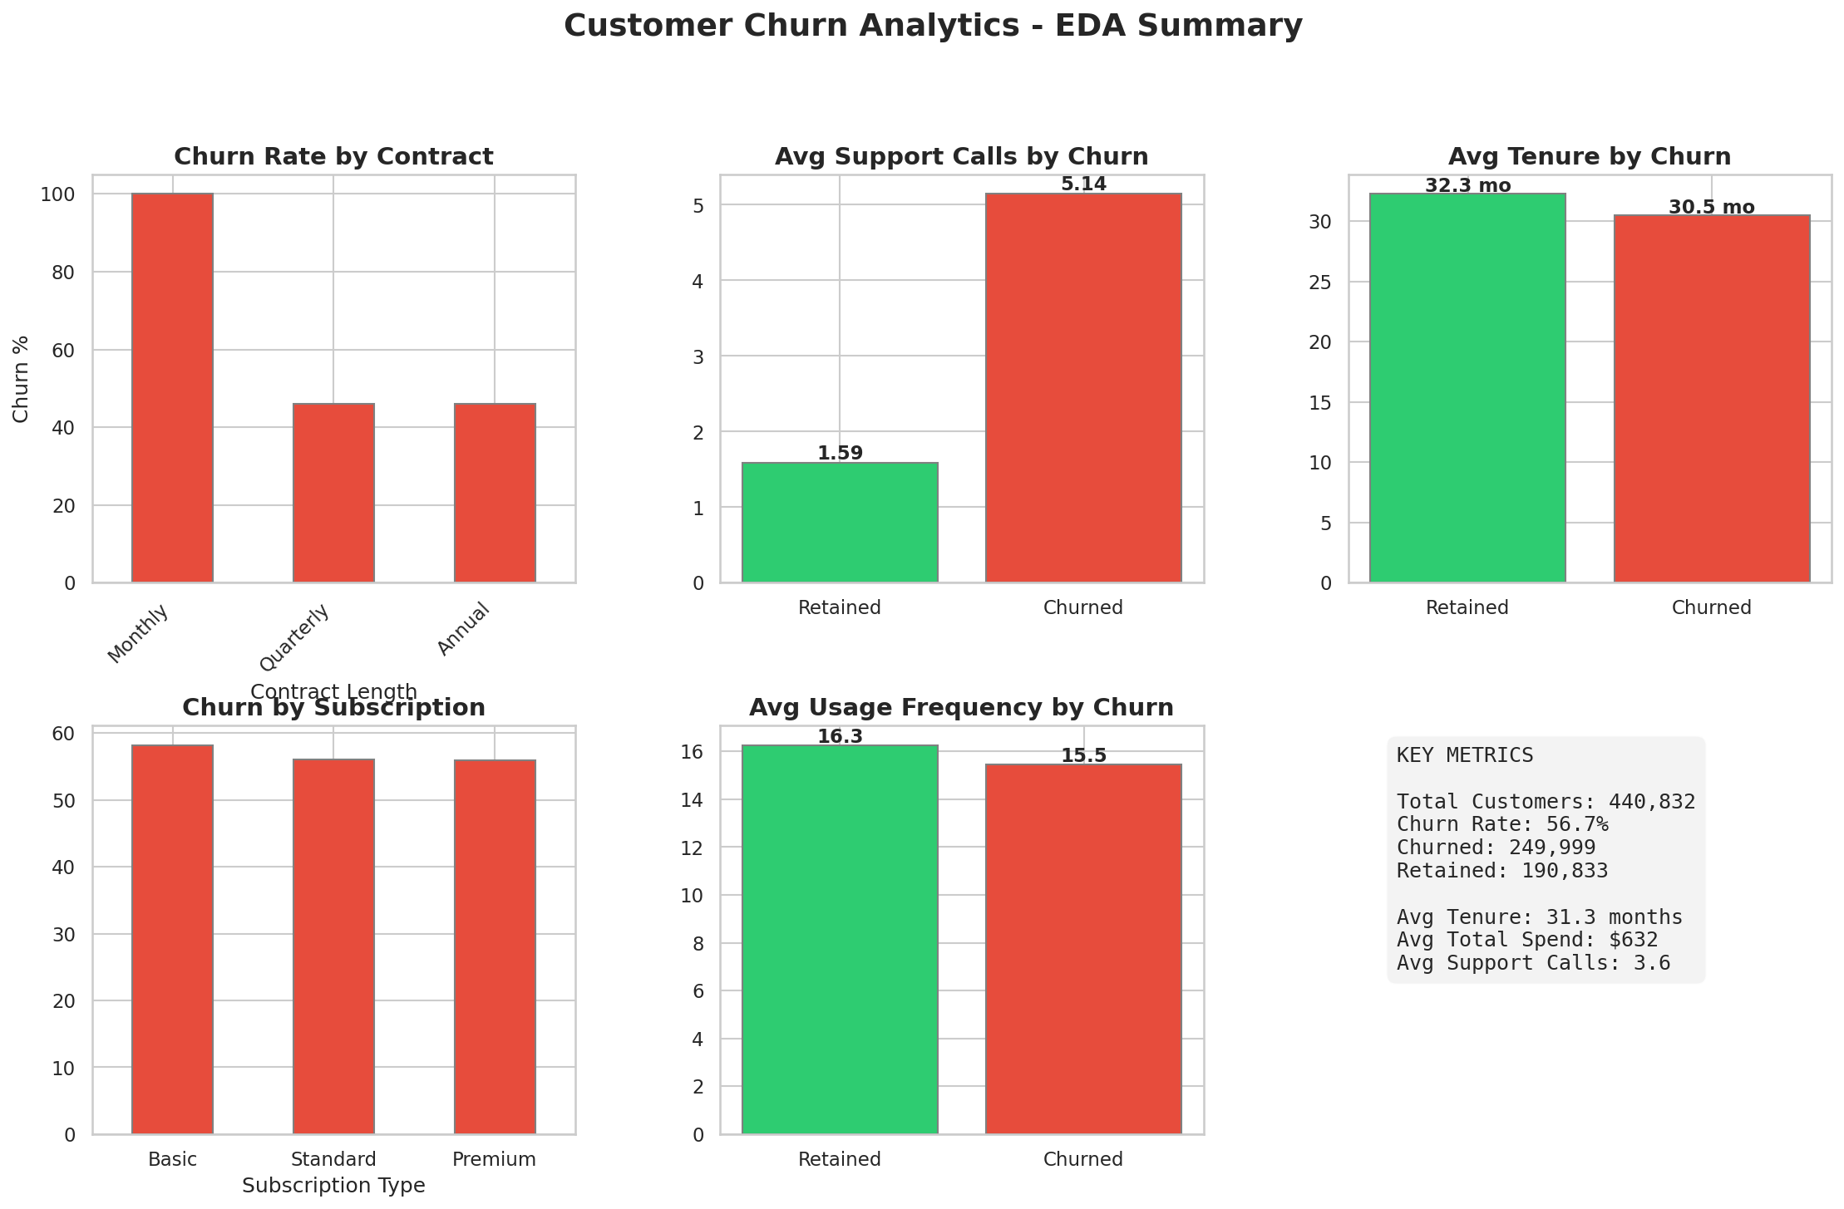
Figure 2: Support Calls vs Churn (Strongest Predictor)
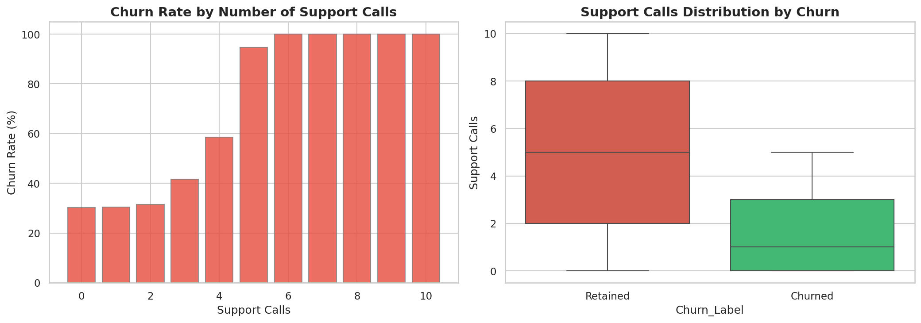

2. Progress Evidence (Board Snapshot)
Backlog Status:
Status | Count | Tasks
✅ Done | 8 | S1-T1 Repo setup, S1-T2 Dataset download/validation, S1-T3 Data cleaning, S1-T4 EDA analysis (11 plots), S1-T5 Business insights report, S1-T6 Preprocessing pipeline, S1-T7 Documentation, S1-T8 Sprint report
🟡 In-Progress | 0 | —
🔴 Blocked | 0 | —

GitHub Repository: github.com/[team-repo]/customer-churn-analytics
Key Files: src/data_loader.py, src/eda_analysis.py, src/business_insights.py, src/data_preprocessing.py
[Insert Trello/GitHub Projects board screenshot before submission]
Quality Gates Met:
• Dataset validated: 440,832 records, 12 columns, 56.7% churn rate, 0 missing values after cleaning
• 11 EDA visualizations generated and saved to outputs/eda_plots/
• Business insights report with churn driver analysis and risk segmentation
• Preprocessing pipeline tested: 308,582 train / 132,250 test split (stratified)

3. Next Sprint Plan (Sprint 2)
Sprint 2 Goal: Build end-to-end ML pipeline with Logistic Regression baseline achieving ROC-AUC ≥ 0.65.

• S2-T1: Implement full preprocessing pipeline (LabelEncoder + StandardScaler + stratified 70/30 split)
• S2-T2: Train Logistic Regression baseline and evaluate with ROC-AUC, F1, Precision, Recall, Confusion Matrix
• S2-T3: Document performance, create model evaluation framework for Sprint 3 advanced models (Random Forest, Gradient Boosting)

Expected Outcome: Baseline model with ROC-AUC ≥ 0.65, preprocessing pipeline ready for advanced models.

