Imam Mohammad Ibn Saud Islamic University
College of Computer and Information Sciences
Computer Science Department

Course Title: | Software Engineering 1
Course Code: | CS1350
Assignment: | Project
Semester: | Second Semester, 2026
Marks: | 10

Train schedule and Reservation Management System

Course Instructor: | Dr. Rawan Albusayli
Section No.: | 1350عال

Student names | Student ID | Section
(Leader) Leen Abdullah Alotaibi | 446004925 | 374
Luluwa Suliman Alhudaithi | 446007785 | 374
Ghada alomar | 446013864 | 374
Layan Abdullah Alotaibi | 446010698 | 374
Shouq Alabdulsalam | 446008008 | 374
Rand Fahad Aloushan | 446008490 | 374

- Project Scope:

The system is developed to manage train schedules, ticket reservation, and database that stores passengers' information.

Core functionalities the system covers:

- Train and Schedule Management: Manipulate train schedules (update, delete, create).

- Passenger information management: Manage and store passenger identification and booking history.

- Reservation and Ticketing Module: Track the remaining seats availability and update capacity.

- Administrative Dashboard: Offer summary decile for the total trains, bookings and revenue.

- Reporting and Analytics: Produce periodic booking and revenue analysis reports.

- Project Objectives:

- Enhance schedules and booking handling
- Guarantee the validation of updated seat availability
- Prevent errors in ticket processing
- Provide recurring reports to backing management decisions
- Protect system data by applying role-based authentication

- Target Audience:

The system is designed for authorized personnel who can manage schedules and reservations, for example:

- Booking staff
- Administrators
- System managers

Users access the system over a secure login system. Different views will be displayed based on the user role and permission.

- Project vision:

The vision of this project aims to implement a secure and scalable train management system that involves scheduling, reservation, and periodic reporting.
The system will offer automatically updates, secure data management, and uphold future development. It will turn out to be developed using Agile methodology with Scrum framework.

2.1 Use Case Diagrams
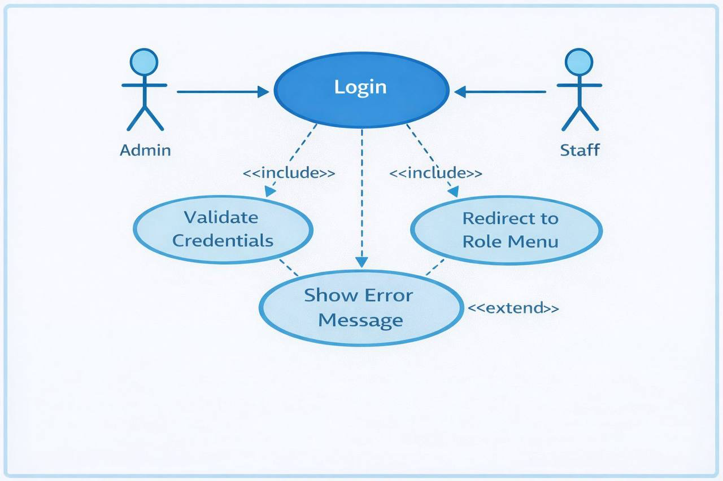
Figure 1: Login Use Case Diagram
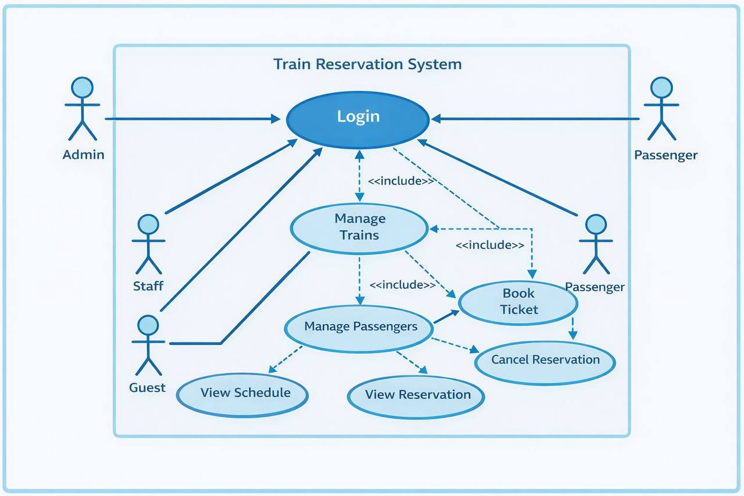
Figure 2: Train Reservation System Use Case Diagram

2.2 Use Case Scenarios – Train Reservation System

Use Case 1: Login
Actor: Admin, Staff
Description: This use case describes how users log into the system.
Main Flow:
- The user opens the login page
- The user enters a username and password
- The system checks that the inputs are valid
- The system searches the database for a matching user
- If the user is found, the system redirects them based on their role

Alternative Flow:
- If the fields are empty, the system shows an error message.
- If the username or password is incorrect, the system displays an “Invalid username or password” message.

Use Case 2: Manage Trains
Actor: Admin
Description: This use case allows the admin to manage train information.
Main Flow:
- The admin selects the “Manage Trains” option.
- The admin can add a new train.
- The admin can update existing train details.
- The admin can delete a train.
- The system updates the database.

Alternative Flow:
- If required fields are missing, the system shows a validation message.
- If invalid data is entered (such as negative capacity), the system displays an error.

Use Case 3: Book Ticket
Actor: Staff
Description: This use case explains how a staff member books a ticket for a passenger
Main Flow:
- The staff selects the “Book Ticket” option.
- The staff chooses a train.
- The system checks seat availability.
- The staff enters passenger details.
- The system creates a reservation in the database.
- The system decreases the number of available seats.
- A confirmation message is shown

Alternative Flow:
- If no seats are available, the system shows a message.
- If passenger information is incomplete, the system displays a validation error

Use Case 4: Cancel Reservation
Actor: Staff
Description: This use case allows a staff member to cancel a reservation
Main Flow:
- The staff enters the reservation ID.
- The system checks whether the reservation exists.
- The system updates the reservation status to “Cancelled”.
- The system increases the available seats.
- A confirmation message is displayed.

Alternative Flow:
- If the reservation is not found, the system shows an error message

Use Case 5: View Reports
Actor: Admin
Description: This use case allows the admin to view booking statistics.
Main Flow:
- The admin selects the “Dashboard” option.
- The system calculates:
  - Total bookings
  - Total revenue
  - Seat occupancy
- The system displays the report data.

1: Login Use Case Diagram
FigureFigure 1: Login Use Case Diagram
صص 1: Login Use Case Diagram.
Did Figure 1: Login Use Case Diagram.
FagFigure 1: Login Use Case Diagram.

