CEUE203-OOP(JAVA)

PROBLEM:- 1(A-1) | Vending machine :-  (a) Define an enum Coin with constants ONE, TWO, FIVE, TEN.  (b) In main, set a snack price of 15 and a running total of 0; create a Scanner.  (c) Loop: read a coin name, use a switch expression to convert the Coin to its value  (ONE→1, TWO→2, FIVE→5, TEN→10), add it to the total, and print the total so  far.  (d) Stop the loop once the total reaches 15 or more.  (e) Print the change to return (total − 15).  Expected output: TEN then FIVE prints “Paid. Change: 0”; TEN then TEN prints  “Paid. Change: 5”.
CODE :- | import java.util.Scanner;  public class VendingMachine {  enum Coin { ONE, TWO, FIVE, TEN }  public static void main(String[] args) {  int price = 15;  int total = 0;  Scanner sc = new Scanner(System.in);  while (total < price) {  System.out.print("Insert coin (ONE/TWO/FIVE/TEN): ");  String input = sc.next().trim().toUpperCase();  Coin coin;  try {  coin = Coin.valueOf(input);  } catch (IllegalArgumentException e) {  System.out.println("Invalid coin. Try again.");  continue;  }  int value = switch (coin) {  case ONE -> 1;  case TWO -> 2;  case FIVE -> 5;  case TEN -> 10;  };  total += value;  System.out.println("Total so far: " + total);  }  System.out.println("Paid. Change: " + (total - price));  sc.close();  }  }
OUTPUT :- | 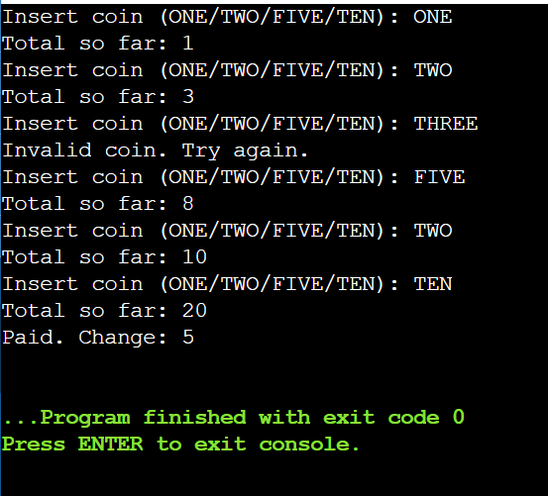

PROBLEM:- 1(A-2) | Toll booth :-  (a) Define a record Vehicle(String number, String type).  (b) In main, keep a running toll total and three counters (bike, car, truck).  (c) Loop until the user types “done” for the number: build a Vehicle, use a switch  expression on its type for the toll (bike→20, car→50, truck→150), add to the total,  and increment that type’s counter.  (d) After the loop, print the total toll and the type with the highest count.  Expected output: two cars + one bike → “Total toll: 120”, “Most frequent: car”.
CODE :- | import java.util.Scanner;  public class TollBooth {  record Vehicle(String number, String type) {}  public static void main(String[] args) {  Scanner sc = new Scanner(System.in);  int totalToll = 0;  int bikeCount = 0, carCount = 0, truckCount = 0;  while (true) {  System.out.print("Enter vehicle number (or 'done' to finish): ");  String number = sc.next().trim();  if (number.equalsIgnoreCase("done")) {  break;  }  System.out.print("Enter vehicle type (bike/car/truck): ");  String type = sc.next().trim().toLowerCase();  Vehicle vehicle = new Vehicle(number, type);  int toll = switch (vehicle.type()) {  case "bike" -> 20;  case "car" -> 50;  case "truck" -> 150;  default -> {  System.out.println("Unknown type, treated as car.");  yield 50;  }  };  totalToll += toll;  switch (vehicle.type()) {  case "bike" -> bikeCount++;  case "car" -> carCount++;  case "truck" -> truckCount++;  default -> carCount++;  }  }  String mostFrequent;  if (bikeCount >= carCount && bikeCount >= truckCount) {  mostFrequent = "bike";  } else if (carCount >= bikeCount && carCount >= truckCount) {  mostFrequent = "car";  } else {  mostFrequent = "truck";  }  System.out.println("Total toll: " + totalToll);  System.out.println("Most frequent: " + mostFrequent);  sc.close();  }  }
OUTPUT :- | 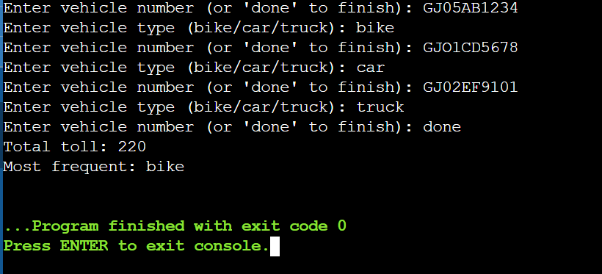

PROBLEM:- 1(A-3) | Rock-Paper-Scissors-Lizard-Spock :-  (a) Define an enum Move with ROCK, PAPER, SCISSORS, LIZARD, SPOCK.  (b) Write winner(Move a, Move b) returning 1 if a beats b, -1 if b beats a, 0 for a tie —  use a switch expression listing what each move beats (Scissors cut Paper, Paper  covers Rock, Rock crushes Lizard, Lizard poisons Spock, Spock smashes Scissors,  and the five mirror cases).  (c) In main, play 5 rounds: pick a random computer Move, read the player’s Move, call  winner(), print the round result and keep score.  (d) After 5 rounds, print the overall winner.  Expected output: each round prints both moves and the round winner; ends with a  “You win 3–2” summary.
CODE :- | import java.util.Random;  import java.util.Scanner;  public class RPSLS {  enum Move { ROCK, PAPER, SCISSORS, LIZARD, SPOCK }  // returns 1 if a beats b, -1 if b beats a, 0 if tie  static int winner(Move a, Move b) {  if (a == b) return 0;  boolean aWins = switch (a) {  case SCISSORS -> b == Move.PAPER || b == Move.LIZARD;  case PAPER -> b == Move.ROCK || b == Move.SPOCK;  case ROCK -> b == Move.LIZARD || b == Move.SCISSORS;  case LIZARD -> b == Move.SPOCK || b == Move.PAPER;  case SPOCK -> b == Move.SCISSORS || b == Move.ROCK;  };  return aWins ? 1 : -1;  }  public static void main(String[] args) {  Scanner sc = new Scanner(System.in);  Random random = new Random();  Move[] moves = Move.values();  int playerScore = 0;  int computerScore = 0;  for (int round = 1; round <= 5; round++) {  Move computerMove = moves[random.nextInt(moves.length)];  System.out.println("Round " + round);  System.out.print("Enter your move (ROCK/PAPER/SCISSORS/LIZARD/SPOCK): ");  String input = sc.next().trim().toUpperCase();  Move playerMove;  try {  playerMove = Move.valueOf(input);  } catch (IllegalArgumentException e) {  System.out.println("Invalid move, you lose this round by default.");  computerScore++;  System.out.println("Computer: " + computerMove + " | You: INVALID");  continue;  }  int result = winner(playerMove, computerMove);  System.out.println("Computer: " + computerMove + " | You: " + playerMove);  if (result == 1) {  playerScore++;  System.out.println("You win this round!");  } else if (result == -1) {  computerScore++;  System.out.println("Computer wins this round!");  } else {  System.out.println("Tie!");  }  System.out.println();  }  System.out.println("Final Score - You: " + playerScore + ", Computer: " + computerScore);  if (playerScore > computerScore) {  System.out.println("You win " + playerScore + "-" + computerScore);  } else if (computerScore > playerScore) {  System.out.println("Computer wins " + computerScore + "-" + playerScore);  } else {  System.out.println("It's an overall tie!");  }  sc.close();  }  }
OUTPUT :- | 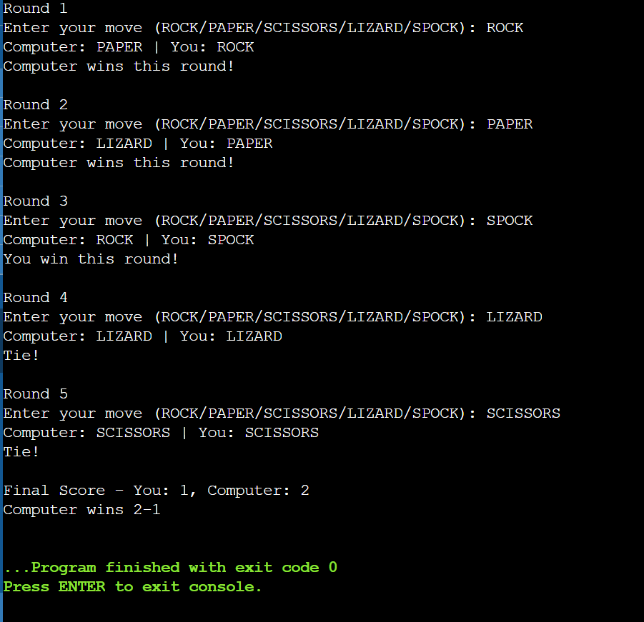

PROBLEM:- 1(B) | MiniBank :-  MiniBank is the console banking application you will build across the whole semester. In this first lab you set up your tools and create the project and its menu shell — the screen the user navigates. Every later lab attaches one real banking feature behind these menu options.  1. Set up your environment: open the project in GitHub Codespaces (or install JDK 17+ and an IDE locally), and create a private GitHub repository named oop-minibank-<rollno>; add the faculty as a collaborator.  2. Create a public class named MiniBank that contains the main method.  3. Define a record named BankInfo with two String fields, name and branch (a record is a short, read-only class; Java auto-generates its constructor and field accessors). Print one BankInfo object as the application header.  4. Define an enum named MenuOption with the constants OPEN_ACCOUNT, DEPOSIT,  WITHDRAW, TRANSFER and EXIT — these are the actions MiniBank will offer.  5. Display the numbered menu to the user and read the chosen number with a Scanner.  6. Use a switch expression on the choice to print a short placeholder for that option (for example, “Deposit — to be implemented in a later lab”). Keep showing the menu in a loop until the user selects EXIT, then print a goodbye message.
CODE :- | import java.util.Scanner;  public class MiniBank {  record BankInfo(String name, String branch) {}  enum MenuOption { OPEN_ACCOUNT, DEPOSIT, WITHDRAW, TRANSFER, HOURS, EXIT }  public static void main(String[] args) {  Scanner sc = new Scanner(System.in);  BankInfo bank = new BankInfo("MiniBank", "Main Branch");  System.out.println("=====================================");  System.out.println(bank.name() + " - " + bank.branch());  System.out.println("=====================================");  boolean running = true;  while (running) {  printMenu();  System.out.print("Enter your choice: ");  String input = sc.nextLine().trim();  int choice;  try {  choice = Integer.parseInt(input);  } catch (NumberFormatException e) {  System.out.println("Invalid input. Please enter a number.\n");  continue;  }  if (choice < 1 || choice > 6) {  System.out.println("Invalid menu number. Please try again.\n");  continue;  }  MenuOption option = switch (choice) {  case 1 -> MenuOption.OPEN_ACCOUNT;  case 2 -> MenuOption.DEPOSIT;  case 3 -> MenuOption.WITHDRAW;  case 4 -> MenuOption.TRANSFER;  case 5 -> MenuOption.HOURS;  case 6 -> MenuOption.EXIT;  default -> throw new IllegalStateException("Unreachable");  };  switch (option) {  case OPEN_ACCOUNT -> System.out.println("Open Account — to be implemented in a later lab.");  case DEPOSIT -> System.out.println("Deposit — to be implemented in a later lab.");  case WITHDRAW -> System.out.println("Withdraw — to be implemented in a later lab.");  case TRANSFER -> System.out.println("Transfer — to be implemented in a later lab.");  case HOURS -> System.out.println("Working hours: Mon-Sat, 9:00 AM - 5:00 PM.");  case EXIT -> {  System.out.println("Thank you for using MiniBank. Goodbye!");  running = false;  }  }  System.out.println();  }  sc.close();  }  static void printMenu() {  System.out.println("---------- MiniBank Menu ----------");  System.out.println("1. Open Account");  System.out.println("2. Deposit");  System.out.println("3. Withdraw");  System.out.println("4. Transfer");  System.out.println("5. Working Hours");  System.out.println("6. Exit");  }  }
OUTPUT :- | 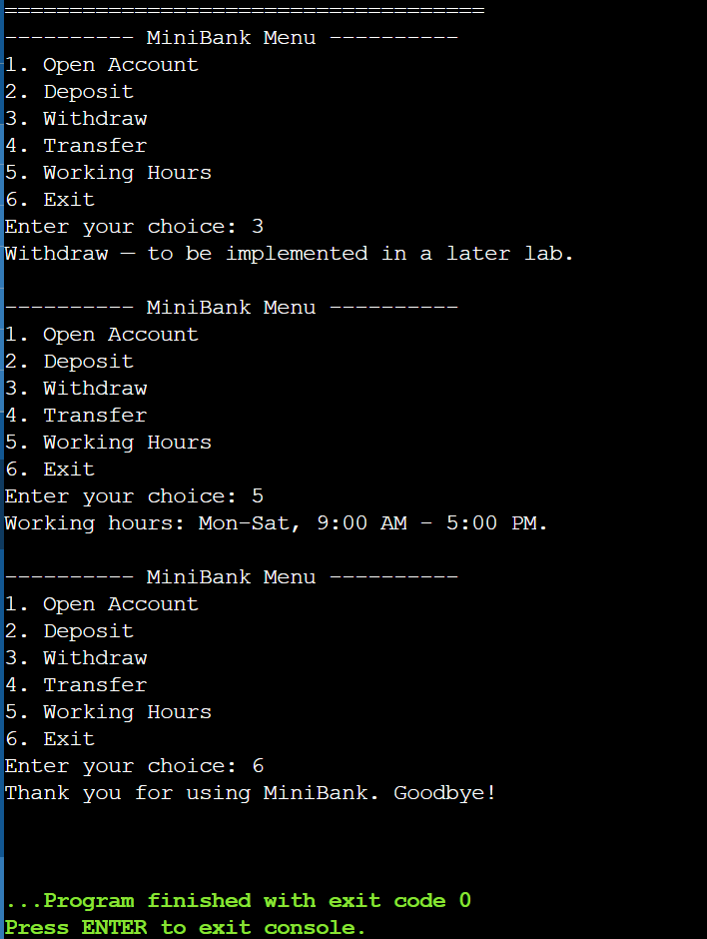

Key Questions / Analysis / Interpretation:

1. What is the role of the JVM, and what file does the javac compiler produce?
- The JVM (Java Virtual Machine) is the runtime engine that executes Java programs. It loads compiled bytecode, verifies it, interprets/JIT-compiles it into native machine instructions, and manages memory (via garbage collection), threads, and security — this is what gives Java its "write once, run anywhere" property, since the same bytecode runs on any platform that has a JVM. The javac compiler takes your .java source file and produces a .class file, which contains platform-independent bytecode (not native machine code). The JVM then reads this .class file to run the program.
2. How does a switch expression differ from a traditional switch statement?

- A switch statement executes code but doesn't produce a value; you typically use break to prevent fall-through, and forgetting break is a classic bug source.
- A switch expression (Java 14+) evaluates to a value that you can assign or return. It uses the -> arrow syntax, doesn't fall through by default, and each branch must either yield a value directly or use yield inside a block. It's more concise, safer (no accidental fall-through), and the compiler can check exhaustiveness (especially useful with enums — it can warn you if you forget a case).

3. Why is an enum a good choice for a fixed set of menu options, and a record for read-only data?
- An enum is ideal for a fixed, known set of constants (like OPEN_ACCOUNT, DEPOSIT, WITHDRAW, TRANSFER, EXIT) because it gives type safety — the compiler won't let you pass an invalid option — and it works naturally with switch expressions, which can even check that all enum cases are handled.
- A record is ideal for simple, immutable data holders (like BankInfo with name and branch) because it automatically generates the constructor, field accessors, equals(), hashCode(), and toString() — saving boilerplate — while enforcing immutability, which is appropriate for data that shouldn't change after creation (like a bank's name/branch header).

