PRACTICAL - 05
Part A — Practice Programs (Hour 1)

PROBLEM1 | Shape areas: an abstract Shape with abstract area(); subclasses Circle, Rectangle, Triangle. Put a mix in a Shape[] and loop once to print each a--rea and the running total, tracking the largest — one loop handling every shape through polymorphism.
CODE | abstract class shape {  public abstract double area();  }  class circle extends shape {  private double r;  public circle(double r) {  this.r = r;  }  @Override  public double area() {  return Math.PI * r * r;  }  }  class rectangle extends shape {  private double l, b;  public rectangle(double l, double b) {  this.l = l;  this.b = b;  }  @Override  public double area() {  return l * b;  }  }  class triangle extends shape {  private double b, h;  public triangle(double b, double h) {  this.b = b;  this.h = h;  }  @Override  public double area() {  return 0.5 * b * h;  }  }  public class ShapeTest {  public static void main(String[] args) {  shape c = new circle(5);  shape r = new rectangle(4, 6);  shape t = new triangle(3, 8);  System.out.println("Area of Circle: " + c.area());  System.out.println("Area of Rectangle: " + r.area());  System.out.println("Area of Triangle: " + t.area());  double totalArea = c.area() + r.area() + t.area();  System.out.println("Total Area: " + totalArea);  double largestarea = 0;  shape largestshape = null;  for (shape s : new shape[] { c, r, t }) {  if (s.area() > largestarea) {  largestarea = s.area();  largestshape = s;  }  }  System.out.println("Largest Area: " + largestarea);  System.out.println("Largest Shape: " + largestshape.getClass().getSimpleName());  }  }
OUTPUT | 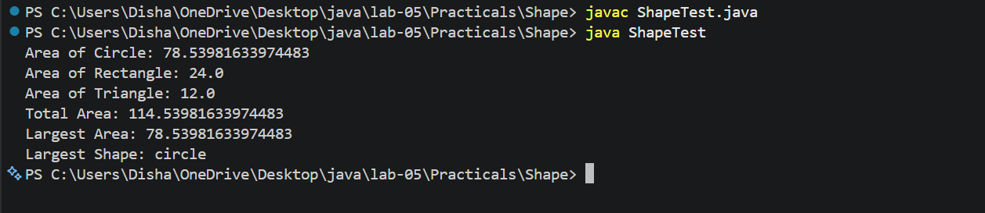
PROBLEM2 | Payroll: an abstract Employee with abstract monthlySalary(); FullTime (fixed), PartTime (hours × rate) and Intern (stipend), each calling super for the shared name/id. Loop a mixed array to print each salary and the total; use instanceof to add a note only for interns.
CODE | abstract class employee {  private String name;  private int id;  public employee(String name, int id) {  this.name = name;  this.id = id;  }  public String getName() {  return name;  }  public int getId() {  return id;  }  public abstract double monthlysalary();  }  class fulltime extends employee {  private double salary;  public fulltime(String name, int id, double salary) {  super(name, id);  this.salary = salary;  }  @Override  public double monthlysalary() {  return salary;  }  }  class parttime extends employee {  private double hour;  private int rate;  public parttime(String name, int id, double hour, int rate) {  super(name, id);  this.hour = hour;  this.rate = rate;  }  @Override  public double monthlysalary() {  return hour * rate;  }  }  class intern extends employee {  private double stipend;  public intern(String name, int id, double stipend) {  super(name, id);  this.stipend = stipend;  }  @Override  public double monthlysalary() {  return stipend;  }  }  public class Payroll {  public static void main(String[] args) {  employee e1 = new fulltime("Disha", 101, 50000);  employee e2 = new parttime("Anshika", 102, 80, 200);  employee e3 = new intern("Shruti", 103, 15000);  System.out.println("Monthly Salary of " + e1.getName() + " (ID: " + e1.getId() + ") is: " + e1.monthlysalary());  System.out.println("Monthly Salary of " + e2.getName() + " (ID: " + e2.getId() + ") is: " + e2.monthlysalary());  System.out.println("Monthly Salary of " + e3.getName() + " (ID: " + e3.getId() + ") is: " + e3.monthlysalary());  double totalSalary = e1.monthlysalary() + e2.monthlysalary() + e3.monthlysalary();  System.out.println("Total Salary: " + totalSalary);  if (e1 instanceof intern) {  System.out.println(e1.getName() + " is an intern");  } else if (e2 instanceof intern) {  System.out.println(e2.getName() + " is a intern ");  } else if (e3 instanceof intern) {  System.out.println(e3.getName() + " is a intern");  }  }  }
OUTPUT | 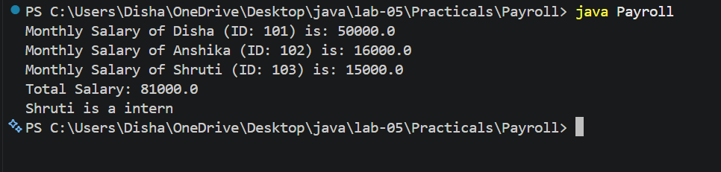
PROBLEM3 | (For Advanced Learners – home) Model a few media types that each compute a late fee differently and total the fees for a returned batch. Design the hierarchy and rules yourself.
CODE | abstract class Media {  private String title;  private int id;  public Media(String title, int id) {  this.title = title;  this.id = id;  }  public String getTitle() {  return title;  }  public int getId() {  return id;  }  public abstract double lateFee(int daysLate);  }  class Book extends Media {  public Book(String title, int id) {  super(title, id);  }  @Override  public double lateFee(int daysLate) {  return daysLate * 2.0;  }  }  class DVD extends Media {  public DVD(String title, int id) {  super(title, id);  }  @Override  public double lateFee(int daysLate) {  return daysLate * 5.0;  }  }  class Magazine extends Media {  public Magazine(String title, int id) {  super(title, id);  }  @Override  public double lateFee(int daysLate) {  return daysLate > 0 ? 10.0 : 0.0;  }  }  public class MediaTest {  public static void main(String[] args) {  Media[] items = {  new Book("Java", 1),  new DVD("Inception", 2),  new Magazine("Weekly Magazine", 3),  new Book("DSA in C++", 4),  new DVD("Interstellar", 5)  };  int[] daysLate = { 3, 1, 0, 5, 2 };  double totalFee = 0;  for (int i = 0; i < items.length; i++) {  double fee = items[i].lateFee(daysLate[i]);  System.out.println(  items[i].getTitle() +  " (ID " + items[i].getId() +  ") late fee = " + fee);  totalFee += fee;  }  System.out.println("Total late fees = " + totalFee);  }  }
OUTPUT | 