Practical 3

Part A
1) | AIM: Distinct points (Point.java + Driver.java with main)  (a) Create class Point with private int x, y and a constructor.  (b) Override toString() to return “(x, y)”.  (c) Override equals(Object) to be true when both x and y match, and hashCode() to agree (e.g. Objects.hash(x, y)).  (d) In Driver.main: build a Point[] with some repeated coordinates.  (e) Count distinct points: for each point, use equals() to check whether it already appeared earlier; count those that did not.  (f) Print “Distinct: N”. Expected output: 5 points with 2 repeats → “Distinct: 3”
 | Point.java
Code | import java.util.*;  public class Point {  private int x;  private int y;  public Point(int x, int y) {  this.x = x;  this.y = y;  }  @Override  public String toString() {  return "(" + x + "," + y + ")";  }  @Override  public boolean equals(Object o){  if(this==o){  return true;  }  if(!(o instanceof Point)){  return false;  }  Point p= (Point )o;  return this.x==p.x && this.y==p.y;  }  @Override  public int hashCode() {  return Objects.hash(x, y);  }  }
 | Driver.java
Code | public class Driver {  public static void main(String []args){  Point[] point={new Point(1,2),new Point(3,4),new Point(5,6),new Point(3,4)};  int distinctcount = 0;  for (int i = 0; i < point.length; i++) {  boolean seenBefore = false;  for (int j = 0; j < i; j++) {  if (point[i].equals(point[j])) {  seenBefore = true;  break;  }  }  if (!seenBefore) distinctcount++;  }  System.out.println("Distinct:" + distinctcount);  }  }
Output | 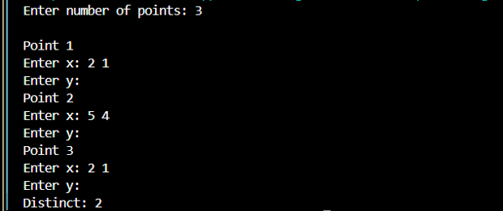
2) | AIM: Duplicate card check (Card.java + Driver.java)  (a) Create class Card with private String rank, suit and a constructor.  (b) Override toString() to return rank + “ of ” + suit (e.g. “Queen of Hearts”). (c) Override equals()/hashCode() by rank + suit.  (d) In Driver.main: add cards to a Card[] one at a time; before adding each, use equals() to check it against the earlier cards.  (e) Print “Duplicate found: ” the first time a repeat appears. Expected output: a second “Ace of Spades” → “Duplicate found: Ace of Spadescalls, printing the result and seats after each, then print getTotalBooked().  Expected output: booking more than available prints false and leaves seats unchanged; totalBooked equals the successful bookings
 | Card.java
Code | import java.util.Objects;  public class Fraction {  private int num, den;  public Fraction(int num, int den) {  int g = gcd(Math.abs(num), Math.abs(den));  this.num = num / g;  this.den = den / g;  }  private int gcd(int a, int b) {  return b == 0 ? a : gcd(b, a % b);  }  @Override  public String toString() {  return num + "/" + den;  }  @Override  public boolean equals(Object o) {  if (this == o){  return true;  }  if (!(o instanceof Fraction)){  return false;  }  Fraction f = (Fraction) o;  return num == f.num && den == f.den;  }  @Override  public int hashCode() {  return Objects.hash(num, den);  }  }
 | Driver.java
import java.util.ArrayList;
import java.util.List;

public class Driver {
public static void main(String[] args) {
List<Card> cards = new ArrayList<>();
Card[] toAdd = {
new Card("Ace", "Spades"),
new Card("King", "Hearts"),
new Card("Ace", "Spades") // duplicate
};

for (Card c : toAdd) {
boolean isDuplicate = false;
for (Card existing : cards) {
if (existing.equals(c)) {
isDuplicate = true;
break;
}
}
if (isDuplicate) {
System.out.println("Duplicate found: " + c);
break; // stop at first repeat, as spec says "the first time"
}
cards.add(c);
}
}
}

Output | 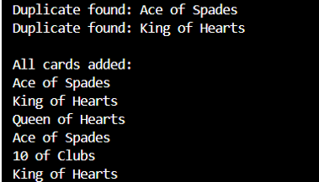
Q3) | AIM: Fractions (Fraction.java + Driver.java)  (a) Create class Fraction with private int num, den.  (b) In the constructor, reduce to lowest terms: compute g = gcd(num, den) and divide both by g.  (c) Override toString() to return num + “/” + den.  (d) Override equals()/hashCode() using the reduced num and den.  (e) In Driver.main: create several equivalent fractions (1/2, 2/4, 3/6) and confirm they are all equal and print the same.  Expected output: new Fraction(2,4) prints “1/2” and equals new Fraction(1,2)
 | Fraction.java
Code | import java.util.Objects;  public class Fraction {  private int num, den;  public Fraction(int num, int den) {  int g = gcd(Math.abs(num), Math.abs(den));  this.num = num / g;  this.den = den / g;  }  private int gcd(int a, int b) {  return b == 0 ? a : gcd(b, a % b);  }  @Override  public String toString() {  return num + "/" + den;  }  @Override  public boolean equals(Object o) {  if (this == o){  return true;  }  if (!(o instanceof Fraction)){  return false;  }  Fraction f = (Fraction) o;  return num == f.num && den == f.den;  }  @Override  public int hashCode() {  return Objects.hash(num, den);  }  }
 | Driver.java
Code | public class Driver {  public static void main(String[] args) {  Fraction a = new Fraction(1, 2);  Fraction b = new Fraction(2, 4);  Fraction c = new Fraction(3, 6);  System.out.println(a);  System.out.println(b);  System.out.println(c);  System.out.println(a.equals(b));  System.out.println(b.equals(c));  }  }
Output | 