Introduction to Compartment Models

Describing a physiological system by decomposition into subsystems, called compartments
Compartments represent a well-mixed, homogeneous material that behaves uniformly
ex.: Tracer in tissue that has been specifically bound, for instance, at the target receptor site
Free tracer in tissue that may diffuse back into the blood
Tracer in the arterial plasma that can be extracted into the tissue
Simplification in the model approach: the change of tracer concentration in each compartment is a linear function of the concentrations in the other compartments
Assumption: observed system is not disturbed by the small amounts of tracer

1TCM
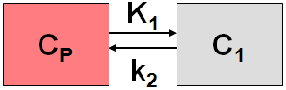
Most simplified model:
Tracer is injected intravenously as a bolus
Distribution by the arterial circulation
Exchange with the tissue at the capillary bed
Some fraction is extracted into the tissue and metabolized while the rest is transported back to the heart → recirculation
2 parameters: K1 and k2
Transfer coefficients K1[ml/min/cm³] and k2 [1/min] describe 1) a perfusion-dependent component and 2) a fraction of mass transferred per unit time
C1: tracer concentration in tissue
Cp: parent concentration (unchanged tracer)
Solution:
The tissue compartment includes free tissue (F), non-specific bound (NS) and specific bound (S) components

2TCM

Locate F and NS component within the tissue while S is outside the tissue, i.e. C1=C_F+C_NS and C2 = C_S
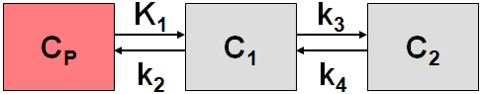

Simplification is justified if the exchange free – non-specific binding is significantly faster than the exchange free specific binding
, total of 4 parameters
including

3TCM

Splitting up the tissue concentration in all the compartments: F, NS and S leading to 3 differential equations:

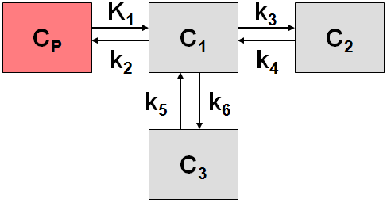
Deriving differential equations in analogy to the 1-tissue compartment model

Looking at each compartment individually and looking for uptakes and emittance

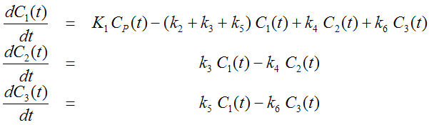

total of 6 parameters which makes it difficult to assess experimentally only limited PET data points

