Multiple Time Graphical Analysis (MTGA)

Tracer concentration curve of a tissue in a ROI and arterial plasma are combined into a single curve
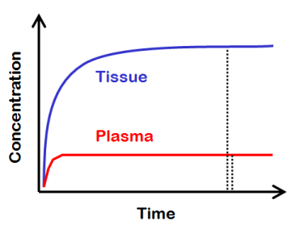
Approximation to a linear behavior under certain conditions ( =steady state condition)

Slope represents the net uptake of the tracer or volume of distribution V_T

V_T = C_T / C_P

ratio of the radio-ligand concentration in tissue (kBq/cm³) and to that in the plasma (kBq/ml) at equilibrium

C_T = C_S + C_NS + C_FT

(specifically bound, nonspecifically, free in tissue)

Volume of distribution is proportional to both receptor densitiy (B_avail) and the binding affinity (1/K_D): V_T ~ B_avail/K_D

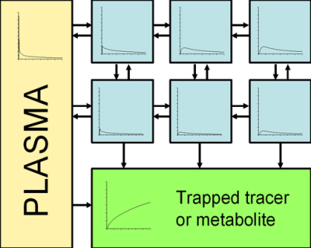
MTGA for irreversible uptake (Patlak plot)

Idea: independent of the tracer, there is at least one irreversible reaction where the tracer or its labeled product cannot escape

Assumption: reversible components are in equilibrium with plasma, i.e. V_T = const.

No irreversible binding in the tissue results in a horizontal patlak curve with slope zero

Patlak Plot

linear, when the equilibrium is achieve

slope represents the net transfer rate K_i (influx constant)
→ amount of accumulated tracer in relation to whats present in the plasma

y axis: ratio of concentrations of tracer in tissue and in plasma
x axis: normalized plasma integral/plasma concentration

reference region: irreversible components do not exist (e.g.: FDOPA studies) → plasma curve is canceled out (replace plasma with reference region)

K_i = (K_1 x k_3) / (k_2 + k_3) vs. K_i(ref) = (k_2 x k_3) / (k_2 + k_3)
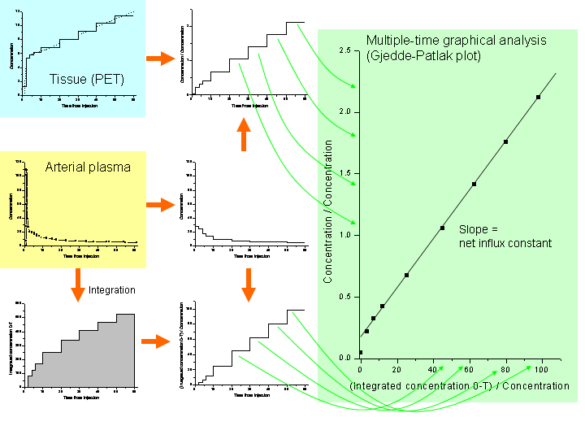
MTGA for reversible uptake (Logan plot)

Provide estimate of equilibrium V_T

Calculate the binding potential B_ND if a reference region is available: BP_ND = V_T/V_T(ref) -1

Equation for the logan plot:

Slope gives arise to the volume of distribution (if reference region is input: distribution volume ratio DVR)

Logan plot need data from tracer injection time (needs both tissue and input integrals from time 0)

