Salwa Ghaffar

INFO 101 Milestone 2

The Evolution of Technology

**Chapter 1**

**Intro to Computing and Security Technology**

If we think about technology that we are using now it doesn’t seem like we have enough of it. We have greatly developed in technology like computers which never existed in some earlier eras. We can advance more, for instance we have smartphones which works like computers. Nonetheless there was a time when these things did not exist previously. These chapters will address some of the inventions that we don’t know the history of. Most of them we don’t know who created them. We are using all these devices whether they are created by Microsoft or Apple, but we don’t know when they started, how they created these devices, and who started programming for computers. We play video games now a days and we even have careers which are for Computer Science, Cyber Security, Gaming, and Data Management, but we don’t know when we had them and who invented them.

Now that the discussion about computing has begun, we will talk about who invented the first computer, and when the computer was invented. The first computer that was invented was a calculator, it was invented by Charles Babbage who is also known as “The Father of Computer.” He wanted to mechanically calculate mathematical tables. In 1812 or 1813 he made a small calculator, which was able to perform certain computations to eight decimals. In the mid-1830s Babbage developed plans for an Analytical Engine, the ancestor of the modern digital computer. In his device he planned the capability of any arithmetical operations (Britannica, n.d.). Babbage was an English mathematician and inventor who created the first digital computer. He developed a plan for an Analytical Engine in the mid-1830s even though it was never completed but it had most of the basic elements of a present-day computer. His Analytical Engine was used later to do the first programming.

Later, in 1843 Augusta Ada, who was an associate of Babbage, annotated an article which was about Babbage’s analytical machine elements. Augusta elaborated on her annotation and proposed the idea that the Analytical Engine can be programmed. She has been addressed as a first programmer in the history who not only gave the idea about codes which can be used to handle symbols and letters along with numbers, but also made the theory for the looping in computer programming. She is like an idol for girls in computing. There were also women who got recognition in the computing world. She was the first programmer and her idea about looping is still being used in programming language (Britannica, n.d.). There is still a lot of people who don’t believe or support women in IT and think that they don’t qualify enough but the history has its own records that the first programming language was started by a woman. In 1980 a new computing language was developed and named “Ada” after Augusta. However, the analytical engine was never completed, but his notebook was discovered in 1937. In 1991 Doron Swade led the Science Museum library in London to construct Difference Engine 2 accurate to 31 digits. Doron Swade used Babbage’s design as reference for this development (News, 2000). Just like Charles Babbage and Augusta Ada there are also some other people who contributed to the development of computing and computer security like Alan Turing.

Alan Turing, who is known as “The Father of Computer Security or Modern Computing”, was a computer scientist, cryptanalyst, and a brilliant mathematician. His biggest invention was the Turing Machine which he created in 1936. It was a simple machine but could simulate any computer algorithm, no matter how complicated it is. During World War II he worked with wartime cryptanalytic headquarters. He created a computer that was used to decode the German Enigma machine which Germans were using during war to encode their messages in which they were discussing war related plans. The Polish Bombe which they used against Germany’s was a more powerful device. It could break any Enigma message where a small portion of plaintext could be guessed correctly (Hodges, n.d.). More details about cyber security and cyber warfare will be discussed later in chapters. There were also some people who can be credited of making the Electronic Numerical Integrator and a commercial computer for business.

John Willaim Mauchly and J. Presper Eckert are the scientists credited with the invention of the Electronic Numerical Integrator and Computer (ENIAC) in 1943-1944. ENIAC was funded as a technology that could be used in war, but the war was over at that time. However, the ENIAC was employed by the military, this invention was revealed in February 1946. They also designed the Electronic Computing System for The U.S. Census Bureau which was the first commercial computer for business and government applications in 1946 (Lemelson-MIT Celebrating invention, inspiring youth, n.d.). In 1949 their company also launched the BINAC Binary Automated Computer which was using magnetic tape to store data. While they were being funded by the Census Bureau, they delivered their first UNIVAC computer to the Census Bureau in June 1951. Just like John Willaim Mauchly and J. Presper Eckert there were two scientists who created the integrated circuit or computer chip. Although they did not work together, their invention was at the same time and the idea to make an integrated circuit came to them around the same time.

Jack Kilby and Robert Noyce, they came up with the idea of putting all elements of an electronic circuit to a single silicon chip. In 1947 they created their integrated circuit which is also known as a microchip. The integrated circuit made it possible to incorporate a roomful of equipment into a device that could be held in the palm of the hand. It also made electronic equipment dramatically cheaper to manufacture. Microchips now control most electrical devices, including all computers (BBC UK, n.d.). In the 1940s to 1950s more people were involved in the industry and bringing their invention. There was also another woman who could be credited for developing the first programming languages.

Grace Hopper was a computer scientist, mathematician and a navy officer. During World War II she joined the U.S. Navy and was assigned to program the Mark I Computer. After the war ended, she continued to work in computing. She was leading the team that created the first computer language compiler, which led to the popular COBOL language in 1953 (Biography, n.d.). After some time of COBOL another programming language FORTRAN was created.

In 1954 John Backus created a programming language called FORTRAN, in full, Formula Translation. His new program made computer programing more accessible because previous programs were written in machine language, which required the programmer to write instructions in binary or hexadecimal arithmetic. Since Backus was frustrated with this hard programming language, he was led to find a simpler way. Backus led IBM employees to create a language that combined a form of English shorthand with algebraic equations. FORTRAN was a faster writing computer program than the other program that ran nearly as efficiently as programs that had been laboriously. He made it as easy as possible because at that time most of the people didn’t have any computers, so it was hard for them to manage writing those long programs. It was expensive for them to afford programming languages because at that time using computers was not common (Britannica FORTRAN , n.d.). Now a days we are using a lot of programming languages, specially Python and JavaScript, also required for almost every technology student to take for their major. There are languages like Java and C++ to name a few. There were also some other inventions rather than programming we all are using now a days, like the mice for computers and the graphical user interface.

Douglas Engelbart was an American inventor who invented the computer mouse in the 1950s. He also developed the basic of graphical user interface which is known as GUI. He also created a groupware which is a type of computer program that shares data between more than one computer for processing. He also won the A.M. Turing Award which is the highest honor in computer science. In 1963 he was funded by SRI for his own laboratory where he worked on inventing and perfecting various devices such as the computer mouse, the multiple window display and hypermedia. His work made it possible for ordinary people to use computers. There were a lot of inventions and mentioning all of them will take chapters to write them down (Hall, n.d.).

As mentioned earlier there were not that many computers to be used by everyone. In 1974-1977 the personal computer, like Scelbi and Mark-8, were an early model of microcomputers based on Intel 8008 processor and CPU, reached the market. In 1975 Bill Gates and Paul Allen formed their own software company Microsoft after their success of writing down a software for the Altair using the new BASIC language. Yes, Microsoft whose products are the most famous ones they started their company in 1975 and after one year another famous and well-known company was formed; Apple, whose products we are using everyday now a days. Steve Jobs and Steve Wonzniak started their Apple Computers on April 1, 1976. Steve Wonzniak was used to work on internal computer and Steve Jobs worked on the external computer. Although there were computers being used by people, Apple took the stage because of their designs and it could be seen even now of how they design their products.

Nevertheless, there were a lot of inventions that came after time to time, but all these modern technologies could never have been possible without the hard work of these inventions. Now a days we have so many devices at home but back in 1812 or 1813 the biggest invention was a calculator which was called a computer those days. If we talk about programming than it was started by women. Women were the ones who led the programming world and Augusta Ada was such a brilliant woman who even gave the idea of looping which we are using in JavaScript and python etc. to make our codes easier.

**Chapter 2**

**The Internet and the WEB**

The internet, what do we know about it? Who invented it? It’s a global network system which connects millions of computers that uses TCP/IP protocol, but what are protocols and what do they do? Now a days we are using this internet regularly whether it’s for communications, or if we want to collect any information. Most of the people don’t know who made this. It will be hard to credit one person for this invention because many scientists, engineers and programmers developed new features and technologies which we can use now. To make it simple many scientist had visions of wireless systems, but it was not invented until the computer scientists developed “packet switching” in the 1960s.

With packet switching, a message that is sent from one computer to another is broken down into small packets of digital data. Each packet is given an address to travel to and is then routed to its destination (Brian Donnelly, n.d.). In 1973 there were 37 nodes in the operation. Even though packet switching was created in the 1960s it was kept in secret until the 1970s. It was revealed based on national security because academic institutions were involved with the research of ARAPANET Department of Defense. Regardless of what type of computer is on a network, there must be software to allow it to be managed and allow it to communicate. This is where the scientists like Vinton Cerf and Robert Kahn came up with the basic idea of “protocol”, a software for computer communications between 1973 and 1974. Protocol is a method for communication between computers on small and large networks. The protocol is actually a combination of TCP/IP (Andrew, 2019).

Transmission Control Protocol (TCP) attempts to assure the dependable transmissions of data between networks and devices. Internet Protocol (IP) attempts to define the path that data, signals, packets, etc., will travel between a sending device and destination. In 1982 the Defense Department implemented the use of TCP/IP protocol on ARAPANET which at that time contained 100 nodes. In the late 80s the government removed restrictions on the internet which gave access to several researchers and scholars to computer networks. In 1989 computer scientist Tim Berners-Lee invented the World Wide Web, which gave the online world more recognition.

Tim Berners-Lee compiled code which allowed access to the global bank of knowledge www via using code such as HTML (Hypertext Markup Languages), URLs (Uniform Resource Locators), communication protocols such as HTTP (Hypertext Transfer Protocol) and internet browsers (Mozilla Firefox, Internet Explorer, and Google Chrome). The term “internet” is used synonymously with www (World Wide Web) but there is a difference between the internet and www. Think of the internet as a large book with many pages and chapters. Www is like a “table of contents” for that book which the reader uses to locate the specific item in it. The things we are searching for could be either small sentences or big chapters, it could also be a video, music or graphics (Spencer).

**Chapter 3**

**Components of Computing Devices**

In all computer systems, there are two major categories of which all other groups of computer aspects fall within: computer hardware versus computer software. You can also call them the components of computers. Hardware is all the parts you can touch, break, throw or trip. These are physical devices related to the computer. Examples of hardware could include the computer case, monitor, printer, hard drive etc. Software is a collection of instructions, files and codes which are written out, stored digitally and utilized by a computer to perform operations, tasks and functions. Comparing a person with a computer, while the human body would be hardware for example “eyes, mouth and hands”, software would be more like a person’s spirit for example “ideas, morals, ethics, and dreams.”

If we talk about the history of software than we can reference back to our chapter one where we talked about computer programming, and who was the first computer programmer. This can give us an idea about the software as well, because software consists of instruction sets created by programmers using many types of programming languages or Computer Code. In early time punch cards were being used for programming. Later, they were replaced by reels of magnetic tape. In the late 1950s several different programming software were created but it was only available to computer scientists and large businesses. They were used to make their own software which could be used specifically for that one system or device. Nevertheless, when ordinary people started using computers, they were not able to create their own software. The ones made by the company were not useful for them because it was specifically made for the companies and couldn’t work for other systems. During that time Operating Systems like MS-DOS was introduced which would operate the computer. MS-DOS was used to operate many early IBM computers. The first commercial software was available to average customers by IBM in the late 1960s and early 1970s (Designer, n.d.).

Now a days we have a lot of software that we are using regularly. Software can be divided into many different categories such as operating system software and Application Software. Application software allow a user to create documents, spreadsheet, send e-mail, view web pages and many other daily technology-related activities. Firmware is also software which allow an operating system to communicate with specific devices such as speakers and printers. Nonetheless, for this software to operate there is another important component, the hardware portion. Deprived of this hardware the computers can’t work automatically. Hardware of today’s computers are the Stored Program which follows the concept of Von Neumann architecture designed in 1945 by John Von Neumann. His concept was that programs and data are stored in a separate storage unit called memories and are treated the same. The Von Neumann machine consists of a central processor with an arithmetic/logic unit along with control unit, memory, mass storage, and input/output (Techopedia, n.d.). Below is a diagram of his design.

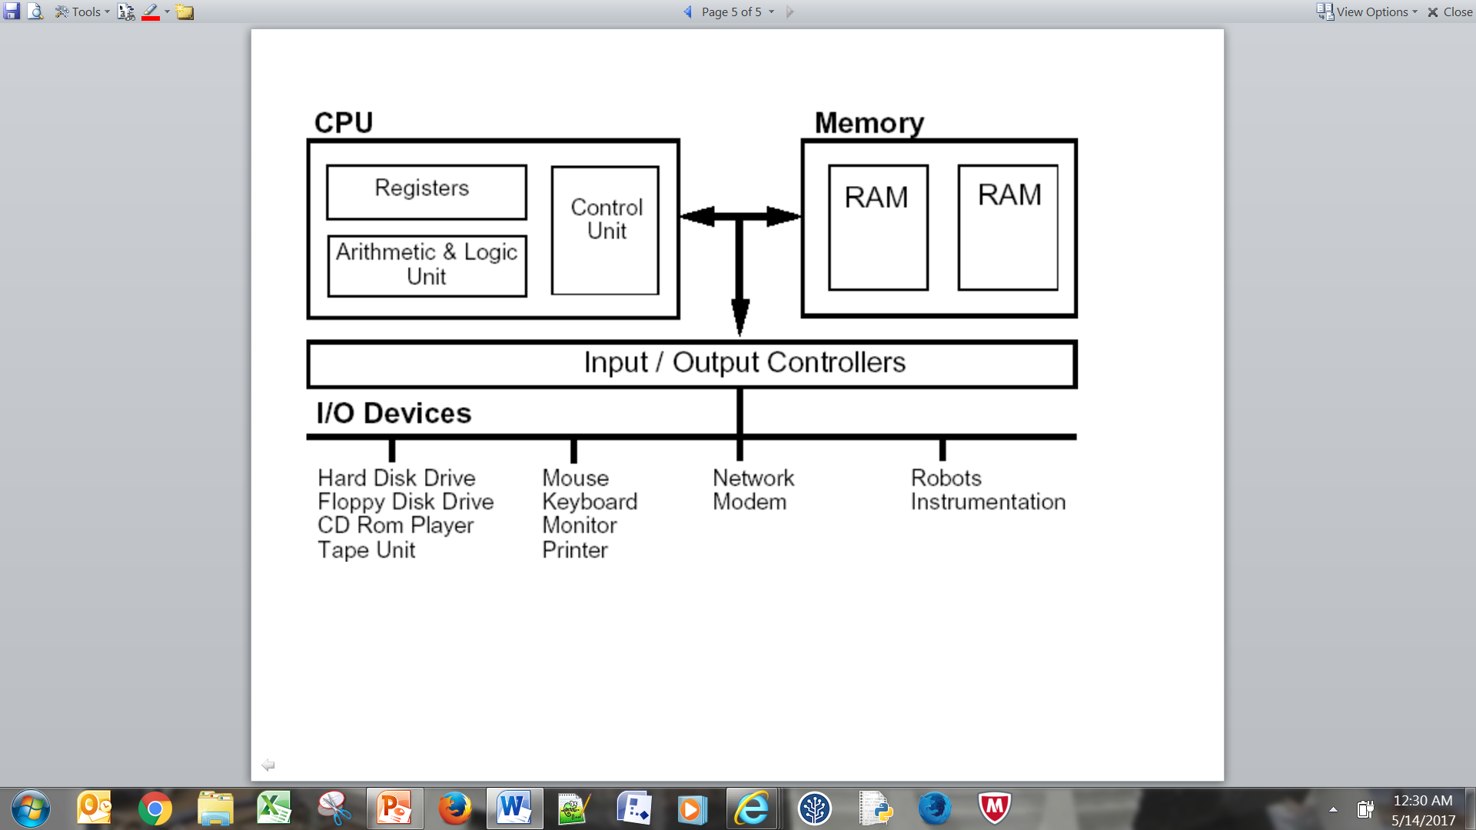

There are many types of hardware which can be either Internal (Inside of the computer case), External (connecting to the outside of the case), or Peripheral (not required for operation of a computer).

Internal Hardware:

* Motherboard
* Power Supply
* Hard Drive
* Optical Drive (e.g. DVD/BD/CD drive)

External Hardware:

* Monitor
* External Hard Drive

Peripheral Hardware:

* Scanners
* Microphones
* Speakers
* Mouse

Some of the hardware parts are “Optical Drive” which allows access as well as storage for data such as documents, files, programs, movies, music and installation of software. “Hard drive” is used as a long-term storage for data. “Motherboard” provides the connection for all internal components such as optical drive, hard drive, CPU, etc. Electricity flows thru motherboard between all devices connected both internally and externally to the computer. There is also “Expansion Card” which can be added to a computer to enhance or add additional functionality to a computer. Some examples of expansion card will be USB Card, Sound Card, Network Interface Card, and Video Card. The most necessary part in the hardware will be the “Power Supply” provides power to all internal devices. The internal devices require at least three different voltages 3.3V, 5V, and 12V (Spencer).

* 3.3V: Motherboard, RAM, onboard ports i.e. USB, NIC, etc.
* 5V: Hard drive circuits, higher-end RAM and standard graphic cards.
* 12V: Hard drive and optical drive motors, fans and High-end graphic cards.

There are a lot of internal hardware and external hardware, and one of them is the Mouse. We have discussed about the invention of this important hardware earlier. The creation of the mouse was discussed in chapter one, it was invented by Douglas Engelbart in the 1950s.

**References**

Alan Turing - A Short Biography. Retrieved 14 October 2019, from https://www.turing.org.uk/publications/dnb.html

BBC - History - Historic Figures: Kilby and Noyce (1923-2005). Retrieved 16 October 2019, from http://www.bbc.co.uk/history/historic_figures/kilby_and_noyce.shtml

BBC News | SCI/TECH | Babbage printer finally runs. (2000). Retrieved 18 October 2019, from http://news.bbc.co.uk/2/hi/science/nature/710950.stm

Charles Babbage | Biography & Facts. Retrieved 12 October 2019, from https://www.britannica.com/biography/Charles-Babbage

Douglas Engelbart | American inventor. Retrieved 13 October 2019, from https://www.britannica.com/biography/Douglas-Engelbart

FORTRAN | computer language. Retrieved 13 October 2019, from https://www.britannica.com/technology/FORTRAN

Grace Hopper. Retrieved 7 October 2019, from https://www.biography.com/scientist/grace-hopper

John Mauchly & J. Presper Eckert | Lemelson-MIT Program. Retrieved 15 October 2019, from https://lemelson.mit.edu/resources/john-mauchly-j-presper-eckert

Lawyering in the Digital Age. Retrieved 10 October 2019, from http://www2.law.columbia.edu/donnelly/lda/index.html

Spencer, R. *Foundations of Windows Computers* (1st ed., pp. 17-22 & 45). Philadelphia.

Team, B. The History and Significance of Software. Retrieved 16 October 2019, from https://bscdesigner.com/software-history.htm

What is Von Neumann Architecture? - Definition from Techopedia. Retrieved 18 October 2019, from https://www.techopedia.com/definition/32480/von-neumann-architecture

Who invented the internet? Retrieved 8 October 2019, from https://www.history.com/news/who-invented-the-internet