**SQL QUERIES**

***A] Create database, tables, select, insert, delete, update, Different datatypes***

mysql> create database if not exists iss;

Query OK, 1 row affected (0.88 sec)

mysql> use iss;

Database changed

mysql> create table department(did tinyint primary key, dname varchar(15) not null unique, dhod varchar(30));

Query OK, 0 rows affected (2.19 sec)

mysql> desc department;

+-------+-------------+------+-----+---------+-------+

| Field | Type | Null | Key | Default | Extra |

+-------+-------------+------+-----+---------+-------+

| did | tinyint | NO | PRI | NULL | |

| dname | varchar(15) | NO | UNI | NULL | |

| dhod | varchar(30) | YES | | NULL | |

+-------+-------------+------+-----+---------+-------+

3 rows in set (0.26 sec)

mysql> select * from department;

Empty set (0.00 sec)

mysql> insert into department values(100,'comps','raj');

Query OK, 1 row affected (0.18 sec)

mysql> insert into department values(101,'it','suman'),(102,'extc','puneet');

Query OK, 2 rows affected (0.21 sec)

Records: 2 Duplicates: 0 Warnings: 0

mysql> select * from department;

+-----+-------+--------+

| did | dname | dhod |

+-----+-------+--------+

| 100 | comps | raj |

| 101 | it | suman |

| 102 | extc | puneet |

+-----+-------+--------+

3 rows in set (0.00 sec)

mysql> delete from department where did=102;

Query OK, 1 row affected (0.12 sec)

mysql> select * from department;

+-----+-------+-------+

| did | dname | dhod |

+-----+-------+-------+

| 100 | comps | raj |

| 101 | it | suman |

+-----+-------+-------+

2 rows in set (0.00 sec)

mysql> update department set dhod='tejas' where did=101;

Query OK, 1 row affected (0.15 sec)

Rows matched: 1 Changed: 1 Warnings: 0

mysql> select * from department;

+-----+-------+-------+

| did | dname | dhod |

+-----+-------+-------+

| 100 | comps | raj |

| 101 | it | tejas |

+-----+-------+-------+

2 rows in set (0.01 sec)

mysql> create table bike

-> (

-> id int unsigned,

-> model_name varchar(40),

-> color enum('red', 'blue','black','white') default 'black',

-> options set('light','helmet','lock')

-> );

Query OK, 0 rows affected (1.91 sec)

mysql> desc bike;

+------------+------------------------------------+------+-----+---------+-------+

| Field | Type | Null | Key | Default | Extra |

+------------+------------------------------------+------+-----+---------+-------+

| id | int unsigned | YES | | NULL | |

| model_name | varchar(40) | YES | | NULL | |

| color | enum('red','blue','black','white') | YES | | black | |

| options | set('light','helmet','lock') | YES | | NULL | |

+------------+------------------------------------+------+-----+---------+-------+

4 rows in set (0.06 sec)

mysql> insert into bike values(10, 'activa 6g', 'red', 'lock');

Query OK, 1 row affected (1.74 sec)

mysql> insert into bike values(20, ' royal enfield', default , 'helmet,lock');

Query OK, 1 row affected (0.58 sec)

mysql> insert into bike values(30, 'yamaha', 'blue', null);

Query OK, 1 row affected (0.15 sec)

mysql> select * from bike;

+------+----------------+-------+-------------+

| id | model_name | color | options |

+------+----------------+-------+-------------+

| 10 | activa 6g | red | lock |

| 20 | royal enfield | black | helmet,lock |

| 30 | yamaha | blue | NULL |

+------+----------------+-------+-------------+

3 rows in set (0.00 sec)

***B] Alter, modify, drop, change, after***

mysql> create table student(name varchar(20), tel bigint unsigned);

Query OK, 0 rows affected (1.19 sec)

mysql> desc student;

+-------+-----------------+------+-----+---------+-------+

| Field | Type | Null | Key | Default | Extra |

+-------+-----------------+------+-----+---------+-------+

| name | varchar(20) | YES | | NULL | |

| tel | bigint unsigned | YES | | NULL | |

+-------+-----------------+------+-----+---------+-------+

2 rows in set (0.00 sec)

mysql> alter table student add column marks tinyint unsigned;

Query OK, 0 rows affected (0.88 sec)

Records: 0 Duplicates: 0 Warnings: 0

mysql> desc student;

+-------+------------------+------+-----+---------+-------+

| Field | Type | Null | Key | Default | Extra |

+-------+------------------+------+-----+---------+-------+

| name | varchar(20) | YES | | NULL | |

| tel | bigint unsigned | YES | | NULL | |

| marks | tinyint unsigned | YES | | NULL | |

+-------+------------------+------+-----+---------+-------+

3 rows in set (0.11 sec)

mysql> alter table student add column address varchar(300), add column email varchar(300);

Query OK, 0 rows affected (2.11 sec)

Records: 0 Duplicates: 0 Warnings: 0

mysql> desc student;

+---------+------------------+------+-----+---------+-------+

| Field | Type | Null | Key | Default | Extra |

+---------+------------------+------+-----+---------+-------+

| name | varchar(20) | YES | | NULL | |

| tel | bigint unsigned | YES | | NULL | |

| marks | tinyint unsigned | YES | | NULL | |

| address | varchar(300) | YES | | NULL | |

| email | varchar(300) | YES | | NULL | |

+---------+------------------+------+-----+---------+-------+

5 rows in set (0.00 sec)

mysql> alter table student add column rno int first;

Query OK, 0 rows affected (1.43 sec)

Records: 0 Duplicates: 0 Warnings: 0

mysql> alter table student add column adcard varchar(15) after name;

Query OK, 0 rows affected (0.91 sec)

Records: 0 Duplicates: 0 Warnings: 0

mysql> alter table student modify address varchar(200);

Query OK, 0 rows affected (2.03 sec)

Records: 0 Duplicates: 0 Warnings: 0

mysql> desc student;

+---------+------------------+------+-----+---------+-------+

| Field | Type | Null | Key | Default | Extra |

+---------+------------------+------+-----+---------+-------+

| rno | int | YES | | NULL | |

| name | varchar(20) | YES | | NULL | |

| adcard | varchar(15) | YES | | NULL | |

| tel | bigint unsigned | YES | | NULL | |

| marks | tinyint unsigned | YES | | NULL | |

| address | varchar(200) | YES | | NULL | |

| email | varchar(300) | YES | | NULL | |

+---------+------------------+------+-----+---------+-------+

7 rows in set (0.08 sec)

mysql> alter table student modify name varchar(20) not null;

Query OK, 0 rows affected (1.18 sec)

Records: 0 Duplicates: 0 Warnings: 0

mysql> alter table student modify address varchar(200) default 'mumbai';

Query OK, 0 rows affected (0.32 sec)

Records: 0 Duplicates: 0 Warnings: 0

mysql> desc student;

+---------+------------------+------+-----+---------+-------+

| Field | Type | Null | Key | Default | Extra |

+---------+------------------+------+-----+---------+-------+

| rno | int | YES | | NULL | |

| name | varchar(20) | NO | | NULL | |

| adcard | varchar(15) | YES | | NULL | |

| tel | bigint unsigned | YES | | NULL | |

| marks | tinyint unsigned | YES | | NULL | |

| address | varchar(200) | YES | | mumbai | |

| email | varchar(300) | YES | | NULL | |

+---------+------------------+------+-----+---------+-------+

7 rows in set (0.00 sec)

mysql> alter table student modify rno int not null;

Query OK, 0 rows affected (1.65 sec)

Records: 0 Duplicates: 0 Warnings: 0

mysql> alter table student drop adcard;

Query OK, 0 rows affected (2.02 sec)

Records: 0 Duplicates: 0 Warnings: 0

mysql> desc student;

+---------+------------------+------+-----+---------+-------+

| Field | Type | Null | Key | Default | Extra |

+---------+------------------+------+-----+---------+-------+

| rno | int | NO | | NULL | |

| name | varchar(20) | NO | | NULL | |

| tel | bigint unsigned | YES | | NULL | |

| marks | tinyint unsigned | YES | | NULL | |

| address | varchar(200) | YES | | mumbai | |

| email | varchar(300) | YES | | NULL | |

+---------+------------------+------+-----+---------+-------+

6 rows in set (0.08 sec)

mysql> alter table student change address home_address varchar(200) default 'mumbai';

Query OK, 0 rows affected (0.21 sec)

Records: 0 Duplicates: 0 Warnings: 0

mysql> desc student;

+--------------+------------------+------+-----+---------+-------+

| Field | Type | Null | Key | Default | Extra |

+--------------+------------------+------+-----+---------+-------+

| rno | int | NO | | NULL | |

| name | varchar(20) | NO | | NULL | |

| tel | bigint unsigned | YES | | NULL | |

| marks | tinyint unsigned | YES | | NULL | |

| home_address | varchar(200) | YES | | mumbai | |

| email | varchar(300) | YES | | NULL | |

+--------------+------------------+------+-----+---------+-------+

6 rows in set (0.00 sec)

mysql> alter table student modify tel bigint unsigned after home_address;

Query OK, 0 rows affected (2.11 sec)

Records: 0 Duplicates: 0 Warnings: 0

mysql> desc student;

+--------------+------------------+------+-----+---------+-------+

| Field | Type | Null | Key | Default | Extra |

+--------------+------------------+------+-----+---------+-------+

| rno | int | NO | | NULL | |

| name | varchar(20) | NO | | NULL | |

| marks | tinyint unsigned | YES | | NULL | |

| home_address | varchar(200) | YES | | mumbai | |

| tel | bigint unsigned | YES | | NULL | |

| email | varchar(300) | YES | | NULL | |

+--------------+------------------+------+-----+---------+-------+

6 rows in set (0.00 sec)

***C] Unique,constraint, primary key***

mysql> create table stu1(

-> rno int unsigned unique,

-> name varchar(20) not null,

-> phone int not null,

-> email varchar(30),

-> engg_year enum('fe','se','te','be'),

-> constraint uk1_email unique(email)

-> );

Query OK, 0 rows affected (1.95 sec)

mysql> desc stu1;

+-----------+---------------------------+------+-----+---------+-------+

| Field | Type | Null | Key | Default | Extra |

+-----------+---------------------------+------+-----+---------+-------+

| rno | int unsigned | YES | UNI | NULL | |

| name | varchar(20) | NO | | NULL | |

| phone | int | NO | | NULL | |

| email | varchar(30) | YES | UNI | NULL | |

| engg_year | enum('fe','se','te','be') | YES | | NULL | |

+-----------+---------------------------+------+-----+---------+-------+

5 rows in set (0.17 sec)

mysql> show index from stu1\G

*************************** 1. row ***************************

Table: stu1

Non_unique: 0

Key_name: rno

Seq_in_index: 1

Column_name: rno

Collation: A

Cardinality: 0

Sub_part: NULL

Packed: NULL

Null: YES

Index_type: BTREE

Comment:

Index_comment:

Visible: YES

Expression: NULL

*************************** 2. row ***************************

Table: stu1

Non_unique: 0

Key_name: uk1_email

Seq_in_index: 1

Column_name: email

Collation: A

Cardinality: 0

Sub_part: NULL

Packed: NULL

Null: YES

Index_type: BTREE

Comment:

Index_comment:

Visible: YES

Expression: NULL

2 rows in set (0.46 sec)

mysql> alter table stu1 add constraint uk2_phone unique(phone);

Query OK, 0 rows affected (2.88 sec)

Records: 0 Duplicates: 0 Warnings: 0

mysql> desc stu1;

+-----------+---------------------------+------+-----+---------+-------+

| Field | Type | Null | Key | Default | Extra |

+-----------+---------------------------+------+-----+---------+-------+

| rno | int unsigned | YES | UNI | NULL | |

| name | varchar(20) | NO | | NULL | |

| phone | int | NO | PRI | NULL | |

| email | varchar(30) | YES | UNI | NULL | |

| engg_year | enum('fe','se','te','be') | YES | | NULL | |

+-----------+---------------------------+------+-----+---------+-------+

5 rows in set (0.00 sec)

mysql> alter table stu1 drop index uk1_email;

Query OK, 0 rows affected (2.16 sec)

Records: 0 Duplicates: 0 Warnings: 0

mysql> desc stu1;

+-----------+---------------------------+------+-----+---------+-------+

| Field | Type | Null | Key | Default | Extra |

+-----------+---------------------------+------+-----+---------+-------+

| rno | int unsigned | YES | UNI | NULL | |

| name | varchar(20) | NO | | NULL | |

| phone | int | NO | PRI | NULL | |

| email | varchar(30) | YES | | NULL | |

| engg_year | enum('fe','se','te','be') | YES | | NULL | |

+-----------+---------------------------+------+-----+---------+-------+

5 rows in set (0.27 sec)

***D] Primary key, foreign key, on delete restrict| cascade| set null***

mysql> create table employee(eid int unsigned,

-> ename varchar(30),

-> esalary decimal(10,2),

-> constraint primary key(eid,ename));

Query OK, 0 rows affected (0.97 sec)

mysql> desc employee;

+---------+---------------+------+-----+---------+-------+

| Field | Type | Null | Key | Default | Extra |

+---------+---------------+------+-----+---------+-------+

| eid | int unsigned | NO | PRI | NULL | |

| ename | varchar(30) | NO | PRI | NULL | |

| esalary | decimal(10,2) | YES | | NULL | |

+---------+---------------+------+-----+---------+-------+

3 rows in set (0.24 sec)

mysql> alter table employee drop primary key;

Query OK, 0 rows affected (3.23 sec)

Records: 0 Duplicates: 0 Warnings: 0

mysql> desc employee;

+---------+---------------+------+-----+---------+-------+

| Field | Type | Null | Key | Default | Extra |

+---------+---------------+------+-----+---------+-------+

| eid | int unsigned | NO | | NULL | |

| ename | varchar(30) | NO | | NULL | |

| esalary | decimal(10,2) | YES | | NULL | |

+---------+---------------+------+-----+---------+-------+

3 rows in set (0.00 sec)

mysql> alter table employee add primary key(eid);

Query OK, 0 rows affected (2.39 sec)

Records: 0 Duplicates: 0 Warnings: 0

mysql> create table if not exists dept ( did int primary key, dname varchar(20));

Query OK, 0 rows affected (1.38 sec)

mysql> desc dept;

+-------+-------------+------+-----+---------+-------+

| Field | Type | Null | Key | Default | Extra |

+-------+-------------+------+-----+---------+-------+

| did | int | NO | PRI | NULL | |

| dname | varchar(20) | YES | | NULL | |

+-------+-------------+------+-----+---------+-------+

2 rows in set (0.01 sec)

mysql> insert into dept values (10, 'comps'),(20,'it'),(30,'extc');

Query OK, 3 rows affected (0.16 sec)

Records: 3 Duplicates: 0 Warnings: 0

mysql>

mysql> create table if not exists student(rno int primary key, name varchar(20), did int,

-> foreign key(did) references dept(did) on delete set null);

Query OK, 0 rows affected (2.06 sec)

mysql>

mysql> desc student;

+-------+-------------+------+-----+---------+-------+

| Field | Type | Null | Key | Default | Extra |

+-------+-------------+------+-----+---------+-------+

| rno | int | NO | PRI | NULL | |

| name | varchar(20) | YES | | NULL | |

| did | int | YES | MUL | NULL | |

+-------+-------------+------+-----+---------+-------+

3 rows in set (0.08 sec)

mysql>

mysql> insert into student values(101, 'onkar', 10);

Query OK, 1 row affected (0.09 sec)

mysql> insert into student values(102, 'raj', 20);

Query OK, 1 row affected (0.16 sec)

mysql> insert into student values(103, 'seema', 10);

Query OK, 1 row affected (0.29 sec)

mysql> insert into student values(104, 'tushar', 30);

Query OK, 1 row affected (0.12 sec)

mysql>

mysql> delete from dept where did=30;

Query OK, 1 row affected (0.39 sec)

mysql> select * from dept;

+-----+-------+

| did | dname |

+-----+-------+

| 10 | comps |

| 20 | it |

+-----+-------+

2 rows in set (0.00 sec)

mysql> select * from student;

+-----+--------+------+

| rno | name | did |

+-----+--------+------+

| 101 | onkar | 10 |

| 102 | raj | 20 |

| 103 | seema | 10 |

| 104 | tushar | NULL |

+-----+--------+------+

4 rows in set (0.00 sec)

***E] Replace, update, desc, asc, limit, concat***

mysql> create table emp(

-> id int primary key,

-> name varchar(100),

-> salary decimal(6,2)

-> );

Query OK, 0 rows affected (2.38 sec)

mysql>

mysql> desc emp;insert into emp values (10,'yogesh',4500),(20,'mahesh',3600),(30,'shailesh',4000);

+--------+--------------+------+-----+---------+-------+

| Field | Type | Null | Key | Default | Extra |

+--------+--------------+------+-----+---------+-------+

| id | int | NO | PRI | NULL | |

| name | varchar(100) | YES | | NULL | |

| salary | decimal(6,2) | YES | | NULL | |

+--------+--------------+------+-----+---------+-------+

3 rows in set (0.56 sec)

Query OK, 3 rows affected (0.50 sec)

Records: 3 Duplicates: 0 Warnings: 0

mysql> select * from emp;

+----+----------+---------+

| id | name | salary |

+----+----------+---------+

| 10 | yogesh | 4500.00 |

| 20 | mahesh | 3600.00 |

| 30 | shailesh | 4000.00 |

+----+----------+---------+

3 rows in set (0.04 sec)

mysql> replace emp values(30,'ramesh',3800);

Query OK, 2 rows affected (0.17 sec)

mysql> select * from emp;

+----+--------+---------+

| id | name | salary |

+----+--------+---------+

| 10 | yogesh | 4500.00 |

| 20 | mahesh | 3600.00 |

| 30 | ramesh | 3800.00 |

+----+--------+---------+

3 rows in set (0.00 sec)

mysql>

mysql> update emp set salary=1.10*salary where id=10;

Query OK, 1 row affected (0.37 sec)

Rows matched: 1 Changed: 1 Warnings: 0

mysql> select * from emp;

+----+--------+---------+

| id | name | salary |

+----+--------+---------+

| 10 | yogesh | 4950.00 |

| 20 | mahesh | 3600.00 |

| 30 | ramesh | 3800.00 |

+----+--------+---------+

3 rows in set (0.00 sec)

mysql>

mysql> update emp set salary=1.20* salary order by salary asc limit 1;

Query OK, 1 row affected (0.12 sec)

Rows matched: 1 Changed: 1 Warnings: 0

mysql> select * from emp;

+----+--------+---------+

| id | name | salary |

+----+--------+---------+

| 10 | yogesh | 4950.00 |

| 20 | mahesh | 4320.00 |

| 30 | ramesh | 3800.00 |

+----+--------+---------+

3 rows in set (0.00 sec)

mysql> select concat(name,' has salary of Rs',salary) as info from emp;

+--------------------------------+

| info |

+--------------------------------+

| yogesh has salary of Rs4950.00 |

| mahesh has salary of Rs4320.00 |

| ramesh has salary of Rs3800.00 |

+--------------------------------+

3 rows in set (0.00 sec)

***F] Where,between, like, order by, limit, group by, insert into select***

mysql> select concat(name,' has secured ',marks,' marks') 'info abt student' from student where marks!='NULL' ;

mysql> select concat(name,' has secured ',marks,' marks') 'info abt student' from student where marks<>'NULL' ;

+----------------------------+

| info abt student |

+----------------------------+

| pooja has secured 99 marks |

| rumit has secured 82 marks |

| ajay has secured 47 marks |

| karan has secured 44 marks |

| aryan has secured 74 marks |

+----------------------------+

5 rows in set, 1 warning (0.00 sec)

mysql> select * from student where marks>=82;

+-----+-------+-------+----------+-------+-----------------+

| rno | name | marks | location | eyear | email |

+-----+-------+-------+----------+-------+-----------------+

| 1 | pooja | 99 | mumbai | be | NULL |

| 2 | rumit | 82 | thane | fe | rumit@gmail.com |

+-----+-------+-------+----------+-------+-----------------+

2 rows in set (0.00 sec)

mysql> select * from student where marks between 44 and 74;

+-----+-------+-------+----------+-------+-------+

| rno | name | marks | location | eyear | email |

+-----+-------+-------+----------+-------+-------+

| 3 | ajay | 47 | mumbai | te | NULL |

| 5 | karan | 44 | mumbai | te | NULL |

| 11 | aryan | 74 | mumbai | te | NULL |

+-----+-------+-------+----------+-------+-------+

3 rows in set (0.02 sec)

mysql> select * from student where name like 'a%';

+-----+-------+-------+----------+-------+-------+

| rno | name | marks | location | eyear | email |

+-----+-------+-------+----------+-------+-------+

| 3 | ajay | 47 | mumbai | te | NULL |

| 11 | aryan | 74 | mumbai | te | NULL |

+-----+-------+-------+----------+-------+-------+

2 rows in set (0.03 sec)

mysql> select * from student order by name desc;

+-----+---------+-------+----------+-------+-----------------+

| rno | name | marks | location | eyear | email |

+-----+---------+-------+----------+-------+-----------------+

| 10 | tina | NULL | mumbai | te | NULL |

| 12 | tanisha | NULL | mumbai | te | NULL |

| 2 | rumit | 82 | thane | fe | rumit@gmail.com |

| 4 | raj | NULL | mumbai | te | NULL |

| 1 | pooja | 99 | mumbai | be | NULL |

| 5 | karan | 44 | mumbai | te | NULL |

| 11 | aryan | 74 | mumbai | te | NULL |

| 3 | ajay | 47 | mumbai | te | NULL |

+-----+---------+-------+----------+-------+-----------------+

8 rows in set (0.00 sec)

mysql> select * from student where marks is not null order by marks desc limit 1,2;

+-----+-------+-------+----------+-------+-----------------+

| rno | name | marks | location | eyear | email |

+-----+-------+-------+----------+-------+-----------------+

| 2 | rumit | 82 | thane | fe | rumit@gmail.com |

| 11 | aryan | 74 | mumbai | te | NULL |

+-----+-------+-------+----------+-------+-----------------+

2 rows in set (0.02 sec)

***G] Joins, union, union all, intersection, minus, having, null functions, having***

mysql> select * from dept,employee;

mysql> select * from dept join employee;

mysql> select * from dept cross join employee;

+-----+-----------+-----+---------+----------+-------------+------+

| did | dname | eid | ename | esalary | ereports_to | did |

+-----+-----------+-----+---------+----------+-------------+------+

| 10 | Marketing | 1 | Kamal | 10000.00 | NULL | 10 |

| 20 | Finance | 1 | Kamal | 10000.00 | NULL | 10 |

| 10 | Marketing | 2 | Vishal | 5000.00 | 1 | 10 |

| 20 | Finance | 2 | Vishal | 5000.00 | 1 | 10 |

| 10 | Marketing | 3 | Avinash | 2000.00 | 1 | 20 |

| 20 | Finance | 3 | Avinash | 2000.00 | 1 | 20 |

| 10 | Marketing | 4 | Raju | 3000.00 | 2 | 10 |

| 20 | Finance | 4 | Raju | 3000.00 | 2 | 10 |

| 10 | Marketing | 5 | Suresh | 2500.00 | 3 | 20 |

| 20 | Finance | 5 | Suresh | 2500.00 | 3 | 20 |

+-----+-----------+-----+---------+----------+-------------+------+

10 rows in set (0.07 sec)

mysql> select * from dept,employee where dname="Marketing" and dept.did=employee.did;

mysql> select * from dept join employee on dname="Marketing" and dept.did=employee.did;

+-----+-----------+-----+--------+----------+-------------+------+

| did | dname | eid | ename | esalary | ereports_to | did |

+-----+-----------+-----+--------+----------+-------------+------+

| 10 | Marketing | 1 | Kamal | 10000.00 | NULL | 10 |

| 10 | Marketing | 2 | Vishal | 5000.00 | 1 | 10 |

| 10 | Marketing | 4 | Raju | 3000.00 | 2 | 10 |

+-----+-----------+-----+--------+----------+-------------+------+

3 rows in set (0.01 sec)

mysql> select a.ename EMPL, b.ename MGR from employee a, employee b where a.ereports_to = b.eid;

+---------+---------+

| EMPL | MGR |

+---------+---------+

| Vishal | Kamal |

| Avinash | Kamal |

| Raju | Vishal |

| Suresh | Avinash |

+---------+---------+

4 rows in set (0.00 sec)

mysql> select a.ename EMPL, b.ename MGR from employee a left join employee b on a.ereports_to = b.eid;

+---------+---------+

| EMPL | MGR |

+---------+---------+

| Kamal | NULL |

| Vishal | Kamal |

| Avinash | Kamal |

| Raju | Vishal |

| Suresh | Avinash |

+---------+---------+

5 rows in set (0.00 sec)

mysql> select a.ename EMPL, b.ename MGR from employee a right join employee b on a.ereports_to = b.eid;

+---------+---------+

| EMPL | MGR |

+---------+---------+

| Vishal | Kamal |

| Avinash | Kamal |

| Raju | Vishal |

| Suresh | Avinash |

| NULL | Raju |

| NULL | Suresh |

+---------+---------+

6 rows in set (0.00 sec)

mysql> select * from student;

+-----+-------+-------+----------+--------+

| rno | name | marks | location | gender |

+-----+-------+-------+----------+--------+

| 10 | amita | 99 | mumbai | f |

| 11 | tina | 34 | kalyan | f |

| 12 | sumit | 76 | mumbai | m |

| 13 | veena | 39 | kalyan | f |

| 14 | rumit | 48 | mumbai | m |

| 15 | neena | 58 | kalyan | f |

| 16 | mit | 92 | kalyan | m |

| 17 | raju | 23 | kalyan | m |

+-----+-------+-------+----------+--------+

8 rows in set (0.00 sec)

mysql> select location,max(marks) from student where gender='m' group by location;

+----------+------------+

| location | max(marks) |

+----------+------------+

| mumbai | 76 |

| kalyan | 92 |

+----------+------------+

2 rows in set (0.05 sec)

mysql> insert into employee(eid,ename,esalary) select id, name, salary from emp;

Query OK, 3 rows affected (0.28 sec)

Records: 3 Duplicates: 0 Warnings: 0

mysql> select * from employee;

+-----+---------+----------+-------------+------+

| eid | ename | esalary | ereports_to | did |

+-----+---------+----------+-------------+------+

| 1 | Kamal | 10000.00 | NULL | 10 |

| 2 | Vishal | 5000.00 | 1 | 10 |

| 3 | Avinash | 2000.00 | 1 | 20 |

| 4 | Raju | 3000.00 | 2 | 10 |

| 5 | Suresh | 2500.00 | 3 | 20 |

| 10 | yogesh | 4950.00 | NULL | NULL |

| 20 | mahesh | 4320.00 | NULL | NULL |

| 30 | ramesh | 3800.00 | NULL | NULL |

+-----+---------+----------+-------------+------+

8 rows in set (0.00 sec)

mysql> select location,gender,count(*) from student group by location,gender having count(*) >2;

+----------+--------+----------+

| location | gender | count(*) |

+----------+--------+----------+

| kalyan | f | 3 |

+----------+--------+----------+

1 row in set (0.05 sec)

mysql> select name from student where isnull(marks);

+------+

| name |

+------+

| kaju |

+------+

1 row in set (0.05 sec)

mysql> select name, ifnull(marks,0) as marks from student;

+-------+-------+

| name | marks |

+-------+-------+

| amita | 99 |

| tina | 34 |

| sumit | 76 |

| veena | 39 |

| rumit | 48 |

| neena | 58 |

| mit | 92 |

| raju | 23 |

| kaju | 0 |

+-------+-------+

9 rows in set (0.00 sec)

mysql> select sum(ifnull(marks,0)) as total_marks from student;

+-------------+

| total_marks |

+-------------+

| 469 |

+-------------+

1 row in set (0.12 sec)

***H] Stored procedure, prepared statement , callable statement***

delimiter $$

drop procedure if exists stu_p1 $$

create procedure stu_p1(r int)

begin

declare n varchar(20) default ' ';

declare c int default 0;

declare m int default 0;

declare res varchar(20) default ' ';

select count(*) into c from student where rno = r;

if c=0 then

select concat(r, ' does not exists ') as REPLY;

else

select marks into m from student where rno = r;

if m>60 then

set res = 'Pass';

else

set res = 'Fail';

end if;

select concat('rno = ',r,' marks = ',m,' result = ',res) as REPLY;

end if;

end $$

delimiter ;

mysql> call stu_p1(20);

+-----------------------------------+

| REPLY |

+-----------------------------------+

| rno = 20 marks = 79 result = Pass |

+-----------------------------------+

1 row in set (0.08 sec)

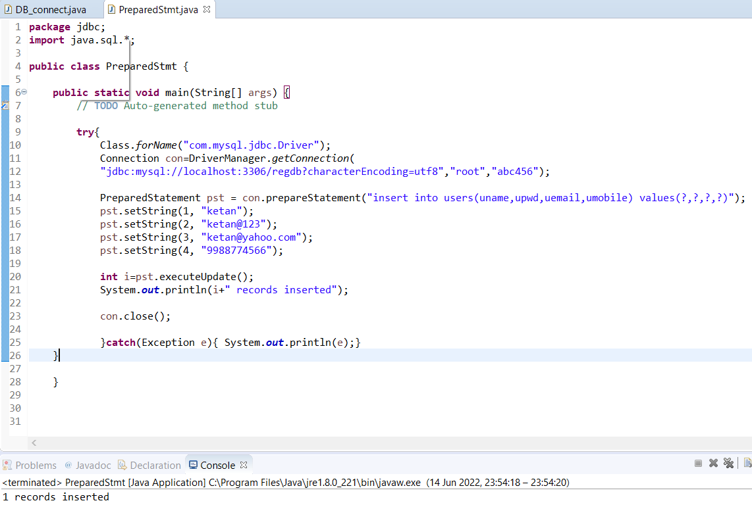

delimiter $$

drop function if exists f1 $$

create function f1(n1 int,n2 int) returns int deterministic

begin

declare co int default 0;

set co=n1+n2;

return co;

end $$

delimiter ;

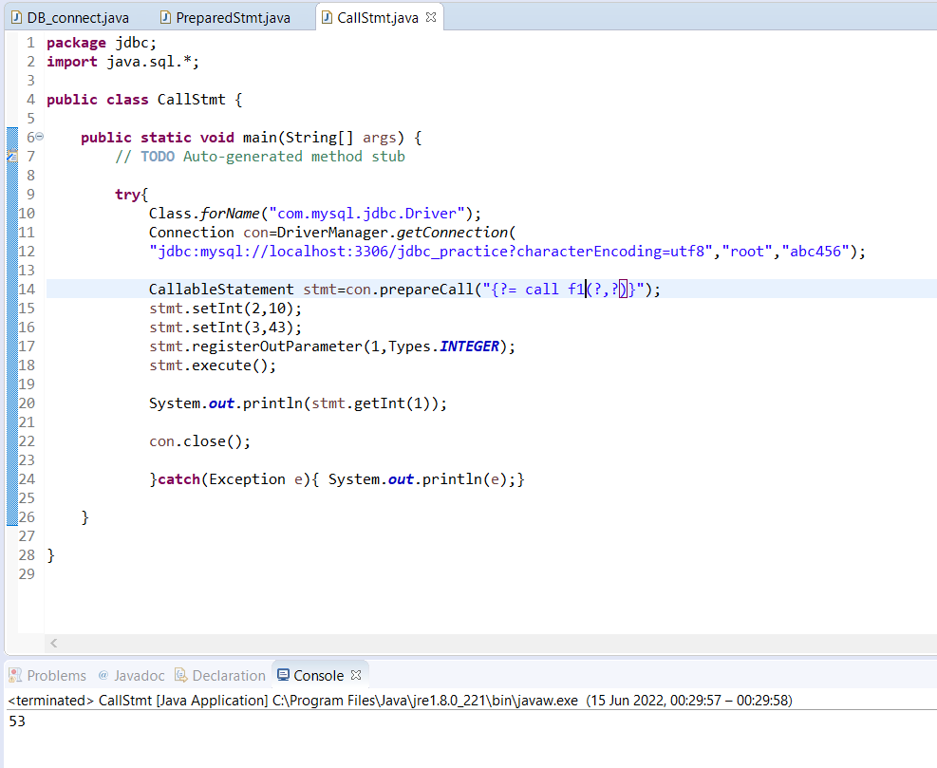

***I] NORMALIZATION***

**1NF**

A relation is in first normal form if it does not contain any composite or multi-valued attribute**.**

Given table student is not in 1NF

| Roll | Name | Course |
| --- | --- | --- |
| 1 | Omkar | C/C++ |
| 2 | Raj | Java |
| 3 | Nitin | Python/SQL |

So,

| Roll | Name | Course |
| --- | --- | --- |
| 1 | Omkar | C |
| 1 | Omkar | C++ |
| 2 | Raj | Java |
| 3 | Nitin | Python |
| 3 | Nitin | SQL |

**2NF**

A table is said to be in 2NF if it satisfies 2 conditions:

1. A table or relation must be in 1 NF.
2. All the non prime attributes should be fully functionally dependent on candidate key.

Given Customer table is not in 2NF

| Customer ID | Store ID | Location |
| --- | --- | --- |
| 1 | 1 | Delhi |
| 1 | 3 | Mumbai |
| 2 | 1 | Delhi |
| 3 | 2 | Banglore |
| 4 | 3 | Mumbai |

Can be converted :

| Customer ID | Store ID |
| --- | --- |
| 1 | 1 |
| 1 | 3 |
| 2 | 1 |
| 3 | 2 |
| 4 | 3 |

| Store ID | Location |
| --- | --- |
| 1 | Delhi |
| 2 | Banglore |
| 3 | Mumbai |

**3NF**

The two conditions which need to be satisfied are:

1. Table/Relation must be in 2NF
2. There should be no transitive dependency in table.

| Roll No | State | City |
| --- | --- | --- |
| 1 | Punjab | Mohali |
| 2 | Haryana | Ambala |
| 3 | Punjab | Mohali |
| 4 | Haryana | Ambala |
| 5 | Bihar | Ambala |

The above table is not in 3NF as Roll No-> State and State->City So, RollNo->City

So,

| Roll No | State |
| --- | --- |
| 1 | Punjab |
| 2 | Haryana |
| 3 | Punjab |
| 4 | Haryana |
| 5 | Bihar |

| State | City |
| --- | --- |
| Punjab | Mohali |
| Haryana | Ambala |
| Bihar | Ambala |

**BCNF**

**A relation is in BCNF if it is in 3NF and for every FD, LHS is super key/ candidate key.**

| **Roll No** | **Name** | **Voter ID** | **Age** |
| --- | --- | --- | --- |
| 1 | Ravi | ABC | 20 |
| 2 | Varun | DEF | 21 |
| 3 | Ravi | GHI | 23 |
| 4 | Rahul | JKL | 21 |

CK:{RollNo, Voter ID}

FD:RollNO->Name, RollNo->VoterID,VoterID->Age,VoterID->RollNo

It satisfies the condition.SO its in BCNF