

Prepared by:

Ghaidaa Baglagel 1506020

Sara Alkhaldi 1506980

gh

* nj

**Assignment 1**

**CPIS 483**

**‏‏**

1. **Introduction**

# In this report, the team members will use Gephi tool to make social network analysis. We downloaded a free dataset form the GitHub in .gexf format. See figure 1. This dataset show the mapping between Science in Society actors on the Internet of 12 European countries.



Figure 1: Dataset format

1. **Graph Information**

After expoting the dataset dirictly the information of the graph will be displayed:

* Number of nodes is 1285.
* Number of edges is 7524.
* Type of graph is directed graph. See figure 2.

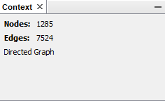

Figure 2: graph information

1. **Displaying the graph**

The following graphs review social networking data. It is contained several nodes and edges that represent the spread of the data in a particular destination and the way it is distributed. The nodes are represented as actors types that they affect the science on the internet. As we can see in figure 3 the nodes are the most presented it is divided by degree. The green nodes also high presented. The node that referred by arrow ((1)) it appears with green color it is the biggest node and it is more node important. In figure 4 it is shows that the name of these node is "Beligan Science Policy". The arrow((2)) shows the second baggiest node with pink color the name of this node is "Universie Libre de Bruxlles". As we see in the figure 3, the larger the node, the greater its importance and impact. There are many small nodes it is less impact to the network..

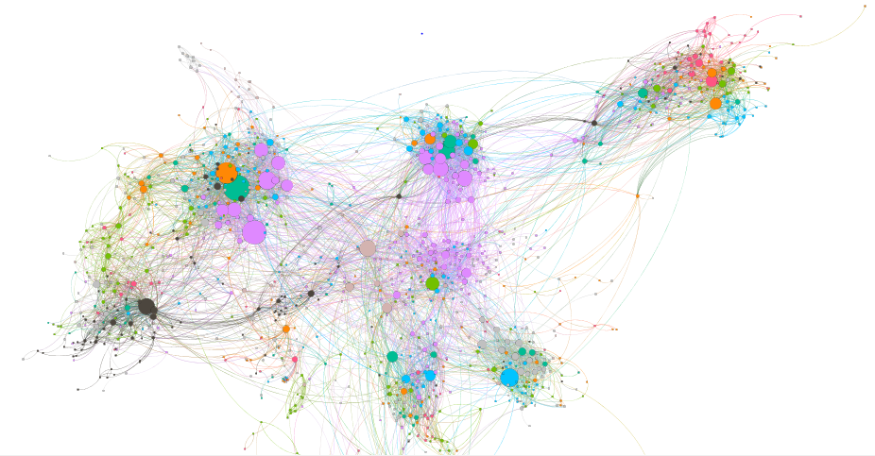

Figure 3: Graph previwe

Figure 3: Data preview graph

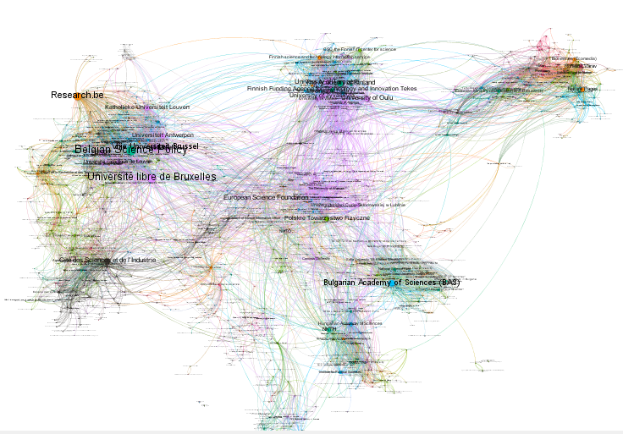

Figure 4: Data preview with labels

1. **Partition**

Partition helps to understand the distribution of percentages between each node according to the choice of the attribute. Each percentage appears in a certain color as shown in the graph. See figure 5 and 6.

As we see in figure 5, there are 22 actor type effect the science on the internet. The most actor type effective is Universities and secondary schools with 17.82% with pink color as we see how it is represented in the graph. As we see that the media ranked sixth in the spread by 7.08%.

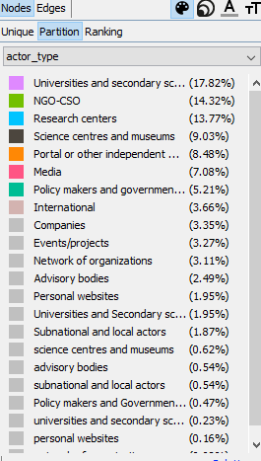In figure 6 shows the distributions of 12 countries have those actors that they effect science on the internet. The Belgium come first with 15.33% and Portugal come ninth with 2.88%.

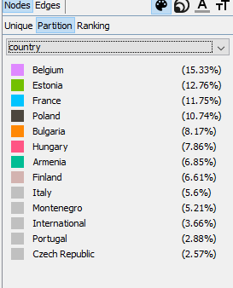

.

Figure 6 : percentage of country

Figure 5: persintige of actor type

1. **Metric result :**

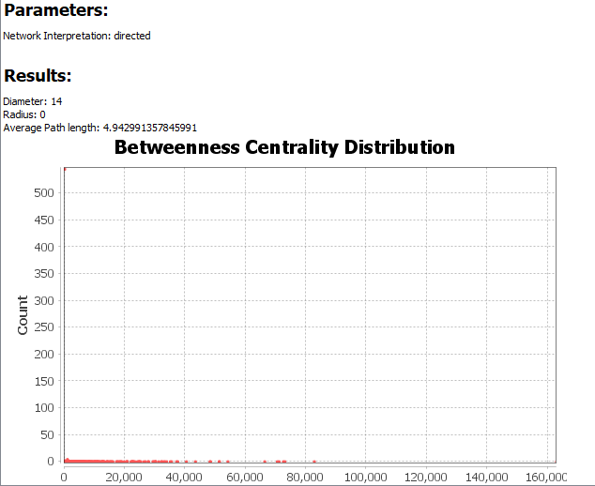We display the average path length result in the graph distance report. Also show the box-plot of betweenness centrally distribution. See figure 7.

Figure 7 : Avarage path length

GitHup Link:

<https://github.com/ghaidaa123/Social-Network-Analysis>